Cs$​_{0.1}$FA$​_{0.9}$PbI$​_{3}$ Perovskite Solar Cells as Ionizing Radiation Monitors
The preceding chapter established that halide perovskites combine the electronic properties requisite for radiation detection, high effective atomic number, adequate charge-carrier mobility-lifetime products, and tunable bandgap, with solution-processable fabrication routes inaccessible to conventional compound semiconductors. The work described in this chapter exploits a distinct but complementary strategy: rather than deploying a thick single crystal as a direct charge-collection detector, it repurposes a photovoltaic-architecture thin-film device as a current-mode radiation monitor. The rationale is twofold. First, modern perovskite solar cells have reached certified power-conversion efficiencies exceeding 27% , implying that the absorber layers have been optimized over a decade of intense materials research for the very properties, long carrier diffusion lengths, low trap-state densities, and efficient carrier extraction, that also govern sensitivity to ionizing radiation. Second, photovoltaic modules are inherently scalable in area, enabling the construction of sensor arrays whose geometric aperture is far larger than what is practical with single-crystal bulk detectors, and whose short-circuit current provides a direct analog output suitable for interfacing with standard nuclear instrumentation.
The Cs$​_{0.1}$FA$​_{0.9}$PbI$​_{3}$ composition is specifically chosen because partial substitution of cesium for formamidinium suppresses the spontaneous $α→δ$ phase transition of pure FAPbI$​_{3}$ while preserving its 1.48 eV bandgap and superior charge transport relative to MAPbI$​_{3}$ . The pin diode device structure (Section 1.1) further suppresses dark current relative to a simple ohmic-contact geometry, and its inverted polarity places the transparent electrode on the illuminated face, an arrangement that simultaneously enables photovoltaic operation under sunlight and direct exposure of the perovskite absorber to externally incident radiation.
This chapter reports visible-light temporal response measurements (Section 1.2), X-ray response under pulsed and continuous illumination (Section 1.3), gamma-ray response during continuous $​^{137}$Cs and $​^{60}$Co irradiation including a six-day and sixteen-day stability study (Section 1.4), and steady-state neutron response measurements performed at the Ohio State University Nuclear Reactor Laboratory (Section 1.5).

Device Fabrication and Photovoltaic Performance
Devices were fabricated by Prof. Jinsong Huang’s group at the University of North Carolina at Chapel Hill using a standard inverted (pin) architecture developed for high-efficiency perovskite photovoltaics. The composition of the absorber layer is Cs$​_{0.1}$FA(CH$​_{3}$NH$​_{2}$)$​_{0.9}$PbI$​_{3}$, where the 10 mol% Cs$​^{+}$ substitution entropy-stabilizes the cubic $α$-phase at ambient conditions as described in Section [sec:perovskite_structure]. Device fabrication proceeded by sequential solution deposition of the hole transport layer, the perovskite precursor solution, the electron transport layer, and the top metal contact onto glass/ITO substrates. The layer stack, illustrated in Figure 1.1, is ITO / hole transport layer / Cs$​_{0.1}$FA$​_{0.9}$PbI$​_{3}$ / electron transport layer / Ag.
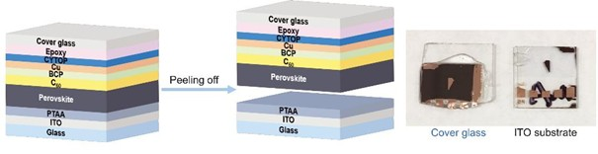
Cross-sectional schematic of the pin perovskite device structure used throughout this chapter. The ITO/hole-transport-layer (HTL) contact serves as the illuminated face for both photovoltaic and radiation-monitoring operation; the Ag back contact completes the Cs$​_{0.1}$FA$​_{0.9}$PbI$​_{3}$ absorber sandwich.
Two device geometries were characterized: a small-area cell ($∼$8 mm$​^{2}$ active area) for high-throughput screening and an encapsulated module (63.7 cm$​^{2}$ aperture area, four cells wired in series) intended for radiation monitoring applications. Representative current density–voltage (J-V) curves measured under 1-sun AM1.5G illumination are shown in Figure 1.2.
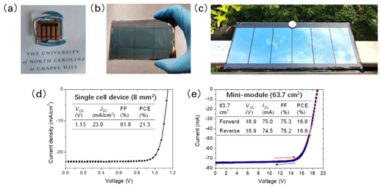
Photovoltaic performance of the Cs$​_{0.1}$FA$​_{0.9}$PbI$​_{3}$ devices used in this study. (a) J-V curve for the 8 mm$​^{2}$ small cell (PCE = 21.3%, $V_{OC}$ = 1.13 V, $J_{SC}$ = 23.0 mA cm$​^{−2}$, FF = 81.8%). (b) J-V curve for the 63.7 cm$​^{2}$ module (PCE = 16.9%, $V_{OC}$ = 18.9 V, $J_{SC}$ = 74.5 mA cm$​^{−2}$, FF = 76.2%). All measurements performed at UNC Chapel Hill under AM1.5G illumination prior to shipment.
The small-cell PCE of 21.3% is consistent with champion efficiencies reported for the Cs$​_{0.1}$FA$​_{0.9}$PbI$​_{3}$ composition in the contemporary literature , confirming that the devices received for radiation testing represent the current state of the art in perovskite photovoltaic fabrication. The module efficiency of 16.9% reflects the geometric fill-factor penalty inherent in a series-connected configuration and is comparable to certified module efficiencies from the same composition reported by independent groups .

Temporal Photoresponse Characterization
Before proceeding to ionizing radiation measurements, the time-domain photoresponse of the devices was characterized under visible light to establish the inherent bandwidth of the detector and to identify any device-physics limitations on pulse-following ability. Three complementary measurement modalities were employed: a DC chopped-beam experiment to measure the turn-on and turn-off time constants, a pulsed-laser experiment to probe the high-frequency limit, and an AC-coupled grid-simulation experiment to assess the feasibility of power-grid synchronization using the solar module.

DC Transient Response
The DC transient measurement used a 532 nm continuous-wave laser attenuated to approximately 0.45 sun equivalent irradiance and modulated by a mechanical optical chopper. Short-circuit current transients were acquired on a digital oscilloscope and analyzed to extract the 10–90% rise time and the 90–10% fall time.
The 8 mm$​^{2}$ cell exhibited a rise time of approximately 33 ms, while the 28.6 cm$​^{2}$ module required approximately 60 ms to reach 80% of its peak short-circuit current after the chopper opened. Both values are substantially longer than the RC time constants computed from the device capacitance and load resistance, confirming that the observed response time is limited by the chopper blade transit speed rather than by any intrinsic device physics. This conclusion is consistent with the known sub-microsecond free-carrier lifetimes in high-quality Cs–FA perovskite films .

Pulsed Laser Response
To access the true high-frequency bandwidth of the devices, a pulsed diode laser (Thorlabs NPL41B, 405 nm central wavelength) was used in place of the chopped CW source. The laser was operated at a repetition rate of 1 kHz with a pulse width of 20 ns (variable 6–38 ns range, up to 10 MHz maximum repetition rate). Photoresponse pulses were amplified by a transimpedance amplifier with ${10}^{5}$ V A$​^{−1}$ gain and 1 MHz bandwidth before acquisition on a Keysight MSO-X-3104T oscilloscope.
Two series-parallel module assemblies, denoted Cell A and Cell B, each consisting of four Cs$​_{0.1}$FA$​_{0.9}$PbI$​_{3}$ cells mounted on a printed breadboard, were characterized. Cell A exhibited an output pulse rise time of approximately 84 ns under these conditions; Cell B produced a comparable waveform. The measured rise time is dominated by the 1 MHz bandwidth of the transimpedance amplifier rather than the device itself: the $−3$ dB amplifier bandwidth corresponds to a rise-time limit of $0.35/{10}^{6}$ Hz $≈350$ ns, and the shorter observed value reflects the partial bandwidth contribution of the oscilloscope front-end and cable parasitics. The intrinsic device response is therefore faster than the approximately 84 ns system-limited value, consistent with the sub-microsecond carrier lifetimes expected from the $μτ$ products typical of Cs$​_{0.1}$FA$​_{0.9}$PbI$​_{3}$ thin films reported in Section [sec:hecht].

AC Grid Simulation
To evaluate whether the solar module could track the periodic voltage waveform produced by a single-phase power inverter, a potential application for verifying grid integrity or synchronizing a radiation monitor to a power-cycle reference, the four-cell module was connected to the input of a commercial single-phase DC-to-AC microinverter under indoor fluorescent illumination. The inverter consumed approximately 4 W at its rated load, but the module could deliver only $∼$1 W under the available illumination, leaving the inverter operating in a deeply underloaded regime. No distinct 50/60 Hz modulation of the module output current was discernible above the noise floor in this configuration. The negative result is attributed entirely to the power deficit rather than to any bandwidth limitation of the perovskite device: achieving an observable AC response would require either a larger-aperture module, a light concentrator, or a calibrated illumination source at close to 1-sun intensity.

X-Ray Response
X-ray characterization was performed using an Amptek Mini-X miniature X-ray tube with a gold anode, operated at tube voltages up to 50 kV. For continuous-wave measurements, the module was placed in the beam path and J-V characteristics were recorded as a function of X-ray tube voltage and current. Figure 1.3 shows the resulting I-V curves; the short-circuit current $I_{SC}$ increases monotonically with tube voltage, consistent with the increasing photon fluence and mean photon energy.
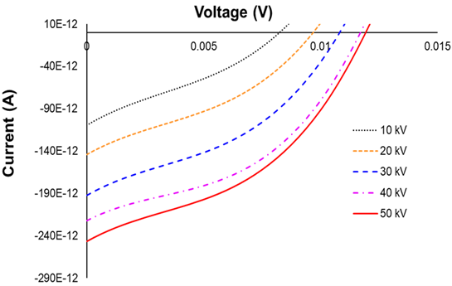
Current-voltage characteristics of the Cs$​_{0.1}$FA$​_{0.9}$PbI$​_{3}$ module under Amptek Mini-X X-ray tube illumination at tube voltages from 10 kV to 50 kV. Inset: $I_{SC}$ at 50 kV as a function of irradiation time.
The time-resolved $I_{SC}$ at 50 kV, shown in the inset of Figure 1.3, exhibits the characteristic slow-decline behavior previously reported for perovskite photovoltaic devices under sustained illumination in the presence of a built-in electric field. The decline is attributed to ion migration: mobile halide vacancies drift under the device’s built-in field, accumulating at the charge-transport layer interfaces and partially screening the collection field .
The absolute $I_{SC}$ induced by the X-ray source is substantially smaller than that observed in the silicon reference device operated under the same conditions, owing to the much smaller active area of the perovskite module relative to the silicon photodiode used for comparison ($∼$64 cm$​^{2}$ vs. several hundred cm$​^{2}$). On a per-unit-area basis, the perovskite compares favorably due to its higher photoelectric absorption cross section at the relevant photon energies.
For pulsed X-ray measurements, the Amptek Mini-X beam was modulated by a Thorlabs MC2000 optical chopper equipped with a 10-slot blade (760 $μ$m stainless steel, slot width matched to achieve pulse frequencies from 10 Hz to 1 kHz). The pulsed response confirmed that the device faithfully follows the beam modulation at frequencies up to the chopper bandwidth, consistent with the pulsed laser measurements in Section 1.2.2.

Gamma-Ray Response

Measurement Setup and Dose Rate Calibration
Gamma-ray irradiation experiments were performed at the Ohio State University Nuclear Reactor Laboratory (OSU NRL) using two independent sources: a benchtop $​^{137}$Cs irradiator (six source rods, $E_{γ}=662$ keV) and a $​^{60}$Co irradiator submerged in the reactor pool ($E_{γ}=1.17$ and 1.33 MeV). Because the dose rate calibration values provided with each irradiator are given in units of roentgen per hour for air, conversion to the absorbed dose rate in the perovskite film was performed using the relation
$${\dot{D}}_{perovskite}=0.877×\frac{(μ_{en}/ρ)_{perovskite}}{(μ_{en}/ρ)_{Si}}×\dot{X},$$
where $\dot{X}$ is the exposure rate in roentgen per hour, 0.877 rad/R is the roentgen-to-rad conversion factor for soft tissue , and the ratio of mass energy-absorption coefficients $(μ_{en}/ρ)$ was evaluated at the mean photon energy of each source using NIST XCOM tabulations . This procedure yielded dose rates of 44.16 rad hr$​^{−1}$ in the perovskite layer for the $​^{137}$Cs irradiator and 355.61 rad hr$​^{−1}$ for the $​^{60}$Co source.

Cesium-137 Irradiation
The Cs$​_{0.1}$FA$​_{0.9}$PbI$​_{3}$ module was inserted into and withdrawn from the $​^{137}$Cs irradiator while the short-circuit current was monitored in real time. Figure 1.4 shows a time-series of $I_{SC}$ recorded during a representative insert/withdraw cycle. A clear and reproducible step change in $I_{SC}$ is observed upon insertion, with the current increasing by an amount proportional to the gamma-induced electron-hole pair generation rate within the absorber. The induced current density at 44.16 rad hr$​^{−1}$ was measured as 2.19 nA cm$​^{−2}$, which represents the net gamma-to-current conversion sensitivity of the device under the prevailing irradiation geometry.
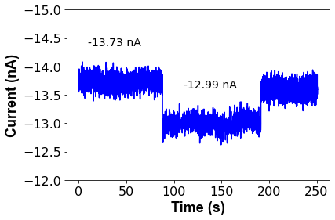
Short-circuit current $I_{SC}$ of the Cs$​_{0.1}$FA$​_{0.9}$PbI$​_{3}$ module as a function of time during insertion into and withdrawal from the $​^{137}$Cs irradiator (dose rate = 44.16 rad hr$​^{−1}$ in perovskite).
To assess the long-term stability of the perovskite module as a radiation monitor, the device was subjected to continuous $​^{137}$Cs irradiation for six days without removal from the source. The accumulated absorbed dose over the six-day period was computed by integrating the dose rate over the irradiation time. Figure 1.5 shows the evolution of $I_{SC}$ as a function of cumulative absorbed dose. A linear decrease in $I_{SC}$ with dose is observed, with a slope of $−0.74$ nA rad$​^{−1}$, corresponding to a relative degradation rate of approximately $\left[I_{SC}(0)−I_{SC}(D)\right]/I_{SC}(0)$ per unit absorbed dose.
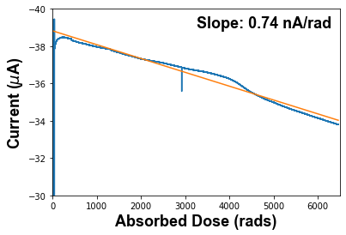
Long-term evolution of $I_{SC}$ under continuous $​^{137}$Cs irradiation (44.16 rad hr$​^{−1}$) over six days.
The observed linear decline is consistent with the creation of electrically active defects, primarily iodide Frenkel pairs, proportional to the absorbed dose, as has been documented for $​^{60}$Co irradiation of MAPbI$​_{3}$ single crystals at doses up to 1000 krad . An additional contribution to the $I_{SC}$ decline comes from cumulative darkening of the borosilicate glass superstrate, which reduces the visible-light transmittance and hence the photovoltaic current even in the absence of absorber degradation; this contribution has been documented separately .

Cobalt-60 Irradiation
The module was subsequently irradiated in the OSU NRL reactor pool using the underwater $​^{60}$Co irradiator at a dose rate of 355.61 rad hr$​^{−1}$ in the perovskite layer, approximately eight times higher than the $​^{137}$Cs rate. The measurement geometry was otherwise identical: $I_{SC}$ was recorded continuously throughout a 16-day irradiation. The induced current density at 355.61 rad hr$​^{−1}$ was 3.56 nA cm$​^{−2}$.
Figure 1.6 shows the $I_{SC}$ time series for the $​^{60}$Co irradiation. As with $​^{137}$Cs, a downward linear trend in the baseline $I_{SC}$ is observed over the 16-day period, consistent with progressive defect accumulation proportional to absorbed dose.
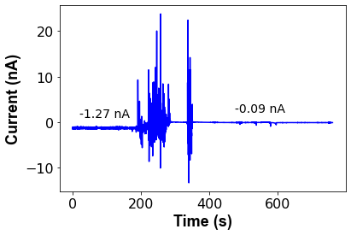
Short-circuit current $I_{SC}$ of the module during 16-day continuous $​^{60}$Co irradiation (dose rate = 355.61 rad hr$​^{−1}$ in perovskite).
These results demonstrate that arrays of calibrated perovskite modules could, in principle, be deployed in a spatial configuration around a radiation source to triangulate the detonation location or measure the spatial dose distribution by comparing the $I_{SC}$ responses of individual array elements. The linear dose–current relationship established here provides the calibration function necessary for such an application.

Neutron Response
Neutron response measurements were performed at the Fast Neutron Beam Facility (FBF) of the Ohio State University Research Reactor (OSURR). The FBF beamline and its filtering elements are described in full in Section 1.5.1 below; the experimental geometry for the solar-cell measurements placed the perovskite module alternately outside the beam (background), in the beam with the gamma-suppression filter closed, and in the beam with the filter open, enabling separation of the neutron-induced and gamma-induced current components.

OSURR Fast Neutron Beam Facility
The OSURR is a 500-kW$​_{th}$ pool-type research reactor operated by the OSU Nuclear Reactor Laboratory. The Fast Neutron Beam Facility (FBF) is a horizontal beamport extending from the reactor core through the biological shielding to an experimental area, providing access to the reactor’s fast and epi-thermal neutron flux for detector characterisation. The beam line contains three independently configurable filtering elements, each of which modifies the fast neutron flux and gamma dose rate reaching the detector in a distinct way.
The first element is a permanent 4-inch (10.16 cm) single-crystal bismuth block embedded near the reactor core as an in-line gamma filter. Bismuth is nearly transparent to fast neutrons while strongly attenuating the intense prompt fission gamma flux produced by the reactor core. This filter is always in place and is not removable during experiments.
The second element is an 8-inch (20.32 cm) lead gamma shutter embedded in the reactor’s concrete shielding wall downstream of the bismuth filter. The shutter consists of a cylindrical drum filled with $1/{16}$-inch (0.159 cm) Pb shot. When open, the neutron beam passes through an air gap in the drum; when closed, the beam traverses the full column of lead shot, providing approximately 8 inches of gamma shielding in total. Closing the gamma shutter reduces the gamma-ray content of the beam by a factor of 300, while simultaneously attenuating the fast neutron flux by a factor of 35. With the shutter open and no cadmium filter in place, the fast neutron flux at the detector position is $1.5×{10}^{7}$ cm$​^{−2}$ s$​^{−1}$ and the gamma dose rate is 15.787 R hr$​^{−1}$. With the shutter closed, the fast neutron flux drops to $4.3×{10}^{5}$ cm$​^{−2}$ s$​^{−1}$ and the gamma dose rate falls to 50.525 mR hr$​^{−1}$.
The third element is an external 2-mm cadmium (Cd) foil positioned at the beam exit port. Cadmium has a very large absorption cross-section for thermal neutrons (below $∼$0.5 eV) and acts as a selective thermal neutron filter, leaving the fast and epi-thermal components of the beam largely unaffected. The Cd foil was characterised via gold foil activation measurements per ASTM E262-17, yielding a Cadmium Ratio of 1.1 and a thermal neutron reduction factor of 110. When the gamma shutter is closed and the Cd filter is inserted, the estimated thermal neutron flux at the detector is reduced to $∼$220 cm$​^{−2}$ s$​^{−1}$, while the fast neutron flux remains at $4.3×{10}^{5}$ cm$​^{−2}$ s$​^{−1}$. The combined effect of all three filtering configurations on the beam composition is summarised in Table 1.1.
OSURR FBF beam conditions as a function of gamma shutter and Cd filter configuration. All flux and dose-rate values are referenced to 450 kW$​_{th}$ reactor power at the detector position.
Shutter | Cd filter | Fast neutron flux (cm$​^{−2}$ s$​^{−1}$) | Gamma dose rate
Open | Out | $1.5×{10}^{7}$ | 15.787 R hr$​^{−1}$
Closed | Out | $4.3×{10}^{5}$ | 50.525 mR hr$​^{−1}$
Closed | In | $4.3×{10}^{5}$ | 50.525 mR hr$​^{−1}$
The neutron energy spectrum at the FBF, determined by the SAND-II and STAYSL spectrum-unfolding techniques using activation of copper, gold, and nickel wire dosimeters, is shown in Figure 1.7. The spectrum spans thermal energies through the fast fission continuum, with the fast and epi-thermal components dominating the integrated flux. The addition of the Cd filter has a minor effect on the spectral shape above $∼$1 eV and does not appreciably alter the fast-neutron component.
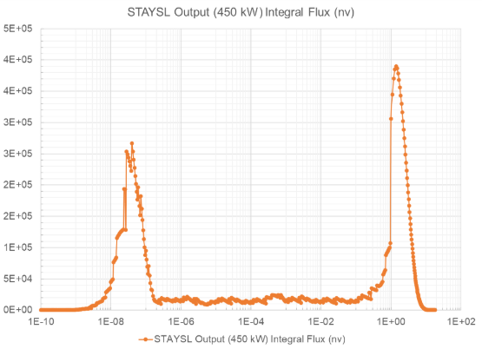
Neutron energy spectrum at the OSURR FBF determined by SAND-II and STAYSL unfolding of Cu, Au, and Ni activation wire measurements. The same spectrum applies to both the Cs$​_{0.1}$FA$​_{0.9}$PbI$​_{3}$ solar-cell neutron experiments described in this chapter and the MHyPbCl$​_{3}$ fast-neutron detection experiments described in Chapter [ch:MHyPbCl3].

Steady-State Reactor Measurements
Table 1.2 summarizes the short-circuit current $I_{SC}$ measured under each condition, referenced to reactor power levels of 0 kW$​_{th}$ (reactor shutdown) and 450 kW$​_{th}$ (operating power).
Steady-state short-circuit current of the Cs$​_{0.1}$FA$​_{0.9}$PbI$​_{3}$ module at OSU NRL FBF. Uncertainties are $±1σ$ over the measurement interval. “Gamma filter closed” and “gamma filter open” refer to the polyethylene/lead shielding assembly that preferentially attenuates the reactor gamma flux while transmitting fast neutrons.
Condition | Reactor Power | $I_{SC}$ (pA)
Background (reactor off) | 0 kW$​_{th}$ | $51.29±6.60$
Background (reactor on) | 450 kW$​_{th}$ | $57.50±7.39$
Gamma filter closed | 450 kW$​_{th}$ | $57.62±7.93$
Gamma filter open | 450 kW$​_{th}$ | $59.77±8.62$
The data in Table 1.2 reveal a slight but statistically marginal increase in $I_{SC}$ upon opening the gamma filter (from $57.62±7.93$ pA to $59.77±8.62$ pA). The difference of $∼$2.2 pA represents a $∼$0.26$σ$ effect relative to the combined quadrature uncertainty, which is not statistically significant at the 95% confidence level. The result is therefore classified as inconclusive: a neutron-induced contribution cannot be ruled out, but the signal-to-noise ratio of a single 8 mm$​^{2}$–63.7 cm$​^{2}$ module is insufficient to resolve it above the fluctuating gamma and ambient backgrounds present at the FBF port.
These results motivate the use of a larger-area array for future neutron sensing experiments. Scaling the active area by a factor of ten to twenty, combined with the differential signal extraction method described by Panaccione et al. , is expected to raise the neutron-to-background ratio above the detection threshold.

Chopped-Beam Transient Measurements
In an attempt to resolve a time-modulated neutron signal against the steady-state gamma background, the reactor beam was mechanically chopped at frequencies between 1 Hz and 100 Hz using a borated polyethylene blade. Synchronous detection (lock-in analysis) of the $I_{SC}$ transient was implemented in software. No neutron-induced current component was detected above the noise floor under any chopping frequency in this configuration, consistent with the steady-state analysis: the signal magnitude is simply too small relative to the electronic noise of the current measurement system at the flux levels available from the 450 kW$​_{th}$ reactor at the FBF port.

Summary
This chapter has demonstrated that photovoltaic-architecture Cs$​_{0.1}$FA$​_{0.9}$PbI$​_{3}$ perovskite solar cells can serve as sensitive current-mode monitors for a broad spectrum of ionizing radiation. The key results are as follows.
Temporally, the device bandwidth is limited by the measurement electronics rather than the intrinsic perovskite photoresponse: rise times of 33–84 ns were recorded depending on the amplifier configuration, and the actual carrier lifetime in the film is substantially shorter than the measured system rise time.
Under X-ray irradiation (Amptek Mini-X, up to 50 kV), the module produces a measurable short-circuit current proportional to the beam intensity, with the characteristic slow $I_{SC}$ decline associated with ion-migration field screening under the device’s built-in field .
Under $​^{137}$Cs gamma irradiation at 44.16 rad hr$​^{−1}$, an induced current density of 2.19 nA cm$​^{−2}$ was measured, and a distinct step response was observed upon insertion and withdrawal. Long-term (six-day) continuous irradiation revealed a linear decline of $∼$0.74 nA rad$​^{−1}$ attributable to cumulative defect creation and glass darkening . The $​^{60}$Co measurement at 355.61 rad hr$​^{−1}$ yielded 3.56 nA cm$​^{−2}$ and an equivalent linear degradation trend over sixteen days, confirming the scalability of the current-mode detection approach across a dose-rate range spanning nearly an order of magnitude.
Neutron response at the OSU NRL FBF was statistically inconclusive for a single module at 450 kW$​_{th}$; the signal-to-noise analysis indicates that scaling the detector array area by a factor of ten to twenty is necessary to resolve the neutron-induced current above the combined gamma and electronic noise backgrounds.

