Perovskite Semiconductor Radiation Detectors
The preceding chapter established that photovoltaic-architecture perovskite thin films can generate measurable current-mode signals in response to X-ray, gamma, and neutron irradiation, exploiting the device’s built-in electric field to sweep radiation-generated carriers to the contacts without any externally applied bias. The present chapter pursues a fundamentally different detection philosophy: deploying halide perovskites as direct-conversion semiconductor radiation detectors in which a large externally applied reverse bias sweeps charge carriers generated by individual radiation interaction events across the device and into a charge-sensitive readout chain. This mode of operation, familiar from conventional compound semiconductor detectors such as CdZnTe (CZT) and CdTe, offers the possibility of pulse-by-pulse energy spectroscopy rather than the integrated current monitoring that characterises the photovoltaic geometry of Chapter [ch:CsFAPbI].
Halide perovskites present a compelling case for direct-conversion detector development. Their heavy-metal cation sublattice, dominated by lead in the systems studied here, provides a high effective atomic number, giving large photoelectric cross sections at gamma and X-ray energies that are difficult or impossible to achieve with silicon or organic semiconductors. Some methylhydrazinium-based compositions additionally incorporate a high density of hydrogen atoms, enabling elastic proton-recoil reactions with fast neutrons that allow direct-conversion neutron detection without requiring a separate conversion layer. Solution-phase crystal growth methods have produced centimetre-scale single crystals with carrier $μτ$ products approaching or exceeding those of polycrystalline CZT, a property critical for efficient charge collection across the millimetre-scale thicknesses required to stop MeV-energy photons and neutrons.
This chapter is organised by device, with each section covering a single detector system from fabrication through characterisation to radiation detection results. Six devices are presented: the MAPbI$​_{3}$-hBN X-ray detector (Section 1.2), the 2D perovskite (PEA$​_{2}$MA$​_{2}$Pb$​_{3}$I$​_{10}$) X-ray detector with 5F-PEAI surface treatment (Section 1.3), the CsPbBr$​_{3}$ gamma-ray detector (Section 1.4), the FAPbBr$​_{3}$ gamma-ray detector (Section 1.5), the MAPbBr$​_{3}$ gamma detector (Section 1.6), and the MHyPbCl$​_{3}$ fast neutron detector (Section 1.7). A cross-device discussion of ion migration, the central performance-limiting mechanism observed across all systems, is presented in Section 1.8, followed by a summary in Section 1.9.

Direct-Conversion Detector Principles
A direct-conversion radiation detector converts the energy deposited by an ionising particle or photon directly into an electrical signal, without an intermediate scintillation step. When a gamma ray, X-ray, or charged particle deposits energy $E$ in a semiconductor detector of bandgap $E_{g}$, approximately $E/W$ electron-hole pairs are created, where $W≈2.8 E_{g}$ is the mean ionisation energy per pair . The carriers are swept by an applied electric field to opposite contacts, where they induce a charge pulse on the readout electronics. For spectroscopic operation, this pulse must be faithfully proportional to the deposited energy, a condition that requires complete charge collection and minimal trapping of carriers en route to the contacts.
The probability that a carrier generated at depth $x$ in the crystal (of thickness $d$) reaches the collecting contact is described by the Hecht equation,
$$η=\frac{μτE}{d}\left[1−exp​\left(−\frac{d}{μτE}\right)\right],$$
where $E=V/d$ is the applied electric field, $V$ is the applied voltage, and $μτ$ is the mobility-lifetime product of the dominant carrier species . Equation ([eq:hecht]) shows that achieving high collection efficiency $η→1$ requires either a large $μτ$ product or a large applied field, or both. For a 1-mm-thick crystal with $μτ={10}^{−3}$ cm$​^{2}$ V$​^{−1}$, complete collection requires fields of order 10 V $μ$m$​^{−1}$, i.e. applied voltages of order 1 kV. This requirement for large applied voltages is in direct tension with the ion-migration instability described in Section 1.8.
Two additional material requirements govern detector performance. First, the dark resistivity $ρ$ must be sufficiently high that the leakage current $I_{dark}=V​A/(ρd)$ produces an electronic noise contribution smaller than the signal charge from the smallest radiation event of interest. For gamma spectroscopy with CZT-like performance, $ρ>{10}^{9}$ $Ω$ cm is typically required . The 3D halide perovskites studied in this work achieve resistivities in the range ${10}^{9}$–${10}^{12}$ $Ω$ cm in their highest-quality single-crystal forms, competitive with or exceeding that of polycrystalline CZT. Second, the crystal must be thick enough to stop a significant fraction of the incident radiation. The mean free path of a 662-keV gamma ray (the primary emission of $​^{137}$Cs) in CsPbBr$​_{3}$ is approximately 7 mm, meaning that crystals of order 5–10 mm are required for reasonable detection efficiency.
For fast neutron detection, the governing interaction is elastic proton recoil: a fast neutron of kinetic energy $E_{n}$ collides with a hydrogen nucleus, transferring up to $E_{n}$ of kinetic energy to the recoil proton in a head-on collision. The recoil proton then deposits its energy densely in the crystal volume. The detection efficiency of a hydrogenous material is therefore proportional to its hydrogen atom density $n_{H}$. Table 1.1 compares $n_{H}$ for the key materials considered in this work.
Hydrogen atom density comparison for selected fast neutron detector materials.
Material | Formula | Density (g cm$​^{−3}$) | $n_{H}$ (cm$​^{−3}$)
Stilbene | C$​_{14}$H$​_{12}$ | 1.16 | $5.67×{10}^{22}$
Rubrene | C$​_{42}$H$​_{28}$ | 1.27 | $3.62×{10}^{22}$
EJ-276 plastic | C$​_{n}$H$​_{m}$ | 1.02 | $4.82×{10}^{22}$
MHyPbCl$​_{3}$ | CH$​_{6}$N$​_{2}$PbCl$​_{3}$ | 3.25 | $∼4.0×{10}^{22}$

MAPbI$​_{3}$-hBN X-Ray Detector
The MAPbI$​_{3}$-hBN device was the primary polycrystalline X-ray detector fabricated and characterised in this work. Its chief contribution is establishing the role of atmospheric humidity in limiting perovskite detector performance under applied bias, and demonstrating that vacuum operation partially restores intrinsic carrier transport.

Material and Device Fabrication
MAPbI$​_{3}$ (methylammonium lead triiodide) doped with hexagonal boron nitride (hBN) was used as the X-ray absorber medium. The hBN inclusions were incorporated to improve grain boundary passivation and reduce the density of deep-level trap states that would otherwise act as recombination centres for radiation-generated carriers. The contact architecture was asymmetric, with the hBN/MAPbI$​_{3}$ layer sandwiched between contacts of differing work function. This asymmetry creates a built-in potential that enables a photovoltaic-like X-ray response even at zero applied bias, as demonstrated below.
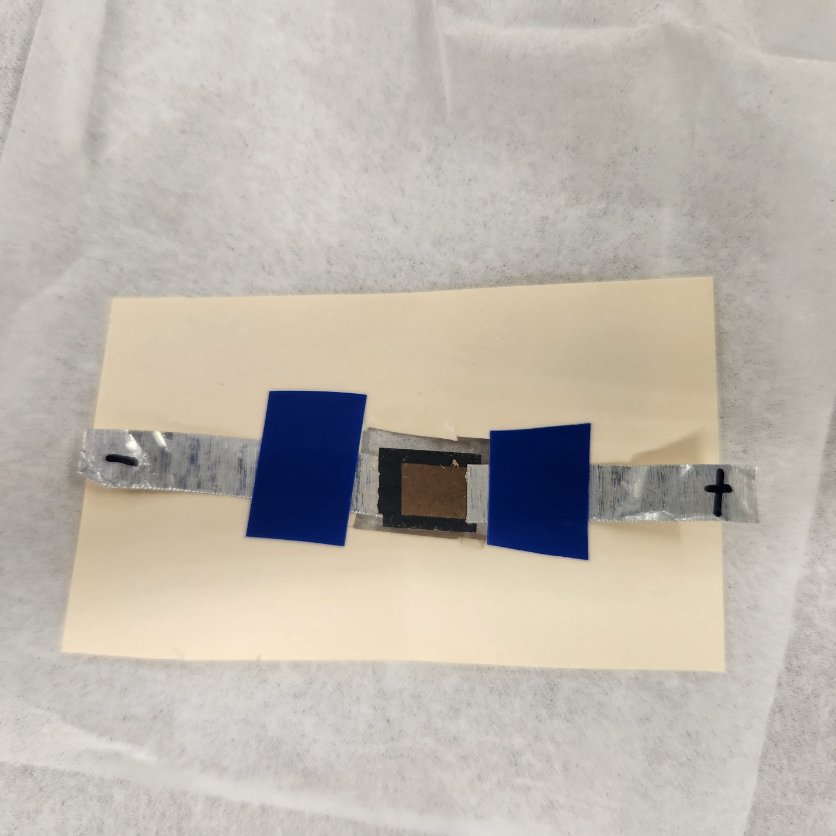
MAPbI$​_{3}$-hBN X-ray detector mounted for electrical testing.

Electrical Characterisation
Current-voltage (IV) characteristics were measured using a Keithley 2612A SourceMeter, with sweep protocols covering $±$2 V for contact resistance extraction up to high-voltage unipolar sweeps (0 to $−200$ V) for leakage characterisation under detector operating conditions. All sweeps were performed in a light-tight enclosure to prevent photogenerated carrier contributions. IV hysteresis measurements at 20 mV s$​^{−1}$ served as a diagnostic for ion-migration-driven charge redistribution; the MAPbI$​_{3}$-hBN device exhibited a measurable sweep-versus-hold difference in the low-voltage regime, indicative of a slow ionic relaxation polarisation effect consistent with field-driven amplification of the ion-migration rate.

X-Ray Sensitivity Measurements
X-ray characterisation was performed using a benchtop X-ray tube operated at 30–50 kVp, collimated to a conical beam with an $∼$2 cm exit aperture. The photocurrent was measured as a function of applied bias with the X-ray beam switched on and off periodically to distinguish the radiation-induced signal from the dark-current baseline. X-ray sensitivity $S$ is defined as
$$S=\frac{ΔI}{A⋅\dot{D}},$$
where $ΔI$ is the X-ray-induced change in current, $A$ is the active contact area, and $\dot{D}$ is the calibrated dose rate. The dose rate was calibrated using a RaySafe 452 dosimeter; however, the conical beam geometry caused dose-rate variation across the dosimeter face, leading to underestimation of the dose rate incident on the small perovskite contact area. NanoDot optically stimulated luminescence (OSL) dosimeters were identified as a more appropriate calibration tool for subsequent experiments.
Sensitivity increased monotonically with applied bias: $0.107 μ$C (Gy cm$​^{2}$)$​^{−1}$ at 5 V, $0.245 μ$C (Gy cm$​^{2}$)$​^{−1}$ at 10 V (confirmed by repeat measurement at $0.252 μ$C (Gy cm$​^{2}$)$​^{−1}$), and $0.411 μ$C (Gy cm$​^{2}$)$​^{−1}$ at 20 V. The sub-linear voltage dependence, a factor of $∼$3.8 sensitivity gain for a factor-of-four voltage increase, indicates the device had not yet entered the charge-collection saturation regime at 20 V.
X-ray sensitivity of the MAPbI$​_{3}$-hBN detector as a function of applied bias.
Applied Bias (V) | Sensitivity ($μ$C (Gy cm$​^{2}$)$​^{−1}$) | Notes
5 | 0.107
10 | 0.245 | First measurement
10 | 0.252 | Repeat, confirms reproducibility
20 | 0.411
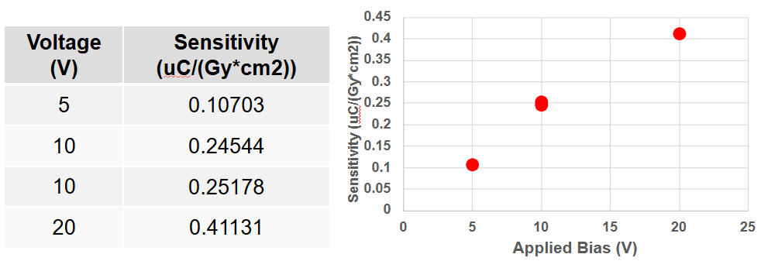
X-ray sensitivity of the MAPbI$​_{3}$-hBN detector as a function of applied reverse bias.
A bi-polar X-ray response was observed at zero applied bias in some device configurations: a spontaneous photovoltaic-like current transient was generated by X-ray exposure without any external voltage. This is attributed to the asymmetric contact architecture creating a built-in potential difference between the hBN/MAPbI$​_{3}$ and Au contact interfaces, which sweeps radiation-generated carriers toward the respective contacts even in the absence of applied bias.

Vacuum Testing and Humidity Effects
To directly evaluate the role of atmospheric humidity, X-ray sensitivity measurements were repeated under vacuum (base pressure $<{10}^{−3}$ Torr) and compared to measurements in ambient laboratory air at matched bias voltages of 5, 10, and 20 V. In every case, the X-ray-induced current was larger and more stable under vacuum, and the dark-current baseline was lower. These improvements are consistent with suppression of moisture-accelerated ion migration: water molecules at grain boundaries facilitate halide vacancy diffusion under the applied field, creating shunting pathways and reducing the effective bulk field. Removing ambient moisture under vacuum disrupts this pathway and partially restores intrinsic carrier transport.
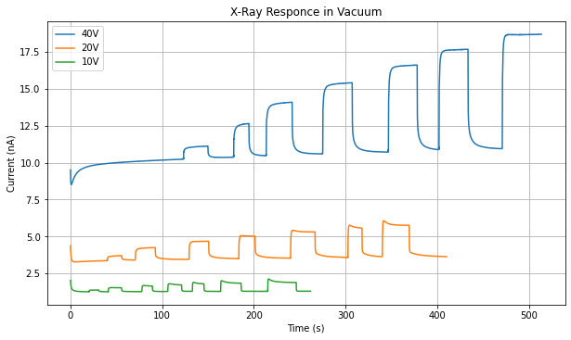
X-ray current transients for the MAPbI$​_{3}$-hBN device at 5, 10, and 20 V bias in ambient air and under vacuum.

Alpha Spectroscopy Under Vacuum
Alpha particles deposit their energy very densely within a few micrometres of the crystal surface and generate a correspondingly large number of electron-hole pairs, for a 5.49-MeV alpha from Am-241 and $W≈2.8 E_{g}≈8$ eV per pair in MAPbI$​_{3}$, approximately $6.8×{10}^{5}$ carriers are generated per event, roughly three orders of magnitude more than a single 662-keV gamma interaction. Despite this large signal charge, alpha spectroscopy had not been attempted with halide perovskite detectors at the time of this work because vacuum operation, which is required to position a source in close proximity without air attenuation of the short-range alpha particles, was known to increase the leakage current of perovskite devices, rendering pulse-height analysis impractical. The physical origin of this vacuum-induced leakage increase is not well established; proposed explanations include a reduction in surface resistance as adsorbed surface species are removed under evacuation, and electrical disturbances arising from outgassing of volatile components from the perovskite film.
The MAPbI$​_{3}$-hBN device was anomalous in this respect: under vacuum (base pressure $<{10}^{−3}$ Torr), the leakage current decreased rather than increased, yielding a stable, low dark current baseline over extended bias hold periods. This behaviour distinguished the device from other perovskite systems tested in this programme and made alpha spectroscopy feasible for the first time. With the noise floor below the alpha signal level, a resolvable Am-241 spectrum was obtained, shown in Figure 1.4.
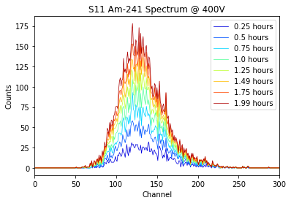
Am-241 spectrum and device stability data for the MAPbI$​_{3}$-hBN detector under vacuum operation.
The broader significance of this result was subsequently confirmed by independent groups. Zhang et al. reported high-resolution alpha particle spectroscopy with a CsPbBr$​_{3}$ single-crystal detector, achieving an energy resolution of 6.9% with commercial electronics and 1.1% with a full-custom readout ASIC designed to minimise parasitic capacitance and electronic noise . That work achieved stable low leakage in ambient conditions through crystal surface thinning to remove the high-concentration CsPb$​_{2}$Br$​_{5}$ phase combined with a Schottky electrode geometry, enabling a dark current of 34.6 nA cm$​^{−2}$ at 200 V without vacuum enclosure.
Despite these improvements, the MAPbI$​_{3}$-hBN device failed irreversibly after approximately five hours of continuous operation at 400 V applied bias. Post-failure inspection showed the device could no longer sustain any significant reverse bias, consistent with the formation of a low-resistance shunting pathway through the crystal bulk. This failure mode is attributed to catastrophic redistribution of ionic species under the large field: as mobile iodide vacancies accumulate at the electrode interfaces, the local electric field increases dramatically, eventually driving decomposition of the perovskite lattice into its constituent binary and ternary phases. Vacuum operation delays but does not eliminate this failure mode.

Charge Trapping and Sensitivity Degradation
A more gradual form of sensitivity degradation, distinct from the acute failure at 400 V, was observed under continuous X-ray exposure at moderate bias. During prolonged irradiation at $−50$ V, the X-ray-induced current decreased monotonically over several minutes even though the incident X-ray flux was constant. A comparable decay was recorded at $+50$ V.
The trapping phenomenon is attributed to progressive filling of mid-gap trap states within the crystal. Carriers trapped at these sites are immobilised and cannot contribute to measured current; additionally, the trapped charge builds an opposing space-charge field that reduces the net electric field for subsequently generated carriers. Trapping occurs on a timescale of seconds to minutes (governed by trap capture cross sections), whereas ion migration proceeds on timescales of tens of minutes to hours (governed by ionic diffusivity). The distinction has implications for mitigation: trap-state filling can be reversed by briefly grounding the device to allow trapped carriers to recombine or detrap thermally, whereas ionic redistribution requires extended equilibration and may in extreme cases represent permanent structural damage.

Discussion
The absolute sensitivity values of the MAPbI$​_{3}$-hBN device, of order ${10}^{−1}$ $μ$C (Gy cm$​^{2}$)$​^{−1}$ at modest bias voltages, are substantially below those of optimised 2D perovskite thin-film detectors (Section 1.3), reflecting the thick absorber geometry rather than any intrinsic material limitation. This device establishes two critical findings: first, that sensitivity follows the Hecht equation field dependence, confirming charge collection, not absorption, is the performance-limiting factor at these bias levels; and second, that vacuum operation demonstrably suppresses the moisture-accelerated degradation pathway, directly motivating the 5F-PEAI surface treatment strategy demonstrated in the next section.

2D Perovskite (PEA$​_{2}$MA$​_{2}$Pb$​_{3}$I$​_{10}$) X-Ray Detector with 5F-PEAI Surface Treatment
The voltage-induced instability observed in the MAPbI$​_{3}$-hBN device is a general challenge for all perovskite direct-conversion detectors requiring sustained reverse bias. To address this in polycrystalline thin-film detectors, Tsai et al. developed a fluorinated surface treatment strategy , with the present author contributing to device fabrication and X-ray characterisation. This section presents that work in full as it directly motivates the mitigation strategies discussed in Section 1.8.

Device Structure and Material Characterisation
The 2D perovskite detector employed a p–i–n diode architecture. The p-type contact was poly[bis(4-phenyl)(2,4,6-trimethylphenyl) amine] (PTAA) and the n-type contact was a fullerene (60 nm) / bathocuproine BCP (10 nm) bilayer, completed with a gold top contact without additional encapsulation. The intrinsic perovskite layer targeted a PEA$​_{2}$MA$​_{2}$Pb$​_{3}$I$​_{10}$ composition (PEA = phenylethylammonium). Cross-sectional SEM showed a continuous, compact film approximately 9 $μ$m thick, with large crystal grains extending through most of the film thickness and a more disordered, smaller-crystallite structure near the surface. Synchrotron GIWAXS confirmed high crystallinity with strong discrete Bragg spots and weak Debye–Scherrer rings from the surface-near disordered layer.

Humidity-Dependent Instability
Devices were tested at controlled relative humidity (RH) of 0%, 20%, and 40% in a sealed chamber. At 0% RH, devices exhibited no measurable I–V hysteresis and remained stable to voltages beyond $−15$ V. As RH was raised to 40%, hysteresis became pronounced and breakdown voltage fell dramatically: devices failed irreversibly between $−8$ and $−10$ V, versus more than twice that at 0% RH. Dark current measurements at $−5$ V in 40% RH air showed device failure within two to three minutes. The combination of reverse bias and humidity was identified as the critical driver of failure, moisture alone was insufficient to cause instantaneous breakdown.

5F-PEAI Surface Treatment and Results
A fluorinated phenylethylammonium iodide (5F-PEAI) barrier layer was applied to the perovskite surface, replacing all five hydrogen atoms on the PEAI phenyl ring with fluorine. This increased the water contact angle from 66.1$​^{∘}$ to 76.0$​^{∘}$ ($≈$15%), confirming enhanced hydrophobicity. At the optimal concentration of 4 mg mL$​^{−1}$, 5F-PEAI penetrated grain boundaries and stabilised the device to $−16$ V in 40% RH, compared to $−10$ V for the untreated device. ToF-SIMS fluorine mapping confirmed grain boundary penetration at the higher concentration.
DFT calculations revealed the mechanism: the PEA surface has a water penetration activation energy of only $∼$5 meV, far below room-temperature thermal energy, whereas the fluorinated 5F-PEA surface raises this barrier to $∼$120 meV, with strong electrostatic repulsion from electronegative fluorine atoms preventing moisture ingress.

X-Ray Detection Performance
EQE measurements showed that 5F-PEAI-coated devices reached 50% at $−10$ V reverse bias, compared to 30% saturation for the uncoated device. X-ray sensitivity at 4 V bias reached an average of $862.5 μ$C (Gy$​_{air}$ cm$​^{2}$)$​^{−1}$ (vs. $726.2 μ$C (Gy$​_{air}$ cm$​^{2}$)$​^{−1}$ for the reference), with a maximum of $996.3 μ$C (Gy$​_{air}$ cm$​^{2}$)$​^{−1}$, among the highest reported for polycrystalline perovskite detectors of comparable absorber thickness.

Discussion
The sensitivity values of the 5F-PEAI-treated 2D detector ($∼$${10}^{3}$ $μ$C (Gy$​_{air}$ cm$​^{2}$)$​^{−1}$) exceed those of the MAPbI$​_{3}$-hBN device ($∼$${10}^{−1}$ $μ$C) by three to four orders of magnitude, reflecting device geometry differences rather than intrinsic material quality. The 5F-PEAI surface treatment demonstrates a clear pathway for stabilising polycrystalline perovskite detectors against moisture-accelerated breakdown. Extending this passivation strategy to the 3D single crystal systems used for gamma-ray and neutron detection is identified as a high-priority direction for future work.

CsPbBr$​_{3}$ Gamma-Ray Detector
CsPbBr$​_{3}$ was the first bromide perovskite single crystal evaluated as a gamma-ray spectrometer in this work. Its wide bandgap ($∼$2.3 eV), large effective atomic number, and high reported resistivity made it a natural candidate for high-voltage spectroscopy. In practice, the device was significantly limited by large, unstable leakage current at the operating bias required for reasonable charge collection.

Crystal Preparation and Contact Fabrication
CsPbBr$​_{3}$ single crystals were grown externally and received by the research group. Crystals judged free of macroscopic defects were mechanically planarised using silicon carbide abrasive paper, then sequentially polished with diamond polishing paste to a 10-nm surface finish. A hexane bath rinse was performed between each polishing stage to remove residual abrasive particles. One CsPbBr$​_{3}$ crystal sustained internal cracking from an accidental drop during handling; while it remained electrically functional, the crack likely introduced additional carrier trapping sites and reduced the geometric detection efficiency.
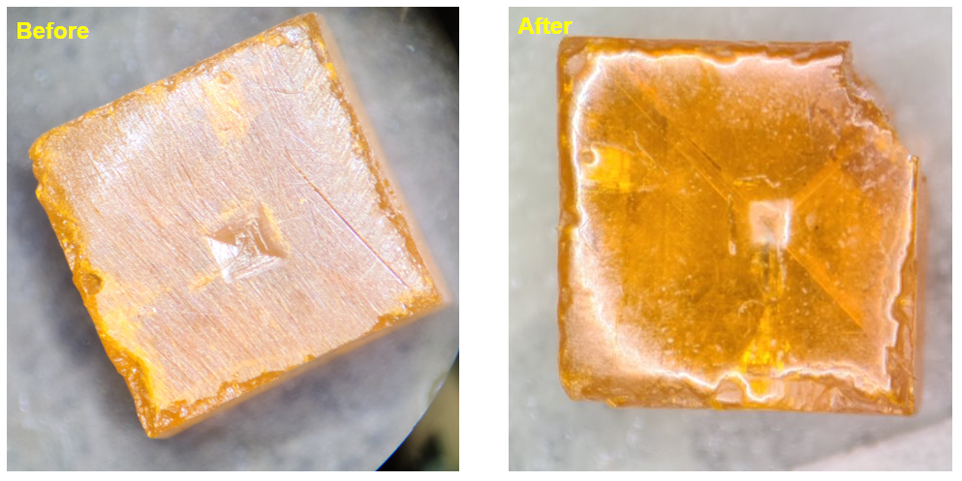
CsPbBr$​_{3}$ crystal during mechanical polishing preparation.
The Schottky contact architecture, common to CsPbBr$​_{3}$, MAPbBr$​_{3}$, and FAPbBr$​_{3}$, is shown schematically in Figure 1.7. The final device design, which produced the best spectroscopic results with the FAPbBr$​_{3}$ crystal, used gold as the pixelated contact and Ti/Ni as a continuous back-face contact. A 2$×$2 array of 1.25-mm-diameter gold pixel contacts surrounded by an integrated guard ring was deposited through a drilled aluminium shadow mask using a Denton sputter coater. On the opposite crystal face, a continuous Ti/Ni bilayer was deposited using an AJA Orion RF/DC sputter system: Ti was deposited at 450 W ($≈$1.15 Å s$​^{−1}$) followed immediately by a 10-nm Ni passivating overlayer at 250 W ($≈$2.1 Å s$​^{−1}$) across the full crystal face. Pixel contacts were wired via Cu leads bonded with silver epoxy.
The necessity of the Ni overlayer was established empirically during early contact deposition trials, in which Ti was deposited without any capping layer. Upon venting the deposition chamber to atmosphere, the bare Ti films were observed to delaminate from the crystal surface in a characteristic rolled pattern, visible in Figure 1.6. The root cause is the oxidation of Ti upon air exposure: as the surface of the Ti film converts to TiO$​_{x}$, the crystallographic lattice mismatch between the oxide and the underlying metallic Ti generates a large in-plane compressive stress. This biaxial stress causes the film to buckle and curl away from the perovskite surface, producing the “swiss-roll” delamination morphology observed. The problem was fully resolved by depositing the 10-nm Ni capping layer immediately after Ti, before venting, which prevents atmospheric oxygen from reaching the Ti surface and thereby eliminates the oxidation-driven stress. No delamination was observed on any device fabricated with the Ti/Ni bilayer contact.
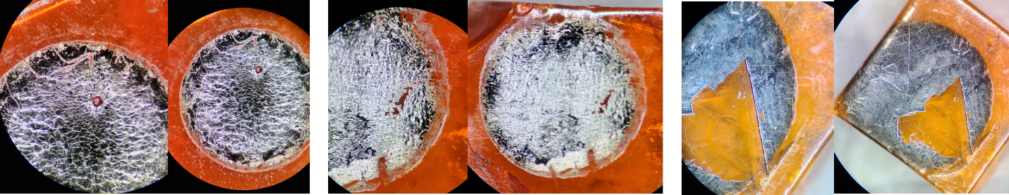
Ti contact delamination on (a, b) FAPbBr$​_{3}$ and (c) CsPbBr$​_{3}$ crystal faces following deposition without a Ni capping layer.
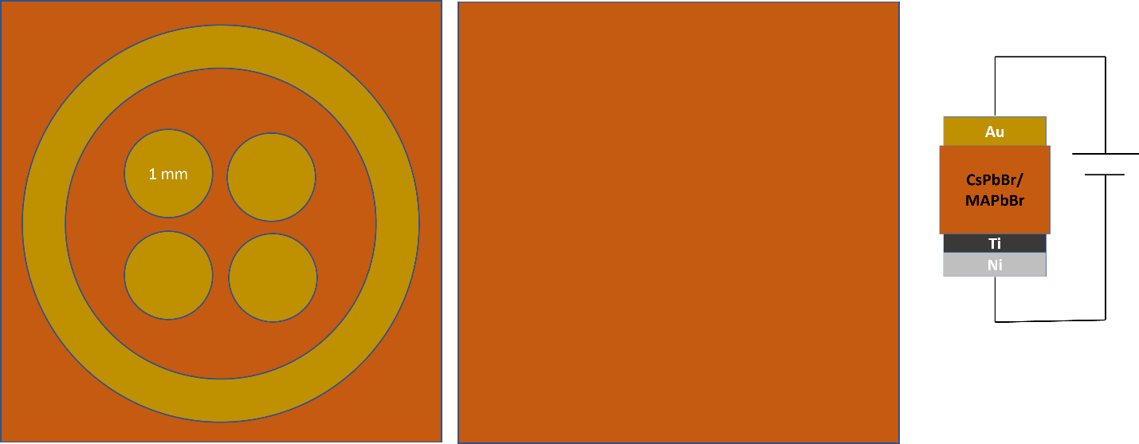
Contact architecture for bromide perovskite gamma-ray detectors showing the Au pixel array with guard ring (left), continuous Ti/Ni back face (centre), and device layer stack (right).

Gamma Spectroscopy Setup
Gamma-ray spectroscopy used a $​^{137}$Cs source (662 keV) and a $​^{57}$Co source (14, 122, 136 keV). The readout chain consisted of a CAEN A1422 charge-sensitive preamplifier connected directly to the pixel contacts, and a CAEN N6724 Digitizer 16-bit ADC (16,384 channels). The 10-$μ$s shaping time minimises ballistic deficit. Digitiser settings: threshold 15 channels, trigger hold-off 1500 ns, input rise time 1200 ns, trapezoid rise time 8 $μ$s, trapezoid flat-top 5 $μ$s, energy fine gain 10. The mean free path of a 662-keV photon in CsPbBr$​_{3}$ ($Z_{eff}≈45$, $ρ≈4.5$ g cm$​^{−3}$) is approximately 7 mm; with crystal thicknesses of 2–3 mm, fewer than 50% of photons interact, so geometric detection efficiency was inherently low.

Electrical Characterisation
The CsPbBr$​_{3}$ device exhibited a working leakage current of 315–710 nA at 1000 V reverse bias. This current overshot its quasi-steady-state value immediately after the voltage step, then decayed gradually over 45 minutes to one hour, consistent with rapid redistribution of mobile halide vacancies followed by slower re-equilibration of the resulting space-charge distribution.

Gamma Spectroscopy Results
The CsPbBr$​_{3}$ detector was operated at 1000 V reverse bias for $​^{137}$Cs measurements. The source count rate was 17.45 counts s$​^{−1}$ against a background of 9.11 counts s$​^{−1}$, a statistically significant response to the 662-keV source. However, no resolvable photopeak at the expected 662-keV channel position was observed. The spectrum displayed a broad continuum at low channels, consistent with incomplete charge collection, and a spurious artefact near channel 16,382 (the ADC maximum), attributed to ADC saturation from large ion-migration-induced current transients. A Geant4 Monte Carlo simulation of the crystal geometry confirmed the features expected for a small-volume Compton spectrometer.
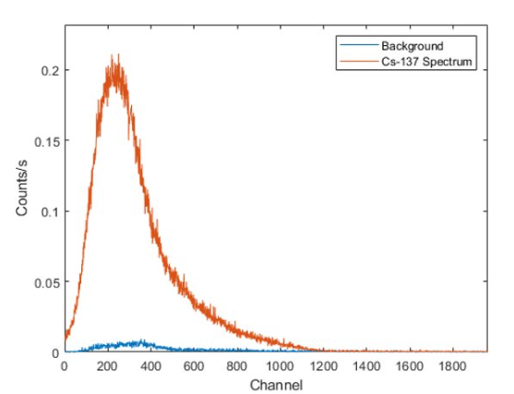
CsPbBr$​_{3}$ pulse-height spectrum acquired at 1000 V reverse bias with a $​^{137}$Cs source.

Discussion
The resolution-limiting factor was the large, unstable leakage current, not the intrinsic charge transport properties of CsPbBr$​_{3}$. At 1000 V, the RMS noise generated by 315–710 nA of leakage current is far larger than the $∼$0.4 pC signal charge from a single 662-keV gamma photon, rendering spectroscopic pulse resolution impossible during the transient stabilisation period. Reducing leakage is therefore the primary engineering challenge, achievable through improved Schottky barrier quality (lower sputter power, better vacuum) and contact passivation to prevent the Ti-Br$​^{−}$ chemical reaction documented in Section 1.8.1.

FAPbBr$​_{3}$ Gamma-Ray Detector
The FAPbBr$​_{3}$ single-crystal detector represented the most successful gamma spectrometer achieved in this work. It demonstrated substantially lower leakage current and greater electrical stability than CsPbBr$​_{3}$, ultimately producing spectral features attributable to both $​^{137}$Cs and $​^{57}$Co, a proof-of-concept demonstration of gamma spectroscopy in a solution-grown halide perovskite crystal.

Crystal Preparation and Contact Fabrication
FAPbBr$​_{3}$ single crystals (FA = HC(NH$​_{2}$)$​_{2}^{+}$) were grown externally and received by the research group. Crystals were inspected, mechanically planarised, and polished to a 10-nm surface finish using the standard hexane-rinsed diamond polishing protocol. One FAPbBr$​_{3}$ crystal cracked during polishing and was excluded from electrical testing. The crystal used in spectroscopy had a thickness of 2.35 mm and contact area of $5.2×6.15$ mm$​^{2}$. Contact architecture followed the same Schottky geometry as CsPbBr$​_{3}$ (Figure 1.7).
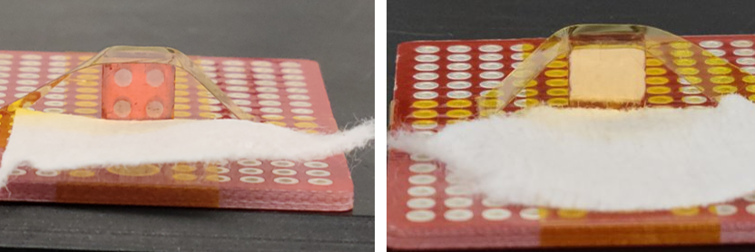
Mounted FAPbBr$​_{3}$ pixelated Schottky detector with copper wire leads bonded to each pixel contact.

Electrical Characterisation
IV sweeps from $−20$ to $+20$ V and $−200$ to $+200$ V confirmed acceptable Schottky behaviour. A bias stability test at $−200$ V over six hours showed leakage reaching a pseudo-steady-state with a maximum of $5±2.5$ nA, approximately 60$×$ lower than the CsPbBr$​_{3}$ leakage at comparable bias, attributable to a better Schottky barrier quality on this crystal. The device showed no signs of electrical instability over more than five hours of sustained high-voltage testing.

Gamma Spectroscopy Results
Spectroscopic measurements with $​^{137}$Cs were performed from 700 V upward. At 700 V, the spectrum showed a broad peak feature centred near the expected 662-keV channel position, with a count rate of $∼$17.45 counts s$​^{−1}$ above a background of 9.11 counts s$​^{−1}$.
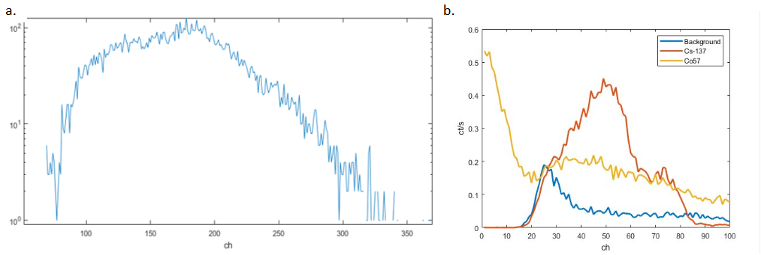
FAPbBr$​_{3}$ pulse-height spectra at (a) 700 V with $​^{137}$Cs and (b) 1600 V with $​^{137}$Cs, $​^{57}$Co, and background overlaid.
At 1600 V bias, a simultaneous acquisition with both $​^{137}$Cs (5 $μ$Ci, 662 keV) and $​^{57}$Co (100 $μ$Ci, 122 keV) produced a spectrum in which two distinct features could be identified at channel positions consistent with the expected photon energies, calibrated against a reference CZT detector. Count rates: 9.11 counts s$​^{−1}$ (background), 17.45 counts s$​^{−1}$ ($​^{137}$Cs), 26.60 counts s$​^{−1}$ ($​^{57}$Co), reflecting the higher specific activity of the $​^{57}$Co source.
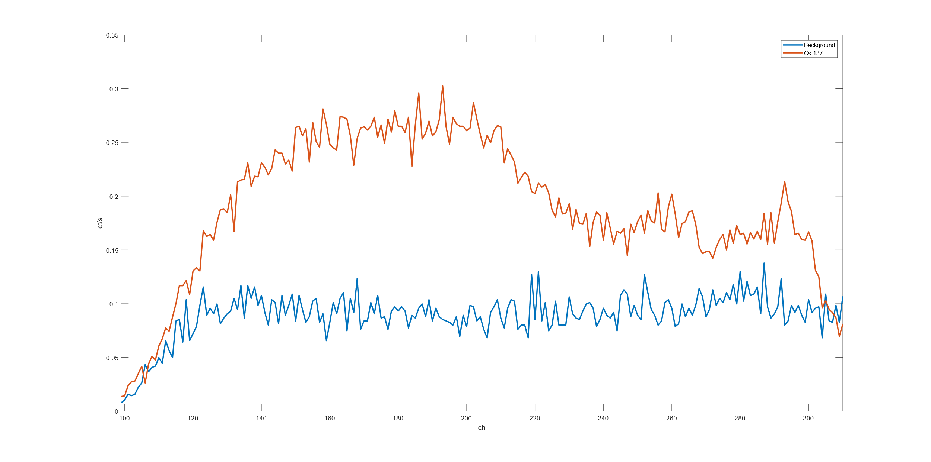
$​^{137}$Cs pulse-height spectrum from the pixelated FAPbBr$​_{3}$ device at 1800 V (zoomed view).
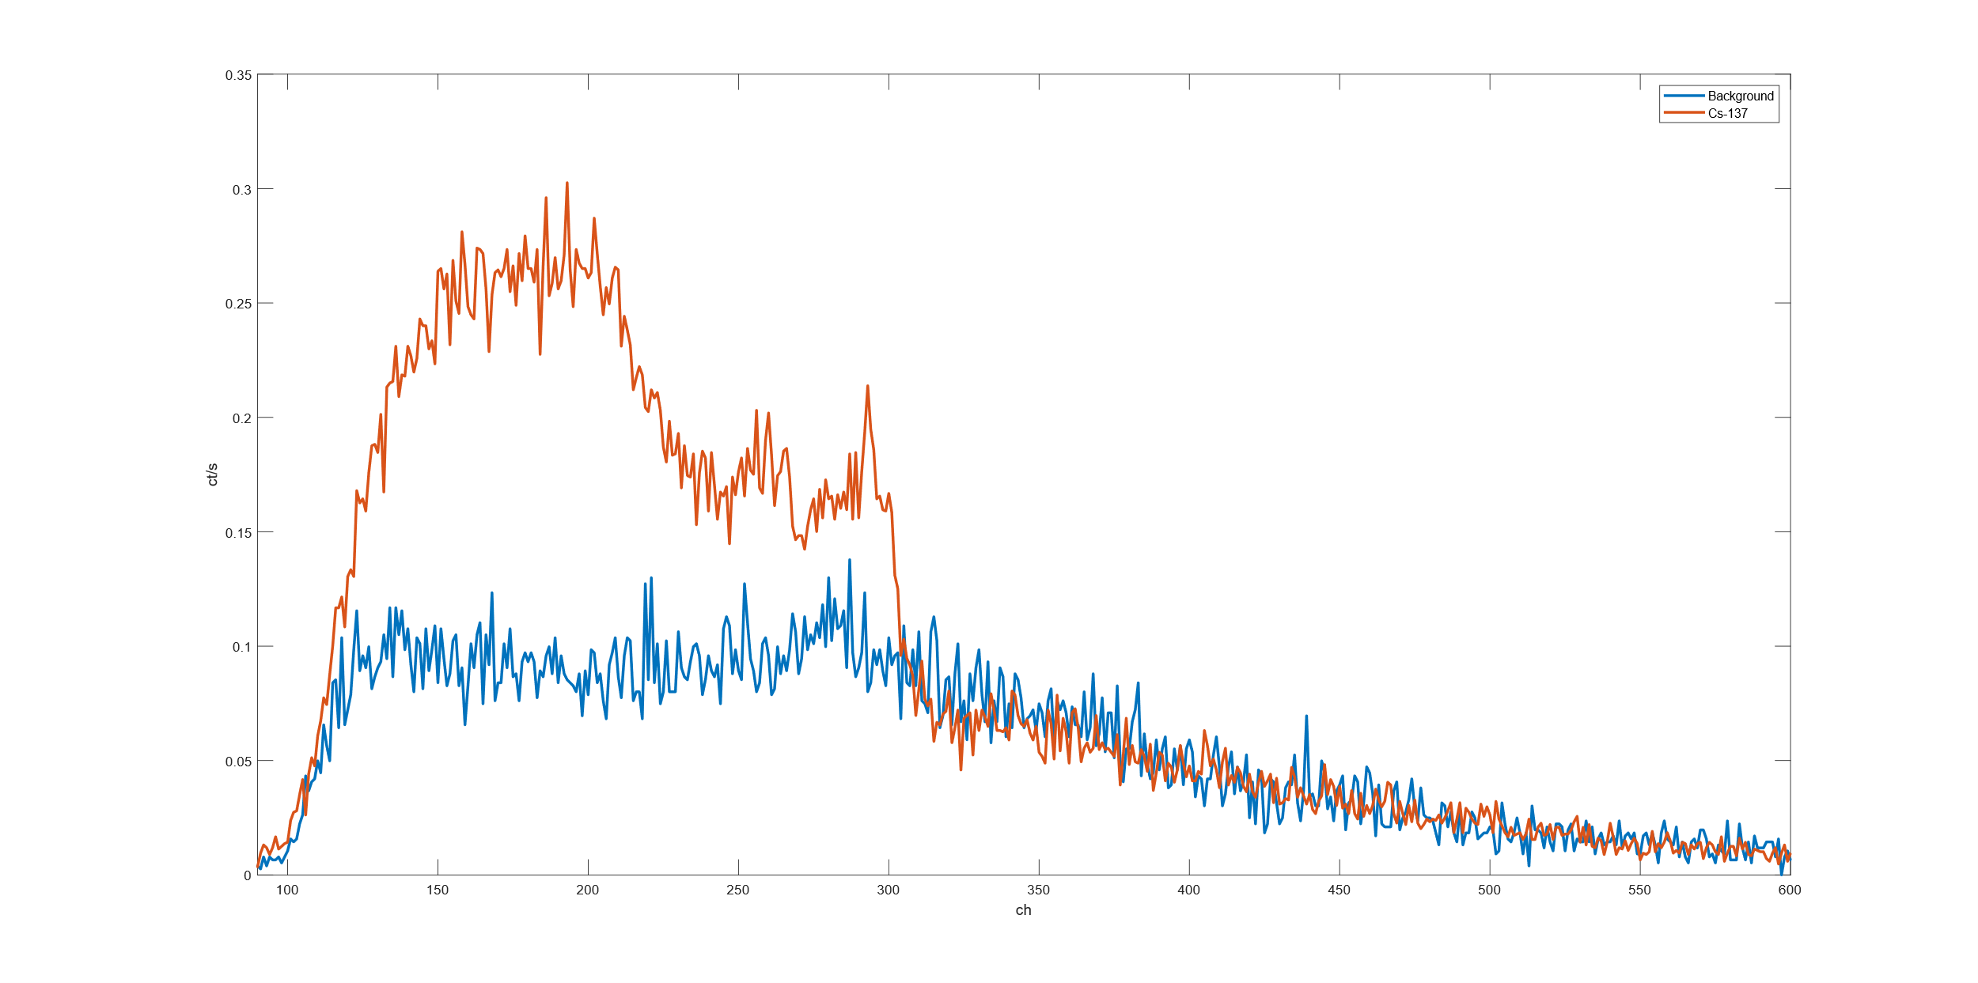
$​^{137}$Cs pulse-height spectrum from the pixelated FAPbBr$​_{3}$ device at 1800 V (full view).

Discussion
The FAPbBr$​_{3}$ results constitute a proof-of-concept demonstration of gamma spectroscopy in a solution-grown halide perovskite crystal. However, energy resolution remains far below that required for isotope identification in practical nuclear security applications. Resolution is limited by: residual leakage-current noise even at 5 nA; incomplete charge collection from carrier trapping analogous to that described in Section 1.2.6; and ion migration-induced fluctuations in the internal electric field during acquisition, causing effective detector gain to drift and broaden spectral features.
The superior performance of FAPbBr$​_{3}$ relative to CsPbBr$​_{3}$ under high-voltage operation is consistent with literature reports that FA-based perovskites exhibit reduced ion migration rates compared to Cs-based compositions : the larger FA$​^{+}$ cation creates a more tightly packed lattice with fewer pathways for halide vacancy migration.

MAPbBr$​_{3}$ Gamma-Ray Detector
MAPbBr$​_{3}$ (methylammonium lead tribromide) single crystals were processed through the same Au-pixel / Ti/Ni back-face contact fabrication protocol as CsPbBr$​_{3}$ and FAPbBr$​_{3}$ and were electrically functional. However, no resolved gamma photopeak was obtained from any MAPbBr$​_{3}$ crystal tested, and no spectroscopic data are presented for this material. This section explains why, as the limiting factors are instructive for understanding the broader requirements for photopeak development in perovskite gamma detectors.

Crystal Preparation
MAPbBr$​_{3}$ single crystals were grown externally and received by the research group. Each crystal was inspected under optical magnification, mechanically planarised using silicon carbide abrasive paper, and polished with diamond polishing paste to a 10-nm surface finish with hexane-bath rinses between stages. Contacts were deposited using the Au-pixel / Ti/Ni back-face protocol described in Section 1.4.1, which produced adhered, non-delaminated contacts on all MAPbBr$​_{3}$ crystals processed.
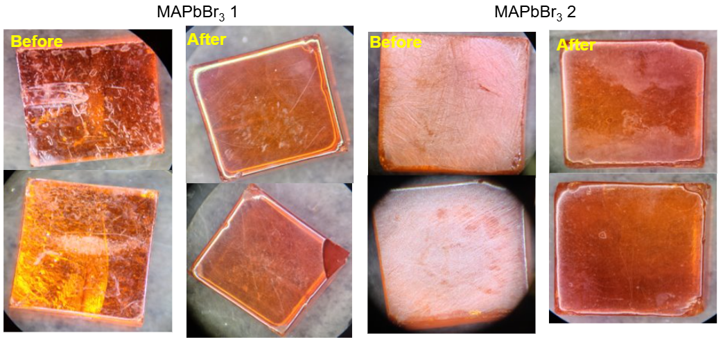
MAPbBr$​_{3}$ crystal during mechanical polishing preparation.

Ion Migration Pulses and the Low-$μτ$ Spectral Background
Even with functional contacts, it is unlikely that the MAPbBr$​_{3}$ crystals available in this work would have yielded resolved gamma photopeaks. The limiting factor is crystal quality, which directly determines the $μτ$ product and therefore the detector’s ability to convert a gamma interaction into a resolvable pulse.
In a crystal with a low $μτ$ product, carriers generated by a gamma interaction are captured by deep trap states before they can traverse the full thickness of the device. The resulting pulse height is reduced and varies with interaction depth, since carriers generated far from the collecting contact must drift further and are more likely to be trapped before arrival. The pulse-height spectrum from such a device is not a sharp photopeak at the full interaction energy but instead a broad Compton continuum extending from zero up to some fraction of the full energy, with no distinguishable photopeak structure, qualitatively identical to the spectrum observed for CsPbBr$​_{3}$ at moderate bias voltages (Section 1.4.4).
At higher applied bias a second and more pernicious effect emerges: ion migration events generate their own large transient current pulses that are registered by the charge-sensitive preamplifier and MCA chain as apparent radiation events. When mobile halide vacancies redistribute under the applied field, they produce sudden changes in the space-charge distribution near the contacts, inducing charge transients on the preamplifier input that can be orders of magnitude larger than the $∼$0.1–0.4 pC signal from a genuine 662-keV gamma interaction. These ion migration pulses are not correlated with any radiation interaction event; they arise purely from ionic motion within the crystal. In the pulse-height spectrum they appear as a large, structureless background at high channel numbers, effectively burying any genuine gamma signal beneath an elevated and irreproducible baseline. This effect was directly observed in the CsPbBr$​_{3}$ device, where the anomalous artefact near channel 16,382 of the ADC (Section 1.4.4) is a manifestation of exactly this mechanism: large ion migration-driven current transients saturating the ADC input.
The practical consequence is that photopeak development in perovskite gamma detectors requires the simultaneous satisfaction of two conditions: a $μτ$ product large enough that radiation-generated carriers can traverse the full crystal thickness before being trapped ($μτE/d≳1$ in the notation of Equation [eq:hecht]), and an ion migration rate low enough that ionic transient pulses do not dominate the acquired spectrum. For the bromide perovskites examined in this work, FAPbBr$​_{3}$ came closest to meeting both conditions, owing to its relatively stable leakage current and the reduced ion migration rate associated with the FA$​^{+}$ sublattice. The MAPbBr$​_{3}$ crystals, by contrast, did not exhibit sufficient crystal purity to clear either threshold. Improving crystal quality, specifically reducing halide vacancy concentrations through controlled stoichiometry and inert-atmosphere growth, is therefore a prerequisite for photopeak development in future MAPbBr$​_{3}$ devices.

MHyPbCl$​_{3}$ Fast Neutron Detector
MHyPbCl$​_{3}$ (methylhydrazinium lead trichloride) represents the first organic-metal halide perovskite semiconductor evaluated as a direct-conversion fast neutron detector. The device uniquely combines a high hydrogen density comparable to conventional organic scintillators with the electrical properties of a high-resistivity semiconductor, enabling direct charge-collection detection of recoil proton pulses without a separate converter layer.

Motivation and Material Selection
Fast neutron detection is challenging because neutrons carry no charge and cannot interact directly with the electron clouds that govern detector response. Instead, fast neutrons are detected via secondary charged particles, predominantly recoil protons, produced in elastic scattering collisions with hydrogen nuclei ($​^{1}$H($n$,$n$)$​^{1}$H). Detection efficiency is proportional to the material’s hydrogen number density $n_{H}$, which for conventional hydrogenous semiconductors is typically far too low to compete with hydrogen-rich organic scintillators such as stilbene or EJ-276 plastic.
MHyPbCl$​_{3}$ was identified as a candidate because its methylhydrazinium cation (CH$​_{3}$NH$​_{2}$NH$​_{2}^{+}$) contributes a substantial number of hydrogen atoms per formula unit, giving a calculated $n_{H}≈4.0×{10}^{22}$ cm$​^{−3}$ (Table 1.1), comparable to stilbene. Crucially, the material also exhibits high resistivity and a large $μτ$ product, making it suitable for direct charge-collection detection of recoil proton pulses. An important complication is the presence of lead ($Z=82$), a highly efficient photon absorber, which creates a significant neutron-gamma discrimination challenge in mixed radiation fields such as those produced by a research reactor .

Crystal Synthesis and Device Fabrication
Methylhydrazinium chloride (MHyCl) was synthesised as the organic precursor salt: 2.63 mL (50 mmol) of methylhydrazine was diluted with 5 mL anhydrous IPA, and 100 mL of 0.5 M HCl solution was added without stirring. White plate crystals of MHyCl precipitated spontaneously after overnight storage in inert atmosphere at room temperature. The crystals were filtered, washed with cold IPA, and dried under vacuum, yielding 3.10 g ($∼$38%).
MHyPbCl$​_{3}$ single crystals were grown by anti-solvent assisted crystallisation: 2 mmol each of MHyCl and PbCl$​_{2}$ dissolved in 5 mL DMF / 1 mL DMSO, stirred for 3 h, then filtered through a 0.22-$μ$m syringe filter. The solution was transferred to a 20-mL vial placed inside a 100-mL bottle containing 15 mL toluene as anti-solvent and sealed in a glovebox. After one week at room temperature, clear hexagonal MHyPbCl$​_{3}$ crystals formed and were harvested, dried under vacuum, and surface-polished immediately prior to electrode deposition.
An ohmic-ohmic contact configuration was adopted. The lower crystal face received a 30-nm C$​_{60}$ / 6-nm BCP electron-transport bilayer, followed by an 80-nm Cu contact. The upper face received a 50-nm Au contact deposited by thermal evaporation. The C$​_{60}$/BCP bilayer serves simultaneously as an electron-selective interlayer and interface-state buffer at the Cu-perovskite junction. IV characterisation confirmed ohmic, symmetric behaviour under both polarities.

Electrical Characterisation
The MHyPbCl$​_{3}$ crystal yielded a resistivity of $4.43×{10}^{11}$ $Ω$ cm, roughly two orders of magnitude higher than commercial polycrystalline CZT, placing it squarely in the range required for high-sensitivity radiation detectors. The $μτ$ product extracted by Hecht equation fitting yielded $μτ=9.1×{10}^{−3}$ cm$​^{2}$ V$​^{−1}$, comparable to high-quality CsPbBr$​_{3}$ single crystals reported in the literature and approximately an order of magnitude larger than typical polycrystalline CZT. This high $μτ$ reflects extended carrier diffusion lengths achievable in defect-lean single crystals grown by the slow anti-solvent method. IV hysteresis measurements showed a measurable sweep-versus-hold difference in the low-voltage regime, indicative of slow ionic relaxation consistent with ion migration.

Beam Facility and Experimental Setup
Neutron beam testing was performed at the OSURR Fast Neutron Beam Facility (FBF), the same beamport used for the Cs$​_{0.1}$FA$​_{0.9}$PbI$​_{3}$ solar-cell neutron measurements in Chapter [ch:CsFAPbI]. The facility hardware, the permanent bismuth in-line gamma filter, the 8-inch lead gamma shutter, the external 2-mm cadmium foil, the beam flux and gamma dose-rate values under each filter configuration, and the neutron energy spectrum determined by SAND-II/STAYSL activation unfolding, are described in full in Section [sec:osurr_fbf]. The beam conditions for the MHyPbCl$​_{3}$ experiments are summarised in Table 1.3.
FBF beam conditions used for MHyPbCl$​_{3}$ neutron detection experiments. See Section [sec:osurr_fbf] for a full description of each filtering element.
Configuration | Fast neutron flux (cm$​^{−2}$ s$​^{−1}$) | Gamma dose rate
Shutter open, no Cd | $1.5×{10}^{7}$ | 15.787 R hr$​^{−1}$
Shutter closed, no Cd | $4.3×{10}^{5}$ | 50.525 mR hr$​^{−1}$
Shutter closed, Cd in | $4.3×{10}^{5}$ | 50.525 mR hr$​^{−1}$
The experimental setup specific to the MHyPbCl$​_{3}$ measurement is shown in Figure 1.14. Data were acquired using a CAEN A1422 charge-sensitive preamplifier connected directly to the MHyPbCl$​_{3}$ detector, with the preamplifier output recorded on a Tektronix MSO54 oscilloscope in waveform-capture mode. A Keithley 2612A SourceMeter provided the detector bias voltage and simultaneously monitored the device leakage current. A cadmium foil chopper driven by a motor was positioned in the beam path during selected measurements to modulate the thermal neutron flux periodically, enabling comparison of chopper-on and chopper-off waveform populations.
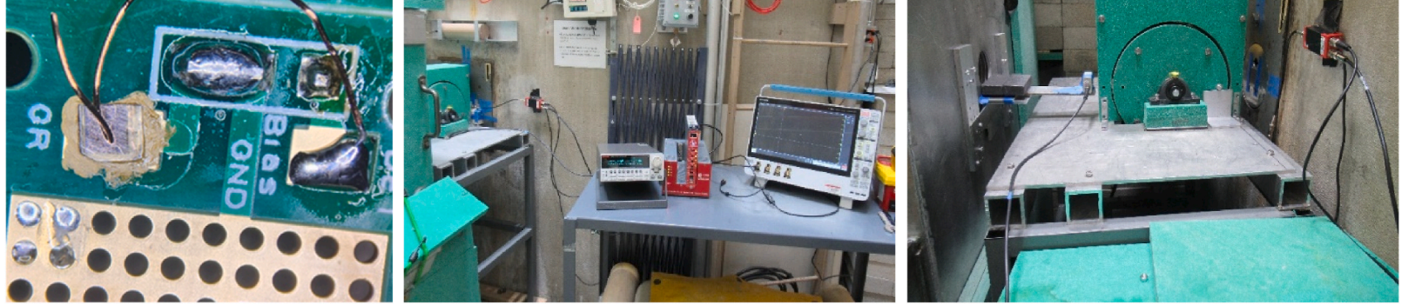
MHyPbCl$​_{3}$ experimental setup at the OSURR FBF showing (a) the detector on its PCB, (b) the data acquisition station, and (c) the detector positioned at the beamport.

Digital Pulse Processing Pipeline
Because the radiation-induced charge pulses from the MHyPbCl$​_{3}$ detector did not exceed approximately 15 mV at the preamplifier output, they were below the threshold at which hardware multichannel analyser (MCA) electronics could reliably discriminate genuine pulses from baseline noise. A custom offline digital pulse processing pipeline was therefore developed in Python to extract pulse-height information from the raw oscilloscope waveforms.
The processing chain proceeded in four steps. First, individual waveforms were loaded from the .mat files written by the Tektronix MSO54 oscilloscope. Voltage data were converted to millivolts and time axes to microseconds to give physically meaningful units. Second, each waveform was smoothed using a Locally Weighted Scatterplot Smoothing (LOWESS) algorithm with a smoothing fraction of 10% and a single robustness iteration. LOWESS fits a low-degree polynomial to a sliding local window of the data, effectively suppressing the high-frequency electronic noise that dominated the raw preamplifier output while preserving the slower temporal profile of genuine charge-collection pulses, whose rise and decay times are governed by carrier transit times across the crystal and the preamplifier time constant. Third, a baseline correction was applied by subtracting the mean of the first 50 data points of each smoothed waveform, a region prior to the expected pulse onset, to remove any DC offset that varied waveform-to-waveform due to amplifier drift or slow ionic polarisation of the detector. Fourth, the pulse height was defined as the maximum absolute value of the baseline-corrected waveform. For each waveform the script additionally extracted the 10%–90% rise time and 90%–10% decay time of the pulse, quantities that in principle allow pulse-shape discrimination between event types, though insufficient statistics prevented this analysis in the present work.
After pulse-height extraction, pulses with amplitudes below a threshold of 2 mV were discarded to suppress noise triggers, and the remaining pulse heights were accumulated into a 50-bin histogram over the range 0–20 mV to produce the pulse-height spectrum used for the analysis in Section 1.7.6. The entire pipeline was applied independently to each beam configuration subfolder (shutter open, shutter closed, and beam background), allowing direct comparison of the pulse-height distributions across conditions.

Results
The MHyPbCl$​_{3}$ detector was operated at reverse bias voltages of 80 V and 120 V for the FBF measurements.
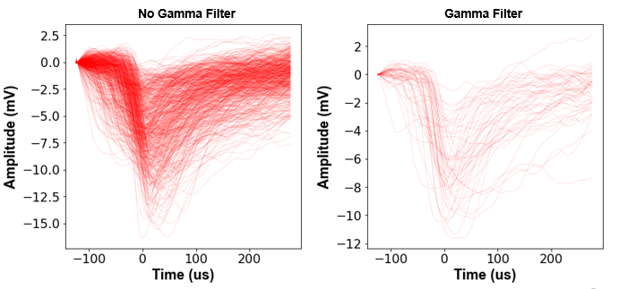
LOWESS-filtered preamplifier waveforms from the MHyPbCl$​_{3}$ detector at 120 V with (a) gamma shutter open, (b) gamma shutter closed, and (c) beam background.
At 120 V reverse bias with the gamma shutter open, 1090 waveforms containing radiation-induced pulses were collected over the acquisition interval. After closing the gamma shutter, 1001 pulses were recorded over a comparable interval; the beam background (reactor at power, beam blocked entirely) yielded 394 pulses. The count rate with the shutter closed ($∼$0.5 counts s$​^{−1}$) was not meaningfully different from the shutter-open count rate at 120 V in the forward bias configuration, a result discussed further below.
At 80 V reverse bias, waveform counts were: 1040 (shutter open), 507 (shutter closed), and 252 (background). The higher source-to-background ratio at 80 V compared to 120 V suggests that the lower field at 80 V produces a different carrier collection regime in which high-charge-deposition events are more clearly separated from the background noise floor.
Pulse-height analysis at 120 V reverse bias yielded a broad continuum of pulse heights, shown in Figure 1.16. The spectrum does not display a sharp Gaussian peak; rather, it exhibits a broad continuum extending from the noise threshold to the maximum digitised amplitude. This spectral shape is physically expected for fast neutron detection: recoil protons from elastic scattering of poly-energetic fast neutrons produce a broad energy deposition distribution, further broadened by incomplete charge collection at the bias voltages used here. Nevertheless, the waveform population is clearly distinct from the background (reactor off) population, confirming that MHyPbCl$​_{3}$ is responding to radiation from the reactor beam.
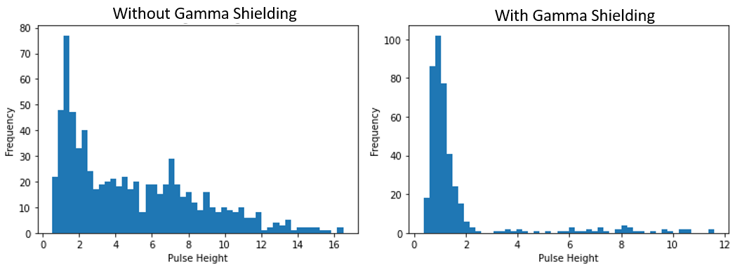
Pulse-height spectrum from the MHyPbCl$​_{3}$ detector at 120 V with (a) no gamma filter and (b) gamma shutter closed.

Discussion: Neutron-Gamma Discrimination and Detection Efficiency
The neutron-gamma discrimination challenge is illustrated by comparing shutter-open and shutter-closed waveform populations. Closing the lead gamma shutter reduces the gamma dose rate by $∼$300$×$ (from 15.787 R hr$​^{−1}$ to 50.525 mR hr$​^{−1}$) while reducing the fast neutron flux by only a factor of 35. If the detector responded purely to neutrons, the shutter-closed count rate should be $≈$0.12 times the shutter-open rate. The observed ratio at 120 V (1090:1001 after background subtraction) does not show this level of suppression, indicating the response is dominated by direct gamma interactions in the Pb sublattice rather than neutron-induced proton recoil events. This highlights the fundamental neutron-gamma discrimination difficulty in a Pb-containing semiconductor.
An upper bound estimate of fast neutron detection efficiency at 1 MeV neutron energy ($σ_{el}≈3$ b) for a 5-mm crystal thickness is
$$P=1−exp(−n_{H}σ_{el}t)≈1−exp(−4.0×{10}^{22}×3×{10}^{−24}×0.5)≈5.8\%,$$
where $t=0.5$ cm is the path length. At the shutter-closed fast neutron flux of $4.3×{10}^{5}$ cm$​^{−2}$ s$​^{−1}$ and the $∼$0.3-cm$​^{2}$ detector area, this implies an expected proton-recoil interaction rate of $∼$750 events s$​^{−1}$, far larger than the 0.5 counts s$​^{−1}$ actually observed. The discrepancy is primarily due to the Tektronix MSO54 oscilloscope waveform-write-rate bottleneck: in single-shot waveform acquisition mode, the maximum write rate was the dominant constraint on the measurable count rate. Switching to a hardware MCA or a fast digitiser in continuous acquisition mode is the highest-priority hardware improvement identified for future neutron detection experiments.

Ion Migration and Device Stability
A single overarching materials-physics challenge pervades the results of Sections 1.2–1.7: the migration of halide ions under large applied electric fields. The detector geometry exacerbates this relative to the photovoltaic geometry in two ways: (1) the fields required for efficient charge collection ($∼$1 V $μ$m$​^{−1}$ across millimetre-scale crystals) are several orders of magnitude larger than photovoltaic built-in fields; and (2) these fields must be sustained continuously for hours during a spectroscopy acquisition.

Contact Degradation at Elevated Bias
A distinct degradation mechanism was identified during extended testing of the FAPbBr$​_{3}$ device: chemical reaction of the Ti/Ni back-face contact with mobile bromide ions driven toward that interface under large applied reverse bias. After a full day of electrical testing, the Ti contact surface was visually observed to have changed colour and the metallic Ti layer appeared to partially recede into or react with the crystal surface. Mobile Br$​^{−}$ ions accumulating at the Ti contact (Ti commonly in the $+3$ oxidation state) can form stable titanium bromide complexes such as TiBr$​_{4}^{2−}$, consuming the metal electrode.
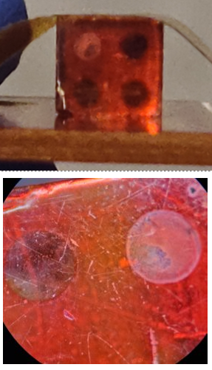
Ti/Ni back-face contact surface of the FAPbBr$​_{3}$ detector after extended high-bias operation.
This has profound implications for contact material selection. Metals that form stable halide compounds under the electrochemical conditions at a biased contact, titanium being one such metal, are fundamentally incompatible with sustained high-field operation in halide perovskite detectors, regardless of the contact geometry. The Au pixel contacts showed no evidence of analogous chemical degradation in any device examined in this work, consistent with gold’s kinetic stability against halide compound formation under mild electrochemical conditions. Alternative back-contact candidates identified in the broader literature include Cr and SnO$​_{2}$, both evaluated on CsPbBr$​_{3}$ in preliminary experiments but not carried through to full spectroscopic evaluation within the scope of this work.

Ion Migration Consequences for Spectroscopy
Ion migration impairs spectroscopic performance through three mechanisms that together set a practical upper bound on the achievable energy resolution in as-fabricated perovskite single crystal detectors.
First, ion redistribution under the applied field creates a non-uniform internal electric field profile. As mobile anions accumulate at the anode and cations at the cathode, space-charge layers form near both contacts. The resulting space charge adds to the applied field at one interface and subtracts from it at the other, so carriers generated at different depths experience different net fields and have different collection probabilities, broadening the pulse-height distribution for monoenergetic radiation events and degrading energy resolution .
Second, the leakage current overshoot upon initial bias application causes the internal field distribution to evolve continuously during acquisition. Since pulse-height peak position is proportional to instantaneous charge collection efficiency, the slow field evolution during ion migration causes effective detector gain to drift, further broadening accumulated spectral peaks.
Third, on long timescales the accumulated ionic charge at the interfaces depresses the net bulk electric field, reducing carrier drift velocity and increasing the probability of trapping before collection. The combination of all three effects means that energy resolution of a perovskite detector operated at high bias in ambient conditions will inevitably worsen over time, even if the initial resolution at the moment of bias application is acceptable.

Mitigation Strategies
Several mitigation strategies were evaluated or identified in the course of this work.
5F-PEAI surface passivation. The most promising approach demonstrated in this work for thin-film geometries (Section 1.3.3). At 4 mg mL$​^{−1}$, 5F-PEAI penetrates grain boundaries and raises the water-penetration activation energy from $∼$5 meV to $∼$120 meV, stabilising the device to $−16$ V in 40% RH air. Extending this passivation strategy to 3D single crystal systems is a high-priority direction for future research.
Contact material engineering. The Ti-Br$​^{−}$ reaction documented in Section 1.8.1 motivates replacing Ti with metals that do not form stable halide compounds under detector operating conditions, such as Au, Pt, or Cr-based multilayers. Carrier-selective interlayers such as the C$​_{60}$:BCP bilayer used in the MHyPbCl$​_{3}$ device can also reduce interface recombination velocity and extend the stable field range.
Improved crystal quality. Reducing halide vacancy concentrations through growth conditions that minimise stoichiometric excess, such as the slow anti-solvent crystallisation used for MHyPbCl$​_{3}$, or single-crystal growth under inert atmosphere, is an important near-term research goal .

Summary
This chapter described the development and characterisation of six halide perovskite direct-conversion radiation detectors across three radiation types: X-rays, gamma rays, and fast neutrons.
The MAPbI$​_{3}$-hBN device (Section 1.2) demonstrated a monotonically increasing X-ray sensitivity with applied bias, $0.107$, $0.245$, and $0.411 μ$C (Gy cm$​^{2}$)$​^{−1}$ at 5, 10, and 20 V, respectively, consistent with the Hecht equation. Vacuum testing confirmed moisture-accelerated ion migration as the principal degradation mechanism, and the device failed irreversibly after $∼$5 hours at 400 V.
The 2D PEA$​_{2}$MA$​_{2}$Pb$​_{3}$I$​_{10}$ detector with 5F-PEAI (Section 1.3) demonstrated that moisture-accelerated instability can be effectively mitigated: breakdown voltage was raised from $−10$ V to $−16$ V at 40% RH, and X-ray sensitivities approaching $∼$1000 $μ$C (Gy$​_{air}$ cm$​^{2}$)$​^{−1}$ were achieved at 4 V bias, among the highest reported for polycrystalline perovskite detectors of comparable thickness.
The CsPbBr$​_{3}$ device (Section 1.4) produced a statistically significant count-rate response to $​^{137}$Cs (17.45 cps vs. 9.11 cps background) at 1000 V, but large unstable leakage (315–710 nA) generated electronic noise that prevented resolution of the 662-keV photopeak.
The FAPbBr$​_{3}$ device (Section 1.5) achieved substantially lower operating leakage ($5±2.5$ nA maximum) and sustained stable high-voltage operation for over five hours. A joint $​^{137}$Cs/$​^{57}$Co acquisition at 1600 V produced spectral features attributable to both sources, a proof-of-concept demonstration of gamma spectroscopy in a solution-grown halide perovskite crystal.
The MAPbBr$​_{3}$ device (Section 1.6) failed to produce functional Schottky contacts due to high sputter power and residual surface contamination, motivating a revised deposition protocol at reduced sputter power ($∼$150–200 W) with in-situ surface cleaning.
MHyPbCl$​_{3}$ (Section 1.7) was characterised as the first organic-metal halide perovskite semiconductor evaluated in a reactor fast neutron beam. The material combines $n_{H}≈4.0×{10}^{22}$ cm$​^{−3}$ (comparable to stilbene) with resistivity $4.43×{10}^{11}$ $Ω$ cm and $μτ=9.1×{10}^{−3}$ cm$​^{2}$ V$​^{−1}$. Waveform data acquired at the OSURR FBF confirmed radiation-induced pulse activity distinct from beam background; pulse-height spectra were consistent with the expected proton-recoil energy deposition distribution from a poly-energetic fast neutron beam. The LOWESS-based digital pulse processing pipeline was essential for extracting these low-amplitude signals ($<15$ mV) from the raw oscilloscope waveforms. Neutron-gamma discrimination remains a challenge due to the large Pb content, and the oscilloscope waveform-write-rate bottleneck prevented collection of sufficient statistics for quantitative efficiency analysis.
Across all six devices, ion migration under applied electric fields emerged as the central performance-limiting mechanism. Surface passivation, demonstrated here via 5F-PEAI for thin-film devices, is identified as the most promising near-term strategy for extending the operational stability of perovskite radiation detectors toward the performance levels required for practical deployment.

