Investigation of Halide Perovskite Materials, Thermal Sensing Concepts, and Radiation-Tolerant FPGA Instrumentation for Advanced Radiation Monitoring
Wyatt Panaccione
Abstract
Radiation monitoring systems for nuclear environments require coordinated advances across functional materials, detection devices, and radiation-tolerant electronic instrumentation. This dissertation investigates halide perovskite materials, fiber-optic thermal sensors, and FPGA-based digital electronics as complementary technologies for advanced radiation detection and monitoring, organized around a materials-to-systems hierarchy.
Photovoltaic-architecture Cs$​_{0.1}$FA$​_{0.9}$PbI$​_{3}$ perovskite solar cells were characterized under X-ray, gamma, and neutron irradiation. Under $​^{137}$Cs gamma irradiation at 44.16 rad hr$​^{−1}$, an induced current density of 2.19 nA cm$​^{−2}$ was measured with a confirmed step response upon source insertion and withdrawal. Extended $​^{60}$Co irradiation at 355.61 rad hr$​^{−1}$ yielded 3.56 nA cm$​^{−2}$, demonstrating that the current-mode detection approach scales across nearly an order of magnitude in dose rate. A linear degradation rate of approximately 0.74 nA rad$​^{−1}$ was observed during six-day continuous irradiation, attributable to cumulative defect creation and substrate darkening.
In parallel, perovskite semiconductor radiation detectors were developed for direct-conversion operation. A two-dimensional perovskite X-ray detector incorporating 5F-PEAI surface passivation was characterized, addressing the voltage-induced instability problem caused by ion migration under applied bias. A MAPbI$​_{3}$–hBN composite detector was demonstrated for X-ray detection, and a solution-grown FAPbBr$​_{3}$ single crystal achieved proof-of-concept gamma spectroscopy. For fast neutron detection, the hydrogen-rich MHyPbCl$​_{3}$ perovskite was synthesized and tested at the Ohio State University Research Reactor Fast Beam Facility, exhibiting a resistivity of $4.43×{10}^{11}$ $Ω$ cm and an X-ray sensitivity of 61.74 $μ$C Gy$​_{air}^{−1}$ cm$​^{−2}$. Distinct radiation-induced pulses were recorded from the reactor fast neutron beam, and gamma discrimination analysis using beam filtering confirmed that the observed signals were predominantly attributable to neutron interactions.
As an alternative sensing pathway, thermal radiation sensing was investigated through simulation and experimental testing of an Optical Fiber-Based Gamma Thermometer (OFBGT) and a proposed Optical Fiber-Based Neutron Dosimeter (OFBND). Analytical thermal models predicted temperature differentials of 27–30$^{∘}$C for the OFBGT and 155–159$^{∘}$C for the OFBND. Experimental testing of the OFBGT yielded a measured differential of approximately 17$^{∘}$C, with the discrepancy attributed to the omission of radiative heat transfer in the original simulations.
For digital instrumentation, radiation-tolerant FPGA-based architectures were evaluated through a Flip-Flop Shift Register (FFSR) with dual modular redundancy and a fixed-point thermal control benchmark, both tested under fast neutron irradiation. During two-day testing of five Spartan-7 FPGAs, configuration memory single-event upsets were observed at moderate fluence levels ($∼$${10}^{9}$ n/cm$​^{2}$), while higher fluences ($∼$${10}^{11}$ n/cm$​^{2}$) produced latch-up events, a multi-SEU cluster, and measurable total ionizing dose degradation. These results demonstrate that configuration memory scrubbing and defense-in-depth strategies are essential for SRAM-based FPGAs in sustained radiation environments.
Together, these investigations span the functional layers of a radiation monitoring system—from radiation-responsive materials and detection devices through alternative thermal sensors to the radiation-tolerant digital electronics required to process their outputs.
Nuclear Engineering
I would like to thank DTRA, NRC and Luna Innovations for their support of this work. I would also like to thank my advisor, Dr. Kandlakunta and Dr. Cao, for their guidance and mentorship throughout my PhD studies. I am grateful to my committee members, Dr. Kandlakunta, Dr. Cao, and Dr. Vasques, for their valuable feedback and support.I would also like to thank Dr. Anothony Birri and Dr. Lei Pan who trailblazed portions of this work. I would also like to thank the OSURR staff for all their condult and help with the experimental setup at the reactor. Finally, I would like to thank my family and friends for their support and encouragement throughout this journey.

Introduction
Nuclear power occupies a singular position among low-carbon energy sources: it is the only technology that delivers firm, dispatchable, high-density electricity without direct greenhouse-gas emissions at a scale already proven across decades of operation. Yet the environments that make nuclear power possible, intense neutron and gamma fields, high temperatures, and chemically aggressive primary coolants (e.g., liquid sodium, molten fluoride salts, and high-pressure water), are precisely the environments that destroy the instruments needed to monitor and control it. Reliable radiation monitoring is not incidental to safe reactor operation; it is the primary mechanism by which operators verify that every defense-in-depth barrier to fission-product release, fuel cladding, reactor pressure boundary, and containment, remains intact. As the existing fleet ages and a generation of advanced and small modular reactors (SMRs) moves from concept to construction, the instrumentation technologies that have served the industry for half a century are confronting hard limits in both technical performance and economic viability. This dissertation investigates two complementary approaches to resolving that tension: the development of perovskite semiconductors as radiation-responsive detector materials, and the implementation of radiation-tolerant digital monitoring systems built on commercially available field-programmable gate arrays (FPGAs). Taken together, these efforts span the full stack from detector material to deployable system and aim to demonstrate that next-generation nuclear instrumentation can be both technically capable and represent a meaningful improvement in economic viability over current approaches.

Nuclear Power and the Global Decarbonization Context
The scale of the decarbonization challenge facing the global electricity system makes any realistic pathway to net-zero heavily dependent on nuclear energy. At the COP28 climate summit in December 2023, twenty-two nations signed a declaration to triple global nuclear generating capacity from approximately 375 GWe to more than 1,125 GWe by 2050; that coalition has since grown to thirty-three countries [@DOE_COP28_2023]. The International Energy Agency’s net-zero pathway requires nuclear capacity to reach approximately 1,079 GWe by 2050, demanding that annual investment in the sector roughly double from its current level of $65–75 billion to $120–150 billion per year by 2030 [@IEA_Nuclear_2024]. The International Atomic Energy Agency (IAEA) has revised its projections upward for five consecutive years, with its 2025 high-case scenario projecting 992 GWe by 2050 [@IAEA_Projections_2025].
The existing global fleet comprises approximately 408 operating reactors in thirty-one countries, with a combined net capacity that reached a record 369 GWe in 2024 [@WNISR_2025]. Nuclear electricity generation also set an all-time high of 2,667 TWh in 2024, narrowly surpassing the 2006 record, though nuclear’s share of global electricity has fallen to approximately 9% as variable renewables have expanded at a far faster pace [@WNISR_2025]. The fleet’s average age of 32.4 years, with 141 units exceeding 41 years of operation, makes life extension, instrumentation modernization, and new construction simultaneously urgent priorities.
Development of advanced reactors is more active and better funded than at any point in the last several decades. In the United States, TerraPower’s 345 MW(e) Natrium sodium-cooled fast reactor received its NRC construction permit in March 2026, the first commercial non-light-water reactor approval in over forty years [@PowerMag_Natrium_2026]. Kairos Power’s Hermes fluoride-salt-cooled test reactor began nuclear safety-related construction in 2025 [@Kairos_Hermes_2025], and X-energy’s Xe-100 pebble-bed high-temperature gas-cooled reactor is under development for an industrial host site with over $1.2 billion in DOE cost-share [@Xenergy_ARDP]. Among light-water SMRs, GE-Hitachi’s BWRX-300 is under construction at Ontario’s Darlington site and has received a $400 million DOE award for deployment at TVA’s Clinch River site [@BWRX300_Wiki]. Each of these programs introduces novel coolant chemistries, fuel geometries, and multi-module control architectures that existing monitoring technologies were never designed to address.

The Regulatory Foundation for Radiation Monitoring
Continuous radiation monitoring across neutron flux, gamma dose, primary coolant activity, and effluent pathways is mandated by the regulatory foundations of nuclear operation, not merely encouraged by best practice. The NRC’s General Design Criteria (GDC), codified in 10 CFR 50 Appendix A, establish this requirement at the highest level of the licensing framework. GDC 13 requires instrumentation capable of monitoring all variables that affect the reactor core, coolant pressure boundary, and containment integrity; GDC 64 mandates monitoring of the containment atmosphere, recirculation spaces, and effluent pathways for radioactivity; and GDC 19 requires that control room operators maintain safe-shutdown capability with adequate instrumentation even under accident conditions [@NRC_GDC_2023]. The IAEA mirrors these requirements through the Safety Requirements for Nuclear Power Plants (SSR-2/1) and provides detailed I&C system guidance in SSG-39 [@IAEA_SSR21; @IAEA_SSG39].
The technical scope of these monitoring requirements is exceptionally broad. Neutron flux measurement alone spans approximately twelve decades, from a few counts per second during refueling to approximately ${10}^{15}$ n cm$​^{−2}$ s$​^{−1}$ at full power, requiring three overlapping detector subsystems. Source-range monitors based on proportional counters or fission chambers operate in pulse-counting mode across the lowest six to seven decades during startup and shutdown. Intermediate-range monitors employ compensated ionization chambers in Campbell mode across approximately eight to ten decades. Power-range monitors using uncompensated boron-lined ionization chambers cover the upper two decades and are calibrated against secondary-side heat balance. Each of these subsystems must meet independent safety-channel redundancy requirements, typically two to four independent channels per range [@NucPower_Excore].
Beyond neutron flux, plants deploy area gamma monitors throughout containment, auxiliary buildings, fuel handling areas, and spent fuel pools to enforce occupational dose limits under 10 CFR 20. On-line gamma spectroscopy of the primary coolant monitors fission-product signatures that indicate fuel-cladding breaches. Containment atmosphere monitors classified as Category 1 under Regulatory Guide 1.97, Revision 5, must survive combined temperature, pressure, radiation, and chemical-spray environments for the full duration of a design-basis accident [@NRC_RG197_2018]. Stack and liquid effluent monitors verify compliance with 10 CFR 50 Appendix I dose objectives, while the Radiological Environmental Monitoring Program tracks off-site air, water, and vegetation samples under RG 4.1.
The Fukushima Daiichi accident of March 2011 provided a severe demonstration of the consequences when monitoring fails. The tsunami rendered 23 of 24 on-site radiation monitoring stations nonfunctional. The subsequent loss of all AC power and battery depletion eliminated reactor vessel pressure, temperature, and water-level indication, forcing operators to manage three simultaneous core-melt progressions with essentially no real-time process data [@NCBI_Fukushima_Lessons; @NAS_Fukushima_2016]. Spent fuel pool instrumentation was unavailable for nearly two weeks. The NRC’s post-Fukushima response, including Order EA-12-051 requiring backup-powered spent fuel pool level instrumentation, the FLEX diverse-coping strategy described in NEI 12-06, and the addition of Type F severe-accident management variables to RG 1.97 Rev. 5, underscored that reliable monitoring is not a compliance formality but the operational foundation of accident management.

Limitations of Current Radiation Detector Technologies
The detector materials deployed across the nuclear industry each carry critical limitations that constrain their use in existing plants and threaten to preclude their adoption in advanced reactor environments. High-purity germanium (HPGe) remains the gold standard for gamma spectroscopy, achieving better than 0.2% full-width at half-maximum energy resolution at 662 keV. However, its narrow bandgap of 0.67 eV mandates cryogenic operation below 120 K. Liquid-nitrogen dewars are impractical for unattended or remote monitoring; mechanical coolers add substantial cost, complexity, and microphonic noise that degrades resolution at low energies. HPGe is therefore confined almost exclusively to laboratory and assay applications rather than continuous in-plant monitoring [@Springer_HPGe_Cooling].
Silicon detectors dominate charged-particle detection and, in research settings, are used for fast-neutron spectrometry via proton-recoil interactions [@Nature_SiDamage], but suffer irreversible displacement damage above approximately ${10}^{14}$–${10}^{15}$ n$​_{eq}$ cm$​^{−2}$ fluence, with charge-collection efficiency falling toward 50%, a threshold easily surpassed in the lifetime of a power-reactor instrument [@Nature_SiDamage]. Silicon’s low atomic number ($Z=14$) also provides poor photoelectric stopping power for gamma-ray energies above a few hundred keV, making it poorly suited to the mixed neutron-gamma fields present throughout a reactor plant.
Scintillators constitute the most widely deployed class of gamma-detection instruments and are valued for their ability to produce measurable light from a wide range of ionizing radiations. Sodium iodide thallium-doped [NaI(Tl)] crystals, the workhorse material, achieve approximately 6–7% energy resolution at 662 keV but are highly hygroscopic, mechanically fragile, and must be coupled to photomultiplier tubes that are sensitive to magnetic fields, fragile under shock and vibration, and require high-voltage supplies of 800–1200 V [@Luxium_NaI]. Advanced scintillators such as LaBr$​_{3}$(Ce) achieve approximately 3% resolution but contain intrinsic radioactivity from $​^{138}$La that creates a flat background continuum complicating low-level measurements. Organic scintillators, including plastic scintillators and stilbene crystals, are well established for fast neutron detection through proton-recoil interactions, but their low effective atomic number renders them essentially transparent to gamma rays, requiring either active discrimination electronics or companion gamma-shielding that adds mass, cost, and complexity.
Cadmium zinc telluride (CZT) represents the most mature room-temperature semiconductor alternative, offering energy resolutions approaching 0.7% at 662 keV in pixelated geometries with full single-carrier-transport correction. However, CZT crystal growth requires extremely precise control of stoichiometry and vapor-phase conditions during directional solidification: high cadmium vapor pressure promotes vacancy defects, tellurium inclusions limit boule diameter, and critical shear stresses of only 0.3 MPa make the material mechanically fragile during processing [@CZT_Wikipedia]. Production costs remain high, supply is constrained, and the situation deteriorated significantly in 2025 when the People’s Republic of China imposed export controls on germanium, gallium, and related critical materials including cadmium telluride compounds.
For thermal neutron detection, the $​^{3}$He tube has been the standard technology since the 1950s by virtue of its high neutron absorption cross-section (5330 barns at 0.025 eV), excellent gamma discrimination, and compatibility with conventional pulse-counting electronics. The supply of $​^{3}$He, produced exclusively as a decay product of tritium from the nuclear-weapons stockpile, was recognized as critically constrained following the post-September 11 deployment of approximately 1,300 radiation portal monitors for border-security applications. Annual demand reached roughly 70,000 L against a production rate of only approximately 8,000 L yr$​^{−1}$, driving prices from approximately $100 L$​^{−1}$ to over $2,000 L$​^{−1}$ and prompting DOE to begin rationing allocation in 2009 [@PhysicsToday_He3]. The episode exposed the fragility of depending on a single non-renewable detection medium and has accelerated development of alternative neutron detectors using $​^{10}$B-lined tubes and $​^{6}$LiF:ZnS scintillator screens.
Halide perovskites have emerged as a compelling alternative class of radiation-responsive materials. Their high effective atomic number, CsPbBr$​_{3}$ has $Z_{eff}=65.9$, compared to 50.2 for CZT, provides excellent photoelectric stopping power for gamma radiation [@Springer_CsPbBr3]. Single-crystal MAPbBr$​_{3}$ and CsPbBr$​_{3}$ devices, operating at room temperature, have demonstrated mobility-lifetime products of up to $8×{10}^{−3}$ cm$​^{2}$ V$​^{−1}$ and energy resolutions approaching 1.4% at 662 keV [@He_NatPhoton_2021], approaching CZT performance without cryogenic cooling or Bridgman growth. A distinctive self-healing mechanism, in which the soft perovskite lattice allows radiation-displaced ions to migrate back toward equilibrium positions at room temperature, has been confirmed under proton irradiation to ${10}^{13}$ p cm$​^{−2}$ and extended gamma exposures [@RG_SelfHealing]. The methylhydrazinium lead chloride (MHyPbCl$​_{3}$) composition investigated in this work introduces a high-hydrogen-density 3D perovskite framework with a hydrogen density of $3.79×{10}^{22}$ cm$​^{−3}$ comparable to organic scintillators, enabling direct fast-neutron conversion through proton recoil without requiring a separate moderator or conversion layer [@Panaccione_NIM_2024].
Significant challenges remain. Ion migration under applied electric fields and elevated humidity drives hysteresis in current-voltage characteristics and accelerates device failure at the biases required for thick-crystal direct-conversion operation. Long-term stability data at power-reactor fluence levels (${10}^{14}$–${10}^{15}$ n cm$​^{−2}$) remain absent from the literature. Lead toxicity presents regulatory and environmental considerations for deployed instruments. These challenges motivate the stabilization strategies, fluorinated surface passivation, hexagonal boron nitride composites, and vacuum operation, investigated in the present work.

The Economics of Nuclear Instrumentation
Cost overruns in nuclear construction have become the defining obstacle to expansion in liberalized electricity markets. The two AP1000 units completed at Plant Vogtle in Georgia cost approximately $35 billion against an original estimate of $14 billion [@AJC_Vogtle]. France’s Flamanville 3 EPR reached 23.7 billion, seven times its original budget, after seventeen years of construction. The UK’s Hinkley Point C has escalated to an estimated £35 billion in 2015 prices against an initial projection of approximately £18 billion [@CounterPunch_HPC]. New nuclear levelized cost of electricity in the United States ranges from approximately $110 MWh$​^{−1}$ (EIA) to $180 MWh$​^{−1}$ (Lazard), compared to approximately $55 MWh$​^{−1}$ for utility-scale solar and $40 MWh$​^{−1}$ for onshore wind. The existing U.S. fleet operates far more competitively, NEI reports a 2023 average total generating cost of $31.76 MWh$​^{−1}$, the lowest on record [@NEI_Costs_2025], but twelve commercial reactors have closed since 2013 due to competitive pressure, and emergency support programs including a $6 billion Civil Nuclear Credit allocation have been required to prevent further premature retirements [@NBC_CivilNuclear].
Instrumentation and control systems, while representing an estimated 5–10% of total plant capital cost, exert a disproportionate influence on both construction timelines and long-term operating expenses. A typical large light-water reactor contains approximately 10,000 sensors, 5,000 km of I&C cabling, and hundreds of electronic cabinets. Nuclear-grade quality assurance requirements under 10 CFR 50 Appendix B impose a cost premium that pervades the entire supply chain: components manufactured to identical functional specifications have been documented at price ratios of 4:1 or greater between nuclear-qualified and commercial-grade procurement, driven by QA documentation requirements, environmental qualification testing, and the severe scarcity of nuclear-qualified suppliers [@ANS_ICModernization_2025]. Dominion Energy’s comprehensive digital I&C modernization across four units at Surry and North Anna is budgeted at $5.45 billion as part of subsequent license renewal [@PowerEng_DigitalAge]. The DOE Light Water Reactor Sustainability (LWRS) Program has explicitly cautioned that “wide-scale modernization of legacy I&C systems could prove to be cost-prohibitive unless implemented to enable significant business innovation.”
The cost of radiation-hardened digital electronics amplifies this problem at the component level. Purpose-built radiation-hardened FPGAs, the Microchip RTG4, AMD/Xilinx XQRKU060, and their equivalents, carry price tags of tens of thousands to hundreds of thousands of dollars per device, a premium of 10$×$ to 100$×$ over commercial equivalents that cost $10–500 [@BISResearch_RadHardFPGA]. The radiation-hardened FPGA market, valued at $465.5 million in 2024, serves primarily space and defense applications where unit volumes are small and alternatives do not exist. These devices trail commercial FPGAs by two to three process generations: the Microchip RTG4 uses a 65 nm flash-based process while commercial devices operate at 3–5 nm, a gap representing multiple orders of magnitude in logic density, performance, and power efficiency [@Microchip_RTG4; @AMD_XQRKU060]. Long lead times of 6–18 months, ITAR export restrictions, and the absence of advanced intellectual property cores compound the challenge. For SMRs targeting a levelized cost of electricity of $60–90 MWh$​^{−1}$, this cost structure is untenable: I&C requirements do not scale down proportionally with reactor output, making instrumentation a higher fraction of total cost in smaller plants. The DOE’s GEMINA program has set an aspirational target of reducing advanced reactor operations and maintenance cost from $23 MWh$​^{−1}$ to $2 MWh$​^{−1}$ through autonomous operations and advanced diagnostics, a goal that cannot be achieved without fundamentally cheaper and more capable sensing and processing hardware [@DOE_GEMINA].
The alternative to purpose-built rad-hard electronics is software-defined radiation tolerance using commercial off-the-shelf FPGAs with designer-inserted mitigation. Triple modular redundancy (TMR) triplicates critical logic with majority voting to correct single-event upsets in real time; configuration memory scrubbing periodically corrects bit-flip errors in SRAM-based FPGAs before they propagate; and partial dynamic reconfiguration enables real-time repair of corrupted fabric regions. CERN’s two-year study of Kintex-7 FPGAs under mixed-field radiation found no permanent operational failures to 300 krad total ionizing dose with TMR and scrubbing [@CERN_FPGA_Rad]. Montana State University’s RadSat program demonstrated COTS FPGA-based radiation tolerance at “a cost 100$×$ lower than existing radiation-hardened computers.” A TMR-with-spares architecture for nuclear reactor protection system logic has been validated under cyclotron irradiation [@SciDirect_TMR_Nuclear]. These results suggest that COTS FPGAs with mature mitigation strategies can meet nuclear monitoring requirements at a fraction of the cost of purpose-built rad-hard devices, provided the mitigation architecture is co-designed with the application from the outset.

Research Objectives and Dissertation Organization
The research presented in this dissertation is organized around four complementary research thrusts aligned with the materials-to-systems hierarchy described above.
The first thrust characterizes the radiation response of photovoltaic-architecture halide perovskite solar cells operating as current-mode radiation monitors. Cs$​_{0.1}$FA$​_{0.9}$PbI$​_{3}$ devices are evaluated under X-ray, $​^{137}$Cs gamma, and $​^{60}$Co gamma irradiation to establish the current-mode detection mechanism, dose-rate scaling, and long-term degradation behavior.
The second thrust develops and demonstrates perovskite semiconductor radiation detectors for direct-conversion operation under applied bias. This encompasses X-ray detection with MAPbI$​_{3}$-hBN composite and two-dimensional perovskite devices, gamma spectroscopy with bromide perovskite single crystals, and fast-neutron detection using the hydrogen-rich MHyPbCl$​_{3}$ composition. Ion migration under applied electric fields is identified and addressed as the central performance-limiting mechanism across all detector systems.
The third thrust investigates thermal radiation sensing as an alternative, non-electronic monitoring pathway for nuclear environments. Analytical thermal models are developed and experimentally validated for an Optical Fiber-Based Gamma Thermometer (OFBGT), and a proposed Optical Fiber-Based Neutron Dosimeter (OFBND) is evaluated through simulation.
The fourth thrust implements and validates radiation-tolerant FPGA-based digital instrumentation for nuclear monitoring. Two complementary benchmarks, a Flip-Flop Shift Register (FFSR) exercising reconfiguration and readback paths, and a fixed-point thermal control loop stressing arithmetic, control, and state evolution, are tested under fast neutron irradiation to characterize configuration memory upsets, latch-up susceptibility, and total ionizing dose effects in SRAM-based FPGAs.
The remainder of this dissertation is organized as follows. Chapter 2 provides the perovskite-focused background necessary for the materials and device investigations, encompassing perovskite crystal structure, radiation interaction physics, ion migration mechanisms, and the current state of perovskite-based radiation detectors. Chapter 3 provides the digital electronics background, covering radiation effects on semiconductor devices, single-event effects in SRAM-based FPGAs, and the taxonomy of fault-tolerant design approaches including triple modular redundancy and configuration scrubbing. Chapter 4 presents the characterization of Cs$​_{0.1}$FA$​_{0.9}$PbI$​_{3}$ perovskite solar cells as current-mode radiation monitors under extended gamma irradiation. Chapter 5 consolidates the direct-conversion perovskite detector investigations, covering X-ray detection with MAPbI$​_{3}$-hBN and two-dimensional perovskite devices, gamma spectroscopy with FAPbBr$​_{3}$ and CsPbBr$​_{3}$ single crystals, and fast-neutron detection with MHyPbCl$​_{3}$. Chapter 6 describes the thermal radiation sensing concepts, including the OFBGT simulation, experimental validation, and the proposed OFBND design. Chapter 7 presents the FFSR digital electronics verification structure and its experimental results under fast neutron irradiation at the Ohio State University Research Reactor. Chapter 8 extends the FPGA irradiation campaign with a fixed-point thermal control benchmark that couples closed-loop feedback control, emulated plant dynamics, and dual-modular redundancy. Chapter 9 synthesizes the principal findings across all four research thrusts and identifies directions for future work.

Background: Halide Perovskite Semiconductors for Radiation Detection
The research reported in Chapters 4 and 5 rests on three intersecting bodies of knowledge: the crystal chemistry and electronic structure of halide perovskites, the physics governing how ionizing radiation deposits energy in matter, and the device physics that determines how efficiently that deposited energy is converted into a measurable electrical signal. This chapter develops each body of knowledge in sufficient depth to motivate the experimental choices made in later chapters and to place the results in the context of the broader literature on semiconductor radiation detectors. The FPGA-based systems work is treated separately in Chapter 3.

The Perovskite Crystal Structure and Material Families

The ABX$​_{3}$ Archetype
The term “perovskite” derives from the mineral calcium titanate (CaTiO$​_{3}$), named for the Russian mineralogist Lev von Perovski and first synthesized in the nineteenth century [@Wells1945]. The defining structural motif is a three-dimensional network of corner-sharing BX$​_{6}$ octahedra in which a larger A-site cation occupies the 12-coordinate cuboctahedral void at the unit-cell body-center (in the ideal cubic setting, space group $Pm\overset{‾}{3}m$). The versatility of this archetype arises from the wide range of chemistries that can be accommodated without destroying the framework: in the oxide family, B-sites range from Ti$​^{4+}$ to Pb$​^{4+}$, while in the halide family addressed here, B is almost exclusively Pb$​^{2+}$ (or Sn$​^{2+}$) and X is a monovalent halide (I$​^{−}$, Br$​^{−}$, or Cl$​^{−}$).
The stability of a given ABX$​_{3}$ composition is conveniently predicted by the Goldschmidt tolerance factor,
$$t=\frac{r_{A}+r_{X}}{\sqrt{2} (r_{B}+r_{X})},$$
where $r_{i}$ denotes the ionic radius of species $i$ [@Goldschmidt1926]. Perovskite formation is generally favored for $0.80≤t≤1.05$; values close to unity favor the ideal cubic structure, while smaller values drive cooperative octahedral tilting that lowers the symmetry to tetragonal or orthorhombic phases. Kieslich et al. extended this framework to hybrid organic-inorganic systems by defining effective radii for polyatomic organic cations from the root-mean-square displacement of their hydrogen envelope [@Kieslich2015], enabling quantitative phase stability predictions for the methylammonium and formamidinium compounds central to this work.
A complementary criterion is the octahedral factor $μ=r_{B}/r_{X}$, which must satisfy $0.414≤μ≤0.732$ for the B cation to fit stably inside the halide octahedron. Pb$​^{2+}$ ($r=1.19$ Å) paired with I$​^{−}$ ($r=2.20$ Å) gives $μ=0.54$, comfortably within the stable range and consistent with the broad tunability of the Pb-halide framework.

Three-Dimensional Structures
Methylammonium lead iodide (MAPbI$​_{3}$). The most extensively studied hybrid halide perovskite, MAPbI$​_{3}$ (methylammonium = CH$​_{3}$NH$​_{3}^{+}$, MA$​^{+}$), adopts a cubic structure above 327 K, a tetragonal structure between 162 K and 327 K, and an orthorhombic structure below 162 K [@Baikie2013]. At room temperature, the tetragonal phase (space group $I4/mcm$) is therefore the operative structure for detector applications. MAPbI$​_{3}$ has a direct bandgap of approximately 1.55 eV and a high optical absorption coefficient ($>{10}^{4}$ cm$​^{−1}$ above the bandgap), along with the excellent charge transport described in Section 2.4.2. Large single crystals with centimeter-scale dimensions can be grown from solution by inverse temperature crystallization [@Saidaminov2015], making bulk detector fabrication feasible. The principal weakness of MAPbI$​_{3}$ for detector applications is the light A-site cation: the low atomic masses of C, N, and H contribute minimally to gamma-ray stopping power, and the modest hydrogen density in the cubic CH$​_{3}$NH$​_{3}^{+}$ cation limits fast-neutron response. The MAPbI$​_{3}$-hBN composite detector described in Chapter 5 addresses the neutron sensitivity limitation by incorporating high-n boron-containing nanoflakes within a MAPbI$​_{3}$ matrix.
Cesium lead bromide (CsPbBr$​_{3}$). Replacing the organic MA$​^{+}$ cation with the monoatomic Cs$​^{+}$ ($r=1.67$ Å) yields an all-inorganic perovskite with significantly improved thermal and photochemical stability [@Stoumpos2013]. CsPbBr$​_{3}$ undergoes orthorhombic-to-tetragonal ($∼$88 $​^{∘}$C) and tetragonal-to-cubic ($∼$130 $​^{∘}$C) transitions, remaining in the orthorhombic phase at room temperature. Its bandgap of approximately 2.3 eV is wide enough to suppress intrinsic carrier excitation at 300 K, yielding resistivities exceeding ${10}^{9}$ $Ω$ cm in single crystals [@He_NatPhoton_2021], a prerequisite for the low dark-current operation required in radiation counting. Most critically for gamma detection, the presence of both Cs ($Z=55$) and Pb ($Z=82$) gives CsPbBr$​_{3}$ a calculated effective atomic number of approximately 65.9, far exceeding that of conventional detector materials such as silicon ($Z_{eff}=14$) and approaching that of cadmium zinc telluride ($Z_{eff}≈49.1$) [@Springer_CsPbBr3]. This high $Z_{eff}$ makes CsPbBr$​_{3}$ among the most promising semiconductor candidates for room-temperature gamma spectroscopy.
Mixed cation Cs$​_{0.1}$FA$​_{0.9}$PbI$​_{3}$. Pure formamidinium lead iodide (FAPbI$​_{3}$, FA$​^{+}$ = CH(NH$​_{2}$)$​_{2}^{+}$) has a narrower bandgap of approximately 1.48 eV and superior thermal stability relative to MAPbI$​_{3}$, but the desired black $α$-phase is metastable at room temperature, spontaneously converting to the photoinactive yellow $δ$-phase [@Weller2015]. Partial substitution of FA$​^{+}$ with Cs$​^{+}$ (typically 5–15 mol%) suppresses this phase transition by reducing the tolerance factor toward unity, entropy-stabilizing the cubic $α$-phase at ambient conditions [@Yi2016]. The composition Cs$​_{0.1}$FA$​_{0.9}$PbI$​_{3}$ investigated in Chapter 4 exploits this stabilization while retaining the narrow bandgap and large absorption cross-section of FAPbI$​_{3}$, enabling its use as a photon-responsive active layer in a photovoltaic architecture repurposed as a radiation monitor.

Two-Dimensional Ruddlesden-Popper Structures
The three-dimensional perovskite framework can be sliced along specific crystallographic planes and the resulting slabs separated by layers of large organic spacer cations to form two-dimensional (2D) or quasi-2D structures. In the Ruddlesden-Popper series the general formula is $(R)_{2}$(MA)$​_{n−1}$Pb$​_{n}$X$​_{3n+1}$, where $R$ is a large organic cation that cannot fit the A-site of the 3D structure, $n$ is the number of corner-sharing PbX$​_{6}$ octahedral layers between adjacent organic spacer bilayers, and the ratio of inorganic to organic content increases with $n$ [@Tsai2018]. In the limit $n→∞$ the three-dimensional structure is recovered.
For the present work, the relevant composition is the $n=3$ member PEA$​_{2}$MA$​_{2}$Pb$​_{3}$I$​_{10}$, where PEA$​^{+}$ denotes the phenylethylammonium cation (C$​_{6}$H$​_{5}$(CH$​_{2}$)$​_{2}$NH$​_{3}^{+}$). The alternating organic-inorganic layering creates a natural quantum-well electrostatic landscape in which charge is preferentially confined within the higher-dielectric inorganic slabs. From a detector perspective, this layered architecture confers two important advantages over its 3D counterpart: the bulky PEA$​^{+}$ layers act as physical barriers to halide vacancy migration, substantially suppressing the ion-transport instabilities detailed in Section 2.6; and the organic layers provide intrinsic passivation of the inorganic slab surfaces, reducing trap-state densities at the heterojunction interfaces [@Cao2018]. The price paid is a modest reduction in charge-carrier mobility relative to three-dimensional analogs, since carriers must traverse the organic-inorganic boundaries. Chapter 5 investigates whether surface-passivation strategies can recover sufficient transport quality to enable practical detector operation while retaining the stability advantages of the 2D architecture.

Methylhydrazinium Lead Chloride (MHyPbCl$​_{3}$)
Methylhydrazinium lead chloride, MHyPbCl$​_{3}$ (MHy$​^{+}$ = CH$​_{3}$NH$​_{2}$NH$​_{2}^{+}$), is a relatively recently reported member of the halide perovskite family in which the conventional monovalent cation is replaced by the methylhydrazinium ion [@Nowok2021]. This composition is of particular interest for fast-neutron detection because of its exceptionally high hydrogen content: the CH$​_{3}$NH$​_{2}$NH$​_{2}^{+}$ cation carries five hydrogen atoms, and the resulting crystallographic hydrogen density is approximately $3.79×{10}^{22}$ H cm$​^{−3}$ [@Panaccione_NIM_2024]. This exceeds the hydrogen density of many purpose-built neutron moderator and detector materials. Fast neutrons (energies above $∼$1 MeV) interact primarily with hydrogen nuclei via elastic scattering, transferring up to 100% of their kinetic energy to the recoil proton in a head-on collision; those recoil protons then ionize the detector medium in the same manner as a directly ionizing particle. The combination of high hydrogen density (for neutron moderation and proton production), moderate bandgap ($∼$3.0 eV, appropriate for room-temperature operation), and the semiconducting perovskite framework (for direct electronic readout) makes MHyPbCl$​_{3}$ a compelling candidate for a compact direct-conversion fast-neutron detector. Chapter 5 presents the synthesis, characterization, and fast-neutron response measurements for this material.

Radiation Detection Fundamentals

Mechanisms of Ionizing Radiation Detection
A radiation detector converts the energy deposited by an ionizing particle or photon into a measurable quantity, in semiconductor detectors, this quantity is an electrical charge pulse whose amplitude is proportional to the deposited energy. The process proceeds in three stages: (1) the primary ionizing event, in which the incident radiation transfers energy to the detector medium, producing a spatial distribution of electron-hole pairs along the particle track or at the absorption site; (2) charge transport, in which the liberated carriers drift under the applied bias field toward the collection electrodes; and (3) signal induction and readout, in which the moving charges induce a current pulse on the electrodes that is amplified and digitized [@knoll2010].
The mean energy required to create one electron-hole pair in a semiconductor is given by Klein’s empirical rule,
$$W≈2.67 E_{g}+0.87 \text{eV},$$
where $E_{g}$ is the bandgap energy [@Klein1968]. For MAPbI$​_{3}$ ($E_{g}≈1.55$ eV), this gives $W≈5.0$ eV per pair; for CsPbBr$​_{3}$ ($E_{g}≈2.3$ eV), $W≈7.0$ eV per pair. These values compare favorably with conventional semiconductor detectors: silicon ($W=3.6$ eV) and germanium ($W=2.9$ eV) produce more pairs per unit energy, but those materials require cryogenic cooling or high-purity growth technologies incompatible with cost-effective deployment. The higher $W$ of perovskites is partially offset by their far greater stopping power per unit thickness (Section 2.4), so the total charge produced by a given photon energy can be comparable to or exceed that in a thinner silicon detector despite the higher pair creation energy.

Energy Resolution and Pulse Height Analysis
The ability to resolve closely spaced photon energies, and thereby identify specific radionuclides, is quantified by the energy resolution $R$, conventionally expressed as the fractional full-width at half-maximum (FWHM) of a spectral peak:
$$R=\frac{ΔE_{FWHM}}{E_{0}},$$
where $E_{0}$ is the incident photon energy. In an ideal semiconductor detector in which Poisson statistics govern pair production, the minimum achievable resolution is set by the Fano limit:
$$ΔE_{FWHM}^{Fano}=2.35 \sqrt{F⋅W⋅E_{0}},$$
where $F$ is the Fano factor ($F≈0.1$–0.2 for most semiconductors) [@knoll2010]. In practice, the measured resolution is degraded by incomplete charge collection due to carrier trapping, electronic noise from the amplifier chain, and dielectric polarization from ion migration (the last factor being specific to halide perovskites and discussed in Section 2.6). The benchmark figure commonly cited in the perovskite detector literature is the 1.4% resolution at 662 keV ($​^{137}$Cs) achieved by He et al. for a CsPbBr$​_{3}$ single crystal coupled to a custom application-specific integrated circuit (ASIC) [@He_NatPhoton_2021], which at the time of publication was the best room-temperature resolution demonstrated by any non-CZT semiconductor detector.
Energy-resolved radiation measurements are performed by connecting the detector preamplifier output to a pulse-height analyzer (PHA), which bins each charge pulse by its amplitude and accumulates a histogram, the pulse-height spectrum, whose peak positions encode incident photon energies and whose areas are proportional to the detected activity. The shaping time of the amplifier is a critical parameter: it must be long enough to integrate the slow hole component of the charge pulse (hole mobilities in halide perovskites are typically 5–10$×$ lower than electron mobilities) but short enough to avoid excessive pileup at practical count rates.

X-Ray Detector Sensitivity
For applications in medical and industrial X-ray imaging, the relevant figure of merit is not energy resolution but sensitivity $S$, defined as the charge collected per unit area per unit X-ray exposure:
$$S=\frac{ΔQ}{A⋅ΔX} \left[μ\text{C} {\text{Gy}}^{−1} {\text{cm}}^{−2}\right],$$
where $ΔX$ is the absorbed dose rate. Sensitivity is controlled by the X-ray absorption efficiency (determined by the stopping power and detector thickness), the charge collection efficiency (determined by $μτ$ products and applied field), and the dark current level (which sets the minimum detectable signal). Perovskite thick-film detectors fabricated from polycrystalline MAPbI$​_{3}$ or MAPbBr$​_{3}$ have demonstrated sensitivities exceeding 4,500 $μ$C Gy$​^{−1}$ cm$​^{−2}$ under 8 keV X-rays, more than ${10}^{4}$ times higher than conventional amorphous selenium panels [@Wei2017]. The high atomic number of the Pb sublattice is the primary driver of this extraordinary sensitivity at soft X-ray energies, where the photoelectric cross-section scales roughly as $Z^{4.5}$.

Neutron Detection and Discrimination
Neutron detection in semiconductor materials is indirect: neutrons carry no charge and interact negligibly with electrons, so they must first undergo a nuclear reaction or elastic scattering event that produces a charged secondary particle capable of ionizing the detector. Thermal neutrons (energies below $∼$0.5 eV) are most efficiently captured via exothermic reactions such as $​^{10}$B(n,$α$)$​^{7}$Li and $​^{6}$Li(n,$α$)$​^{3}$H. Fast neutrons above $∼$1 MeV interact principally through elastic scattering from hydrogen nuclei, producing recoil protons with a continuous energy spectrum up to the full neutron energy. The detection efficiency for fast neutrons is proportional to the hydrogen areal density in the active medium, making hydrogen-rich materials intrinsically advantageous. The measured $​^{1}$H density in MHyPbCl$​_{3}$ of $3.79×{10}^{22}$ cm$​^{−3}$ exceeds that of common polymer moderator materials and places this perovskite in a unique position as a combined moderating and detecting medium for fast neutrons [@Panaccione_NIM_2024].
Discrimination between neutron and gamma signals is accomplished by exploiting differences in the ionization density (linear energy transfer, LET) of the respective secondary particles. Recoil protons from fast-neutron elastic scattering and alpha particles from thermal capture reactions deposit energy far more densely than the Compton electrons produced by gamma photons of similar incident energy. In systems with sufficient time resolution, pulse-shape discrimination (PSD) can separate the fast and slow scintillation components that arise from these different ionization densities; in solid-state detectors, differences in carrier extraction dynamics under the high local ionization density of heavy charged particles can be exploited in a similar manner [@knoll2010].

Wide Bandgap Semiconductors for Room-Temperature Detection

The Room-Temperature Constraint
The operating requirement most often overlooked in academic detector comparisons, yet most consequential for deployment in nuclear plants, field instruments, and space systems, is that the detector must function reliably at room temperature without active cooling. This single constraint eliminates two of the highest-performing semiconductor detector technologies: germanium (HPGe) must be operated below 120 K to suppress thermally generated leakage current, requiring liquid-nitrogen dewars or mechanical cryocoolers that add cost, mass, and failure modes incompatible with unattended monitoring [@knoll2010]. Silicon drift detectors, while operable at modest Peltier cooling ($−20$ to $−40 ^{∘}$C), still suffer from displacement damage under high neutron fluences that degrade their spectroscopic performance irreversibly.
The root cause of the temperature sensitivity in narrow-gap semiconductors is the intrinsic carrier concentration $n_{i}$, which increases exponentially with temperature as:
$$n_{i}=\sqrt{N_{c}N_{v}} exp​\left(−\frac{E_{g}}{2kT}\right),$$
where $N_{c}$ and $N_{v}$ are the effective density of states in the conduction and valence bands, respectively, and $k$ is Boltzmann’s constant [@Sze2007]. At room temperature ($T=300$ K), germanium ($E_{g}=0.67$ eV) has $n_{i}≈2.4×{10}^{13}$ cm$​^{−3}$, producing a leakage current density many orders of magnitude larger than the signal currents from typical radiation fields. Silicon ($E_{g}=1.12$ eV) fares considerably better with $n_{i}≈1.5×{10}^{10}$ cm$​^{−3}$, but displacement damage from neutron irradiation introduces compensating defects that effectively raise the intrinsic carrier density and degrade the depletion voltage over time.
For a semiconductor to operate as a room-temperature detector without active cooling or impractically high reverse bias, $n_{i}$ must be sufficiently low that the thermal generation current is smaller than the smallest radiation-induced signal of interest. A widely cited rule of thumb requires $n_{i}≲{10}^{7}$ cm$​^{−3}$, which for silicon-like band structure translates to a minimum bandgap of approximately 1.5 eV [@Owens2004]. This threshold defines the wide bandgap semiconductor regime relevant to room-temperature radiation detection.

Figures of Merit for Wide Bandgap Detector Materials
The suitability of a wide bandgap semiconductor for radiation detection is characterized by several interrelated figures of merit beyond the bandgap itself:
Resistivity ($ρ$, $Ω$ cm). High bulk resistivity minimizes the dark current $I_{dark}=V/R=VA/(Lρ)$ that flows under the applied bias field and sets the noise floor. For spectroscopic applications, resistivities above ${10}^{9}$ $Ω$ cm are typically required; for imaging applications where high flux dominates shot noise, values above ${10}^{7}$ $Ω$ cm may be acceptable. Wide bandgap materials achieve high resistivity by a combination of large $E_{g}$ (reducing $n_{i}$) and the absence of shallow donor or acceptor impurities in the bandgap. CsPbBr$​_{3}$ single crystals have been measured at $ρ>{10}^{10}$ $Ω$ cm at room temperature [@He_NatPhoton_2021], exceeding the resistivity of commercial CdZnTe by approximately one order of magnitude.
Mobility-lifetime product ($μτ$, cm$​^{2}$ V$​^{−1}$). As derived in Section 2.4.2, $μτ$ directly governs the mean free path of carriers between generation and trapping events. Wide bandgap semiconductors generally have lower carrier mobilities than narrow-gap materials (because heavier effective masses accompany larger bandgaps in many crystal systems), but the lifetime can be extraordinarily long in materials with low defect densities, partially compensating. The target for spectroscopic detectors is $μ_{e}τ_{e}≳{10}^{−3}$ cm$​^{2}$ V$​^{−1}$; for hole collection, the equivalent target is often relaxed to ${10}^{−4}$ cm$​^{2}$ V$​^{−1}$ when single-polarity collection schemes are employed [@Luke1995].
Effective atomic number ($Z_{eff}$). For gamma and X-ray detection, $Z_{eff}$ determines the photoelectric stopping power, which scales as $Z^{4.5}$. Wide bandgap semiconductors based on heavy elements (Pb, Bi, Hg, Cd, Te) combine the thermal benefits of a large bandgap with high stopping power in a way that narrow-gap elemental semiconductors cannot achieve. Silicon ($Z=14$) requires centimeters of active thickness to stop 662 keV photons, while a few millimeters of CsPbBr$​_{3}$ ($Z_{eff}=65.9$) or CdZnTe ($Z_{eff}=49.1$) provide equivalent absorption [@Murty1965].
Pair creation energy ($W$, eV). As noted in Eq. [eq:klein], $W$ is approximately proportional to $E_{g}$. Wide bandgap materials therefore produce fewer electron-hole pairs per unit of deposited energy than narrow-gap ones, increasing the statistical (Fano) contribution to the energy resolution. This is the principal penalty paid for room-temperature operability: it must be offset by large $μτ$ products that ensure complete charge collection, since any additional variance from trapping further degrades the resolution beyond the Fano limit.

The Wide Bandgap Material Landscape
Table 2.1 contextualizes the halide perovskites investigated in this dissertation within the wider landscape of wide bandgap semiconductor detector materials.
Selected properties of wide bandgap semiconductor detector materials at 300 K. CZT = cadmium zinc telluride Cd$​_{0.9}$Zn$​_{0.1}$Te. Data compiled from [@Owens2004; @He_NatPhoton_2021; @Springer_CsPbBr3; @knoll2010].
Material | $E_{g}$ (eV) | $Z_{eff}$ | $ρ$ ($Ω$ cm) | $μ_{e}τ_{e}$ (cm$​^{2}$ V$​^{−1}$) | $W$ (eV) | Best $R_{662}$
Si | 1.12 | 14 | $>{10}^{4}$ | $>1$ | 3.6 | $<0.1$% (cryo)
CdTe | 1.50 | 49.5 | ${10}^{9}$ | $3×{10}^{−3}$ | 4.4 | 1.7%
CZT | 1.57 | 49.1 | ${10}^{10}$ | ${10}^{−2}$ | 4.6 | 0.5%
GaAs | 1.42 | 31.6 | ${10}^{7}$ | ${10}^{−5}$ | 4.2 | $∼$2%
4H-SiC | 3.26 | 14 | $>{10}^{12}$ | ${10}^{−6}$ | 8.0 | $∼$1%*
HgI$​_{2}$ | 2.13 | 62.2 | ${10}^{13}$ | ${10}^{−4}$ | 4.2 | 0.5%
CsPbBr$​_{3}$ | 2.30 | 65.9 | $>{10}^{10}$ | $1.3×{10}^{−2}$ | 7.0 | 1.4%
MAPbI$​_{3}$ | 1.55 | 51.4 | ${10}^{8}$ | $8×{10}^{−3}$ | 5.0 | $∼$6%
For alpha particles; gamma spectroscopy performance is limited by the low $Z_{eff}$.
Several observations emerge from this comparison. CdZnTe has long occupied the upper tier of room-temperature gamma spectrometers, combining a near-ideal bandgap for thermal leakage suppression, high $Z_{eff}$, and a $μ_{e}τ_{e}$ product sufficient for millimeter-to-centimeter-scale crystals, but its dominance rests entirely on the extraordinary effort invested in Bridgman crystal growth and post-growth processing that has accumulated over three decades. HgI$​_{2}$ offers the highest $Z_{eff}$ and resistivity of the conventional materials but suffers from mechanical fragility and a phase transition at 127 $​^{∘}$C that has limited commercial uptake. Silicon carbide (4H-SiC) is exceptional in its radiation hardness and thermal tolerance but its low $Z_{eff}$ confines it to charged-particle and neutron applications where stopping power from the heavy-element sublattice is not required [@Owens2004].
CsPbBr$​_{3}$ occupies a remarkably favorable position in this landscape. Its $Z_{eff}$ of 65.9 is the highest of any material in common laboratory study, its $μ_{e}τ_{e}$ is competitive with CdZnTe despite far simpler solution-based crystal growth, and its resistivity exceeds that of CdZnTe by an order of magnitude. The 1.4% energy resolution at 662 keV achieved by He et al. is already within a factor of three of the best CdZnTe single-element detectors, and it was achieved after only a few years of focused development [@He_NatPhoton_2021]. The remaining gap is attributable primarily to the ion-migration polarization effect (Section 2.6), which introduces a time-dependent component to charge collection efficiency not present in purely electronic semiconductors.

Why Bandgap Engineering Matters: The Perovskite Advantage
The halide perovskite family is unique among wide bandgap detector candidates in that the bandgap is continuously tunable over the range 1.2–3.5 eV by compositional substitution at all three crystallographic sites, without changing the crystal structure or growth method. Replacing iodide with bromide shifts the bandgap from 1.55 eV (MAPbI$​_{3}$) to 2.3 eV (MAPbBr$​_{3}$); substituting Pb$​^{2+}$ with Sn$​^{2+}$ narrows the gap to $∼$1.2 eV; replacing MA$​^{+}$ with the larger FA$​^{+}$ cation narrows the gap marginally to $∼$1.48 eV [@Stoumpos2013]. This tunability enables the optimization of three competing requirements simultaneously: (1) $E_{g}$ large enough to suppress thermal leakage at the maximum operating temperature; (2) $E_{g}$ small enough to keep $W$, and therefore the Fano noise, acceptably low; and (3) $Z_{eff}$ high enough for efficient photon stopping in the energy range of interest. No other material family offers all three degrees of freedom within a single, solution-processable crystal system, which is the central motivation for investigating multiple perovskite compositions across the chapters that follow.

Radiation Interaction with High-Z Semiconductors

Photon Interactions
Three mechanisms govern the interaction of gamma and X-ray photons with matter: the photoelectric effect, Compton scattering, and pair production. Each dominates over a different energy range and scales differently with the atomic number of the absorber, making the choice of detector material central to the detection efficiency for a given source energy.
The photoelectric effect is dominant below approximately 100 keV in high-$Z$ materials. An incident photon is completely absorbed by an inner-shell electron, which is ejected with kinetic energy $E_{e}=hν−E_{b}$, where $E_{b}$ is the binding energy of that shell. The photoelectric cross-section scales strongly with atomic number and inversely with photon energy as $σ_{pe}∝Z^{4.5}/E^{3.5}$, so high-$Z$ semiconductors provide orders-of-magnitude higher photoelectric absorption than silicon or germanium for the same detector volume. The complete energy deposition of the photoelectric process produces the full-energy peak in the pulse-height spectrum, making it the principal mechanism for photon spectroscopy.
Compton scattering dominates for photon energies between approximately 100 keV and several MeV in heavy materials. An incident photon transfers a fraction of its energy to a loosely bound or free electron, with the scattered photon carrying the remainder. Because only partial energy is deposited, Compton events populate a continuum below the full-energy peak rather than contributing to it. The Compton cross-section is proportional to $Z$, so high-$Z$ absorbers still offer a substantial geometric advantage, but the spectroscopic information is contained only in the photopeak fraction.
Pair production becomes significant above the threshold energy of 1.022 MeV and dominates at multi-MeV photon energies. The photon is converted into an electron-positron pair in the Coulomb field of the nucleus; the 511-keV annihilation photons from the subsequent positron annihilation appear as characteristic escape peaks in the spectrum. The pair-production cross-section scales as $Z^{2}$.
The combined effect of these mechanisms is captured by the mass attenuation coefficient $μ/ρ$, tabulated as a function of energy for all elements by the National Institute of Standards and Technology (NIST XCOM database). For a compound material, the effective atomic number is calculated as:
Zeff=i​wiZin1/n,
where $w_{i}$ is the weight fraction of element $i$ and the exponent $n≈3.5$ is chosen to match the photoelectric cross-section scaling [@Murty1965]. Applying this formula to CsPbBr$​_{3}$ (Cs: $Z=55$, Pb: $Z=82$, Br: $Z=35$; stoichiometric weight fractions of 0.229, 0.449, and 0.322, respectively) yields $Z_{eff}≈65.9$, substantially higher than silicon ($Z_{eff}=14$), germanium (32), or even CdZnTe ($Z_{eff}≈49.1$) [@Springer_CsPbBr3].

Charge Transport and the Hecht Equation
Even if radiation deposits charge in the bulk of a detector, that charge must be transported to the collection electrodes without recombination or trapping if a proportional signal is to be measured. The quality of charge transport is characterized by the mobility-lifetime product $μτ$ for electrons and holes separately. Carrier mobility $μ$ (cm$​^{2}$ V$​^{−1}$ s$​^{−1}$) quantifies the drift velocity per unit electric field; carrier lifetime $τ$ (s) is the mean time before a carrier is irreversibly trapped at a deep defect and removed from the circuit. The product $μτ$ has units of cm$​^{2}$ V$​^{−1}$ and represents the mean distance a carrier drifts per unit of applied field before being trapped; a large $μτ$ indicates that carriers can traverse a thick crystal without significant charge loss.
The fractional charge collection for a detector of thickness $L$ under applied field $E$ can be derived rigorously for a planar single-carrier case. For a general double-carrier detector with the interaction site at depth $x$ from the cathode, the Hecht equation gives:
$$Q(x)=Q_{0}\left[\frac{μ_{e}τ_{e}E}{L}\left(1−e^{−(L−x)/μ_{e}τ_{e}E}\right)+\frac{μ_{h}τ_{h}E}{L}\left(1−e^{−x/μ_{h}τ_{h}E}\right)\right],$$
where $Q_{0}=eN_{0}$ is the charge generated by the initial ionizing event [@Hecht1932]. For uniform irradiation, averaging Eq. [eq:hecht] over $x$ from 0 to $L$ gives the mean charge collection efficiency (CCE), which approaches unity only when both $μ_{e}τ_{e}E/L≫1$ and $μ_{h}τ_{h}E/L≫1$. In practice this requires either very high applied fields, very thin detectors, or very large $μτ$ products.
Halide perovskites have demonstrated $μτ$ products competitive with those of mature compound semiconductors. Single-crystal MAPbI$​_{3}$ exhibits $μ_{e}τ_{e}≈8×{10}^{−3}$ cm$​^{2}$ V$​^{−1}$ and $μ_{h}τ_{h}≈3×{10}^{−3}$ cm$​^{2}$ V$​^{−1}$ [@Saidaminov2015], values that in a 1-mm-thick crystal at a modest field of 100 V cm$​^{−1}$ yield a mean electron drift length of $∼$8 mm, far exceeding the crystal thickness. CsPbBr$​_{3}$ single crystals have achieved $μ_{e}τ_{e}$ up to $1.34×{10}^{−2}$ cm$​^{2}$ V$​^{−1}$, supporting the 1.4% energy resolution reported by He et al. [@He_NatPhoton_2021]. These values are within a factor of two to three of CdZnTe ($μ_{e}τ_{e}∼{10}^{−2}$ cm$​^{2}$ V$​^{−1}$), a material that has required decades of crystal growth refinement to achieve its current performance levels.
The hole transport is typically the limiting factor in halide perovskites, as in most compound semiconductors. The hole $μτ$ in both MAPbI$​_{3}$ and CsPbBr$​_{3}$ is typically 5–10$×$ lower than the electron value, leading to a characteristic single-polarity collection signature in which events occurring near the cathode (from which electrons must traverse the full crystal thickness) are preferentially detected. Electronic techniques such as single-carrier collection (using a Frisch collar or virtual Frisch ring) and waveform analysis can mitigate poor hole collection [@Luke1995], and perovskite detectors are amenable to these approaches.

Schottky Diode Contacts in Semiconductor Detectors

Metal-Semiconductor Junction Physics
When a metal is brought into contact with a semiconductor, charge redistributes at the interface until the Fermi levels align, creating a built-in potential difference and a depletion region in the semiconductor. For a metal in contact with an n-type semiconductor, the Schottky barrier height is:
$$ϕ_{B}=ϕ_{m}−χ_{s},$$
where $ϕ_{m}$ is the metal work function and $χ_{s}$ is the electron affinity of the semiconductor [@Sze2007]. The depletion region extends a distance $W$ into the semiconductor:
$$W=\sqrt{\frac{2εε_{0}(V_{bi}−V)}{eN_{D}}},$$
where $ε$ is the static dielectric constant, $V_{bi}$ is the built-in voltage, $V$ is the applied reverse bias, and $N_{D}$ is the donor concentration. The rectifying current-voltage relationship of the Schottky diode follows the thermionic emission model:
$$J=J_{0}\left(e^{qV/nkT}−1\right), J_{0}=A^{**}T^{2} e^{−qϕ_{B}/kT},$$
where $A^{**}$ is the effective Richardson constant and $n$ is the ideality factor [@Sze2007].
In contrast, an ohmic contact is formed when the metal work function is matched to the Fermi level of the semiconductor such that no barrier to majority-carrier flow exists. Ohmic contacts allow free exchange of majority carriers with the external circuit and are necessary on the collection side of the detector to avoid field distortion near the electrode.

Application to Halide Perovskite Detectors
The asymmetric contact architecture, one ohmic and one Schottky electrode, has become the standard configuration for halide perovskite radiation detectors because it simultaneously achieves low dark current and efficient charge collection [@Wei2016]. Under reverse bias, the Schottky junction is depleted, suppressing majority-carrier injection from the blocking contact; minority carriers generated by ionizing radiation within the depletion region are swept by the electric field toward the appropriate electrode. Because the dark current is thermally limited by the Schottky barrier rather than set by the bulk resistivity, even moderate barrier heights of 0.5–0.8 eV can reduce the dark current density by several orders of magnitude relative to the ohmic-contact geometry.
For MAPbI$​_{3}$-based detectors, gold (Au, $ϕ_{m}=5.1$ eV) forms a near-ohmic contact on the p-type surface, while chromium (Cr, $ϕ_{m}=4.5$ eV), gallium, or indium contacts on the opposite face exhibit Schottky character [@Wei2016]. For CsPbBr$​_{3}$, the typical asymmetric pair is a carbon paste or Au ohmic contact on one face and a Ga or indium-gallium eutectic Schottky contact on the other. The net result is a device structure functionally analogous to a $p$-$i$-$n$ junction in which the intrinsic region (the semi-insulating bulk crystal) contains the active detector volume, and the contact asymmetry enforces unipolar drift under bias [@He_NatPhoton_2021].
For the 2D perovskite devices studied in Chapter 5, the layered crystal architecture introduces an additional consideration: charge transport perpendicular to the organic spacer layers (the out-of-plane direction, which is the relevant direction for planar detector geometry) is more resistive than in-plane transport, and the contact interface with the topmost organic spacer layer must be carefully engineered to avoid a secondary barrier that would impede collection. Surface passivation using Lewis-base molecules that coordinate to surface Pb$​^{2+}$ sites can simultaneously reduce trap-state density and tune the contact work function alignment.

Ion Migration in Halide Perovskites

Origins and Mechanisms
The same structural softness that enables solution-processable crystal growth from precursor salts also makes halide perovskites susceptible to ionic transport under applied fields, a property that distinguishes them fundamentally from conventional covalent or ionic semiconductors such as silicon or CdZnTe. Density functional theory calculations and activation energy measurements converge on halide vacancy migration as the dominant ionic conduction mechanism, with activation energies of approximately 0.1–0.6 eV depending on the halide and A-site cation [@Eames2015]. For comparison, the thermal energy at room temperature ($kT≈26$ meV) is sufficient to drive significant vacancy hopping across these barriers on detector-relevant timescales, particularly under the electric fields of 10–1,000 V cm$​^{−1}$ routinely applied to semiconductor detectors.
The migration pathway for iodide vacancies in MAPbI$​_{3}$ proceeds via nearest-neighbor hopping through the faces of the PbI$​_{6}$ octahedra, with a computed activation barrier of approximately 0.58 eV [@Eames2015]. Bromide vacancies in CsPbBr$​_{3}$ have a somewhat higher barrier of $∼$0.74 eV, consistent with the greater thermal stability of that compound. Chloride vacancies, which are the operative mobile species in MHyPbCl$​_{3}$, have not been as extensively studied computationally, but experimental activation energies inferred from temperature-dependent dark current measurements suggest similar or slightly higher barriers than for iodide.

Consequences for Detector Performance
Ion migration manifests in detector operation through three interrelated phenomena. First, under sustained bias, mobile ions drift to the electrodes and accumulate, establishing an internal dipole that screens the applied field and reduces the effective field within the crystal bulk. This polarization effect depresses charge collection efficiency over time and produces the characteristic dark current spike followed by slow decay observed in the current transient of a freshly biased perovskite crystal [@He_NatPhoton_2021]. Second, the accumulation of ions at the electrode interfaces modifies the contact barrier height, causing the rectification ratio and dark current to evolve continuously during operation, a direct threat to the baseline stability required in nuclear instrumentation. Third, if the bias polarity is reversed (as during AC-coupled readout or impedance spectroscopy measurements), the accumulated ion profiles transiently drive the internal field in the opposite direction to the intended collection field, producing severe measurement artifacts.
These effects are not merely theoretical concerns: in a systematic study of CsPbBr$​_{3}$ single-crystal detectors, Pan et al. demonstrated that the charge collection efficiency under a fixed field of 200 V cm$​^{−1}$ dropped by approximately 30% over the first 100 seconds of bias application before reaching a new quasi-equilibrium dominated by ionic rather than electronic currents [@Pan2019]. The voltage-induced degradation was partially reversible upon removal of bias, with recovery occurring on timescales of minutes to hours, consistent with thermal relaxation of the accumulated ion profiles [@Zhao2019].

Mitigation Strategies
Several strategies have been demonstrated to suppress or circumvent ion-migration instability in perovskite detectors. 2D spacer layers (the Ruddlesden-Popper architecture) interpose wide-gap organic bilayers at regular intervals through the crystal thickness, acting as electrostatic barriers to halide vacancy drift while preserving charge transport via tunneling or thermally activated hopping [@Tsai2018]. Surface passivation with Lewis-base ligands such as phenethylammonium iodide (PEAI), methylammonium chloride, or thiophene-2-carboxylic acid coordinates unsaturated surface Pb$​^{2+}$ sites that would otherwise serve as ion-migration nucleation points and electronic trap states [@Cao2018]. All-inorganic compositions such as CsPbBr$​_{3}$ exhibit significantly slower ion drift than their hybrid organic-inorganic analogs because the rigid Cs$​^{+}$ sublattice provides fewer low-energy migration pathways. Finally, low-temperature operation reduces the ionic conductivity exponentially (Arrhenius behavior) and has been used to virtually eliminate polarization artifacts in experimental detector characterizations, though at the cost of the room-temperature operability that is one of perovskite’s primary advantages [@He_NatPhoton_2021]. Chapter 5 investigates the combination of 2D architecture with chemical surface passivation as a room-temperature solution to the voltage-induced instability problem.

Prior Art in Perovskite Radiation Detectors

Early Single-Crystal Gamma Detectors
The first demonstration of halide perovskite single crystals as room-temperature radiation detectors appeared in a pair of landmark papers in 2016. Wei et al. grew large MAPbI$​_{3}$ single crystals by inverse temperature crystallization and contacted them in an asymmetric Au/perovskite/Cr geometry; at 662 keV they observed a resolved $​^{137}$Cs photopeak with an energy resolution of approximately 6.8% [@Wei2016]. While this was inferior to the best CdZnTe devices, the demonstration that a solution-processed hybrid perovskite could rival polycrystalline CdZnTe, at a fraction of the material cost and with far simpler growth conditions, generated immediate and sustained interest. Concurrently, Yakunin et al. reported sensitivity values exceeding ${10}^{3}$ $μ$C Gy$​^{−1}$ cm$​^{−2}$ for MAPbI$​_{3}$ thick-film X-ray detectors, establishing the perovskite platform for medical and industrial X-ray imaging [@Yakunin2015].

CsPbBr$​_{3}$ and the Resolution Record
The shift from hybrid to all-inorganic CsPbBr$​_{3}$ was motivated by the thermal and photo-instability of MAPbI$​_{3}$, which loses iodide at temperatures above $∼$85 $​^{∘}$C and degrades rapidly in ambient humidity. Pan et al. demonstrated in 2019 that centimeter-scale CsPbBr$​_{3}$ single crystals grown by the Bridgman method exhibit a resistivity exceeding ${10}^{9}$ $Ω$ cm, $μ_{e}τ_{e}$ products above ${10}^{−2}$ cm$​^{2}$ V$​^{−1}$, and a 662 keV energy resolution of approximately 3.9% [@Pan2019]. The subsequent integration of CsPbBr$​_{3}$ detectors with custom-designed ASICs, rather than laboratory charge-sensitive amplifiers, addressed the electronic noise limitation and enabled the record 1.4% resolution at 662 keV reported by He et al. in 2021 [@He_NatPhoton_2021], subsequently approached and extended by other groups employing refined crystal growth and improved contact engineering [@NatComm_CsPbBr3_ASIC].

X-Ray Detection and Imaging
Polycrystalline thick films of MAPbI$​_{3}$, MAPbBr$​_{3}$, and CsPbI$​_{2}$Br have been investigated extensively as direct-conversion X-ray detector arrays for applications in digital radiography and computed tomography. The high atomic number of the Pb sublattice confers exceptional sensitivity at soft X-ray energies (below $∼$30 keV), where the photoelectric cross-section makes lead-bearing compounds intrinsically more absorbing than the amorphous selenium currently deployed in flat-panel detectors. Wei et al. reported a sensitivity of 4,500 $μ$C Gy$​^{−1}$ cm$​^{−2}$ for a 2-mm-thick solution-processed MAPbI$​_{3}$ film under an 8 keV X-ray beam [@Wei2017], and subsequent optimization of film deposition and contact passivation has pushed sensitivities above 10$​^{4}$ $μ$C Gy$​^{−1}$ cm$​^{−2}$ in several laboratories. The principal challenges remaining for commercial deployment are long-term operational stability (particularly under the high photon fluences of medical imaging), the toxicity of lead-bearing materials in a clinical environment, and the uniformity of thick-film deposition over large detector areas.

Neutron Detection
Neutron detection by perovskite materials has been demonstrated via two complementary approaches: neutron-capture via the incorporation of $​^{10}$B or $​^{6}$LiI into the perovskite matrix, and direct fast-neutron detection via hydrogen-recoil in hydrogen-rich perovskites. The composite approach was demonstrated in this group’s own prior work: MAPbI$​_{3}$ crystals incorporating hexagonal boron nitride (hBN) nanoflakes were shown to exhibit a measurable response to thermal neutrons, with the neutron signal distinguished from the ambient gamma background by pulse-shape analysis [@Panaccione_NIM_2024]. The MHyPbCl$​_{3}$ results reported in Chapter 5 represent the first systematic investigation of a perovskite designed from the outset for high hydrogen content, aiming to maximize the fast-neutron elastic-scatter cross-section in a single-phase semiconducting medium. The availability of a structurally well-characterized perovskite with both high H density and a bandgap suitable for room-temperature electronic detection opens a path toward compact direct-conversion fast-neutron detectors that do not require external moderators or $​^{3}$He-filled proportional tubes.

Mixed-Cation and 2D Detector Architectures
The instability of single-phase 3D perovskites under sustained bias has driven interest in compositionally engineered architectures designed to suppress ion migration while retaining the favorable electronic properties of the perovskite host. Two-dimensional Ruddlesden-Popper compounds were first applied to radiation detection by Xu et al., who demonstrated that PEA$​_{2}$MA$​_{3}$Pb$​_{4}$I$​_{13}$ ($n=4$) single crystals exhibited suppressed polarization current compared to 3D MAPbI$​_{3}$ under identical bias conditions, attributed to the PEA$​^{+}$ barriers impeding halide vacancy drift [@Xu2020]. The compositions studied in Chapter 5 extend this concept to the $n=3$ compound PEA$​_{2}$MA$​_{2}$Pb$​_{3}$I$​_{10}$, where the additional organic layer density provides even stronger suppression of ion migration, and investigates the interaction between the 2D architecture and chemical surface passivation as a dual strategy for achieving stable, low-dark-current detector operation.

Summary
This chapter has established the conceptual framework necessary to interpret the experimental results reported in Chapters 4 and 5. The ABX$​_{3}$ halide perovskite framework accommodates a diverse family of compositions spanning 3D, quasi-2D, and layered architectures, with A-site chemistry tunable from inorganic Cs$​^{+}$ through hybrid organic-inorganic MA$​^{+}$ and FA$​^{+}$ to the hydrogen-rich methylhydrazinium cation of MHyPbCl$​_{3}$. The physics of semiconductor radiation detectors connects material properties, bandgap, effective atomic number, $μτ$ product, to measurable figures of merit such as energy resolution, sensitivity, and neutron detection efficiency via the Hecht equation and Klein’s pair-creation rule. The Schottky diode contact architecture suppresses dark current to levels compatible with radiation counting without sacrificing charge collection, provided that ion migration is controlled by compositional engineering or surface passivation. The problem of voltage-induced instability driven by halide vacancy migration is identified as the central unsolved challenge for room-temperature perovskite detector operation, motivating the 2D and passivation strategies pursued in the experimental chapters that follow. The experimental investigation begins in Chapter 4 with photovoltaic-architecture perovskite solar cells operating as current-mode monitors at zero bias, establishing the radiation-response baseline before Chapter 5 introduces the applied-bias, direct-conversion detector geometries that enable pulse-by-pulse energy spectroscopy.

Background: Radiation Effects on Digital Electronics and FPGA-Based Instrumentation
The deployment of field-programmable gate arrays (FPGAs) in nuclear instrumentation and control (I&C) systems represents a convergence of two historically separate engineering disciplines: the radiation effects community, which has characterized and mitigated the response of microelectronics to ionizing radiation primarily in the context of space and defense applications, and the nuclear industry, which is confronting the simultaneous pressures of fleet aging, digital modernization, and cost reduction described in Chapter 1. This chapter provides the technical background required to understand the FPGA-based monitoring systems developed in Chapters 7 and 8. It begins with the radiation environments of concern, then develops the physical mechanisms by which ionizing particles damage or disturb microelectronic devices, surveys the taxonomy of single-event effects (SEEs) with emphasis on those most relevant to SRAM-based FPGAs, describes the fault-tolerance architectures used to mitigate those effects, and concludes with the testing methodologies used to characterize and qualify devices for radiation environments.

Radiation Environments for Digital Electronics
Digital electronics encounter ionizing radiation in three principal deployment contexts relevant to this work: the near-Earth space environment, the nuclear reactor plant environment, and the terrestrial cosmic-ray environment at ground level. Each environment differs in particle species, energy spectra, and dose rates, and each imposes distinct qualification requirements.

The Space Radiation Environment
The space environment exposes electronics to three primary sources of energetic particles. Trapped protons and electrons in the Van Allen belts (primarily 1–10 MeV protons in the inner belt, up to several hundred MeV in the South Atlantic Anomaly) produce continuous total ionizing dose accumulation and displacement damage that degrades device performance over mission lifetime [@petersen2011single]. Galactic cosmic rays (GCRs) are fully ionized nuclei spanning the entire periodic table, with energies from tens of MeV/nucleon to above 10$​^{20}$ eV; they are isotropic, difficult to shield, and responsible for the bulk of single-event effects at high altitude [@ziegler1996terrestrial]. Solar energetic particles (SEPs), produced during coronal mass ejections and solar flares, deliver intense but episodic fluences of protons (up to hundreds of MeV) and heavy ions that can cause acute upsets far exceeding the GCR background [@ecoffet2013inorbit].
The cumulative radiation dose received by a spacecraft depends strongly on orbit, shielding, and mission duration. Low-Earth orbit (LEO) satellites at International Space Station altitude ($∼$400 km, 51.6$​^{∘}$ inclination) accumulate roughly 5–20 krad(Si)/year behind 100 mil aluminum shielding, while geostationary (GEO) and medium-Earth orbit (MEO) satellites may see 30–100 krad(Si)/year due to prolonged residence in the Van Allen belts [@schwank2013radiation]. Qualification standards such as MIL-STD-883 and ESA ESCC 22900 require demonstration of margin over these mission doses before flight hardware can be approved.

The Nuclear Plant Radiation Environment
Within an operating nuclear power plant, electronics installed in or near the reactor building are exposed to a mixed neutron-gamma field whose intensity depends strongly on location. In-core instrumentation must withstand integrated fast-neutron fluences of ${10}^{17}$–${10}^{19}$ n/cm$​^{2}$ and total gamma doses of ${10}^{6}$–${10}^{8}$ rad over the reactor lifetime. Ex-core instrumentation in the primary containment sees lower but still significant fluences of ${10}^{13}$–${10}^{16}$ n/cm$​^{2}$ and gamma doses of ${10}^{4}$–${10}^{6}$ rad [@iaea2016design]. Safety I&C systems in the auxiliary building and control room operate at much lower dose rates (typically well below 1 rad/year) but must maintain functionality under design-basis accident conditions that could spike the local dose rate by several orders of magnitude for hours to days [@nrc1997digital].
The neutron fluence in reactor environments produces displacement damage in semiconductor lattices that is qualitatively distinct from ionizing dose effects: energetic neutrons displace silicon atoms from lattice sites, creating vacancy-interstitial pairs and vacancy clusters that act as generation-recombination centers, increase leakage current, reduce minority carrier lifetime, and degrade transistor gain [@messenger1992effects]. SRAM-based FPGAs, whose configuration memory cells rely on stable stored charge, are particularly sensitive to neutron-induced displacement damage in the pass transistors that gate cell access.

The Terrestrial Cosmic-Ray Environment
At sea level, the secondary cosmic-ray flux consists primarily of muons, with a smaller but device-relevant component of high-energy neutrons (“spallation” neutrons) produced by hadronic showers in the upper atmosphere. The terrestrial fast-neutron flux at sea level is approximately $1.3×{10}^{−2}$ n/cm$​^{2}$/s for neutrons above 10 MeV, increasing by roughly a factor of three per kilometer of altitude [@normand1996single; @ziegler1996terrestrial]. Although this flux is orders of magnitude lower than in accelerator or reactor environments, it is ubiquitous and non-negligible for high-density memories operating in safety-critical ground applications. The JEDEC standard JESD89A quantifies the terrestrial soft-error rate environment and defines the reference neutron spectrum at sea level against which device qualification measurements are normalized [@jedec2006jesd89a].

Total Ionizing Dose Effects
Total ionizing dose (TID) refers to the cumulative energy deposited in a material by ionizing radiation, principally energetic electrons, protons, and gamma photons, integrated over the operating lifetime of the device. In metal-oxide-semiconductor (MOS) structures, which form the transistor basis of all modern digital FPGAs, the primary site of TID damage is the gate oxide and the field oxide used to isolate adjacent transistors.

Charge Trapping in Gate Oxides
When ionizing radiation passes through a SiO$​_{2}$ gate oxide, it generates electron-hole pairs with a yield proportional to the local electric field and the oxide thickness. Electrons, which have high mobility in SiO$​_{2}$ ($μ_{e}≈20$ cm$​^{2}$/V$⋅$s), sweep out of the oxide rapidly under the applied gate field on nanosecond timescales. Holes, with a mobility orders of magnitude lower, undergo a dispersive hopping transport toward the Si/SiO$​_{2}$ interface, where a fraction become trapped at pre-existing or radiation-induced oxide trap sites [@oldham2003total]. The resulting positive oxide trapped charge shifts the transistor threshold voltage $V_{T}$ in the negative direction (for n-channel MOSFETs), eventually causing the device to conduct when it should be off, a failure mode known as threshold-voltage rolloff [@fleetwood2013total].
In parallel, radiation generates interface trap states at the Si/SiO$​_{2}$ boundary by breaking Si-H bonds. These interface traps contribute both a fixed charge and a frequency-dependent recombination current that degrades transistor transconductance, increases $1/f$ noise, and reduces drive current. Unlike oxide trapped charge, which anneals partially at room temperature, interface traps are thermally stable on device-lifetime timescales [@oldham2003total].

TID Effects in Modern FPGAs
The susceptibility of a CMOS process to TID is strongly dependent on gate oxide thickness: thinner oxides, which dominate in sub-micron nodes, trap fewer holes because the thin-oxide regime favors rapid recombination before hole transport can occur. A 65-nm process FPGA may tolerate 300–500 krad(Si) before functional failure, compared to 30–100 krad(Si) for older 1-$μ$m process devices [@schwank2013radiation]. However, the isolation structures (shallow trench isolation, STI) in modern processes are relatively thick and remain a TID-sensitive element, causing leakage current between adjacent transistors at doses that do not yet affect the gate oxides.
For the nuclear instrumentation context, the TID tolerance of commercial SRAM FPGAs in the control room or auxiliary building is generally adequate without special hardening, as cumulative doses over a plant lifetime at those locations are well below the few-krad level [@ANS_ICModernization_2025]. The primary concern for FPGAs in nuclear plants is therefore not TID but the stochastic single-event effects described in the next section, which occur at arbitrarily low dose rates and cannot be mitigated by simply limiting exposure time.

Single-Event Effects: Physical Mechanisms

Ion Track Formation and Charge Collection
A single-event effect (SEE) is a functional or physical disturbance in a microelectronic device caused by the passage of a single energetic particle. The mechanism begins with the energy deposition of the incident particle along its track through the semiconductor. Charged particles, heavy ions, protons, and the recoil nuclei from neutron elastic scattering or nuclear reactions, lose energy primarily through Coulomb interactions with the semiconductor electrons, creating a dense column of electron-hole plasma along the track.
The key parameter governing SEE sensitivity is the linear energy transfer (LET), defined as the energy deposited per unit path length:
$$\text{LET}=−\frac{1}{ρ}\frac{dE}{dx} \left[\text{MeV}⋅{\text{cm}}^{2}\text{/mg}\right],$$
where $ρ$ is the material density. For a silicon target, an LET of 1 MeV$⋅$cm$​^{2}$/mg deposits approximately $1.6×{10}^{−13}$ J per micron of path length, producing roughly 10$​^{4}$ electron-hole pairs per micron. The LET of a given ion depends on its atomic number $Z$, mass $A$, and kinetic energy; heavy ions near the middle of the periodic table (e.g., Fe, Kr, Xe, Bi) with energies of tens of MeV/nucleon achieve the highest LETs, up to $∼$100 MeV$⋅$cm$​^{2}$/mg in silicon [@petersen2011single].
Following the primary ionization event, the excess carriers are collected at the nearest reverse-biased junction by two mechanisms illustrated in Figs. 3.1 and 3.2. Drift collection occurs because the high carrier density temporarily collapses the depletion region and extends the electric field deep into the substrate, a phenomenon known as funneling, sweeping charge toward the junction on picosecond timescales [@dodd2003basic]. Diffusion collection then operates on slower nanosecond timescales as carriers generated outside the funnel diffuse through the neutral substrate and are eventually collected. The total collected charge $Q_{coll}$ is determined by the integral of the current transient at the junction and must exceed the critical charge $Q_{crit}$ of the struck node to cause a SEE.
Figure 1: Simulated electron concentration during the funneling phase following a heavy-ion strike in a reverse-biased n$​^{+}$/p junction.
Figure 2: Electrostatic potential distribution during funneling, showing the field distortion caused by the ion track [@dodd2003basic].

The SEE Sensitivity Figure of Merit: Cross-Section
The probability that a particle causes a SEE is characterized by the device SEE cross-section $σ$, defined as the number of events observed per unit incident particle fluence:
$$σ(L)=\frac{N_{events}}{Φ} \left[{\text{cm}}^{2}{\text{/device or cm}}^{2}\text{/bit}\right],$$
where $Φ$ is the fluence in particles/cm$​^{2}$. The cross-section is measured as a function of LET or proton energy and typically exhibits a threshold below which no events are observed and a plateau at high LET where every ion strike within the sensitive volume causes an event. The threshold LET (LET$​_{th}$) and the saturation cross-section ($σ_{sat}$) together characterize the inherent hardness of the device [@petersen1992rate].
The on-orbit SEE rate is computed by convolving the measured cross-section curve with the environment’s differential LET spectrum, a calculation codified in tools such as CREME96 and OMERE [@petersen2013revolution]. For a device with $σ_{sat}={10}^{−6}$ cm$​^{2}$/bit and LET$​_{th}=3$ MeV$⋅$cm$​^{2}$/mg in a LEO orbit, the predicted upset rate is typically ${10}^{−5}$–${10}^{−3}$ upsets/bit/day, meaning a 16-Mbit configuration memory will experience roughly 10–1,000 upsets per day without mitigation.

Single-Event Effects Taxonomy
SEEs span a range of severity from fully recoverable bit flips to permanent device destruction. Fig. 3.3 presents the standard SEE taxonomy tree, which organizes effects by their recoverability and the circuit element affected.
Figure 3: Taxonomy of single-event effects in microelectronic devices, organized by recoverability (soft vs. hard) and affected circuit element. Effects most relevant to SRAM-based FPGA operation are shown in bold.

Single-Event Upset (SEU)
A single-event upset (SEU) is a non-destructive, recoverable change in the logic state of a bistable storage element, a flip-flop, SRAM cell, or register, caused by charge collection from a single particle strike. The struck node’s voltage is transiently driven past the switching threshold of the latch, causing it to adopt the opposite state [@dodd2003basic]. In an SRAM-based FPGA, the configuration memory that encodes the user’s design is implemented as an array of SRAM cells; an SEU in this array changes the programmed function of a logic element, routing multiplexer, or interconnect switch, potentially altering the circuit’s behavior in ways that are not immediately apparent without continuous monitoring [@quinn2007review].
The critical charge for SEU in a modern 28-nm SRAM cell is on the order of 1–10 fC, achievable by the recoil nucleus from a proton nuclear interaction or by a moderate-LET heavy ion [@baumann2005radiation]. As process nodes have scaled, $Q_{crit}$ has decreased roughly proportionally with feature size, partially offset by reductions in node capacitance and improvements in cell drive strength.

Multiple Cell Upset (MCU)
A multiple cell upset (MCU) occurs when a single particle deposits sufficient charge to simultaneously flip two or more adjacent memory cells. MCUs are of particular concern because they can defeat single-bit error correction codes (SECDED) that are effective against isolated SEUs. The probability of MCU scales with LET and is strongly geometry-dependent: cells laid out in adjacent rows and columns of the SRAM array are co-vulnerable, while cells interleaved across different physical locations are not [@black2013mcu]. In modern planar CMOS processes, MCU events can involve tens of cells from a single high-LET heavy-ion strike, while proton-induced MCUs typically involve two to four cells from the recoil of a proton nuclear reaction [@baumann2005radiation].

Single-Event Transient (SET)
A single-event transient (SET) is a voltage glitch on a combinational logic node caused by charge collection at a circuit junction. Unlike an SEU, which corrupts a storage element, an SET propagates through combinational logic and may or may not be captured by a downstream flip-flop, depending on the timing relationship between the transient and the clock edge. Fig. 3.4 illustrates the generation of an SET at an inverter output, and Fig. 3.5 shows the conditions under which an SET propagating through a logic cone is captured by a flip-flop.
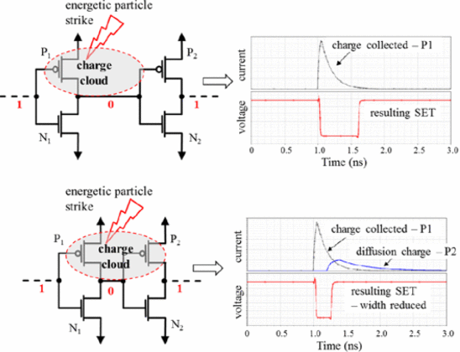
Figure 4: Generation of a single-event transient (SET) at a CMOS inverter output, showing ion-track charge deposition at a reverse-biased drain junction [@ferletcavrois2013set].
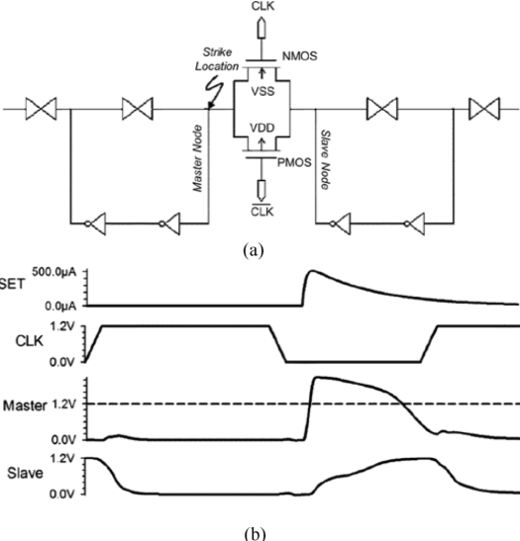
Figure 5: SET propagation through a combinational logic cone and arrival at a flip-flop data input, showing the timing relationship with the clock edge [@ferletcavrois2013set].
In high-speed digital logic, SET pulse widths of tens to hundreds of picoseconds are comparable to clock periods, making SET-induced SEUs a dominant error mechanism in modern FPGAs operating above 100 MHz [@ferletcavrois2013set]. At the lower clock rates typical of nuclear I&C applications, SET capture probability is reduced, but long transients from high-LET events remain a concern.

Single-Event Functional Interrupt (SEFI)
A single-event functional interrupt (SEFI) is an SEU in a control register, finite state machine, or configuration memory that causes a device to enter an erroneous operating mode, resetting itself, locking up, or outputting invalid data, that requires a system-level reset to clear. In FPGAs, SEFIs in the configuration controller or global control registers can cause a partial or complete loss of the user’s programmed logic, a far more serious consequence than a single flipped bit in the data path [@quinn2007review]. SEFI rates are typically much lower than SEU rates per bit (because control registers represent a small fraction of total bits), but their operational consequence is disproportionately severe.

Single-Event Latchup (SEL)
Single-event latchup (SEL) is a potentially destructive condition in which a particle strike triggers the parasitic p-n-p-n thyristor inherent in bulk CMOS processes, causing a low-impedance path to form between the supply rails. If not cleared by power cycling within milliseconds, the resulting current can permanently destroy the device through thermal runaway [@sexton2003destructive]. SEL susceptibility is strongly suppressed in silicon-on-insulator (SOI) processes (which lack the bulk substrate needed for the parasitic thyristor) and by epitaxial substrates with heavily doped buried layers. Modern commercial SRAM FPGAs fabricated in bulk CMOS are SEL-susceptible and require current-limiting power supply protection and power-cycling circuitry in space and nuclear applications.

Single-Event Burnout (SEB) and Gate Rupture (SEGR)
Single-event burnout (SEB) and single-event gate rupture (SEGR) are catastrophic destructive effects confined primarily to power MOSFETs and bipolar transistors operating at high drain-source voltages. SEB occurs when a heavy-ion strike in the epitaxial drain region of an OFF-state power MOSFET triggers a parasitic n-p-n transistor, causing sustained high-current conduction that thermally destroys the device [@sexton2003destructive]. SEGR results from the momentary field enhancement in the gate oxide caused by the ion-track plasma, which can exceed the oxide breakdown field and permanently rupture the gate dielectric. Figs. 3.6, 3.7, and 3.8 illustrate the cross-sectional geometry and onset conditions for these effects.
Figure 6: Cross-sectional schematic of single-event burnout (SEB) in an n-channel power MOSFET, showing the heavy-ion track (dashed), epitaxial drain, and parasitic n-p-n transistor [@sexton2003destructive].
Figure 7: Schematic of the single-event gate rupture (SEGR) mechanism, showing the ion-track plasma and gate-oxide field region [@sexton2003destructive].
Figure 8: Measured SEGR onset $V_{GS}$ as a function of heavy-ion LET for several gate-metal species [@sexton2003destructive].
SEB and SEGR are not directly applicable to logic-level SRAM FPGAs, which operate at supply voltages far below the breakdown thresholds of their internal power transistors. They are, however, relevant to the power supply circuitry and gate drivers that support an FPGA-based system, and must be considered at the system level in any radiation-hardened design.

FPGA Architecture and Radiation Vulnerability

SRAM-Based FPGA Architecture
Modern high-density FPGAs are organized as a two-dimensional array of configurable logic blocks (CLBs), interconnected by a programmable routing fabric and surrounded by dedicated I/O, clock management, block RAM, DSP, and hard-IP peripherals. The entire programmable function of the device is encoded in a configuration memory bitstream stored in an on-chip SRAM array, which for large devices may contain 50–500 million configuration bits [@kuon2008fpga]. The configuration SRAM is loaded from external non-volatile storage (typically QSPI flash or EEPROM) on power-up and retained in SRAM for the duration of operation.
This architecture has a fundamental radiation vulnerability: every bit of the configuration SRAM is continuously susceptible to SEU throughout device operation. An SEU in the configuration memory can alter the function of a lookup table (LUT), change the routing of a signal, enable or disable a flip-flop reset, or modify the address decode of a block RAM, depending on which configuration bit is struck. Unlike an SEU in a user-data register, which affects only the current computation, a configuration memory SEU silently corrupts the device’s programmed behavior until it is detected and corrected [@kastensmidt2014survey].
The sensitivity of different FPGA configuration bit types to functional corruption varies substantially. Bits that control LUT contents are always functionally significant; bits that control unused routing resources may have no effect. Studies of Xilinx Virtex and Kintex FPGAs have found that roughly 15–30% of configuration bits are “essential”, their upset causes a detectable output error, with the remainder corresponding to unused or redundant resources [@quinn2007review; @lee2014kintex]. This essential bit fraction is critical for predicting the functional upset rate from a measured raw upset rate.

Radiation Sensitivity Across FPGA Generations
Quinn et al. surveyed the radiation reliability concerns of Xilinx FPGAs from the Virtex through Virtex-5 generations, finding that each new process node brought reduced $Q_{crit}$ (worsening raw SEU sensitivity per bit) but also reduced bit count per logic function (improving functional upset rate per implemented operation) [@quinn2007review]. SRAM cell cross-sections measured at particle accelerators for 90-nm-class devices (Virtex-4/5) are typically in the range of ${10}^{−14}$–${10}^{−13}$ cm$​^{2}$/bit at high LET, corresponding to functional upset rates of ${10}^{−3}$–${10}^{−2}$ upsets per device per day in a representative LEO orbit. Rakhman et al. characterized the SRAM configuration cells of a Xilinx Kintex-7 FPGA under both heavy-ion and proton irradiation, finding a saturation cross-section of approximately $5×{10}^{−14}$ cm$​^{2}$/bit and a proton cross-section of $∼{10}^{−15}$ cm$​^{2}$/bit at 200 MeV [@rakhman2017sram].
For nuclear plant environments, the neutron-induced upset rate at control-room locations (fast-neutron flux $<{10}^{3}$ n/cm$​^{2}$/s) is orders of magnitude lower than in space and may be further reduced by modest concrete shielding. However, design-basis accident scenarios that expose I&C systems to elevated fluences over hours to days require that the system either be immune to configuration upsets or be capable of detecting and correcting them within the plant’s safety response time.

Fault-Tolerant Mitigation Techniques

Triple Modular Redundancy
The foundational technique for SEU mitigation in digital systems is triple modular redundancy (TMR), originally proposed by Lyons and Vanderkulk in 1962 for improving the reliability of vacuum-tube computers [@lyons1962tmr]. In TMR, the protected function is replicated three times, and a majority voter selects the output of the two (or three) agreeing copies. A single SEU in any one replica is masked because the two healthy copies outvote the corrupted one, and the voter output remains correct. The technique requires the voter itself to be robust, either because it is implemented in radiation-hard technology or because the voter is a simple gate whose critical charge greatly exceeds that of the storage elements it protects.
Figure 9: Overview of fault-tolerant mechanisms for SRAM-based FPGAs, ranging from single-level flip-flop TMR to full-system architectural redundancy [@kastensmidt2014survey].
Figure 10: Voter logic flowchart for a TMR system, showing majority voting across three independent replicas [@lyons1962tmr; @johnson2010voter].
In FPGA implementations, TMR is applied at multiple granularities. Full TMR triplicates every logic element, flip-flop, and routing resource in the design, providing maximum fault coverage at the cost of roughly $3×$ resource usage and power. Partial TMR applies triplication only to the most safety-critical paths, reducing overhead while protecting against the most consequential upsets [@pratt2008partial]. Register-file TMR protects only the storage elements (flip-flops and block RAMs) while leaving combinational logic unprotected, trading reduced area for acceptance of transient SET-induced errors that are not captured [@sterpone2005tmr]. Fig. 3.9 illustrates these trade-offs, and Fig. 3.10 shows the voter logic in detail.
The TMR approach is well-established in space applications and has been demonstrated to reduce functional upset rates by approximately two orders of magnitude in Xilinx Virtex-class FPGAs at representative GCR fluences [@wirthlin2015high]. For nuclear I&C applications, Sciber et al. demonstrated a TMR-protected FPGA-based safety system for a research reactor that maintained correct output through simulated configuration upsets at a rate 500$×$ the expected plant environment level [@SciDirect_TMR_Nuclear].

Configuration Scrubbing
TMR corrects the voter output but does not repair the configuration memory of the corrupted replica. After a sufficient number of upsets accumulate, two replicas may be simultaneously corrupted, defeating majority voting. Configuration scrubbing addresses this by periodically refreshing the FPGA’s configuration memory from a known-good reference stored in non-volatile memory [@berg2008scrubbing].
In external scrubbing, an external processor reads the current configuration bitstream from the FPGA, compares it bit-by-bit with the golden reference, and writes back corrected frames where differences are detected. This approach can detect and correct errors at rates determined by the scrub period, which must be short compared to the mean time between double upsets in the TMR replicas [@heiner2009scrubbing]. For a device with ${10}^{7}$ configuration bits, a bit-upset rate of ${10}^{−3}$ upsets/bit/day, and a required double-upset probability below ${10}^{−6}$ per mission, the required scrub period is on the order of seconds, achievable with standard scrubbing controllers operating at JTAG bitstream rates [@wirthlin2016scrubbing].
Partial reconfiguration scrubbing uses the FPGA vendor’s partial reconfiguration infrastructure to overwrite individual configuration frames without resetting the entire device, allowing scrubbing to proceed concurrently with normal device operation [@pratt2008partial]. Xilinx Virtex/UltraScale and Intel Stratix devices both support partial reconfiguration, and open-source scrubbing controllers (e.g., the Scrub Engine developed at Brigham Young University) implement this approach [@wirthlin2016scrubbing]. Herrera-Alzu and López-Vallejo systematically characterized the scrubber performance for Xilinx Virtex-5 FPGAs, demonstrating that scrub periods below 50 ms reduced the effective functional upset rate below ${10}^{−6}$ upsets/day at LEO conditions [@herreraalzu2013scrubbers].

Combined TMR-Scrubbing and Hybrid Approaches
For the highest reliability requirements, TMR and scrubbing are deployed together: TMR provides instant correction of single upsets, while scrubbing prevents the accumulation of uncorrected errors that would eventually defeat TMR [@kastensmidt2014survey]. The combination reduces the effective uncorrectable upset rate to the probability of two upsets occurring within a single scrub period before the first is corrected, typically several orders of magnitude lower than either technique alone.
Hybrid approaches extend these concepts to the system level. Stoddard et al. demonstrated a configuration in which an FPGA running a spacecraft attitude control algorithm was protected by TMR at the register level, partial-reconfiguration scrubbing at the configuration level, and watchdog-timer reset at the system level, achieving an estimated mean time between failures of $>{10}^{5}$ hours in a GEO radiation environment [@stoddard2017hybrid]. The architecture developed in Chapters 7 and 8 for nuclear plant monitoring adopts a similar layered approach, with TMR protecting the safety logic, periodic configuration scrubbing maintaining the configuration integrity, and a redundant processor monitoring the voter-disagreement signal to detect any uncorrected upset before it propagates to a safety output.

Error Detection and Correction in Block RAMs
Block RAMs (BRAMs) in FPGAs store application data, not configuration bits, and are equally susceptible to SEUs. Xilinx and Intel FPGAs provide optional built-in single-error correction, double-error detection (SECDED) Hamming codes for BRAM data, which correct single-bit upsets transparently and flag double-bit upsets as uncorrectable [@morgan2007comparison]. For nuclear applications where the BRAM stores measurement data or plant state variables, SECDED with periodic scrubbing provides an acceptable level of protection, while dual-port BRAM with cross-checking between two separate memory arrays provides an additional layer of protection against MCU events that span multiple bits within the same Hamming word.

COTS FPGAs in Nuclear and Radiation-Critical Applications

The Cost-Performance Trade-off
Purpose-built radiation-hardened FPGAs, such as the Microchip RTG4 (130-nm flash-based, inherently SEU-immune configuration) and the AMD/Xilinx XQRKU060 (16-nm FinFET, rad-hard by design), provide guaranteed TID tolerance exceeding 300 krad(Si) and quantified SEL immunity, but at unit prices of $50,000–$500,000 and with logic densities one to two generations behind commercial equivalents [@Microchip_RTG4; @AMD_XQRKU060]. For nuclear plant I&C modernization programs that may require hundreds of processing nodes, this cost premium is prohibitive.
Commercial off-the-shelf (COTS) FPGAs from the Xilinx 7-series, UltraScale, and Intel Cyclone/Arria families offer $50$–$100×$ lower cost per gate, higher logic density, and access to modern soft-IP ecosystems, at the cost of no radiation-hardness guarantee from the manufacturer [@BISResearch_RadHardFPGA]. The engineering question is therefore not whether COTS FPGAs are radiation-tolerant, but whether their radiation response, combined with appropriate mitigation, can be characterized to a level of assurance sufficient for the safety classification of the application.

Demonstrated COTS FPGA Performance in Radiation Environments
Several accelerator and nuclear programs have demonstrated that COTS FPGAs with TMR and scrubbing can meet stringent reliability requirements at radiation levels consistent with nuclear plant I&C. Lee et al. irradiated a Xilinx Kintex-7 FPGA (28-nm) with protons at TRIUMF and with neutrons at Los Alamos National Laboratory’s Weapons Neutron Research facility, measuring a total accumulated dose of 300 krad(Si) with no functional failure, and recording zero configuration upsets attributable to TID at that dose level [@lee2014kintex]. Wirthlin et al. demonstrated a Leon3 soft-core processor implemented on a Kintex-7 FPGA that maintained correct program execution through $3×{10}^{10}$ n/cm$​^{2}$ of 14-MeV neutron irradiation with TMR+scrubbing active, corresponding to a ground-level exposure equivalent of several decades of control-room operation [@wirthlin2016leon3].
The CERN high-energy physics community has deployed COTS FPGAs extensively in the LHC detector electronics, where annual doses in some locations reach tens of krad and the SEE environment from secondary shower particles is comparable to LEO. Systematic characterization programs at CERN show that 28-nm Kintex-7 and UltraScale devices exhibit no destructive effects (SEL, SEB, SEGR) at bias voltages within datasheet ratings at LET up to 62 MeV$⋅$cm$​^{2}$/mg, and that TMR+scrubbing reduces functional upset rates below the ${10}^{−9}$/hour target imposed by LHC safety systems [@CERN_FPGA_Rad].
Pignol reviewed the use of COTS components in safety-critical space avionics and concluded that the combination of architectural mitigation (TMR, watchdog), physical mitigation (shielding, latchup current limiters), and comprehensive testing is sufficient to achieve failure-in-time rates competitive with purpose-built rad-hard parts, at substantially lower cost [@pignol2010cots]. The same conclusion drives the DOE GEMINA program, which targets AI/ML-enabled COTS digital systems for advanced reactor I&C [@DOE_GEMINA], and the ANS-recommended roadmap for I&C modernization at the existing LWR fleet [@ANS_ICModernization_2025].

Regulatory Pathway for COTS FPGAs in Nuclear Plants
The NRC’s regulatory framework for digital I&C in nuclear plants (10 CFR 50 Appendix A, GDC 21–25; Regulatory Guide 1.152; NUREG/CR-6263) does not prohibit COTS devices but requires that the licensee demonstrate that the device meets the qualification requirements for its safety classification, including radiation qualification per IEEE Std 7-4.3.2 and post-accident monitoring per RG 1.97 [@nrc1997digital]. The key qualification documentation for an FPGA-based safety function includes: (1) a radiation characterization data package demonstrating TID tolerance, SEL immunity, and SEU cross-section measurement; (2) a functional upset rate prediction for the plant-specific radiation environment; (3) a mitigation architecture description showing that the functional upset rate with TMR+scrubbing meets the specified single failure criterion; and (4) a test program demonstrating correct operation under the combined effects of irradiation and functional loading [@iaea2016design; @natacad2018testing].

Testing Methodologies for FPGA Radiation Qualification
The qualification of FPGAs for radiation environments requires experimental measurement of both TID and SEE parameters, since analytical prediction from process parameters alone is not sufficiently accurate for safety-relevant applications. Fig. 3.11 illustrates the principal testing approaches and their relationship to the environment being simulated.
Figure 11: Summary of testing approaches for radiation hardness assurance of digital electronics, organized by radiation source, simulated environment, and measured effect [@schwank2013radiation; @coronetti2021systemlevel].

Heavy-Ion Testing
Heavy-ion irradiation at particle accelerators is the primary technique for measuring SEE cross-sections as a function of LET and for identifying the SEL, SEB, and SEGR thresholds of a device. Facilities commonly used for FPGA radiation testing include the Brookhaven National Laboratory Tandem Van de Graaff (LET range 1–100 MeV$⋅$cm$​^{2}$/mg), the Lawrence Berkeley National Laboratory 88-Inch Cyclotron (LET up to 85 MeV$⋅$cm$​^{2}$/mg), the Texas A&M K500 Cyclotron, and the GANIL facility in Caen, France [@natacad2018testing].
During a heavy-ion test, the device under test (DUT) is mounted in a vacuum chamber, biased and clocked at normal operating conditions, and exposed to a uniform beam of a selected heavy ion species at controlled LET and fluence. For FPGA testing, two complementary readout strategies are used: static testing, in which the device is irradiated with configuration memory pre-loaded and then readback to count configuration bit flips, and dynamic testing, in which the FPGA executes a test design that monitors its own outputs for errors in real time [@quinn2007review]. Dynamic testing captures both configuration upsets and user-register upsets but is limited in the depth of design validation per test run; static testing provides complete configuration memory coverage but misses upsets in the user logic flip-flops.

Proton Testing
Proton irradiation at energies of 50–200 MeV provides a practical and cost-effective alternative to heavy-ion testing for devices whose SEE cross-section vs. LET curve is required through the proton-relevant range, and for devices intended for use in proton-dominated environments (trapped proton belts, low-altitude orbits). Protons cause SEEs primarily through nuclear elastic scattering (which produces silicon or oxygen recoil nuclei with typical LET of 5–15 MeV$⋅$cm$​^{2}$/mg) and through non-elastic nuclear reactions (which produce heavy recoil fragments with higher LET) [@petersen1992rate]. The resulting SEU cross-section is lower than the heavy-ion saturation cross-section by one to two orders of magnitude, but the high proton fluences available at accelerators like TRIUMF (Vancouver), IUCF (Bloomington), and the Paul Scherrer Institute (Villigen) allow statistically meaningful measurements [@schwank2013radiation].
Proton testing also accumulates significant TID during the SEE test (at 100 MeV, 10$​^{11}$ p/cm$​^{2}$ corresponds to $∼$1 krad(Si)), which must be accounted for in test planning to avoid confusing TID degradation with SEE events.

Neutron Testing
Neutron testing is the most directly relevant modality for nuclear plant applications and for ground-level qualification [@stirk2023comparison]. The upset mechanisms for neutrons above $∼$10 MeV are similar to protons, nuclear elastic scattering producing silicon recoil nuclei plus non-elastic spallation reactions producing heavier fragments, but the neutron’s lack of charge means it produces no ionization along its own track and the DUT need not be operated in vacuum. This simplifies the experimental setup considerably.
Several neutron irradiation facilities are available for FPGA testing. The Los Alamos Neutron Science Center (LANSCE) ICE House provides a quasi-monoenergetic neutron spectrum peaked at 800 MeV that is often used as a reference for atmospheric cosmic-ray testing [@wirthlin2016leon3]. The Indiana University Cyclotron Facility (IUCF) produced monoenergetic 200-MeV neutrons, now primarily replaced by the Triangle Universities Nuclear Laboratory (TUNL) and the nTOF facility at CERN for intermediate energies. For reactor neutron environments, fission reactor irradiation facilities such as the MIT reactor’s fission converter beam [@harling2006fission] and the Ohio State University Research Reactor (OSURR) provide thermal-to-fast neutron spectra representative of ex-core I&C locations.
The standard approach for neutron SEE testing of FPGAs follows the JEDEC JESD89A protocol: the device is irradiated with a known neutron fluence at the test facility’s reference spectrum, and the measured upset count is scaled to the terrestrial sea-level equivalent fluence using the spectral overlap integral [@jedec2006jesd89a]. Stirk et al. compared three neutron testing approaches (monoenergetic, white-spectrum, and reactor) for a complex system-on-chip and found that the accelerator white-spectrum test at LANSCE gave the closest agreement with reactor exposure results, while monoenergetic beam tests required more careful spectral correction [@stirk2023comparison].

Total Ionizing Dose Testing
TID testing is performed by exposing the device to a controlled dose from a $​^{60}$Co gamma source or an X-ray irradiator at a specified dose rate, with the device biased in a representative operating condition. The JEDEC/MIL-STD-883 Method 1019 protocol specifies the irradiation conditions, readout intervals, and post-irradiation anneal procedure required for military and space qualification [@schwank2013radiation].
A critical subtlety in TID testing is dose-rate dependence: many MOS devices exhibit enhanced low-dose-rate sensitivity (ELDRS), in which the damage at low dose rates ($<$0.1 rad(Si)/s) exceeds that at high dose rates (1–100 rad(Si)/s) for the same total dose [@fleetwood2013total]. ELDRS occurs in bipolar transistors and certain MOS linear circuits but is less pronounced in digital CMOS; it is nonetheless a qualification concern for reactor I&C systems that accumulate dose over decades at rates of millirad per hour rather than the rad-per-second rates used in accelerated laboratory tests. The MIL-STD-883 Method 1019 elevated-temperature anneal procedure is designed to provide a conservative bound on ELDRS without requiring multi-year low-dose-rate exposures [@shaneyfelt2008qualification].

Ground-Level and Accelerated System Testing
For applications where the primary concern is the terrestrial cosmic-ray neutron environment, system-level testing at the actual deployment site or at a representative high-altitude location provides the most directly applicable qualification data [@coronetti2021systemlevel]. However, at sea-level neutron flux ($∼{10}^{−2}$ n/cm$​^{2}$/s above 10 MeV), accumulating ${10}^{10}$ n/cm$​^{2}$, a fluence corresponding to several decades of ground-level exposure, would require $∼3×{10}^{10}$ seconds, making direct ground-level testing impractical for qualification purposes. Accelerated testing at mountain-top observatories (e.g., Mauna Kea, 5 km altitude, flux $∼10×$ sea level) or accelerator facilities bridging this gap.
Adell et al. and Artola et al. developed simulation frameworks using GEANT4 to predict ground-level neutron upset rates from device-level cross-section measurements, validating the approach against measured field failure data from commercial servers [@adell2008assessing; @artola2021benchmarks]. The GEANT4 Monte Carlo toolkit [@agostinelli2003geant4], which models hadronic and electromagnetic interactions from eV to TeV energies, has become the standard simulation infrastructure for predicting SEE rates in complex radiation environments including both atmospheric and reactor neutron spectra.

FPGA Verification Challenges in Nuclear Beam Environments
Beyond the physics of radiation damage, the experimental characterization of FPGA upset susceptibility at nuclear beam facilities presents several practical constraints that inform the design of in-beam test instruments such as those developed in Chapters 7 and 8.
State-volume coverage. An SEE cross-section measurement requires observing a statistically significant number of events. The cross-section for a single memory cell is of order ${10}^{−14}$ to ${10}^{−12}$ cm$​^{2}$, so at a flux of ${10}^{5}$–${10}^{7}$ n/cm$​^{2}$/s a single cell would require impractically long exposures to accumulate even one event on average. Maximising the monitored state population is therefore essential.
Observability without intrusion. Reading every flip-flop off-chip individually during irradiation is infeasible for large state populations and introduces additional wiring susceptible to radiation and noise. A compact on-chip checker that compresses the health of the state array into a small digital flag is preferable.
Configuration vs. data upsets. Any experimental design must be capable of distinguishing a user-data upset from a configuration memory upset. The two mechanisms require different mitigation strategies: data-path redundancy (DMR/TMR) addresses the former, while periodic configuration scrubbing addresses the latter.
Telemetry reliability. The UART or other communication channel used to export results is itself implemented in FPGA resources and therefore subject to the same configuration upsets. A robust transmitter design reduces the risk that the observability channel itself is corrupted during an experiment.
These constraints motivate the specific design choices made in the FFSR shift-register test structure (Chapter 7) and the fixed-point thermal control benchmark (Chapter 8), both of which employ on-chip redundancy comparison, compact telemetry encoding, and large monitored state populations to maximize the probability of detecting radiation-induced errors within the available beam time.

Summary
This chapter has established the physical and engineering framework for the FPGA-based nuclear instrumentation systems developed in Chapters 7 and 8. The three radiation environments of concern, space, nuclear plant, and terrestrial cosmic-ray, each impose distinct TID and SEE demands on digital electronics. TID damage in MOS gate oxides accumulates throughout device operation and degrades transistor performance at doses that, for control-room I&C in nuclear plants, remain well within the tolerance of modern CMOS processes. The more consequential threat is stochastic single-event effects, which occur at arbitrarily low dose rates: SEUs corrupt FPGA configuration memory silently and persistently, SEFIs can interrupt device operation, and SELs can destroy devices if power cycling is not promptly applied.
Triple modular redundancy, applied at the register and routing level within the FPGA fabric, corrects single upsets instantaneously without interrupting the safety function; periodic configuration scrubbing prevents upset accumulation that would eventually defeat TMR. The combination of these two techniques reduces the uncorrectable upset probability to levels that can be demonstrated to meet the single-failure criterion of nuclear safety standards. COTS FPGAs from the 28-nm and 16-nm Kintex-7 and UltraScale families have been qualified for radiation environments substantially more demanding than nuclear plant I&C through heavy-ion, proton, and neutron testing at national accelerator facilities, and the regulatory pathway for their use in safety-related applications is established in IAEA SSG-39 and NRC Regulatory Guide 1.152. The dissertation now turns to the perovskite materials and device investigations (Chapters 4–5) and thermal sensing concepts (Chapter 6) before returning to experimentally validate these FPGA principles: Chapter 7 presents the Flip-Flop Shift Register (FFSR) verification structure tested under fast neutron irradiation, and Chapter 8 extends that campaign with a computationally richer fixed-point thermal control benchmark.

Cs$​_{0.1}$FA$​_{0.9}$PbI$​_{3}$ Perovskite Solar Cells as Ionizing Radiation Monitors
The preceding chapter established that halide perovskites combine the electronic properties requisite for radiation detection, high effective atomic number, adequate charge-carrier mobility-lifetime products, and tunable bandgap, with solution-processable fabrication routes inaccessible to conventional compound semiconductors. The work described in this chapter exploits a distinct but complementary strategy: rather than deploying a thick single crystal as a direct charge-collection detector, it repurposes a photovoltaic-architecture thin-film device as a current-mode radiation monitor. The rationale is twofold. First, modern perovskite solar cells have reached certified power-conversion efficiencies exceeding 27% [@Li2026record], implying that the absorber layers have been optimized over a decade of intense materials research for the very properties, long carrier diffusion lengths, low trap-state densities, and efficient carrier extraction, that also govern sensitivity to ionizing radiation. Second, photovoltaic modules are inherently scalable in area, enabling the construction of sensor arrays whose geometric aperture is far larger than what is practical with single-crystal bulk detectors, and whose short-circuit current provides a direct analog output suitable for interfacing with standard nuclear instrumentation.
The Cs$​_{0.1}$FA$​_{0.9}$PbI$​_{3}$ composition is specifically chosen because partial substitution of cesium for formamidinium suppresses the spontaneous $α→δ$ phase transition of pure FAPbI$​_{3}$ while preserving its 1.48 eV bandgap and superior charge transport relative to MAPbI$​_{3}$ [@Yi2016]. The pin diode device structure (Section 4.1) further suppresses dark current relative to a simple ohmic-contact geometry, and its inverted polarity places the transparent electrode on the illuminated face, an arrangement that simultaneously enables photovoltaic operation under sunlight and direct exposure of the perovskite absorber to externally incident radiation.
This chapter reports visible-light temporal response measurements (Section 4.2), X-ray response under pulsed and continuous illumination (Section 4.3), gamma-ray response during continuous $​^{137}$Cs and $​^{60}$Co irradiation including a six-day and sixteen-day stability study (Section 4.4), and steady-state neutron response measurements performed at the Ohio State University Nuclear Reactor Laboratory (Section 4.5).

Device Fabrication and Photovoltaic Performance
Devices were fabricated by Prof. Jinsong Huang’s group at the University of North Carolina at Chapel Hill using a standard inverted (pin) architecture developed for high-efficiency perovskite photovoltaics. The composition of the absorber layer is Cs$​_{0.1}$FA(CH$​_{3}$NH$​_{2}$)$​_{0.9}$PbI$​_{3}$, where the 10 mol% Cs$​^{+}$ substitution entropy-stabilizes the cubic $α$-phase at ambient conditions as described in Section 2.1. Device fabrication proceeded by sequential solution deposition of the hole transport layer, the perovskite precursor solution, the electron transport layer, and the top metal contact onto glass/ITO substrates. The layer stack, illustrated in Figure 4.1, is ITO / hole transport layer / Cs$​_{0.1}$FA$​_{0.9}$PbI$​_{3}$ / electron transport layer / Ag.
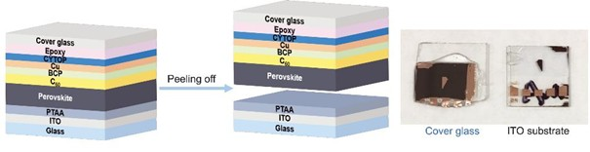
Figure 12: Cross-sectional schematic of the pin perovskite device structure used throughout this chapter. The ITO/hole-transport-layer (HTL) contact serves as the illuminated face for both photovoltaic and radiation-monitoring operation; the Ag back contact completes the Cs$​_{0.1}$FA$​_{0.9}$PbI$​_{3}$ absorber sandwich.
Two device geometries were characterized: a small-area cell ($∼$8 mm$​^{2}$ active area) for high-throughput screening and an encapsulated module (63.7 cm$​^{2}$ aperture area, four cells wired in series) intended for radiation monitoring applications. Representative current density–voltage (J-V) curves measured under 1-sun AM1.5G illumination are shown in Figure 4.2.
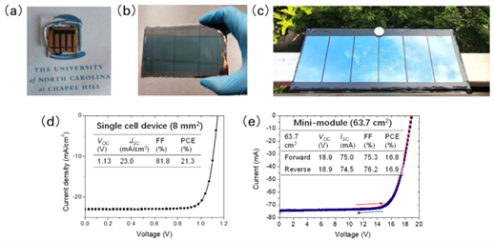
Figure 13: Photovoltaic performance of the Cs$​_{0.1}$FA$​_{0.9}$PbI$​_{3}$ devices used in this study. (a) J-V curve for the 8 mm$​^{2}$ small cell (PCE = 21.3%, $V_{OC}$ = 1.13 V, $J_{SC}$ = 23.0 mA cm$​^{−2}$, FF = 81.8%). (b) J-V curve for the 63.7 cm$​^{2}$ module (PCE = 16.9%, $V_{OC}$ = 18.9 V, $J_{SC}$ = 74.5 mA cm$​^{−2}$, FF = 76.2%). All measurements performed at UNC Chapel Hill under AM1.5G illumination prior to shipment.
The small-cell PCE of 21.3% is consistent with champion efficiencies reported for the Cs$​_{0.1}$FA$​_{0.9}$PbI$​_{3}$ composition in the contemporary literature [@Liu2024inverted], confirming that the devices received for radiation testing represent the current state of the art in perovskite photovoltaic fabrication. The module efficiency of 16.9% reflects the geometric fill-factor penalty inherent in a series-connected configuration and is comparable to certified module efficiencies from the same composition reported by independent groups [@Li2026record].

Temporal Photoresponse Characterization
Before proceeding to ionizing radiation measurements, the time-domain photoresponse of the devices was characterized under visible light to establish the inherent bandwidth of the detector and to identify any device-physics limitations on pulse-following ability. Three complementary measurement modalities were employed: a DC chopped-beam experiment to measure the turn-on and turn-off time constants, a pulsed-laser experiment to probe the high-frequency limit, and an AC-coupled grid-simulation experiment to assess the feasibility of power-grid synchronization using the solar module.

DC Transient Response
The DC transient measurement used a 532 nm continuous-wave laser attenuated to approximately 0.45 sun equivalent irradiance and modulated by a mechanical optical chopper. Short-circuit current transients were acquired on a digital oscilloscope and analyzed to extract the 10–90% rise time and the 90–10% fall time.
The 8 mm$​^{2}$ cell exhibited a rise time of approximately 33 ms, while the 28.6 cm$​^{2}$ module required approximately 60 ms to reach 80% of its peak short-circuit current after the chopper opened. Both values are substantially longer than the RC time constants computed from the device capacitance and load resistance, confirming that the observed response time is limited by the chopper blade transit speed rather than by any intrinsic device physics. This conclusion is consistent with the known sub-microsecond free-carrier lifetimes in high-quality Cs–FA perovskite films [@Guerrero2021chemrev].

Pulsed Laser Response
To access the true high-frequency bandwidth of the devices, a pulsed diode laser (Thorlabs NPL41B, 405 nm central wavelength) was used in place of the chopped CW source. The laser was operated at a repetition rate of 1 kHz with a pulse width of 20 ns (variable 6–38 ns range, up to 10 MHz maximum repetition rate). Photoresponse pulses were amplified by a transimpedance amplifier with ${10}^{5}$ V A$​^{−1}$ gain and 1 MHz bandwidth before acquisition on a Keysight MSO-X-3104T oscilloscope.
Two series-parallel module assemblies, denoted Cell A and Cell B, each consisting of four Cs$​_{0.1}$FA$​_{0.9}$PbI$​_{3}$ cells mounted on a printed breadboard, were characterized. Cell A exhibited an output pulse rise time of approximately 84 ns under these conditions; Cell B produced a comparable waveform. The measured rise time is dominated by the 1 MHz bandwidth of the transimpedance amplifier rather than the device itself: the $−3$ dB amplifier bandwidth corresponds to a rise-time limit of $0.35/{10}^{6}$ Hz $≈350$ ns, and the shorter observed value reflects the partial bandwidth contribution of the oscilloscope front-end and cable parasitics. The intrinsic device response is therefore faster than the approximately 84 ns system-limited value, consistent with the sub-microsecond carrier lifetimes expected from the $μτ$ products typical of Cs$​_{0.1}$FA$​_{0.9}$PbI$​_{3}$ thin films reported in Section 2.4.2.

AC Grid Simulation
To evaluate whether the solar module could track the periodic voltage waveform produced by a single-phase power inverter, a potential application for verifying grid integrity or synchronizing a radiation monitor to a power-cycle reference, the four-cell module was connected to the input of a commercial single-phase DC-to-AC microinverter under indoor fluorescent illumination. The inverter consumed approximately 4 W at its rated load, but the module could deliver only $∼$1 W under the available illumination, leaving the inverter operating in a deeply underloaded regime. No distinct 50/60 Hz modulation of the module output current was discernible above the noise floor in this configuration. The negative result is attributed entirely to the power deficit rather than to any bandwidth limitation of the perovskite device: achieving an observable AC response would require either a larger-aperture module, a light concentrator, or a calibrated illumination source at close to 1-sun intensity.

X-Ray Response
X-ray characterization was performed using an Amptek Mini-X miniature X-ray tube with a gold anode, operated at tube voltages up to 50 kV. For continuous-wave measurements, the module was placed in the beam path and J-V characteristics were recorded as a function of X-ray tube voltage and current. Figure 4.3 shows the resulting I-V curves; the short-circuit current $I_{SC}$ increases monotonically with tube voltage, consistent with the increasing photon fluence and mean photon energy.
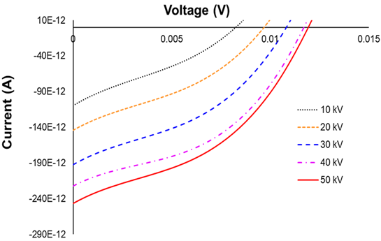
Figure 14: Current-voltage characteristics of the Cs$​_{0.1}$FA$​_{0.9}$PbI$​_{3}$ module under Amptek Mini-X X-ray tube illumination at tube voltages from 10 kV to 50 kV. Inset: $I_{SC}$ at 50 kV as a function of irradiation time.
The time-resolved $I_{SC}$ at 50 kV, shown in the inset of Figure 4.3, exhibits the characteristic slow-decline behavior previously reported for perovskite photovoltaic devices under sustained illumination in the presence of a built-in electric field. The decline is attributed to ion migration: mobile halide vacancies drift under the device’s built-in field, accumulating at the charge-transport layer interfaces and partially screening the collection field [@Thiesbrummel2024ionmig; @Eames2015].
The absolute $I_{SC}$ induced by the X-ray source is substantially smaller than that observed in the silicon reference device operated under the same conditions, owing to the much smaller active area of the perovskite module relative to the silicon photodiode used for comparison ($∼$64 cm$​^{2}$ vs. several hundred cm$​^{2}$). On a per-unit-area basis, the perovskite compares favorably due to its higher photoelectric absorption cross section at the relevant photon energies.
For pulsed X-ray measurements, the Amptek Mini-X beam was modulated by a Thorlabs MC2000 optical chopper equipped with a 10-slot blade (760 $μ$m stainless steel, slot width matched to achieve pulse frequencies from 10 Hz to 1 kHz). The pulsed response confirmed that the device faithfully follows the beam modulation at frequencies up to the chopper bandwidth, consistent with the pulsed laser measurements in Section 4.2.2.

Gamma-Ray Response

Measurement Setup and Dose Rate Calibration
Gamma-ray irradiation experiments were performed at the Ohio State University Nuclear Reactor Laboratory (OSU NRL) using two independent sources: a benchtop $​^{137}$Cs irradiator (six source rods, $E_{γ}=662$ keV) and a $​^{60}$Co irradiator submerged in the reactor pool ($E_{γ}=1.17$ and 1.33 MeV). Because the dose rate calibration values provided with each irradiator are given in units of roentgen per hour for air, conversion to the absorbed dose rate in the perovskite film was performed using the relation
$${\dot{D}}_{perovskite}=0.877×\frac{(μ_{en}/ρ)_{perovskite}}{(μ_{en}/ρ)_{Si}}×\dot{X},$$
where $\dot{X}$ is the exposure rate in roentgen per hour, 0.877 rad/R is the roentgen-to-rad conversion factor for soft tissue [@knoll2010], and the ratio of mass energy-absorption coefficients $(μ_{en}/ρ)$ was evaluated at the mean photon energy of each source using NIST XCOM tabulations [@Berger2010xcom]. This procedure yielded dose rates of 44.16 rad hr$​^{−1}$ in the perovskite layer for the $​^{137}$Cs irradiator and 355.61 rad hr$​^{−1}$ for the $​^{60}$Co source.

Cesium-137 Irradiation
The Cs$​_{0.1}$FA$​_{0.9}$PbI$​_{3}$ module was inserted into and withdrawn from the $​^{137}$Cs irradiator while the short-circuit current was monitored in real time. Figure 4.4 shows a time-series of $I_{SC}$ recorded during a representative insert/withdraw cycle. A clear and reproducible step change in $I_{SC}$ is observed upon insertion, with the current increasing by an amount proportional to the gamma-induced electron-hole pair generation rate within the absorber. The induced current density at 44.16 rad hr$​^{−1}$ was measured as 2.19 nA cm$​^{−2}$, which represents the net gamma-to-current conversion sensitivity of the device under the prevailing irradiation geometry.
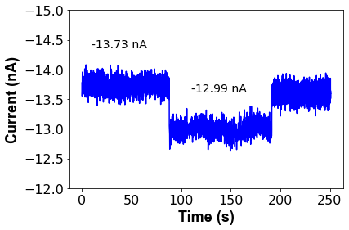
Figure 15: Short-circuit current $I_{SC}$ of the Cs$​_{0.1}$FA$​_{0.9}$PbI$​_{3}$ module as a function of time during insertion into and withdrawal from the $​^{137}$Cs irradiator (dose rate = 44.16 rad hr$​^{−1}$ in perovskite).
To assess the long-term stability of the perovskite module as a radiation monitor, the device was subjected to continuous $​^{137}$Cs irradiation for six days without removal from the source. The accumulated absorbed dose over the six-day period was computed by integrating the dose rate over the irradiation time. Figure 4.5 shows the evolution of $I_{SC}$ as a function of cumulative absorbed dose. A linear decrease in $I_{SC}$ with dose is observed, with a slope of $−0.74$ nA rad$​^{−1}$, corresponding to a relative degradation rate of approximately $\left[I_{SC}(0)−I_{SC}(D)\right]/I_{SC}(0)$ per unit absorbed dose.
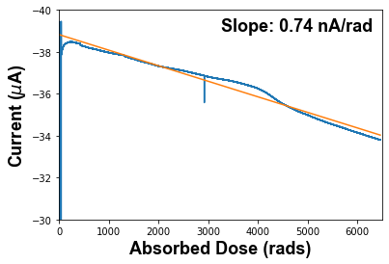
Figure 16: Long-term evolution of $I_{SC}$ under continuous $​^{137}$Cs irradiation (44.16 rad hr$​^{−1}$) over six days.
The observed linear decline is consistent with the creation of electrically active defects, primarily iodide Frenkel pairs, proportional to the absorbed dose, as has been documented for $​^{60}$Co irradiation of MAPbI$​_{3}$ single crystals at doses up to 1000 krad [@Boldyreva2020gammarad]. An additional contribution to the $I_{SC}$ decline comes from cumulative darkening of the borosilicate glass superstrate, which reduces the visible-light transmittance and hence the photovoltaic current even in the absence of absorber degradation; this contribution has been documented separately [@Boldyreva2024cs137].

Cobalt-60 Irradiation
The module was subsequently irradiated in the OSU NRL reactor pool using the underwater $​^{60}$Co irradiator at a dose rate of 355.61 rad hr$​^{−1}$ in the perovskite layer, approximately eight times higher than the $​^{137}$Cs rate. The measurement geometry was otherwise identical: $I_{SC}$ was recorded continuously throughout a 16-day irradiation. The induced current density at 355.61 rad hr$​^{−1}$ was 3.56 nA cm$​^{−2}$.
Figure 4.6 shows the $I_{SC}$ time series for the $​^{60}$Co irradiation. As with $​^{137}$Cs, a downward linear trend in the baseline $I_{SC}$ is observed over the 16-day period, consistent with progressive defect accumulation proportional to absorbed dose.
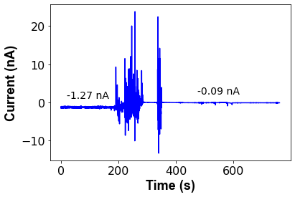
Figure 17: Short-circuit current $I_{SC}$ of the module during 16-day continuous $​^{60}$Co irradiation (dose rate = 355.61 rad hr$​^{−1}$ in perovskite).
These results demonstrate that arrays of calibrated perovskite modules could, in principle, be deployed in a spatial configuration around a radiation source to triangulate the detonation location or measure the spatial dose distribution by comparing the $I_{SC}$ responses of individual array elements. The linear dose–current relationship established here provides the calibration function necessary for such an application.

Neutron Response
Neutron response measurements were performed at the Fast Neutron Beam Facility (FBF) of the Ohio State University Research Reactor (OSURR). The FBF beamline and its filtering elements are described in full in Section 4.5.1 below; the experimental geometry for the solar-cell measurements placed the perovskite module alternately outside the beam (background), in the beam with the gamma-suppression filter closed, and in the beam with the filter open, enabling separation of the neutron-induced and gamma-induced current components.

OSURR Fast Neutron Beam Facility
The OSURR is a 500-kW$​_{th}$ pool-type research reactor operated by the OSU Nuclear Reactor Laboratory. The Fast Neutron Beam Facility (FBF) is a horizontal beamport extending from the reactor core through the biological shielding to an experimental area, providing access to the reactor’s fast and epi-thermal neutron flux for detector characterisation. The beam line contains three independently configurable filtering elements, each of which modifies the fast neutron flux and gamma dose rate reaching the detector in a distinct way.
The first element is a permanent 4-inch (10.16 cm) single-crystal bismuth block embedded near the reactor core as an in-line gamma filter. Bismuth is nearly transparent to fast neutrons while strongly attenuating the intense prompt fission gamma flux produced by the reactor core. This filter is always in place and is not removable during experiments.
The second element is an 8-inch (20.32 cm) lead gamma shutter embedded in the reactor’s concrete shielding wall downstream of the bismuth filter. The shutter consists of a cylindrical drum filled with $1/{16}$-inch (0.159 cm) Pb shot. When open, the neutron beam passes through an air gap in the drum; when closed, the beam traverses the full column of lead shot, providing approximately 8 inches of gamma shielding in total. Closing the gamma shutter reduces the gamma-ray content of the beam by a factor of 300, while simultaneously attenuating the fast neutron flux by a factor of 35. With the shutter open and no cadmium filter in place, the fast neutron flux at the detector position is $1.5×{10}^{7}$ cm$​^{−2}$ s$​^{−1}$ and the gamma dose rate is 15.787 R hr$​^{−1}$. With the shutter closed, the fast neutron flux drops to $4.3×{10}^{5}$ cm$​^{−2}$ s$​^{−1}$ and the gamma dose rate falls to 50.525 mR hr$​^{−1}$.
The third element is an external 2-mm cadmium (Cd) foil positioned at the beam exit port. Cadmium has a very large absorption cross-section for thermal neutrons (below $∼$0.5 eV) and acts as a selective thermal neutron filter, leaving the fast and epi-thermal components of the beam largely unaffected. The Cd foil was characterised via gold foil activation measurements per ASTM E262-17, yielding a Cadmium Ratio of 1.1 and a thermal neutron reduction factor of 110. When the gamma shutter is closed and the Cd filter is inserted, the estimated thermal neutron flux at the detector is reduced to $∼$220 cm$​^{−2}$ s$​^{−1}$, while the fast neutron flux remains at $4.3×{10}^{5}$ cm$​^{−2}$ s$​^{−1}$. The combined effect of all three filtering configurations on the beam composition is summarised in Table 4.1.
OSURR FBF beam conditions as a function of gamma shutter and Cd filter configuration. All flux and dose-rate values are referenced to 450 kW$​_{th}$ reactor power at the detector position.
Shutter | Cd filter | Fast neutron flux (cm$​^{−2}$ s$​^{−1}$) | Gamma dose rate
Open | Out | $1.5×{10}^{7}$ | 15.787 R hr$​^{−1}$
Closed | Out | $4.3×{10}^{5}$ | 50.525 mR hr$​^{−1}$
Closed | In | $4.3×{10}^{5}$ | 50.525 mR hr$​^{−1}$
The neutron energy spectrum at the FBF, determined by the SAND-II and STAYSL spectrum-unfolding techniques using activation of copper, gold, and nickel wire dosimeters, is shown in Figure 4.7. The spectrum spans thermal energies through the fast fission continuum, with the fast and epi-thermal components dominating the integrated flux. The addition of the Cd filter has a minor effect on the spectral shape above $∼$1 eV and does not appreciably alter the fast-neutron component.
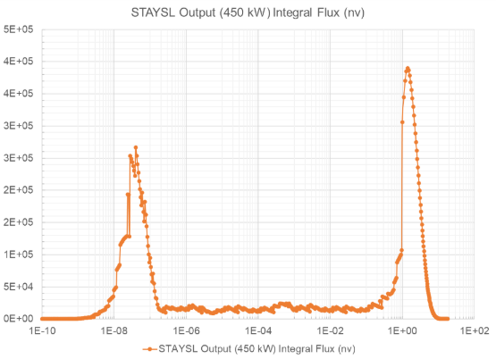
Figure 18: Neutron energy spectrum at the OSURR FBF determined by SAND-II and STAYSL unfolding of Cu, Au, and Ni activation wire measurements. The same spectrum applies to both the Cs$​_{0.1}$FA$​_{0.9}$PbI$​_{3}$ solar-cell neutron experiments described in this chapter and the MHyPbCl$​_{3}$ fast-neutron detection experiments described in Chapter [ch:MHyPbCl3].

Steady-State Reactor Measurements
Table 4.2 summarizes the short-circuit current $I_{SC}$ measured under each condition, referenced to reactor power levels of 0 kW$​_{th}$ (reactor shutdown) and 450 kW$​_{th}$ (operating power).
Steady-state short-circuit current of the Cs$​_{0.1}$FA$​_{0.9}$PbI$​_{3}$ module at OSU NRL FBF. Uncertainties are $±1σ$ over the measurement interval. “Gamma filter closed” and “gamma filter open” refer to the polyethylene/lead shielding assembly that preferentially attenuates the reactor gamma flux while transmitting fast neutrons.
Condition | Reactor Power | $I_{SC}$ (pA)
Background (reactor off) | 0 kW$​_{th}$ | $51.29±6.60$
Background (reactor on) | 450 kW$​_{th}$ | $57.50±7.39$
Gamma filter closed | 450 kW$​_{th}$ | $57.62±7.93$
Gamma filter open | 450 kW$​_{th}$ | $59.77±8.62$
The data in Table 4.2 reveal a slight but statistically marginal increase in $I_{SC}$ upon opening the gamma filter (from $57.62±7.93$ pA to $59.77±8.62$ pA). The difference of $∼$2.2 pA represents a $∼$0.26$σ$ effect relative to the combined quadrature uncertainty, which is not statistically significant at the 95% confidence level. The result is therefore classified as inconclusive: a neutron-induced contribution cannot be ruled out, but the signal-to-noise ratio of a single 8 mm$​^{2}$–63.7 cm$​^{2}$ module is insufficient to resolve it above the fluctuating gamma and ambient backgrounds present at the FBF port.
These results motivate the use of a larger-area array for future neutron sensing experiments. Scaling the active area by a factor of ten to twenty, combined with the differential signal extraction method described by Panaccione et al. [@Panaccione_NIM_2024], is expected to raise the neutron-to-background ratio above the detection threshold.

Chopped-Beam Transient Measurements
In an attempt to resolve a time-modulated neutron signal against the steady-state gamma background, the reactor beam was mechanically chopped at frequencies between 1 Hz and 100 Hz using a borated polyethylene blade. Synchronous detection (lock-in analysis) of the $I_{SC}$ transient was implemented in software. No neutron-induced current component was detected above the noise floor under any chopping frequency in this configuration, consistent with the steady-state analysis: the signal magnitude is simply too small relative to the electronic noise of the current measurement system at the flux levels available from the 450 kW$​_{th}$ reactor at the FBF port.

Summary
This chapter has demonstrated that photovoltaic-architecture Cs$​_{0.1}$FA$​_{0.9}$PbI$​_{3}$ perovskite solar cells can serve as sensitive current-mode monitors for a broad spectrum of ionizing radiation. The key results are as follows.
Temporally, the device bandwidth is limited by the measurement electronics rather than the intrinsic perovskite photoresponse: rise times of 33–84 ns were recorded depending on the amplifier configuration, and the actual carrier lifetime in the film is substantially shorter than the measured system rise time.
Under X-ray irradiation (Amptek Mini-X, up to 50 kV), the module produces a measurable short-circuit current proportional to the beam intensity, with the characteristic slow $I_{SC}$ decline associated with ion-migration field screening under the device’s built-in field [@Thiesbrummel2024ionmig].
Under $​^{137}$Cs gamma irradiation at 44.16 rad hr$​^{−1}$, an induced current density of 2.19 nA cm$​^{−2}$ was measured, and a distinct step response was observed upon insertion and withdrawal. Long-term (six-day) continuous irradiation revealed a linear decline of $∼$0.74 nA rad$​^{−1}$ attributable to cumulative defect creation and glass darkening [@Boldyreva2020gammarad; @Boldyreva2024cs137]. The $​^{60}$Co measurement at 355.61 rad hr$​^{−1}$ yielded 3.56 nA cm$​^{−2}$ and an equivalent linear degradation trend over sixteen days, confirming the scalability of the current-mode detection approach across a dose-rate range spanning nearly an order of magnitude.
Neutron response at the OSU NRL FBF was statistically inconclusive for a single module at 450 kW$​_{th}$; the signal-to-noise analysis indicates that scaling the detector array area by a factor of ten to twenty is necessary to resolve the neutron-induced current above the combined gamma and electronic noise backgrounds.

Perovskite Semiconductor Radiation Detectors
The preceding chapter established that photovoltaic-architecture perovskite thin films can generate measurable current-mode signals in response to X-ray, gamma, and neutron irradiation, exploiting the device’s built-in electric field to sweep radiation-generated carriers to the contacts without any externally applied bias. The present chapter pursues a fundamentally different detection philosophy: deploying halide perovskites as direct-conversion semiconductor radiation detectors in which a large externally applied reverse bias sweeps charge carriers generated by individual radiation interaction events across the device and into a charge-sensitive readout chain. This mode of operation, familiar from conventional compound semiconductor detectors such as CdZnTe (CZT) and CdTe, offers the possibility of pulse-by-pulse energy spectroscopy rather than the integrated current monitoring that characterises the photovoltaic geometry of Chapter 4.
Halide perovskites present a compelling case for direct-conversion detector development. Their heavy-metal cation sublattice, dominated by lead in the systems studied here, provides a high effective atomic number, giving large photoelectric cross sections at gamma and X-ray energies that are difficult or impossible to achieve with silicon or organic semiconductors. Some methylhydrazinium-based compositions additionally incorporate a high density of hydrogen atoms, enabling elastic proton-recoil reactions with fast neutrons that allow direct-conversion neutron detection without requiring a separate conversion layer. Solution-phase crystal growth methods have produced centimetre-scale single crystals with carrier $μτ$ products approaching or exceeding those of polycrystalline CZT, a property critical for efficient charge collection across the millimetre-scale thicknesses required to stop MeV-energy photons and neutrons.
This chapter is organised by device, with each section covering a single detector system from fabrication through characterisation to radiation detection results. Six devices are presented: the MAPbI$​_{3}$-hBN X-ray detector (Section 5.2), the 2D perovskite (PEA$​_{2}$MA$​_{2}$Pb$​_{3}$I$​_{10}$) X-ray detector with 5F-PEAI surface treatment (Section 5.3), the CsPbBr$​_{3}$ gamma-ray detector (Section 5.4), the FAPbBr$​_{3}$ gamma-ray detector (Section 5.5), the MAPbBr$​_{3}$ gamma detector (Section 5.6), and the MHyPbCl$​_{3}$ fast neutron detector (Section 5.7). A cross-device discussion of ion migration, the central performance-limiting mechanism observed across all systems, is presented in Section 5.8, followed by a summary in Section 5.9.

Direct-Conversion Detector Principles
A direct-conversion radiation detector converts the energy deposited by an ionising particle or photon directly into an electrical signal, without an intermediate scintillation step. When a gamma ray, X-ray, or charged particle deposits energy $E$ in a semiconductor detector of bandgap $E_{g}$, approximately $E/W$ electron-hole pairs are created, where $W≈2.8 E_{g}$ is the mean ionisation energy per pair [@knoll2010]. The carriers are swept by an applied electric field to opposite contacts, where they induce a charge pulse on the readout electronics. For spectroscopic operation, this pulse must be faithfully proportional to the deposited energy, a condition that requires complete charge collection and minimal trapping of carriers en route to the contacts.
The probability that a carrier generated at depth $x$ in the crystal (of thickness $d$) reaches the collecting contact is described by the Hecht equation,
$$η=\frac{μτE}{d}\left[1−exp​\left(−\frac{d}{μτE}\right)\right],$$
where $E=V/d$ is the applied electric field, $V$ is the applied voltage, and $μτ$ is the mobility-lifetime product of the dominant carrier species [@Hofstadter1949]. Equation ([eq:hecht]) shows that achieving high collection efficiency $η→1$ requires either a large $μτ$ product or a large applied field, or both. For a 1-mm-thick crystal with $μτ={10}^{−3}$ cm$​^{2}$ V$​^{−1}$, complete collection requires fields of order 10 V $μ$m$​^{−1}$, i.e. applied voltages of order 1 kV. This requirement for large applied voltages is in direct tension with the ion-migration instability described in Section 5.8.
Two additional material requirements govern detector performance. First, the dark resistivity $ρ$ must be sufficiently high that the leakage current $I_{dark}=V​A/(ρd)$ produces an electronic noise contribution smaller than the signal charge from the smallest radiation event of interest. For gamma spectroscopy with CZT-like performance, $ρ>{10}^{9}$ $Ω$ cm is typically required [@Luke1995]. The 3D halide perovskites studied in this work achieve resistivities in the range ${10}^{9}$–${10}^{12}$ $Ω$ cm in their highest-quality single-crystal forms, competitive with or exceeding that of polycrystalline CZT. Second, the crystal must be thick enough to stop a significant fraction of the incident radiation. The mean free path of a 662-keV gamma ray (the primary emission of $​^{137}$Cs) in CsPbBr$​_{3}$ is approximately 7 mm, meaning that crystals of order 5–10 mm are required for reasonable detection efficiency.
For fast neutron detection, the governing interaction is elastic proton recoil: a fast neutron of kinetic energy $E_{n}$ collides with a hydrogen nucleus, transferring up to $E_{n}$ of kinetic energy to the recoil proton in a head-on collision. The recoil proton then deposits its energy densely in the crystal volume. The detection efficiency of a hydrogenous material is therefore proportional to its hydrogen atom density $n_{H}$. Table 5.1 compares $n_{H}$ for the key materials considered in this work.
Hydrogen atom density comparison for selected fast neutron detector materials.
Material | Formula | Density (g cm$​^{−3}$) | $n_{H}$ (cm$​^{−3}$)
Stilbene | C$​_{14}$H$​_{12}$ | 1.16 | $5.67×{10}^{22}$
Rubrene | C$​_{42}$H$​_{28}$ | 1.27 | $3.62×{10}^{22}$
EJ-276 plastic | C$​_{n}$H$​_{m}$ | 1.02 | $4.82×{10}^{22}$
MHyPbCl$​_{3}$ | CH$​_{6}$N$​_{2}$PbCl$​_{3}$ | 3.25 | $∼4.0×{10}^{22}$

MAPbI$​_{3}$-hBN X-Ray Detector
The MAPbI$​_{3}$-hBN device was the primary polycrystalline X-ray detector fabricated and characterised in this work. Its chief contribution is establishing the role of atmospheric humidity in limiting perovskite detector performance under applied bias, and demonstrating that vacuum operation partially restores intrinsic carrier transport.

Material and Device Fabrication
MAPbI$​_{3}$ (methylammonium lead triiodide) doped with hexagonal boron nitride (hBN) was used as the X-ray absorber medium. The hBN inclusions were incorporated to improve grain boundary passivation and reduce the density of deep-level trap states that would otherwise act as recombination centres for radiation-generated carriers. The contact architecture was asymmetric, with the hBN/MAPbI$​_{3}$ layer sandwiched between contacts of differing work function. This asymmetry creates a built-in potential that enables a photovoltaic-like X-ray response even at zero applied bias, as demonstrated below.
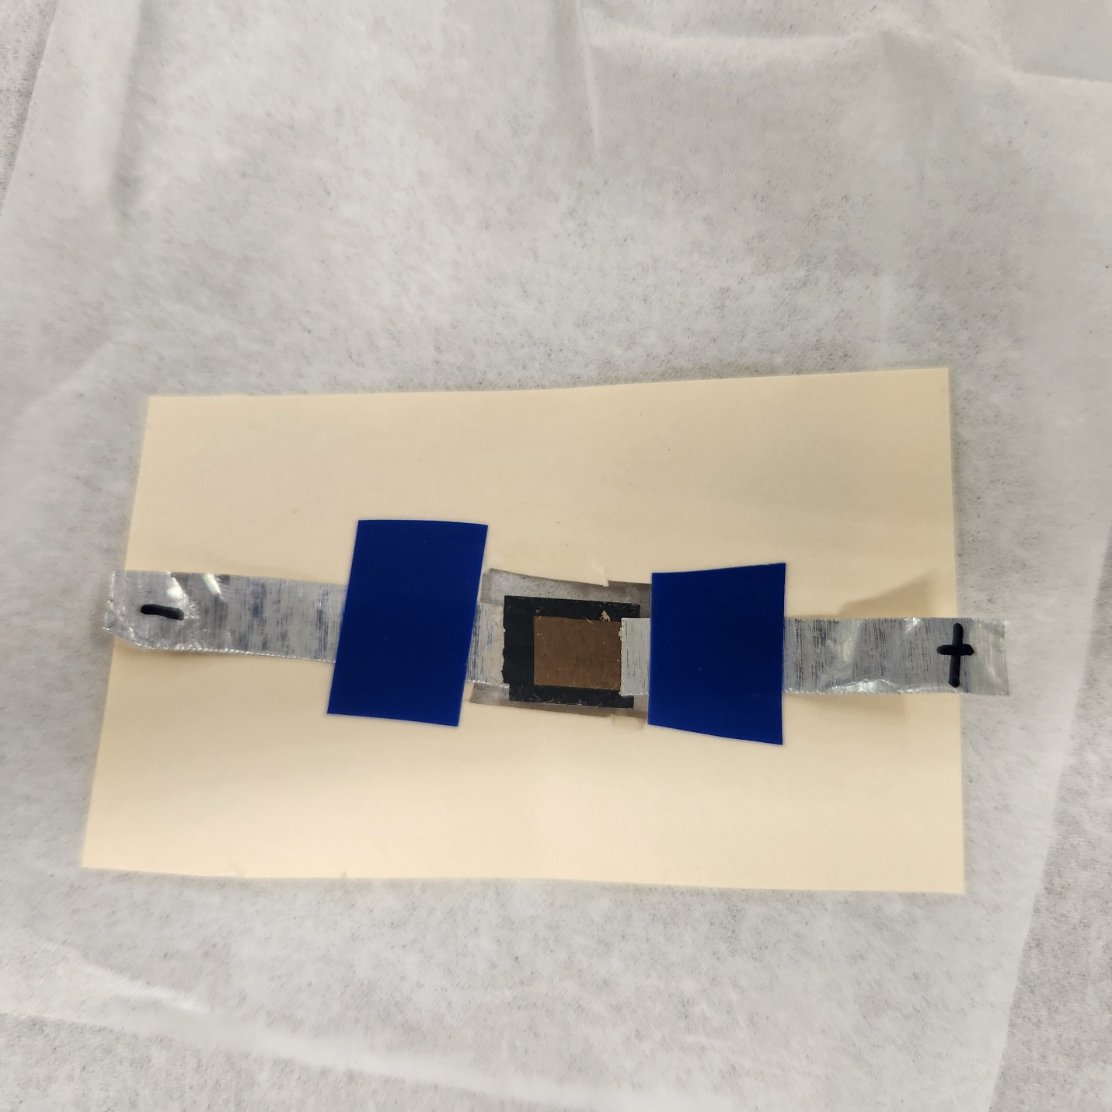
Figure 19: MAPbI$​_{3}$-hBN X-ray detector mounted for electrical testing.

Electrical Characterisation
Current-voltage (IV) characteristics were measured using a Keithley 2612A SourceMeter, with sweep protocols covering $±$2 V for contact resistance extraction up to high-voltage unipolar sweeps (0 to $−200$ V) for leakage characterisation under detector operating conditions. All sweeps were performed in a light-tight enclosure to prevent photogenerated carrier contributions. IV hysteresis measurements at 20 mV s$​^{−1}$ served as a diagnostic for ion-migration-driven charge redistribution; the MAPbI$​_{3}$-hBN device exhibited a measurable sweep-versus-hold difference in the low-voltage regime, indicative of a slow ionic relaxation polarisation effect consistent with field-driven amplification of the ion-migration rate.

X-Ray Sensitivity Measurements
X-ray characterisation was performed using a benchtop X-ray tube operated at 30–50 kVp, collimated to a conical beam with an $∼$2 cm exit aperture. The photocurrent was measured as a function of applied bias with the X-ray beam switched on and off periodically to distinguish the radiation-induced signal from the dark-current baseline. X-ray sensitivity $S$ is defined as
$$S=\frac{ΔI}{A⋅\dot{D}},$$
where $ΔI$ is the X-ray-induced change in current, $A$ is the active contact area, and $\dot{D}$ is the calibrated dose rate. The dose rate was calibrated using a RaySafe 452 dosimeter; however, the conical beam geometry caused dose-rate variation across the dosimeter face, leading to underestimation of the dose rate incident on the small perovskite contact area. NanoDot optically stimulated luminescence (OSL) dosimeters were identified as a more appropriate calibration tool for subsequent experiments.
Sensitivity increased monotonically with applied bias: $0.107 μ$C (Gy cm$​^{2}$)$​^{−1}$ at 5 V, $0.245 μ$C (Gy cm$​^{2}$)$​^{−1}$ at 10 V (confirmed by repeat measurement at $0.252 μ$C (Gy cm$​^{2}$)$​^{−1}$), and $0.411 μ$C (Gy cm$​^{2}$)$​^{−1}$ at 20 V. The sub-linear voltage dependence, a factor of $∼$3.8 sensitivity gain for a factor-of-four voltage increase, indicates the device had not yet entered the charge-collection saturation regime at 20 V.
X-ray sensitivity of the MAPbI$​_{3}$-hBN detector as a function of applied bias.
Applied Bias (V) | Sensitivity ($μ$C (Gy cm$​^{2}$)$​^{−1}$) | Notes
5 | 0.107
10 | 0.245 | First measurement
10 | 0.252 | Repeat, confirms reproducibility
20 | 0.411
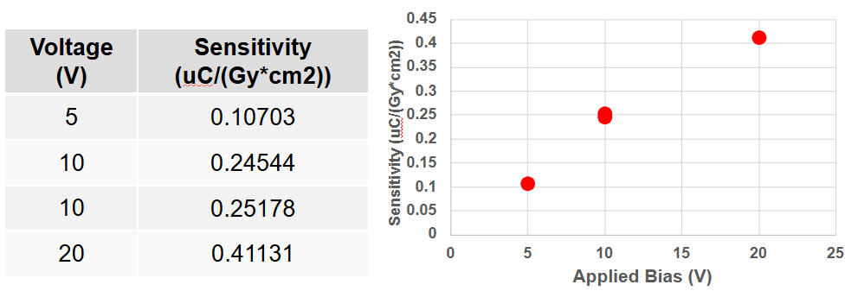
Figure 20: X-ray sensitivity of the MAPbI$​_{3}$-hBN detector as a function of applied reverse bias.
A bi-polar X-ray response was observed at zero applied bias in some device configurations: a spontaneous photovoltaic-like current transient was generated by X-ray exposure without any external voltage. This is attributed to the asymmetric contact architecture creating a built-in potential difference between the hBN/MAPbI$​_{3}$ and Au contact interfaces, which sweeps radiation-generated carriers toward the respective contacts even in the absence of applied bias.

Vacuum Testing and Humidity Effects
To directly evaluate the role of atmospheric humidity, X-ray sensitivity measurements were repeated under vacuum (base pressure $<{10}^{−3}$ Torr) and compared to measurements in ambient laboratory air at matched bias voltages of 5, 10, and 20 V. In every case, the X-ray-induced current was larger and more stable under vacuum, and the dark-current baseline was lower. These improvements are consistent with suppression of moisture-accelerated ion migration: water molecules at grain boundaries facilitate halide vacancy diffusion under the applied field, creating shunting pathways and reducing the effective bulk field. Removing ambient moisture under vacuum disrupts this pathway and partially restores intrinsic carrier transport.
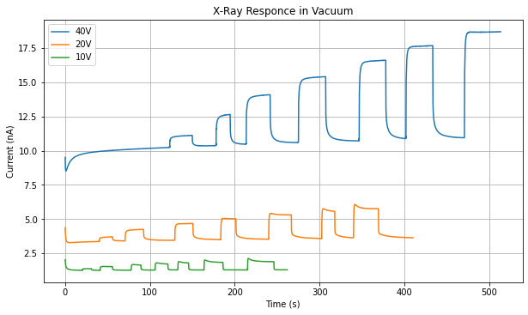
Figure 21: X-ray current transients for the MAPbI$​_{3}$-hBN device at 5, 10, and 20 V bias in ambient air and under vacuum.

Alpha Spectroscopy Under Vacuum
Alpha particles deposit their energy very densely within a few micrometres of the crystal surface and generate a correspondingly large number of electron-hole pairs, for a 5.49-MeV alpha from Am-241 and $W≈2.8 E_{g}≈8$ eV per pair in MAPbI$​_{3}$, approximately $6.8×{10}^{5}$ carriers are generated per event, roughly three orders of magnitude more than a single 662-keV gamma interaction. Despite this large signal charge, alpha spectroscopy had not been attempted with halide perovskite detectors at the time of this work because vacuum operation, which is required to position a source in close proximity without air attenuation of the short-range alpha particles, was known to increase the leakage current of perovskite devices, rendering pulse-height analysis impractical. The physical origin of this vacuum-induced leakage increase is not well established; proposed explanations include a reduction in surface resistance as adsorbed surface species are removed under evacuation, and electrical disturbances arising from outgassing of volatile components from the perovskite film.
The MAPbI$​_{3}$-hBN device was anomalous in this respect: under vacuum (base pressure $<{10}^{−3}$ Torr), the leakage current decreased rather than increased, yielding a stable, low dark current baseline over extended bias hold periods. This behaviour distinguished the device from other perovskite systems tested in this programme and made alpha spectroscopy feasible for the first time. With the noise floor below the alpha signal level, a resolvable Am-241 spectrum was obtained, shown in Figure 5.4.
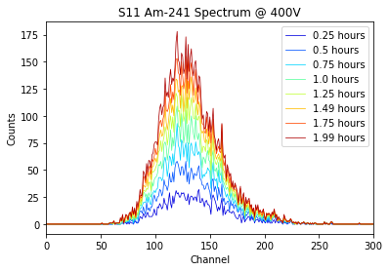
Figure 22: Am-241 spectrum and device stability data for the MAPbI$​_{3}$-hBN detector under vacuum operation.
The broader significance of this result was subsequently confirmed by independent groups. Zhang et al. reported high-resolution alpha particle spectroscopy with a CsPbBr$​_{3}$ single-crystal detector, achieving an energy resolution of 6.9% with commercial electronics and 1.1% with a full-custom readout ASIC designed to minimise parasitic capacitance and electronic noise [@Zhang2024alpha]. That work achieved stable low leakage in ambient conditions through crystal surface thinning to remove the high-concentration CsPb$​_{2}$Br$​_{5}$ phase combined with a Schottky electrode geometry, enabling a dark current of 34.6 nA cm$​^{−2}$ at 200 V without vacuum enclosure.
Despite these improvements, the MAPbI$​_{3}$-hBN device failed irreversibly after approximately five hours of continuous operation at 400 V applied bias. Post-failure inspection showed the device could no longer sustain any significant reverse bias, consistent with the formation of a low-resistance shunting pathway through the crystal bulk. This failure mode is attributed to catastrophic redistribution of ionic species under the large field: as mobile iodide vacancies accumulate at the electrode interfaces, the local electric field increases dramatically, eventually driving decomposition of the perovskite lattice into its constituent binary and ternary phases. Vacuum operation delays but does not eliminate this failure mode.

Charge Trapping and Sensitivity Degradation
A more gradual form of sensitivity degradation, distinct from the acute failure at 400 V, was observed under continuous X-ray exposure at moderate bias. During prolonged irradiation at $−50$ V, the X-ray-induced current decreased monotonically over several minutes even though the incident X-ray flux was constant. A comparable decay was recorded at $+50$ V.
The trapping phenomenon is attributed to progressive filling of mid-gap trap states within the crystal. Carriers trapped at these sites are immobilised and cannot contribute to measured current; additionally, the trapped charge builds an opposing space-charge field that reduces the net electric field for subsequently generated carriers. Trapping occurs on a timescale of seconds to minutes (governed by trap capture cross sections), whereas ion migration proceeds on timescales of tens of minutes to hours (governed by ionic diffusivity). The distinction has implications for mitigation: trap-state filling can be reversed by briefly grounding the device to allow trapped carriers to recombine or detrap thermally, whereas ionic redistribution requires extended equilibration and may in extreme cases represent permanent structural damage.

Discussion
The absolute sensitivity values of the MAPbI$​_{3}$-hBN device, of order ${10}^{−1}$ $μ$C (Gy cm$​^{2}$)$​^{−1}$ at modest bias voltages, are substantially below those of optimised 2D perovskite thin-film detectors (Section 5.3), reflecting the thick absorber geometry rather than any intrinsic material limitation. This device establishes two critical findings: first, that sensitivity follows the Hecht equation field dependence, confirming charge collection, not absorption, is the performance-limiting factor at these bias levels; and second, that vacuum operation demonstrably suppresses the moisture-accelerated degradation pathway, directly motivating the 5F-PEAI surface treatment strategy demonstrated in the next section.

2D Perovskite (PEA$​_{2}$MA$​_{2}$Pb$​_{3}$I$​_{10}$) X-Ray Detector with 5F-PEAI Surface Treatment
The voltage-induced instability observed in the MAPbI$​_{3}$-hBN device is a general challenge for all perovskite direct-conversion detectors requiring sustained reverse bias. To address this in polycrystalline thin-film detectors, Tsai et al. developed a fluorinated surface treatment strategy [@Tsai2022ionmig], with the present author contributing to device fabrication and X-ray characterisation. This section presents that work in full as it directly motivates the mitigation strategies discussed in Section 5.8.

Device Structure and Material Characterisation
The 2D perovskite detector employed a p–i–n diode architecture. The p-type contact was poly[bis(4-phenyl)(2,4,6-trimethylphenyl) amine] (PTAA) and the n-type contact was a fullerene (60 nm) / bathocuproine BCP (10 nm) bilayer, completed with a gold top contact without additional encapsulation. The intrinsic perovskite layer targeted a PEA$​_{2}$MA$​_{2}$Pb$​_{3}$I$​_{10}$ composition (PEA = phenylethylammonium). Cross-sectional SEM showed a continuous, compact film approximately 9 $μ$m thick, with large crystal grains extending through most of the film thickness and a more disordered, smaller-crystallite structure near the surface. Synchrotron GIWAXS confirmed high crystallinity with strong discrete Bragg spots and weak Debye–Scherrer rings from the surface-near disordered layer.

Humidity-Dependent Instability
Devices were tested at controlled relative humidity (RH) of 0%, 20%, and 40% in a sealed chamber. At 0% RH, devices exhibited no measurable I–V hysteresis and remained stable to voltages beyond $−15$ V. As RH was raised to 40%, hysteresis became pronounced and breakdown voltage fell dramatically: devices failed irreversibly between $−8$ and $−10$ V, versus more than twice that at 0% RH. Dark current measurements at $−5$ V in 40% RH air showed device failure within two to three minutes. The combination of reverse bias and humidity was identified as the critical driver of failure, moisture alone was insufficient to cause instantaneous breakdown.

5F-PEAI Surface Treatment and Results
A fluorinated phenylethylammonium iodide (5F-PEAI) barrier layer was applied to the perovskite surface, replacing all five hydrogen atoms on the PEAI phenyl ring with fluorine. This increased the water contact angle from 66.1$​^{∘}$ to 76.0$​^{∘}$ ($≈$15%), confirming enhanced hydrophobicity. At the optimal concentration of 4 mg mL$​^{−1}$, 5F-PEAI penetrated grain boundaries and stabilised the device to $−16$ V in 40% RH, compared to $−10$ V for the untreated device. ToF-SIMS fluorine mapping confirmed grain boundary penetration at the higher concentration.
DFT calculations revealed the mechanism: the PEA surface has a water penetration activation energy of only $∼$5 meV, far below room-temperature thermal energy, whereas the fluorinated 5F-PEA surface raises this barrier to $∼$120 meV, with strong electrostatic repulsion from electronegative fluorine atoms preventing moisture ingress.

X-Ray Detection Performance
EQE measurements showed that 5F-PEAI-coated devices reached 50% at $−10$ V reverse bias, compared to 30% saturation for the uncoated device. X-ray sensitivity at 4 V bias reached an average of $862.5 μ$C (Gy$​_{air}$ cm$​^{2}$)$​^{−1}$ (vs. $726.2 μ$C (Gy$​_{air}$ cm$​^{2}$)$​^{−1}$ for the reference), with a maximum of $996.3 μ$C (Gy$​_{air}$ cm$​^{2}$)$​^{−1}$, among the highest reported for polycrystalline perovskite detectors of comparable absorber thickness.

Discussion
The sensitivity values of the 5F-PEAI-treated 2D detector ($∼$${10}^{3}$ $μ$C (Gy$​_{air}$ cm$​^{2}$)$​^{−1}$) exceed those of the MAPbI$​_{3}$-hBN device ($∼$${10}^{−1}$ $μ$C) by three to four orders of magnitude, reflecting device geometry differences rather than intrinsic material quality. The 5F-PEAI surface treatment demonstrates a clear pathway for stabilising polycrystalline perovskite detectors against moisture-accelerated breakdown. Extending this passivation strategy to the 3D single crystal systems used for gamma-ray and neutron detection is identified as a high-priority direction for future work.

CsPbBr$​_{3}$ Gamma-Ray Detector
CsPbBr$​_{3}$ was the first bromide perovskite single crystal evaluated as a gamma-ray spectrometer in this work. Its wide bandgap ($∼$2.3 eV), large effective atomic number, and high reported resistivity made it a natural candidate for high-voltage spectroscopy. In practice, the device was significantly limited by large, unstable leakage current at the operating bias required for reasonable charge collection.

Crystal Preparation and Contact Fabrication
CsPbBr$​_{3}$ single crystals were grown externally and received by the research group. Crystals judged free of macroscopic defects were mechanically planarised using silicon carbide abrasive paper, then sequentially polished with diamond polishing paste to a 10-nm surface finish. A hexane bath rinse was performed between each polishing stage to remove residual abrasive particles. One CsPbBr$​_{3}$ crystal sustained internal cracking from an accidental drop during handling; while it remained electrically functional, the crack likely introduced additional carrier trapping sites and reduced the geometric detection efficiency.
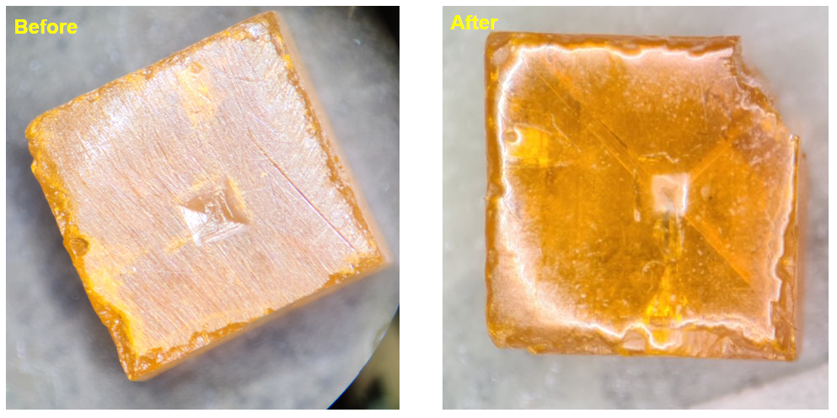
Figure 23: CsPbBr$​_{3}$ crystal during mechanical polishing preparation.
The Schottky contact architecture, common to CsPbBr$​_{3}$, MAPbBr$​_{3}$, and FAPbBr$​_{3}$, is shown schematically in Figure 5.7. The final device design, which produced the best spectroscopic results with the FAPbBr$​_{3}$ crystal, used gold as the pixelated contact and Ti/Ni as a continuous back-face contact. A 2$×$2 array of 1.25-mm-diameter gold pixel contacts surrounded by an integrated guard ring was deposited through a drilled aluminium shadow mask using a Denton sputter coater. On the opposite crystal face, a continuous Ti/Ni bilayer was deposited using an AJA Orion RF/DC sputter system: Ti was deposited at 450 W ($≈$1.15 Å s$​^{−1}$) followed immediately by a 10-nm Ni passivating overlayer at 250 W ($≈$2.1 Å s$​^{−1}$) across the full crystal face. Pixel contacts were wired via Cu leads bonded with silver epoxy.
The necessity of the Ni overlayer was established empirically during early contact deposition trials, in which Ti was deposited without any capping layer. Upon venting the deposition chamber to atmosphere, the bare Ti films were observed to delaminate from the crystal surface in a characteristic rolled pattern, visible in Figure 5.6. The root cause is the oxidation of Ti upon air exposure: as the surface of the Ti film converts to TiO$​_{x}$, the crystallographic lattice mismatch between the oxide and the underlying metallic Ti generates a large in-plane compressive stress. This biaxial stress causes the film to buckle and curl away from the perovskite surface, producing the “swiss-roll” delamination morphology observed. The problem was fully resolved by depositing the 10-nm Ni capping layer immediately after Ti, before venting, which prevents atmospheric oxygen from reaching the Ti surface and thereby eliminates the oxidation-driven stress. No delamination was observed on any device fabricated with the Ti/Ni bilayer contact.
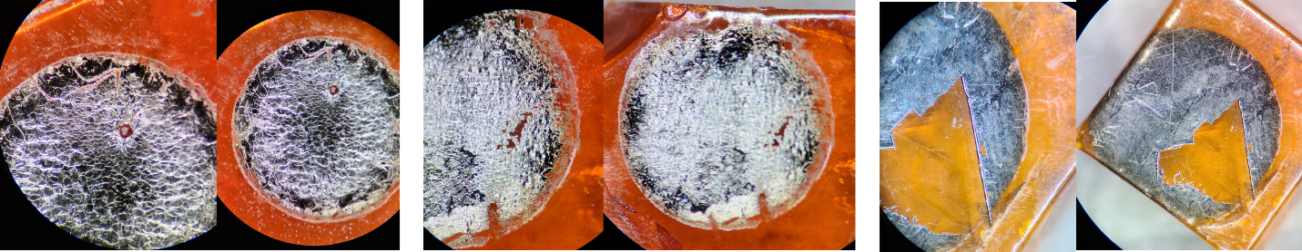
Figure 24: Ti contact delamination on (a, b) FAPbBr$​_{3}$ and (c) CsPbBr$​_{3}$ crystal faces following deposition without a Ni capping layer.
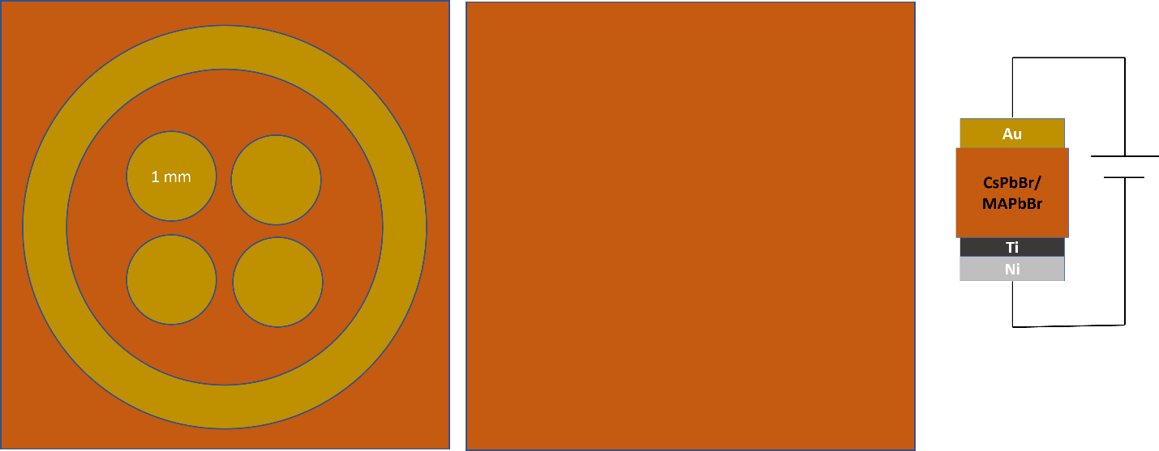
Figure 25: Contact architecture for bromide perovskite gamma-ray detectors showing the Au pixel array with guard ring (left), continuous Ti/Ni back face (centre), and device layer stack (right).

Gamma Spectroscopy Setup
Gamma-ray spectroscopy used a $​^{137}$Cs source (662 keV) and a $​^{57}$Co source (14, 122, 136 keV). The readout chain consisted of a CAEN A1422 charge-sensitive preamplifier connected directly to the pixel contacts, and a CAEN N6724 Digitizer 16-bit ADC (16,384 channels). The 10-$μ$s shaping time minimises ballistic deficit. Digitiser settings: threshold 15 channels, trigger hold-off 1500 ns, input rise time 1200 ns, trapezoid rise time 8 $μ$s, trapezoid flat-top 5 $μ$s, energy fine gain 10. The mean free path of a 662-keV photon in CsPbBr$​_{3}$ ($Z_{eff}≈45$, $ρ≈4.5$ g cm$​^{−3}$) is approximately 7 mm; with crystal thicknesses of 2–3 mm, fewer than 50% of photons interact, so geometric detection efficiency was inherently low.

Electrical Characterisation
The CsPbBr$​_{3}$ device exhibited a working leakage current of 315–710 nA at 1000 V reverse bias. This current overshot its quasi-steady-state value immediately after the voltage step, then decayed gradually over 45 minutes to one hour, consistent with rapid redistribution of mobile halide vacancies followed by slower re-equilibration of the resulting space-charge distribution.

Gamma Spectroscopy Results
The CsPbBr$​_{3}$ detector was operated at 1000 V reverse bias for $​^{137}$Cs measurements. The source count rate was 17.45 counts s$​^{−1}$ against a background of 9.11 counts s$​^{−1}$, a statistically significant response to the 662-keV source. However, no resolvable photopeak at the expected 662-keV channel position was observed. The spectrum displayed a broad continuum at low channels, consistent with incomplete charge collection, and a spurious artefact near channel 16,382 (the ADC maximum), attributed to ADC saturation from large ion-migration-induced current transients. A Geant4 Monte Carlo simulation of the crystal geometry confirmed the features expected for a small-volume Compton spectrometer.
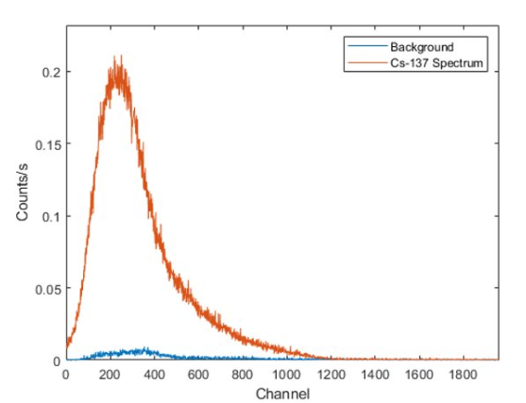
Figure 26: CsPbBr$​_{3}$ pulse-height spectrum acquired at 1000 V reverse bias with a $​^{137}$Cs source.

Discussion
The resolution-limiting factor was the large, unstable leakage current, not the intrinsic charge transport properties of CsPbBr$​_{3}$. At 1000 V, the RMS noise generated by 315–710 nA of leakage current is far larger than the $∼$0.4 pC signal charge from a single 662-keV gamma photon, rendering spectroscopic pulse resolution impossible during the transient stabilisation period. Reducing leakage is therefore the primary engineering challenge, achievable through improved Schottky barrier quality (lower sputter power, better vacuum) and contact passivation to prevent the Ti-Br$​^{−}$ chemical reaction documented in Section 5.8.1.

FAPbBr$​_{3}$ Gamma-Ray Detector
The FAPbBr$​_{3}$ single-crystal detector represented the most successful gamma spectrometer achieved in this work. It demonstrated substantially lower leakage current and greater electrical stability than CsPbBr$​_{3}$, ultimately producing spectral features attributable to both $​^{137}$Cs and $​^{57}$Co, a proof-of-concept demonstration of gamma spectroscopy in a solution-grown halide perovskite crystal.

Crystal Preparation and Contact Fabrication
FAPbBr$​_{3}$ single crystals (FA = HC(NH$​_{2}$)$​_{2}^{+}$) were grown externally and received by the research group. Crystals were inspected, mechanically planarised, and polished to a 10-nm surface finish using the standard hexane-rinsed diamond polishing protocol. One FAPbBr$​_{3}$ crystal cracked during polishing and was excluded from electrical testing. The crystal used in spectroscopy had a thickness of 2.35 mm and contact area of $5.2×6.15$ mm$​^{2}$. Contact architecture followed the same Schottky geometry as CsPbBr$​_{3}$ (Figure 5.7).
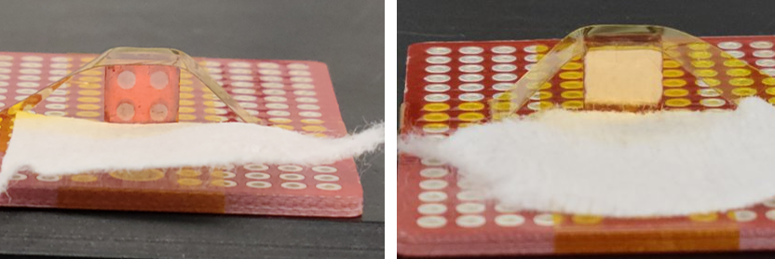
Figure 27: Mounted FAPbBr$​_{3}$ pixelated Schottky detector with copper wire leads bonded to each pixel contact.

Electrical Characterisation
IV sweeps from $−20$ to $+20$ V and $−200$ to $+200$ V confirmed acceptable Schottky behaviour. A bias stability test at $−200$ V over six hours showed leakage reaching a pseudo-steady-state with a maximum of $5±2.5$ nA, approximately 60$×$ lower than the CsPbBr$​_{3}$ leakage at comparable bias, attributable to a better Schottky barrier quality on this crystal. The device showed no signs of electrical instability over more than five hours of sustained high-voltage testing.

Gamma Spectroscopy Results
Spectroscopic measurements with $​^{137}$Cs were performed from 700 V upward. At 700 V, the spectrum showed a broad peak feature centred near the expected 662-keV channel position, with a count rate of $∼$17.45 counts s$​^{−1}$ above a background of 9.11 counts s$​^{−1}$.
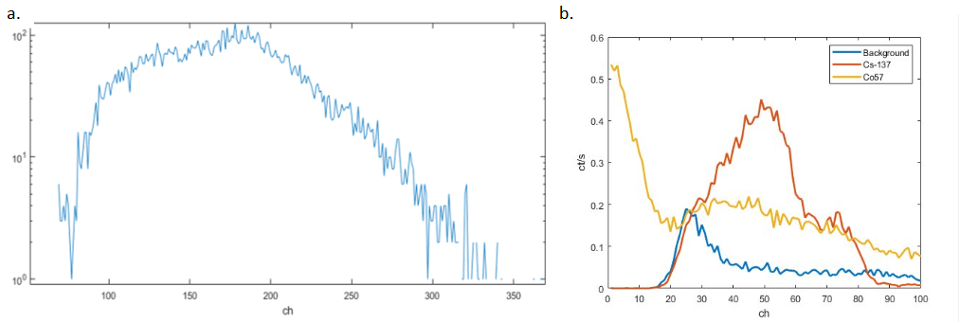
Figure 28: FAPbBr$​_{3}$ pulse-height spectra at (a) 700 V with $​^{137}$Cs and (b) 1600 V with $​^{137}$Cs, $​^{57}$Co, and background overlaid.
At 1600 V bias, a simultaneous acquisition with both $​^{137}$Cs (5 $μ$Ci, 662 keV) and $​^{57}$Co (100 $μ$Ci, 122 keV) produced a spectrum in which two distinct features could be identified at channel positions consistent with the expected photon energies, calibrated against a reference CZT detector. Count rates: 9.11 counts s$​^{−1}$ (background), 17.45 counts s$​^{−1}$ ($​^{137}$Cs), 26.60 counts s$​^{−1}$ ($​^{57}$Co), reflecting the higher specific activity of the $​^{57}$Co source.
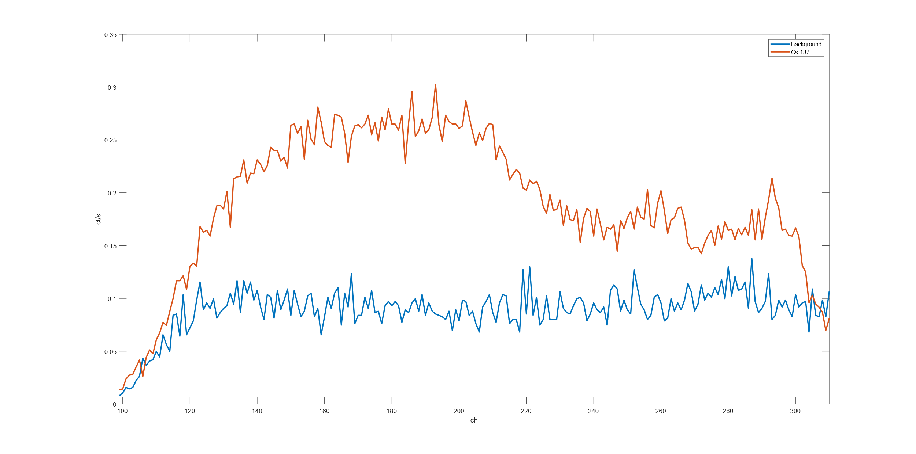
Figure 29: $​^{137}$Cs pulse-height spectrum from the pixelated FAPbBr$​_{3}$ device at 1800 V (zoomed view).
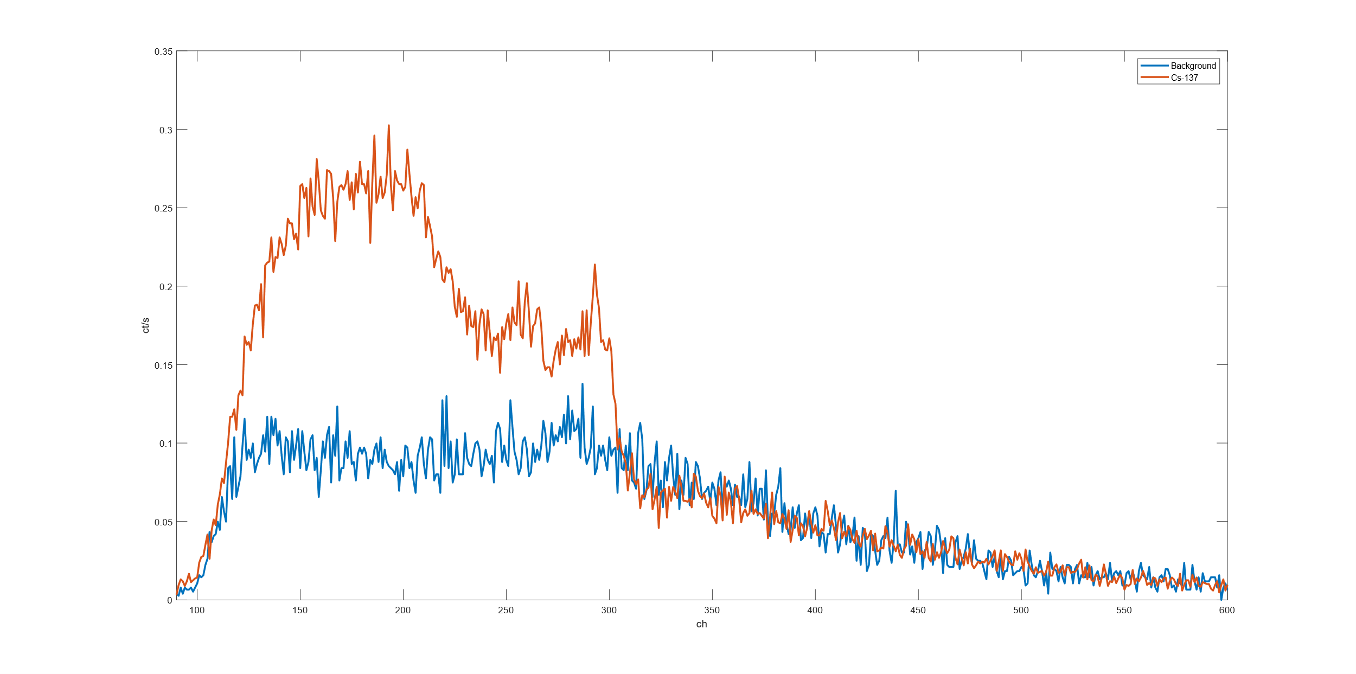
Figure 30: $​^{137}$Cs pulse-height spectrum from the pixelated FAPbBr$​_{3}$ device at 1800 V (full view).

Discussion
The FAPbBr$​_{3}$ results constitute a proof-of-concept demonstration of gamma spectroscopy in a solution-grown halide perovskite crystal. However, energy resolution remains far below that required for isotope identification in practical nuclear security applications. Resolution is limited by: residual leakage-current noise even at 5 nA; incomplete charge collection from carrier trapping analogous to that described in Section 5.2.6; and ion migration-induced fluctuations in the internal electric field during acquisition, causing effective detector gain to drift and broaden spectral features.
The superior performance of FAPbBr$​_{3}$ relative to CsPbBr$​_{3}$ under high-voltage operation is consistent with literature reports that FA-based perovskites exhibit reduced ion migration rates compared to Cs-based compositions [@Yuan2016ionmig]: the larger FA$​^{+}$ cation creates a more tightly packed lattice with fewer pathways for halide vacancy migration.

MAPbBr$​_{3}$ Gamma-Ray Detector
MAPbBr$​_{3}$ (methylammonium lead tribromide) single crystals were processed through the same Au-pixel / Ti/Ni back-face contact fabrication protocol as CsPbBr$​_{3}$ and FAPbBr$​_{3}$ and were electrically functional. However, no resolved gamma photopeak was obtained from any MAPbBr$​_{3}$ crystal tested, and no spectroscopic data are presented for this material. This section explains why, as the limiting factors are instructive for understanding the broader requirements for photopeak development in perovskite gamma detectors.

Crystal Preparation
MAPbBr$​_{3}$ single crystals were grown externally and received by the research group. Each crystal was inspected under optical magnification, mechanically planarised using silicon carbide abrasive paper, and polished with diamond polishing paste to a 10-nm surface finish with hexane-bath rinses between stages. Contacts were deposited using the Au-pixel / Ti/Ni back-face protocol described in Section 5.4.1, which produced adhered, non-delaminated contacts on all MAPbBr$​_{3}$ crystals processed.
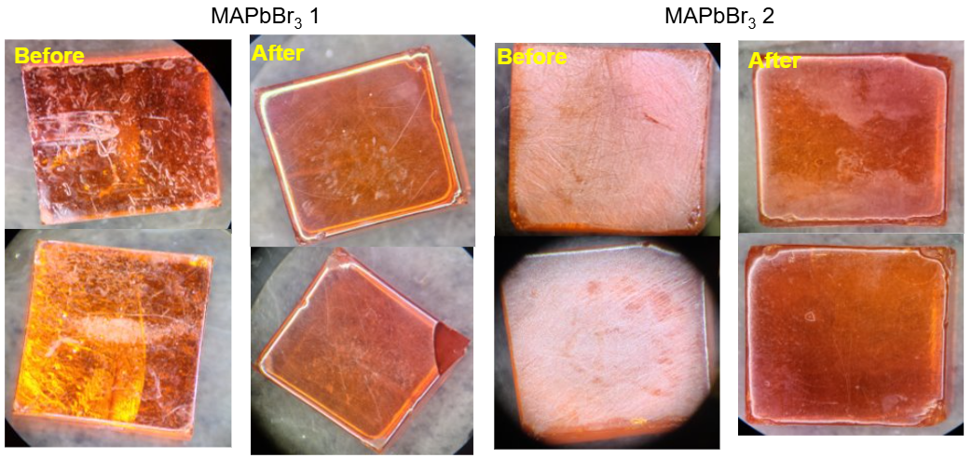
Figure 31: MAPbBr$​_{3}$ crystal during mechanical polishing preparation.

Ion Migration Pulses and the Low-$μτ$ Spectral Background
Even with functional contacts, it is unlikely that the MAPbBr$​_{3}$ crystals available in this work would have yielded resolved gamma photopeaks. The limiting factor is crystal quality, which directly determines the $μτ$ product and therefore the detector’s ability to convert a gamma interaction into a resolvable pulse.
In a crystal with a low $μτ$ product, carriers generated by a gamma interaction are captured by deep trap states before they can traverse the full thickness of the device. The resulting pulse height is reduced and varies with interaction depth, since carriers generated far from the collecting contact must drift further and are more likely to be trapped before arrival. The pulse-height spectrum from such a device is not a sharp photopeak at the full interaction energy but instead a broad Compton continuum extending from zero up to some fraction of the full energy, with no distinguishable photopeak structure, qualitatively identical to the spectrum observed for CsPbBr$​_{3}$ at moderate bias voltages (Section 5.4.4).
At higher applied bias a second and more pernicious effect emerges: ion migration events generate their own large transient current pulses that are registered by the charge-sensitive preamplifier and MCA chain as apparent radiation events. When mobile halide vacancies redistribute under the applied field, they produce sudden changes in the space-charge distribution near the contacts, inducing charge transients on the preamplifier input that can be orders of magnitude larger than the $∼$0.1–0.4 pC signal from a genuine 662-keV gamma interaction. These ion migration pulses are not correlated with any radiation interaction event; they arise purely from ionic motion within the crystal. In the pulse-height spectrum they appear as a large, structureless background at high channel numbers, effectively burying any genuine gamma signal beneath an elevated and irreproducible baseline. This effect was directly observed in the CsPbBr$​_{3}$ device, where the anomalous artefact near channel 16,382 of the ADC (Section 5.4.4) is a manifestation of exactly this mechanism: large ion migration-driven current transients saturating the ADC input.
The practical consequence is that photopeak development in perovskite gamma detectors requires the simultaneous satisfaction of two conditions: a $μτ$ product large enough that radiation-generated carriers can traverse the full crystal thickness before being trapped ($μτE/d≳1$ in the notation of Equation [eq:hecht]), and an ion migration rate low enough that ionic transient pulses do not dominate the acquired spectrum. For the bromide perovskites examined in this work, FAPbBr$​_{3}$ came closest to meeting both conditions, owing to its relatively stable leakage current and the reduced ion migration rate associated with the FA$​^{+}$ sublattice. The MAPbBr$​_{3}$ crystals, by contrast, did not exhibit sufficient crystal purity to clear either threshold. Improving crystal quality, specifically reducing halide vacancy concentrations through controlled stoichiometry and inert-atmosphere growth, is therefore a prerequisite for photopeak development in future MAPbBr$​_{3}$ devices.

MHyPbCl$​_{3}$ Fast Neutron Detector
MHyPbCl$​_{3}$ (methylhydrazinium lead trichloride) represents the first organic-metal halide perovskite semiconductor evaluated as a direct-conversion fast neutron detector. The device uniquely combines a high hydrogen density comparable to conventional organic scintillators with the electrical properties of a high-resistivity semiconductor, enabling direct charge-collection detection of recoil proton pulses without a separate converter layer.

Motivation and Material Selection
Fast neutron detection is challenging because neutrons carry no charge and cannot interact directly with the electron clouds that govern detector response. Instead, fast neutrons are detected via secondary charged particles, predominantly recoil protons, produced in elastic scattering collisions with hydrogen nuclei ($​^{1}$H($n$,$n$)$​^{1}$H). Detection efficiency is proportional to the material’s hydrogen number density $n_{H}$, which for conventional hydrogenous semiconductors is typically far too low to compete with hydrogen-rich organic scintillators such as stilbene or EJ-276 plastic.
MHyPbCl$​_{3}$ was identified as a candidate because its methylhydrazinium cation (CH$​_{3}$NH$​_{2}$NH$​_{2}^{+}$) contributes a substantial number of hydrogen atoms per formula unit, giving a calculated $n_{H}≈4.0×{10}^{22}$ cm$​^{−3}$ (Table 5.1), comparable to stilbene. Crucially, the material also exhibits high resistivity and a large $μτ$ product, making it suitable for direct charge-collection detection of recoil proton pulses. An important complication is the presence of lead ($Z=82$), a highly efficient photon absorber, which creates a significant neutron-gamma discrimination challenge in mixed radiation fields such as those produced by a research reactor [@Panaccione_NIM_2024].

Crystal Synthesis and Device Fabrication
Methylhydrazinium chloride (MHyCl) was synthesised as the organic precursor salt: 2.63 mL (50 mmol) of methylhydrazine was diluted with 5 mL anhydrous IPA, and 100 mL of 0.5 M HCl solution was added without stirring. White plate crystals of MHyCl precipitated spontaneously after overnight storage in inert atmosphere at room temperature. The crystals were filtered, washed with cold IPA, and dried under vacuum, yielding 3.10 g ($∼$38%).
MHyPbCl$​_{3}$ single crystals were grown by anti-solvent assisted crystallisation: 2 mmol each of MHyCl and PbCl$​_{2}$ dissolved in 5 mL DMF / 1 mL DMSO, stirred for 3 h, then filtered through a 0.22-$μ$m syringe filter. The solution was transferred to a 20-mL vial placed inside a 100-mL bottle containing 15 mL toluene as anti-solvent and sealed in a glovebox. After one week at room temperature, clear hexagonal MHyPbCl$​_{3}$ crystals formed and were harvested, dried under vacuum, and surface-polished immediately prior to electrode deposition.
An ohmic-ohmic contact configuration was adopted. The lower crystal face received a 30-nm C$​_{60}$ / 6-nm BCP electron-transport bilayer, followed by an 80-nm Cu contact. The upper face received a 50-nm Au contact deposited by thermal evaporation. The C$​_{60}$/BCP bilayer serves simultaneously as an electron-selective interlayer and interface-state buffer at the Cu-perovskite junction. IV characterisation confirmed ohmic, symmetric behaviour under both polarities.

Electrical Characterisation
The MHyPbCl$​_{3}$ crystal yielded a resistivity of $4.43×{10}^{11}$ $Ω$ cm, roughly two orders of magnitude higher than commercial polycrystalline CZT, placing it squarely in the range required for high-sensitivity radiation detectors. The $μτ$ product extracted by Hecht equation fitting yielded $μτ=9.1×{10}^{−3}$ cm$​^{2}$ V$​^{−1}$, comparable to high-quality CsPbBr$​_{3}$ single crystals reported in the literature [@He2019CsPbBr] and approximately an order of magnitude larger than typical polycrystalline CZT. This high $μτ$ reflects extended carrier diffusion lengths achievable in defect-lean single crystals grown by the slow anti-solvent method. IV hysteresis measurements showed a measurable sweep-versus-hold difference in the low-voltage regime, indicative of slow ionic relaxation consistent with ion migration.

Beam Facility and Experimental Setup
Neutron beam testing was performed at the OSURR Fast Neutron Beam Facility (FBF), the same beamport used for the Cs$​_{0.1}$FA$​_{0.9}$PbI$​_{3}$ solar-cell neutron measurements in Chapter 4. The facility hardware, the permanent bismuth in-line gamma filter, the 8-inch lead gamma shutter, the external 2-mm cadmium foil, the beam flux and gamma dose-rate values under each filter configuration, and the neutron energy spectrum determined by SAND-II/STAYSL activation unfolding, are described in full in Section 4.5.1. The beam conditions for the MHyPbCl$​_{3}$ experiments are summarised in Table 5.3.
FBF beam conditions used for MHyPbCl$​_{3}$ neutron detection experiments. See Section 4.5.1 for a full description of each filtering element.
Configuration | Fast neutron flux (cm$​^{−2}$ s$​^{−1}$) | Gamma dose rate
Shutter open, no Cd | $1.5×{10}^{7}$ | 15.787 R hr$​^{−1}$
Shutter closed, no Cd | $4.3×{10}^{5}$ | 50.525 mR hr$​^{−1}$
Shutter closed, Cd in | $4.3×{10}^{5}$ | 50.525 mR hr$​^{−1}$
The experimental setup specific to the MHyPbCl$​_{3}$ measurement is shown in Figure 5.14. Data were acquired using a CAEN A1422 charge-sensitive preamplifier connected directly to the MHyPbCl$​_{3}$ detector, with the preamplifier output recorded on a Tektronix MSO54 oscilloscope in waveform-capture mode. A Keithley 2612A SourceMeter provided the detector bias voltage and simultaneously monitored the device leakage current. A cadmium foil chopper driven by a motor was positioned in the beam path during selected measurements to modulate the thermal neutron flux periodically, enabling comparison of chopper-on and chopper-off waveform populations.
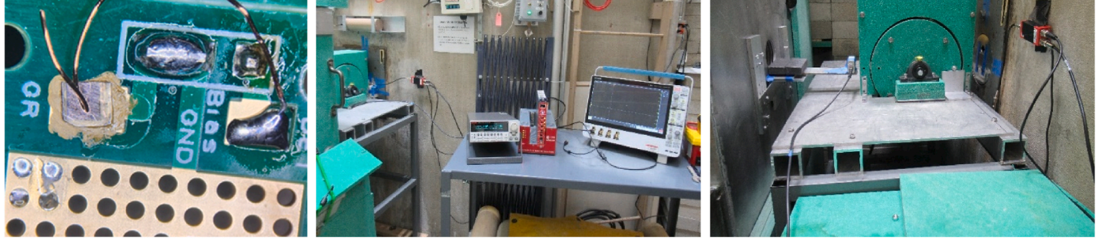
Figure 32: MHyPbCl$​_{3}$ experimental setup at the OSURR FBF showing (a) the detector on its PCB, (b) the data acquisition station, and (c) the detector positioned at the beamport.

Digital Pulse Processing Pipeline
Because the radiation-induced charge pulses from the MHyPbCl$​_{3}$ detector did not exceed approximately 15 mV at the preamplifier output, they were below the threshold at which hardware multichannel analyser (MCA) electronics could reliably discriminate genuine pulses from baseline noise. A custom offline digital pulse processing pipeline was therefore developed in Python to extract pulse-height information from the raw oscilloscope waveforms.
The processing chain proceeded in four steps. First, individual waveforms were loaded from the .mat files written by the Tektronix MSO54 oscilloscope. Voltage data were converted to millivolts and time axes to microseconds to give physically meaningful units. Second, each waveform was smoothed using a Locally Weighted Scatterplot Smoothing (LOWESS) algorithm with a smoothing fraction of 10% and a single robustness iteration. LOWESS fits a low-degree polynomial to a sliding local window of the data, effectively suppressing the high-frequency electronic noise that dominated the raw preamplifier output while preserving the slower temporal profile of genuine charge-collection pulses, whose rise and decay times are governed by carrier transit times across the crystal and the preamplifier time constant. Third, a baseline correction was applied by subtracting the mean of the first 50 data points of each smoothed waveform, a region prior to the expected pulse onset, to remove any DC offset that varied waveform-to-waveform due to amplifier drift or slow ionic polarisation of the detector. Fourth, the pulse height was defined as the maximum absolute value of the baseline-corrected waveform. For each waveform the script additionally extracted the 10%–90% rise time and 90%–10% decay time of the pulse, quantities that in principle allow pulse-shape discrimination between event types, though insufficient statistics prevented this analysis in the present work.
After pulse-height extraction, pulses with amplitudes below a threshold of 2 mV were discarded to suppress noise triggers, and the remaining pulse heights were accumulated into a 50-bin histogram over the range 0–20 mV to produce the pulse-height spectrum used for the analysis in Section 5.7.6. The entire pipeline was applied independently to each beam configuration subfolder (shutter open, shutter closed, and beam background), allowing direct comparison of the pulse-height distributions across conditions.

Results
The MHyPbCl$​_{3}$ detector was operated at reverse bias voltages of 80 V and 120 V for the FBF measurements.
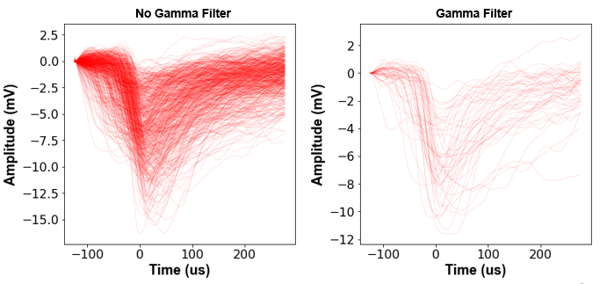
Figure 33: LOWESS-filtered preamplifier waveforms from the MHyPbCl$​_{3}$ detector at 120 V with (a) gamma shutter open, (b) gamma shutter closed, and (c) beam background.
At 120 V reverse bias with the gamma shutter open, 1090 waveforms containing radiation-induced pulses were collected over the acquisition interval. After closing the gamma shutter, 1001 pulses were recorded over a comparable interval; the beam background (reactor at power, beam blocked entirely) yielded 394 pulses. The count rate with the shutter closed ($∼$0.5 counts s$​^{−1}$) was not meaningfully different from the shutter-open count rate at 120 V in the forward bias configuration, a result discussed further below.
At 80 V reverse bias, waveform counts were: 1040 (shutter open), 507 (shutter closed), and 252 (background). The higher source-to-background ratio at 80 V compared to 120 V suggests that the lower field at 80 V produces a different carrier collection regime in which high-charge-deposition events are more clearly separated from the background noise floor.
Pulse-height analysis at 120 V reverse bias yielded a broad continuum of pulse heights, shown in Figure 5.16. The spectrum does not display a sharp Gaussian peak; rather, it exhibits a broad continuum extending from the noise threshold to the maximum digitised amplitude. This spectral shape is physically expected for fast neutron detection: recoil protons from elastic scattering of poly-energetic fast neutrons produce a broad energy deposition distribution, further broadened by incomplete charge collection at the bias voltages used here. Nevertheless, the waveform population is clearly distinct from the background (reactor off) population, confirming that MHyPbCl$​_{3}$ is responding to radiation from the reactor beam.
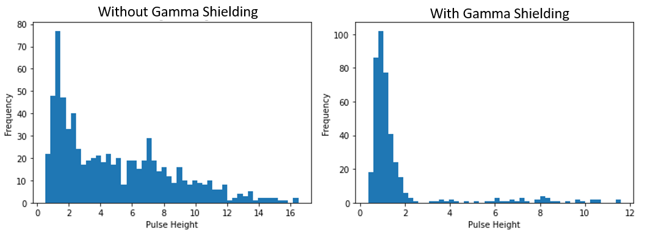
Figure 34: Pulse-height spectrum from the MHyPbCl$​_{3}$ detector at 120 V with (a) no gamma filter and (b) gamma shutter closed.

Discussion: Neutron-Gamma Discrimination and Detection Efficiency
The neutron-gamma discrimination challenge is illustrated by comparing shutter-open and shutter-closed waveform populations. Closing the lead gamma shutter reduces the gamma dose rate by $∼$300$×$ (from 15.787 R hr$​^{−1}$ to 50.525 mR hr$​^{−1}$) while reducing the fast neutron flux by only a factor of 35. If the detector responded purely to neutrons, the shutter-closed count rate should be $≈$0.12 times the shutter-open rate. The observed ratio at 120 V (1090:1001 after background subtraction) does not show this level of suppression, indicating the response is dominated by direct gamma interactions in the Pb sublattice rather than neutron-induced proton recoil events. This highlights the fundamental neutron-gamma discrimination difficulty in a Pb-containing semiconductor.
An upper bound estimate of fast neutron detection efficiency at 1 MeV neutron energy ($σ_{el}≈3$ b) for a 5-mm crystal thickness is
$$P=1−exp(−n_{H}σ_{el}t)≈1−exp(−4.0×{10}^{22}×3×{10}^{−24}×0.5)≈5.8\%,$$
where $t=0.5$ cm is the path length. At the shutter-closed fast neutron flux of $4.3×{10}^{5}$ cm$​^{−2}$ s$​^{−1}$ and the $∼$0.3-cm$​^{2}$ detector area, this implies an expected proton-recoil interaction rate of $∼$750 events s$​^{−1}$, far larger than the 0.5 counts s$​^{−1}$ actually observed. The discrepancy is primarily due to the Tektronix MSO54 oscilloscope waveform-write-rate bottleneck: in single-shot waveform acquisition mode, the maximum write rate was the dominant constraint on the measurable count rate. Switching to a hardware MCA or a fast digitiser in continuous acquisition mode is the highest-priority hardware improvement identified for future neutron detection experiments.

Ion Migration and Device Stability
A single overarching materials-physics challenge pervades the results of Sections 5.2–5.7: the migration of halide ions under large applied electric fields. The detector geometry exacerbates this relative to the photovoltaic geometry in two ways: (1) the fields required for efficient charge collection ($∼$1 V $μ$m$​^{−1}$ across millimetre-scale crystals) are several orders of magnitude larger than photovoltaic built-in fields; and (2) these fields must be sustained continuously for hours during a spectroscopy acquisition.

Contact Degradation at Elevated Bias
A distinct degradation mechanism was identified during extended testing of the FAPbBr$​_{3}$ device: chemical reaction of the Ti/Ni back-face contact with mobile bromide ions driven toward that interface under large applied reverse bias. After a full day of electrical testing, the Ti contact surface was visually observed to have changed colour and the metallic Ti layer appeared to partially recede into or react with the crystal surface. Mobile Br$​^{−}$ ions accumulating at the Ti contact (Ti commonly in the $+3$ oxidation state) can form stable titanium bromide complexes such as TiBr$​_{4}^{2−}$, consuming the metal electrode.
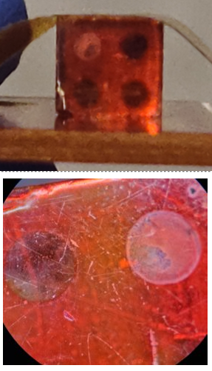
Figure 35: Ti/Ni back-face contact surface of the FAPbBr$​_{3}$ detector after extended high-bias operation.
This has profound implications for contact material selection. Metals that form stable halide compounds under the electrochemical conditions at a biased contact, titanium being one such metal, are fundamentally incompatible with sustained high-field operation in halide perovskite detectors, regardless of the contact geometry. The Au pixel contacts showed no evidence of analogous chemical degradation in any device examined in this work, consistent with gold’s kinetic stability against halide compound formation under mild electrochemical conditions. Alternative back-contact candidates identified in the broader literature include Cr and SnO$​_{2}$, both evaluated on CsPbBr$​_{3}$ in preliminary experiments but not carried through to full spectroscopic evaluation within the scope of this work.

Ion Migration Consequences for Spectroscopy
Ion migration impairs spectroscopic performance through three mechanisms that together set a practical upper bound on the achievable energy resolution in as-fabricated perovskite single crystal detectors.
First, ion redistribution under the applied field creates a non-uniform internal electric field profile. As mobile anions accumulate at the anode and cations at the cathode, space-charge layers form near both contacts. The resulting space charge adds to the applied field at one interface and subtracts from it at the other, so carriers generated at different depths experience different net fields and have different collection probabilities, broadening the pulse-height distribution for monoenergetic radiation events and degrading energy resolution [@He1997CZT].
Second, the leakage current overshoot upon initial bias application causes the internal field distribution to evolve continuously during acquisition. Since pulse-height peak position is proportional to instantaneous charge collection efficiency, the slow field evolution during ion migration causes effective detector gain to drift, further broadening accumulated spectral peaks.
Third, on long timescales the accumulated ionic charge at the interfaces depresses the net bulk electric field, reducing carrier drift velocity and increasing the probability of trapping before collection. The combination of all three effects means that energy resolution of a perovskite detector operated at high bias in ambient conditions will inevitably worsen over time, even if the initial resolution at the moment of bias application is acceptable.

Mitigation Strategies
Several mitigation strategies were evaluated or identified in the course of this work.
5F-PEAI surface passivation. The most promising approach demonstrated in this work for thin-film geometries (Section 5.3.3). At 4 mg mL$​^{−1}$, 5F-PEAI penetrates grain boundaries and raises the water-penetration activation energy from $∼$5 meV to $∼$120 meV, stabilising the device to $−16$ V in 40% RH air. Extending this passivation strategy to 3D single crystal systems is a high-priority direction for future research.
Contact material engineering. The Ti-Br$​^{−}$ reaction documented in Section 5.8.1 motivates replacing Ti with metals that do not form stable halide compounds under detector operating conditions, such as Au, Pt, or Cr-based multilayers. Carrier-selective interlayers such as the C$​_{60}$:BCP bilayer used in the MHyPbCl$​_{3}$ device can also reduce interface recombination velocity and extend the stable field range.
Improved crystal quality. Reducing halide vacancy concentrations through growth conditions that minimise stoichiometric excess, such as the slow anti-solvent crystallisation used for MHyPbCl$​_{3}$, or single-crystal growth under inert atmosphere, is an important near-term research goal [@Saidaminov2015].

Summary
This chapter described the development and characterisation of six halide perovskite direct-conversion radiation detectors across three radiation types: X-rays, gamma rays, and fast neutrons.
The MAPbI$​_{3}$-hBN device (Section 5.2) demonstrated a monotonically increasing X-ray sensitivity with applied bias, $0.107$, $0.245$, and $0.411 μ$C (Gy cm$​^{2}$)$​^{−1}$ at 5, 10, and 20 V, respectively, consistent with the Hecht equation. Vacuum testing confirmed moisture-accelerated ion migration as the principal degradation mechanism, and the device failed irreversibly after $∼$5 hours at 400 V.
The 2D PEA$​_{2}$MA$​_{2}$Pb$​_{3}$I$​_{10}$ detector with 5F-PEAI (Section 5.3) demonstrated that moisture-accelerated instability can be effectively mitigated: breakdown voltage was raised from $−10$ V to $−16$ V at 40% RH, and X-ray sensitivities approaching $∼$1000 $μ$C (Gy$​_{air}$ cm$​^{2}$)$​^{−1}$ were achieved at 4 V bias, among the highest reported for polycrystalline perovskite detectors of comparable thickness.
The CsPbBr$​_{3}$ device (Section 5.4) produced a statistically significant count-rate response to $​^{137}$Cs (17.45 cps vs. 9.11 cps background) at 1000 V, but large unstable leakage (315–710 nA) generated electronic noise that prevented resolution of the 662-keV photopeak.
The FAPbBr$​_{3}$ device (Section 5.5) achieved substantially lower operating leakage ($5±2.5$ nA maximum) and sustained stable high-voltage operation for over five hours. A joint $​^{137}$Cs/$​^{57}$Co acquisition at 1600 V produced spectral features attributable to both sources, a proof-of-concept demonstration of gamma spectroscopy in a solution-grown halide perovskite crystal.
The MAPbBr$​_{3}$ device (Section 5.6) failed to produce functional Schottky contacts due to high sputter power and residual surface contamination, motivating a revised deposition protocol at reduced sputter power ($∼$150–200 W) with in-situ surface cleaning.
MHyPbCl$​_{3}$ (Section 5.7) was characterised as the first organic-metal halide perovskite semiconductor evaluated in a reactor fast neutron beam. The material combines $n_{H}≈4.0×{10}^{22}$ cm$​^{−3}$ (comparable to stilbene) with resistivity $4.43×{10}^{11}$ $Ω$ cm and $μτ=9.1×{10}^{−3}$ cm$​^{2}$ V$​^{−1}$. Waveform data acquired at the OSURR FBF confirmed radiation-induced pulse activity distinct from beam background; pulse-height spectra were consistent with the expected proton-recoil energy deposition distribution from a poly-energetic fast neutron beam. The LOWESS-based digital pulse processing pipeline was essential for extracting these low-amplitude signals ($<15$ mV) from the raw oscilloscope waveforms. Neutron-gamma discrimination remains a challenge due to the large Pb content, and the oscilloscope waveform-write-rate bottleneck prevented collection of sufficient statistics for quantitative efficiency analysis.
Across all six devices, ion migration under applied electric fields emerged as the central performance-limiting mechanism. Surface passivation, demonstrated here via 5F-PEAI for thin-film devices, is identified as the most promising near-term strategy for extending the operational stability of perovskite radiation detectors toward the performance levels required for practical deployment.

Thermal Radiation Sensing Concepts for Nuclear Systems

Introduction
In addition to the direct detection approaches explored in the preceding chapters, indirect methods of radiation sensing, those that infer radiation fields from their thermal signatures, represent an alternative pathway for monitoring nuclear environments. Within the materials-to-systems hierarchy that organizes this dissertation, thermal sensing occupies the conceptual bridge between the materials and device investigations of Chapters 4–5 and the digital electronics instrumentation of Chapters 7–8: it addresses a system-level sensing function without relying on either semiconductor detector materials or active electronic components in the radiation field. This chapter describes the investigation of two such concepts: the Optical Fiber-Based Gamma Thermometer (OFBGT) and the Optical Fiber-Based Neutron Dosimeter (OFBND). Both devices exploit the temperature differential that arises when ionizing radiation deposits energy in a thermally isolated material, and both rely on distributed fiber-optic temperature sensing to measure that differential. Of the two concepts, the OFBGT reached the experimental validation stage, while the OFBND remains a simulation-based design study.
The OFBGT was originally conceived and developed by Birri [@Birri2021Dissertation] at The Ohio State University. The present work extends that effort to a new sensor design intended for deployment in the Central Irradiation Facility (CIF) of the Ohio State University Research Reactor (OSURR), carried out in partnership with Luna Innovations [@LunaDOE2024]. The author’s contribution centered on executing and validating thermal simulations of the redesigned OFBGT using analytical models previously established by Birri, as well as extending those models to predict the performance of a proposed neutron-sensitive variant, the OFBND. The simulation methodology, calculational results, and implications for the experimental campaign are presented in the sections that follow.

Gamma Heating and the Gamma Thermometer Principle
When a material is placed in a mixed radiation field inside a reactor core, gamma rays interact with the material primarily through the photoelectric effect, Compton scattering, and pair production. These interactions transfer kinetic energy to secondary electrons, which subsequently deposit that energy locally as heat through ionization and excitation of the lattice. The volumetric rate at which energy is deposited, $Q^{‴}$ (W/m$​^{3}$), depends on the gamma-ray flux, the energy spectrum of the gamma-ray field, and the mass energy-absorption coefficient of the target material.
A gamma thermometer exploits this heating effect by measuring the temperature difference, $ΔT$, that develops between a thermally insulated internal mass, referred to here as the thermal mass or insulating tube, and an outer metallic sheath that is in thermal contact with the reactor coolant. Because the insulating gas gap between the thermal mass and the sheath represents the dominant thermal resistance, the temperature within the thermal mass is elevated relative to the sheath. When the sensor is calibrated by applying a known electrical power to an internal heating wire, a relationship between the linear power density $q^{′}$ and $ΔT$ is established. During reactor operation, the measured $ΔT(z)$ at each axial position $z$ can then be converted to the local $q^{′}(z)$, and hence to the local gamma-ray dose rate [@Birri2021Dissertation; @Birri2020IEEE].

Optical Frequency Domain Reflectometry
The temperature sensing modality employed in both the OFBGT and OFBND is optical frequency domain reflectometry (OFDR). In OFDR, a tunable laser is swept in wavelength and coupled into a sensing fiber. The backscattered Rayleigh signal, or the reflected signal from fiber Bragg gratings (FBGs) inscribed along the fiber, is interfered with a reference signal to produce a spatial map of spectral shift along the fiber. A shift in the reflected spectrum at a given location is linearly related to the local temperature change. Phase-shifted, continuously written (PSC) type II FBGs, inscribed by ultrafast laser pulses, were chosen for this application because of their demonstrated radiation hardness and thermal stability at elevated temperatures [@Birri2021Dissertation].

Optical Fiber-Based Gamma Thermometer Design

Cross-Sectional Geometry
A generalized cross-section of the OFBGT active sensing region is shown in Figure 6.1. The central element is a repurposed four-hole thermocouple-wire electrical insulator tube composed of 80% mullite and 20% silica. Two of the four holes carry optical fibers that measure the temperature of the thermal mass; the remaining two holes carry a nichrome heating wire that forms a loop for calibration purposes. When a known current is passed through the heating wire, a known $q^{′}$ is generated, establishing the calibration relationship between $q^{′}$ and $ΔT$.
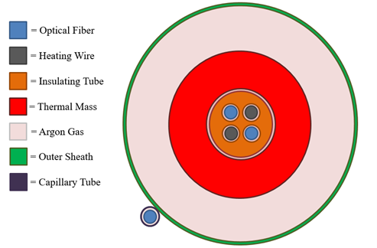
Figure 36: Cross-sectional view of the optical fiber-based gamma thermometer, showing the insulating tube/thermal mass, optical fibers, heating wire, argon gas gap, and nested outer sheath tubes. Adapted from the OFBGT Simulation Response Document [@SimReport2023], p. 2.
The insulating tube/thermal mass is surrounded by an argon gas gap at atmospheric pressure (760 mmHg). Argon was selected for its chemical inertness and well-characterized thermal conductivity ($κ_{G}=22.6$ mW/(m$⋅$K) at room temperature). Because of its low thermal conductivity, the gas gap constitutes the dominant thermal resistance in the radial heat transfer path, making the temperature distribution within the thermal mass nearly uniform.
Two nested aluminum 6061 tubes form the outer sheath. The inner nested tube has two grooves machined into its outer surface, each containing an optical fiber that senses the sheath temperature. The temperature difference $ΔT(z)=T_{fiber,inner}(z)−T_{fiber,outer}(z)$ between the fibers in the thermal mass and those in the outer sheath is the principal measurement quantity of the OFBGT.

Axial Layout
An overall view of the OFBGT design as configured for the OSURR is shown in Figure 6.2. The sensor has three regions in the axial direction. The bottom-most region is the active sensor region, where the thermal mass, the gas gap, and the outer sheath are present. The active sensor length was approximately 24 inches (61 cm), constrained by the longest available continuous length of the mullite insulator. The bottom of the OFBGT is welded shut to maintain the inert argon atmosphere. Glass disc spacers keep the thermal mass centered within the sheath.
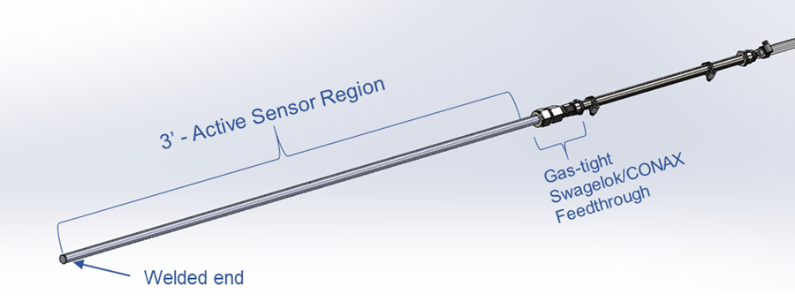
Figure 37: Overall view of the OFBGT design for the OSURR, showing the active sensor region, the gas-tight Swagelok/CONAX feedthrough, and the welded end. Adapted from the OFBGT Simulation Response Document [@SimReport2023], p. 4.
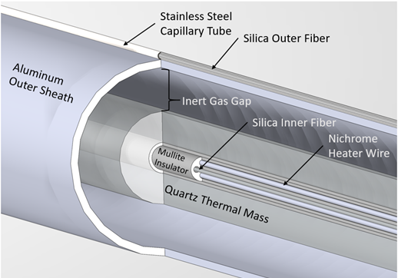
Figure 38: Internal view of the active sensor region of the OFBGT, showing the mullite insulator, nichrome heater wire, silica optical fibers, inert gas gap, and aluminum outer sheath. Adapted from the OFBGT Simulation Response Document [@SimReport2023], p. 4.

Optical Fiber-Based Neutron Dosimeter Concept
The OFBND extends the gamma thermometer concept to neutron fields by replacing the mullite insulator with borosilicate glass. Borosilicate glass contains boron-10, which has a large thermal-neutron absorption cross-section ($σ_{B}≈755$ barns for natural boron). When a thermal neutron is absorbed by $​^{10}$B, the resulting $​^{10}$B(n,$α$)$​^{7}$Li reaction releases charged particles whose kinetic energy is deposited locally as heat:
$$⟨Q_{α}^{B}+Q_{Li}^{B}⟩=3.75×{10}^{−13} \text{J/reaction} .$$
where the angle brackets denote averaging over the two branches of the reaction. The volumetric energy deposition rate in the borosilicate thermal mass is then
$$Q^{‴}=N_{B} σ_{B} φ ⟨Q_{α}^{B}+Q_{Li}^{B}⟩$$
where $N_{B}$ is the boron number density and $φ$ is the thermal neutron flux.
The OFBND is geometrically similar to the OFBGT but uses a smaller-diameter thermal mass. Whereas the OFBGT employs a 1/8-inch (3.175 mm) OD mullite tube, the OFBND uses a 1/16-inch (1.5875 mm) OD borosilicate glass tube. The smaller diameter was driven by the availability of borosilicate capillary tubing. The neutron-sensitive thermal mass is to be deployed in the Auxiliary Irradiation Facility (AIF) of the OSURR, where the thermal neutron flux is $6.0×{10}^{12}$ n cm$​^{−2}$s$​^{−1}$.
By placing a standard gamma-sensitive OFBGT and a neutron-sensitive OFBND at adjacent positions in the reactor, it becomes possible in principle to separate the neutron and gamma contributions to the local dose rate. The neutron-to-gamma heating ratio in the borosilicate glass thermal mass is approximately 4:1 at the thermal neutron fluxes encountered in the AIF, making the OFBND substantially more responsive to neutrons than to gamma rays [@SimReport2023].

Simulation Methodology

Analytical Thermal Model
The thermal response of the OFBGT and OFBND was predicted using an analytical model originally developed by Birri [@Birri2020IEEE; @Birri2021Dissertation]. The model treats the sensor as a series of concentric cylindrical regions, thermal mass, gas gap, and outer sheath, with azimuthal symmetry assumed. Deviations from azimuthal symmetry due to the heating wire and optical fiber holes are small and were neglected.
Under the assumption that the linear power density $q^{′}$ is axially uniform and the outer sheath surface temperature $T(r_{So},z)$ is axially constant, the temperature difference between the fiber location in the thermal mass and the outer sheath surface is
$$ΔT(z)=T(r_{f},z)−T(r_{So},z)=q^{′} R_{r_{f}}^{r_{So}}$$
where $q^{′}=Q^{‴}πr_{TM}^{2}$ is the linear power density for the sensor, $r_{f}$ is the radial position of the optical fiber within the thermal mass, $r_{TM}$ is the outer radius of the thermal mass, and $R_{r_{f}}^{r_{So}}$ is the thermal resistance from the fiber location to the outer sheath surface:
$$R_{r_{f}}^{r_{So}}=\frac{1}{2π}\left[\frac{1−\frac{r_{f}^{2}}{r_{TM}^{2}}}{2κ_{TM}}+\frac{ln\left(\frac{r_{Si}}{r_{TM}}\right)}{κ_{G}}+\frac{ln\left(\frac{r_{So}}{r_{Si}}\right)}{κ_{S}}\right]$$
Here $κ_{TM}$, $κ_{G}$, and $κ_{S}$ are the thermal conductivities of the thermal mass, gas gap, and sheath, respectively, and $r_{Si}$ and $r_{So}$ are the inner and outer radii of the outer sheath.
This expression is exact for the case of axially constant $q^{′}$ and axially constant outer sheath temperature. In a reactor, however, $q^{′}(z)$ varies axially following the neutron flux profile. To characterize the resulting error, a modulation transfer function (MTF) formalism was employed.

Modulation Transfer Function
The concept of a modulation transfer function, borrowed from optical imaging theory, was applied to the OFBGT by Palmer and Blue [@Palmer2018]. When the volumetric energy deposition $q^{‴}(z)$ varies sinusoidally with spatial frequency $k=2π/λ$, axial diffusion of thermal energy in the thermal mass, gas gap, and sheath causes the measured $ΔT(z)$ to be attenuated (modulated) relative to the true $q^{‴}(z)$ distribution. During calibration with a spatially uniform heat source ($k=0$), this axial diffusion does not occur. The normalized MTF quantifies the ratio of the sensor response at spatial frequency $k$ to the response at $k=0$:
$${MTF}_{norm}(k)=\frac{MTF(k)}{MTF(k=0)}=\frac{R_{TM}(r_{f})|_{k}}{R_{TM}(r_{f})|_{k=0}}$$
where $R_{TM}(r_{f})|_{k}$ is a function of the modified Bessel functions $I_{0}$ and $K_{0}$ evaluated at the boundaries of the three regions, determined by solving a $5×5$ matrix equation that enforces continuity of temperature and heat flux at the interfaces [@Birri2020IEEE; @SimReport2023].
A value of ${MTF}_{norm}$ close to unity indicates that the OFBGT faithfully reproduces the axial variation in $q^{‴}(z)$ at that spatial frequency. As $k$ increases, the MTF decreases, indicating a loss of axial resolution.

Computational Implementation
Two computational implementations of the analytical model were used:
- Python model. A point calculation based on Equations [eq:deltaT]–[eq:thermal_resistance] was implemented in Python to compute $ΔT$ at the axial location of maximum $q^{′}$. This model assumed constant (room-temperature) thermal conductivities.
- MATLAB model. A more comprehensive model was implemented in MATLAB that solved the matrix equation for the temperature distribution $T(r,z)$ throughout the entire sensor, iteratively updating the temperature-dependent thermal conductivities of the argon gas gap, the thermal mass, and the outer sheath at each axial and radial position until convergence was achieved. The MATLAB model also computed the normalized MTF as a function of spatial frequency $k$.
The MATLAB code iterated on the thermal conductivities as follows: an initial temperature field was computed using room-temperature conductivities; the thermal conductivities were then re-evaluated at the local temperatures using tabulated data and the matrix equation was re-solved; this process was repeated until the maximum change in $ΔT$ between successive iterations fell below ${10}^{−6}$ $​^{∘}$C.

Sensor Design Parameters
The design parameters for the OFBGT and OFBND are summarized in Tables 6.1 and 6.2, respectively. The irradiation conditions and resulting linear power densities are given in Table 6.3.
Part details and parameters for the OFBGT. Adapted from the OFBGT Simulation Response Document [@SimReport2023], p. 10.
Component | Material | Dimensions | Parameters
Outer sheath (inner tube) | Al 6061 | 5/16” OD, 0.243” ID | $r_{Si}=3.09$ mm, $r_{So}=3.97$ mm
 |  |  | $κ_{S}=177$ W/(m$⋅$K)
Outer sheath (outer tube) | Al 6061 | 3/8” OD, 0.319” ID | (Not used in calculation)
Insulating tube | 80% Mullite, | 1/8” OD, 0.02” ID | $r_{f}=1.058$ mm
 | 20% Silica |  | $r_{TM}=1.588$ mm
 |  |  | $κ_{TM}=5$ W/(m$⋅$K)
Gas gap | Argon, 760 mmHg | $t_{G}=1.5$ mm | $κ_{G}=22.6$ mW/(m$⋅$K)
Part details and parameters for the OFBND. Adapted from the OFBGT Simulation Response Document [@SimReport2023], p. 11.
Component | Material | Dimensions | Parameters
Outer sheath (inner tube) | Al 6061 | 5/16” OD, 0.243” ID | $r_{Si}=3.09$ mm, $r_{So}=3.97$ mm
 |  |  | $κ_{S}=177$ W/(m$⋅$K)
Outer sheath (outer tube) | Al 6061 | 3/8” OD, 0.319” ID | (Not used in calculation)
Insulating tube | Borosilicate | 0.062” OD, 0.015” ID | $r_{f}=0.529$ mm
 | glass |  | $r_{TM}=0.794$ mm
 |  |  | $κ_{TM}=1.15$ W/(m$⋅$K)
Gas gap | Argon, 760 mmHg | $t_{G}=2.3$ mm | $κ_{G}=22.6$ mW/(m$⋅$K)
Irradiation facilities and calculated linear power densities for the OFBGT and OFBND, not accounting for the volume of the through-holes. Adapted from the OFBGT Simulation Response Document [@SimReport2023], p. 12.
Sensor | Material | Dimensions | Facility | $q^{′}$ (W/m)
OFBGT | Mullite | 3.175 mm OD, 0.508 mm ID | CIF | 5.77
OFBND | Borosilicate glass | 1.5875 mm OD, 0.381 mm ID | AIF | 16.6
The linear power density for the OFBGT was calculated from the absorbed dose rate for silicon in the CIF ($\dot{D}=87$ Mrad/h), scaled to mullite using the ratio of mass energy-absorption coefficients evaluated at 1 MeV ($μ_{e}^{Mullite}/μ_{e}^{Si}=1.296$), yielding $Q^{‴}=0.731$ W/cm$​^{3}$ and $q^{′}=5.77$ W/m [@SimReport2023]. The linear power density for the OFBND was calculated from the thermal neutron flux in the AIF ($φ=6.0×{10}^{12}$ n cm$​^{−2}$s$​^{−1}$) using Equation [eq:Qppp_neutron], assuming 13% boron trioxide by weight and a borosilicate glass density of 2.23 g/cm$​^{3}$, yielding $Q^{‴}=8.52$ W/cm$​^{3}$ and $q^{′}=16.6$ W/m [@SimReport2023]. The detailed derivations of these quantities are provided in the simulation response document [@SimReport2023].
For both sensors, the radial position of the fiber within the thermal mass was estimated as $r_{f}=\frac{2}{3}r_{TM}$, since exact dimensions of the through-hole locations were not available from the vendor. The sensitivity of $ΔT$ to this assumption is small because the temperature distribution within the thermal mass is nearly uniform.

Simulation Results

Predicted Temperature Differential
The results of the $ΔT$ calculations from both the Python and MATLAB models are summarized in Table 6.4.
Comparison of the OFBGT and OFBND modeling results from the Python (constant thermal conductivity) and MATLAB (temperature-dependent thermal conductivity, iterative) models. Adapted from the OFBGT Simulation Response Document [@SimReport2023], p. 14.
Parameter | OFBGT | OFBND
Thermal mass material | Mullite | Borosilicate glass
Thermal mass radius (mm) | 1.588 | 0.794
Gas gap thickness (mm) | 1.5 | 2.3
$κ_{TM}$ (W/(m$⋅$K)) | 5 | 1.15
$q^{′}$ (W/m) | 5.77 | 16.6
$ΔT$ from Python ($​^{∘}$C) | 27.1 | 159.4
$ΔT$ from MATLAB ($​^{∘}$C) | 29.66 | 154.8
Relative error (%) | 8.77 | 2.96
The Python model predicted a maximum $ΔT$ of 27.1 $​^{∘}$C for the OFBGT and 159.4 $​^{∘}$C for the OFBND. The MATLAB model, which accounts for the temperature dependence of the argon thermal conductivity, predicted values of 29.66 $​^{∘}$C and 154.8 $​^{∘}$C, respectively. The relative errors between the two models were 8.77% for the OFBGT and 2.96% for the OFBND. The principal source of discrepancy is the treatment of the gas gap thermal conductivity: the Python model uses a single constant value, whereas the MATLAB model evaluates it locally at the temperature-dependent gas conductivity, which is significant because of the large temperature gradient across the gap.
The substantially larger $ΔT$ predicted for the OFBND relative to the OFBGT arises from two factors. First, the linear power density is approximately 2.9 times greater for the OFBND ($q^{′}=16.6$ W/m versus 5.77 W/m). Second, the gas gap is 53% wider in the OFBND (2.3 mm versus 1.5 mm), increasing the thermal resistance. Although the borosilicate glass thermal mass has a lower thermal conductivity than mullite (1.15 versus 5 W/(m$⋅$K)), the contribution of the thermal mass resistance to the overall $ΔT$ is small relative to the gas gap resistance.

Temperature Distributions
The temperature distributions computed by the MATLAB model, plotted as contour maps in the radial–axial ($r$–$z$) plane, are shown in Figure 6.4. The axial variation follows the sinusoidal flux profile of the reactor, with the maximum temperatures occurring near the axial center of the core. The radial temperature drop is concentrated in the gas gap region, consistent with the dominance of the gap thermal resistance.
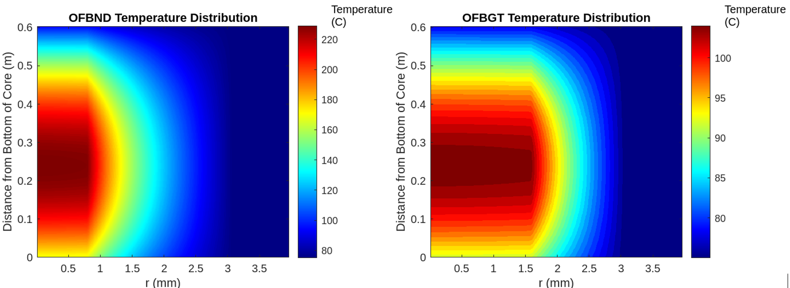
Figure 39: Temperature distributions plotted as contour maps in the radial ($r$) and axial ($z$) directions for the OFBND (left) and the OFBGT (right). The OFBND reaches significantly higher peak temperatures due to its larger linear power density. Adapted from the OFBGT Simulation Response Document [@SimReport2023], p. 15.

Modulation Transfer Function Results
The normalized MTF curves for both the OFBGT and OFBND are compared in Figure 6.5. The MTF quantifies the sensor’s ability to faithfully reproduce axial variations in the energy deposition rate at different spatial frequencies. A value of unity corresponds to perfect fidelity; lower values indicate spatial smoothing.
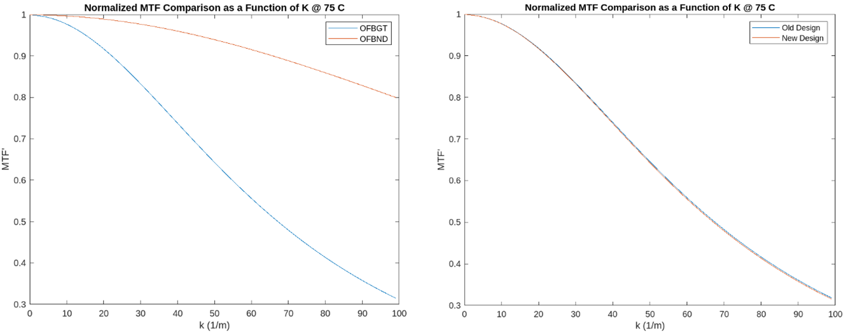
Figure 40: Left: comparison of the normalized MTF curves for the OFBGT and OFBND as a function of spatial frequency $k$. The OFBND exhibits a higher MTF at all spatial frequencies due to its smaller cross-sectional area and lower thermal mass conductivity. Right: comparison of the new (Luna) OFBGT design with the original (Birri) OFBGT design, showing nearly identical MTF performance. Adapted from the OFBGT Simulation Response Document [@SimReport2023], p. 16.
The OFBND exhibited a higher MTF at all spatial frequencies than the OFBGT. This improved axial resolution is a consequence of the smaller cross-sectional area of the borosilicate glass thermal mass, which reduces the length scale over which axial thermal diffusion can smooth out spatial variations. The MTF curves for the new (Luna) OFBGT design were found to be nearly identical to those of the original Birri design, confirming that the design modifications did not degrade the sensor’s spatial resolution characteristics.

Experimental Testing and Discussion of the OFBGT

Reactor Testing Campaign
Following the simulation work, an OFBGT was fabricated by Luna Innovations and tested in the CIF of the OSURR during a seven-hour reactor test campaign [@LunaDOE2024]. The sensor was equipped with ten FBG sensor pairs (inner and outer fiber) distributed along the 24-inch active sensor length. The reactor was operated at multiple power levels (50%, 70%, 80%, and 90% of full power), and the temperature data from each FBG pair were recorded in real time.

Discrepancy Between Predicted and Measured $ΔT$
The simulations presented in Section 6.7 predicted a maximum $ΔT$ of approximately 27–30 $​^{∘}$C for the OFBGT when deployed in the CIF at full reactor power, which exceeded the estimated measurement threshold of approximately 25 $​^{∘}$C needed for reliable power inference. However, the experimental measurements yielded a significantly lower $ΔT$, on the order of 17 $​^{∘}$C at full power. This discrepancy rendered the $ΔT$ insufficient for reliable calibration and power measurement, and the test was consequently deemed unsuccessful in meeting the original performance targets.
The primary source of the discrepancy was identified as the neglect of radiative heat transfer in the simulation models. Both the Python and MATLAB models considered only conductive heat transfer through the gas gap. However, at the operating temperatures of the thermal mass (approaching 100 $​^{∘}$C above ambient), radiative heat transfer across the gas gap between the thermal mass surface and the inner surface of the outer sheath provides a parallel pathway for heat dissipation that is not accounted for by conduction alone. The radiative heat flux is governed by
$$q_{rad}^{″}=\frac{σ(T_{1}^{4}−T_{2}^{4})}{\frac{1}{ε_{1}}+\frac{(1−ε_{2})}{ε_{2}}\frac{r_{TM}}{r_{Si}}}$$
where $σ$ is the Stefan–Boltzmann constant, $T_{1}$ and $T_{2}$ are the absolute temperatures of the thermal mass surface and the sheath inner surface, respectively, and $ε_{1}$ and $ε_{2}$ are the emissivities of these surfaces.
The inclusion of this radiative pathway effectively reduces the thermal resistance of the gas gap, lowering the equilibrium $ΔT$. The MATLAB code contained provisions for incorporating radiative heat transfer (with $ε_{1}=0.76$ for the mullite surface and $ε_{2}=0.05$ for the aluminum sheath), but this term was set to zero in the simulations presented in the response document based on the recommendation to neglect it at the time [@SimReport2023]. When radiative heat transfer was subsequently included in the model, the predicted $ΔT$ dropped from approximately 27 $​^{∘}$C to approximately 17 $​^{∘}$C, in much closer agreement with the experimental observations.
This result underscores the importance of including all relevant heat transfer mechanisms, conduction, convection (if applicable), and radiation, in the thermal modeling of gamma thermometers, particularly when the gas gap temperature differential is large. The lesson is especially pertinent for the OFBND, which operates at still higher temperatures and for which the neglect of radiative heat transfer would introduce even greater modeling errors.

Status of the OFBND
The OFBND concept was investigated through simulation only during this research effort. The modeling results predict a substantially larger $ΔT$ (on the order of 155–159 $​^{∘}$C without radiative heat transfer corrections) for the OFBND in the AIF than for the OFBGT in the CIF, suggesting that the neutron dosimeter concept is viable from a signal-strength perspective. The higher MTF of the OFBND further suggests superior axial resolution relative to the OFBGT.
However, no OFBND prototype has yet been fabricated or tested experimentally. Several aspects of the OFBND design require experimental validation before the concept can be considered proven:
- Thermal performance. The simulations predict operating temperatures in excess of 200 $​^{∘}$C in the thermal mass. At such temperatures, radiative heat transfer, which was shown to be the dominant source of modeling error for the OFBGT, will be even more significant. Updated simulations including radiative heat transfer are essential before a prototype is fabricated.
- Material compatibility. The borosilicate glass thermal mass must survive prolonged exposure to the combined thermal, gamma, and neutron environment of the AIF without degradation in mechanical integrity or thermal properties. The transmutation of boron-10 through the (n,$α$) reaction will deplete the boron content over time, reducing the sensor’s neutron sensitivity and introducing helium gas into the glass matrix.
- Calibration methodology. The calibration of the OFBND with an internal heating wire is analogous to that of the OFBGT. However, the separation of the neutron and gamma contributions to the measured $ΔT$ requires a paired measurement with a collocated, purely gamma-sensitive OFBGT. The practical feasibility of this approach remains to be demonstrated.
- Signal-to-noise ratio. While the predicted $ΔT$ is large, the FBG measurement uncertainty (typically $±0.1$ $​^{∘}$C) must be small relative to the minimum resolvable $ΔT$ at the lowest flux levels of interest.
The OFBND therefore remains a promising but unproven concept that requires experimental testing to validate the theoretical predictions presented here.

Summary
This chapter has presented the simulation and analysis work performed in support of the OFBGT and OFBND sensor development. The analytical thermal model, originally developed by Birri, was applied to a redesigned OFBGT intended for deployment in the CIF of the OSURR and extended to a neutron-sensitive variant (OFBND) intended for the AIF.
Two modeling approaches, a simplified Python model and an iterative MATLAB model with temperature-dependent thermal conductivities, yielded consistent predictions of $ΔT$ for both sensors. The simulations predicted a maximum $ΔT$ of approximately 27–30 $​^{∘}$C for the OFBGT in the CIF and 155–159 $​^{∘}$C for the OFBND in the AIF, without accounting for radiative heat transfer. The MTF analysis confirmed that both sensors possess adequate axial resolution for the spatial frequencies expected in the OSURR flux profiles, with the OFBND exhibiting superior resolution due to its smaller thermal mass.
Experimental testing of the OFBGT revealed that the measured $ΔT$ was approximately 17 $​^{∘}$C, falling short of the approximately 25 $​^{∘}$C threshold required for reliable operation. The discrepancy was attributed to the omission of radiative heat transfer in the original simulations. When radiative heat transfer was included retrospectively, the model predictions agreed closely with the experimental observations.
The OFBND has not yet been fabricated or tested. While the simulations indicate a favorable signal strength, experimental validation is required to confirm the thermal performance, material compatibility, and calibration methodology of the neutron dosimeter concept. The inclusion of radiative heat transfer in future OFBND simulations is essential, given the high operating temperatures predicted for this sensor.

Digital Electronics Verification Methods for Radiation Environments

Introduction
Radiation environments impose two fundamentally distinct threats on digital electronics, cumulative damage mechanisms (TID and displacement damage) and stochastic single-event effects (SEEs), whose physics and mitigation were developed in Chapter 3. Of the SEE mechanisms described there, single-event upsets in SRAM configuration memory are the dominant concern for FPGA-based instrumentation because they silently alter the implemented circuit until detected and corrected. Assessing this vulnerability requires purpose-built verification instruments that can observe radiation-induced state changes in real time while remaining compact enough to deploy inside a beam facility with limited infrastructure.
This chapter describes the design, implementation, and experimental results of the Flip-Flop Shift Register (FFSR) test structure used to evaluate Xilinx Spartan-7 FPGAs under fast neutron irradiation at the Ohio State University Research Reactor (OSURR) Fast Neutron Beam Facility (FNBF). The FFSR serves as a case study in digital electronics verification methodology for radiation environments: its deliberately simple shift-register architecture isolates the effects of radiation on configuration memory and flip-flop state from algorithmic complexity, establishing a baseline against which the more computationally rich fixed-point thermal control benchmark of Chapter 8 can be compared. Section 7.2 presents the FFSR RTL architecture and governing algorithms. Section 7.3 describes the test configuration and radiation environment. Section 7.4 presents the experimental results from two reactor runs and the intervening overnight monitoring period. Section 7.5 discusses the observed upset mechanisms and their implications, and Section 7.6 summarizes the principal findings.

FFSR RTL Architecture

System-Level Overview
The FFSR test structure is an FPGA-resident self-test instrument designed to address the observability and state-volume challenges described in Section 3.9. Its purpose is to instantiate a large, controllable population of sequential elements, exercise those elements with known scan/capture behavior, and report any deviation from the expected internal state in real time. The design contains four cooperating subsystems:
- A top-level experiment controller (top_selftest_100mhz_dbg) that generates experiment timing, reset sequences, capture windows, and telemetry cadence.
- A scan-farm fabric (ff_scanfarm / ff_scanfarm_sig) that instantiates many shift-register chains in parallel, scaling the monitored state volume.
- A signature checker that computes an expected compact signature from the chain contents and compares it against the observed signature to produce live and latched error flags.
- A UART telemetry path that serialises concise status words for logging on a host computer, enabling offline correlation with beam current, fluence, and shutter state.
Rather than streaming every monitored bit off chip, the design compresses the health of a large state space into a smaller set of mismatch indicators and counters. This separation of upset occurrence from complete state readout enables larger monitored populations and simpler experimental integration while still supporting controlled injection tests and persistent error latching.

Module Descriptions
Table 7.1 summarizes the primary RTL blocks.
Summary of primary RTL blocks in the FFSR design.
Module | Primary Role | Key Parameters / Signals | Main Algorithmic Idea
top_selftest_ 100mhz_dbg | Top-level experiment controller and telemetry wrapper | Clock, reset, scan enable, capture enable, clear_errors, UART handshake, status/counter outputs | Coordinates test phases; periodically packages status for serial transmission
ff_scanfarm | Wrapper layer for the scan farm | CHAINS, BITS_PER_CHAIN, INJECT_EN, INJ_TAP, error_live, error_any | Preserves a stable top-level interface while instantiating the robust signature-based implementation
ff_scanfarm_sig / scan-chain fabric | Core monitored state array | clk_scan, scan_en, capture_en, scan_in/out, signature bits, mismatch flags | Updates each chain per shift/capture rules; compares compact state signature against expected value
scan_chain primitive | One lane of monitored sequential storage | Serial input/output, per-stage registers, optional injection tap | Implements shift-register recurrences; optional controlled bit-flip insertion for self-verification
prbs31 | Pseudo-random pattern source | 31-bit state, enable/reset, PRBS output bit/word | Maximal-length LFSR using $x^{31}+x^{28}+1$; $2^{31}−1$ states before repetition
uart_tx / uart_tx_robust | UART serialiser; robust variant adds framing protection | tx_start, tx_data, baud divider, tx_busy, txd | Converts parallel byte to start bit + 8 data bits + stop bit at programmable baud rate; robust variant prevents malformed frames
top_selftest_100mhz_dbg
The top_selftest_100mhz_dbg module is the supervisory block of the FFSR experiment. It establishes the operating clock domain, applies reset, sequences the scan and capture phases, clears latched errors when requested, and routes status information into the UART telemetry path. In a typical implementation, operation is divided into repeated frames or epochs: the design allows the farm to evolve or hold state, then enables capture, then enables scan shifting, then examines mismatch outputs, and finally serialises the results.
ff_scanfarm and ff_scanfarm_sig
The ff_scanfarm module acts as a named interface to the monitored sequential fabric. In the wrapper variant used in this project, it preserves a stable external interface while instantiating the more robust internal implementation ff_scanfarm_sig. This decouples the project hierarchy from changes in the checker implementation. The key outputs are a real-time mismatch indicator, error_live, and a sticky fault memory, error_any.
The scan-farm core is parameterised by the number of parallel chains $C$ and the number of bits per chain $B$, giving a total monitored state volume of:
$$N_{\text{state}}=C×B.$$
scan_chain Primitive
At the lowest level, the scan_chain logic implements the per-stage shift-register recurrence. A chain receives a serial input bit, shifts stored data through successive registers when scan_en is asserted, and presents the final stage at scan_out. An optional injection feature can flip a selected stage, allowing the checker path to be validated without radiation. Because the chain state is deterministic under commanded scan and capture sequences, any uncommanded state change is detectable through signature mismatch.

Core Algorithms
Shift-Register State Update
Let $q_{c,i}[k]$ denote the state of stage $i$ in chain $c$ at clock step $k$, where $i=0,1,…,B−1$ and $c=0,1,…,C−1$. During scan mode the chain obeys the standard shift recurrence:
$$\begin{aligned}q_{c,0}[k+1]&=u_{c}[k], \\ q_{c,i}[k+1]&=q_{c,i−1}[k], i>0,\end{aligned}$$
where $u_{c}[k]$ is the applied serial scan input for chain $c$. In hold mode, $q_{c,i}[k+1]=q_{c,i}[k]$.
Optional Upset Injection for Verification
To validate the detector path without radiation exposure, a controlled injection can be applied at tap $t_{\text{inj}}$:
$$q_{c, t_{\text{inj}}}[k+1]=q_{c, t_{\text{inj}}}^{ \text{nom}}[k+1]⊕ \text{inj}[k],$$
where $\text{inj}[k]$ is asserted only during a commanded test window and $q^{\text{nom}}$ denotes the nominal update in the absence of injection.
Signature Computation and Mismatch Detection
A compact checker is formed by reducing chain contents into parity-like signatures. The signature for chain $c$ is:
$$s_{c}[k]=⨁_{i=0}^{B−1}q_{c,i}[k].$$
The fabric-level signature vector is $S[k]=[s_{0}[k], s_{1}[k], …, s_{C−1}[k]]$. The instantaneous mismatch flag is:
$$e_{\text{live}}[k]=\left\{\begin{matrix}1 & \text{if }S_{\text{obs}}[k]≠S_{\text{exp}}[k], \\ 0 & \text{otherwise.}\end{matrix}\right.$$
Sticky Error Memory
A sticky fault flag preserves the occurrence of any prior mismatch even if the chain later returns to agreement:
$$e_{\text{any}}[k+1]=\left(e_{\text{any}}[k] ∨ e_{\text{live}}[k]\right) ∧ \overline{\text{clear_errors}[k]}.$$
This form is essential in beam testing because transient upsets are not lost between telemetry packets.
PRBS31 Recurrence
The prbs31 module generates a pseudo-random binary sequence using a 31-bit linear feedback shift register with the primitive polynomial $p(z)=z^{31}+z^{28}+1$. Using zero-based indexing with $x_{30}$ as the most-significant stage, the feedback bit is:
$$f[k]=x_{30}[k]⊕x_{27}[k],$$
and the next state is:
$$x[k+1]=\{x_{29}[k], x_{28}[k], …, x_{0}[k], f[k]\}.$$
Provided the all-zero state is avoided, this recurrence cycles through $2^{31}−1$ non-zero states before repeating, yielding strong transition density and good statistical coverage for stressing the sequential fabric.
UART Frame Formation
For an 8-bit telemetry byte $D=[d_{0},d_{1},…,d_{7}]$, the UART transmitter outputs:
$$\text{TX frame}=[0, d_{0}, d_{1}, …, d_{7}, 1],$$
where 0 is the start bit and 1 is the stop bit. The nominal bit-period divider is:
$$N_{\text{baud}}=\left\lfloor \frac{f_{\text{clk}}}{f_{\text{baud}}}\right\rceil ,$$
where $⌊⋅⌉$ denotes rounding to the nearest integer. The uart_tx_robust variant extends the baseline transmitter with stronger start-request handling, safer state transitions, and additional protection against malformed back-to-back frames under transient control behavior.

Test Configuration

Devices Under Test
Five Digilent CMOD S7 boards, each loaded with the FFSR dual modular redundancy (DMR) firmware on a Xilinx Spartan-7 FPGA, were monitored simultaneously. Each device was connected to the host data acquisition PC via a dedicated USB-to-serial COM port at 115 200 baud. The DMR comparator within the FFSR design monitored two redundant data paths and incremented a 32-bit upset counter whenever a mismatch was detected. The counter value was reported over UART every 5 seconds. A non-zero counter output indicated detection of one or more SEUs in the user data path. Table 7.2 summarizes the device configuration and test timeline.
CMOD S7 device configuration and test timeline.
Device | COM Port | Baseline Start | Reactor Start | Reactor End
FFSR1 | COM8 | 21:21, Jan 26 | 11:42, Jan 27 | 16:34, Jan 27
FFSR2 | COM7 | 22:41, Jan 26 | 11:42, Jan 27 | 16:34, Jan 27
FFSR3 | COM6 | 22:41, Jan 26 | 11:42, Jan 27 | 16:34, Jan 27
FFSR4 | COM9 | 22:41, Jan 26 | 11:42, Jan 27 | 16:34, Jan 27
FFSR5 | COM4 | 22:41, Jan 26 | 11:42, Jan 27 | 16:34, Jan 27

Radiation Environment
The test was conducted at the OSURR Fast Neutron Beam Facility over two days using distinct beam configurations that produced substantially different neutron flux and fluence levels.
Day 1 (gamma shutter closed, January 27). The reactor operated at approximately 400 kW (steady-state), reached within $∼$10 minutes of start-up and sustained for approximately 4.7 hours. The fast neutron flux (steady-state) was approximately $2×{10}^{5}$ n/cm$​^{2}$/s; the thermal component was approximately one order of magnitude lower. Total accumulated fast neutron fluence was approximately $6$–$7×{10}^{9}$ n/cm$​^{2}$. The fast and total fluence curves were nearly coincident throughout, confirming fast-neutron dominance.
Day 2 (gamma shutter open, January 28). Reactor power remained at approximately 400 kW, but the open-shutter configuration produced a fast neutron flux of approximately $1.5×{10}^{7}$ n/cm$​^{2}$/s, roughly two orders of magnitude higher than Day 1. The thermal flux was approximately $6×{10}^{6}$ n/cm$​^{2}$/s (within a factor of 2–3 of the fast flux). Total accumulated fast neutron fluence was approximately $8$–$9×{10}^{11}$ n/cm$​^{2}$, also approximately two orders of magnitude greater than Day 1.
Figures 7.1–7.3 show the neutron fluence, flux, and power profiles for the Day 1 run; Figures 7.4–7.6 show the corresponding plots for the Day 2 run. Figures 7.7–7.9 provide overlay comparisons of total fluence, flux, and reactor power between the two runs.
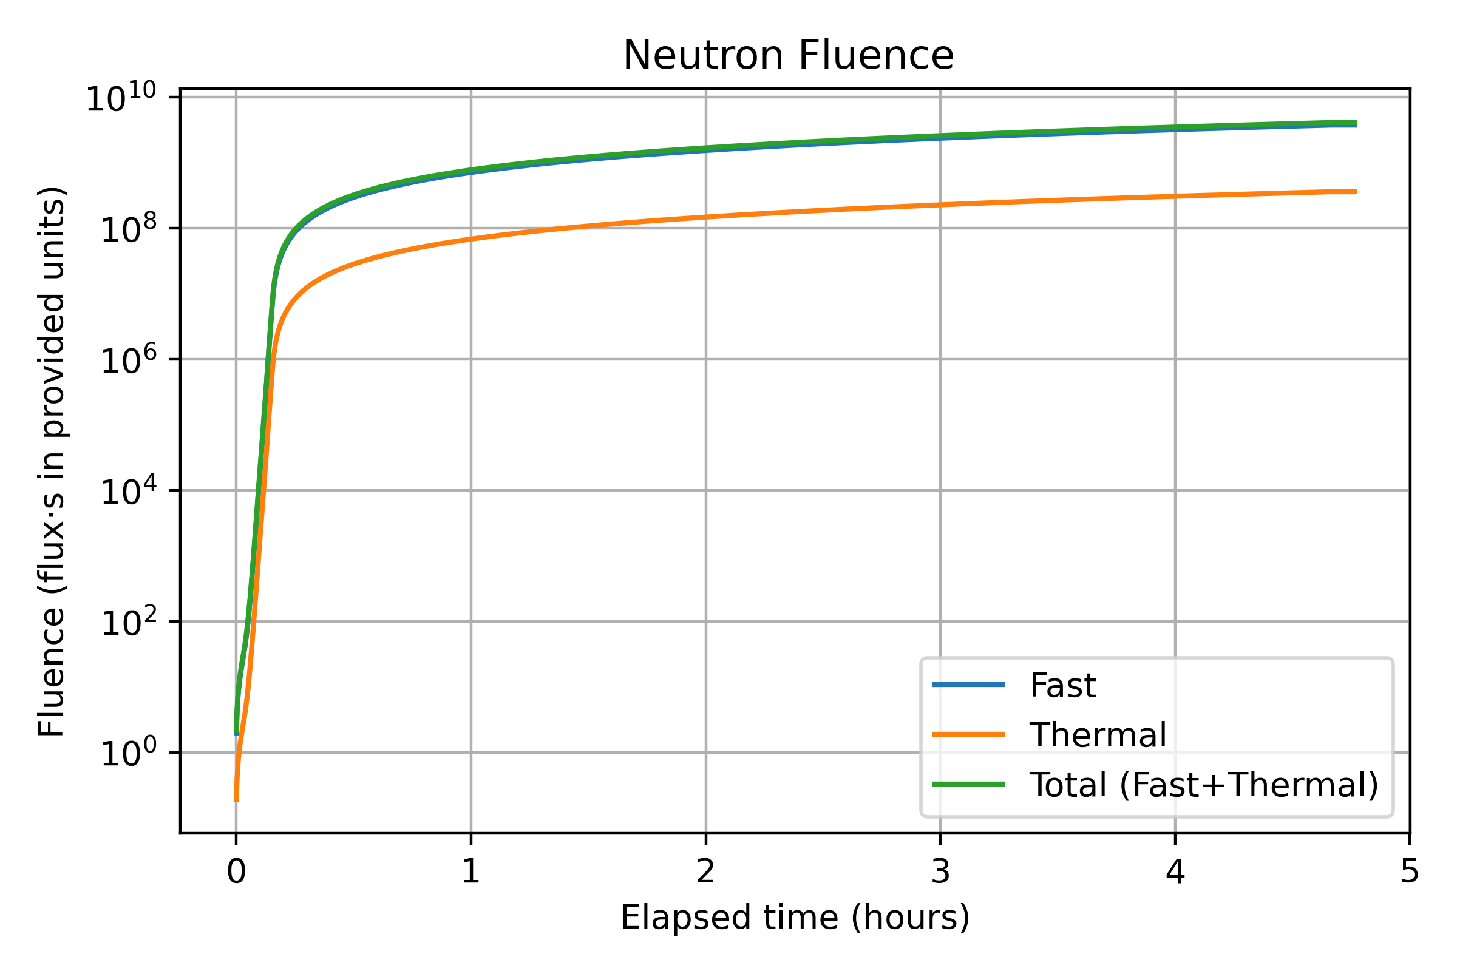
Figure 41: Neutron fluence (fast, thermal, and total) accumulated during the Day 1 (gamma shutter closed) reactor run at the OSURR FNBF.
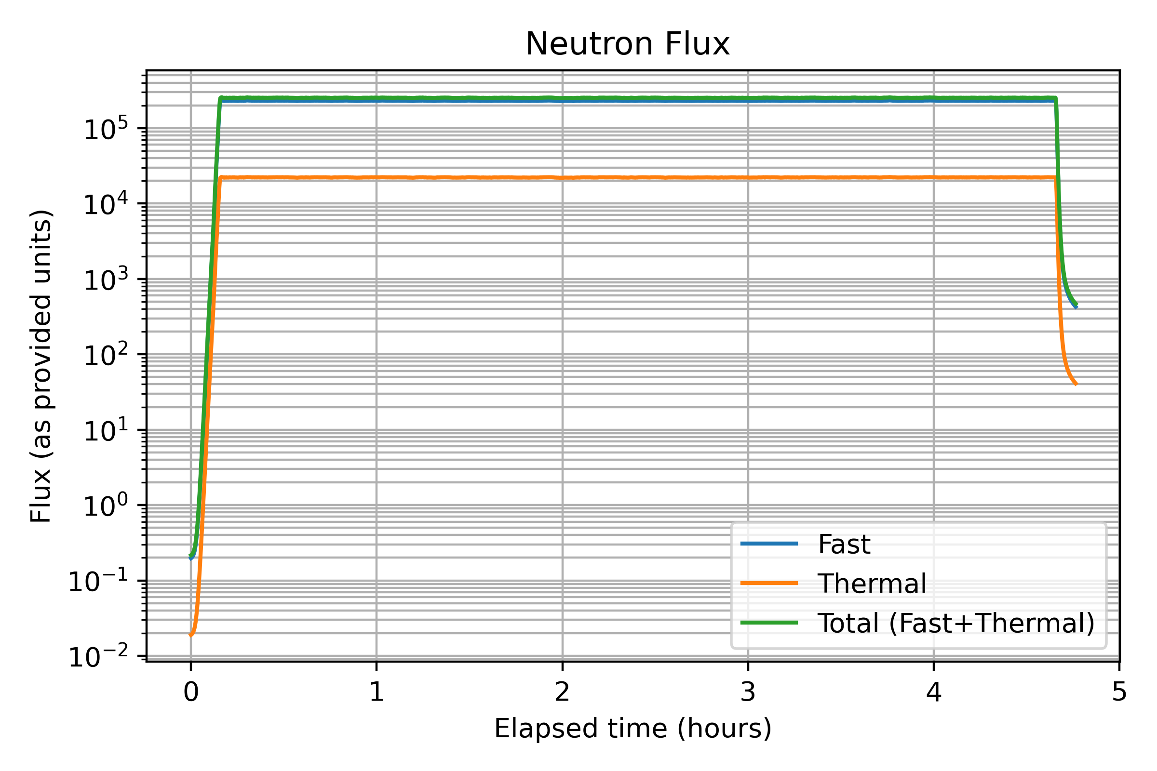
Figure 42: Neutron flux (fast, thermal, and total) during the Day 1 (gamma shutter closed) run.
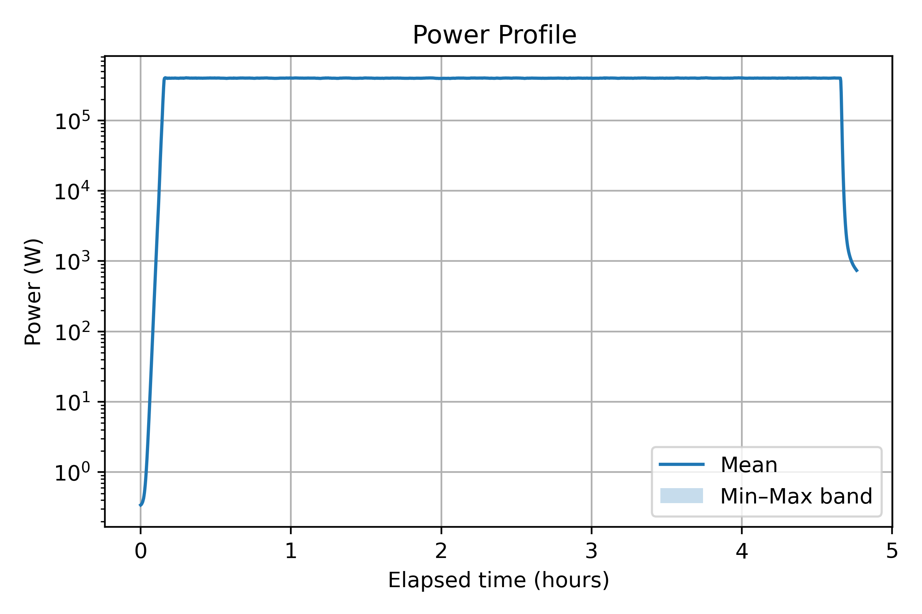
Figure 43: Reactor power profile during the Day 1 run.
The Day 1 beam configuration corresponds to the gamma shutter closed condition at the OSURR Fast Neutron Beam Facility. The FNBF beamline incorporates a 4-inch (10.16 cm) single-crystal bismuth block near the reactor core as a passive in-line gamma filter, followed by an 8-inch (20.32 cm) lead gamma shutter embedded in the reactor’s concrete shielding wall [@Panaccione2024]. When the lead shutter is closed, the gamma-ray content of the beam is reduced by a factor of 311 relative to the fully open configuration, while fast neutrons are simultaneously attenuated by a factor of 58. Under these conditions, the steady-state fast neutron flux ($E_{n}>0.5$ eV) at the beam collimator exit is approximately $2.6×{10}^{5}$ n/cm$​^{2}$/s, while the thermal neutron flux ($E_{n}<0.5$ eV) is approximately $2.5×{10}^{4}$ n/cm$​^{2}$/s, roughly one order of magnitude lower than the fast component. The residual gamma dose rate with the shutter closed is approximately 50 mR/h. The neutron energy spectrum of the FNBF beam, characterized using the SAND-II and STAYSL unfolding techniques with Cu, Au, and Ni metal wire neutron activation, spans thermal energies through the fast fission spectrum, but the fast and epi-thermal components dominate the integrated flux [@Panaccione2024]. As a result, the fast and total neutron fluence curves are nearly coincident in Figure 7.1, with the thermal contribution representing a minor fraction throughout the irradiation period.
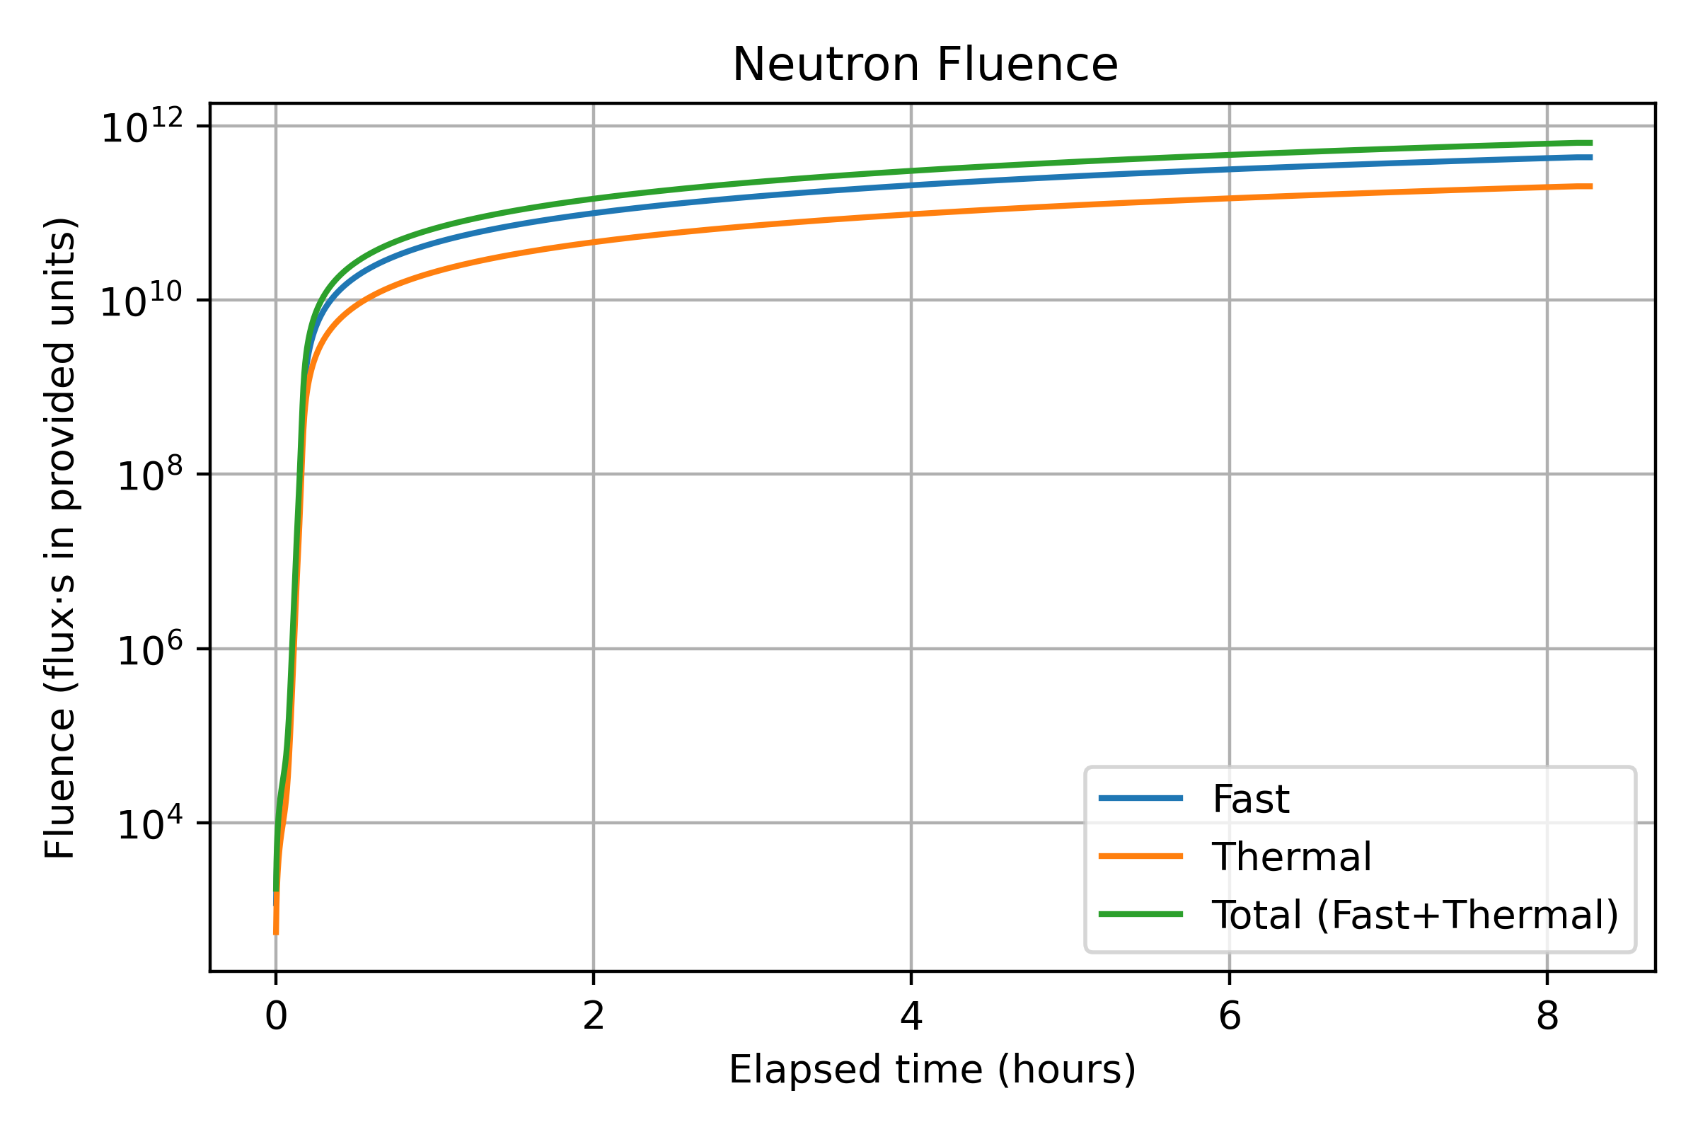
Figure 44: Neutron fluence (fast, thermal, and total) accumulated during the Day 2 (gamma shutter open) reactor run.
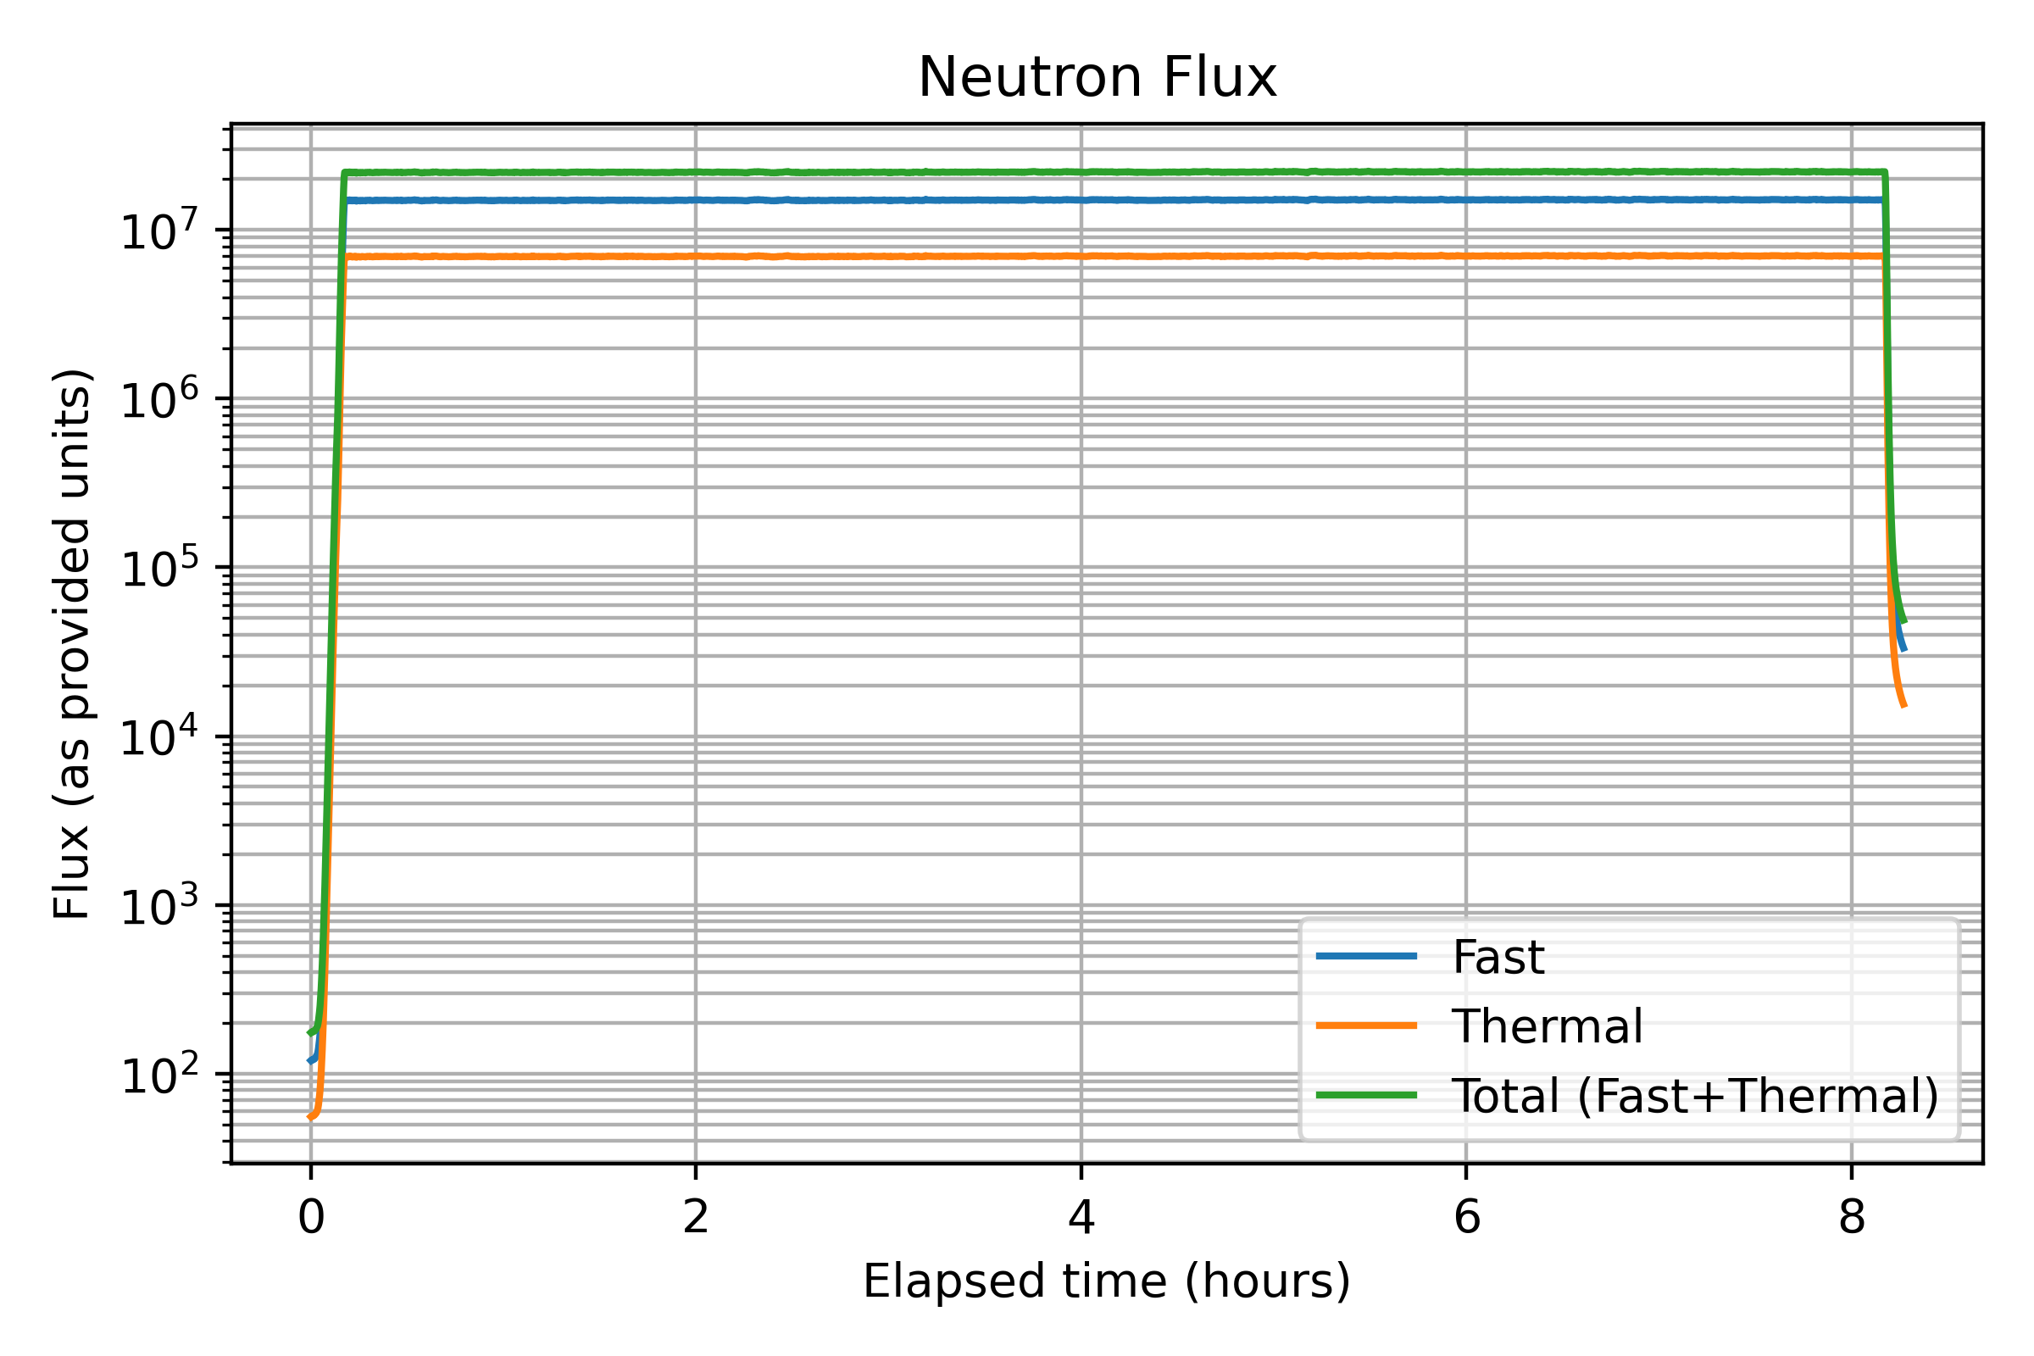
Figure 45: Neutron flux (fast, thermal, and total) during the Day 2 (gamma shutter open) run.
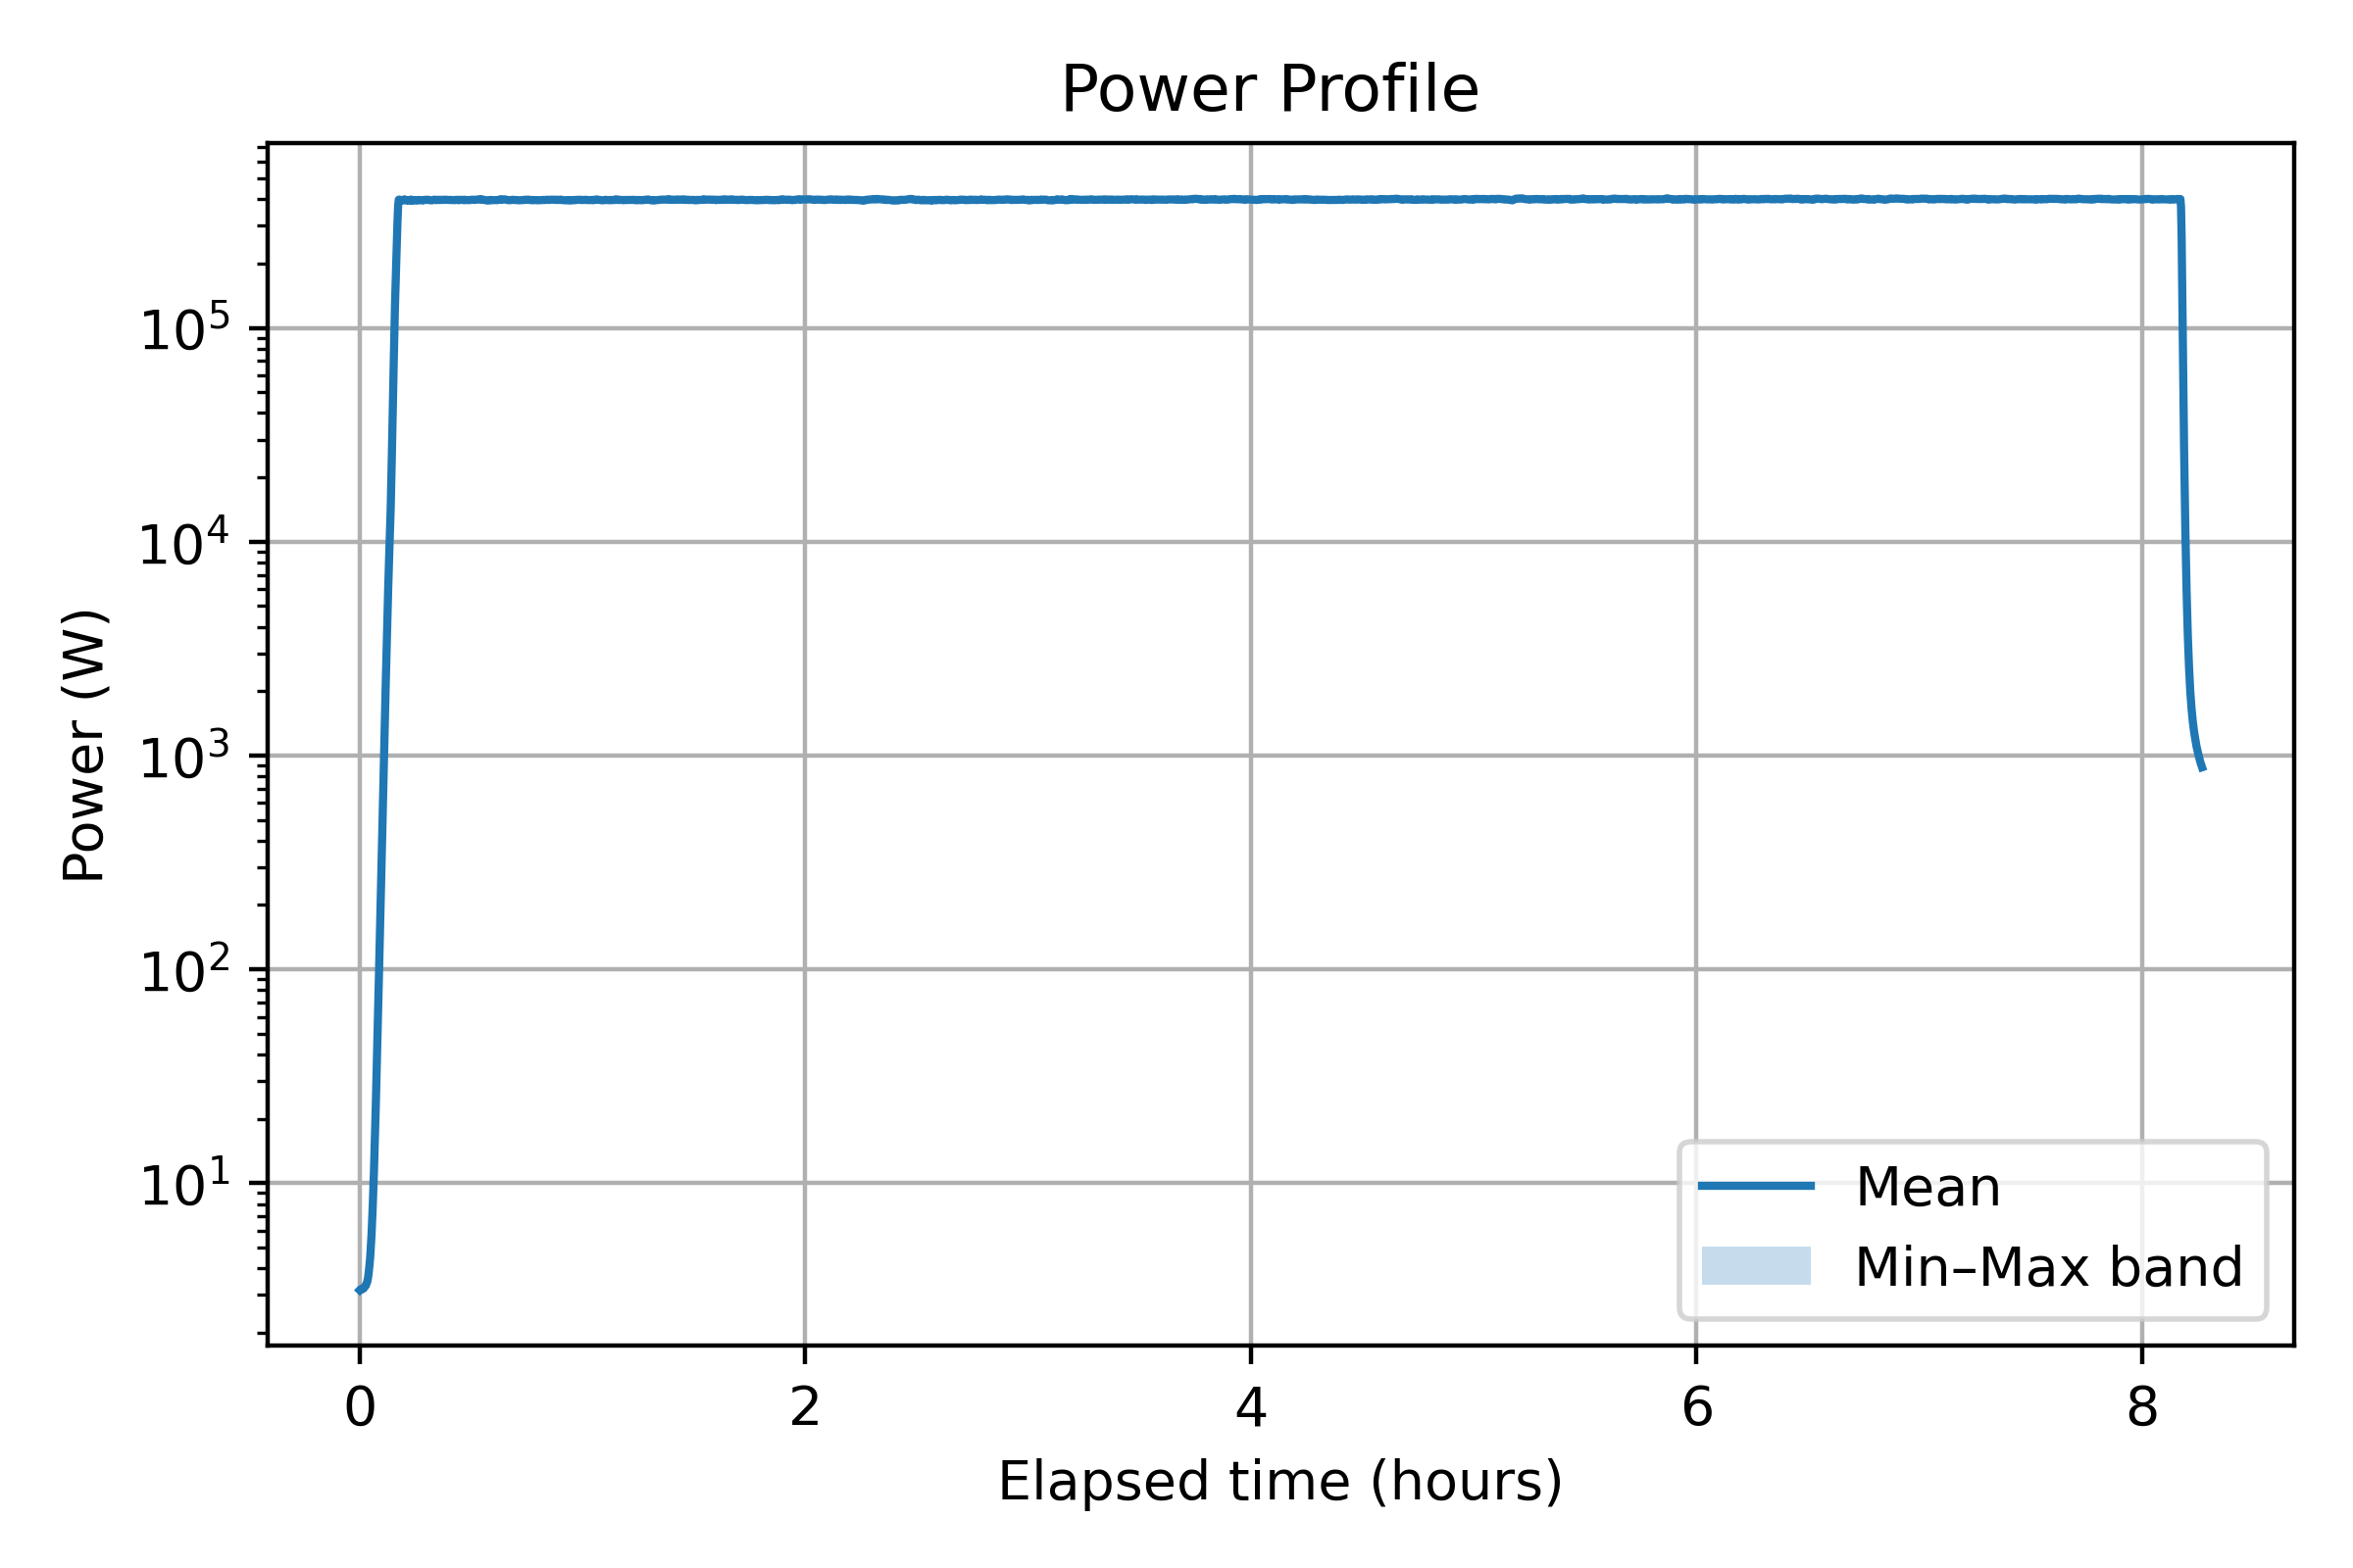
Figure 46: Reactor power profile during the Day 2 run.
The Day 2 beam configuration corresponds to the gamma shutter open condition. With the lead shutter removed from the beam path, the fast neutron flux at the collimator exit increases by a factor of approximately 58, reaching a steady-state value of approximately $1.5×{10}^{7}$ n/cm$​^{2}$/s [@Panaccione2024]. The thermal neutron flux simultaneously rises to approximately $8.3×{10}^{6}$ n/cm$​^{2}$/s, now within approximately a factor of two of the fast component, a substantially narrower fast-to-thermal ratio than the one order of magnitude separation observed in the shutter-closed configuration. This narrowing occurs because the lead shutter attenuates neutrons across the full energy spectrum; when it is removed, the beam carries a larger thermal contribution that is otherwise suppressed by the lead. The elevated thermal flux in the open-shutter configuration is relevant for interpreting FPGA upset behavior because both fast and thermal neutrons can induce nuclear recoil events in silicon, though fast neutrons dominate displacement damage due to their higher energy transfer per elastic scatter interaction. Taken together, the Day 2 exposure accumulated a total fast neutron fluence of approximately $8$–$9×{10}^{11}$ n/cm$​^{2}$ over the 8.5-hour run, roughly two orders of magnitude greater than Day 1, and it is this step change in fluence that drives the qualitative difference in observed device behavior between the two runs.
The overlay figures below place both beam configurations on common axes, making the shutter-state-driven difference in delivered fluence and flux directly apparent and confirming that the reactor power profile was consistent across the two days.
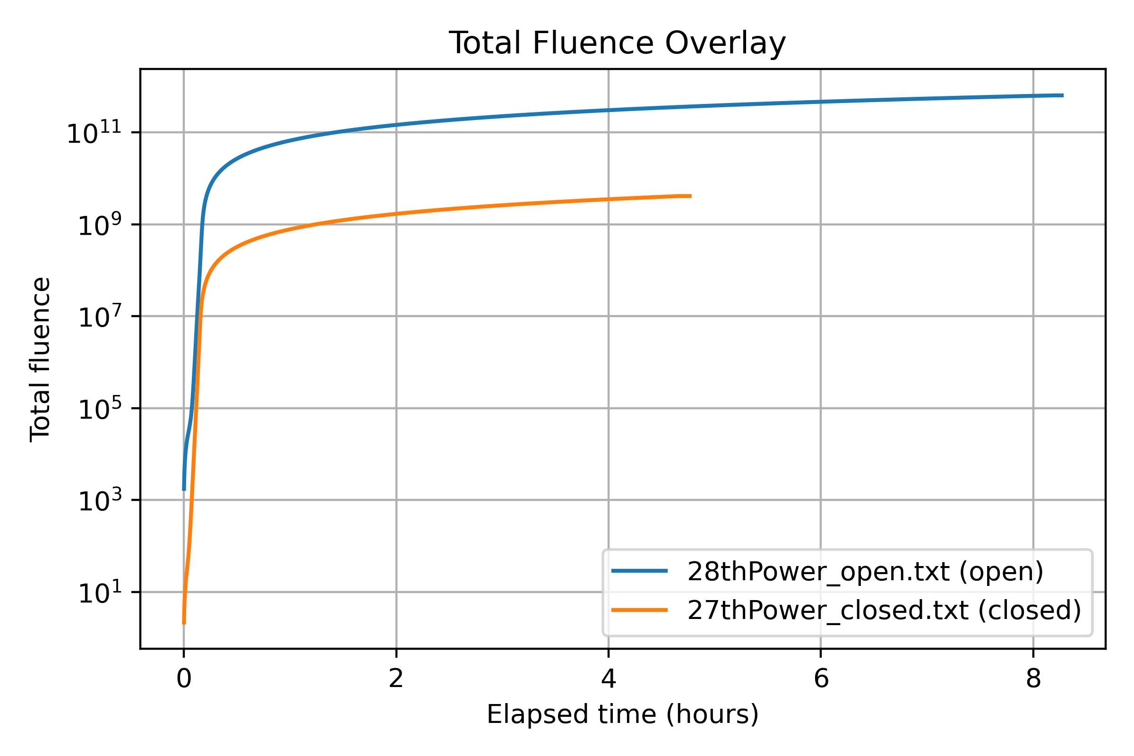
Figure 47: Overlay of total neutron fluence (fast + thermal) for the Day 1 (shutter closed) and Day 2 (shutter open) runs.
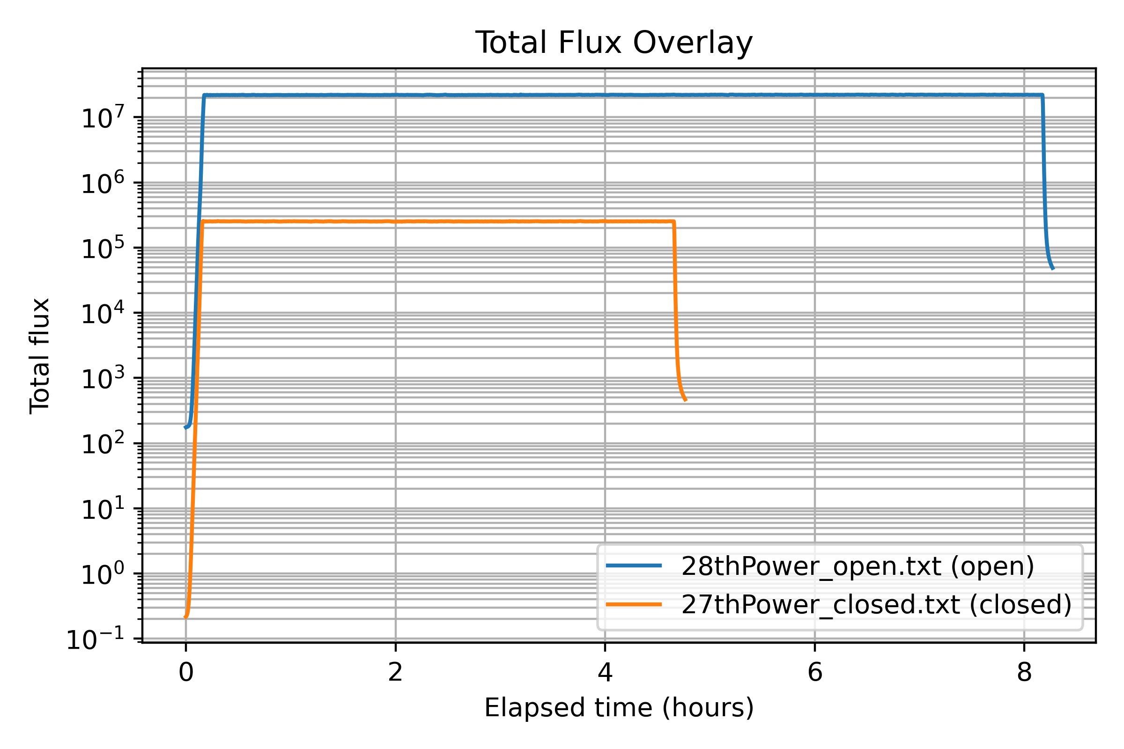
Figure 48: Overlay of total neutron flux for the Day 1 (shutter closed) and Day 2 (shutter open) runs.
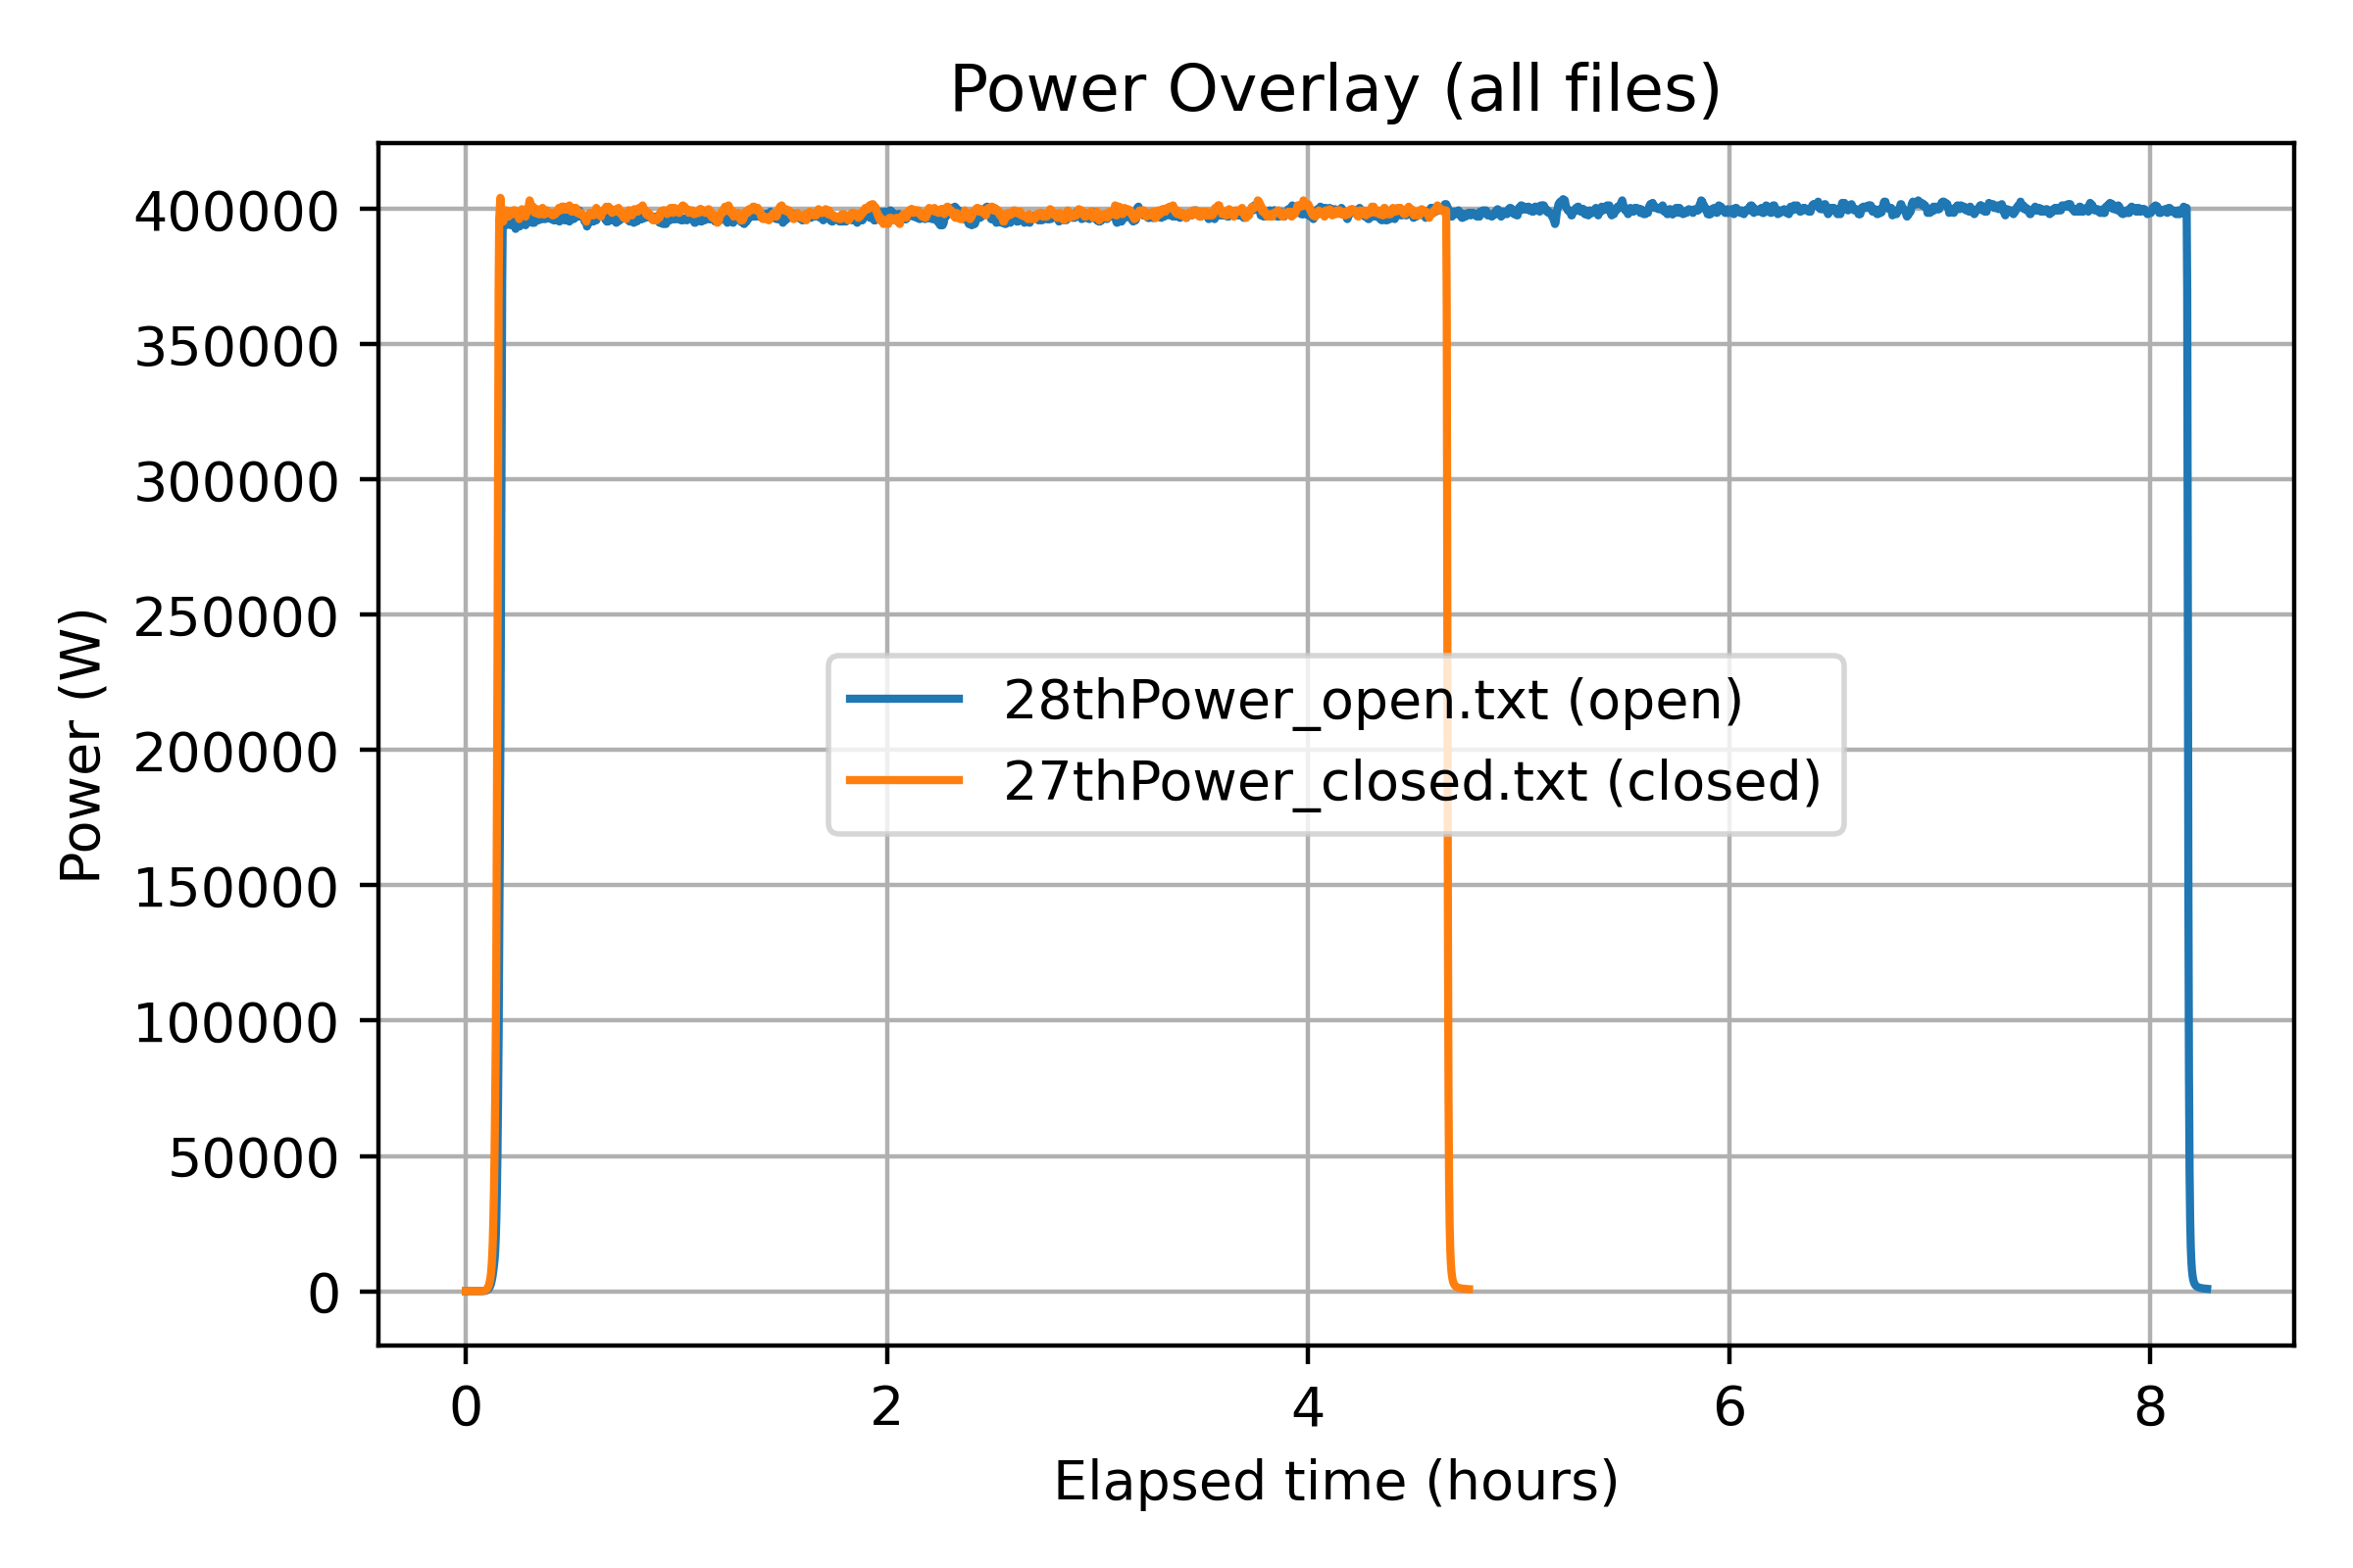
Figure 49: Reactor power overlay for the Day 1 and Day 2 runs on a linear scale.

Experimental Results

Baseline Test (January 26, Out of Beam)
Prior to transport to the reactor facility, all five devices were operated at ambient background radiation levels to establish a baseline and to confirm correct data acquisition system operation. FFSR1 began logging at 21:21 on January 26; FFSR2–5 began at 22:41. All devices reported CNT:00000000 continuously throughout the baseline period, confirming zero false positives from the test setup and demonstrating that the DMR detection logic was functioning correctly.
Logging on all five devices terminated simultaneously at approximately 22:59 due to a Windows Update reboot on the acquisition PC. This was not a device failure. After the reboot, logging was not restarted until the devices were at the reactor facility the following morning. Future tests should disable automatic OS updates on the acquisition PC for the duration of the experiment.

Day 1 Reactor Run (January 27)
Logging resumed at the reactor facility at approximately 11:42 on January 27 for all five devices. The reactor reached full power within the first 10–15 minutes. All devices monitored continuously through reactor shutdown at approximately 16:34, providing approximately five hours of reactor run data.
Upset Count Results
Zero SEUs were detected on any of the five devices throughout the entire Day 1 reactor run at a total fast neutron fluence of approximately $6$–$7×{10}^{9}$ n/cm$​^{2}$. All devices reported a consistent CNT:00000000 output for the full irradiation duration. Table 7.3 summarizes the Day 1 results.
Day 1 reactor run upset detection results. $​^{*}$FFSR1 count includes 250 CNT-format and $≈$3 252 CNZ-format readings (see Section 7.4.2.3).
Device | COM | Start | End | Readings | SEUs
FFSR1 | COM8 | 11:42 | 16:34 | $≈$3 502$​^{*}$ | 0
FFSR2 | COM7 | 11:42 | 16:34 | 3 491 | 0
FFSR3 | COM6 | 11:42 | 16:34 | 3 496 | 0
FFSR4 | COM9 | 11:42 | 16:34 | 3 497 | 0
FFSR5 | COM4 | 11:42 | 16:34 | 3 496 | 0
PSU Current Monitoring—Day 1
Power supply current was monitored for the CMOD board array throughout the Day 1 run. As shown in Figure 7.10, the current profile exhibits a power-on inrush transient from approximately 0.175 A, rising rapidly to a steady-state value of approximately 0.283–0.286 A within the first $∼$200 seconds as the boards initialised. The current then remained essentially flat for the entire $∼$17 500-second run ($∼$4.9 hours).
One small transient spike to approximately 0.289 A is visible at $∼$12 500 s, consistent with a brief radiation-induced transient event; the current returned immediately to the baseline level with no permanent change. Critically, no monotonic TID-induced current increase is evident across the Day 1 run. The flat current profile is consistent with the Day 1 fluence level being insufficient to produce measurable TID-related leakage current degradation in the CMOS circuitry, providing a useful baseline for comparison with the Day 2 profile (Section 7.4.4.2).
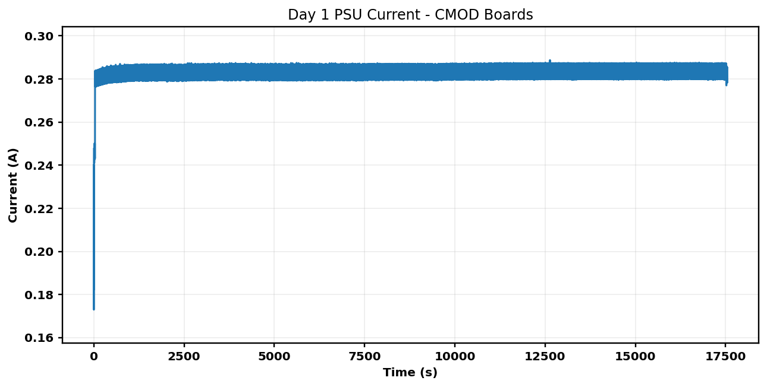
Figure 50: PSU current for the CMOD board array during the Day 1 (gamma shutter closed) reactor run.
FFSR1 UART Format Change—Candidate Configuration Memory SEU
At approximately 12:03 on January 27, the UART output format on FFSR1 changed from CNT:00000000 to CNZ0000. The label changed from CNT to CNZ, the colon delimiter disappeared, and the counter field width reduced from 8 hex digits to 4. This format change persisted for the remainder of the run; the upset count remained zero throughout in both formats; and FFSR2–5 showed no similar change.
This behavior is consistent with a single-event upset in the FPGA configuration memory (SRAM) rather than in the user data path. The Spartan-7 is an SRAM-based FPGA, meaning the design implementation, LUT contents, routing resources, and embedded string constants, is stored in volatile SRAM configuration bits as susceptible to neutron-induced upsets as any other SRAM. A bit flip in one or more configuration cells controlling the UART formatting logic could plausibly alter the output label and field width in exactly the structured manner observed.
This event is significant for two reasons. First, the DMR logic correctly protected the user flip-flop data path and reported zero upsets throughout, but it does not protect the configuration memory; the observation highlights that data-path redundancy alone is insufficient for SRAM-based FPGAs in radiation environments. Second, the single affected device (out of five) is consistent with the stochastic nature of SEUs at the Day 1 fluence level.

Overnight Monitoring (January 27–28)
Following the Day 1 reactor run, all five devices were left running overnight out of beam at the reactor facility. Logging ran from approximately 16:42 on January 27 to approximately 07:13 on January 28, providing roughly 14.5 hours of out-of-beam monitoring at ambient background levels. All five devices reported zero upsets throughout the overnight period, as expected. Table 7.4 summarizes the results.
Overnight (out-of-beam) monitoring results.
Device | COM | Log Start | Log End | Readings | SEUs
FFSR1 | COM8 | 16:48, Jan 27 | 07:13, Jan 28 | 13 981 | 0
FFSR2 | COM7 | 16:48, Jan 27 | 07:13, Jan 28 | 10 389 | 0
FFSR3 | COM6 | 16:48, Jan 27 | 07:13, Jan 28 | 10 354 | 0
FFSR4 | COM9 | 16:48, Jan 27 | 07:13, Jan 28 | 10 353 | 0
FFSR5 | COM4 | 16:48, Jan 27 | 07:13, Jan 28 | 10 353 | 0
Notably, FFSR1 continued to output in the CNZ0000 format throughout the entire overnight period, including after three reconnect attempts (16:42, 16:45, 16:48). For an SRAM-based FPGA, configuration memory is volatile, loaded from flash at power-up and held in SRAM during operation. A bit flip in the configuration SRAM will persist indefinitely until either the device is power-cycled or a scrubbing operation overwrites the affected cell. The persistence of the CNZ format through logging restarts, which do not cause a power cycle, but the expectation that it would be cleared by a full power cycle, is consistent with a configuration SRAM upset. This observation reinforces the importance of distinguishing between logging-session restarts and full device power cycles when interpreting FPGA behavior in radiation test environments.
Figure 7.11 shows the PSU current during the overnight period. Current was stable near 0.2835 A with occasional small transient spikes, confirming normal device operation at ambient background levels and providing a clean pre-Day-2 baseline.
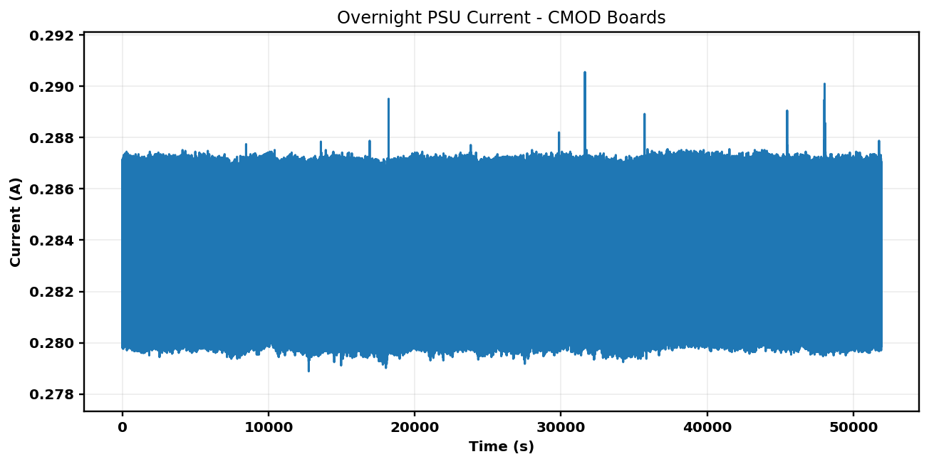
Figure 51: PSU current for the CMOD board array during the overnight (out-of-beam) monitoring period (January 27–28).

Day 2 Reactor Run (January 28)
The Day 2 reactor run was conducted with the gamma shutter open, producing a fast neutron flux approximately two orders of magnitude higher than Day 1. All five devices began logging at 07:21 and the reactor reached full power within approximately 20 minutes. The reactor ran for approximately 8.5 hours before controlled shutdown. Table 7.5 summarizes the Day 2 results.
Day 2 (gamma shutter open) upset detection results.
Device | COM | Log Start | Log End | Readings | SEUs / Notes
FFSR1 | COM8 | 07:21, Jan 28 | 15:54, Jan 28 | 715 | CNZ0800 detected (Sec. 7.4.4.3)
FFSR2 | COM7 | 07:21, Jan 28 | 14:44, Jan 28 | 5 298 | 0
FFSR3 | COM6 | 07:21, Jan 28 | 08:10, Jan 28 | 580 | 0—early dropout ($∼$49 min)
FFSR4 | COM9 | 07:21, Jan 28 | 07:57, Jan 28 | 431 | 0—early dropout ($∼$36 min)
FFSR5 | COM4 | 07:21, Jan 28 | 15:55, Jan 28 | 6 144 | 0
FFSR3 and FFSR4 Early Dropouts
FFSR4 ceased transmitting at approximately 07:57 ($∼$36 minutes into the run) and FFSR3 at approximately 08:10 ($∼$49 minutes in). Both devices stopped cleanly with no error messages; data simply ended mid-run and neither device recovered. Two plausible mechanisms are consistent with these observations:
- Radiation-induced latch-up. A high-energy neutron interaction could trigger a latch-up condition in the FPGA I/O or core circuitry, causing the device to lock up and halt UART output. Latch-up typically requires a power cycle to recover and can cause permanent damage if not cleared promptly.
- Critical configuration memory upset. A severe or multi-bit upset in a critical portion of the configuration memory (e.g., clock management or I/O control logic) could halt device operation entirely, even without a true latch-up.
The PSU current data (Figure 7.12) shows step increases at approximately 2 800 s and 5 000 s into the run. FFSR4 stopped at approximately 2 160 s and FFSR3 at approximately 2 940 s, placing both dropouts near the step increase at $∼$2 800 s. An abrupt change in aggregate board current at this time is consistent with a latch-up event altering one or both devices’ current draw. These early dropouts represent the most severe functional failures observed during the two-day campaign and are consistent with the two-orders-of-magnitude increase in fast neutron flux on Day 2.
PSU Current Monitoring—Day 2
Figures 7.12 and 7.13 show the CMOD board aggregate PSU current during the Day 2 run. Key observations are:
- Part 1 ($∼$07:21–14:15): Current increased steadily from approximately 0.28 A at run start to approximately 0.315 A by the end of the logging window, an increase of approximately 12.5%. This is in stark contrast to the flat Day 1 profile and is consistent with TID effects accumulating in the FPGA and support circuitry, increasing leakage current monotonically under the much higher Day 2 fluence. Step increases near 2 800 s and 5 000 s correspond to the approximate dropout times of FFSR4 and FFSR3 respectively.
- Part 2 ($∼$14:28–16:00): Current was approximately 0.315 A at the start of this window with a continued slow increase to $∼$0.319 A. Brief sharp transients at approximately 4 300 s and 5 200 s into this window are consistent with transient radiation events affecting the boards.
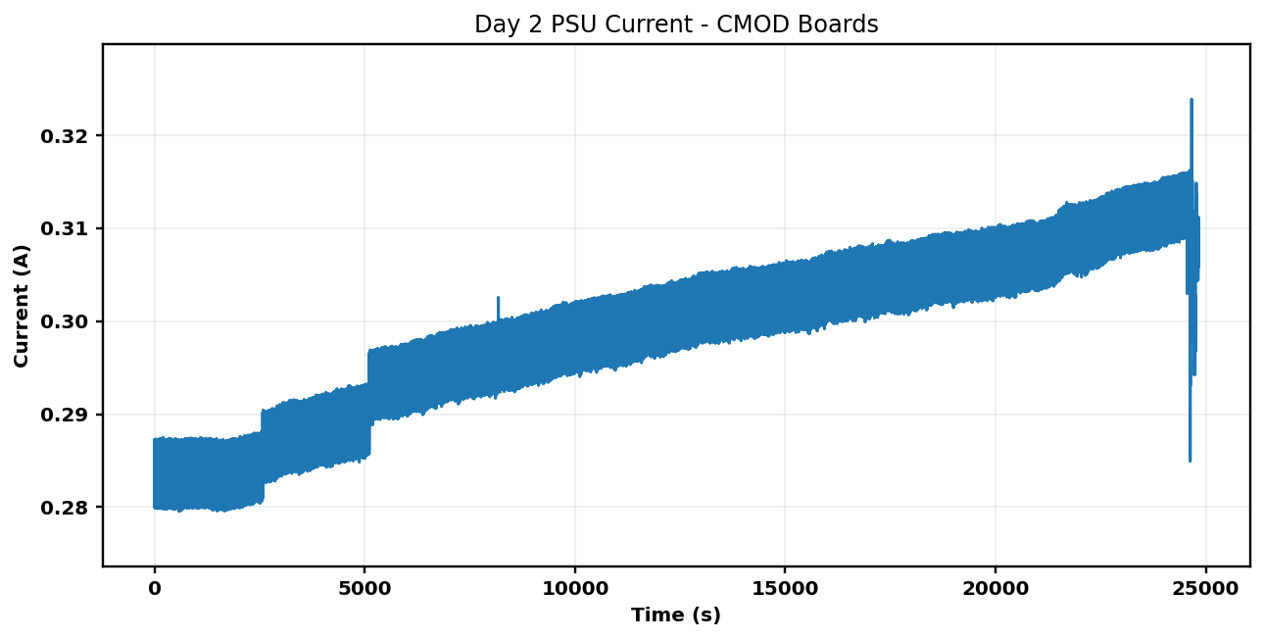
Figure 52: PSU current for the CMOD board array during the first part of the Day 2 (gamma shutter open) reactor run.
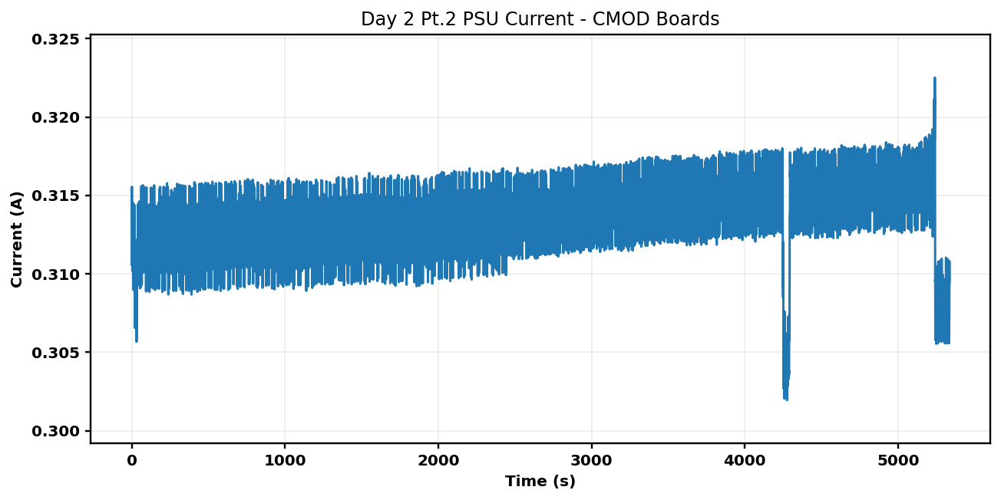
Figure 53: PSU current for the CMOD board array during the second part of the Day 2 run.
FFSR1 End-of-Run Burst Event and Confirmed DMR Upset
The most significant finding of the entire test campaign occurred on FFSR1 at approximately 15:54:44 on January 28. Under normal operation, FFSR1 transmitted one CNZ output line every $∼$5 seconds. At 15:54:44, the device abruptly began transmitting at an extremely high rate, approximately 400 readings within a 2-second window, roughly 500$×$ the normal output rate. Within this burst the following anomalies were observed:
- Multiple corrupted character substitutions: cNZ0000 (lowercase ‘c’), CLZ0000 (‘L’ for ‘N’), KNZ0000 (‘K’ for ‘C’), CN[0000 (‘[’ for ‘Z’).
- A truncated output: CNZ0 (partial transmission).
- A non-zero upset count: CNZ0800 (hexadecimal 0x0800 = 2 048 decimal).
The value CNZ0800 is the first and only non-zero DMR upset count recorded across the entire two-day test campaign, representing a confirmed detection of one or more single-event upsets in the FFSR user data path by the DMR comparator logic.
The burst event itself, the $∼$500$×$ increase in UART transmission rate, is strongly indicative of a second configuration memory SEU on FFSR1, this time affecting the UART baud rate generation logic. The baud rate divider is implemented in FPGA configuration resources; a bit flip in the timing register can reduce the inter-character delay to near zero, producing exactly the rapid-fire transmission pattern observed. The coincidence of the baud rate upset, the character corruption events, and the non-zero DMR count within a 2-second window is consistent with a high-rate SEU cluster, multiple configuration and data memory upsets occurring in rapid succession near the end of the reactor run when cumulative fluence was at its maximum.

Discussion

SEU Sensitivity of the DMR Design
The absence of any DMR-detected upsets across all five devices at the Day 1 fast neutron fluence of approximately $6$–$7×{10}^{9}$ n/cm$​^{2}$ indicates either that the DMR design successfully masked data path upsets that would otherwise be detectable, or that the Spartan-7 shift-register fabric did not experience a sufficient number of upset events to register a DMR mismatch at this fluence level. To distinguish between these interpretations, a companion test without DMR protection (e.g., a bare shift-register comparison) would be needed to establish the intrinsic SEU cross-section of the Spartan-7 fabric under this beam condition.
On Day 2, the first confirmed DMR data path SEU (counter value 2 048) was observed on FFSR1 at the highest fluence level of the campaign ($∼$$8$–$9×{10}^{11}$ n/cm$​^{2}$ total fast fluence). The two-orders-of-magnitude increase in flux and fluence from Day 1 to Day 2 is qualitatively consistent with the transition from zero detectable data-path upsets on Day 1 to device failures, latch-up events, and confirmed DMR detection on Day 2.

Configuration Memory Vulnerability
The FFSR1 observations across both days provide clear evidence of configuration memory SEUs manifesting as persistent, structured changes in device behavior. The Day 1 UART label change (Section 7.4.2.3) and the Day 2 burst event (Section 7.4.4.3) both represent configuration memory upsets whose effects persisted until the device was power-cycled, consistent with the volatile SRAM nature of the Spartan-7 configuration store. These observations highlight that SRAM-based FPGAs have two distinct radiation vulnerability mechanisms: upsets in the user data registers (addressed by DMR/TMR) and upsets in the configuration SRAM (addressed by periodic scrubbing). Radiation-hardened designs intended for extended exposure environments must address both.

TID Effects in PSU Current Data
The PSU current monitoring data provides a consistent and clear picture of TID accumulation across the two days. The Day 1 current profile was flat throughout ($∼$0.284 A), indicating negligible TID-induced leakage at the Day 1 fluence level. In contrast, the Day 2 current profile exhibited a steady monotonic increase of approximately 12.5% over the approximately 7-hour run. This is consistent with TID effects in the FPGA and support circuitry at the much higher Day 2 fluence. The step increases in the Day 2 current profile near 2 800 s and 5 000 s provide independent corroborating evidence for latch-up events at the times of the FFSR4 and FFSR3 dropouts.

Implications for FPGA Radiation Hardening
Taken together, the results of this two-day test campaign demonstrate several conclusions relevant to the use of SRAM-based FPGAs in fast neutron environments.
First, at moderate fluence levels ($∼$${10}^{9}$ n/cm$​^{2}$), configuration memory SEUs can occur before data-path SEUs are detectable at the DMR counter level, suggesting that configuration scrubbing should be considered even in designs that rely on DMR or TMR for data-path protection.
Second, at higher fluence levels ($∼$${10}^{11}$ n/cm$​^{2}$ and above), latch-up, multiple simultaneous SEUs, and TID-induced leakage all become significant concerns that require active mitigation strategies including latch-up detection and recovery circuitry, TID-hardened component selection, and TID-aware power budget margins.
Third, the FFSR architecture proved effective as a radiation test instrument. The DMR comparator correctly identified the single confirmed data-path upset event while maintaining consistent zero-count output throughout normal operation, and the UART telemetry path provided a reliable real-time window into device state for the duration of both reactor runs.

Summary
This chapter presented the design and experimental results of the FFSR DMR irradiation test conducted at the OSURR Fast Neutron Beam Facility on January 26–28, 2026. The principal findings are as follows.
Day 1 (gamma shutter closed, $∼$$6$–$7×{10}^{9}$ n/cm$​^{2}$ fast fluence). Zero DMR-detected SEUs across all five devices during approximately five hours of irradiation. FFSR1 exhibited a UART output format change consistent with a configuration memory SEU while the DMR upset counter remained zero. No measurable TID effects were observed in the PSU current data.
Overnight (out of beam, January 27–28). Zero upsets across all five devices during approximately 14.5 hours of ambient monitoring. The FFSR1 CNZ format persisted through all logging restarts, confirming a persistent SRAM hardware state change rather than a software artifact.
Day 2 (gamma shutter open, $∼$$8$–$9×{10}^{11}$ n/cm$​^{2}$ fast fluence). FFSR3 and FFSR4 experienced early functional dropouts at approximately 36 and 49 minutes respectively, consistent with radiation-induced latch-up supported by the PSU current data. FFSR2 and FFSR5 completed the full run with zero DMR upsets. FFSR1 experienced a severe multi-SEU cluster event near the end of the run, producing the first and only confirmed non-zero DMR upset count of the campaign (CNZ0800, 0x0800 = 2 048) along with a second configuration memory SEU affecting the UART baud rate. PSU current monitoring showed a sustained $∼$12.5% increase over the Day 2 run, consistent with TID-induced leakage current accumulation.
Overall, these results demonstrate that SRAM-based FPGAs operating in this fast neutron environment are susceptible to configuration memory SEUs at moderate fluence levels, and to data-path SEUs, latch-up, and TID degradation at higher fluence levels. The FFSR DMR architecture successfully fulfilled its design objective of detecting data-path upsets while operating reliably throughout the test campaign, and highlights the need for configuration memory scrubbing and latch-up recovery circuitry for SRAM-based FPGAs intended for extended operation in radiation environments. The following chapter extends this irradiation campaign with the fixed-point thermal control benchmark, which complements the FFSR by stressing arithmetic computation, closed-loop control, and continuous state evolution rather than simple shift-register propagation.

Methods and Algorithms of the Fixed-Point Thermal Control Benchmark

Introduction
The preceding chapter described experiments conducted with the Free-Form Spatial Reference (FFSR) benchmark to evaluate FPGA behaviour under irradiation. The present chapter introduces a complementary benchmark designed for the same class of irradiation campaign, but with a richer computational workload and built-in self-comparison capability. Whereas the FFSR design exercised basic reconfiguration and readback paths, the fixed-point thermal control benchmark couples closed-loop feedback control, emulated physical plant dynamics, nonlinear actuator mapping, and dual-modular redundancy (DMR) within a single synthesizable Verilog design. Because the two benchmarks share the same neutron irradiation facility and beam configuration, the experimental infrastructure described in Chapter 7 applies directly here, and the present chapter focuses exclusively on the design methods, algorithms, and implementation choices that distinguish this benchmark.
The benchmark is implemented entirely in synthesizable, fixed-point Verilog and is intended to operate continuously during an irradiation session, producing a 100 Hz serial telemetry stream that records the internal state of the control loop. Any radiation-induced perturbation that alters arithmetic results, corrupts stored state, or disrupts the routing of signals within the FPGA is therefore observable in real time through the telemetry output or, for subtle divergences, through the pipelined mismatch flag generated by the DMR wrapper. This combination of control significance and fault-detection capability makes the benchmark especially well suited to in-situ FPGA irradiation studies.
The remainder of this chapter is organized as follows. Section 8.2 describes the top-level architecture and design rationale. Section 8.3 defines the fixed-point number representation and sampling structure. Sections 8.4–8.8 present the individual algorithmic subsystems in mathematical and implementation detail. Section 8.9 covers the redundancy, fault detection, and telemetry mechanisms. Section 8.10 maps each RTL module to its mathematical role. Section 8.11 describes the neutron irradiation experiment setup. Section 8.12 presents comparative observations from two telemetry runs and discusses the failure mechanism. Section 8.13 discusses relevance to the radiation-effects objectives of this dissertation, and Section 8.14 concludes with a chapter summary.
Implementation snapshot, key parameters of the fixed-point thermal control benchmark as configured in the present irradiation experiments.
Parameter | Value / Description
Clock frequency | 100 MHz top-level system clock
Control/plant sample rate | 1 kHz global tick generated in the stimulus block
Arithmetic format | Predominantly signed Q1.15; Q1.30 internal accumulation in the thermal plant
Redundancy | Two duplicated control-plant chains compared inside the DMR wrapper with CSV-style UART telemetry
Button control | 20 ms debounce; 3 s hold to stop; short press-and-release issues restart_pulse and resumes run mode
UART output decimation | decim $=10$, giving one CSV record every 10 ms (100 Hz) while running
DMR compare tolerance | dmr_tol_q15 $=\text{0x0000}$ (exact comparison)

System-Level Methodology
At the highest level, the benchmark is organized as a sampled-data loop executed inside a single FPGA clock domain running at 100 MHz. A one-cycle sample strobe at 1 kHz acts as the logical update event for the control algorithm, the plant emulation, and telemetry capture. In the current top-level implementation (top_pid_thermal_dmr.v), this strobe is generated in u_stim.v and forwarded as the global tick only while the run-enable signal is asserted, so the dynamic state of the benchmark freezes when the experiment is stopped. The top-level integration additionally includes a dedicated power-on-reset counter, button-driven run and restart control, a millisecond time base that is reset by the restart pulse, the DMR-protected control-plant core, and the UART output path.
The design is organized around five functional layers: (1) input stimulus generation, (2) the closed-loop control algorithm, (3) actuator and nonlinear valve mapping, (4) the two-node thermal plant and measurement model, and (5) redundancy and telemetry infrastructure. Each layer is implemented in one or more dedicated RTL modules, and the inter-module interfaces use fixed-point Q1.15 values throughout.
This methodology has several advantages for radiation-effects experimentation. First, the state evolution is deterministic and repeatable, which allows observed anomalies to be attributed more confidently to hardware perturbations rather than software timing jitter. Second, the use of bounded fixed-point states and saturating arithmetic prevents uncontrolled numeric growth during upset conditions. Third, the benchmark simultaneously exercises arithmetic pipelines, state registers, lookup tables, comparators, counters, and serial communication logic, all categories of FPGA resource that can respond differently to configuration upsets or transient single-event effects. Finally, the explicit run gating, exact DMR comparison, and deterministic restart behaviour make it well suited to repeatable irradiation campaigns where reproducible initial conditions are important.

Numerical Representation and Sampling Structure
Nearly all signals in the design are encoded in signed Q1.15 format. In this representation, a 16-bit signed integer $x_{q15}$ represents the real quantity $x$ through the scaling relation
$$x ≈ \frac{x_{q15}}{2^{15}} .$$
This choice provides compact arithmetic, deterministic synthesis, and direct use of FPGA DSP-slice resources while maintaining sufficient precision for the normalized thermal benchmark, where all physical quantities are expressed as dimensionless fractions of their respective full-scale values.
The reusable multiplier pipeline in q15_mul_pipe.v implements rounded fixed-point multiplication. For Q1.15 operands $a$ and $b$, the full-precision product is formed in Q1.30, rounded by adding one-half least-significant bit of the target scale, and then shifted right by 15 bits:
$$p_{q15} = round​\left(\frac{a_{q15}⋅b_{q15}}{2^{15}}\right) .$$
Simple additions and subtractions that could exceed the numeric range are performed with saturation rather than wraparound. This is especially important in a closed-loop design, because two’s-complement overflow produces nonphysical values that are indistinguishable in the binary record from genuine radiation-induced upsets. The thermal plant goes one step further and stores its internal accumulator state in signed Q1.30 format, thereby reducing deadband and truncation error in the forward-Euler integration even though block inputs and outputs remain Q1.15.
Sampling is derived from the 100 MHz FPGA clock by a divider in u_stim.v. One global tick is generated every 100,000 system-clock cycles, corresponding to a sample period $T_{s}=1$ ms. Because tick_1k is taken directly from the stimulus-valid pulse, the controller, plant, DMR wrapper, and UART logger all advance only when the benchmark is in run mode. The control chain is pipelined over several 100 MHz cycles so that the algorithmic latency from tick assertion to updated measured output is approximately 70 ns, negligible relative to the 1 ms control period.

Input Stimulus and Run/Restart Control

Button-Controlled Run Logic
Human interaction with the benchmark during an irradiation session is handled by btn_run_ctrl.v. The pushbutton signal is synchronized through a two-flip-flop chain to eliminate metastability, then debounced by requiring a stable level for a programmable window of 20 ms. A short press-and-release sequence issues a one-cycle restart pulse and enables run mode; a long press of at least 3 s latches the design into a stopped state. This approach prevents mechanical bounce from spuriously retriggering the experiment and provides an operator-friendly means to restart the benchmark between irradiation intervals without requiring FPGA reconfiguration.

Stimulus Generator
The block u_stim.v generates the closed-loop reference $r[k]$ and the disturbance (thermal power input) term $Q[k]$. The pattern repeats every 600 s and is indexed by a millisecond counter $t_{ms}$ that wraps after 600 000 updates. The reference target follows a piecewise-constant schedule, while the disturbance is applied as a direct step profile:
$$r_{tgt}(t) = \left\{\begin{matrix}0.55, & 0≤t<30 s \\ 0.60, & 30≤t<250 s \\ 0.57, & 250≤t<400 s \\ 0.61, & 400≤t<530 s \\ 0.55, & 530≤t<600 s\end{matrix}\right.$$
$$Q(t) = \left\{\begin{matrix}0.0850, & 0≤t<300 s \\ 0.0935, & 300≤t<600 s\end{matrix}\right.$$
The reference actually delivered to the controller is slew-rate limited to prevent discontinuous command changes. It is updated every 10 ms by a bounded increment $Δr$. The slew law implemented in RTL is
$$r[k+1] = sat​\left\{r[k]+clip\left(r_{tgt}[k]−r[k], −Δr, +Δr\right)\right\} ,$$
with $Δr=5/32768≈1.53×{10}^{−4}$. This produces a finite ramp toward each new target, yielding a more informative transient response and avoiding step-like commands that would otherwise cause the controller output to rail immediately upon each reference change. Table 8.2 summarizes the piecewise schedule.
Piecewise input schedule implemented by the stimulus generator.
Interval | $r_{tgt}$ | $Q$ | Purpose in experiment
$0$–$30$ s | 0.55 | 0.0850 | Initial settling and baseline establishment
$30$–$250$ s | 0.60 | 0.0850 | Positive reference step and steady-state recovery
$250$–$300$ s | 0.57 | 0.0850 | Small reference decrease before disturbance change
$300$–$400$ s | 0.57 | 0.0935 | Disturbance increase at constant reference
$400$–$530$ s | 0.61 | 0.0935 | Combined reference increase under higher disturbance
$530$–$600$ s | 0.55 | 0.0935 | Return toward baseline before pattern repeats

Controller Algorithm: Reverse-Acting I-PD with Anti-Windup
The controller is implemented in ipd_ctrl_q15.v as a reverse-acting I-PD structure. In this formulation the proportional and derivative actions act on the measured plant output rather than on the tracking error directly, which prevents actuator kicks when the reference changes abruptly. Only the integral state is updated from the control error. The sampled error and measured increment are
$$\begin{aligned}e[k]&=r[k]−y_{m}[k] , \\ Δy[k]&=y_{m}[k]−y_{m}[k−1] .\end{aligned}$$
The derivative channel is low-pass filtered to suppress finite-difference noise. Using smoothing coefficient $α∈[0,1]$, the filtered derivative state is updated as
$$Δy_{f}[k] = α Δy_{f}[k−1]+(1−α) Δy[k] .$$
The pre-saturation control command combines the proportional contribution on measurement, the derivative contribution on filtered measurement change, and the integral accumulator:
$$u_{pre}[k] = K_{p} y_{m}[k] + K_{d} Δy_{f}[k] + I_{int}[k] .$$
The physical command is bounded to the allowable actuator range:
$$u[k] = sat​\left(u_{pre}[k], U_{min}, U_{max}\right) .$$
To prevent integrator windup during saturation, a condition of particular importance in radiation testing where prolonged actuator saturation following an upset could mask recovery dynamics, the RTL includes a back-calculation anti-windup correction. The integral state update is
$$I_{int}[k+1] = I_{int}[k] − K_{i} e[k] + K_{t}\left(u[k]−u_{pre}[k]\right) .$$
The term $K_{t}(u−u_{pre})$ drives the integral state back toward consistency with the saturated output, preventing prolonged recovery times after rail contact. In the current top-level configuration $K_{p}≈1.0$, $K_{i}≈5.49×{10}^{−4}$, $K_{d}=0$, $α≈0.90$, $U_{min}≈0.020$, $U_{max}≈0.980$, and $K_{t}≈0.025$. The derivative gain is set to zero in the present benchmark configuration, so the instantiated RTL retains the full I-PD architecture but operates effectively as a PI controller.

Actuator Dynamics and Nonlinear Valve Mapping

First-Order Actuator with Slew Limiting
The valve actuator is implemented in valve_act_q15.v as a first-order lag from the demanded command $u[k]$ to the realized valve position $v[k]$. The unconstrained update law is
$$v_{pred}[k] = a_{v} v[k−1] + (1−a_{v}) u[k] ,$$
where $a_{v}$ approximates $e^{−T_{s}/τ_{v}}$. In the present configuration $a_{v}=0.9502$. An explicit slew-rate limit and a hard clamp to $[0,1]$ are also applied. With $Δv_{max}$ denoting the maximum admissible change per sample:
$$v[k] = {clamp}_{[0,1]}​\left\{clip\left(v_{pred}[k], v[k−1]−Δv_{max}, v[k−1]+Δv_{max}\right)\right\} .$$

Equal-Percentage Valve Characteristic
The relationship between valve position and normalized flow is implemented with a lookup table in valve_map_case.v. Rather than evaluate a transcendental mapping at run time, the RTL indexes a 256-entry case-ROM using the upper bits of the Q15 valve position. The table was generated offline to match a normalized equal-percentage characteristic with gain parameter $g=2.0$ and exponent $n=0.6$:
$$φ(v) = \frac{g^{v}−1}{g−1} , 0≤v≤1 .$$
A second exported table stores a nonlinear power of this flow quantity:
$$φ_{pow}(v) = {\left[φ(v)\right]}^{n} .$$
The LUT-based approach preserves a nonlinear actuator-to-flow relation while remaining fully deterministic, synthesizable, and timing friendly. From a radiation-testing perspective, the LUT content resides in FPGA configuration memory and is therefore vulnerable to single-event upsets that alter the stored coefficients, making the valve map a useful target for future fault-injection studies.

Coefficient Builder
The block coeff_builder.v converts the valve-map outputs into flow-dependent plant coefficients. Floor values $ε$ and $ε_{pow}$ prevent the effective mass-flow and heat-transfer terms from collapsing to zero:
$$\begin{aligned}{\dot{m}}_{rel}[k]&=max​\left(φ[k], ε\right) , \\ {\dot{m}}_{rel,pow}[k]&=max​\left(φ_{pow}[k], ε_{pow}\right) , \\ mcp[k]&={mcp}_{0}+k_{m} {\dot{m}}_{rel}[k] , \\ hA[k]&={hA}_{0}+k_{h} {\dot{m}}_{rel,pow}[k] .\end{aligned}$$
Both the coolant heat-capacity flow rate $mcp$ and the effective thermal conductance $hA$ therefore vary with valve opening, introducing a state-dependent nonlinearity into the plant model and exercising the coefficient-computation path of the FPGA on every sample tick.

Two-Node Thermal Plant

Two-Node Forward-Euler Integration
The thermal plant is implemented in plant_two_node_q15.v as a two-node lumped-parameter model consisting of a fuel node temperature $T_{f}$ and a coolant node temperature $T_{c}$. The state equations are discretized with forward-Euler integration, with $T_{s}/C_{f}$ and $T_{s}/C_{c}$ supplied as precomputed coefficients:
$$T_{f}[k+1]=T_{f}[k]+\frac{T_{s}}{C_{f}}\left(Q[k]−hA[k]\left(T_{f}[k]−T_{c}[k]\right)\right) ,$$
$$T_{c}[k+1]=T_{c}[k]+\frac{T_{s}}{C_{c}}\left(hA[k]\left(T_{f}[k]−T_{c}[k]\right)−mcp[k]\left(T_{c}[k]−T_{in}[k]\right)\right) .$$
Several implementation choices are noteworthy from a radiation-testing perspective. First, internal state is stored in Q1.30 accumulators, reducing numeric deadband and making the integration less sensitive to quantization errors introduced by bit-flip upsets. Second, the plant snapshots its inputs on the update tick and executes a four-stage arithmetic pipeline before committing the new temperatures, ensuring that a partially completed pipeline state cannot produce a corrupted but plausible output. Third, an optional clamp constrains the final temperatures to $[0,1)$, ensuring the emulated plant remains bounded even under prolonged actuator saturation following an upset.

Outlet Transport Lag
The measured outlet temperature is not taken directly as the coolant-node temperature. Instead, transport_lag_q15.v implements an additional first-order mixing lag:
$$y[k] = a_{p} y[k−1] + (1−a_{p}) T_{c}[k] ,$$
where $a_{p}=0.99786$ approximates $e^{−T_{s}/τ_{p}}$. This added lag introduces a second persistent state register whose vulnerability to upsets is distinct from the plant accumulator states.

Quantized Measurement Path
The module quantizer_fifo.v models analog-to-digital conversion and optional transport latency. For an $N$-bit ADC, the input $y$ is clamped to $[0,1]$, optionally dithered, and quantized:
$$\begin{aligned}c[k]&=round​\left(y[k]⋅(2^{N}−1)\right) , \\ y_{m}[k]&=c[k]⋅2^{15−N} .\end{aligned}$$
In the present configuration, $N=15$, the FIFO latency is zero, and dither is disabled. The measurement path therefore behaves almost transparently at present, but the block remains methodologically important as a clean insertion point for future studies involving reduced measurement resolution, explicit sample delay, or dither-assisted quantization noise shaping.

Redundancy, Fault Detection, and Telemetry

Dual-Modular Redundancy
The module dmr_wrap_ctrlplant.v instantiates two identical copies of the complete control-plant chain. Chain A drives the live outputs; Chain B serves as the redundant checker. Selected outputs from both copies are snapshotted on the sample tick and then compared signal-by-signal with a programmable tolerance. The mismatch condition for each monitored signal $s$ is
$$m_{s}[k] = \left\{\begin{matrix}1, & \text{if }|s_{A}[k]−s_{B}[k]|>tol \\ 0, & \text{otherwise.}\end{matrix}\right.$$
The present implementation checks six signals: $u$, $v$, $T_{f}$, $T_{c}$, $y$, and $y_{m}$. The six per-signal mismatch bits are first registered, then OR-reduced in a second pipeline stage to ease timing closure at 100 MHz. The result drives a sticky status bit and an event counter that increments on each rising edge of the mismatch condition. With $\text{dmr_tol_q15}=0$, the comparison is exact. This arrangement detects silent divergence between redundant implementations without requiring invasive internal probes.

Saturation Activity Monitor
The project also includes the health-monitor block sat_monitor.v, which observes whether the controller output is at or near either actuator rail. The saturation flag is
$$s[k] = \left\{\begin{matrix}1, & \text{if }u[k]≥U_{max}−δ\text{ or }u[k]≤U_{min}+δ \\ 0, & \text{otherwise,}\end{matrix}\right.$$
and an exponentially weighted moving average (EMA) of saturation activity is computed as
$$EMA[k] = EMA[k−1] − 2^{−d} EMA[k−1] + 2^{−d} s[k] .$$
Although sat_monitor.v is not instantiated in the current top-level path, the logger receives the direct saturation flag and the $\text{sat_ema_q15}$ input is tied to zero, the block formalizes how saturation activity could be compressed into a single bounded diagnostic state in future experiments where sustained actuator saturation following a large upset is an expected outcome.

UART Logging Method
The benchmark exports its internal state through uart_logger.v and uart_tx_simple.v. The logger snapshots the principal state variables on the 1 kHz tick, applies a decimation factor of ten, and serializes the snapshots into comma-separated hexadecimal records at 115,200 baud. One record is therefore emitted every 10 ms, corresponding to a 100 Hz logging rate. The field list includes time stamp, reference, disturbance, inlet temperature, pre- and post-measurement outlet temperatures, control command, valve position, node temperatures, tracking error, controller saturation flag, the tied-off saturation EMA field, and the DMR mismatch status. This record structure provides a complete state history of the closed-loop system and is the primary data source for the radiation-effects analysis presented in Section 8.12.

Timing and Module-to-Method Mapping
The complete chain is pipelined across the fast FPGA clock. The controller and actuator sample on the primary tick; the coefficient path aligns the nonlinear valve map with the plant update; the two-node plant commits new temperatures after its four-stage internal arithmetic sequence; and the transport-lag and measurement blocks subsequently publish the final measured output. The latency from tick assertion to updated $y_{m}$ is seven 100 MHz clock cycles ($≈ 70$ ns), negligible relative to the 1 ms control period. Table 8.3 maps each RTL module to the mathematical method it implements.
Mapping between RTL modules and the mathematical methods they implement.
RTL Module | Implemented Method | Primary Mathematical Role
u_stim.v | Reference and disturbance scheduling | Piecewise input generation; slew-limited command shaping
ipd_ctrl_q15.v | Control law | I-PD feedback, derivative filtering, anti-windup
valve_act_q15.v | Actuator dynamics | First-order lag, rate limit, hard clamp
valve_map_case.v | Nonlinear static map | Valve position to normalized flow via 256-entry LUT
coeff_builder.v | Flow-dependent coefficients | $mcp$ and $hA$ generation from mapped flow
plant_two_node_q15.v | Thermal dynamics | Forward-Euler update of $T_{f}$ and $T_{c}$
transport_lag_q15.v | Output lag | First-order outlet mixing/transport delay
quantizer_fifo.v | Measurement model | Quantization, optional dither, optional sample latency
dmr_wrap_ctrlplant.v | Fault detection | Redundant execution and signal-level comparison
sat_monitor.v | Optional health monitoring (inactive) | Rail detection and EMA of saturation activity
uart_logger.v | Telemetry | Decimated state snapshot and serialized CSV output
btn_run_ctrl.v | Run/restart supervision | Debounce, hold-time stop latch, short-press restart
q15_mul_pipe.v | Arithmetic primitive | Rounded pipelined Q1.15 multiplication
ctrl_plant_chain.v | Latency-aligned subsystem composition | Orders controller, actuator, LUT, coefficients, plant, lag, and measurement updates
top_pid_thermal_dmr.v | System integration | Binds parameters, gates run state, connects DMR and UART
uart_tx_simple.v | Serial transport | Bytewise UART at 115 200 baud
Table 8.4 lists the complete Q1.15-valued parameter set extracted from the current top-level RTL.
Current top-level benchmark parameters extracted from the RTL implementation.
Parameter | Q15 Hex | Decimal | Module | Interpretation
$K_{p}$ | 0x7FFF | $≈1.000$ | Controller | Proportional gain on measured output
$K_{i}$ | 0x0012 | $5.49×{10}^{−4}$ | Controller | Integral gain per sample
$K_{d}$ | 0x0000 | $0$ | Controller | Derivative gain (disabled)
$α$ | 0x7333 | $0.9000$ | Controller | Derivative low-pass coefficient
$U_{min}/U_{max}$ | 0x0290/0x7D70 | $0.020/0.980$ | Controller | Command saturation limits
$K_{t}$ | 0x0333 | $0.0250$ | Controller | Back-calculation anti-windup gain
$a_{v}$ | 0x79A0 | $0.9502$ | Actuator | Valve first-order pole
$Δv_{max}$ | 0x0147 | $0.00998$ | Actuator | Maximum valve change per sample
${mcp}_{0}/k_{m}$ | 0x3000/0x3000 | $0.375/0.375$ | Coeff. builder | Baseline and slope for $mcp$
${hA}_{0}/k_{h}$ | 0x6666/0x7333 | $0.800/0.900$ | Coeff. builder | Baseline and slope for $hA$
$T_{s}/C_{f}$ | 0x000D | $3.97×{10}^{−4}$ | Plant | Fuel-node Euler step coefficient
$T_{s}/C_{c}$ | 0x0001 | $3.05×{10}^{−5}$ | Plant | Coolant-node Euler step coefficient
$a_{p}$ | 0x7FBA | $0.99786$ | Transport lag | Outlet first-order lag pole
$T_{in}$ | 0x3333 | $0.4000$ | Plant | Normalized inlet temperature
$ε/ε_{pow}$ | 0x0008/0x0001 | $2.44×{10}^{−4}$/$3.05×{10}^{−5}$ | Coeff. builder | Lower bounds on mapped flow terms
$dmr_tol$ | 0x0000 | $0$ | DMR wrapper | Exact comparison threshold
$R_{reset}/Q_{reset}$ | 0x4666/0x0AE1 | $0.550/0.085$ | Stimulus gen. | Values loaded at POR/restart

Neutron Irradiation Experiment Setup
The neutron irradiation experiment used to evaluate the fixed-point thermal control benchmark was conducted at the same facility and under the same beam configuration as the FFSR experiments described in Chapter 7. A full description of the Ohio State University Research Reactor (OSURR) fast neutron beam facility, including its collimation geometry, shutter arrangements, and beam characterization, is provided in Chapter 7 and is not repeated here. Table 8.5 summarizes the key beam parameters for reference.
Summary of neutron beam facility parameters used in the fixed-point thermal control benchmark experiment.
Parameter | Value / Description | Notes
Facility | OSURR fast neutron beam
Reactor power | 450 kW$​_{th}$ (rated full power); operated at $≈$400 kW during both runs
Fast neutron flux (shutter open, no Cd) | $≈1.5×{10}^{7}$ cm$​^{−2}$s$​^{−1}$ | Used for irradiation runs
Thermal neutron flux (shutter open, no Cd) | $≈8×{10}^{6}$ cm$​^{−2}$s$​^{−1}$ | Suppressed with Cd filter
Fast neutron flux (shutter open, Cd filter) | $≈1.5×{10}^{7}$ cm$​^{−2}$s$​^{−1}$ | Thermal component suppressed
Scattered flux (shutter closed) | $≈4.3×{10}^{5}$ cm$​^{−2}$s$​^{−1}$ | Background reference
Beam configuration used | Shutter open, Cd filter installed, N chopper open | Predominantly fast neutron field
The FPGA board was positioned at the beam exit in the same geometry used for the FFSR experiments. The benchmark was programmed onto the device and the run/restart control was exercised prior to beam exposure to verify nominal telemetry output. The UART telemetry stream was logged continuously throughout each irradiation interval. The DMR mismatch counter and sticky flag fields in the telemetry record served as the primary real-time indicators of radiation-induced functional divergence. A comparative analysis of two telemetry runs, one exhibiting radiation-induced degradation and one serving as a nominal baseline, is presented in Section 8.12.

Experimental Observations and Discussion
Two UART telemetry acquisitions from the irradiation campaign were selected for detailed comparison. Run 1 (beginning at 07:21:56 on Day 2) was acquired after approximately 19 hours of cumulative device operation, 4 hours of irradiation on Day 1 plus 15 hours of overnight standby without reactor flux. Run 2 (beginning at 11:42:24) was acquired under nominal conditions and serves as the reference baseline. Both runs executed the same deterministic ROM stimulus cycle. Time alignment was performed by detecting the first departure of the setpoint signal $r$ from its initial plateau value; all times reported below are relative to this alignment edge.

ROM Stimulus Integrity
The ROM-sourced inputs $Q$ (heat input) and $T_{in}$ (inlet temperature) are identical between runs to within floating-point representation limits ($ΔQ_{max}=7.09×{10}^{−13}$, $ΔT_{in}=0$), confirming that the BRAM cells storing these stimulus signals were not corrupted during or after irradiation.
The setpoint $r$ follows the identical cycling pattern in both runs for the first approximately 10 000 s. After this point, Run 1 exhibits corrupted $r$ values dropping to the range 0.50–0.54. This ROM corruption is temporally distinct from and subsequent to the plant-state failure described below, and is consistent with a separate configuration memory upset affecting the rom_stim address or data routing at a later time. Figure 8.1 shows the setpoint overlay for both runs.
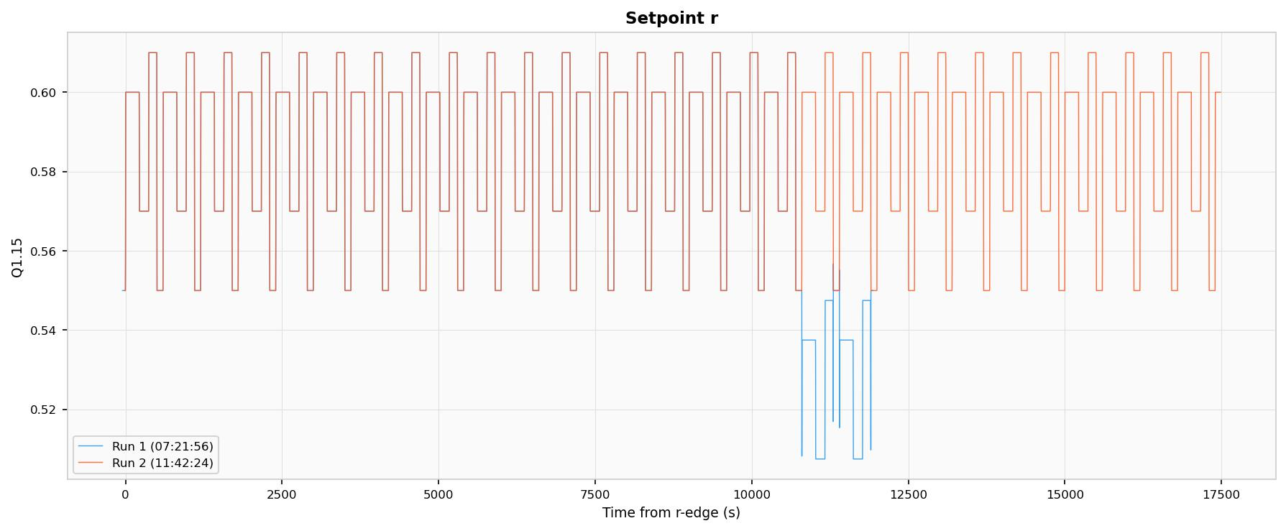
Figure 54: Setpoint $r$ overlay for Run 1 (blue) and Run 2 (red).

Plant-State Decay
The primary failure signature in Run 1 is a smooth, monotonic decay of both plant-model node temperatures ($T_{f}$ and $T_{c}$), the outlet temperature $y$, and the measured feedback signal $y_{m}$ toward zero. The decay onset occurs at approximately $t=2,500$ s and reaches the zero clamp by approximately $t=5,000$ s, a transition duration of roughly 2 500 s. The decay profile is approximately exponential with no discontinuities or step changes. Run 2 maintains stable periodic operation throughout the same interval. Figures 8.2–8.4 show the overlay plots for $T_{f}$, $T_{c}$, and $y$.
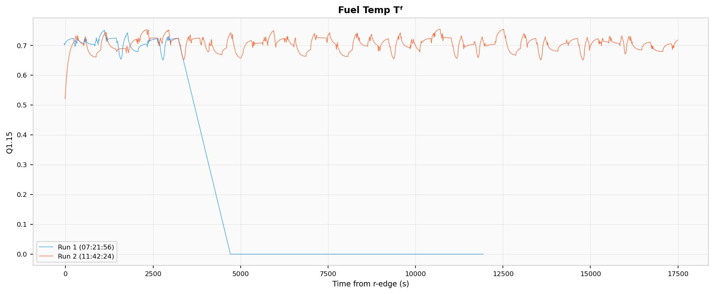
Figure 55: Fuel temperature $T_{f}$ overlay for Run 1 (blue) and Run 2 (red).
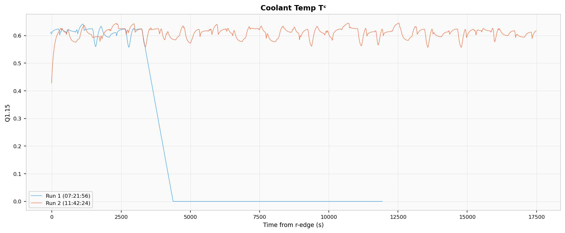
Figure 56: Coolant temperature $T_{c}$ overlay for Run 1 (blue) and Run 2 (red).
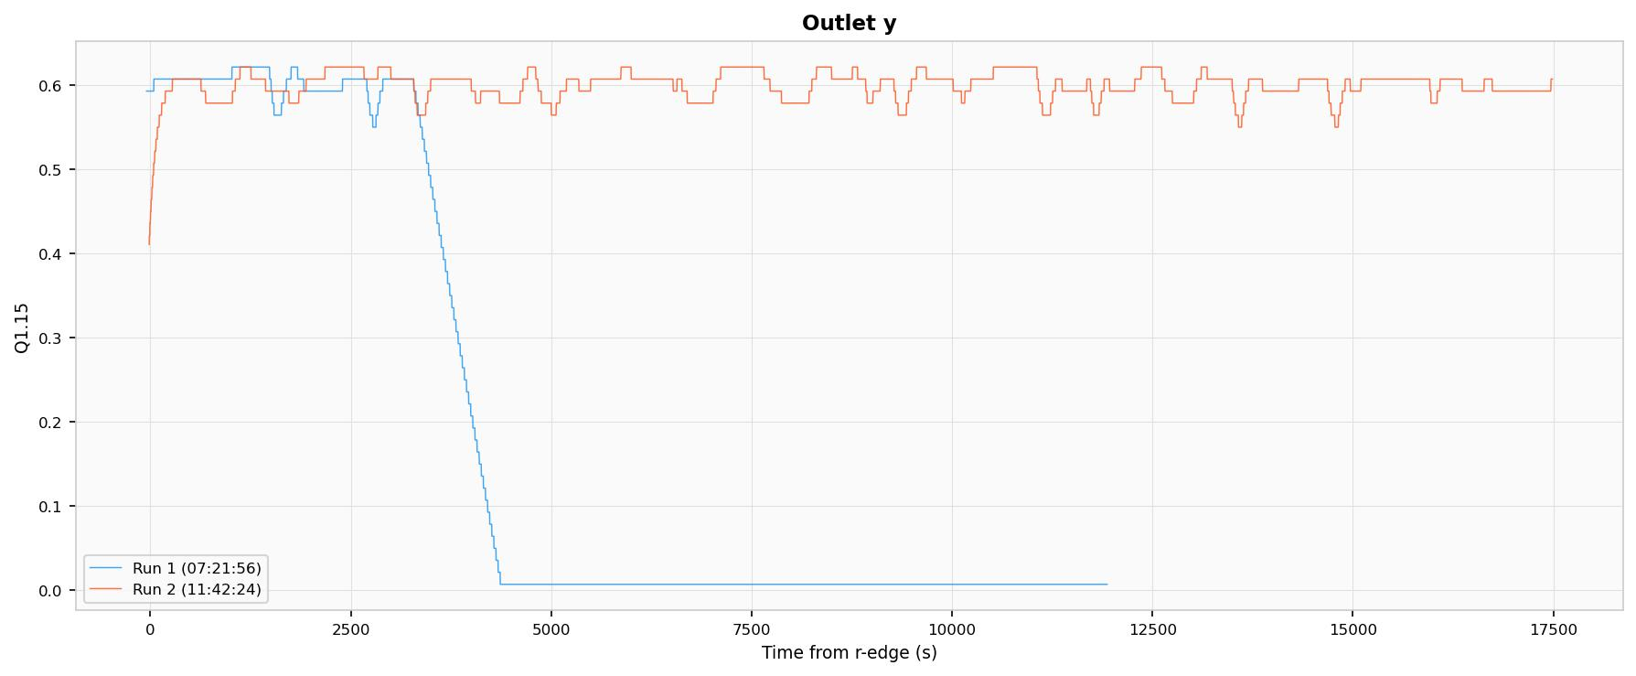
Figure 57: Outlet temperature $y$ overlay for Run 1 (blue) and Run 2 (red).
The fuel temperature difference between runs reaches a sustained magnitude of approximately $−0.72$ in Q1.15 units, the coolant temperature difference reaches approximately $−0.62$, and the outlet difference reaches approximately $−0.61$. These are near-full-scale departures relative to the Q1.15 representable range of $[−1, +1)$. The difference traces are shown in Figures 8.5–8.6.
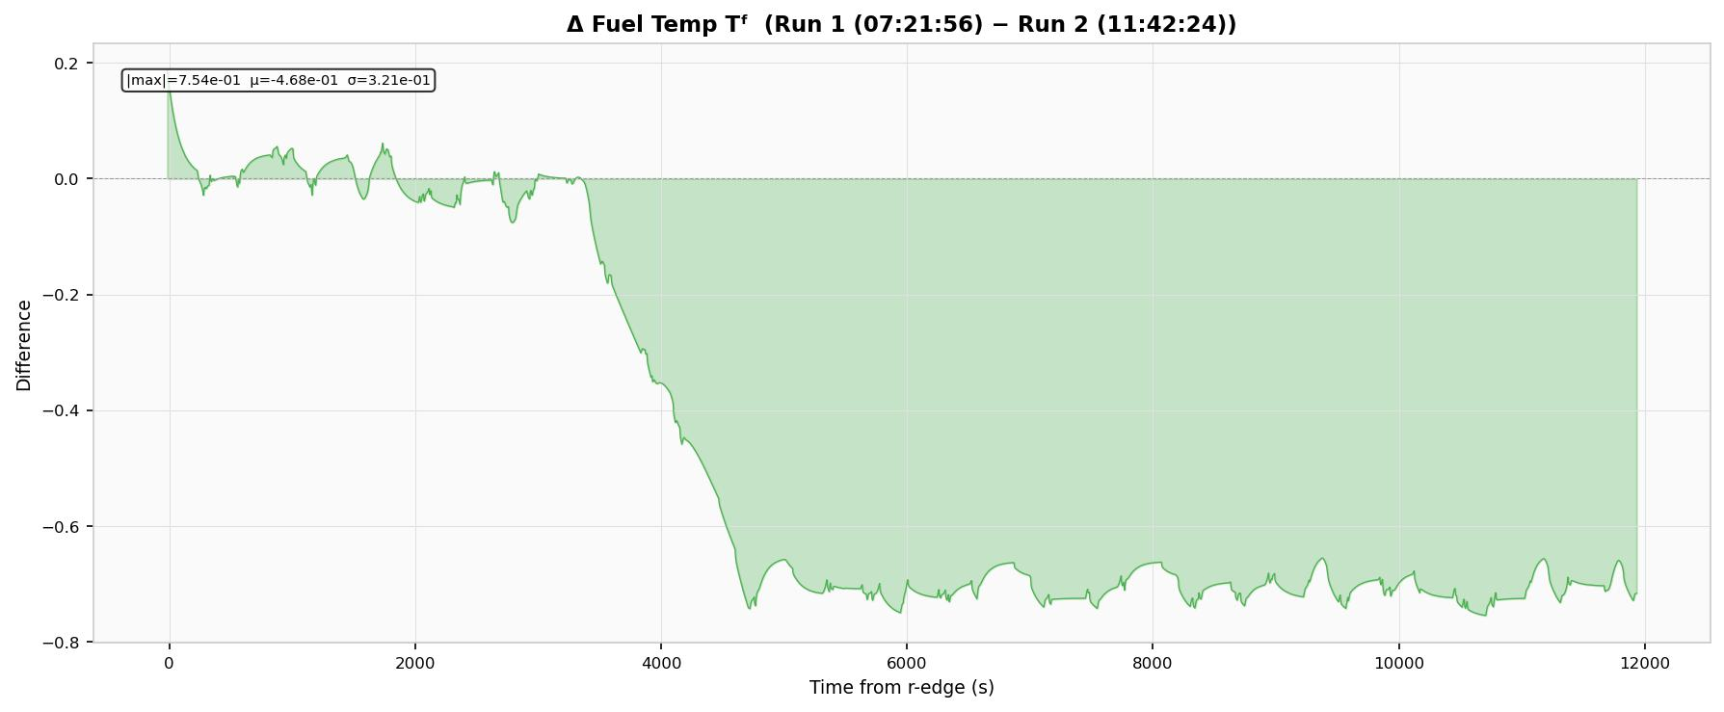
Figure 58: Fuel temperature difference (Run 1 $−$ Run 2).
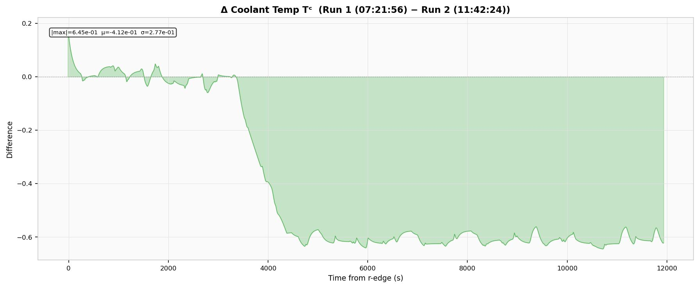
Figure 59: Coolant temperature difference (Run 1 $−$ Run 2).
As the plant temperatures decay, the error signal ($e=r−y_{m}$) grows from near-zero to approximately 0.57–0.60 (Figure 8.7), the controller output $u$ saturates at its limits, and the valve position $v$ collapses to near-zero (Figure 8.8), all expected consequences of the plant state approaching zero while the setpoint remains at its nominal value.
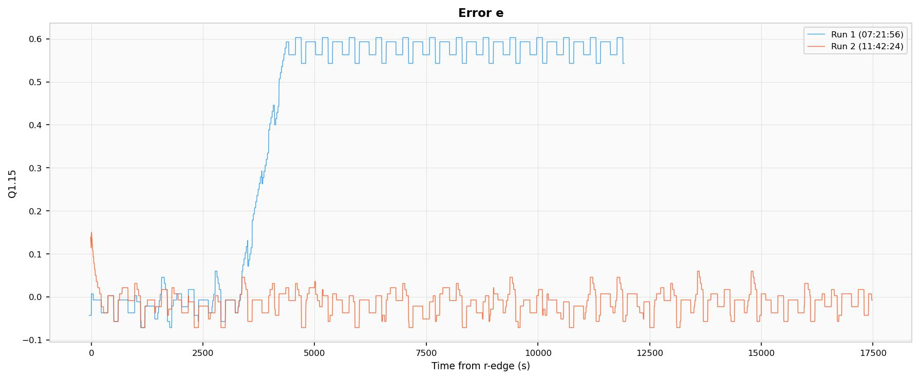
Figure 60: Error signal $e=r−y_{m}$ overlay for Run 1 (blue) and Run 2 (red).
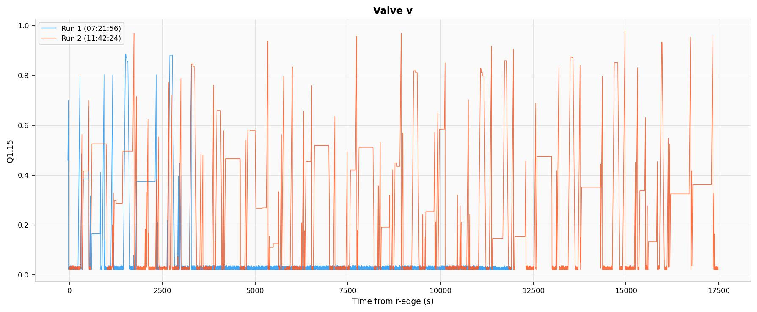
Figure 61: Valve position $v$ overlay for Run 1 (blue) and Run 2 (red).

DMR Response
No DMR mismatch events were reported during the plant-state decay. The dmr_event_count field remained at zero throughout the entire Run 1 acquisition. Both redundant controller–plant chains produced identical outputs at every compared sample tick, despite the anomalous decay of all plant-model state variables.

Discussion of Failure Mechanism
Exclusion of Firmware-Induced Numerical Drift
To determine whether the observed decay could arise from numerical accumulation effects intrinsic to the Q1.15 fixed-point arithmetic, a bit-exact simulation of the complete closed-loop system was executed for 48 simulated hours. The simulation reproduced the identical arithmetic operations, rounding rules, and pipeline structure implemented in the Verilog RTL, including the stage-2 read-before-write dependency in the plant_two_node_q15 module and the unsaturated integrator update in the controller. The simulation produced zero drift in all state variables: the system reaches a fixed point at which every Q1.15 multiply-accumulate operation rounds to zero incremental change per tick.
Additionally, the decay morphology is inconsistent with integer overflow or wrap-around. An overflow of a 16-bit Q1.15 register would produce an instantaneous polarity reversal (e.g., $+0.99$ wrapping to $−1.0$), not a smooth 2 500-second exponential decay. Firmware-induced numerical drift is therefore excluded as a causal mechanism.
Exclusion of BRAM Data Corruption
A single-event upset in a BRAM cell, for example, a corrupted entry in the phi_q15 or pow_q15 lookup table, or a corrupted ROM stimulus value, would affect only one of the two DMR chains, because BRAM instances are physically separate per chain. The resulting output divergence would be detected by the DMR comparators. No such detection occurred, excluding single-chain BRAM corruption as the failure mechanism. This exclusion is further supported by the zero inter-run difference observed for the shared-BRAM stimulus signals $Q$ and $T_{in}$.
Consistency with Configuration Memory SEU
The failure characteristics are collectively consistent with a single-event upset in the FPGA configuration SRAM (CRAM). CRAM bits define the logic function of every lookup table (LUT), the routing of every signal interconnect, and the configuration of every DSP48 slice. A CRAM SEU does not alter stored data; it alters the function computed by the logic fabric. Table 8.6 summarises the mapping between the observed failure characteristics and the CRAM SEU mechanism.
Observed failure characteristics of the PID thermal control benchmark and their consistency with a CRAM SEU mechanism.
Observation | Consistency with CRAM SEU
DMR silent (no mismatches detected) | CRAM bits are shared between both DMR chains. The DMR architecture instantiates two chains from the same synthesised netlist, placed and routed in the same fabric. A CRAM upset on shared parameter routing (e.g., $K_{p}$, $h_{A,0}$, $T_{s}/C_{c}$) or on shared arithmetic logic (e.g., a LUT in the coefficient builder) delivers the same corrupted result to both chains. The DMR comparator sees matching but incorrect outputs.
Smooth exponential decay (not a step or spike) | A CRAM bit flip alters a LUT truth table for one specific input combination, or reroutes one signal net. This introduces a small systematic bias in the plant integration that accumulates over many sample ticks, producing a gradual drift rather than an instantaneous jump.
Temperatures decay to exactly zero (clamped) | The plant_two_node_q15 module applies clamp01_q15, which clamps outputs to $[0, \text{0x7FFF}]$. A negative integration bias drives temperatures through zero, where the clamp arrests further descent.
Onset at $t≈2,500$ s, not at $t=0$ | The CRAM upset likely occurred during Day 1 irradiation (hours prior to Run 1). The corrupted logic path may only activate for specific input combinations encountered during particular phases of the ROM stimulus cycle, producing no visible effect during other phases. The 2 500 s delay represents the time for the corrupted integration to accumulate past the noise floor.
ROM stimulus $r$ corrupts later ($t>10,000$ s) | Consistent with a second, independent CRAM upset affecting ROM address or data routing. Multiple CRAM upsets are expected after hours of cumulative irradiation.
The most probable specific upset sites, given the observed decay morphology, are:
- Routing or computation of the parameter Ts_over_Cc. This parameter has a raw Q1.15 value of 1 (0x0001). A single-bit flip to 0x0000 would completely disable coolant temperature integration; a flip to 0x8001 would invert the integration direction, causing $T_{c}$ to decay.
- A high-order bit in the hA or mcp coefficient path. These coefficients multiply temperature differences in the two-node model. A single-bit corruption in a high-order bit would introduce a large systematic error in the heat balance, biasing the forward-Euler integration toward decay.
- A LUT truth-table bit in the behavioural mul_q15 function. The plant uses behavioural function calls (not the pipelined DSP48 multiplier) for its internal multiplies. A corrupted LUT in this multiply chain would bias every product computation that traverses the affected input pattern.
The persistence of the failure from Day 1 irradiation through the overnight standby period and into Day 2 Run 1 is consistent with the volatile SRAM nature of the Spartan-7 configuration store: CRAM upsets persist until the device is reconfigured or the affected configuration frame is scrubbed. This mirrors the persistent UART format change observed on FFSR1 (Chapter 7, Section 7.5.2), and together these two independent observations, one from a shift-register test structure, one from a closed-loop control system, establish that configuration memory SEUs are a primary concern for SRAM-based FPGAs at the fluence levels encountered in this campaign.
Implications for DMR Effectiveness
The complete functional collapse of the thermal control plant with zero DMR detection demonstrates a fundamental limitation of dual modular redundancy when both chains share common configuration memory. DMR protects against BRAM data upsets (which are physically instantiated per chain) but is transparent to CRAM logic and routing upsets (which affect both chains identically). Effective mitigation for this class of upset requires either configuration memory scrubbing via ICAP/PCAP readback, triple modular redundancy (TMR) with physical placement constraints to ensure distinct configuration frames per voter group, or periodic functional self-testing against known reference trajectories.

Relevance to Radiation-Effects Objectives
From a dissertation perspective, the value of this benchmark is not only that it performs closed-loop control, but that it does so in a form that is highly amenable to radiation-effects study. The design simultaneously exercises arithmetic pipelines, persistent state registers, lookup tables, comparators, counters, and serial communication logic, all categories of FPGA resource that can respond differently to configuration upsets or transient single-event effects. At the same time, the benchmark remains analytically tractable: each module corresponds to a clear mathematical operation, and the overall system response can be interpreted in terms of familiar control and thermal-system theory.
The DMR wrapper transforms the benchmark from a simple controller into a self-checking experiment. Under nominal conditions the two chains evolve identically, so any discrepancy is attributable to an external perturbation. A radiation-induced upset that perturbs logic, corrupts a stored state, or disrupts routing within the FPGA may therefore be detected through inter-chain divergence even if the output trajectory has not yet become visibly unstable. However, as the experimental results of Section 8.12 demonstrate, this detection capability has an important blind spot: CRAM upsets affecting logic or routing shared by both chains produce identical corruption in both outputs, rendering the DMR comparator ineffective against this failure class. This finding refines the initial design expectation and motivates the complementary use of configuration scrubbing or TMR with physical separation constraints.
The combination of a meaningful closed-loop workload, bounded fixed-point arithmetic, deterministic restart capability, and pipelined DMR comparison makes this benchmark a well-instrumented platform that complements the FFSR approach. Where the FFSR experiments focused on configuration integrity and readback verification, the fixed-point thermal control benchmark focuses on arithmetic correctness and control-loop functional continuity under irradiation. Together, the two benchmarks provide a multi-faceted evaluation of FPGA behaviour in a neutron radiation environment relevant to nuclear instrumentation and monitoring applications.

Chapter Summary
This chapter presented the methods and algorithms used to construct the fixed-point thermal control benchmark. The benchmark operates as a 1 kHz sampled-data loop on a 100 MHz FPGA clock and integrates a reverse-acting I-PD controller with anti-windup (Equations [eq:error]–[eq:antiwindup]), first-order actuator dynamics with slew limiting (Equations [eq:valve_fo]–[eq:valve_slew]), a nonlinear equal-percentage valve map implemented as a 256-entry lookup table (Equations [eq:equal_pct]–[eq:hA]), a two-node forward-Euler thermal plant with Q1.30 internal accumulators (Equations [eq:Tf]–[eq:Tc]), an outlet transport lag (Equation [eq:transport_lag]), a configurable quantized measurement path (Equations [eq:quant_counts]–[eq:quant_q15]), and a dual-modular redundancy wrapper that compares six key signals on every sample tick (Equation [eq:dmr_mismatch]). Run gating, deterministic restart, and 100 Hz UART telemetry complete the design.
The neutron irradiation experiment was conducted at the OSURR fast neutron beam facility under the same beam configuration used for the FFSR experiments in Chapter 7. Comparative analysis of two telemetry acquisitions, one exhibiting radiation-induced degradation (Run 1, acquired after 19 hours of cumulative operation including Day 1 irradiation) and one serving as a nominal baseline (Run 2), revealed a smooth exponential decay of all plant state variables to zero over approximately 2 500 s, with zero DMR mismatch detection throughout. Bit-exact 48-hour closed-loop simulation confirmed that the decay cannot arise from firmware numerical drift. The failure signature is consistent with a configuration memory (CRAM) SEU affecting shared arithmetic or routing logic, and demonstrates a fundamental limitation of DMR when both redundant chains share common FPGA configuration memory.
By encoding the entire benchmark in synthesizable Verilog and tying each module to explicit mathematical relations, the design provides both a technically meaningful control workload and a well-instrumented, self-checking platform for the radiation-effects evaluation presented in the following chapter.

Conclusions and Future Work

Summary of Research Contributions
This dissertation has investigated radiation-responsive materials, detector devices, alternative sensing concepts, and radiation-tolerant digital electronics for advanced radiation detection and monitoring. The research was organized around four complementary research thrusts aligned with a materials-to-systems hierarchy: (1) characterizing the radiation response of photovoltaic-architecture halide perovskite solar cells as current-mode radiation monitors, (2) developing and demonstrating perovskite semiconductor radiation detectors for direct-conversion operation across X-ray, gamma, and fast-neutron modalities, (3) investigating thermal radiation sensing concepts as an alternative, non-electronic monitoring pathway for nuclear environments, and (4) implementing and validating radiation-tolerant FPGA-based digital instrumentation through two complementary benchmarks tested under fast neutron irradiation. The following sections consolidate the principal findings, discuss their implications for nuclear monitoring systems, and identify directions for future research.

Key Findings

Perovskite Solar Cells as Current-Mode Radiation Monitors
The work presented in Chapter 4 demonstrated that photovoltaic-architecture Cs$​_{0.1}$FA$​_{0.9}$PbI$​_{3}$ perovskite solar cells can function as sensitive current-mode monitors for ionizing radiation spanning X-ray, gamma, and potentially neutron fields. Under $​^{137}$Cs gamma irradiation at 44.16 rad hr$​^{−1}$, an induced current density of 2.19 nA cm$​^{−2}$ was measured, and a distinct step response was confirmed upon insertion and withdrawal of the source. Extended irradiation with $​^{60}$Co at 355.61 rad hr$​^{−1}$ yielded 3.56 nA cm$​^{−2}$, confirming that the current-mode detection approach scales across a dose-rate range spanning nearly an order of magnitude. A linear degradation rate of approximately 0.74 nA rad$​^{−1}$ was observed during six-day continuous $​^{137}$Cs irradiation, attributable to cumulative defect creation and glass darkening in the substrate.
The device bandwidth was found to be limited by the measurement electronics rather than the intrinsic perovskite photoresponse, with rise times of 33–84 ns depending on amplifier configuration. Under X-ray irradiation, the device produced measurable short-circuit current proportional to beam intensity, although a characteristic slow current decline was observed consistent with ion-migration field screening. Neutron response at the OSURR Fast Beam Facility was statistically inconclusive for a single module, and the signal-to-noise analysis indicated that scaling the detector array area by a factor of ten to twenty would be necessary to resolve the neutron-induced current above the combined gamma and electronic noise backgrounds.

Perovskite Semiconductor Radiation Detectors
Chapter 5 extended the investigation to direct-conversion semiconductor radiation detectors spanning three radiation types.
For X-ray detection, the MAPbI$​_{3}$-hBN polycrystalline device exhibited a monotonically increasing sensitivity with applied bias, reaching 0.411 $μ$C (Gy cm$​^{2}$)$​^{−1}$ at 20 V, consistent with Hecht equation predictions for improving charge collection at higher fields. Vacuum testing confirmed that the removal of ambient moisture enhanced both sensitivity and stability, directly linking performance degradation to moisture-accelerated ion migration. The 2D perovskite (PEA$​_{2}$MA$​_{2}$Pb$​_{3}$I$​_{10}$) detector with 5F-PEAI surface treatment demonstrated that this moisture-accelerated instability can be effectively mitigated: the fluorinated barrier layer raised the breakdown voltage from $−10$ V to $−16$ V at 40% relative humidity and enabled X-ray sensitivities approaching $∼$1000 $μ$C (Gy$​_{air}$ cm$​^{2}$)$​^{−1}$ at 4 V bias, among the highest reported for polycrystalline perovskite detectors of comparable thickness.
For gamma-ray detection, three bromide perovskite single-crystal systems were evaluated. The CsPbBr$​_{3}$ device produced a statistically significant count-rate response to a $​^{137}$Cs source (17.45 cps vs. 9.11 cps background) at 1000 V bias, but high and unstable leakage current (315–710 nA) prevented resolution of the 662-keV photopeak. The FAPbBr$​_{3}$ device achieved substantially lower operating leakage ($5±2.5$ nA maximum), sustained stable high-voltage operation for over five hours, and produced spectral features attributable to both $​^{137}$Cs and $​^{57}$Co in a joint acquisition at 1600 V bias, representing a proof-of-concept demonstration of gamma spectroscopy in a solution-grown halide perovskite crystal. The MAPbBr$​_{3}$ device failed to produce functional Schottky contacts under the deposition conditions used, motivating a revised contact deposition protocol at reduced sputter power.
For fast neutron detection, MHyPbCl$​_{3}$ crystals were characterised as the first organic–metal halide perovskite semiconductor evaluated in a reactor fast neutron beam. The material combines a high hydrogen density ($∼4.0×{10}^{22}$ cm$​^{−3}$, comparable to stilbene) with an exceptional resistivity of $4.43×{10}^{11}$ $Ω$ cm and a mobility-lifetime product of $9.1×{10}^{−3}$ cm$​^{2}$ V$​^{−1}$. Waveform data acquired at the OSURR Fast Beam Facility confirmed radiation-induced pulse activity distinct from the beam background, and pulse-height analysis produced spectra consistent with the expected broad proton-recoil energy deposition distribution from a poly-energetic fast neutron beam. Neutron–gamma discrimination remains a challenge due to the large Pb content, and data acquisition limitations prevented collection of sufficient statistics for quantitative efficiency analysis.
Across all three detection modes, ion migration under applied electric fields emerged as the central performance-limiting mechanism. The correlation of device instability with ambient humidity, confirmed by vacuum tests on MAPbI$​_{3}$-hBN and by the systematic humidity-dependence study on 2D perovskite detectors, identifies surface passivation, such as the 5F-PEAI treatment, as the most promising near-term strategy for extending the operational stability of perovskite radiation detectors.

Thermal Radiation Sensing Concepts
Chapter 6 presented the simulation and analysis work performed in support of the Optical Fiber-Based Gamma Thermometer (OFBGT) and the Optical Fiber-Based Neutron Dosimeter (OFBND). Two modeling approaches, a simplified Python model and an iterative MATLAB model with temperature-dependent thermal conductivities, yielded consistent predictions, forecasting a maximum temperature differential of approximately 27–30$^{∘}$C for the OFBGT in the CIF and 155–159$^{∘}$C for the OFBND in the AIF of the OSURR.
Experimental testing of the OFBGT revealed a measured temperature differential of approximately 17$^{∘}$C, falling short of the approximately 25$^{∘}$C threshold required for reliable operation. The discrepancy was attributed to the omission of radiative heat transfer in the original simulations; when radiative heat transfer was included retrospectively, the model predictions agreed closely with the experimental observations. The Modulation Transfer Function analysis confirmed that both sensors possess adequate axial resolution for the spatial frequencies expected in the OSURR flux profiles. The OFBND has not yet been fabricated or tested, but the simulation results indicate a favorable signal strength contingent on the inclusion of radiative heat transfer in future design iterations.

Digital Electronics Verification for Radiation Environments
Chapters 7 and 8 addressed the design and experimental validation of two complementary FPGA-based test structures under fast neutron irradiation at the OSURR Fast Neutron Beam Facility.
The Flip-Flop Shift Register (FFSR) DMR test structure (Chapter 7) was deployed across five Spartan-7 FPGAs during a two-day irradiation campaign. During Day 1 ($∼$6–7$×{10}^{9}$ n/cm$​^{2}$ fast fluence, gamma shutter closed), zero DMR-detected SEUs were observed across all five devices, although one device (FFSR1) exhibited a UART output format change consistent with a configuration memory SEU that the DMR counter was unable to detect. During Day 2 ($∼$8–9$×{10}^{11}$ n/cm$​^{2}$, gamma shutter open), two devices experienced early functional dropouts consistent with radiation-induced latch-up, one device experienced a severe multi-SEU cluster event producing 2,048 detected upsets together with a second configuration memory SEU affecting the UART baud rate, and PSU current monitoring showed a sustained $∼$12.5% increase consistent with TID-induced leakage current accumulation.
The fixed-point thermal control benchmark (Chapter 8) provided a complementary assessment by exercising a closed-loop I-PD controller, forward-Euler thermal plant emulation, nonlinear valve mapping, and DMR comparison within a single synthesizable Verilog design. Comparative analysis of two telemetry acquisitions revealed a smooth exponential decay of all plant state variables to zero over approximately 2,500 s, with zero DMR mismatch detection throughout. Bit-exact simulation confirmed that the decay could not arise from firmware numerical drift. The failure signature was consistent with a configuration memory (CRAM) SEU affecting arithmetic or routing logic shared by both DMR chains, demonstrating a fundamental limitation of dual modular redundancy when both redundant chains share common FPGA configuration memory.
Together, these two independent observations, one from a shift-register test structure and one from a closed-loop control system, establish that configuration memory SEUs are a primary concern for SRAM-based FPGAs at the fluence levels encountered in nuclear instrumentation environments, and that effective mitigation requires configuration memory scrubbing, triple modular redundancy with physical placement constraints, or periodic functional self-testing against known reference trajectories.

Implications for Nuclear Monitoring Systems
The findings of this dissertation carry several implications for the design and deployment of integrated radiation monitoring systems in nuclear environments.
First, halide perovskite materials have been shown to produce measurable electrical responses to X-rays, gamma rays, and fast neutrons across a range of device architectures. The current-mode photovoltaic approach and the direct-conversion semiconductor approach represent complementary detection philosophies, the former offering large-area, zero-bias sensing suitable for integrated dose monitoring and prompt detonation forensics, and the latter offering the possibility of pulse-by-pulse energy spectroscopy at the cost of applied high voltage and the attendant ion migration challenges. The demonstration of gamma spectroscopy in a solution-grown FAPbBr$​_{3}$ crystal and of fast neutron sensitivity in MHyPbCl$​_{3}$ establishes that perovskite materials can address multiple radiation types within a common materials platform, a capability not available from conventional compound semiconductors without resorting to separate detector materials for each radiation species.
Second, the thermal sensing concepts explored for the OFBGT and OFBND represent an alternative, non-electronic sensing pathway that avoids the radiation susceptibility of semiconductor detectors entirely. Although the experimental results highlight the importance of accounting for radiative heat transfer in the design, the fiber-optic sensing modality is inherently radiation-hard and offers distributed measurement capability along the entire sensor length, making it well suited for spatially resolved monitoring of flux profiles inside reactor cores.
Third, the FPGA verification results provide quantitative evidence that SRAM-based FPGAs are susceptible to configuration memory upsets at moderate fast neutron fluences and to latch-up and TID degradation at higher fluence levels. The inability of DMR alone to detect configuration memory upsets that affect both redundant chains identically underscores the necessity of a defense-in-depth strategy combining TMR with physical separation, configuration scrubbing via ICAP/PCAP readback, and periodic functional self-testing for any FPGA-based instrumentation deployed in a sustained radiation environment.
Fourth, the hierarchy investigated in this dissertation, from radiation-responsive materials through detector devices, alternative sensing approaches, and digital electronics instrumentation, reflects the functional layers that must be addressed in any complete radiation monitoring system. The results demonstrate that no single technology addresses all requirements: perovskite detectors offer material sensitivity but face ion migration stability challenges; thermal sensors offer radiation hardness but sacrifice time resolution and spectroscopic capability; and FPGA-based electronics offer reconfigurability but require dedicated radiation mitigation strategies. An integrated monitoring architecture would therefore draw on each technology for the function to which it is best suited, with perovskite or conventional semiconductor detectors providing the primary sensing element, thermal sensors providing complementary dose verification, and radiation-tolerant FPGAs providing the digital signal processing and data acquisition backbone.

Future Research Directions
The work presented in this dissertation opens several avenues for continued investigation.

Perovskite Materials and Devices
The central limitation identified across all perovskite detector systems was ion migration under applied electric fields, exacerbated by ambient humidity. Future work should pursue the optimization of surface passivation strategies, building on the 5F-PEAI treatment demonstrated in Chapter 5, with the goal of enabling sustained high-bias operation under ambient conditions. Encapsulation methodologies that maintain the low-humidity performance observed in vacuum testing, without requiring a permanent vacuum environment, would represent a significant step toward practical deployment.
For gamma spectroscopy, the FAPbBr$​_{3}$ proof-of-concept motivates the growth of larger single crystals with improved surface preparation and contact deposition. The revised low-power sputtering protocol identified as necessary for MAPbBr$​_{3}$ should be evaluated systematically across all bromide compositions. Achieving spectroscopic energy resolution comparable to that of established CZT detectors remains a long-term goal that will require simultaneous advances in crystal quality, contact metallurgy, and electronic noise reduction.
For fast neutron detection, the MHyPbCl$​_{3}$ results warrant follow-up experiments with a dedicated digital pulse-processing system to replace the oscilloscope-based waveform acquisition that limited the statistical power of the present measurements. Neutron–gamma discrimination techniques, including pulse-shape discrimination algorithms, should be investigated to assess whether the organic cation’s hydrogen content can be exploited for fast neutron detection while rejecting the gamma background inherent to the lead-containing lattice.
For the current-mode photovoltaic approach, the signal-to-noise analysis of Chapter 4 identified array area scaling as the path to resolving neutron-induced currents. Fabrication and testing of multi-module perovskite solar cell arrays, with parallel development of low-noise current amplification electronics, would directly test this prediction and move the concept toward the large-area, real-time monitoring applications envisioned for post-detonation forensics.

Thermal Radiation Sensing
The OFBGT results highlight the critical importance of including radiative heat transfer in design-stage simulations. Future iterations of the sensor should incorporate radiative corrections from the outset and explore design modifications, such as reduced gas-gap dimensions or alternative fill gases, to increase the temperature differential above the operational threshold. The OFBND concept remains to be validated experimentally, and fabrication and in-reactor testing of the borosilicate glass thermal mass should be prioritized as a near-term objective.

FPGA-Based Instrumentation
The DMR blind spot identified in this work, configuration memory upsets that corrupt both redundant chains identically, motivates the development and irradiation testing of a TMR implementation with explicit physical placement constraints ensuring that each voter group occupies distinct configuration frames. Integration of ICAP-based configuration scrubbing with the FFSR or thermal control benchmark would allow quantitative evaluation of scrubbing effectiveness against the CRAM upset rates measured in this campaign. Additionally, the implementation and testing of automated latch-up detection and power-cycling recovery circuitry is needed to address the functional dropouts observed during the high-fluence Day 2 irradiation. The fixed-point thermal control benchmark, with its deterministic state evolution and 100 Hz telemetry, is particularly well suited as a test vehicle for evaluating these mitigation strategies in future irradiation campaigns.

System Integration
Looking further ahead, the integration of perovskite radiation sensors with radiation-tolerant FPGA-based readout electronics into a single prototype monitoring system would represent a natural convergence of the materials, device, and electronics work streams pursued in this dissertation. Such a prototype would provide a platform for evaluating system-level performance metrics, including detection sensitivity, energy resolution, long-term stability, and radiation tolerance of the complete signal chain, under realistic nuclear environment conditions.

