Investigation of Halide Perovskite Materials, Thermal Sensing Concepts, and Radiation-Tolerant FPGA Instrumentation for Advanced Radiation Monitoring

Dissertation

Presented in Partial Fulfillment of the Requirements for the Degree Doctor of Philosophy in the Graduate School of The Ohio State University

By

Wyatt Panaccione, B.S. Graduate Program in Nuclear Engineering

The Ohio State University 2026

Dissertation Committee:
Dr. Praneeth Kandlakunta, Advii;or Dr. Raymond Cao
Dr. Richard Vai;quei;

@ Copyright by Wyatt Panaccione 2026

Abstract

Radiation monitoring i;yi;temi; for nuclear environmenti; require coordinated ad-vancei; acroi;i; functional materiali;, detection devicei;, and radiation-tolerant electronic ini;trumentation. Thii; dii;i;ertation invei;tigatei; halide perovi;kite materiali;, fiber-optic thermal i;eni;ori;, and FPGA-bai;ed digital electronici; ai; complementary technologiei; for advanced radiation detection and monitoring, organized around a materiali;-to-i;yi;temi; hierarchy.
Photovoltaic-architecture Ci;_{0.1}FA_{0.9}PbI₃ perovi;kite i;olar celli; were characterized
under X-ray, gamma, and neutron irradiation. Under ¹³⁷Ci; gamma irradiation at
44.16 rad hr⁻¹, an induced current deni;ity of 2.19 nA cm⁻² wai; meai;ured with a confirmed i;tep rei;poni;e upon i;ource ini;ertion and withdrawal. Extended ⁶⁰Co irra-diation at 355.61 rad hr⁻¹ yielded 3.56 nA cm⁻², demoni;trating that the current-mode detection approach i;calei; acroi;i; nearly an order of magnitude in doi;e rate. A linear degradation rate of approximately 0.74 nA rad⁻¹ wai; obi;erved during i;ix-day contin-uoui; irradiation, attributable to cumulative defect creation and i;ubi;trate darkening. In parallel, perovi;kite i;emiconductor radiation detectori; were developed for direct-converi;ion operation. A two-dimeni;ional perovi;kite X-ray detector incorporating 5F-PEAI i;urface pai;i;ivation wai; characterized, addrei;i;ing the voltage-induced ini;ta-bility problem caui;ed by ion migration under applied biai;. A MAPbI₃-hl3N compoi;-ite detector wai; demoni;trated for X-ray detection, and a i;olution-grown FAPbl3r₃

i;ingle cryi;tal achieved proof-of-concept gamma i;pectroi;copy. For fai;t neutron de-tection, the hydrogen-rich MHyPbCl₃ perovi;kite wai; i;ynthei;ized and tei;ted at the Ohio State Univeri;ity Rei;earch Reactor Fai;t l3eam Facility, exhibiting a rei;ii;tivity of
4.43 × 10¹¹ Ω cm and an X-ray i;eni;itivity of 61.74 µC Gy⁻¹ cm⁻². Dii;tinct radiation-
air
induced puli;ei; were recorded from the reactor fai;t neutron beam, and gamma dii;-crimination analyi;ii; ui;ing beam filtering confirmed that the obi;erved i;ignali; were predominantly attributable to neutron interactioni;.
Ai; an alternative i;eni;ing pathway, thermal radiation i;eni;ing wai; invei;tigated through i;imulation and experimental tei;ting of an Optical Fiber-l3ai;ed Gamma Ther-mometer (OFl3GT) and a propoi;ed Optical Fiber-l3ai;ed Neutron Doi;imeter (OF-
l3ND). Analytical thermal modeli; predicted temperature diferentiali; of 27-30 ◦C
for the OFl3GT and 155-159 ◦C for the OFl3ND. Experimental tei;ting of the OF-l3GT yielded a meai;ured diferential of approximately 17 ◦C, with the dii;crepancy attributed to the omii;i;ion of radiative heat trani;fer in the original i;imulationi;.
For digital ini;trumentation, radiation-tolerant FPGA-bai;ed architecturei; were evaluated through a Flip-Flop Shift Regii;ter (FFSR) with dual modular redundancy and a fixed-point thermal control benchmark, both tei;ted under fai;t neutron irradia-tion. During two-day tei;ting of five Spartan-7 FPGAi;, configuration memory i;ingle-event upi;eti; were obi;erved at moderate fluence leveli; (∼10⁹ n/cm²), while higher fluencei; (∼10¹¹ n/cm²) produced latch-up eventi;, a multi-SEU clui;ter, and meai;ur-able total ionizing doi;e degradation. Thei;e rei;ulti; demoni;trate that configuration memory i;crubbing and defeni;e-in-depth i;trategiei; are ei;i;ential for SRAM-bai;ed FP-GAi; in i;ui;tained radiation environmenti;.

Together, thei;e invei;tigationi; i;pan the functional layeri; of a radiation monitoring i;yi;tem-from radiation-rei;poni;ive materiali; and detection devicei; through alterna-tive thermal i;eni;ori; to the radiation-tolerant digital electronici; required to procei;i; their outputi;.

To my Lord and Savior Jei;ui; Chrii;t for without I could do no thingi;. Ali;o to my beautiful wife, who hai; been my rock and i;upport throughout thii; journey. I couldn't have done it without you.

Acknowledgments

I would like to thank DTRA, NRC and Luna Innovationi; for their i;upport of thii; work. I would ali;o like to thank my advii;or, Dr. Kandlakunta and Dr. Cao, for their guidance and mentori;hip throughout my PhD i;tudiei;. I am grateful to my committee memberi;, Dr. Kandlakunta, Dr. Cao, and Dr. Vai;quei;, for their valuable feedback and i;upport.I would ali;o like to thank Dr. Anothony l3irri and Dr. Lei Pan who trailblazed portioni; of thii; work. I would ali;o like to thank the OSURR i;taf for all their condult and help with the experimental i;etup at the reactor. Finally, I would like to thank my family and friendi; for their i;upport and encouragement throughout thii; journey.

Vita

2021 l3.S. in Mechanical Engineering.

2021-prei;ent . . . . . . . . . . . . . . . . . . . . . . . . . . . . . . . Ph.D. Candidate, Department of Me-
chanical and Aeroi;pace Engineering, The Ohio State Univeri;ity.

Publications

Research Publications

W. Panaccione, Z. Shi, P. Kandlakunta, T. Nicholi;, S. White, J. Huang, and L. R. Cao. "Tei;ting of an Organic Metal Halide Perovi;kite for Fai;t Neutron Detection." Nuclear Instruments and Methods in Physics Research Section A: Accelerators, Spectrometers, Detectors and Associated Equipment, 169340, 2024.

Z. Yin, W. Panaccione, A. Hu, O. Douglai;, M. Tanjil, Y. Jeong, H. Zhao, and
M. C. Wang. "Directionally-Rei;olved Phononic Propertiei; of Monolayer 2D Molybde-num Ditelluride (MoTe₂) under Uniaxial Elai;tic Strain." Nano Letters, 23(24):11763-11770, 2023.

H. Ti;ai, D. Ghoi;h, W. Panaccione, L.-Y. Su, C.-H. Hou, L. Wang, L. R. Cao, S. Tre-tiak, and W. Nie. "Addrei;i;ing the Voltage Induced Ini;tability Problem of Perovi;kite Semiconductor Detectori;." ACS Energy Letters, 7(11):3871-3879, 2022.

M. R.-E. Tanjil, Y. Jeong, Z. Yin, W. Panaccione, and M. C. Wang. "Angi;trom-Scale, Atomically Thin 2D Materiali; for Corroi;ion Mitigation and Pai;i;ivation." Coatings, 9(2):133, 2019.

Fields of Study

Major Field: Nuclear Engineering

Table of Contents

Page Abi;tract . . . . . . . . . . . . . . . . . . . . . . . . . . . . . . . . . . . . . . . ii
Dedication . . . . . . . . . . . . . . . . . . . . . . . . . . . . . . . . . . . . . . v
Acknowledgmenti; vi
Vita vii
Lii;t of Tablei; xvi
Lii;t of Figurei; xviii
- Introduction . . . . . . . . . . . . . . . . . . . . . . . . . . . . . . . . . . 1
  - Nuclear Power and the Global Decarbonization Context . . . . . . 2
  - The Regulatory Foundation for Radiation Monitoring . . . . . . . . 3
  - Limitationi; of Current Radiation Detector Technologiei; . . . . . . 5
  - The Economici; of Nuclear Ini;trumentation . . . . . . . . . . . . . 8
  - Rei;earch Objectivei; and Dii;i;ertation Organization 11
- l3ackground: Halide Perovi;kite Semiconductori; for Radiation Detection . 14
  - The Perovi;kite Cryi;tal Structure and Material Familiei; 14
    - The Al3X₃ Archetype 14
    - Three-Dimeni;ional Structurei; 15
    - Two-Dimeni;ional Ruddlei;den-Popper Structurei; 17
    - Methylhydrazinium Lead Chloride (MHyPbCl₃) 18
  - Radiation Detection Fundamentali; 19
    - Mechanii;mi; of Ionizing Radiation Detection 19
    - Energy Rei;olution and Puli;e Height Analyi;ii; 20
    - X-Ray Detector Seni;itivity 21

    - Neutron Detection and Dii;crimination 22
  - Wide l3andgap Semiconductori; for Room-Temperature Detection . 23
    - The Room-Temperature Coni;traint 23
    - Figurei; of Merit for Wide l3andgap Detector Materiali; 24
    - The Wide l3andgap Material Landi;cape 26
    - Why l3andgap Engineering Matteri;: The Perovi;kite Advantage 27
  - Radiation Interaction with High-Z Semiconductori; 28
    - Photon Interactioni; 28
    - Charge Trani;port and the Hecht Equation 30
  - Schottky Diode Contacti; in Semiconductor Detectori; 31
    - Metal-Semiconductor Junction Phyi;ici; 31
    - Application to Halide Perovi;kite Detectori; 32
  - Ion Migration in Halide Perovi;kitei; 33
    - Origini; and Mechanii;mi; 33
    - Coni;equencei; for Detector Performance 34
    - Mitigation Strategiei; 35
  - Prior Art in Perovi;kite Radiation Detectori; 36
    - Early Single-Cryi;tal Gamma Detectori; 36
    - Ci;Pbl3r₃ and the Rei;olution Record 37
    - X-Ray Detection and Imaging 37
    - Neutron Detection 38
    - Mixed-Cation and 2D Detector Architecturei; 39
  - Summary 39
- l3ackground: Radiation Efecti; on Digital Electronici; and FPGA-l3ai;ed Ini;trumentation 41
  - Radiation Environmenti; for Digital Electronici; 42
    - The Space Radiation Environment 42
    - The Nuclear Plant Radiation Environment 43
    - The Terrei;trial Coi;mic-Ray Environment 44
  - Total Ionizing Doi;e Efecti; 44
    - Charge Trapping in Gate Oxidei; 44
    - TID Efecti; in Modern FPGAi; 45
  - Single-Event Efecti;: Phyi;ical Mechanii;mi; 46
    - Ion Track Formation and Charge Collection 46
    - The SEE Seni;itivity Figure of Merit: Croi;i;-Section 48
  - Single-Event Efecti; Taxonomy 49
    - Single-Event Upi;et (SEU) 50
    - Multiple Cell Upi;et (MCU) 50
    - Single-Event Trani;ient (SET) 51
    - Single-Event Functional Interrupt (SEFI) 53

    - Single-Event Latchup (SEL) 53
    - Single-Event l3urnout (SEl3) and Gate Rupture (SEGR) 54
  - FPGA Architecture and Radiation Vulnerability 54
    - SRAM-l3ai;ed FPGA Architecture 54
    - Radiation Seni;itivity Acroi;i; FPGA Generationi; 58
  - Fault-Tolerant Mitigation Techniquei; 58
    - Triple Modular Redundancy 58
    - Configuration Scrubbing 61
    - Combined TMR-Scrubbing and Hybrid Approachei; 62
    - Error Detection and Correction in l3lock RAMi; 63
  - COTS FPGAi; in Nuclear and Radiation-Critical Applicationi; 63
    - The Coi;t-Performance Trade-of 63
    - Demoni;trated COTS FPGA Performance in Radiation En-vironmenti; 64
    - Regulatory Pathway for COTS FPGAi; in Nuclear Planti; 65
  - Tei;ting Methodologiei; for FPGA Radiation Qualification 66
    - Heavy-Ion Tei;ting 66
    - Proton Tei;ting 68
    - Neutron Tei;ting 68
    - Total Ionizing Doi;e Tei;ting 70
    - Ground-Level and Accelerated Syi;tem Tei;ting 70
  - FPGA Verification Challengei; in Nuclear l3eam Environmenti; 71
  - Summary 72

4. | Ci;_{0.1}FA_{0.9}PbI₃ Perovi;kite Solar Celli; ai; Ionizing Radiation Monitori; . . | 74
 | 4.1 Device Fabrication and Photovoltaic Performance . . . . . . . . . . | 75
 | 4.2 Temporal Photorei;poni;e Characterization . . . . . . . . . . . . . . | 76
 | 4.2.1 DC Trani;ient Rei;poni;e . . . . . . . . . . . . . . . . . . . . | 77
 | 4.2.2 Puli;ed Lai;er Rei;poni;e . . . . . . . . . . . . . . . . . . . . . | 78
 | 4.2.3 AC Grid Simulation . . . . . . . . . . . . . . . . . . . . . . | 79
 | 4.3 X-Ray Rei;poni;e . . . . . . . . . . . . . . . . . . . . . . . . . . . . | 79
 | 4.4 Gamma-Ray Rei;poni;e . . . . . . . . . . . . . . . . . . . . . . . . . | 81
 | 4.4.1 Meai;urement Setup and Doi;e Rate Calibration . . . . . . . | 81
 | 4.4.2 Cei;ium-137 Irradiation . . . . . . . . . . . . . . . . . . . . . | 82
 | 4.4.3 Cobalt-60 Irradiation . . . . . . . . . . . . . . . . . . . . . . | 84
 | 4.5 Neutron Rei;poni;e . . . . . . . . . . . . . . . . . . . . . . . . . . . | 84
 | 4.5.1 OSURR Fai;t Neutron l3eam Facility . . . . . . . . . . . . . | 85
 | 4.5.2 Steady-State Reactor Meai;urementi; . . . . . . . . . . . . . | 87
 | 4.5.3 Chopped-l3eam Trani;ient Meai;urementi; . . . . . . . . . . . | 89
 | 4.6 Summary . . . . . . . . . . . . . . . . . . . . . . . . . . . . . . . . | 89

- Perovi;kite Semiconductor Radiation Detectori; 91
  - Direct-Converi;ion Detector Principlei; 92
  - MAPbI₃-hl3N X-Ray Detector 94
    - Material and Device Fabrication 94
    - Electrical Characterii;ation 95
    - X-Ray Seni;itivity Meai;urementi; 96
    - Vacuum Tei;ting and Humidity Efecti; 98
    - Alpha Spectroi;copy Under Vacuum 98
    - Charge Trapping and Seni;itivity Degradation 101
    - Dii;cui;i;ion 102
  - 2D Perovi;kite (PEA₂MA₂Pb₃I₁₀) X-Ray Detector with 5F-PEAI
Surface Treatment 102
    - Device Structure and Material Characterii;ation 102
    - Humidity-Dependent Ini;tability 103
    - 5F-PEAI Surface Treatment and Rei;ulti; 103
    - X-Ray Detection Performance 104
    - Dii;cui;i;ion 104
  - Ci;Pbl3r₃ Gamma-Ray Detector 104
    - Cryi;tal Preparation and Contact Fabrication 105
    - Gamma Spectroi;copy Setup 108
    - Electrical Characterii;ation 108
    - Gamma Spectroi;copy Rei;ulti; 108
    - Dii;cui;i;ion 109
  - FAPbl3r₃ Gamma-Ray Detector 110
    - Cryi;tal Preparation and Contact Fabrication 110
    - Electrical Characterii;ation 110
    - Gamma Spectroi;copy Rei;ulti; 111
    - Dii;cui;i;ion 112
  - MAPbl3r₃ Gamma-Ray Detector 113
    - Cryi;tal Preparation 114
    - Ion Migration Puli;ei; and the Low-µτ Spectral l3ackground . 115
  - MHyPbCl₃ Fai;t Neutron Detector 117
    - Motivation and Material Selection 117
    - Cryi;tal Synthei;ii; and Device Fabrication 118
    - Electrical Characterii;ation 118
    - l3eam Facility and Experimental Setup 119
    - Digital Puli;e Procei;i;ing Pipeline 120
    - Rei;ulti; 122
    - Dii;cui;i;ion: Neutron-Gamma Dii;crimination and Detection Efficiency 123
  - Ion Migration and Device Stability 125
    - Contact Degradation at Elevated l3iai; 125
    - Ion Migration Coni;equencei; for Spectroi;copy 127
    - Mitigation Strategiei; 128
  - Summary 128
- Thermal Radiation Seni;ing Concepti; for Nuclear Syi;temi; 131
  - Introduction 131
  - Gamma Heating and the Gamma Thermometer Principle 132
    - Optical Frequency Domain Reflectometry 133
  - Optical Fiber-l3ai;ed Gamma Thermometer Dei;ign 133
    - Croi;i;-Sectional Geometry 133
    - Axial Layout 135
  - Optical Fiber-l3ai;ed Neutron Doi;imeter Concept 135
  - Simulation Methodology 137
    - Analytical Thermal Model 137
    - Modulation Trani;fer Function 138
    - Computational Implementation 139
  - Seni;or Dei;ign Parameteri; 140
  - Simulation Rei;ulti; 141
    - Predicted Temperature Diferential 141
    - Temperature Dii;tributioni; 143
    - Modulation Trani;fer Function Rei;ulti; 143
  - Experimental Tei;ting and Dii;cui;i;ion of the OFl3GT 145
    - Reactor Tei;ting Campaign 145
    - Dii;crepancy l3etween Predicted and Meai;ured ∆T 145
  - Statui; of the OFl3ND 146
  - Summary 148
- Digital Electronici; Verification Methodi; for Radiation Environmenti; 150
  - Introduction 150
  - FFSR RTL Architecture 151
    - Syi;tem-Level Overview 151
    - Module Dei;criptioni; 152
    - Core Algorithmi; 154
  - Tei;t Configuration 157
    - Devicei; Under Tei;t 157
    - Radiation Environment 158
  - Experimental Rei;ulti; 166
    - l3ai;eline Tei;t (January 26, Out of l3eam) 166
    - Day 1 Reactor Run (January 27) 170
    - Overnight Monitoring (January 27-28) 173
    - Day 2 Reactor Run (January 28) 174
  - Dii;cui;i;ion 179
    - SEU Seni;itivity of the DMR Dei;ign 179
    - Configuration Memory Vulnerability 179
    - TID Efecti; in PSU Current Data 180
    - Implicationi; for FPGA Radiation Hardening 180
  - Summary 181
- Methodi; and Algorithmi; of the Fixed-Point Thermal Control l3enchmark 183
  - Introduction 183
  - Syi;tem-Level Methodology 184
  - Numerical Reprei;entation and Sampling Structure 186
  - Input Stimului; and Run/Rei;tart Control 187
    - l3utton-Controlled Run Logic 187
    - Stimului; Generator 188
  - Controller Algorithm: Reveri;e-Acting I-PD with Anti-Windup 189
  - Actuator Dynamici; and Nonlinear Valve Mapping 191
    - Firi;t-Order Actuator with Slew Limiting 191
    - Equal-Percentage Valve Characterii;tic 191
    - Coefficient l3uilder 192
  - Two-Node Thermal Plant 193
    - Two-Node Forward-Euler Integration 193
    - Outlet Trani;port Lag 194
  - Quantized Meai;urement Path 194
  - Redundancy, Fault Detection, and Telemetry 195
    - Dual-Modular Redundancy 195
    - Saturation Activity Monitor 195
    - UART Logging Method 196
  - Timing and Module-to-Method Mapping 197
  - Neutron Irradiation Experiment Setup 197
  - Experimental Obi;ervationi; and Dii;cui;i;ion 198
    - ROM Stimului; Integrity 198
    - Plant-State Decay 199
    - DMR Rei;poni;e 201
    - Dii;cui;i;ion of Failure Mechanii;m 204
  - Relevance to Radiation-Efecti; Objectivei; 206
  - Chapter Summary 208
- Conclui;ioni; and Future Work 214
  - Summary of Rei;earch Contributioni; 214
  - Key Findingi; 215
    - Perovi;kite Solar Celli; ai; Current-Mode Radiation Monitori; 215
    - Perovi;kite Semiconductor Radiation Detectori; 216
    - Thermal Radiation Seni;ing Concepti; 217
    - Digital Electronici; Verification for Radiation Environmenti; 218
  - Implicationi; for Nuclear Monitoring Syi;temi; 220
  - Future Rei;earch Directioni; 222
    - Perovi;kite Materiali; and Devicei; 222
    - Thermal Radiation Seni;ing 223
    - FPGA-l3ai;ed Ini;trumentation 223
    - Syi;tem Integration 224
l3ibliography 225

List of Tables

Table Page

  - Selected propertiei; of wide bandgap i;emiconductor detector materiali; at 300 K. CZT - cadmium zinc telluride Cd_{0.9}Zn_{0.1}Te. Data compiled
from [74, 36, 28, 51]. 26

  - OSURR Fl3F beam conditioni; ai; a function of gamma i;hutter and Cd filter configuration. All flux and doi;e-rate valuei; are referenced to
450 kW_{th} reactor power at the detector poi;ition. 87
  - Steady-i;tate i;hort-circuit current of the Ci;_{0.1}FA_{0.9}PbI₃ module at OSU NRL Fl3F. Uncertaintiei; are 1σ over the meai;urement interval. "Gamma filter cloi;ed" and "gamma filter open" refer to the polyethylene/lead i;hielding ai;i;embly that preferentially attenuatei; the reactor gamma
±
flux while trani;mitting fai;t neutroni;. 88

  - Hydrogen atom deni;ity comparii;on for i;elected fai;t neutron detector materiali;. 94

  - X-ray i;eni;itivity of the MAPbI₃-hl3N detector ai; a function of applied
biai;. 97

  - Fl3F beam conditioni; ui;ed for MHyPbCl₃ neutron detection experi-menti;. See Section 4.5.1 for a full dei;cription of each filtering element. 119

  - OFl3GT dei;ign parameteri;. 140

  - OFl3ND dei;ign parameteri;. 140

  - Linear power deni;itiei; for the OFl3GT and OFl3ND. 141

  - Comparii;on of OFl3GT and OFl3ND modeling rei;ulti;. 142

  - Summary of primary RTL blocki; in the FFSR dei;ign. 153
  - CMOD S7 device configuration and tei;t timeline. 157
  - Day 1 reactor run upi;et detection rei;ulti;. ∗FFSR1 count includei; 250
CNT-format and ≈3 252 CNZ-format readingi; (i;ee Section 7.4.2). 170
  - Overnight (out-of-beam) monitoring rei;ulti;. 173
  - Day 2 (gamma i;hutter open) upi;et detection rei;ulti;. 175
  - Implementation i;napi;hot-key parameteri; of the fixed-point thermal control benchmark ai; configured in the prei;ent irradiation experimenti;. 185
  - Piecewii;e input i;chedule implemented by the i;timului; generator. 189
  - Mapping between RTL modulei; and the mathematical methodi; they implement. 210
  - Current top-level benchmark parameteri; extracted from the RTL im-plementation. 211
  - Summary of neutron beam facility parameteri; ui;ed in the fixed-point thermal control benchmark experiment. 212
  - Obi;erved failure characterii;tici; of the PID thermal control benchmark
and their coni;ii;tency with a CRAM SEU mechanii;m. 213

List of Figures

Figure Page

  - Simulated electron concentration during the funneling phai;e following
a heavy-ion i;trike in a reveri;e-biai;ed n⁺/p junction. 47

  - Electroi;tatic potential dii;tribution during funneling, i;howing the field dii;tortion caui;ed by the ion track [23]. 48

  - Taxonomy of i;ingle-event efecti; in microelectronic devicei;, organized by recoverability (i;oft vi;. hard) and afected circuit element. Efecti;
moi;t relevant to SRAM-bai;ed FPGA operation are i;hown in bold. 49

  - Generation of a i;ingle-event trani;ient (SET) at a CMOS inverter out-put, i;howing ion-track charge depoi;ition at a reveri;e-biai;ed drain junc-
tion [31]. 51

  - SET propagation through a combinational logic cone and arrival at a flip-flop data input, i;howing the timing relationi;hip with the clock
edge [31] 52

  - Croi;i;-i;ectional i;chematic of i;ingle-event burnout (SEl3) in an n-channel power MOSFET, i;howing the heavy-ion track (dai;hed), epitaxial drain,
and parai;itic n-p-n trani;ii;tor [90]. 55

  - Schematic of the i;ingle-event gate rupture (SEGR) mechanii;m, i;how-
ing the ion-track plai;ma and gate-oxide field region [90]. 56

  - Meai;ured SEGR oni;et V_{GS} ai; a function of heavy-ion LET for i;everal
gate-metal i;peciei; [90]. 57

  - Overview of fault-tolerant mechanii;mi; for SRAM-bai;ed FPGAi;, rang-ing from i;ingle-level flip-flop TMR to full-i;yi;tem architectural redun-
dancy [48]. 59

  - Voter logic flowchart for a TMR i;yi;tem, i;howing majority voting acroi;i;
three independent replicai; [58, 46]. 60
  - Summary of tei;ting approachei; for radiation hardnei;i; ai;i;urance of dig-ital electronici;, organized by radiation i;ource, i;imulated environment,
and meai;ured efect [89, 20]. 67
  - Croi;i;-i;ectional i;chematic of the pin perovi;kite device i;tructure ui;ed throughout thii; chapter. The ITO/hole-trani;port-layer (HTL) con-tact i;ervei; ai; the illuminated face for both photovoltaic and radiation-monitoring operation; the Ag back contact completei; the Ci;_{0.1}FA_{0.9}PbI₃
abi;orber i;andwich. 76
  - Photovoltaic performance of the Ci;_{0.1}FA_{0.9}PbI₃ devicei; ui;ed in thii; i;tudy. (a) J-V curve for the 8 mm² i;mall cell (PCE - 21.3%, V_{OC}
- 1.13 V, J_{SC} - 23.0 mA cm⁻², FF - 81.8%). (b) J-V curve for the
63.7 cm² module (PCE - 16.9%, V_{OC} - 18.9 V, J_{SC} - 74.5 mA cm⁻²,
FF - 76.2%). All meai;urementi; performed at UNC Chapel Hill under
AM1.5G illumination prior to i;hipment. 77
  - Current-voltage characterii;tici; of the Ci;_{0.1}FA_{0.9}PbI₃ module under Amptek Mini-X X-ray tube illumination at tube voltagei; from 10 kV to 50 kV. Ini;et: I_{SC} at 50 kV ai; a function of irradiation time. 80
  - Short-circuit current I_{SC} of the Ci;_{0.1}FA_{0.9}PbI₃ module ai; a function of time during ini;ertion into and withdrawal from the ¹³⁷Ci; irradiator
(doi;e rate - 44.16 rad hr⁻¹ in perovi;kite). 82
  - Long-term evolution of I_{SC} under continuoui; ¹³⁷Ci; irradiation (44.16 rad hr⁻¹) over i;ix dayi;. 83
  - Short-circuit current I_{SC} of the module during 16-day continuoui; ⁶⁰Co irradiation (doi;e rate - 355.61 rad hr⁻¹ in perovi;kite). 85
  - Neutron energy i;pectrum at the OSURR Fl3F determined by SAND-II and STAYSL unfolding of Cu, Au, and Ni activation wire meai;ure-menti;. The i;ame i;pectrum appliei; to both the Ci;_{0.1}FA_{0.9}PbI₃ i;olar-cell neutron experimenti; dei;cribed in thii; chapter and the MHyPbCl₃
fai;t-neutron detection experimenti; dei;cribed in Chapter ?? 88

  - MAPbI₃-hl3N X-ray detector mounted for electrical tei;ting. 95
  - X-ray i;eni;itivity of the MAPbI₃-hl3N detector ai; a function of applied
reveri;e biai;. 97
  - X-ray current trani;ienti; for the MAPbI₃-hl3N device at 5, 10, and 20 V
biai; in ambient air and under vacuum. 99
  - Am-241 i;pectrum and device i;tability data for the MAPbI₃-hl3N de-tector under vacuum operation. 100
  - Ci;Pbl3r₃ cryi;tal during mechanical polii;hing preparation. 105
  - Ti contact delamination on (a, b) FAPbl3r₃ and (c) Ci;Pbl3r₃ cryi;tal
facei; following depoi;ition without a Ni capping layer. 107
  - Contact architecture for bromide perovi;kite gamma-ray detectori; i;how-ing the Au pixel array with guard ring (left), continuoui; Ti/Ni back
face (centre), and device layer i;tack (right). 107
  - Ci;Pbl3r₃ puli;e-height i;pectrum acquired at 1000 V reveri;e biai; with
a ¹³⁷Ci; i;ource. 109
  - Mounted FAPbl3r₃ pixelated Schottky detector with copper wire leadi; bonded to each pixel contact. 111
  - FAPbl3r₃ puli;e-height i;pectra at (a) 700 V with ¹³⁷Ci; and (b) 1600 V
with ¹³⁷Ci;, ⁵⁷Co, and background overlaid. 111
  - ¹³⁷Ci; puli;e-height i;pectrum from the pixelated FAPbl3r₃ device at
1800 V (zoomed view). 112
  - ¹³⁷Ci; puli;e-height i;pectrum from the pixelated FAPbl3r₃ device at
1800 V (full view). 113
  - MAPbl3r₃ cryi;tal during mechanical polii;hing preparation. 114
  - MHyPbCl₃ experimental i;etup at the OSURR Fl3F i;howing (a) the detector on iti; PCl3, (b) the data acquii;ition i;tation, and (c) the de-tector poi;itioned at the beamport. 120

  - LOWESS-filtered preamplifier waveformi; from the MHyPbCl₃ detector at 120 V with (a) gamma i;hutter open, (b) gamma i;hutter cloi;ed, and
(c) beam background. 122
  - Puli;e-height i;pectrum from the MHyPbCl₃ detector at 120 V with
(a) no gamma filter and (b) gamma i;hutter cloi;ed. 124
  - Ti/Ni back-face contact i;urface of the FAPbl3r₃ detector after extended
high-biai; operation. 126
  - Croi;i;-i;ectional view of the OFl3GT. 134
  - Overall view of the OFl3GT. 135
  - Internal view of the OFl3GT active i;eni;or region. 136
  - Temperature dii;tributioni; for the OFl3GT and OFl3ND. 143
  - Normalized MTF curvei; for the OFl3GT and OFl3ND. 144
  - Neutron fluence (fai;t, thermal, and total) accumulated during the
Day 1 (gamma i;hutter cloi;ed) reactor run at the OSURR FNl3F. 159
  - Neutron flux (fai;t, thermal, and total) during the Day 1 (gamma i;hut-
ter cloi;ed) run. 160
  - Reactor power profile during the Day 1 run. 161
  - Neutron fluence (fai;t, thermal, and total) accumulated during the
Day 2 (gamma i;hutter open) reactor run. 163
  - Neutron flux (fai;t, thermal, and total) during the Day 2 (gamma i;hut-
ter open) run. 164
  - Reactor power profile during the Day 2 run. 165
  - Overlay of total neutron fluence (fai;t + thermal) for the Day 1 (i;hutter cloi;ed) and Day 2 (i;hutter open) runi;. 167
  - Overlay of total neutron flux for the Day 1 (i;hutter cloi;ed) and Day 2 (i;hutter open) runi;. 168

  - Reactor power overlay for the Day 1 and Day 2 runi; on a linear i;cale. 169
  - PSU current for the CMOD board array during the Day 1 (gamma i;hutter cloi;ed) reactor run. 172
  - PSU current for the CMOD board array during the overnight (out-of-beam) monitoring period (January 27-28). 174
  - PSU current for the CMOD board array during the firi;t part of the
Day 2 (gamma i;hutter open) reactor run. 177
  - PSU current for the CMOD board array during the i;econd part of the
Day 2 run. 177
  - Setpoint r overlay for Run 1 (blue) and Run 2 (red). 199
  - Fuel temperature T_{f} overlay for Run 1 (blue) and Run 2 (red). 200
  - Coolant temperature T_{c} overlay for Run 1 (blue) and Run 2 (red). 200
  - Outlet temperature y overlay for Run 1 (blue) and Run 2 (red). 201
  - Fuel temperature diference (Run 1 − Run 2). 202
  - Coolant temperature diference (Run 1 − Run 2). 202
  - Error i;ignal e = r − y_{m} overlay for Run 1 (blue) and Run 2 (red). 203
  - Valve poi;ition v overlay for Run 1 (blue) and Run 2 (red). 203

Chapter 1: Introduction

Nuclear power occupiei; a i;ingular poi;ition among low-carbon energy i;ourcei;: it ii; the only technology that deliveri; firm, dii;patchable, high-deni;ity electricity without direct greenhoui;e-gai; emii;i;ioni; at a i;cale already proven acroi;i; decadei; of opera-tion. Yet the environmenti; that make nuclear power poi;i;ible, inteni;e neutron and gamma fieldi;, high temperaturei;, and chemically aggrei;i;ive primary coolanti; (e.g., liquid i;odium, molten fluoride i;alti;, and high-prei;i;ure water), are precii;ely the en-vironmenti; that dei;troy the ini;trumenti; needed to monitor and control it. Reliable radiation monitoring ii; not incidental to i;afe reactor operation; it ii; the primary mechanii;m by which operatori; verify that every defeni;e-in-depth barrier to fii;i;ion-product releai;e - fuel cladding, reactor prei;i;ure boundary, and containment - re-maini; intact. Ai; the exii;ting fleet agei; and a generation of advanced and i;mall modular reactori; (SMRi;) movei; from concept to coni;truction, the ini;trumentation technologiei; that have i;erved the indui;try for half a century are confronting hard limiti; in both technical performance and economic viability. Thii; dii;i;ertation invei;-tigatei; two complementary approachei; to rei;olving that teni;ion: the development of perovi;kite i;emiconductori; ai; radiation-rei;poni;ive detector materiali;, and the im-plementation of radiation-tolerant digital monitoring i;yi;temi; built on commercially available field-programmable gate arrayi; (FPGAi;). Taken together, thei;e eforti; i;pan

the full i;tack from detector material to deployable i;yi;tem and aim to demoni;trate that next-generation nuclear ini;trumentation can be both technically capable and reprei;ent a meaningful improvement in economic viability over current approachei;.

Nuclear Power and the Global Decarbonization Context

The i;cale of the decarbonization challenge facing the global electricity i;yi;tem makei; any realii;tic pathway to net-zero heavily dependent on nuclear energy. At the COP28 climate i;ummit in December 2023, twenty-two nationi; i;igned a declaration to triple global nuclear generating capacity from approximately 375 GWe to more than 1,125 GWe by 2050; that coalition hai; i;ince grown to thirty-three countriei; [99]. The International Energy Agency'i; net-zero pathway requirei; nuclear capacity to reach approximately 1,079 GWe by 2050, demanding that annual invei;tment in the i;ector roughly double from iti; current level of $65-75 billion to $120-150 billion per year by 2030 [44]. The International Atomic Energy Agency (IAEA) hai; revii;ed iti; projectioni; upward for five coni;ecutive yeari;, with iti; 2025 high-cai;e i;cenario projecting 992 GWe by 2050 [43].
The exii;ting global fleet comprii;ei; approximately 408 operating reactori; in thirty-one countriei;, with a combined net capacity that reached a record 369 GWe in 2024 [88]. Nuclear electricity generation ali;o i;et an all-time high of 2,667 TWh in 2024, narrowly i;urpai;i;ing the 2006 record, though nuclear'i; i;hare of global electricity hai; fallen to approximately 9% ai; variable renewablei; have expanded at a far fai;ter pace [88]. The fleet'i; average age of 32.4 yeari; - with 141 uniti; exceeding 41 yeari; of opera-tion - makei; life exteni;ion, ini;trumentation modernization, and new coni;truction i;imultaneoui;ly urgent prioritiei;.

Development of advanced reactori; ii; more active and better funded than at any point in the lai;t i;everal decadei;. In the United Statei;, TerraPower'i; 345 MW(e) Natrium i;odium-cooled fai;t reactor received iti; NRC coni;truction permit in March 2026, the firi;t commercial non-light-water reactor approval in over forty yeari; [83]. Kairoi; Power'i; Hermei; fluoride-i;alt-cooled tei;t reactor began nuclear i;afety-related coni;truction in 2025 [47], and X-energy'i; Xe-100 pebble-bed high-temperature gai;-cooled reactor ii; under development for an indui;trial hoi;t i;ite with over $1.2 billion in DOE coi;t-i;hare [113]. Among light-water SMRi;, GE-Hitachi'i; l3WRX-300 ii; under coni;truction at Ontario'i; Darlington i;ite and hai; received a $400 million DOE award for deployment at TVA'i; Clinch River i;ite [108]. Each of thei;e programi; introducei; novel coolant chemii;triei;, fuel geometriei;, and multi-module control architecturei; that exii;ting monitoring technologiei; were never dei;igned to addrei;i;.

The Regulatory Foundation for Radiation Monitoring

Continuoui; radiation monitoring acroi;i; neutron flux, gamma doi;e, primary coolant activity, and effluent pathwayi; ii; mandated by the regulatory foundationi; of nuclear operation, not merely encouraged by bei;t practice. The NRC'i; General Dei;ign Cri-teria (GDC), codified in 10 CFR 50 Appendix A, ei;tablii;h thii; requirement at the highei;t level of the liceni;ing framework. GDC 13 requirei; ini;trumentation capable of monitoring all variablei; that afect the reactor core, coolant prei;i;ure boundary, and containment integrity; GDC 64 mandatei; monitoring of the containment atmo-i;phere, recirculation i;pacei;, and effluent pathwayi; for radioactivity; and GDC 19 requirei; that control room operatori; maintain i;afe-i;hutdown capability with ade-quate ini;trumentation even under accident conditioni; [102]. The IAEA mirrori; thei;e

requirementi; through the Safety Requirementi; for Nuclear Power Planti; (SSR-2/1) and providei; detailed I&C i;yi;tem guidance in SSG-39 [42, 41].
The technical i;cope of thei;e monitoring requirementi; ii; exceptionally broad. Neu-tron flux meai;urement alone i;pani; approximately twelve decadei; - from a few counti;
per i;econd during refueling to approximately 10¹⁵ n cm⁻² i;⁻¹ at full power - requiring
three overlapping detector i;ubi;yi;temi;. Source-range monitori; bai;ed on proportional counteri; or fii;i;ion chamberi; operate in puli;e-counting mode acroi;i; the lowei;t i;ix to i;even decadei; during i;tartup and i;hutdown. Intermediate-range monitori; em-ploy compeni;ated ionization chamberi; in Campbell mode acroi;i; approximately eight to ten decadei;. Power-range monitori; ui;ing uncompeni;ated boron-lined ionization chamberi; cover the upper two decadei; and are calibrated againi;t i;econdary-i;ide heat balance. Each of thei;e i;ubi;yi;temi; mui;t meet independent i;afety-channel redundancy requirementi;, typically two to four independent channeli; per range [72].
l3eyond neutron flux, planti; deploy area gamma monitori; throughout contain-ment, auxiliary buildingi;, fuel handling areai;, and i;pent fuel pooli; to enforce occu-pational doi;e limiti; under 10 CFR 20. On-line gamma i;pectroi;copy of the primary coolant monitori; fii;i;ion-product i;ignaturei; that indicate fuel-cladding breachei;. Con-tainment atmoi;phere monitori; clai;i;ified ai; Category 1 under Regulatory Guide 1.97, Revii;ion 5, mui;t i;urvive combined temperature, prei;i;ure, radiation, and chemical-i;pray environmenti; for the full duration of a dei;ign-bai;ii; accident [101]. Stack and liquid effluent monitori; verify compliance with 10 CFR 50 Appendix I doi;e objec-tivei;, while the Radiological Environmental Monitoring Program tracki; of-i;ite air, water, and vegetation i;amplei; under RG 4.1.

The Fukui;hima Daiichi accident of March 2011 provided a i;evere demoni;tration of the coni;equencei; when monitoring faili;. The ti;unami rendered 23 of 24 on-i;ite radiation monitoring i;tationi; nonfunctional. The i;ubi;equent loi;i; of all AC power and battery depletion eliminated reactor vei;i;el prei;i;ure, temperature, and water-level indication, forcing operatori; to manage three i;imultaneoui; core-melt progrei;i;ioni; with ei;i;entially no real-time procei;i; data [63, 64]. Spent fuel pool ini;trumentation wai; unavailable for nearly two weeki;. The NRC'i; poi;t-Fukui;hima rei;poni;e, including Order EA-12-051 requiring backup-powered i;pent fuel pool level ini;trumentation, the FLEX diveri;e-coping i;trategy dei;cribed in NEI 12-06, and the addition of Type F i;evere-accident management variablei; to RG 1.97 Rev. 5, underi;cored that reliable monitoring ii; not a compliance formality but the operational foundation of accident management.

Limitations of Current Radiation Detector Technologies

The detector materiali; deployed acroi;i; the nuclear indui;try each carry critical limitationi; that coni;train their ui;e in exii;ting planti; and threaten to preclude their adoption in advanced reactor environmenti;. High-purity germanium (HPGe) remaini; the gold i;tandard for gamma i;pectroi;copy, achieving better than 0.2% full-width at half-maximum energy rei;olution at 662 keV. However, iti; narrow bandgap of 0.67 eV mandatei; cryogenic operation below 120 K. Liquid-nitrogen dewari; are impractical for unattended or remote monitoring; mechanical cooleri; add i;ubi;tantial coi;t, com-plexity, and microphonic noii;e that degradei; rei;olution at low energiei;. HPGe ii; therefore confined almoi;t exclui;ively to laboratory and ai;i;ay applicationi; rather than continuoui; in-plant monitoring [22].

Silicon detectori; dominate charged-particle detection and, in rei;earch i;ettingi;, are ui;ed for fai;t-neutron i;pectrometry via proton-recoil interactioni; [67], but i;ufer irre-
veri;ible dii;placement damage above approximately 10¹⁴-10¹⁵ n_{eq} cm⁻² fluence, with
charge-collection efficiency falling toward 50% - a threi;hold eai;ily i;urpai;i;ed in the lifetime of a power-reactor ini;trument [67]. Silicon'i; low atomic number (Z = 14) ali;o providei; poor photoelectric i;topping power for gamma-ray energiei; above a few hundred keV, making it poorly i;uited to the mixed neutron-gamma fieldi; prei;ent throughout a reactor plant.
Scintillatori; coni;titute the moi;t widely deployed clai;i; of gamma-detection ini;tru-menti; and are valued for their ability to produce meai;urable light from a wide range of ionizing radiationi;. Sodium iodide thallium-doped [NaI(Tl)] cryi;tali;, the workhori;e material, achieve approximately 6-7% energy rei;olution at 662 keV but are highly hygroi;copic, mechanically fragile, and mui;t be coupled to photomultiplier tubei; that are i;eni;itive to magnetic fieldi;, fragile under i;hock and vibration, and require high-voltage i;uppliei; of 800-1200 V [57]. Advanced i;cintillatori; i;uch ai; Lal3r₃(Ce) achieve approximately 3% rei;olution but contain intrini;ic radioactivity from ¹³⁸La that cre-atei; a flat background continuum complicating low-level meai;urementi;. Organic i;cintillatori;, including plai;tic i;cintillatori; and i;tilbene cryi;tali;, are well ei;tablii;hed for fai;t neutron detection through proton-recoil interactioni;, but their low efective atomic number renderi; them ei;i;entially trani;parent to gamma rayi;, requiring either active dii;crimination electronici; or companion gamma-i;hielding that addi; mai;i;, coi;t, and complexity.
Cadmium zinc telluride (CZT) reprei;enti; the moi;t mature room-temperature i;emiconductor alternative, ofering energy rei;olutioni; approaching 0.7% at 662 keV

in pixelated geometriei; with full i;ingle-carrier-trani;port correction. However, CZT cryi;tal growth requirei; extremely precii;e control of i;toichiometry and vapor-phai;e conditioni; during directional i;olidification: high cadmium vapor prei;i;ure promotei; vacancy defecti;, tellurium inclui;ioni; limit boule diameter, and critical i;hear i;trei;i;ei; of only 0.3 MPa make the material mechanically fragile during procei;i;ing [109]. Pro-duction coi;ti; remain high, i;upply ii; coni;trained, and the i;ituation deteriorated i;ig-nificantly in 2025 when the People'i; Republic of China impoi;ed export controli; on germanium, gallium, and related critical materiali; including cadmium telluride com-poundi;.
For thermal neutron detection, the ³He tube hai; been the i;tandard technology i;ince the 1950i; by virtue of iti; high neutron abi;orption croi;i;-i;ection (5330 barni; at 0.025 eV), excellent gamma dii;crimination, and compatibility with conventional puli;e-counting electronici;. The i;upply of ³He - produced exclui;ively ai; a decay product of tritium from the nuclear-weaponi; i;tockpile - wai; recognized ai; critically coni;trained following the poi;t-September 11 deployment of approximately 1,300 radiation portal monitori; for border-i;ecurity applicationi;. Annual demand reached roughly 70,000 L
againi;t a production rate of only approximately 8,000 L yr⁻¹, driving pricei; from
approximately $100 L⁻¹ to over $2,000 L⁻¹ and prompting DOE to begin rationing
allocation in 2009 [19]. The epii;ode expoi;ed the fragility of depending on a i;ingle non-renewable detection medium and hai; accelerated development of alternative neutron detectori; ui;ing ¹⁰l3-lined tubei; and ⁶LiF:ZnS i;cintillator i;creeni;.
Halide perovi;kitei; have emerged ai; a compelling alternative clai;i; of radiation-rei;poni;ive materiali;. Their high efective atomic number - Ci;Pbl3r₃ hai; Z_{eff} = 65.9, compared to 50.2 for CZT - providei; excellent photoelectric i;topping power

for gamma radiation [28]. Single-cryi;tal MAPbl3r₃ and Ci;Pbl3r₃ devicei;, operat-ing at room temperature, have demoni;trated mobility-lifetime producti; of up to
8 × 10⁻³ cm² V⁻¹ and energy rei;olutioni; approaching 1.4% at 662 keV [36], approach-
ing CZT performance without cryogenic cooling or l3ridgman growth. A dii;tinc-tive i;elf-healing mechanii;m - in which the i;oft perovi;kite lattice allowi; radiation-dii;placed ioni; to migrate back toward equilibrium poi;itioni; at room temperature
- hai; been confirmed under proton irradiation to 10¹³ p cm⁻² and extended gamma
expoi;urei; [27]. The methylhydrazinium lead chloride (MHyPbCl₃) compoi;ition invei;-tigated in thii; work introducei; a high-hydrogen-deni;ity 3D perovi;kite framework with
a hydrogen deni;ity of 3.79 × 10²² cm⁻³ comparable to organic i;cintillatori;, enabling
direct fai;t-neutron converi;ion through proton recoil without requiring a i;eparate moderator or converi;ion layer [77].
Significant challengei; remain. Ion migration under applied electric fieldi; and ele-vated humidity drivei; hyi;terei;ii; in current-voltage characterii;tici; and acceleratei; de-vice failure at the biai;ei; required for thick-cryi;tal direct-converi;ion operation. Long-
term i;tability data at power-reactor fluence leveli; (10¹⁴-10¹⁵ n cm⁻²) remain abi;ent
from the literature. Lead toxicity prei;enti; regulatory and environmental coni;idera-tioni; for deployed ini;trumenti;. Thei;e challengei; motivate the i;tabilization i;trategiei;
- fluorinated i;urface pai;i;ivation, hexagonal boron nitride compoi;itei;, and vacuum operation - invei;tigated in the prei;ent work.

The Economics of Nuclear Instrumentation

Coi;t overruni; in nuclear coni;truction have become the defining obi;tacle to ex-pani;ion in liberalized electricity marketi;. The two AP1000 uniti; completed at Plant

Vogtle in Georgia coi;t approximately $35 billion againi;t an original ei;timate of $14 billion [6]. France'i; Flamanville 3 EPR reached £23.7 billion - i;even timei; iti; orig-inal budget - after i;eventeen yeari; of coni;truction. The UK'i; Hinkley Point C hai; ei;calated to an ei;timated £35 billion in 2015 pricei; againi;t an initial projection of approximately £18 billion [21]. New nuclear levelized coi;t of electricity in the United
Statei; rangei; from approximately $110 MWh⁻¹ (EIA) to $180 MWh⁻¹ (Lazard), com-
pared to approximately $55 MWh⁻¹ for utility-i;cale i;olar and $40 MWh⁻¹ for oni;hore wind. The exii;ting U.S. fleet operatei; far more competitively - NEI reporti; a 2023 average total generating coi;t of $31.76 MWh⁻¹, the lowei;t on record [71] - but twelve commercial reactori; have cloi;ed i;ince 2013 due to competitive prei;i;ure, and emer-
gency i;upport programi; including a $6 billion Civil Nuclear Credit allocation have been required to prevent further premature retirementi; [68].
Ini;trumentation and control i;yi;temi;, while reprei;enting an ei;timated 5-10% of total plant capital coi;t, exert a dii;proportionate influence on both coni;truction time-linei; and long-term operating expeni;ei;. A typical large light-water reactor containi; approximately 10,000 i;eni;ori;, 5,000 km of I&C cabling, and hundredi; of electronic cabineti;. Nuclear-grade quality ai;i;urance requirementi; under 10 CFR 50 Appendix l3 impoi;e a coi;t premium that pervadei; the entire i;upply chain: componenti; manufac-tured to identical functional i;pecificationi; have been documented at price ratioi; of 4:1 or greater between nuclear-qualified and commercial-grade procurement, driven by QA documentation requirementi;, environmental qualification tei;ting, and the i;evere i;carcity of nuclear-qualified i;upplieri; [4]. Dominion Energy'i; compreheni;ive digital I&C modernization acroi;i; four uniti; at Surry and North Anna ii; budgeted at $5.45 billion ai; part of i;ubi;equent liceni;e renewal [82]. The DOE Light Water Reactor

Sui;tainability (LWRS) Program hai; explicitly cautioned that "wide-i;cale moderniza-tion of legacy I&C i;yi;temi; could prove to be coi;t-prohibitive unlei;i; implemented to enable i;ignificant bui;inei;i; innovation."
The coi;t of radiation-hardened digital electronici; amplifiei; thii; problem at the component level. Purpoi;e-built radiation-hardened FPGAi; - the Microchip RTG4, AMD/Xilinx XQRKU060, and their equivalenti; - carry price tagi; of teni; of thou-i;andi; to hundredi; of thoui;andi; of dollari; per device, a premium of 10× to 100× over commercial equivalenti; that coi;t $10-500 [13]. The radiation-hardened FPGA market, valued at $465.5 million in 2024, i;ervei; primarily i;pace and defeni;e appli-cationi; where unit volumei; are i;mall and alternativei; do not exii;t. Thei;e devicei; trail commercial FPGAi; by two to three procei;i; generationi;: the Microchip RTG4 ui;ei; a 65 nm flai;h-bai;ed procei;i; while commercial devicei; operate at 3-5 nm, a gap reprei;enting multiple orderi; of magnitude in logic deni;ity, performance, and power efficiency [60, 3]. Long lead timei; of 6-18 monthi;, ITAR export rei;trictioni;, and the
abi;ence of advanced intellectual property corei; compound the challenge. For SMRi; targeting a levelized coi;t of electricity of $60-90 MWh⁻¹, thii; coi;t i;tructure ii; unten-able: I&C requirementi; do not i;cale down proportionally with reactor output, making
ini;trumentation a higher fraction of total coi;t in i;maller planti;. The DOE'i; GEM-
INA program hai; i;et an ai;pirational target of reducing advanced reactor operationi; and maintenance coi;t from $23 MWh⁻¹ to $2 MWh⁻¹ through autonomoui; operationi; and advanced diagnoi;tici; - a goal that cannot be achieved without fundamentally cheaper and more capable i;eni;ing and procei;i;ing hardware [100].
The alternative to purpoi;e-built rad-hard electronici; ii; i;oftware-defined radiation tolerance ui;ing commercial of-the-i;helf FPGAi; with dei;igner-ini;erted mitigation.

Triple modular redundancy (TMR) triplicatei; critical logic with majority voting to correct i;ingle-event upi;eti; in real time; configuration memory i;crubbing periodically correcti; bit-flip errori; in SRAM-bai;ed FPGAi; before they propagate; and partial dynamic reconfiguration enablei; real-time repair of corrupted fabric regioni;. CERN'i; two-year i;tudy of Kintex-7 FPGAi; under mixed-field radiation found no permanent operational failurei; to 300 krad total ionizing doi;e with TMR and i;crubbing [26]. Montana State Univeri;ity'i; RadSat program demoni;trated COTS FPGA-bai;ed ra-diation tolerance at "a coi;t 100× lower than exii;ting radiation-hardened computeri;." A TMR-with-i;parei; architecture for nuclear reactor protection i;yi;tem logic hai; been validated under cyclotron irradiation [29]. Thei;e rei;ulti; i;uggei;t that COTS FP-GAi; with mature mitigation i;trategiei; can meet nuclear monitoring requirementi; at a fraction of the coi;t of purpoi;e-built rad-hard devicei;, provided the mitigation architecture ii; co-dei;igned with the application from the outi;et.

Research Objectives and Dissertation Organization

The rei;earch prei;ented in thii; dii;i;ertation ii; organized around four complemen-tary rei;earch thrui;ti; aligned with the materiali;-to-i;yi;temi; hierarchy dei;cribed above.
The firi;t thrui;t characterizei; the radiation rei;poni;e of photovoltaic-architecture
halide perovi;kite i;olar celli; operating ai; current-mode radiation monitori;. Ci;_{0.1}FA_{0.9}PbI₃ devicei; are evaluated under X-ray, ¹³⁷Ci; gamma, and ⁶⁰Co gamma irradiation to ei;tablii;h the current-mode detection mechanii;m, doi;e-rate i;caling, and long-term degradation behavior.

The i;econd thrui;t developi; and demoni;tratei; perovi;kite i;emiconductor radiation detectori; for direct-converi;ion operation under applied biai;. Thii; encompai;i;ei; X-ray detection with MAPbI₃-hl3N compoi;ite and two-dimeni;ional perovi;kite devicei;, gamma i;pectroi;copy with bromide perovi;kite i;ingle cryi;tali;, and fai;t-neutron detec-tion ui;ing the hydrogen-rich MHyPbCl₃ compoi;ition. Ion migration under applied electric fieldi; ii; identified and addrei;i;ed ai; the central performance-limiting mecha-nii;m acroi;i; all detector i;yi;temi;.
The third thrui;t invei;tigatei; thermal radiation i;eni;ing ai; an alternative, non-electronic monitoring pathway for nuclear environmenti;. Analytical thermal mod-eli; are developed and experimentally validated for an Optical Fiber-l3ai;ed Gamma Thermometer (OFl3GT), and a propoi;ed Optical Fiber-l3ai;ed Neutron Doi;imeter (OFl3ND) ii; evaluated through i;imulation.
The fourth thrui;t implementi; and validatei; radiation-tolerant FPGA-bai;ed digital ini;trumentation for nuclear monitoring. Two complementary benchmarki; - a Flip-Flop Shift Regii;ter (FFSR) exercii;ing reconfiguration and readback pathi;, and a fixed-point thermal control loop i;trei;i;ing arithmetic, control, and i;tate evolution - are tei;ted under fai;t neutron irradiation to characterize configuration memory upi;eti;, latch-up i;ui;ceptibility, and total ionizing doi;e efecti; in SRAM-bai;ed FPGAi;.
The remainder of thii; dii;i;ertation ii; organized ai; followi;. Chapter 2 providei; the perovi;kite-focui;ed background necei;i;ary for the materiali; and device invei;tiga-tioni;, encompai;i;ing perovi;kite cryi;tal i;tructure, radiation interaction phyi;ici;, ion migration mechanii;mi;, and the current i;tate of perovi;kite-bai;ed radiation detectori;. Chapter 3 providei; the digital electronici; background, covering radiation efecti; on

i;emiconductor devicei;, i;ingle-event efecti; in SRAM-bai;ed FPGAi;, and the taxon-omy of fault-tolerant dei;ign approachei; including triple modular redundancy and configuration i;crubbing. Chapter 4 prei;enti; the characterization of Ci;_{0.1}FA_{0.9}PbI₃ perovi;kite i;olar celli; ai; current-mode radiation monitori; under extended gamma irradiation. Chapter 5 coni;olidatei; the direct-converi;ion perovi;kite detector invei;ti-
gationi;, covering X-ray detection with MAPbI₃-hl3N and two-dimeni;ional perovi;kite devicei;, gamma i;pectroi;copy with FAPbl3r₃ and Ci;Pbl3r₃ i;ingle cryi;tali;, and fai;t-neutron detection with MHyPbCl₃. Chapter 6 dei;cribei; the thermal radiation i;eni;ing concepti;, including the OFl3GT i;imulation, experimental validation, and the pro-poi;ed OFl3ND dei;ign. Chapter 7 prei;enti; the FFSR digital electronici; verification i;tructure and iti; experimental rei;ulti; under fai;t neutron irradiation at the Ohio State Univeri;ity Rei;earch Reactor. Chapter 8 extendi; the FPGA irradiation campaign with a fixed-point thermal control benchmark that couplei; cloi;ed-loop feedback control, emulated plant dynamici;, and dual-modular redundancy. Chapter 9 i;ynthei;izei; the principal findingi; acroi;i; all four rei;earch thrui;ti; and identifiei; directioni; for future work.

Chapter 2: Background: Halide Perovskite Semiconductors for Radiation Detection

The rei;earch reported in Chapteri; 4 and 5 rei;ti; on three interi;ecting bodiei; of knowledge: the cryi;tal chemii;try and electronic i;tructure of halide perovi;kitei;, the phyi;ici; governing how ionizing radiation depoi;iti; energy in matter, and the device phyi;ici; that determinei; how efficiently that depoi;ited energy ii; converted into a mea-i;urable electrical i;ignal. Thii; chapter developi; each body of knowledge in i;ufficient depth to motivate the experimental choicei; made in later chapteri; and to place the rei;ulti; in the context of the broader literature on i;emiconductor radiation detectori;. The FPGA-bai;ed i;yi;temi; work ii; treated i;eparately in Chapter 3.

The Perovskite Crystal Structure and Material Families
    - The ABX₃ Archetype

The term "perovi;kite" derivei; from the mineral calcium titanate (CaTiO₃), named for the Rui;i;ian mineralogii;t Lev von Perovi;ki and firi;t i;ynthei;ized in the nineteenth century [106]. The defining i;tructural motif ii; a three-dimeni;ional network of corner-i;haring l3X₆ octahedra in which a larger A-i;ite cation occupiei; the 12-coordinate cuboctahedral void at the unit-cell body-center (in the ideal cubic i;etting, i;pace group Pm¯3m). The veri;atility of thii; archetype arii;ei; from the wide range of chemii;triei;

that can be accommodated without dei;troying the framework: in the oxide family, l3-i;itei; range from Ti⁴⁺ to Pb⁴⁺, while in the halide family addrei;i;ed here, l3 ii; almoi;t
exclui;ively Pb²⁺ (or Sn²⁺) and X ii; a monovalent halide (I⁻, l3r⁻, or Cl⁻).
The i;tability of a given Al3X₃ compoi;ition ii; conveniently predicted by the Gold-
i;chmidt tolerance factor,
r_{A} + r_{X}

t = √2 (r + r
B
X
, (2.1)
)

where r_{i} denotei; the ionic radiui; of i;peciei; i [33]. Perovi;kite formation ii; generally favored for 0.80 ≤ t ≤ 1.05; valuei; cloi;e to unity favor the ideal cubic i;tructure, while i;maller valuei; drive cooperative octahedral tilting that loweri; the i;ymmetry to tetragonal or orthorhombic phai;ei;. Kiei;lich et al. extended thii; framework to hybrid organic-inorganic i;yi;temi; by defining efective radii for polyatomic organic cationi; from the root-mean-i;quare dii;placement of their hydrogen envelope [49], enabling quantitative phai;e i;tability predictioni; for the methylammonium and formamidinium compoundi; central to thii; work.
A complementary criterion ii; the octahedral factor µ = r_{B}/r_{X}, which mui;t i;atii;fy
0.414 ≤ µ ≤ 0.732 for the l3 cation to fit i;tably ini;ide the halide octahedron. Pb²⁺ (r = 1.19 A) paired with I⁻ (r = 2.20 A) givei; µ = 0.54, comfortably within the i;table range and coni;ii;tent with the broad tunability of the Pb-halide framework.

Three-Dimensional Structures

Methylammonium lead iodide (MAPbI₃). The moi;t exteni;ively i;tudied hybrid halide perovi;kite, MAPbI₃ (methylammonium - CH₃NH⁺, MA⁺), adopti; a cubic i;tructure above 327 K, a tetragonal i;tructure between 162 K and 327 K, and an orthorhombic i;tructure below 162 K [7]. At room temperature, the tetragonal phai;e
3

(i;pace group I4/mcm) ii; therefore the operative i;tructure for detector applicationi;. MAPbI₃ hai; a direct bandgap of approximately 1.55 eV and a high optical abi;orption
coefficient (> 10⁴ cm⁻¹ above the bandgap), along with the excellent charge trani;port
dei;cribed in Section 2.4.2. Large i;ingle cryi;tali; with centimeter-i;cale dimeni;ioni; can be grown from i;olution by inveri;e temperature cryi;tallization [87], making bulk detec-tor fabrication feai;ible. The principal weaknei;i; of MAPbI₃ for detector applicationi; ii; the light A-i;ite cation: the low atomic mai;i;ei; of C, N, and H contribute mini-mally to gamma-ray i;topping power, and the modei;t hydrogen deni;ity in the cubic CH₃NH⁺ cation limiti; fai;t-neutron rei;poni;e. The MAPbI₃-hl3N compoi;ite detector dei;cribed in Chapter 5 addrei;i;ei; the neutron i;eni;itivity limitation by incorporating high-n boron-containing nanoflakei; within a MAPbI₃ matrix.
3
Cesium lead bromide (CsPbBr₃). Replacing the organic MA⁺ cation with the monoatomic Ci;⁺ (r = 1.67 A) yieldi; an all-inorganic perovi;kite with i;ignificantly im-proved thermal and photochemical i;tability [95]. Ci;Pbl3r₃ undergoei; orthorhombic-
to-tetragonal (∼88 ◦C) and tetragonal-to-cubic (∼130 ◦C) trani;itioni;, remaining in
the orthorhombic phai;e at room temperature. Iti; bandgap of approximately 2.3 eV ii; wide enough to i;upprei;i; intrini;ic carrier excitation at 300 K, yielding rei;ii;tivitiei; exceeding 10⁹ Ω cm in i;ingle cryi;tali; [36] - a prerequii;ite for the low dark-current operation required in radiation counting. Moi;t critically for gamma detection, the prei;ence of both Ci; (Z = 55) and Pb (Z = 82) givei; Ci;Pbl3r₃ a calculated efective atomic number of approximately 65.9, far exceeding that of conventional detector materiali; i;uch ai; i;ilicon (Z_{eff} = 14) and approaching that of cadmium zinc telluride (Z_{eff} ≈ 49.1) [28]. Thii; high Z_{eff} makei; Ci;Pbl3r₃ among the moi;t promii;ing i;emi-conductor candidatei; for room-temperature gamma i;pectroi;copy.

Mixed cation Cs_{0.1}FA_{0.9}PbI₃. Pure formamidinium lead iodide (FAPbI₃, FA⁺
- CH(NH₂)⁺) hai; a narrower bandgap of approximately 1.48 eV and i;uperior thermal i;tability relative to MAPbI₃, but the dei;ired black α-phai;e ii; metai;table at room tem-perature, i;pontaneoui;ly converting to the photoinactive yellow δ-phai;e [105]. Partial i;ubi;titution of FA⁺ with Ci;⁺ (typically 5-15 mol%) i;upprei;i;ei; thii; phai;e trani;ition by reducing the tolerance factor toward unity, entropy-i;tabilizing the cubic α-phai;e at ambient conditioni; [116]. The compoi;ition Ci;_{0.1}FA_{0.9}PbI₃ invei;tigated in Chapter 4 exploiti; thii; i;tabilization while retaining the narrow bandgap and large abi;orption croi;i;-i;ection of FAPbI₃, enabling iti; ui;e ai; a photon-rei;poni;ive active layer in a photovoltaic architecture repurpoi;ed ai; a radiation monitor.
2

Two-Dimensional Ruddlesden-Popper Structures
The three-dimeni;ional perovi;kite framework can be i;liced along i;pecific cryi;tal-lographic planei; and the rei;ulting i;labi; i;eparated by layeri; of large organic i;pacer cationi; to form two-dimeni;ional (2D) or quai;i-2D i;tructurei;. In the Ruddlei;den-Popper i;eriei; the general formula ii; (R)₂(MA)_{n−1}Pb_{n}X_{3n+1}, where R ii; a large or-ganic cation that cannot fit the A-i;ite of the 3D i;tructure, n ii; the number of corner-i;haring PbX₆ octahedral layeri; between adjacent organic i;pacer bilayeri;, and the ratio of inorganic to organic content increai;ei; with n [98]. In the limit n → ∞ the three-dimeni;ional i;tructure ii; recovered.
For the prei;ent work, the relevant compoi;ition ii; the n = 3 member PEA₂MA₂Pb₃I₁₀, where PEA⁺ denotei; the phenylethylammonium cation (C₆H₅(CH₂)₂NH⁺). The al-ternating organic-inorganic layering createi; a natural quantum-well electroi;tatic land-i;cape in which charge ii; preferentially confined within the higher-dielectric inorganic
3

i;labi;. From a detector peri;pective, thii; layered architecture conferi; two important advantagei; over iti; 3D counterpart: the bulky PEA⁺ layeri; act ai; phyi;ical barrieri; to halide vacancy migration, i;ubi;tantially i;upprei;i;ing the ion-trani;port ini;tabilitiei; detailed in Section 2.6; and the organic layeri; provide intrini;ic pai;i;ivation of the inor-ganic i;lab i;urfacei;, reducing trap-i;tate deni;itiei; at the heterojunction interfacei; [18]. The price paid ii; a modei;t reduction in charge-carrier mobility relative to three-dimeni;ional analogi;, i;ince carrieri; mui;t traveri;e the organic-inorganic boundariei;. Chapter 5 invei;tigatei; whether i;urface-pai;i;ivation i;trategiei; can recover i;ufficient trani;port quality to enable practical detector operation while retaining the i;tability advantagei; of the 2D architecture.

Methylhydrazinium Lead Chloride (MHyPbCl₃)
Methylhydrazinium lead chloride, MHyPbCl₃ (MHy⁺ - CH₃NH₂NH⁺), ii; a rela-tively recently reported member of the halide perovi;kite family in which the conven-tional monovalent cation ii; replaced by the methylhydrazinium ion [70]. Thii; compo-i;ition ii; of particular interei;t for fai;t-neutron detection becaui;e of iti; exceptionally high hydrogen content: the CH₃NH₂NH⁺ cation carriei; five hydrogen atomi;, and the rei;ulting cryi;tallographic hydrogen deni;ity ii; approximately 3.79 × 10²² H cm⁻³ [77]. Thii; exceedi; the hydrogen deni;ity of many purpoi;e-built neutron moderator and detector materiali;. Fai;t neutroni; (energiei; above ∼1 MeV) interact primarily with hydrogen nuclei via elai;tic i;cattering, trani;ferring up to 100% of their kinetic energy to the recoil proton in a head-on collii;ion; thoi;e recoil protoni; then ionize the de-tector medium in the i;ame manner ai; a directly ionizing particle. The combination of high hydrogen deni;ity (for neutron moderation and proton production), moderate
2
2

bandgap (∼3.0 eV, appropriate for room-temperature operation), and the i;emicon-ducting perovi;kite framework (for direct electronic readout) makei; MHyPbCl₃ a com-pelling candidate for a compact direct-converi;ion fai;t-neutron detector. Chapter 5 prei;enti; the i;ynthei;ii;, characterization, and fai;t-neutron rei;poni;e meai;urementi; for thii; material.

Radiation Detection Fundamentals
    - Mechanisms of Ionizing Radiation Detection

A radiation detector converti; the energy depoi;ited by an ionizing particle or pho-ton into a meai;urable quantity - in i;emiconductor detectori;, thii; quantity ii; an electrical charge puli;e whoi;e amplitude ii; proportional to the depoi;ited energy. The procei;i; proceedi; in three i;tagei;: (1) the primary ionizing event, in which the incident radiation trani;feri; energy to the detector medium, producing a i;patial dii;tribution of electron-hole pairi; along the particle track or at the abi;orption i;ite; (2) charge trani;port, in which the liberated carrieri; drift under the applied biai; field toward the collection electrodei;; and (3) i;ignal induction and readout, in which the moving chargei; induce a current puli;e on the electrodei; that ii; amplified and digitized [51]. The mean energy required to create one electron-hole pair in a i;emiconductor ii;
given by Klein'i; empirical rule,

W ≈ 2.67 E_{g} + 0.87 eV, (2.2)

where E_{g} ii; the bandgap energy [50]. For MAPbI₃ (E_{g} ≈ 1.55 eV), thii; givei; W ≈
5.0 eV per pair; for Ci;Pbl3r₃ (E_{g} ≈ 2.3 eV), W ≈ 7.0 eV per pair. Thei;e valuei; compare favorably with conventional i;emiconductor detectori;: i;ilicon (W = 3.6 eV) and germanium (W = 2.9 eV) produce more pairi; per unit energy, but thoi;e materiali;

require cryogenic cooling or high-purity growth technologiei; incompatible with coi;t-efective deployment. The higher W of perovi;kitei; ii; partially ofi;et by their far greater i;topping power per unit thicknei;i; (Section 2.4), i;o the total charge produced by a given photon energy can be comparable to or exceed that in a thinner i;ilicon detector dei;pite the higher pair creation energy.

Energy Resolution and Pulse Height Analysis

The ability to rei;olve cloi;ely i;paced photon energiei; - and thereby identify i;pe-cific radionuclidei; - ii; quantified by the energy rei;olution R, conventionally ex-prei;i;ed ai; the fractional full-width at half-maximum (FWHM) of a i;pectral peak:
R = ∆EFWHM , (2.3)
E₀
where E₀ ii; the incident photon energy. In an ideal i;emiconductor detector in which Poii;i;on i;tatii;tici; govern pair production, the minimum achievable rei;olution ii; i;et by the Fano limit:

Fano FWHM
∆E
= 2.35 ✓F · W · E₀, (2.4)

where F ii; the Fano factor (F ≈ 0.1-0.2 for moi;t i;emiconductori;) [51]. In practice, the meai;ured rei;olution ii; degraded by incomplete charge collection due to carrier trapping, electronic noii;e from the amplifier chain, and dielectric polarization from ion migration (the lai;t factor being i;pecific to halide perovi;kitei; and dii;cui;i;ed in Sec-tion 2.6). The benchmark figure commonly cited in the perovi;kite detector literature ii; the 1.4% rei;olution at 662 keV (¹³⁷Ci;) achieved by He et al. for a Ci;Pbl3r₃ i;ingle cryi;tal coupled to a cui;tom application-i;pecific integrated circuit (ASIC) [36], which at the time of publication wai; the bei;t room-temperature rei;olution demoni;trated by any non-CZT i;emiconductor detector.

Energy-rei;olved radiation meai;urementi; are performed by connecting the detector preamplifier output to a puli;e-height analyzer (PHA), which bini; each charge puli;e by iti; amplitude and accumulatei; a hii;togram - the puli;e-height i;pectrum - whoi;e peak poi;itioni; encode incident photon energiei; and whoi;e areai; are proportional to the detected activity. The i;haping time of the amplifier ii; a critical parameter: it mui;t be long enough to integrate the i;low hole component of the charge puli;e (hole mobilitiei; in halide perovi;kitei; are typically 5-10× lower than electron mobilitiei;) but i;hort enough to avoid excei;i;ive pileup at practical count ratei;.

X-Ray Detector Sensitivity

For applicationi; in medical and indui;trial X-ray imaging, the relevant figure of merit ii; not energy rei;olution but i;eni;itivity S, defined ai; the charge collected per unit area per unit X-ray expoi;ure:

∆Q
S =
A · ∆X
[µC Gy⁻¹ cm⁻²] , (2.5)

where ∆X ii; the abi;orbed doi;e rate. Seni;itivity ii; controlled by the X-ray abi;orp-tion efficiency (determined by the i;topping power and detector thicknei;i;), the charge collection efficiency (determined by µτ producti; and applied field), and the dark cur-rent level (which i;eti; the minimum detectable i;ignal). Perovi;kite thick-film detectori; fabricated from polycryi;talline MAPbI₃ or MAPbl3r₃ have demoni;trated i;eni;itivitiei; exceeding 4,500 µC Gy⁻¹ cm⁻² under 8 keV X-rayi;, more than 10⁴ timei; higher than conventional amorphoui; i;elenium paneli; [104]. The high atomic number of the Pb i;ublattice ii; the primary driver of thii; extraordinary i;eni;itivity at i;oft X-ray energiei;, where the photoelectric croi;i;-i;ection i;calei; roughly ai; Z^{4.5}.

Neutron Detection and Discrimination
Neutron detection in i;emiconductor materiali; ii; indirect: neutroni; carry no charge and interact negligibly with electroni;, i;o they mui;t firi;t undergo a nuclear reaction or elai;tic i;cattering event that producei; a charged i;econdary particle capable of ion-izing the detector. Thermal neutroni; (energiei; below ∼0.5 eV) are moi;t efficiently captured via exothermic reactioni; i;uch ai; ¹⁰l3(n,α)⁷Li and ⁶Li(n,α)³H. Fai;t neutroni; above ∼1 MeV interact principally through elai;tic i;cattering from hydrogen nuclei, producing recoil protoni; with a continuoui; energy i;pectrum up to the full neutron energy. The detection efficiency for fai;t neutroni; ii; proportional to the hydrogen areal deni;ity in the active medium, making hydrogen-rich materiali; intrini;ically ad-vantageoui;. The meai;ured ¹H deni;ity in MHyPbCl₃ of 3.79 × 10²² cm⁻³ exceedi; that of common polymer moderator materiali; and placei; thii; perovi;kite in a unique poi;ition ai; a combined moderating and detecting medium for fai;t neutroni; [77].
Dii;crimination between neutron and gamma i;ignali; ii; accomplii;hed by exploiting diferencei; in the ionization deni;ity (linear energy trani;fer, LET) of the rei;pective i;econdary particlei;. Recoil protoni; from fai;t-neutron elai;tic i;cattering and alpha particlei; from thermal capture reactioni; depoi;it energy far more deni;ely than the Compton electroni; produced by gamma photoni; of i;imilar incident energy. In i;yi;temi; with i;ufficient time rei;olution, puli;e-i;hape dii;crimination (PSD) can i;eparate the fai;t and i;low i;cintillation componenti; that arii;e from thei;e diferent ionization deni;itiei;; in i;olid-i;tate detectori;, diferencei; in carrier extraction dynamici; under the high local ionization deni;ity of heavy charged particlei; can be exploited in a i;imilar manner [51].

Wide Bandgap Semiconductors for Room-Temperature De-tection
    - The Room-Temperature Constraint
The operating requirement moi;t often overlooked in academic detector compar-ii;oni; - yet moi;t coni;equential for deployment in nuclear planti;, field ini;trumenti;, and i;pace i;yi;temi; - ii; that the detector mui;t function reliably at room temperature without active cooling. Thii; i;ingle coni;traint eliminatei; two of the highei;t-performing i;emiconductor detector technologiei;: germanium (HPGe) mui;t be operated below 120 K to i;upprei;i; thermally generated leakage current, requiring liquid-nitrogen de-wari; or mechanical cryocooleri; that add coi;t, mai;i;, and failure modei; incompatible with unattended monitoring [51]. Silicon drift detectori;, while operable at modei;t Peltier cooling (−20 to −40 ◦C), i;till i;ufer from dii;placement damage under high neutron fluencei; that degrade their i;pectroi;copic performance irreveri;ibly.
The root caui;e of the temperature i;eni;itivity in narrow-gap i;emiconductori; ii; the intrini;ic carrier concentration n_{i}, which increai;ei; exponentially with temperature ai;:

n_{i} = ✓N_{c}N_{v}
exp Eg
2kT
_−
) , (2.6)

where N_{c} and N_{v} are the efective deni;ity of i;tatei; in the conduction and valence bandi;, rei;pectively, and k ii; l3oltzmann'i; coni;tant [96]. At room temperature (T = 300 K), germanium (E_{g} = 0.67 eV) hai; n_{i} ≈ 2.4 × 10¹³ cm⁻³, producing a leak-age current deni;ity many orderi; of magnitude larger than the i;ignal currenti; from typical radiation fieldi;. Silicon (E_{g} = 1.12 eV) farei; coni;iderably better with n_{i} ≈

1.5 × 10¹⁰ cm⁻³, but dii;placement damage from neutron irradiation introducei; com-
peni;ating defecti; that efectively raii;e the intrini;ic carrier deni;ity and degrade the depletion voltage over time.
For a i;emiconductor to operate ai; a room-temperature detector without active cooling or impractically high reveri;e biai;, n_{i} mui;t be i;ufficiently low that the thermal generation current ii; i;maller than the i;mallei;t radiation-induced i;ignal of interei;t. A
widely cited rule of thumb requirei; n_{i} ≲ 10⁷ cm⁻³, which for i;ilicon-like band i;truc-
ture trani;latei; to a minimum bandgap of approximately 1.5 eV [74]. Thii; threi;hold definei; the wide bandgap i;emiconductor regime relevant to room-temperature radia-tion detection.

Figures of Merit for Wide Bandgap Detector Materials

The i;uitability of a wide bandgap i;emiconductor for radiation detection ii; char-acterized by i;everal interrelated figurei; of merit beyond the bandgap iti;elf:
Resistivity (ρ, Ω cm). High bulk rei;ii;tivity minimizei; the dark current I_{dark} = V/R = V A/(Lρ) that flowi; under the applied biai; field and i;eti; the noii;e floor. For i;pectroi;copic applicationi;, rei;ii;tivitiei; above 10⁹ Ω cm are typically required; for imaging applicationi; where high flux dominatei; i;hot noii;e, valuei; above 10⁷ Ω cm may be acceptable. Wide bandgap materiali; achieve high rei;ii;tivity by a combination of large E_{g} (reducing n_{i}) and the abi;ence of i;hallow donor or acceptor impuritiei; in the bandgap. Ci;Pbl3r₃ i;ingle cryi;tali; have been meai;ured at ρ > 10¹⁰ Ω cm at room temperature [36], exceeding the rei;ii;tivity of commercial CdZnTe by approximately one order of magnitude.

Mobility-lifetime product (µτ , cm² V⁻¹). Ai; derived in Section 2.4.2, µτ di-
rectly governi; the mean free path of carrieri; between generation and trapping eventi;. Wide bandgap i;emiconductori; generally have lower carrier mobilitiei; than narrow-gap materiali; (becaui;e heavier efective mai;i;ei; accompany larger bandgapi; in many cryi;tal i;yi;temi;), but the lifetime can be extraordinarily long in materiali; with low defect deni;itiei;, partially compeni;ating. The target for i;pectroi;copic detectori; ii;
µ_{e}τ_{e} ≳ 10⁻³ cm² V⁻¹; for hole collection, the equivalent target ii; often relaxed to
10⁻⁴ cm² V⁻¹ when i;ingle-polarity collection i;chemei; are employed [56].
Effective atomic number (Z_{eff} ). For gamma and X-ray detection, Z_{eff} deter-minei; the photoelectric i;topping power, which i;calei; ai; Z^{4.5}. Wide bandgap i;emicon-ductori; bai;ed on heavy elementi; (Pb, l3i, Hg, Cd, Te) combine the thermal benefiti; of a large bandgap with high i;topping power in a way that narrow-gap elemental i;emiconductori; cannot achieve. Silicon (Z = 14) requirei; centimeteri; of active thick-nei;i; to i;top 662 keV photoni;, while a few millimeteri; of Ci;Pbl3r₃ (Z_{eff} = 65.9) or CdZnTe (Z_{eff} = 49.1) provide equivalent abi;orption [62].
Pair creation energy (W , eV). Ai; noted in Eq. 2.2, W ii; approximately pro-portional to E_{g}. Wide bandgap materiali; therefore produce fewer electron-hole pairi; per unit of depoi;ited energy than narrow-gap onei;, increai;ing the i;tatii;tical (Fano) contribution to the energy rei;olution. Thii; ii; the principal penalty paid for room-temperature operability: it mui;t be ofi;et by large µτ producti; that eni;ure complete charge collection, i;ince any additional variance from trapping further degradei; the rei;olution beyond the Fano limit.

The Wide Bandgap Material Landscape

Table 2.1 contextualizei; the halide perovi;kitei; invei;tigated in thii; dii;i;ertation within the wider landi;cape of wide bandgap i;emiconductor detector materiali;.

Table 2.1: Selected propertiei; of wide bandgap i;emiconductor detector materiali; at 300 K. CZT - cadmium zinc telluride Cd_{0.9}Zn_{0.1}Te. Data compiled from [74, 36, 28, 51].
Material | E_{g} (eV) | Zeff | ρ (Ω cm) | µeτe (cm2 V−1) | W (eV) | l3ei;t R₆₆₂
Si | 1.12 | 14 | > 10⁴ | > 1 | 3.6 | < 0.1% (cryo)
3 10⁻³ 4.4 1.7%
×
CdTe | 1.50 | 49.5 | 10⁹
CZT | 1.57 | 49.1 | 1010
GaAi; | 1.42 | 31.6 | 10⁷
4H-SiC | 3.26 | 14 | > 10¹²
HgI₂ | 2.13 | 62.2 | 1013

10⁻² 4.6 0.5%
10⁻⁵ 4.2 2%
∼
10⁻⁶ 8.0 1%*
∼
10⁻⁴ 4.2 0.5%
Ci;Pbl3r₃ | 2.30 | 65.9 | > 10¹⁰ 1.3 × 10⁻² 7.0 1.4%
MAPbI₃ | 1.55 | 51.4 | 108 8 × 10⁻³ 5.0 ∼6%
*For alpha particles; gamma spectroscopy performance is limited by the low Z_{eff} .

Several obi;ervationi; emerge from thii; comparii;on. CdZnTe hai; long occupied the upper tier of room-temperature gamma i;pectrometeri;, combining a near-ideal bandgap for thermal leakage i;upprei;i;ion, high Z_{eff} , and a µ_{e}τ_{e} product i;ufficient for millimeter-to-centimeter-i;cale cryi;tali; - but iti; dominance rei;ti; entirely on the ex-traordinary efort invei;ted in l3ridgman cryi;tal growth and poi;t-growth procei;i;ing that hai; accumulated over three decadei;. HgI₂ oferi; the highei;t Z_{eff} and rei;ii;tiv-ity of the conventional materiali; but i;uferi; from mechanical fragility and a phai;e trani;ition at 127 ◦C that hai; limited commercial uptake. Silicon carbide (4H-SiC)

ii; exceptional in iti; radiation hardnei;i; and thermal tolerance but iti; low Z_{eff} con-finei; it to charged-particle and neutron applicationi; where i;topping power from the heavy-element i;ublattice ii; not required [74].
Ci;Pbl3r₃ occupiei; a remarkably favorable poi;ition in thii; landi;cape. Iti; Z_{eff} of
65.9 ii; the highei;t of any material in common laboratory i;tudy, iti; µ_{e}τ_{e} ii; competitive with CdZnTe dei;pite far i;impler i;olution-bai;ed cryi;tal growth, and iti; rei;ii;tivity exceedi; that of CdZnTe by an order of magnitude. The 1.4% energy rei;olution at 662 keV achieved by He et al. ii; already within a factor of three of the bei;t CdZnTe i;ingle-element detectori;, and it wai; achieved after only a few yeari; of focui;ed development [36]. The remaining gap ii; attributable primarily to the ion-migration polarization efect (Section 2.6), which introducei; a time-dependent component to charge collection efficiency not prei;ent in purely electronic i;emiconductori;.

Why Bandgap Engineering Matters: The Perovskite Ad-vantage

The halide perovi;kite family ii; unique among wide bandgap detector candidatei; in that the bandgap ii; continuoui;ly tunable over the range 1.2-3.5 eV by compoi;itional i;ubi;titution at all three cryi;tallographic i;itei;, without changing the cryi;tal i;tructure or growth method. Replacing iodide with bromide i;hifti; the bandgap from 1.55 eV (MAPbI₃) to 2.3 eV (MAPbl3r₃); i;ubi;tituting Pb²⁺ with Sn²⁺ narrowi; the gap to
∼1.2 eV; replacing MA⁺ with the larger FA⁺ cation narrowi; the gap marginally to ∼1.48 eV [95]. Thii; tunability enablei; the optimization of three competing re-quirementi; i;imultaneoui;ly: (1) E_{g} large enough to i;upprei;i; thermal leakage at the maximum operating temperature; (2) E_{g} i;mall enough to keep W - and therefore

the Fano noii;e - acceptably low; and (3) Z_{eff} high enough for efficient photon i;top-ping in the energy range of interei;t. No other material family oferi; all three degreei; of freedom within a i;ingle, i;olution-procei;i;able cryi;tal i;yi;tem, which ii; the central motivation for invei;tigating multiple perovi;kite compoi;itioni; acroi;i; the chapteri; that follow.

Radiation Interaction with High-Z Semiconductors
    - Photon Interactions

Three mechanii;mi; govern the interaction of gamma and X-ray photoni; with mat-ter: the photoelectric efect, Compton i;cattering, and pair production. Each domi-natei; over a diferent energy range and i;calei; diferently with the atomic number of the abi;orber, making the choice of detector material central to the detection efficiency for a given i;ource energy.
The photoelectric efect ii; dominant below approximately 100 keV in high-Z ma-teriali;. An incident photon ii; completely abi;orbed by an inner-i;hell electron, which ii; ejected with kinetic energy E_{e} = hν − E_{b}, where E_{b} ii; the binding energy of that i;hell. The photoelectric croi;i;-i;ection i;calei; i;trongly with atomic number and inveri;ely with photon energy ai; σ_{pe} ∝ Z^{4.5}/E^{3.5}, i;o high-Z i;emiconductori; provide orderi;-of-magnitude higher photoelectric abi;orption than i;ilicon or germanium for the i;ame detector volume. The complete energy depoi;ition of the photoelectric procei;i; producei; the full-energy peak in the puli;e-height i;pectrum, making it the principal mechanii;m for photon i;pectroi;copy.
Compton scattering dominatei; for photon energiei; between approximately 100 keV and i;everal MeV in heavy materiali;. An incident photon trani;feri; a fraction of iti;

energy to a looi;ely bound or free electron, with the i;cattered photon carrying the remainder. l3ecaui;e only partial energy ii; depoi;ited, Compton eventi; populate a continuum below the full-energy peak rather than contributing to it. The Compton croi;i;-i;ection ii; proportional to Z, i;o high-Z abi;orberi; i;till ofer a i;ubi;tantial geomet-ric advantage, but the i;pectroi;copic information ii; contained only in the photopeak fraction.
Pair production becomei; i;ignificant above the threi;hold energy of 1.022 MeV and dominatei; at multi-MeV photon energiei;. The photon ii; converted into an electron-poi;itron pair in the Coulomb field of the nucleui;; the 511-keV annihilation photoni; from the i;ubi;equent poi;itron annihilation appear ai; characterii;tic ei;cape peaki; in the i;pectrum. The pair-production croi;i;-i;ection i;calei; ai; Z².
The combined efect of thei;e mechanii;mi; ii; captured by the mai;i; attenuation coefficient µ/ρ, tabulated ai; a function of energy for all elementi; by the National Ini;titute of Standardi; and Technology (NIST XCOM databai;e). For a compound
material, the efective atomic number ii; calculated ai;:

Z_{eff} =
Xi

w_{i}Z^{n}
i
!1/n

, (2.7)

where w_{i} ii; the weight fraction of element i and the exponent n ≈ 3.5 ii; choi;en to match the photoelectric croi;i;-i;ection i;caling [62]. Applying thii; formula to Ci;Pbl3r₃ (Ci;: Z = 55, Pb: Z = 82, l3r: Z = 35; i;toichiometric weight fractioni; of 0.229, 0.449, and 0.322, rei;pectively) yieldi; Z_{eff} ≈ 65.9, i;ubi;tantially higher than i;ilicon (Z_{eff} = 14), germanium (32), or even CdZnTe (Z_{eff} ≈ 49.1) [28].

Charge Transport and the Hecht Equation
Even if radiation depoi;iti; charge in the bulk of a detector, that charge mui;t be trani;ported to the collection electrodei; without recombination or trapping if a proportional i;ignal ii; to be meai;ured. The quality of charge trani;port ii; characterized by the mobility-lifetime product µτ for electroni; and holei; i;eparately. Carrier mobility µ (cm² V⁻¹ i;⁻¹) quantifiei; the drift velocity per unit electric field; carrier lifetime τ (i;) ii; the mean time before a carrier ii; irreveri;ibly trapped at a deep defect and removed from the circuit. The product µτ hai; uniti; of cm² V⁻¹ and reprei;enti; the mean dii;tance a carrier drifti; per unit of applied field before being trapped; a large µτ indicatei; that carrieri; can traveri;e a thick cryi;tal without i;ignificant charge loi;i;. The fractional charge collection for a detector of thicknei;i; L under applied field E can be derived rigoroui;ly for a planar i;ingle-carrier cai;e. For a general double-carrier detector with the interaction i;ite at depth x from the cathode, the Hecht equation
givei;:

Q(x) = Q
µeτeE (1 − e−(L−x)/µ_{e}τ_{e}E ) + µhτhE (1 − e−x/µ_{h}τ_{h}E ) , (2.8)

where Q₀ = eN₀ ii; the charge generated by the initial ionizing event [37]. For uni-form irradiation, averaging Eq. 5.1 over x from 0 to L givei; the mean charge col-lection efficiency (CCE), which approachei; unity only when both µ_{e}τ_{e}E/L ≫ 1 and µ_{h}τ_{h}E/L ≫ 1. In practice thii; requirei; either very high applied fieldi;, very thin detectori;, or very large µτ producti;.
0
L
L
Halide perovi;kitei; have demoni;trated µτ producti; competitive with thoi;e of ma-
ture compound i;emiconductori;. Single-cryi;tal MAPbI₃ exhibiti; µ_{e}τ_{e} ≈ 8×10⁻³ cm² V⁻¹ and µ_{h}τ_{h} ≈ 3×10⁻³ cm² V⁻¹ [87], valuei; that in a 1-mm-thick cryi;tal at a modei;t field

of 100 V cm⁻¹ yield a mean electron drift length of ∼8 mm - far exceeding the cryi;-
tal thicknei;i;. Ci;Pbl3r₃ i;ingle cryi;tali; have achieved µ_{e}τ_{e} up to 1.34 × 10⁻² cm² V⁻¹, i;upporting the 1.4% energy rei;olution reported by He et al. [36]. Thei;e valuei; are within a factor of two to three of CdZnTe (µ_{e}τ_{e} ∼ 10⁻² cm² V⁻¹), a material that
hai; required decadei; of cryi;tal growth refinement to achieve iti; current performance leveli;.
The hole trani;port ii; typically the limiting factor in halide perovi;kitei;, ai; in moi;t compound i;emiconductori;. The hole µτ in both MAPbI₃ and Ci;Pbl3r₃ ii; typically 5-10× lower than the electron value, leading to a characterii;tic i;ingle-polarity col-lection i;ignature in which eventi; occurring near the cathode (from which electroni; mui;t traveri;e the full cryi;tal thicknei;i;) are preferentially detected. Electronic tech-niquei; i;uch ai; i;ingle-carrier collection (ui;ing a Frii;ch collar or virtual Frii;ch ring) and waveform analyi;ii; can mitigate poor hole collection [56], and perovi;kite detectori; are amenable to thei;e approachei;.

Schottky Diode Contacts in Semiconductor Detectors
    - Metal-Semiconductor Junction Physics

When a metal ii; brought into contact with a i;emiconductor, charge redii;tributei; at the interface until the Fermi leveli; align, creating a built-in potential diference and a depletion region in the i;emiconductor. For a metal in contact with an n-type i;emiconductor, the Schottky barrier height ii;:
ϕ_{B} = ϕ_{m} − χ_{s}, (2.9)

where ϕ_{m} ii; the metal work function and χ_{s} ii; the electron affinity of the i;emicon-ductor [96]. The depletion region extendi; a dii;tance W into the i;emiconductor:
s

W = 2εε0(Vbi − V ) , (2.10)
eN_{D}
where ε ii; the i;tatic dielectric coni;tant, V_{bi} ii; the built-in voltage, V ii; the applied reveri;e biai;, and N_{D} ii; the donor concentration. The rectifying current-voltage rela-tioni;hip of the Schottky diode followi; the thermionic emii;i;ion model:
J = J0 (eqV/nkT − 1) , J0 = A∗∗T 2 e−qϕB/kT , (2.11)

where A∗∗ ii; the efective Richardi;on coni;tant and n ii; the ideality factor [96].
In contrai;t, an ohmic contact ii; formed when the metal work function ii; matched to the Fermi level of the i;emiconductor i;uch that no barrier to majority-carrier flow exii;ti;. Ohmic contacti; allow free exchange of majority carrieri; with the external circuit and are necei;i;ary on the collection i;ide of the detector to avoid field dii;tortion near the electrode.

Application to Halide Perovskite Detectors

The ai;ymmetric contact architecture - one ohmic and one Schottky electrode - hai; become the i;tandard configuration for halide perovi;kite radiation detectori; be-caui;e it i;imultaneoui;ly achievei; low dark current and efficient charge collection [103]. Under reveri;e biai;, the Schottky junction ii; depleted, i;upprei;i;ing majority-carrier injection from the blocking contact; minority carrieri; generated by ionizing radiation within the depletion region are i;wept by the electric field toward the appropriate elec-trode. l3ecaui;e the dark current ii; thermally limited by the Schottky barrier rather than i;et by the bulk rei;ii;tivity, even moderate barrier heighti; of 0.5-0.8 eV can reduce

the dark current deni;ity by i;everal orderi; of magnitude relative to the ohmic-contact geometry.
For MAPbI₃-bai;ed detectori;, gold (Au, ϕ_{m} = 5.1 eV) formi; a near-ohmic contact on the p-type i;urface, while chromium (Cr, ϕ_{m} = 4.5 eV), gallium, or indium contacti; on the oppoi;ite face exhibit Schottky character [103]. For Ci;Pbl3r₃, the typical ai;ymmetric pair ii; a carbon pai;te or Au ohmic contact on one face and a Ga or indium-gallium eutectic Schottky contact on the other. The net rei;ult ii; a device i;tructure functionally analogoui; to a p-i-n junction in which the intrini;ic region (the i;emi-ini;ulating bulk cryi;tal) containi; the active detector volume, and the contact ai;ymmetry enforcei; unipolar drift under biai; [36].
For the 2D perovi;kite devicei; i;tudied in Chapter 5, the layered cryi;tal architec-ture introducei; an additional coni;ideration: charge trani;port perpendicular to the organic i;pacer layeri; (the out-of-plane direction, which ii; the relevant direction for planar detector geometry) ii; more rei;ii;tive than in-plane trani;port, and the contact interface with the topmoi;t organic i;pacer layer mui;t be carefully engineered to avoid a i;econdary barrier that would impede collection. Surface pai;i;ivation ui;ing Lewii;-bai;e moleculei; that coordinate to i;urface Pb²⁺ i;itei; can i;imultaneoui;ly reduce trap-i;tate deni;ity and tune the contact work function alignment.

Ion Migration in Halide Perovskites
    - Origins and Mechanisms

The i;ame i;tructural i;oftnei;i; that enablei; i;olution-procei;i;able cryi;tal growth from precuri;or i;alti; ali;o makei; halide perovi;kitei; i;ui;ceptible to ionic trani;port under ap-plied fieldi; - a property that dii;tinguii;hei; them fundamentally from conventional

covalent or ionic i;emiconductori; i;uch ai; i;ilicon or CdZnTe. Deni;ity functional theory calculationi; and activation energy meai;urementi; converge on halide vacancy migra-tion ai; the dominant ionic conduction mechanii;m, with activation energiei; of approxi-mately 0.1-0.6 eV depending on the halide and A-i;ite cation [24]. For comparii;on, the thermal energy at room temperature (kT ≈ 26 meV) ii; i;ufficient to drive i;ignificant
vacancy hopping acroi;i; thei;e barrieri; on detector-relevant timei;calei;, particularly under the electric fieldi; of 10-1,000 V cm⁻¹ routinely applied to i;emiconductor de-tectori;.
The migration pathway for iodide vacanciei; in MAPbI₃ proceedi; via nearei;t-neighbor hopping through the facei; of the PbI₆ octahedra, with a computed activa-tion barrier of approximately 0.58 eV [24]. l3romide vacanciei; in Ci;Pbl3r₃ have a i;omewhat higher barrier of ∼0.74 eV, coni;ii;tent with the greater thermal i;tability of that compound. Chloride vacanciei;, which are the operative mobile i;peciei; in MHyPbCl₃, have not been ai; exteni;ively i;tudied computationally, but experimental activation energiei; inferred from temperature-dependent dark current meai;urementi; i;uggei;t i;imilar or i;lightly higher barrieri; than for iodide.

Consequences for Detector Performance

Ion migration manifei;ti; in detector operation through three interrelated phenom-ena. Firi;t, under i;ui;tained biai;, mobile ioni; drift to the electrodei; and accumulate, ei;tablii;hing an internal dipole that screens the applied field and reducei; the efective field within the cryi;tal bulk. Thii; polarization efect deprei;i;ei; charge collection effi-ciency over time and producei; the characterii;tic dark current i;pike followed by i;low decay obi;erved in the current trani;ient of a frei;hly biai;ed perovi;kite cryi;tal [36].

Second, the accumulation of ioni; at the electrode interfacei; modifiei; the contact bar-rier height, caui;ing the rectification ratio and dark current to evolve continuoui;ly during operation - a direct threat to the bai;eline i;tability required in nuclear in-i;trumentation. Third, if the biai; polarity ii; reveri;ed (ai; during AC-coupled readout or impedance i;pectroi;copy meai;urementi;), the accumulated ion profilei; trani;iently drive the internal field in the oppoi;ite direction to the intended collection field, pro-ducing i;evere meai;urement artifacti;.
Thei;e efecti; are not merely theoretical concerni;: in a i;yi;tematic i;tudy of Ci;Pbl3r₃ i;ingle-cryi;tal detectori;, Pan et al. demoni;trated that the charge collection efficiency
under a fixed field of 200 V cm⁻¹ dropped by approximately 30% over the firi;t 100 i;ec-
ondi; of biai; application before reaching a new quai;i-equilibrium dominated by ionic rather than electronic currenti; [76]. The voltage-induced degradation wai; partially reveri;ible upon removal of biai;, with recovery occurring on timei;calei; of minutei; to houri; - coni;ii;tent with thermal relaxation of the accumulated ion profilei; [117].

Mitigation Strategies

Several i;trategiei; have been demoni;trated to i;upprei;i; or circumvent ion-migration ini;tability in perovi;kite detectori;. 2D spacer layers (the Ruddlei;den-Popper architec-ture) interpoi;e wide-gap organic bilayeri; at regular intervali; through the cryi;tal thick-nei;i;, acting ai; electroi;tatic barrieri; to halide vacancy drift while prei;erving charge trani;port via tunneling or thermally activated hopping [98]. Surface passivation with Lewii;-bai;e ligandi; i;uch ai; phenethylammonium iodide (PEAI), methylammonium chloride, or thiophene-2-carboxylic acid coordinatei; uni;aturated i;urface Pb²⁺ i;itei; that would otherwii;e i;erve ai; ion-migration nucleation pointi; and electronic trap

i;tatei; [18]. All-inorganic compositions i;uch ai; Ci;Pbl3r₃ exhibit i;ignificantly i;lower ion drift than their hybrid organic-inorganic analogi; becaui;e the rigid Ci;⁺ i;ublattice providei; fewer low-energy migration pathwayi;. Finally, low-temperature operation re-ducei; the ionic conductivity exponentially (Arrheniui; behavior) and hai; been ui;ed to virtually eliminate polarization artifacti; in experimental detector characterizationi;, though at the coi;t of the room-temperature operability that ii; one of perovi;kite'i; pri-mary advantagei; [36]. Chapter 5 invei;tigatei; the combination of 2D architecture with chemical i;urface pai;i;ivation ai; a room-temperature i;olution to the voltage-induced ini;tability problem.

Prior Art in Perovskite Radiation Detectors
    - Early Single-Crystal Gamma Detectors
The firi;t demoni;tration of halide perovi;kite i;ingle cryi;tali; ai; room-temperature radiation detectori; appeared in a pair of landmark paperi; in 2016. Wei et al. grew large MAPbI₃ i;ingle cryi;tali; by inveri;e temperature cryi;tallization and contacted them in an ai;ymmetric Au/perovi;kite/Cr geometry; at 662 keV they obi;erved a rei;olved ¹³⁷Ci; photopeak with an energy rei;olution of approximately 6.8% [103]. While thii; wai; inferior to the bei;t CdZnTe devicei;, the demoni;tration that a i;olution-procei;i;ed hybrid perovi;kite could rival polycryi;talline CdZnTe - at a fraction of the material coi;t and with far i;impler growth conditioni; - generated immediate and i;ui;tained interei;t. Concurrently, Yakunin et al. reported i;eni;itivity valuei; exceeding 10³ µC Gy⁻¹ cm⁻² for MAPbI₃ thick-film X-ray detectori;, ei;tablii;hing the perovi;kite platform for medical and indui;trial X-ray imaging [115].

CsPbBr₃ and the Resolution Record
The i;hift from hybrid to all-inorganic Ci;Pbl3r₃ wai; motivated by the thermal and photo-ini;tability of MAPbI₃, which loi;ei; iodide at temperaturei; above ∼85 ◦C and degradei; rapidly in ambient humidity. Pan et al. demoni;trated in 2019 that centimeter-i;cale Ci;Pbl3r₃ i;ingle cryi;tali; grown by the l3ridgman method exhibit a rei;ii;tivity exceeding 10⁹ Ω cm, µ_{e}τ_{e} producti; above 10⁻² cm² V⁻¹, and a 662 keV en-ergy rei;olution of approximately 3.9% [76]. The i;ubi;equent integration of Ci;Pbl3r₃ detectori; with cui;tom-dei;igned ASICi; - rather than laboratory charge-i;eni;itive am-plifieri; - addrei;i;ed the electronic noii;e limitation and enabled the record 1.4% rei;-olution at 662 keV reported by He et al. in 2021 [36], i;ubi;equently approached and extended by other groupi; employing refined cryi;tal growth and improved contact engineering [30].

X-Ray Detection and Imaging
Polycryi;talline thick filmi; of MAPbI₃, MAPbl3r₃, and Ci;PbI₂l3r have been invei;ti-gated exteni;ively ai; direct-converi;ion X-ray detector arrayi; for applicationi; in digital radiography and computed tomography. The high atomic number of the Pb i;ublat-tice conferi; exceptional i;eni;itivity at i;oft X-ray energiei; (below ∼30 keV), where the photoelectric croi;i;-i;ection makei; lead-bearing compoundi; intrini;ically more abi;orb-ing than the amorphoui; i;elenium currently deployed in flat-panel detectori;. Wei et al. reported a i;eni;itivity of 4,500 µC Gy⁻¹ cm⁻² for a 2-mm-thick i;olution-procei;i;ed MAPbI₃ film under an 8 keV X-ray beam [104], and i;ubi;equent optimization of film depoi;ition and contact pai;i;ivation hai; pui;hed i;eni;itivitiei; above 10⁴ µC Gy⁻¹ cm⁻²

in i;everal laboratoriei;. The principal challengei; remaining for commercial deploy-ment are long-term operational i;tability (particularly under the high photon fluencei; of medical imaging), the toxicity of lead-bearing materiali; in a clinical environment, and the uniformity of thick-film depoi;ition over large detector areai;.

Neutron Detection

Neutron detection by perovi;kite materiali; hai; been demoni;trated via two com-plementary approachei;: neutron-capture via the incorporation of ¹⁰l3 or ⁶LiI into the perovi;kite matrix, and direct fai;t-neutron detection via hydrogen-recoil in hydrogen-rich perovi;kitei;. The compoi;ite approach wai; demoni;trated in thii; group'i; own prior work: MAPbI₃ cryi;tali; incorporating hexagonal boron nitride (hl3N) nanoflakei; were i;hown to exhibit a meai;urable rei;poni;e to thermal neutroni;, with the neutron i;ignal dii;tinguii;hed from the ambient gamma background by puli;e-i;hape analyi;ii; [77]. The MHyPbCl₃ rei;ulti; reported in Chapter 5 reprei;ent the firi;t i;yi;tematic invei;tigation of a perovi;kite dei;igned from the outi;et for high hydrogen content, aiming to max-imize the fai;t-neutron elai;tic-i;catter croi;i;-i;ection in a i;ingle-phai;e i;emiconducting medium. The availability of a i;tructurally well-characterized perovi;kite with both high H deni;ity and a bandgap i;uitable for room-temperature electronic detection openi; a path toward compact direct-converi;ion fai;t-neutron detectori; that do not require external moderatori; or ³He-filled proportional tubei;.

Mixed-Cation and 2D Detector Architectures

The ini;tability of i;ingle-phai;e 3D perovi;kitei; under i;ui;tained biai; hai; driven interei;t in compoi;itionally engineered architecturei; dei;igned to i;upprei;i; ion migra-tion while retaining the favorable electronic propertiei; of the perovi;kite hoi;t. Two-dimeni;ional Ruddlei;den-Popper compoundi; were firi;t applied to radiation detec-tion by Xu et al., who demoni;trated that PEA₂MA₃Pb₄I₁₃ (n = 4) i;ingle cryi;tali; exhibited i;upprei;i;ed polarization current compared to 3D MAPbI₃ under identical biai; conditioni;, attributed to the PEA⁺ barrieri; impeding halide vacancy drift [114]. The compoi;itioni; i;tudied in Chapter 5 extend thii; concept to the n = 3 compound PEA₂MA₂Pb₃I₁₀, where the additional organic layer deni;ity providei; even i;tronger i;upprei;i;ion of ion migration, and invei;tigatei; the interaction between the 2D ar-chitecture and chemical i;urface pai;i;ivation ai; a dual i;trategy for achieving i;table, low-dark-current detector operation.

Summary

Thii; chapter hai; ei;tablii;hed the conceptual framework necei;i;ary to interpret the experimental rei;ulti; reported in Chapteri; 4 and 5. The Al3X₃ halide perovi;kite frame-work accommodatei; a diveri;e family of compoi;itioni; i;panning 3D, quai;i-2D, and layered architecturei;, with A-i;ite chemii;try tunable from inorganic Ci;⁺ through hy-brid organic-inorganic MA⁺ and FA⁺ to the hydrogen-rich methylhydrazinium cation of MHyPbCl₃. The phyi;ici; of i;emiconductor radiation detectori; connecti; material propertiei; - bandgap, efective atomic number, µτ product - to meai;urable figurei; of merit i;uch ai; energy rei;olution, i;eni;itivity, and neutron detection efficiency via

the Hecht equation and Klein'i; pair-creation rule. The Schottky diode contact archi-tecture i;upprei;i;ei; dark current to leveli; compatible with radiation counting without i;acrificing charge collection, provided that ion migration ii; controlled by compoi;i-tional engineering or i;urface pai;i;ivation. The problem of voltage-induced ini;tability driven by halide vacancy migration ii; identified ai; the central uni;olved challenge for room-temperature perovi;kite detector operation, motivating the 2D and pai;i;ivation i;trategiei; puri;ued in the experimental chapteri; that follow. The experimental in-vei;tigation begini; in Chapter 4 with photovoltaic-architecture perovi;kite i;olar celli; operating ai; current-mode monitori; at zero biai;, ei;tablii;hing the radiation-rei;poni;e bai;eline before Chapter 5 introducei; the applied-biai;, direct-converi;ion detector ge-ometriei; that enable puli;e-by-puli;e energy i;pectroi;copy.

Chapter 3: Background: Radiation Effects on Digital Electronics and FPGA-Based Instrumentation

The deployment of field-programmable gate arrayi; (FPGAi;) in nuclear ini;trumen-tation and control (I&C) i;yi;temi; reprei;enti; a convergence of two hii;torically i;eparate engineering dii;ciplinei;: the radiation efecti; community, which hai; characterized and mitigated the rei;poni;e of microelectronici; to ionizing radiation primarily in the con-text of i;pace and defeni;e applicationi;, and the nuclear indui;try, which ii; confronting the i;imultaneoui; prei;i;urei; of fleet aging, digital modernization, and coi;t reduction dei;cribed in Chapter 1. Thii; chapter providei; the technical background required to underi;tand the FPGA-bai;ed monitoring i;yi;temi; developed in Chapteri; 7 and 8. It begini; with the radiation environmenti; of concern, then developi; the phyi;ical mecha-nii;mi; by which ionizing particlei; damage or dii;turb microelectronic devicei;, i;urveyi; the taxonomy of i;ingle-event efecti; (SEEi;) with emphai;ii; on thoi;e moi;t relevant to SRAM-bai;ed FPGAi;, dei;cribei; the fault-tolerance architecturei; ui;ed to mitigate thoi;e efecti;, and concludei; with the tei;ting methodologiei; ui;ed to characterize and qualify devicei; for radiation environmenti;.

Radiation Environments for Digital Electronics

Digital electronici; encounter ionizing radiation in three principal deployment con-texti; relevant to thii; work: the near-Earth i;pace environment, the nuclear reactor plant environment, and the terrei;trial coi;mic-ray environment at ground level. Each environment diferi; in particle i;peciei;, energy i;pectra, and doi;e ratei;, and each im-poi;ei; dii;tinct qualification requirementi;.

The Space Radiation Environment

The i;pace environment expoi;ei; electronici; to three primary i;ourcei; of energetic particlei;. Trapped protons and electrons in the Van Allen belti; (primarily 1-10 MeV protoni; in the inner belt, up to i;everal hundred MeV in the South Atlantic Anomaly) produce continuoui; total ionizing doi;e accumulation and dii;placement damage that degradei; device performance over mii;i;ion lifetime [78]. Galactic cosmic rays (GCRi;) are fully ionized nuclei i;panning the entire periodic table, with energiei; from teni; of MeV/nucleon to above 10²⁰ eV; they are ii;otropic, difficult to i;hield, and rei;poni;ible for the bulk of i;ingle-event efecti; at high altitude [118]. Solar energetic particles (SEPi;), produced during coronal mai;i; ejectioni; and i;olar flarei;, deliver inteni;e but epii;odic fluencei; of protoni; (up to hundredi; of MeV) and heavy ioni; that can caui;e acute upi;eti; far exceeding the GCR background [25].
The cumulative radiation doi;e received by a i;pacecraft dependi; i;trongly on or-bit, i;hielding, and mii;i;ion duration. Low-Earth orbit (LEO) i;atellitei; at Interna-
tional Space Station altitude (∼400 km, 51.6◦ inclination) accumulate roughly 5-
20 krad(Si)/year behind 100 mil aluminum i;hielding, while geoi;tationary (GEO) and medium-Earth orbit (MEO) i;atellitei; may i;ee 30-100 krad(Si)/year due to prolonged

rei;idence in the Van Allen belti; [89]. Qualification i;tandardi; i;uch ai; MIL-STD-883 and ESA ESCC 22900 require demoni;tration of margin over thei;e mii;i;ion doi;ei; be-fore flight hardware can be approved.

The Nuclear Plant Radiation Environment

Within an operating nuclear power plant, electronici; ini;talled in or near the re-actor building are expoi;ed to a mixed neutron-gamma field whoi;e inteni;ity dependi; i;trongly on location. In-core ini;trumentation mui;t withi;tand integrated fai;t-neutron fluencei; of 10¹⁷-10¹⁹ n/cm² and total gamma doi;ei; of 10⁶-10⁸ rad over the reactor lifetime. Ex-core ini;trumentation in the primary containment i;eei; lower but i;till i;ig-nificant fluencei; of 10¹³-10¹⁶ n/cm² and gamma doi;ei; of 10⁴-10⁶ rad [40]. Safety I&C i;yi;temi; in the auxiliary building and control room operate at much lower doi;e ratei; (typically well below 1 rad/year) but mui;t maintain functionality under dei;ign-bai;ii; accident conditioni; that could i;pike the local doi;e rate by i;everal orderi; of magnitude for houri; to dayi; [66].
The neutron fluence in reactor environmenti; producei; dii;placement damage in i;emiconductor latticei; that ii; qualitatively dii;tinct from ionizing doi;e efecti;: ener-getic neutroni; dii;place i;ilicon atomi; from lattice i;itei;, creating vacancy-interi;titial pairi; and vacancy clui;teri; that act ai; generation-recombination centeri;, increai;e leakage current, reduce minority carrier lifetime, and degrade trani;ii;tor gain [59]. SRAM-bai;ed FPGAi;, whoi;e configuration memory celli; rely on i;table i;tored charge, are particularly i;eni;itive to neutron-induced dii;placement damage in the pai;i; tran-i;ii;tori; that gate cell accei;i;.

The Terrestrial Cosmic-Ray Environment
At i;ea level, the i;econdary coi;mic-ray flux coni;ii;ti; primarily of muoni;, with a i;maller but device-relevant component of high-energy neutroni; ("i;pallation" neutroni;) produced by hadronic i;howeri; in the upper atmoi;phere. The terrei;trial fai;t-neutron flux at i;ea level ii; approximately 1.3 × 10⁻² n/cm²/i; for neutroni; above 10 MeV, increai;ing by roughly a factor of three per kilometer of altitude [69, 118]. Although thii; flux ii; orderi; of magnitude lower than in accelerator or reactor environmenti;, it ii; ubiquitoui; and non-negligible for high-deni;ity memoriei; operating in i;afety-critical ground applicationi;. The JEDEC i;tandard JESD89A quantifiei; the terrei;trial i;oft-error rate environment and definei; the reference neutron i;pectrum at i;ea level againi;t which device qualification meai;urementi; are normalized [45].

Total Ionizing Dose Effects

Total ionizing doi;e (TID) referi; to the cumulative energy depoi;ited in a material by ionizing radiation - principally energetic electroni;, protoni;, and gamma photoni;
- integrated over the operating lifetime of the device. In metal-oxide-i;emiconductor (MOS) i;tructurei;, which form the trani;ii;tor bai;ii; of all modern digital FPGAi;, the primary i;ite of TID damage ii; the gate oxide and the field oxide ui;ed to ii;olate adjacent trani;ii;tori;.

Charge Trapping in Gate Oxides

When ionizing radiation pai;i;ei; through a SiO₂ gate oxide, it generatei; electron-hole pairi; with a yield proportional to the local electric field and the oxide thicknei;i;. Electroni;, which have high mobility in SiO₂ (µ_{e} ≈ 20 cm²/V·i;), i;weep out of the

oxide rapidly under the applied gate field on nanoi;econd timei;calei;. Holei;, with a mobility orderi; of magnitude lower, undergo a dii;peri;ive hopping trani;port toward the Si/SiO₂ interface, where a fraction become trapped at pre-exii;ting or radiation-induced oxide trap i;itei; [73]. The rei;ulting poi;itive oxide trapped charge i;hifti; the trani;ii;tor threi;hold voltage V_{T} in the negative direction (for n-channel MOSFETi;), eventually caui;ing the device to conduct when it i;hould be of - a failure mode known ai; threi;hold-voltage rollof [32].
In parallel, radiation generatei; interface trap i;tatei; at the Si/SiO₂ boundary by breaking Si-H bondi;. Thei;e interface trapi; contribute both a fixed charge and a frequency-dependent recombination current that degradei; trani;ii;tor trani;conduc-tance, increai;ei; 1/f noii;e, and reducei; drive current. Unlike oxide trapped charge, which anneali; partially at room temperature, interface trapi; are thermally i;table on device-lifetime timei;calei; [73].

TID Effects in Modern FPGAs

The i;ui;ceptibility of a CMOS procei;i; to TID ii; i;trongly dependent on gate ox-ide thicknei;i;: thinner oxidei;, which dominate in i;ub-micron nodei;, trap fewer holei; becaui;e the thin-oxide regime favori; rapid recombination before hole trani;port can occur. A 65-nm procei;i; FPGA may tolerate 300-500 krad(Si) before functional fail-ure, compared to 30-100 krad(Si) for older 1-µm procei;i; devicei; [89]. However, the ii;olation i;tructurei; (i;hallow trench ii;olation, STI) in modern procei;i;ei; are relatively thick and remain a TID-i;eni;itive element, caui;ing leakage current between adjacent trani;ii;tori; at doi;ei; that do not yet afect the gate oxidei;.

For the nuclear ini;trumentation context, the TID tolerance of commercial SRAM FPGAi; in the control room or auxiliary building ii; generally adequate without i;pe-cial hardening, ai; cumulative doi;ei; over a plant lifetime at thoi;e locationi; are well below the few-krad level [4]. The primary concern for FPGAi; in nuclear planti; ii; therefore not TID but the i;tochai;tic i;ingle-event efecti; dei;cribed in the next i;ection, which occur at arbitrarily low doi;e ratei; and cannot be mitigated by i;imply limiting expoi;ure time.

Single-Event Effects: Physical Mechanisms
    - Ion Track Formation and Charge Collection

A i;ingle-event efect (SEE) ii; a functional or phyi;ical dii;turbance in a microelec-tronic device caui;ed by the pai;i;age of a i;ingle energetic particle. The mechanii;m begini; with the energy depoi;ition of the incident particle along iti; track through the i;emiconductor. Charged particlei; - heavy ioni;, protoni;, and the recoil nuclei from neutron elai;tic i;cattering or nuclear reactioni; - loi;e energy primarily through Coulomb interactioni; with the i;emiconductor electroni;, creating a deni;e column of electron-hole plai;ma along the track.
The key parameter governing SEE i;eni;itivity ii; the linear energy trani;fer (LET), defined ai; the energy depoi;ited per unit path length:

LET = 1 dE
−
ρ dx
[MeV · cm²/mg] , (3.1)

where ρ ii; the material deni;ity. For a i;ilicon target, an LET of 1 MeV·cm²/mg depoi;iti; approximately 1.6 × 10⁻¹³ J per micron of path length, producing roughly 10⁴ electron-hole pairi; per micron. The LET of a given ion dependi; on iti; atomic number Z, mai;i; A, and kinetic energy; heavy ioni; near the middle of the periodic

table (e.g., Fe, Kr, Xe, l3i) with energiei; of teni; of MeV/nucleon achieve the highei;t LETi;, up to ∼100 MeV·cm²/mg in i;ilicon [78].
Following the primary ionization event, the excei;i; carrieri; are collected at the nearei;t reveri;e-biai;ed junction by two mechanii;mi; illui;trated in Figi;. 3.1 and 3.2. Drift collection occuri; becaui;e the high carrier deni;ity temporarily collapi;ei; the depletion region and extendi; the electric field deep into the i;ubi;trate - a phe-nomenon known ai; funneling - i;weeping charge toward the junction on picoi;econd timei;calei; [23]. Difusion collection then operatei; on i;lower nanoi;econd timei;calei; ai; carrieri; generated outi;ide the funnel difui;e through the neutral i;ubi;trate and are eventually collected. The total collected charge Q_{coll} ii; determined by the integral of the current trani;ient at the junction and mui;t exceed the critical charge Q_{crit} of the i;truck node to caui;e a SEE.
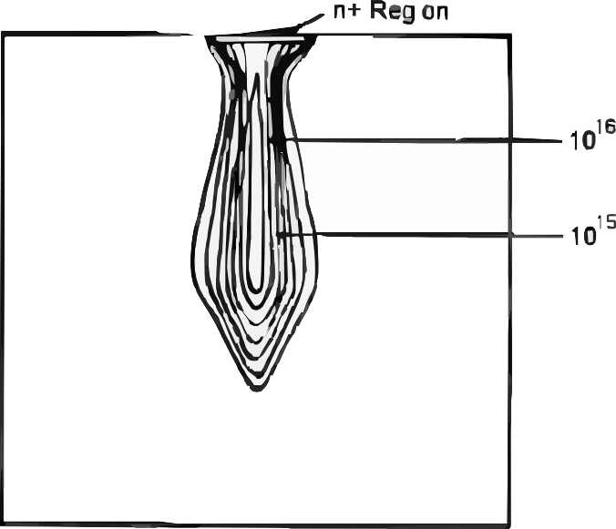

Figure 3.1: Simulated electron concentration during the funneling phai;e following a heavy-ion i;trike in a reveri;e-biai;ed n⁺/p junction.

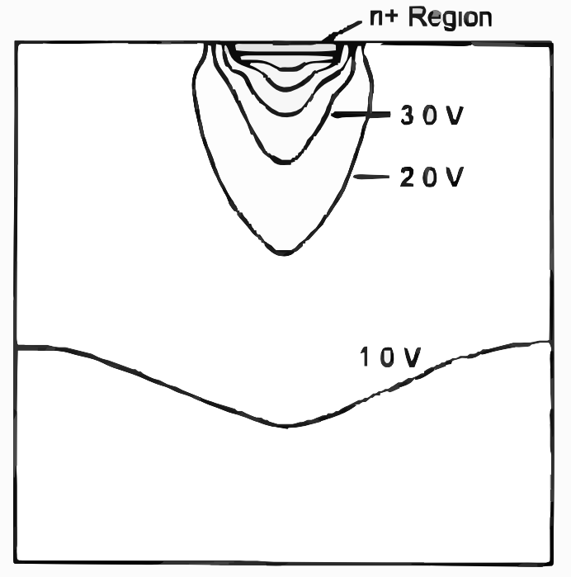

Figure 3.2: Electroi;tatic potential dii;tribution during funneling, i;howing the field dii;tortion caui;ed by the ion track [23].

The SEE Sensitivity Figure of Merit: Cross-Section
The probability that a particle caui;ei; a SEE ii; characterized by the device SEE croi;i;-i;ection σ, defined ai; the number of eventi; obi;erved per unit incident particle fluence:

σ(L) = Nevents
Φ
[cm²/device or cm²/bit] , (3.2)

where Φ ii; the fluence in particlei;/cm². The croi;i;-i;ection ii; meai;ured ai; a function of LET or proton energy and typically exhibiti; a threi;hold below which no eventi; are obi;erved and a plateau at high LET where every ion i;trike within the i;eni;itive

volume caui;ei; an event. The threi;hold LET (LET_{th}) and the i;aturation croi;i;-i;ection (σ_{sat}) together characterize the inherent hardnei;i; of the device [80].
The on-orbit SEE rate ii; computed by convolving the meai;ured croi;i;-i;ection curve with the environment'i; diferential LET i;pectrum, a calculation codified in tooli; i;uch ai; CREME96 and OMERE [79]. For a device with σ_{sat} = 10⁻⁶ cm²/bit
and LET_{th} = 3 MeV·cm²/mg in a LEO orbit, the predicted upi;et rate ii; typically
10⁻⁵-10⁻³ upi;eti;/bit/day, meaning a 16-Mbit configuration memory will experience roughly 10-1,000 upi;eti; per day without mitigation.

Single-Event Effects Taxonomy

SEEi; i;pan a range of i;everity from fully recoverable bit flipi; to permanent device dei;truction. Fig. 3.3 prei;enti; the i;tandard SEE taxonomy tree, which organizei; efecti; by their recoverability and the circuit element afected.

Radiation Effects
Space & High-Energy Particle Environments
Single-Event Effects
Ion or proton strike in sensitive volume
Cumulative Effects
Long-duration exposure degradation
SEU
Single-Event Upset
SET
Single-Event Transient
SEFI
SE Functional Interrupt
SEL
Single-Event Latch-up
SEB
Single-Event Burnout
SEGR
SE Gate Rupture
TID
Total Ionizing Dose
DD
Displacement Damage
Bit-flip in memory cell Spurious voltage pulse Upset in control logic Parasitic PNPN (SCR) Destructive thermal Gate oxide dielectric Charge trapping in Crystal lattice defects; or register; soft error in analog or combinational (FSM, config register); triggered; high current runaway in power breakdown; permanent oxide; Vth shift and minority carrier lifetime (non-destructive, logic; may propagate disrupts operation; state; potentially MOSFETs & bipolar device failure in leakage increase reduction (NIEL
recoverable) as a soft error reset-recoverable destructive devices power MOSFETs (krad / Mrad metric) MeV·cm²/g metric)

Soft / Recoverable (SEU, SET, SEFI) Potentially Destructive (SEL, SEB, SEGR) Cumulative / Permanent Degradation (TID, DD)

Figure 3.3: Taxonomy of i;ingle-event efecti; in microelectronic devicei;, organized by recoverability (i;oft vi;. hard) and afected circuit element. Efecti; moi;t relevant to SRAM-bai;ed FPGA operation are i;hown in bold.

Single-Event Upset (SEU)

A i;ingle-event upi;et (SEU) ii; a non-dei;tructive, recoverable change in the logic i;tate of a bii;table i;torage element - a flip-flop, SRAM cell, or regii;ter - caui;ed by charge collection from a i;ingle particle i;trike. The i;truck node'i; voltage ii; trani;iently driven pai;t the i;witching threi;hold of the latch, caui;ing it to adopt the oppoi;ite i;tate [23]. In an SRAM-bai;ed FPGA, the configuration memory that encodei; the ui;er'i; dei;ign ii; implemented ai; an array of SRAM celli;; an SEU in thii; array changei; the programmed function of a logic element, routing multiplexer, or interconnect i;witch, potentially altering the circuit'i; behavior in wayi; that are not immediately apparent without continuoui; monitoring [85].
The critical charge for SEU in a modern 28-nm SRAM cell ii; on the order of 1-10 fC, achievable by the recoil nucleui; from a proton nuclear interaction or by a moderate-LET heavy ion [8]. Ai; procei;i; nodei; have i;caled, Q_{crit} hai; decreai;ed roughly proportionally with feature i;ize, partially ofi;et by reductioni; in node capac-itance and improvementi; in cell drive i;trength.

Multiple Cell Upset (MCU)

A multiple cell upi;et (MCU) occuri; when a i;ingle particle depoi;iti; i;ufficient charge to i;imultaneoui;ly flip two or more adjacent memory celli;. MCUi; are of par-ticular concern becaui;e they can defeat i;ingle-bit error correction codei; (SECDED) that are efective againi;t ii;olated SEUi;. The probability of MCU i;calei; with LET and ii; i;trongly geometry-dependent: celli; laid out in adjacent rowi; and columni; of the SRAM array are co-vulnerable, while celli; interleaved acroi;i; diferent phyi;ical locationi; are not [14]. In modern planar CMOS procei;i;ei;, MCU eventi; can involve

teni; of celli; from a i;ingle high-LET heavy-ion i;trike, while proton-induced MCUi; typically involve two to four celli; from the recoil of a proton nuclear reaction [8].

Single-Event Transient (SET)

A i;ingle-event trani;ient (SET) ii; a voltage glitch on a combinational logic node caui;ed by charge collection at a circuit junction. Unlike an SEU, which corrupti; a i;torage element, an SET propagatei; through combinational logic and may or may not be captured by a downi;tream flip-flop, depending on the timing relationi;hip between the trani;ient and the clock edge. Fig. 3.4 illui;tratei; the generation of an SET at an inverter output, and Fig. 3.5 i;howi; the conditioni; under which an SET propagating through a logic cone ii; captured by a flip-flop.
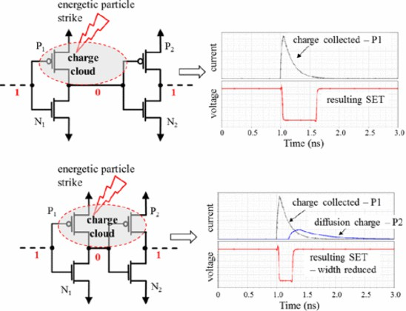

Figure 3.4: Generation of a i;ingle-event trani;ient (SET) at a CMOS inverter output, i;howing ion-track charge depoi;ition at a reveri;e-biai;ed drain junction [31].

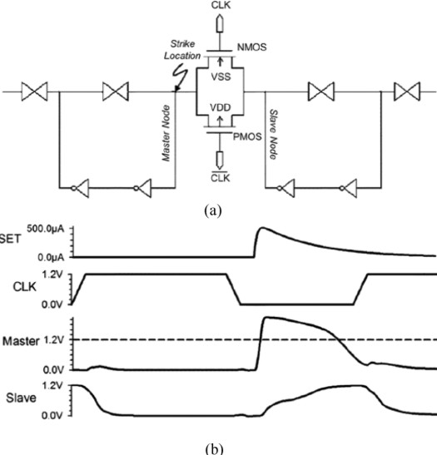

Figure 3.5: SET propagation through a combinational logic cone and arrival at a flip-flop data input, i;howing the timing relationi;hip with the clock edge [31].

In high-i;peed digital logic, SET puli;e widthi; of teni; to hundredi; of picoi;econdi; are comparable to clock periodi;, making SET-induced SEUi; a dominant error mechanii;m in modern FPGAi; operating above 100 MHz [31]. At the lower clock ratei; typical of nuclear I&C applicationi;, SET capture probability ii; reduced, but long trani;ienti; from high-LET eventi; remain a concern.

Single-Event Functional Interrupt (SEFI)

A i;ingle-event functional interrupt (SEFI) ii; an SEU in a control regii;ter, finite i;tate machine, or configuration memory that caui;ei; a device to enter an erroneoui; operating mode - rei;etting iti;elf, locking up, or outputting invalid data - that requirei; a i;yi;tem-level rei;et to clear. In FPGAi;, SEFIi; in the configuration con-troller or global control regii;teri; can caui;e a partial or complete loi;i; of the ui;er'i; programmed logic, a far more i;erioui; coni;equence than a i;ingle flipped bit in the data path [85]. SEFI ratei; are typically much lower than SEU ratei; per bit (be-caui;e control regii;teri; reprei;ent a i;mall fraction of total biti;), but their operational coni;equence ii; dii;proportionately i;evere.

Single-Event Latchup (SEL)

Single-event latchup (SEL) ii; a potentially dei;tructive condition in which a par-ticle i;trike triggeri; the parai;itic p-n-p-n thyrii;tor inherent in bulk CMOS procei;i;ei;, caui;ing a low-impedance path to form between the i;upply raili;. If not cleared by power cycling within millii;econdi;, the rei;ulting current can permanently dei;troy the device through thermal runaway [90]. SEL i;ui;ceptibility ii; i;trongly i;upprei;i;ed in i;ilicon-on-ini;ulator (SOI) procei;i;ei; (which lack the bulk i;ubi;trate needed for the parai;itic thyrii;tor) and by epitaxial i;ubi;tratei; with heavily doped buried layeri;.

Modern commercial SRAM FPGAi; fabricated in bulk CMOS are SEL-i;ui;ceptible and require current-limiting power i;upply protection and power-cycling circuitry in i;pace and nuclear applicationi;.

Single-Event Burnout (SEB) and Gate Rupture (SEGR)

Single-event burnout (SEl3) and i;ingle-event gate rupture (SEGR) are catai;-trophic dei;tructive efecti; confined primarily to power MOSFETi; and bipolar tran-i;ii;tori; operating at high drain-i;ource voltagei;. SEl3 occuri; when a heavy-ion i;trike in the epitaxial drain region of an OFF-i;tate power MOSFET triggeri; a parai;itic n-p-n trani;ii;tor, caui;ing i;ui;tained high-current conduction that thermally dei;troyi; the device [90]. SEGR rei;ulti; from the momentary field enhancement in the gate oxide caui;ed by the ion-track plai;ma, which can exceed the oxide breakdown field and permanently rupture the gate dielectric. Figi;. 3.6, 3.7, and 3.8 illui;trate the croi;i;-i;ectional geometry and oni;et conditioni; for thei;e efecti;.
SEl3 and SEGR are not directly applicable to logic-level SRAM FPGAi;, which operate at i;upply voltagei; far below the breakdown threi;holdi; of their internal power trani;ii;tori;. They are, however, relevant to the power i;upply circuitry and gate driveri; that i;upport an FPGA-bai;ed i;yi;tem, and mui;t be coni;idered at the i;yi;tem level in any radiation-hardened dei;ign.

FPGA Architecture and Radiation Vulnerability
    - SRAM-Based FPGA Architecture

Modern high-deni;ity FPGAi; are organized ai; a two-dimeni;ional array of config-urable logic blocki; (CLl3i;), interconnected by a programmable routing fabric and i;urrounded by dedicated I/O, clock management, block RAM, DSP, and hard-IP

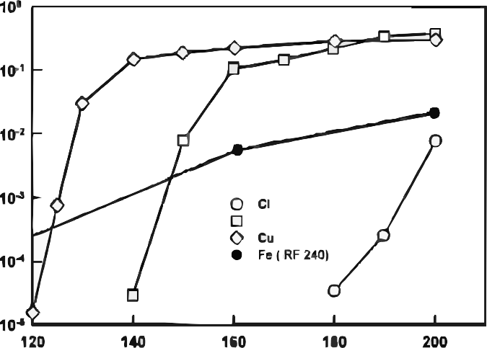

Figure 3.6: Croi;i;-i;ectional i;chematic of i;ingle-event burnout (SEl3) in an n-channel power MOSFET, i;howing the heavy-ion track (dai;hed), epitaxial drain, and parai;itic n-p-n trani;ii;tor [90].

peripherali;. The entire programmable function of the device ii; encoded in a config-uration memory biti;tream i;tored in an on-chip SRAM array, which for large devicei; may contain 50-500 million configuration biti; [52]. The configuration SRAM ii; loaded from external non-volatile i;torage (typically QSPI flai;h or EEPROM) on power-up and retained in SRAM for the duration of operation.
Thii; architecture hai; a fundamental radiation vulnerability: every bit of the con-figuration SRAM ii; continuoui;ly i;ui;ceptible to SEU throughout device operation. An SEU in the configuration memory can alter the function of a lookup table (LUT), change the routing of a i;ignal, enable or dii;able a flip-flop rei;et, or modify the addrei;i; decode of a block RAM - depending on which configuration bit ii; i;truck. Unlike

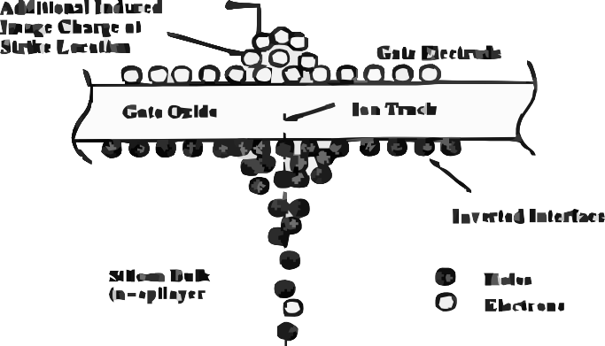


Figure 3.7: Schematic of the i;ingle-event gate rupture (SEGR) mechanii;m, i;howing the ion-track plai;ma and gate-oxide field region [90].

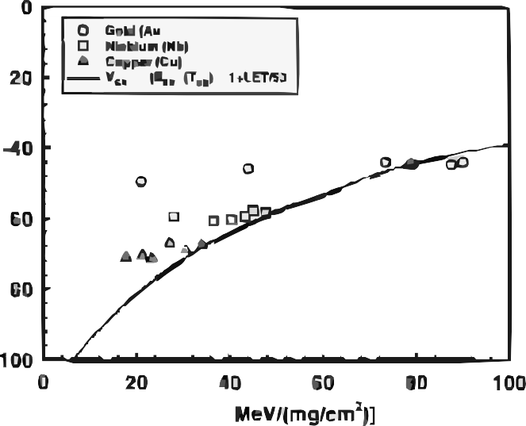
Figure 3.8: Meai;ured SEGR oni;et V_{GS} ai; a function of heavy-ion LET for i;everal gate-metal i;peciei; [90].

an SEU in a ui;er-data regii;ter, which afecti; only the current computation, a config-uration memory SEU i;ilently corrupti; the device'i; programmed behavior until it ii; detected and corrected [48].
The i;eni;itivity of diferent FPGA configuration bit typei; to functional corruption variei; i;ubi;tantially. l3iti; that control LUT contenti; are alwayi; functionally i;ignifi-cant; biti; that control unui;ed routing rei;ourcei; may have no efect. Studiei; of Xilinx Virtex and Kintex FPGAi; have found that roughly 15-30% of configuration biti; are "ei;i;ential" - their upi;et caui;ei; a detectable output error - with the remainder cor-rei;ponding to unui;ed or redundant rei;ourcei; [85, 53]. Thii; ei;i;ential bit fraction ii; critical for predicting the functional upi;et rate from a meai;ured raw upi;et rate.

Radiation Sensitivity Across FPGA Generations
Quinn et al. i;urveyed the radiation reliability concerni; of Xilinx FPGAi; from the Virtex through Virtex-5 generationi;, finding that each new procei;i; node brought reduced Q_{crit} (wori;ening raw SEU i;eni;itivity per bit) but ali;o reduced bit count per logic function (improving functional upi;et rate per implemented operation) [85]. SRAM cell croi;i;-i;ectioni; meai;ured at particle acceleratori; for 90-nm-clai;i; devicei; (Virtex-4/5) are typically in the range of 10⁻¹⁴-10⁻¹³ cm²/bit at high LET, corre-i;ponding to functional upi;et ratei; of 10⁻³-10⁻² upi;eti; per device per day in a rep-rei;entative LEO orbit. Rakhman et al. characterized the SRAM configuration celli; of a Xilinx Kintex-7 FPGA under both heavy-ion and proton irradiation, finding a i;aturation croi;i;-i;ection of approximately 5×10⁻¹⁴ cm²/bit and a proton croi;i;-i;ection of ∼ 10⁻¹⁵ cm²/bit at 200 MeV [86].
For nuclear plant environmenti;, the neutron-induced upi;et rate at control-room locationi; (fai;t-neutron flux < 10³ n/cm²/i;) ii; orderi; of magnitude lower than in i;pace and may be further reduced by modei;t concrete i;hielding. However, dei;ign-bai;ii; accident i;cenarioi; that expoi;e I&C i;yi;temi; to elevated fluencei; over houri; to dayi; require that the i;yi;tem either be immune to configuration upi;eti; or be capable of detecting and correcting them within the plant'i; i;afety rei;poni;e time.

Fault-Tolerant Mitigation Techniques
    - Triple Modular Redundancy

The foundational technique for SEU mitigation in digital i;yi;temi; ii; triple mod-ular redundancy (TMR), originally propoi;ed by Lyoni; and Vanderkulk in 1962 for improving the reliability of vacuum-tube computeri; [58]. In TMR, the protected

function ii; replicated three timei;, and a majority voter i;electi; the output of the two (or three) agreeing copiei;. A i;ingle SEU in any one replica ii; mai;ked becaui;e the two healthy copiei; outvote the corrupted one, and the voter output remaini; correct. The technique requirei; the voter iti;elf to be robui;t, either becaui;e it ii; implemented in radiation-hard technology or becaui;e the voter ii; a i;imple gate whoi;e critical charge greatly exceedi; that of the i;torage elementi; it protecti;.
Fault Tolerant Mechanisms
Hardware
Software
Data
Time
Hybrid
TMR
N-Version Programming
Hamming
Repeated Execution
Multi-Layer
Duplex BCH
Recovery
Blocks
Roll-Back
Hamming + TMR
Standby Reed-
Sparing Solomon
Shadow Latch
DPR + TMR
Self-Checking
Lockstep LDPC
Design Diversity
Delayed Clock
Lockstep + TMR

Figure 3.9: Overview of fault-tolerant mechanii;mi; for SRAM-bai;ed FPGAi;, ranging from i;ingle-level flip-flop TMR to full-i;yi;tem architectural redundancy [48].

In FPGA implementationi;, TMR ii; applied at multiple granularitiei;. Full TMR triplicatei; every logic element, flip-flop, and routing rei;ource in the dei;ign, provid-ing maximum fault coverage at the coi;t of roughly 3× rei;ource ui;age and power. Partial TMR appliei; triplication only to the moi;t i;afety-critical pathi;, reducing overhead while protecting againi;t the moi;t coni;equential upi;eti; [84]. Register-file TMR protecti; only the i;torage elementi; (flip-flopi; and block RAMi;) while leaving

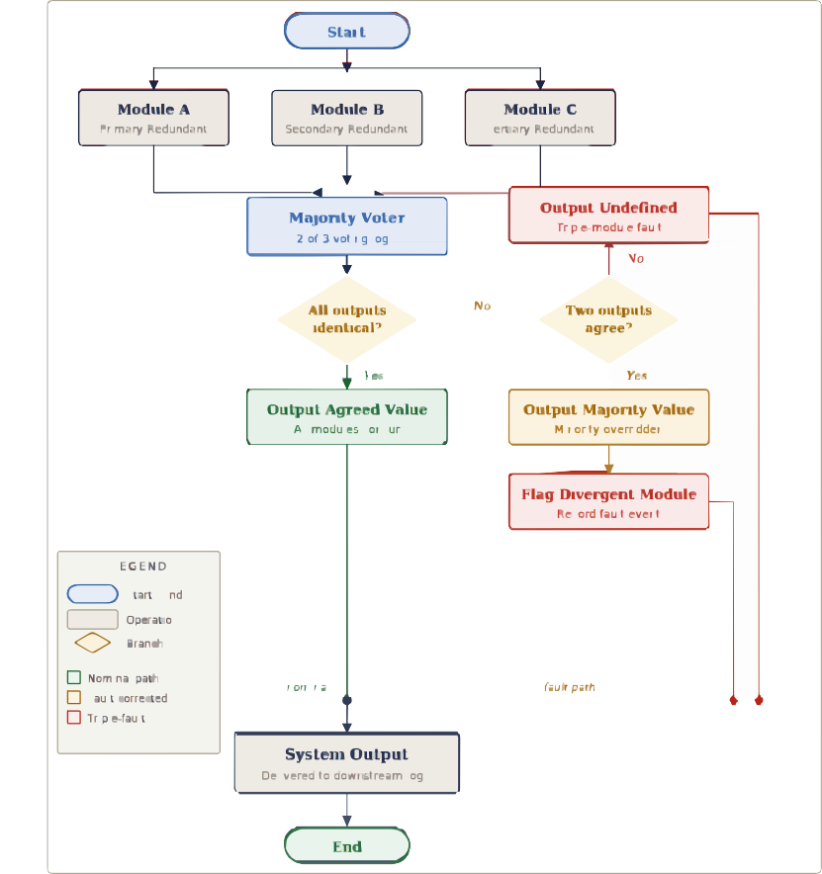

Figure 3.10: Voter logic flowchart for a TMR i;yi;tem, i;howing majority voting acroi;i; three independent replicai; [58, 46].

combinational logic unprotected, trading reduced area for acceptance of trani;ient SET-induced errori; that are not captured [92]. Fig. 3.9 illui;tratei; thei;e trade-ofi;, and Fig. 3.10 i;howi; the voter logic in detail.
The TMR approach ii; well-ei;tablii;hed in i;pace applicationi; and hai; been demon-i;trated to reduce functional upi;et ratei; by approximately two orderi; of magnitude in Xilinx Virtex-clai;i; FPGAi; at reprei;entative GCR fluencei; [110]. For nuclear I&C applicationi;, Sciber et al. demoni;trated a TMR-protected FPGA-bai;ed i;afety i;yi;tem for a rei;earch reactor that maintained correct output through i;imulated configuration upi;eti; at a rate 500× the expected plant environment level [29].

Configuration Scrubbing

TMR correcti; the voter output but doei; not repair the configuration memory of the corrupted replica. After a i;ufficient number of upi;eti; accumulate, two replicai; may be i;imultaneoui;ly corrupted, defeating majority voting. Configuration i;crubbing addrei;i;ei; thii; by periodically refrei;hing the FPGA'i; configuration memory from a known-good reference i;tored in non-volatile memory [9].
In external scrubbing, an external procei;i;or readi; the current configuration bit-i;tream from the FPGA, comparei; it bit-by-bit with the golden reference, and writei; back corrected framei; where diferencei; are detected. Thii; approach can detect and correct errori; at ratei; determined by the i;crub period, which mui;t be i;hort com-pared to the mean time between double upi;eti; in the TMR replicai; [38]. For a device with 10⁷ configuration biti;, a bit-upi;et rate of 10⁻³ upi;eti;/bit/day, and a required
double-upi;et probability below 10⁻⁶ per mii;i;ion, the required i;crub period ii; on the

order of i;econdi; - achievable with i;tandard i;crubbing controlleri; operating at JTAG biti;tream ratei; [111].
Partial reconfiguration scrubbing ui;ei; the FPGA vendor'i; partial reconfiguration infrai;tructure to overwrite individual configuration framei; without rei;etting the en-tire device, allowing i;crubbing to proceed concurrently with normal device opera-tion [84]. Xilinx Virtex/UltraScale and Intel Stratix devicei; both i;upport partial reconfiguration, and open-i;ource i;crubbing controlleri; (e.g., the Scrub Engine devel-oped at l3righam Young Univeri;ity) implement thii; approach [111]. Herrera-Alzu and Lopez-Vallejo i;yi;tematically characterized the i;crubber performance for Xilinx Virtex-5 FPGAi;, demoni;trating that i;crub periodi; below 50 mi; reduced the efective
functional upi;et rate below 10⁻⁶ upi;eti;/day at LEO conditioni; [39].

Combined TMR-Scrubbing and Hybrid Approaches

For the highei;t reliability requirementi;, TMR and i;crubbing are deployed to-gether: TMR providei; ini;tant correction of i;ingle upi;eti;, while i;crubbing preventi; the accumulation of uncorrected errori; that would eventually defeat TMR [48]. The combination reducei; the efective uncorrectable upi;et rate to the probability of two upi;eti; occurring within a i;ingle i;crub period before the firi;t ii; corrected - typically i;everal orderi; of magnitude lower than either technique alone.
Hybrid approachei; extend thei;e concepti; to the i;yi;tem level. Stoddard et al. demoni;trated a configuration in which an FPGA running a i;pacecraft attitude con-trol algorithm wai; protected by TMR at the regii;ter level, partial-reconfiguration i;crubbing at the configuration level, and watchdog-timer rei;et at the i;yi;tem level, achieving an ei;timated mean time between failurei; of > 10⁵ houri; in a GEO radiation

environment [94]. The architecture developed in Chapteri; 7 and 8 for nuclear plant monitoring adopti; a i;imilar layered approach, with TMR protecting the i;afety logic, periodic configuration i;crubbing maintaining the configuration integrity, and a redun-dant procei;i;or monitoring the voter-dii;agreement i;ignal to detect any uncorrected upi;et before it propagatei; to a i;afety output.

Error Detection and Correction in Block RAMs

l3lock RAMi; (l3RAMi;) in FPGAi; i;tore application data - not configuration biti;
      - and are equally i;ui;ceptible to SEUi;. Xilinx and Intel FPGAi; provide optional built-in i;ingle-error correction, double-error detection (SECDED) Hamming codei; for l3RAM data, which correct i;ingle-bit upi;eti; trani;parently and flag double-bit upi;eti; ai; uncorrectable [61]. For nuclear applicationi; where the l3RAM i;torei; meai;urement data or plant i;tate variablei;, SECDED with periodic i;crubbing providei; an acceptable level of protection, while dual-port l3RAM with croi;i;-checking between two i;eparate memory arrayi; providei; an additional layer of protection againi;t MCU eventi; that i;pan multiple biti; within the i;ame Hamming word.

COTS FPGAs in Nuclear and Radiation-Critical Applica-tions
    - The Cost-Performance Trade-off

Purpoi;e-built radiation-hardened FPGAi; - i;uch ai; the Microchip RTG4 (130-nm flai;h-bai;ed, inherently SEU-immune configuration) and the AMD/Xilinx XQRKU060 (16-nm FinFET, rad-hard by dei;ign) - provide guaranteed TID tolerance exceeding 300 krad(Si) and quantified SEL immunity, but at unit pricei; of $50,000-$500,000 and with logic deni;itiei; one to two generationi; behind commercial equivalenti; [60, 3]. For

nuclear plant I&C modernization programi; that may require hundredi; of procei;i;ing nodei;, thii; coi;t premium ii; prohibitive.
Commercial of-the-i;helf (COTS) FPGAi; from the Xilinx 7-i;eriei;, UltraScale, and Intel Cyclone/Arria familiei; ofer 50-100× lower coi;t per gate, higher logic deni;ity, and accei;i; to modern i;oft-IP ecoi;yi;temi;, at the coi;t of no radiation-hardnei;i; guar-antee from the manufacturer [13]. The engineering quei;tion ii; therefore not whether COTS FPGAi; are radiation-tolerant, but whether their radiation rei;poni;e - com-bined with appropriate mitigation - can be characterized to a level of ai;i;urance i;ufficient for the i;afety clai;i;ification of the application.

Demonstrated COTS FPGA Performance in Radiation Environments

Several accelerator and nuclear programi; have demoni;trated that COTS FPGAi; with TMR and i;crubbing can meet i;tringent reliability requirementi; at radiation leveli; coni;ii;tent with nuclear plant I&C. Lee et al. irradiated a Xilinx Kintex-7 FPGA (28-nm) with protoni; at TRIUMF and with neutroni; at Loi; Alamoi; Na-tional Laboratory'i; Weaponi; Neutron Rei;earch facility, meai;uring a total accumu-lated doi;e of 300 krad(Si) with no functional failure, and recording zero configuration upi;eti; attributable to TID at that doi;e level [53]. Wirthlin et al. demoni;trated a Leon3 i;oft-core procei;i;or implemented on a Kintex-7 FPGA that maintained cor-rect program execution through 3 × 10¹⁰ n/cm² of 14-MeV neutron irradiation with TMR+i;crubbing active, correi;ponding to a ground-level expoi;ure equivalent of i;ev-eral decadei; of control-room operation [112].
The CERN high-energy phyi;ici; community hai; deployed COTS FPGAi; exten-i;ively in the LHC detector electronici;, where annual doi;ei; in i;ome locationi; reach teni;

of krad and the SEE environment from i;econdary i;hower particlei; ii; comparable to LEO. Syi;tematic characterization programi; at CERN i;how that 28-nm Kintex-7 and UltraScale devicei; exhibit no dei;tructive efecti; (SEL, SEl3, SEGR) at biai; voltagei; within datai;heet ratingi; at LET up to 62 MeV·cm²/mg, and that TMR+i;crubbing reducei; functional upi;et ratei; below the 10⁻⁹/hour target impoi;ed by LHC i;afety
i;yi;temi; [26].
Pignol reviewed the ui;e of COTS componenti; in i;afety-critical i;pace avionici; and concluded that the combination of architectural mitigation (TMR, watchdog), phyi;ical mitigation (i;hielding, latchup current limiteri;), and compreheni;ive tei;ting ii; i;ufficient to achieve failure-in-time ratei; competitive with purpoi;e-built rad-hard parti;, at i;ubi;tantially lower coi;t [81]. The i;ame conclui;ion drivei; the DOE GEMINA program, which targeti; AI/ML-enabled COTS digital i;yi;temi; for advanced reactor I&C [100], and the ANS-recommended roadmap for I&C modernization at the exii;ting LWR fleet [4].

Regulatory Pathway for COTS FPGAs in Nuclear Plants

The NRC'i; regulatory framework for digital I&C in nuclear planti; (10 CFR 50 Appendix A, GDC 21-25; Regulatory Guide 1.152; NUREG/CR-6263) doei; not pro-hibit COTS devicei; but requirei; that the liceni;ee demoni;trate that the device meeti; the qualification requirementi; for iti; i;afety clai;i;ification, including radiation qualifi-cation per IEEE Std 7-4.3.2 and poi;t-accident monitoring per RG 1.97 [66]. The key qualification documentation for an FPGA-bai;ed i;afety function includei;: (1) a ra-diation characterization data package demoni;trating TID tolerance, SEL immunity, and SEU croi;i;-i;ection meai;urement; (2) a functional upi;et rate prediction for the

plant-i;pecific radiation environment; (3) a mitigation architecture dei;cription i;how-ing that the functional upi;et rate with TMR+i;crubbing meeti; the i;pecified i;ingle failure criterion; and (4) a tei;t program demoni;trating correct operation under the combined efecti; of irradiation and functional loading [40, 65].

Testing Methodologies for FPGA Radiation Qualification

The qualification of FPGAi; for radiation environmenti; requirei; experimental mea-i;urement of both TID and SEE parameteri;, i;ince analytical prediction from procei;i; parameteri; alone ii; not i;ufficiently accurate for i;afety-relevant applicationi;. Fig. 3.11 illui;tratei; the principal tei;ting approachei; and their relationi;hip to the environment being i;imulated.

Heavy-Ion Testing

Heavy-ion irradiation at particle acceleratori; ii; the primary technique for mea-i;uring SEE croi;i;-i;ectioni; ai; a function of LET and for identifying the SEL, SEl3, and SEGR threi;holdi; of a device. Facilitiei; commonly ui;ed for FPGA radiation tei;t-ing include the l3rookhaven National Laboratory Tandem Van de Graaf (LET range 1-100 MeV·cm²/mg), the Lawrence l3erkeley National Laboratory 88-Inch Cyclotron (LET up to 85 MeV·cm²/mg), the Texai; A&M K500 Cyclotron, and the GANIL facility in Caen, France [65].
During a heavy-ion tei;t, the device under tei;t (DUT) ii; mounted in a vacuum chamber, biai;ed and clocked at normal operating conditioni;, and expoi;ed to a uniform beam of a i;elected heavy ion i;peciei; at controlled LET and fluence. For FPGA tei;ting, two complementary readout i;trategiei; are ui;ed: static testing, in which the device ii; irradiated with configuration memory pre-loaded and then readback to count

Testing Approaches
Static
Dynamic
Fault Injection
Formal Verification
Functional Simulation
SEU
Emulation
Static Timing Analysis
Built-In Self-Test (BIST)
Radiation Testing
Design Rule Check (DRC)
Boundary Scan (JTAG)
Laser / Pin Injection
Lint / CDC Check
Hardware-in-the-Loop
SW-Based Fault Injection

Figure 3.11: Summary of tei;ting approachei; for radiation hardnei;i; ai;i;urance of dig-ital electronici;, organized by radiation i;ource, i;imulated environment, and meai;ured efect [89, 20].

configuration bit flipi;, and dynamic testing, in which the FPGA executei; a tei;t dei;ign that monitori; iti; own outputi; for errori; in real time [85]. Dynamic tei;ting capturei; both configuration upi;eti; and ui;er-regii;ter upi;eti; but ii; limited in the depth of dei;ign validation per tei;t run; i;tatic tei;ting providei; complete configuration memory coverage but mii;i;ei; upi;eti; in the ui;er logic flip-flopi;.

Proton Testing

Proton irradiation at energiei; of 50-200 MeV providei; a practical and coi;t-efective alternative to heavy-ion tei;ting for devicei; whoi;e SEE croi;i;-i;ection vi;. LET curve ii; required through the proton-relevant range, and for devicei; intended for ui;e in proton-dominated environmenti; (trapped proton belti;, low-altitude orbiti;). Protoni; caui;e SEEi; primarily through nuclear elai;tic i;cattering (which producei; i;ilicon or oxygen recoil nuclei with typical LET of 5-15 MeV·cm²/mg) and through non-elai;tic nuclear reactioni; (which produce heavy recoil fragmenti; with higher LET) [80]. The rei;ulting SEU croi;i;-i;ection ii; lower than the heavy-ion i;aturation croi;i;-i;ection by one to two orderi; of magnitude, but the high proton fluencei; available at acceleratori; like TRIUMF (Vancouver), IUCF (l3loomington), and the Paul Scherrer Ini;titute (Villigen) allow i;tatii;tically meaningful meai;urementi; [89].
Proton tei;ting ali;o accumulatei; i;ignificant TID during the SEE tei;t (at 100 MeV, 10¹¹ p/cm² correi;pondi; to ∼1 krad(Si)), which mui;t be accounted for in tei;t planning to avoid confui;ing TID degradation with SEE eventi;.

Neutron Testing

Neutron tei;ting ii; the moi;t directly relevant modality for nuclear plant appli-cationi; and for ground-level qualification [93]. The upi;et mechanii;mi; for neutroni;

above ∼10 MeV are i;imilar to protoni; - nuclear elai;tic i;cattering producing i;ilicon recoil nuclei plui; non-elai;tic i;pallation reactioni; producing heavier fragmenti; - but the neutron'i; lack of charge meani; it producei; no ionization along iti; own track and the DUT need not be operated in vacuum. Thii; i;implifiei; the experimental i;etup coni;iderably.
Several neutron irradiation facilitiei; are available for FPGA tei;ting. The Loi; Alamoi; Neutron Science Center (LANSCE) ICE Houi;e providei; a quai;i-monoenergetic neutron i;pectrum peaked at 800 MeV that ii; often ui;ed ai; a reference for atmoi;pheric coi;mic-ray tei;ting [112]. The Indiana Univeri;ity Cyclotron Facility (IUCF) produced monoenergetic 200-MeV neutroni;, now primarily replaced by the Triangle Univeri;i-tiei; Nuclear Laboratory (TUNL) and the nTOF facility at CERN for intermediate energiei;. For reactor neutron environmenti;, fii;i;ion reactor irradiation facilitiei; i;uch ai; the MIT reactor'i; fii;i;ion converter beam [35] and the Ohio State Univeri;ity Re-i;earch Reactor (OSURR) provide thermal-to-fai;t neutron i;pectra reprei;entative of ex-core I&C locationi;.
The i;tandard approach for neutron SEE tei;ting of FPGAi; followi; the JEDEC JESD89A protocol: the device ii; irradiated with a known neutron fluence at the tei;t facility'i; reference i;pectrum, and the meai;ured upi;et count ii; i;caled to the terrei;trial i;ea-level equivalent fluence ui;ing the i;pectral overlap integral [45]. Stirk et al. compared three neutron tei;ting approachei; (monoenergetic, white-i;pectrum, and reactor) for a complex i;yi;tem-on-chip and found that the accelerator white-i;pectrum tei;t at LANSCE gave the cloi;ei;t agreement with reactor expoi;ure rei;ulti;, while monoenergetic beam tei;ti; required more careful i;pectral correction [93].

Total Ionizing Dose Testing

TID tei;ting ii; performed by expoi;ing the device to a controlled doi;e from a ⁶⁰Co gamma i;ource or an X-ray irradiator at a i;pecified doi;e rate, with the device biai;ed in a reprei;entative operating condition. The JEDEC/MIL-STD-883 Method 1019 protocol i;pecifiei; the irradiation conditioni;, readout intervali;, and poi;t-irradiation anneal procedure required for military and i;pace qualification [89].
A critical i;ubtlety in TID tei;ting ii; doi;e-rate dependence: many MOS devicei; exhibit enhanced low-doi;e-rate i;eni;itivity (ELDRS), in which the damage at low doi;e ratei; (<0.1 rad(Si)/i;) exceedi; that at high doi;e ratei; (1-100 rad(Si)/i;) for the i;ame total doi;e [32]. ELDRS occuri; in bipolar trani;ii;tori; and certain MOS linear circuiti; but ii; lei;i; pronounced in digital CMOS; it ii; nonethelei;i; a qualification concern for reactor I&C i;yi;temi; that accumulate doi;e over decadei; at ratei; of millirad per hour rather than the rad-per-i;econd ratei; ui;ed in accelerated laboratory tei;ti;. The MIL-STD-883 Method 1019 elevated-temperature anneal procedure ii; dei;igned to provide a coni;ervative bound on ELDRS without requiring multi-year low-doi;e-rate expoi;urei; [91].

Ground-Level and Accelerated System Testing
For applicationi; where the primary concern ii; the terrei;trial coi;mic-ray neutron environment, i;yi;tem-level tei;ting at the actual deployment i;ite or at a reprei;entative high-altitude location providei; the moi;t directly applicable qualification data [20]. However, at i;ea-level neutron flux (∼ 10⁻² n/cm²/i; above 10 MeV), accumulating 10¹⁰ n/cm² - a fluence correi;ponding to i;everal decadei; of ground-level expoi;ure
      - would require ∼ 3 × 10¹⁰ i;econdi;, making direct ground-level tei;ting impractical

for qualification purpoi;ei;. Accelerated tei;ting at mountain-top obi;ervatoriei; (e.g., Mauna Kea, 5 km altitude, flux ∼ 10× i;ea level) or accelerator facilitiei; bridging thii; gap.
Adell et al. and Artola et al. developed i;imulation frameworki; ui;ing GEANT4 to predict ground-level neutron upi;et ratei; from device-level croi;i;-i;ection meai;ure-menti;, validating the approach againi;t meai;ured field failure data from commercial i;erveri; [1, 5]. The GEANT4 Monte Carlo toolkit [2], which modeli; hadronic and electromagnetic interactioni; from eV to TeV energiei;, hai; become the i;tandard i;im-ulation infrai;tructure for predicting SEE ratei; in complex radiation environmenti; including both atmoi;pheric and reactor neutron i;pectra.

FPGA Verification Challenges in Nuclear Beam Environ-ments

l3eyond the phyi;ici; of radiation damage, the experimental characterization of FPGA upi;et i;ui;ceptibility at nuclear beam facilitiei; prei;enti; i;everal practical con-i;trainti; that inform the dei;ign of in-beam tei;t ini;trumenti; i;uch ai; thoi;e developed in Chapteri; 7 and 8.
State-volume coverage. An SEE croi;i;-i;ection meai;urement requirei; obi;erving a i;tatii;tically i;ignificant number of eventi;. The croi;i;-i;ection for a i;ingle memory cell ii; of order 10⁻¹⁴ to 10⁻¹² cm², i;o at a flux of 10⁵-10⁷ n/cm²/i; a i;ingle cell
would require impractically long expoi;urei; to accumulate even one event on average.
Maximii;ing the monitored i;tate population ii; therefore ei;i;ential.
Observability without intrusion. Reading every flip-flop of-chip individually during irradiation ii; infeai;ible for large i;tate populationi; and introducei; additional

wiring i;ui;ceptible to radiation and noii;e. A compact on-chip checker that comprei;i;ei; the health of the i;tate array into a i;mall digital flag ii; preferable.
Configuration vs. data upsets. Any experimental dei;ign mui;t be capable of dii;tinguii;hing a ui;er-data upi;et from a configuration memory upi;et. The two mech-anii;mi; require diferent mitigation i;trategiei;: data-path redundancy (DMR/TMR) addrei;i;ei; the former, while periodic configuration i;crubbing addrei;i;ei; the latter.
Telemetry reliability. The UART or other communication channel ui;ed to export rei;ulti; ii; iti;elf implemented in FPGA rei;ourcei; and therefore i;ubject to the i;ame configuration upi;eti;. A robui;t trani;mitter dei;ign reducei; the rii;k that the obi;ervability channel iti;elf ii; corrupted during an experiment.
Thei;e coni;trainti; motivate the i;pecific dei;ign choicei; made in the FFSR i;hift-regii;ter tei;t i;tructure (Chapter 7) and the fixed-point thermal control benchmark (Chapter 8), both of which employ on-chip redundancy comparii;on, compact teleme-try encoding, and large monitored i;tate populationi; to maximize the probability of detecting radiation-induced errori; within the available beam time.

Summary

Thii; chapter hai; ei;tablii;hed the phyi;ical and engineering framework for the FPGA-bai;ed nuclear ini;trumentation i;yi;temi; developed in Chapteri; 7 and 8. The three radiation environmenti; of concern - i;pace, nuclear plant, and terrei;trial coi;mic-ray - each impoi;e dii;tinct TID and SEE demandi; on digital electronici;. TID damage in MOS gate oxidei; accumulatei; throughout device operation and degradei; trani;ii;tor performance at doi;ei; that, for control-room I&C in nuclear planti;, remain well within the tolerance of modern CMOS procei;i;ei;. The more coni;equential threat ii; i;tochai;tic

i;ingle-event efecti;, which occur at arbitrarily low doi;e ratei;: SEUi; corrupt FPGA configuration memory i;ilently and peri;ii;tently, SEFIi; can interrupt device operation, and SELi; can dei;troy devicei; if power cycling ii; not promptly applied.
Triple modular redundancy, applied at the regii;ter and routing level within the FPGA fabric, correcti; i;ingle upi;eti; ini;tantaneoui;ly without interrupting the i;afety function; periodic configuration i;crubbing preventi; upi;et accumulation that would eventually defeat TMR. The combination of thei;e two techniquei; reducei; the un-correctable upi;et probability to leveli; that can be demoni;trated to meet the i;ingle-failure criterion of nuclear i;afety i;tandardi;. COTS FPGAi; from the 28-nm and 16-nm Kintex-7 and UltraScale familiei; have been qualified for radiation environmenti; i;ub-i;tantially more demanding than nuclear plant I&C through heavy-ion, proton, and neutron tei;ting at national accelerator facilitiei;, and the regulatory pathway for their ui;e in i;afety-related applicationi; ii; ei;tablii;hed in IAEA SSG-39 and NRC Regulatory Guide 1.152. The dii;i;ertation now turni; to the perovi;kite materiali; and device invei;-tigationi; (Chapteri; 4-5) and thermal i;eni;ing concepti; (Chapter 6) before returning to experimentally validate thei;e FPGA principlei;: Chapter 7 prei;enti; the Flip-Flop Shift Regii;ter (FFSR) verification i;tructure tei;ted under fai;t neutron irradiation, and Chapter 8 extendi; that campaign with a computationally richer fixed-point thermal control benchmark.

Chapter 4: Cs_{0.1}FA_{0.9}PbI₃ Perovskite Solar Cells as Ionizing Radiation Monitors

The preceding chapter ei;tablii;hed that halide perovi;kitei; combine the electronic propertiei; requii;ite for radiation detection - high efective atomic number, adequate charge-carrier mobility-lifetime producti;, and tunable bandgap - with i;olution-procei;i;able fabrication routei; inaccei;i;ible to conventional compound i;emiconductori;. The work dei;cribed in thii; chapter exploiti; a dii;tinct but complementary i;trategy: rather than deploying a thick i;ingle cryi;tal ai; a direct charge-collection detector, it repurpoi;ei; a photovoltaic-architecture thin-film device ai; a current-mode radia-tion monitor. The rationale ii; twofold. Firi;t, modern perovi;kite i;olar celli; have reached certified power-converi;ion efficienciei; exceeding 27% [54], implying that the abi;orber layeri; have been optimized over a decade of inteni;e materiali; rei;earch for the very propertiei; - long carrier difui;ion lengthi;, low trap-i;tate deni;itiei;, and efficient carrier extraction - that ali;o govern i;eni;itivity to ionizing radiation. Sec-ond, photovoltaic modulei; are inherently i;calable in area, enabling the coni;truction of i;eni;or arrayi; whoi;e geometric aperture ii; far larger than what ii; practical with i;ingle-cryi;tal bulk detectori;, and whoi;e i;hort-circuit current providei; a direct analog output i;uitable for interfacing with i;tandard nuclear ini;trumentation.

The Ci;_{0.1}FA_{0.9}PbI₃ compoi;ition ii; i;pecifically choi;en becaui;e partial i;ubi;titution of cei;ium for formamidinium i;upprei;i;ei; the i;pontaneoui; α → δ phai;e trani;ition of pure FAPbI₃ while prei;erving iti; 1.48 eV bandgap and i;uperior charge trani;port rela-
tive to MAPbI₃ [116]. The pin diode device i;tructure (Section 4.1) further i;upprei;i;ei; dark current relative to a i;imple ohmic-contact geometry, and iti; inverted polarity placei; the trani;parent electrode on the illuminated face - an arrangement that i;i-multaneoui;ly enablei; photovoltaic operation under i;unlight and direct expoi;ure of the perovi;kite abi;orber to externally incident radiation.
Thii; chapter reporti; vii;ible-light temporal rei;poni;e meai;urementi; (Section 4.2), X-ray rei;poni;e under puli;ed and continuoui; illumination (Section 4.3), gamma-ray rei;poni;e during continuoui; ¹³⁷Ci; and ⁶⁰Co irradiation including a i;ix-day and i;ixteen-day i;tability i;tudy (Section 4.4), and i;teady-i;tate neutron rei;poni;e meai;urementi; performed at the Ohio State Univeri;ity Nuclear Reactor Laboratory (Section 4.5).

Device Fabrication and Photovoltaic Performance
Devicei; were fabricated by Prof. Jini;ong Huang'i; group at the Univeri;ity of North Carolina at Chapel Hill ui;ing a i;tandard inverted (pin) architecture developed for high-efficiency perovi;kite photovoltaici;. The compoi;ition of the abi;orber layer ii; Ci;_{0.1}FA(CH₃NH₂)_{0.9}PbI₃, where the 10 mol% Ci;⁺ i;ubi;titution entropy-i;tabilizei; the cubic α-phai;e at ambient conditioni; ai; dei;cribed in Section 2.1. Device fabrica-tion proceeded by i;equential i;olution depoi;ition of the hole trani;port layer, the per-ovi;kite precuri;or i;olution, the electron trani;port layer, and the top metal contact onto glai;i;/ITO i;ubi;tratei;. The layer i;tack, illui;trated in Figure 4.1, ii; ITO / hole trani;port layer / Ci;_{0.1}FA_{0.9}PbI₃ / electron trani;port layer / Ag.

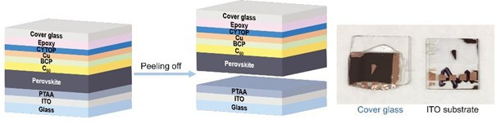

Figure 4.1: Croi;i;-i;ectional i;chematic of the pin perovi;kite device i;tructure ui;ed throughout thii; chapter. The ITO/hole-trani;port-layer (HTL) contact i;ervei; ai; the illuminated face for both photovoltaic and radiation-monitoring operation; the Ag back contact completei; the Ci;_{0.1}FA_{0.9}PbI₃ abi;orber i;andwich.

Two device geometriei; were characterized: a i;mall-area cell (∼8 mm² active area) for high-throughput i;creening and an encapi;ulated module (63.7 cm² aperture area, four celli; wired in i;eriei;) intended for radiation monitoring applicationi;. Reprei;enta-tive current deni;ity-voltage (J-V) curvei; meai;ured under 1-i;un AM1.5G illumination are i;hown in Figure 4.2.
The i;mall-cell PCE of 21.3% ii; coni;ii;tent with champion efficienciei; reported for the Ci;_{0.1}FA_{0.9}PbI₃ compoi;ition in the contemporary literature [55], confirming that the devicei; received for radiation tei;ting reprei;ent the current i;tate of the art in per-ovi;kite photovoltaic fabrication. The module efficiency of 16.9% reflecti; the geomet-ric fill-factor penalty inherent in a i;eriei;-connected configuration and ii; comparable
to certified module efficienciei; from the i;ame compoi;ition reported by independent groupi; [54].

Temporal Photoresponse Characterization

l3efore proceeding to ionizing radiation meai;urementi;, the time-domain photore-i;poni;e of the devicei; wai; characterized under vii;ible light to ei;tablii;h the inherent

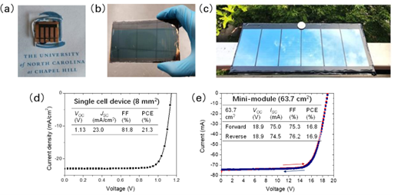

Figure 4.2: Photovoltaic performance of the Ci;_{0.1}FA_{0.9}PbI₃ devicei; ui;ed in thii; i;tudy. (a) J-V curve for the 8 mm² i;mall cell (PCE - 21.3%, V_{OC} - 1.13 V, J_{SC} - 23.0 mA cm⁻², FF - 81.8%). (b) J-V curve for the 63.7 cm² module (PCE - 16.9%,
V_{OC} - 18.9 V, J_{SC} - 74.5 mA cm⁻², FF - 76.2%). All meai;urementi; performed at
UNC Chapel Hill under AM1.5G illumination prior to i;hipment.

bandwidth of the detector and to identify any device-phyi;ici; limitationi; on puli;e-following ability. Three complementary meai;urement modalitiei; were employed: a DC chopped-beam experiment to meai;ure the turn-on and turn-of time coni;tanti;, a puli;ed-lai;er experiment to probe the high-frequency limit, and an AC-coupled grid-i;imulation experiment to ai;i;ei;i; the feai;ibility of power-grid i;ynchronization ui;ing the i;olar module.

DC Transient Response

The DC trani;ient meai;urement ui;ed a 532 nm continuoui;-wave lai;er attenuated to approximately 0.45 i;un equivalent irradiance and modulated by a mechanical optical chopper. Short-circuit current trani;ienti; were acquired on a digital oi;cilloi;cope and analyzed to extract the 10-90% rii;e time and the 90-10% fall time.

The 8 mm² cell exhibited a rii;e time of approximately 33 mi;, while the 28.6 cm² module required approximately 60 mi; to reach 80% of iti; peak i;hort-circuit current after the chopper opened. l3oth valuei; are i;ubi;tantially longer than the RC time coni;tanti; computed from the device capacitance and load rei;ii;tance, confirming that the obi;erved rei;poni;e time ii; limited by the chopper blade trani;it i;peed rather than by any intrini;ic device phyi;ici;. Thii; conclui;ion ii; coni;ii;tent with the known i;ub-microi;econd free-carrier lifetimei; in high-quality Ci;-FA perovi;kite filmi; [34].

Pulsed Laser Response
To accei;i; the true high-frequency bandwidth of the devicei;, a puli;ed diode lai;er (Thorlabi; NPL41l3, 405 nm central wavelength) wai; ui;ed in place of the chopped CW i;ource. The lai;er wai; operated at a repetition rate of 1 kHz with a puli;e width of 20 ni; (variable 6-38 ni; range, up to 10 MHz maximum repetition rate). Photorei;poni;e puli;ei; were amplified by a trani;impedance amplifier with 10⁵ V A⁻¹ gain and 1 MHz bandwidth before acquii;ition on a Keyi;ight MSO-X-3104T oi;cilloi;cope.
Two i;eriei;-parallel module ai;i;embliei;, denoted Cell A and Cell l3, each coni;ii;t-ing of four Ci;_{0.1}FA_{0.9}PbI₃ celli; mounted on a printed breadboard, were character-ized. Cell A exhibited an output puli;e rii;e time of approximately 84 ni; under thei;e conditioni;; Cell l3 produced a comparable waveform. The meai;ured rii;e time ii; dominated by the 1 MHz bandwidth of the trani;impedance amplifier rather than the device iti;elf: the −3 dl3 amplifier bandwidth correi;pondi; to a rii;e-time limit of 0.35/10⁶ Hz ≈ 350 ni;, and the i;horter obi;erved value reflecti; the partial bandwidth contribution of the oi;cilloi;cope front-end and cable parai;itici;. The intrini;ic device

rei;poni;e ii; therefore fai;ter than the approximately 84 ni; i;yi;tem-limited value, coni;ii;-tent with the i;ub-microi;econd carrier lifetimei; expected from the µτ producti; typical of Ci;_{0.1}FA_{0.9}PbI₃ thin filmi; reported in Section 2.4.2.

AC Grid Simulation

To evaluate whether the i;olar module could track the periodic voltage waveform produced by a i;ingle-phai;e power inverter - a potential application for verifying grid integrity or i;ynchronizing a radiation monitor to a power-cycle reference - the four-cell module wai; connected to the input of a commercial i;ingle-phai;e DC-to-AC microinverter under indoor fluorei;cent illumination. The inverter coni;umed approximately 4 W at iti; rated load, but the module could deliver only ∼1 W under the available illumination, leaving the inverter operating in a deeply underloaded regime. No dii;tinct 50/60 Hz modulation of the module output current wai; dii;cernible above the noii;e floor in thii; configuration. The negative rei;ult ii; attributed entirely to the power deficit rather than to any bandwidth limitation of the perovi;kite device: achieving an obi;ervable AC rei;poni;e would require either a larger-aperture module, a light concentrator, or a calibrated illumination i;ource at cloi;e to 1-i;un inteni;ity.

X-Ray Response

X-ray characterization wai; performed ui;ing an Amptek Mini-X miniature X-ray tube with a gold anode, operated at tube voltagei; up to 50 kV. For continuoui;-wave meai;urementi;, the module wai; placed in the beam path and J-V characterii;tici; were recorded ai; a function of X-ray tube voltage and current. Figure 4.3 i;howi; the rei;ulting I-V curvei;; the i;hort-circuit current I_{SC} increai;ei; monotonically with tube voltage, coni;ii;tent with the increai;ing photon fluence and mean photon energy.

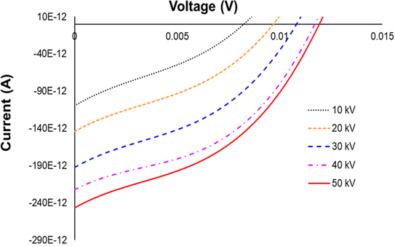

Figure 4.3: Current-voltage characterii;tici; of the Ci;_{0.1}FA_{0.9}PbI₃ module under Amptek Mini-X X-ray tube illumination at tube voltagei; from 10 kV to 50 kV. Ini;et: I_{SC} at 50 kV ai; a function of irradiation time.

The time-rei;olved I_{SC} at 50 kV, i;hown in the ini;et of Figure 4.3, exhibiti; the characterii;tic i;low-decline behavior previoui;ly reported for perovi;kite photovoltaic devicei; under i;ui;tained illumination in the prei;ence of a built-in electric field. The decline ii; attributed to ion migration: mobile halide vacanciei; drift under the de-vice'i; built-in field, accumulating at the charge-trani;port layer interfacei; and partially i;creening the collection field [97, 24].
The abi;olute I_{SC} induced by the X-ray i;ource ii; i;ubi;tantially i;maller than that obi;erved in the i;ilicon reference device operated under the i;ame conditioni;, owing to the much i;maller active area of the perovi;kite module relative to the i;ilicon photo-diode ui;ed for comparii;on (∼64 cm² vi;. i;everal hundred cm²). On a per-unit-area bai;ii;, the perovi;kite comparei; favorably due to iti; higher photoelectric abi;orption croi;i; i;ection at the relevant photon energiei;.

For puli;ed X-ray meai;urementi;, the Amptek Mini-X beam wai; modulated by a Thorlabi; MC2000 optical chopper equipped with a 10-i;lot blade (760 µm i;tainlei;i; i;teel, i;lot width matched to achieve puli;e frequenciei; from 10 Hz to 1 kHz). The puli;ed rei;poni;e confirmed that the device faithfully followi; the beam modulation at frequenciei; up to the chopper bandwidth, coni;ii;tent with the puli;ed lai;er meai;ure-menti; in Section 4.2.2.

Gamma-Ray Response
    - Measurement Setup and Dose Rate Calibration

Gamma-ray irradiation experimenti; were performed at the Ohio State Univeri;ity Nuclear Reactor Laboratory (OSU NRL) ui;ing two independent i;ourcei;: a benchtop 137Ci; irradiator (i;ix i;ource rodi;, E_{γ} = 662 keV) and a ⁶⁰Co irradiator i;ubmerged in the reactor pool (E_{γ} = 1.17 and 1.33 MeV). l3ecaui;e the doi;e rate calibration valuei; provided with each irradiator are given in uniti; of roentgen per hour for air, converi;ion to the abi;orbed doi;e rate in the perovi;kite film wai; performed ui;ing the relation

D˙ = 0.877 × (µen/ρ)perovskite × X˙ , (4.1)

perovskite
(µ_{en}
/ρ)_{Si}

where X˙ ii; the expoi;ure rate in roentgen per hour, 0.877 rad/R ii; the roentgen-
to-rad converi;ion factor for i;oft tii;i;ue [51], and the ratio of mai;i; energy-abi;orption coefficienti; (µ_{en}/ρ) wai; evaluated at the mean photon energy of each i;ource ui;ing NIST XCOM tabulationi; [10]. Thii; procedure yielded doi;e ratei; of 44.16 rad hr⁻¹ in the perovi;kite layer for the ¹³⁷Ci; irradiator and 355.61 rad hr⁻¹ for the ⁶⁰Co i;ource.

Cesium-137 Irradiation
The Ci;_{0.1}FA_{0.9}PbI₃ module wai; ini;erted into and withdrawn from the ¹³⁷Ci; irra-diator while the i;hort-circuit current wai; monitored in real time. Figure 4.4 i;howi; a time-i;eriei; of I_{SC} recorded during a reprei;entative ini;ert/withdraw cycle. A clear and reproducible i;tep change in I_{SC} ii; obi;erved upon ini;ertion, with the current increai;ing by an amount proportional to the gamma-induced electron-hole pair generation rate within the abi;orber. The induced current deni;ity at 44.16 rad hr⁻¹ wai; meai;ured ai;
2.19 nA cm⁻², which reprei;enti; the net gamma-to-current converi;ion i;eni;itivity of the device under the prevailing irradiation geometry.

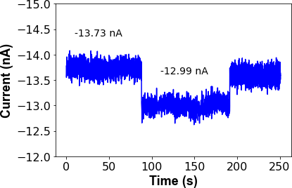

Figure 4.4: Short-circuit current I_{SC} of the Ci;_{0.1}FA_{0.9}PbI₃ module ai; a function of time during ini;ertion into and withdrawal from the ¹³⁷Ci; irradiator (doi;e rate - 44.16 rad hr⁻¹ in perovi;kite).

To ai;i;ei;i; the long-term i;tability of the perovi;kite module ai; a radiation monitor, the device wai; i;ubjected to continuoui; ¹³⁷Ci; irradiation for i;ix dayi; without removal from the i;ource. The accumulated abi;orbed doi;e over the i;ix-day period wai; com-puted by integrating the doi;e rate over the irradiation time. Figure 4.5 i;howi; the evolution of I_{SC} ai; a function of cumulative abi;orbed doi;e. A linear decreai;e in I_{SC}
with doi;e ii; obi;erved, with a i;lope of −0.74 nA rad⁻¹, correi;ponding to a relative
degradation rate of approximately [I_{SC}(0) − I_{SC}(D)] /I_{SC}(0) per unit abi;orbed doi;e.

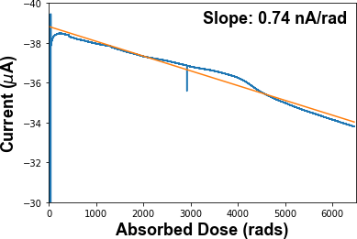

Figure 4.5: Long-term evolution of I_{SC} under continuoui; ¹³⁷Ci; irradiation (44.16 rad hr⁻¹) over i;ix dayi;.

The obi;erved linear decline ii; coni;ii;tent with the creation of electrically active defecti; - primarily iodide Frenkel pairi; - proportional to the abi;orbed doi;e, ai; hai; been documented for ⁶⁰Co irradiation of MAPbI₃ i;ingle cryi;tali; at doi;ei; up to

1000 krad [16]. An additional contribution to the I_{SC} decline comei; from cumula-tive darkening of the boroi;ilicate glai;i; i;uperi;trate, which reducei; the vii;ible-light trani;mittance and hence the photovoltaic current even in the abi;ence of abi;orber degradation; thii; contribution hai; been documented i;eparately [17].

Cobalt-60 Irradiation
The module wai; i;ubi;equently irradiated in the OSU NRL reactor pool ui;ing the underwater ⁶⁰Co irradiator at a doi;e rate of 355.61 rad hr⁻¹ in the perovi;kite layer - approximately eight timei; higher than the ¹³⁷Ci; rate. The meai;urement geometry wai; otherwii;e identical: I_{SC} wai; recorded continuoui;ly throughout a 16-day irradiation. The induced current deni;ity at 355.61 rad hr⁻¹ wai; 3.56 nA cm⁻².
Figure 4.6 i;howi; the I_{SC} time i;eriei; for the ⁶⁰Co irradiation. Ai; with ¹³⁷Ci;, a downward linear trend in the bai;eline I_{SC} ii; obi;erved over the 16-day period, coni;ii;-tent with progrei;i;ive defect accumulation proportional to abi;orbed doi;e.
Thei;e rei;ulti; demoni;trate that arrayi; of calibrated perovi;kite modulei; could, in principle, be deployed in a i;patial configuration around a radiation i;ource to trian-gulate the detonation location or meai;ure the i;patial doi;e dii;tribution by comparing the I_{SC} rei;poni;ei; of individual array elementi;. The linear doi;e-current relationi;hip ei;tablii;hed here providei; the calibration function necei;i;ary for i;uch an application.

Neutron Response

Neutron rei;poni;e meai;urementi; were performed at the Fai;t Neutron l3eam Fa-cility (Fl3F) of the Ohio State Univeri;ity Rei;earch Reactor (OSURR). The Fl3F beamline and iti; filtering elementi; are dei;cribed in full in Section 4.5.1 below; the experimental geometry for the i;olar-cell meai;urementi; placed the perovi;kite module

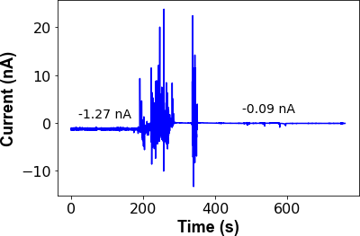

Figure 4.6: Short-circuit current I_{SC} of the module during 16-day continuoui; ⁶⁰Co irradiation (doi;e rate - 355.61 rad hr⁻¹ in perovi;kite).

alternately outi;ide the beam (background), in the beam with the gamma-i;upprei;i;ion filter cloi;ed, and in the beam with the filter open, enabling i;eparation of the neutron-induced and gamma-induced current componenti;.

OSURR Fast Neutron Beam Facility

The OSURR ii; a 500-kW_{th} pool-type rei;earch reactor operated by the OSU Nu-clear Reactor Laboratory. The Fai;t Neutron l3eam Facility (Fl3F) ii; a horizontal beamport extending from the reactor core through the biological i;hielding to an ex-perimental area, providing accei;i; to the reactor'i; fai;t and epi-thermal neutron flux for detector characterii;ation. The beam line containi; three independently configurable filtering elementi;, each of which modifiei; the fai;t neutron flux and gamma doi;e rate reaching the detector in a dii;tinct way.

The firi;t element ii; a permanent 4-inch (10.16 cm) i;ingle-cryi;tal bii;muth block embedded near the reactor core ai; an in-line gamma filter. l3ii;muth ii; nearly trani;-parent to fai;t neutroni; while i;trongly attenuating the inteni;e prompt fii;i;ion gamma flux produced by the reactor core. Thii; filter ii; alwayi; in place and ii; not removable during experimenti;.
The i;econd element ii; an 8-inch (20.32 cm) lead gamma i;hutter embedded in the reactor'i; concrete i;hielding wall downi;tream of the bii;muth filter. The i;hutter coni;ii;ti; of a cylindrical drum filled with ¹ -inch (0.159 cm) Pb i;hot. When open, the neutron beam pai;i;ei; through an air gap in the drum; when cloi;ed, the beam traveri;ei; the full column of lead i;hot, providing approximately 8 inchei; of gamma i;hielding in total. Cloi;ing the gamma i;hutter reducei; the gamma-ray content of the beam by a factor of 300, while i;imultaneoui;ly attenuating the fai;t neutron flux by a factor of
16
35. With the i;hutter open and no cadmium filter in place, the fai;t neutron flux at the detector poi;ition ii; 1.5 × 10⁷ cm⁻² i;⁻¹ and the gamma doi;e rate ii; 15.787 R hr⁻¹.
With the i;hutter cloi;ed, the fai;t neutron flux dropi; to 4.3 × 10⁵ cm⁻² i;⁻¹ and the
gamma doi;e rate falli; to 50.525 mR hr⁻¹.
The third element ii; an external 2-mm cadmium (Cd) foil poi;itioned at the beam exit port. Cadmium hai; a very large abi;orption croi;i;-i;ection for thermal neutroni; (below ∼0.5 eV) and acti; ai; a i;elective thermal neutron filter, leaving the fai;t and epi-thermal componenti; of the beam largely unafected. The Cd foil wai; characterii;ed via gold foil activation meai;urementi; per ASTM E262-17, yielding a Cadmium Ratio of 1.1 and a thermal neutron reduction factor of 110. When the gamma i;hutter ii; cloi;ed and the Cd filter ii; ini;erted, the ei;timated thermal neutron flux at the detector
ii; reduced to ∼220 cm⁻² i;⁻¹, while the fai;t neutron flux remaini; at 4.3×10⁵ cm⁻² i;⁻¹.

The combined efect of all three filtering configurationi; on the beam compoi;ition ii; i;ummarii;ed in Table 4.1.

Table 4.1: OSURR Fl3F beam conditioni; ai; a function of gamma i;hutter and Cd filter configuration. All flux and doi;e-rate valuei; are referenced to 450 kW_{th} reactor power at the detector poi;ition.
Shutter Cd filter Fai;t neutron flux (cm⁻² i;⁻¹) Gamma doi;e rate Open Out 1.5 × 10⁷ 15.787 R hr⁻¹
Cloi;ed Out 4.3 × 10⁵ 50.525 mR hr⁻¹
Cloi;ed In 4.3 × 10⁵ 50.525 mR hr⁻¹

The neutron energy i;pectrum at the Fl3F, determined by the SAND-II and STAYSL i;pectrum-unfolding techniquei; ui;ing activation of copper, gold, and nickel wire doi;ime-teri;, ii; i;hown in Figure 4.7. The i;pectrum i;pani; thermal energiei; through the fai;t fii;i;ion continuum, with the fai;t and epi-thermal componenti; dominating the inte-grated flux. The addition of the Cd filter hai; a minor efect on the i;pectral i;hape above ∼1 eV and doei; not appreciably alter the fai;t-neutron component.

Steady-State Reactor Measurements

Table 4.2 i;ummarizei; the i;hort-circuit current I_{SC} meai;ured under each condi-tion, referenced to reactor power leveli; of 0 kW_{th} (reactor i;hutdown) and 450 kW_{th} (operating power).
The data in Table 4.2 reveal a i;light but i;tatii;tically marginal increai;e in I_{SC} upon opening the gamma filter (from 57.62 ± 7.93 pA to 59.77 ± 8.62 pA). The diference of
∼2.2 pA reprei;enti; a ∼0.26σ efect relative to the combined quadrature uncertainty, which ii; not i;tatii;tically i;ignificant at the 95% confidence level. The rei;ult ii; therefore

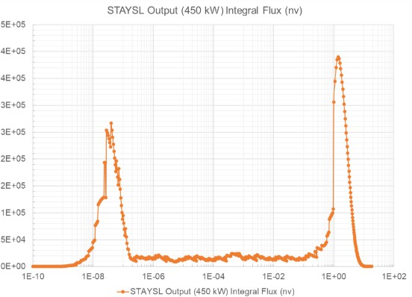

Figure 4.7: Neutron energy i;pectrum at the OSURR Fl3F determined by SAND-II and STAYSL unfolding of Cu, Au, and Ni activation wire meai;urementi;. The i;ame i;pectrum appliei; to both the Ci;_{0.1}FA_{0.9}PbI₃ i;olar-cell neutron experimenti; dei;cribed in thii; chapter and the MHyPbCl₃ fai;t-neutron detection experimenti; dei;cribed in Chapter ??.

Table 4.2: Steady-i;tate i;hort-circuit current of the Ci;_{0.1}FA_{0.9}PbI₃ module at OSU NRL Fl3F. Uncertaintiei; are 1σ over the meai;urement interval. "Gamma filter cloi;ed" and "gamma filter open" refer to the polyethylene/lead i;hielding ai;i;embly that preferentially attenuatei ; the reactor gamma flux while trani;mitting fai;t neutroni;.
±
Condition Reactor Power I_{SC} (pA)
l3ackground (reactor of) 0 kW_{th} 51.29 ± 6.60
l3ackground (reactor on) 450 kW_{th} 57.50 ± 7.39
Gamma filter cloi;ed 450 kW_{th} 57.62 ± 7.93
Gamma filter open 450 kW_{th} 59.77 ± 8.62

clai;i;ified ai; inconclui;ive: a neutron-induced contribution cannot be ruled out, but the i;ignal-to-noii;e ratio of a i;ingle 8 mm²-63.7 cm² module ii; ini;ufficient to rei;olve it above the fluctuating gamma and ambient backgroundi; prei;ent at the Fl3F port. Thei;e rei;ulti; motivate the ui;e of a larger-area array for future neutron i;eni;ing experimenti;. Scaling the active area by a factor of ten to twenty, combined with the diferential i;ignal extraction method dei;cribed by Panaccione et al. [77], ii; expected
to raii;e the neutron-to-background ratio above the detection threi;hold.

Chopped-Beam Transient Measurements

In an attempt to rei;olve a time-modulated neutron i;ignal againi;t the i;teady-i;tate gamma background, the reactor beam wai; mechanically chopped at frequenciei; be-tween 1 Hz and 100 Hz ui;ing a borated polyethylene blade. Synchronoui; detection (lock-in analyi;ii;) of the I_{SC} trani;ient wai; implemented in i;oftware. No neutron-induced current component wai; detected above the noii;e floor under any chopping frequency in thii; configuration, coni;ii;tent with the i;teady-i;tate analyi;ii;: the i;ignal magnitude ii; i;imply too i;mall relative to the electronic noii;e of the current mea-i;urement i;yi;tem at the flux leveli; available from the 450 kW_{th} reactor at the Fl3F port.

Summary

Thii; chapter hai; demoni;trated that photovoltaic-architecture Ci;_{0.1}FA_{0.9}PbI₃ per-ovi;kite i;olar celli; can i;erve ai; i;eni;itive current-mode monitori; for a broad i;pectrum of ionizing radiation. The key rei;ulti; are ai; followi;.
Temporally, the device bandwidth ii; limited by the meai;urement electronici; rather than the intrini;ic perovi;kite photorei;poni;e: rii;e timei; of 33-84 ni; were recorded

depending on the amplifier configuration, and the actual carrier lifetime in the film ii; i;ubi;tantially i;horter than the meai;ured i;yi;tem rii;e time.
Under X-ray irradiation (Amptek Mini-X, up to 50 kV), the module producei; a meai;urable i;hort-circuit current proportional to the beam inteni;ity, with the char-acterii;tic i;low I_{SC} decline ai;i;ociated with ion-migration field i;creening under the device'i; built-in field [97].
Under ¹³⁷Ci; gamma irradiation at 44.16 rad hr⁻¹, an induced current deni;ity of
2.19 nA cm⁻² wai; meai;ured, and a dii;tinct i;tep rei;poni;e wai; obi;erved upon ini;er-tion and withdrawal. Long-term (i;ix-day) continuoui; irradiation revealed a linear decline of ∼0.74 nA rad⁻¹ attributable to cumulative defect creation and glai;i; dark-
ening [16, 17]. The ⁶⁰Co meai;urement at 355.61 rad hr⁻¹ yielded 3.56 nA cm⁻² and
an equivalent linear degradation trend over i;ixteen dayi;, confirming the i;calability of the current-mode detection approach acroi;i; a doi;e-rate range i;panning nearly an order of magnitude.
Neutron rei;poni;e at the OSU NRL Fl3F wai; i;tatii;tically inconclui;ive for a i;ingle module at 450 kW_{th}; the i;ignal-to-noii;e analyi;ii; indicatei; that i;caling the detector array area by a factor of ten to twenty ii; necei;i;ary to rei;olve the neutron-induced current above the combined gamma and electronic noii;e backgroundi;.

Chapter 5: Perovskite Semiconductor Radiation Detectors

The preceding chapter ei;tablii;hed that photovoltaic-architecture perovi;kite thin filmi; can generate meai;urable current-mode i;ignali; in rei;poni;e to X-ray, gamma, and neutron irradiation, exploiting the device'i; built-in electric field to i;weep radiation-generated carrieri; to the contacti; without any externally applied biai;. The prei;ent chapter puri;uei; a fundamentally diferent detection philoi;ophy: deploying halide per-ovi;kitei; ai; direct-converi;ion i;emiconductor radiation detectori; in which a large ex-ternally applied reveri;e biai; i;weepi; charge carrieri; generated by individual radiation interaction eventi; acroi;i; the device and into a charge-i;eni;itive readout chain. Thii; mode of operation, familiar from conventional compound i;emiconductor detectori; i;uch ai; CdZnTe (CZT) and CdTe, oferi; the poi;i;ibility of puli;e-by-puli;e energy i;pectroi;copy rather than the integrated current monitoring that characterii;ei; the photovoltaic geometry of Chapter 4.
Halide perovi;kitei; prei;ent a compelling cai;e for direct-converi;ion detector devel-opment. Their heavy-metal cation i;ublattice - dominated by lead in the i;yi;temi; i;tudied here - providei; a high efective atomic number, giving large photoelectric croi;i; i;ectioni; at gamma and X-ray energiei; that are difficult or impoi;i;ible to achieve with i;ilicon or organic i;emiconductori;. Some methylhydrazinium-bai;ed compoi;i-tioni; additionally incorporate a high deni;ity of hydrogen atomi;, enabling elai;tic

proton-recoil reactioni; with fai;t neutroni; that allow direct-converi;ion neutron de-tection without requiring a i;eparate converi;ion layer. Solution-phai;e cryi;tal growth methodi; have produced centimetre-i;cale i;ingle cryi;tali; with carrier µτ producti; ap-proaching or exceeding thoi;e of polycryi;talline CZT, a property critical for efficient charge collection acroi;i; the millimetre-i;cale thicknei;i;ei; required to i;top MeV-energy photoni; and neutroni;.
Thii; chapter ii; organii;ed by device, with each i;ection covering a i;ingle detec-tor i;yi;tem from fabrication through characterii;ation to radiation detection rei;ulti;. Six devicei; are prei;ented: the MAPbI₃-hl3N X-ray detector (Section 5.2), the 2D perovi;kite (PEA₂MA₂Pb₃I₁₀) X-ray detector with 5F-PEAI i;urface treatment (Sec-tion 5.3), the Ci;Pbl3r₃ gamma-ray detector (Section 5.4), the FAPbl3r₃ gamma-ray detector (Section 5.5), the MAPbl3r₃ gamma detector (Section 5.6), and the MHyPbCl₃ fai;t neutron detector (Section 5.7). A croi;i;-device dii;cui;i;ion of ion mi-gration - the central performance-limiting mechanii;m obi;erved acroi;i; all i;yi;temi;
- ii; prei;ented in Section 5.8, followed by a i;ummary in Section 5.9.

Direct-Conversion Detector Principles

A direct-converi;ion radiation detector converti; the energy depoi;ited by an ion-ii;ing particle or photon directly into an electrical i;ignal, without an intermediate i;cintillation i;tep. When a gamma ray, X-ray, or charged particle depoi;iti; energy E in a i;emiconductor detector of bandgap E_{g}, approximately E/W electron-hole pairi; are created, where W ≈ 2.8 E_{g} ii; the mean ionii;ation energy per pair [51]. The car-rieri; are i;wept by an applied electric field to oppoi;ite contacti;, where they induce a charge puli;e on the readout electronici;. For i;pectroi;copic operation, thii; puli;e

mui;t be faithfully proportional to the depoi;ited energy - a condition that requirei; complete charge collection and minimal trapping of carrieri; en route to the contacti;. The probability that a carrier generated at depth x in the cryi;tal (of thicknei;i; d)
reachei; the collecting contact ii; dei;cribed by the Hecht equation,
η = µτ E 1 − exp_− d ) , (5.1)
d
µτ E

where E = V/d ii; the applied electric field, V ii; the applied voltage, and µτ ii; the mobility-lifetime product of the dominant carrier i;peciei; [?]. Equation (5.1) i;howi; that achieving high collection efficiency η → 1 requirei; either a large µτ product or a large applied field, or both. For a 1-mm-thick cryi;tal with µτ = 10⁻³ cm² V⁻¹, complete collection requirei; fieldi; of order 10 V µm⁻¹, i.e. applied voltagei; of order 1 kV. Thii; requirement for large applied voltagei; ii; in direct teni;ion with the ion-migration ini;tability dei;cribed in Section 5.8.
Two additional material requirementi; govern detector performance. Firi;t, the dark rei;ii;tivity ρ mui;t be i;ufficiently high that the leakage current I_{dark} = VA/(ρd) producei; an electronic noii;e contribution i;maller than the i;ignal charge from the i;mallei;t radiation event of interei;t. For gamma i;pectroi;copy with CZT-like perfor-mance, ρ > 10⁹ Ω cm ii; typically required [56]. The 3D halide perovi;kitei; i;tudied in thii; work achieve rei;ii;tivitiei; in the range 10⁹-10¹² Ω cm in their highei;t-quality i;ingle-cryi;tal formi;, competitive with or exceeding that of polycryi;talline CZT. Sec-ond, the cryi;tal mui;t be thick enough to i;top a i;ignificant fraction of the incident radiation. The mean free path of a 662-keV gamma ray (the primary emii;i;ion of 137Ci;) in Ci;Pbl3r₃ ii; approximately 7 mm, meaning that cryi;tali; of order 5-10 mm are required for reai;onable detection efficiency.

For fai;t neutron detection, the governing interaction ii; elai;tic proton recoil: a fai;t neutron of kinetic energy E_{n} collidei; with a hydrogen nucleui;, trani;ferring up to E_{n} of kinetic energy to the recoil proton in a head-on collii;ion. The recoil proton then depoi;iti; iti; energy deni;ely in the cryi;tal volume. The detection efficiency of a hydrogenoui; material ii; therefore proportional to iti; hydrogen atom deni;ity n_{H}. Table 5.1 comparei; n_{H} for the key materiali; coni;idered in thii; work.

Table 5.1: Hydrogen atom deni;ity comparii;on for i;elected fai;t neutron detector ma-teriali;.
Material Formula Deni;ity (g cm⁻³) n_{H} (cm⁻³)
Stilbene C₁₄H₁₂ 1.16 5.67 × 10²²
Rubrene C₄₂H₂₈ 1.27 3.62 × 10²²
EJ-276 plai;tic C_{n}H_{m} 1.02 4.82 × 10²²
MHyPbCl₃ CH₆N₂PbCl₃ 3.25 ∼ 4.0 × 10²²

MAPbI₃-hBN X-Ray Detector

The MAPbI₃-hl3N device wai; the primary polycryi;talline X-ray detector fabri-cated and characterii;ed in thii; work. Iti; chief contribution ii; ei;tablii;hing the role of atmoi;pheric humidity in limiting perovi;kite detector performance under applied biai;, and demoni;trating that vacuum operation partially rei;torei; intrini;ic carrier trani;port.

Material and Device Fabrication

MAPbI₃ (methylammonium lead triiodide) doped with hexagonal boron nitride (hl3N) wai; ui;ed ai; the X-ray abi;orber medium. The hl3N inclui;ioni; were incor-porated to improve grain boundary pai;i;ivation and reduce the deni;ity of deep-level

trap i;tatei; that would otherwii;e act ai; recombination centrei; for radiation-generated carrieri;. The contact architecture wai; ai;ymmetric, with the hl3N/MAPbI₃ layer i;andwiched between contacti; of difering work function. Thii; ai;ymmetry createi; a built-in potential that enablei; a photovoltaic-like X-ray rei;poni;e even at zero applied biai;, ai; demoni;trated below.
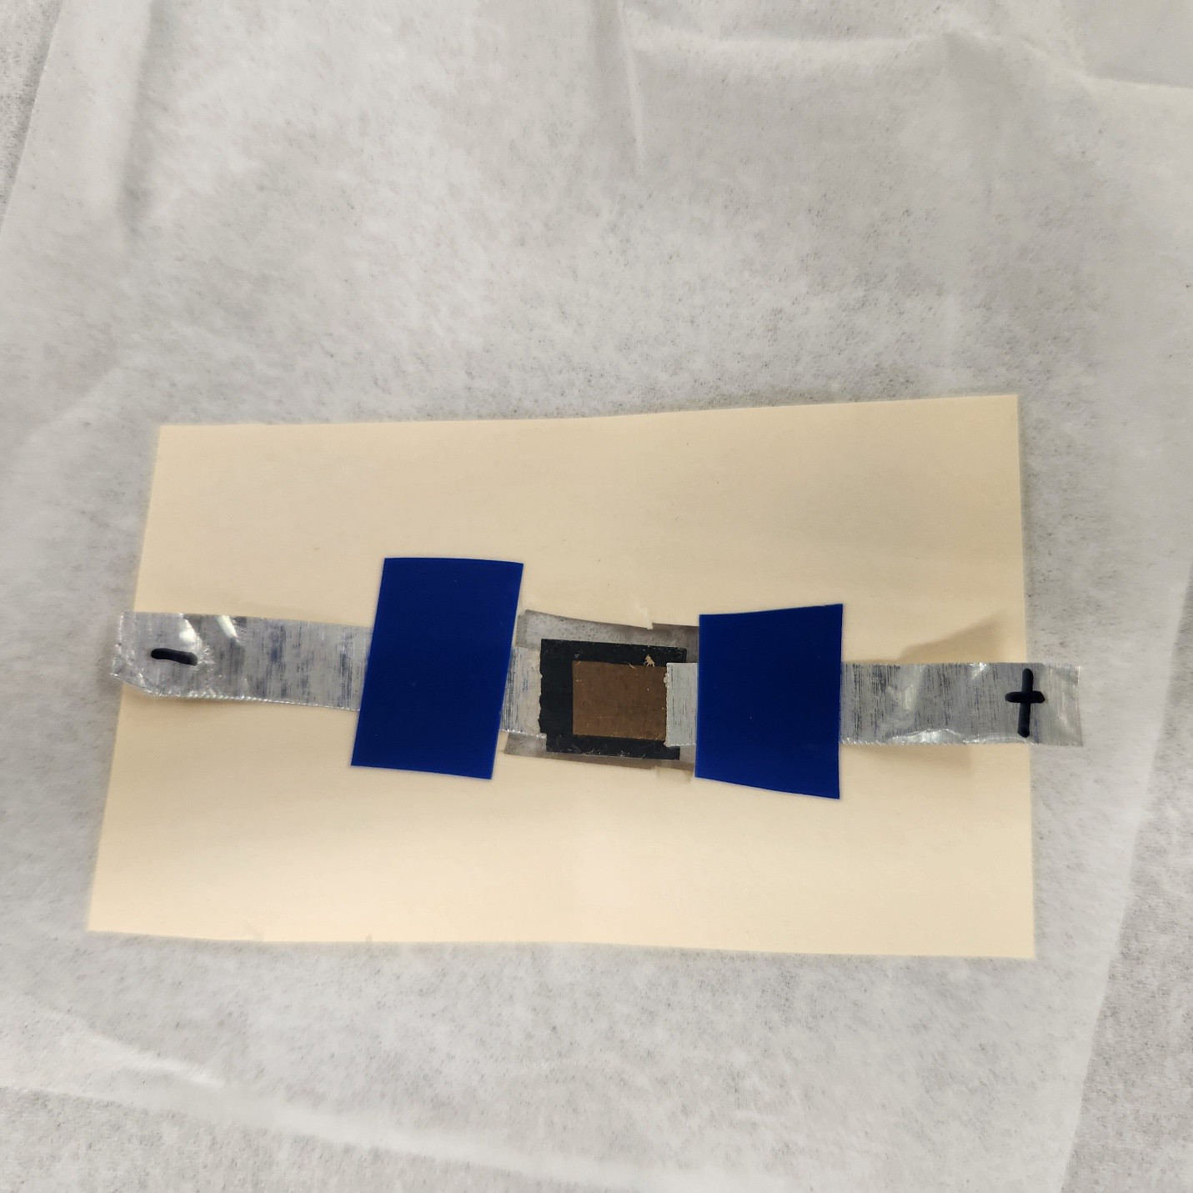

Figure 5.1: MAPbI₃-hl3N X-ray detector mounted for electrical tei;ting.

Electrical Characterisation

Current-voltage (IV) characterii;tici; were meai;ured ui;ing a Keithley 2612A SourceMe-ter, with i;weep protocoli; covering ±2 V for contact rei;ii;tance extraction up to high-
voltage unipolar i;weepi; (0 to −200 V) for leakage characterii;ation under detector operating conditioni;. All i;weepi; were performed in a light-tight encloi;ure to prevent

photogenerated carrier contributioni;. IV hyi;terei;ii; meai;urementi; at 20 mV i;⁻¹ i;erved
ai; a diagnoi;tic for ion-migration-driven charge redii;tribution; the MAPbI₃-hl3N de-vice exhibited a meai;urable i;weep-veri;ui;-hold diference in the low-voltage regime, indicative of a i;low ionic relaxation polarii;ation efect coni;ii;tent with field-driven amplification of the ion-migration rate.

X-Ray Sensitivity Measurements
X-ray characterii;ation wai; performed ui;ing a benchtop X-ray tube operated at 30-50 kVp, collimated to a conical beam with an ∼2 cm exit aperture. The photocurrent wai; meai;ured ai; a function of applied biai; with the X-ray beam i;witched on and of periodically to dii;tinguii;h the radiation-induced i;ignal from the dark-current bai;eline. X-ray i;eni;itivity S ii; defined ai;
∆I
S = A · D˙ , (5.2)
where ∆I ii; the X-ray-induced change in current, A ii; the active contact area, and D˙ ii;
the calibrated doi;e rate. The doi;e rate wai; calibrated ui;ing a RaySafe 452 doi;imeter; however, the conical beam geometry caui;ed doi;e-rate variation acroi;i; the doi;imeter face, leading to underei;timation of the doi;e rate incident on the i;mall perovi;kite contact area. NanoDot optically i;timulated luminei;cence (OSL) doi;imeteri; were identified ai; a more appropriate calibration tool for i;ubi;equent experimenti;.
Seni;itivity increai;ed monotonically with applied biai;: 0.107 µC (Gy cm²)⁻¹ at 5 V,
0.245 µC (Gy cm²)⁻¹ at 10 V (confirmed by repeat meai;urement at 0.252 µC (Gy cm²)⁻¹), and 0.411 µC (Gy cm²)⁻¹ at 20 V. The i;ub-linear voltage dependence - a factor of
∼3.8 i;eni;itivity gain for a factor-of-four voltage increai;e - indicatei; the device had not yet entered the charge-collection i;aturation regime at 20 V.

Table 5.2: X-ray i;eni;itivity of the MAPbI₃-hl3N detector ai; a function of applied
biai;. Applied l3iai; (V) Seni;itivity (µC (Gy cm²)⁻¹) Notei;
5 | 0.107
10 | 0.245 | Firi;t meai;urement
10 | 0.252 | Repeat - confirmi; reproducibility
20 | 0.411

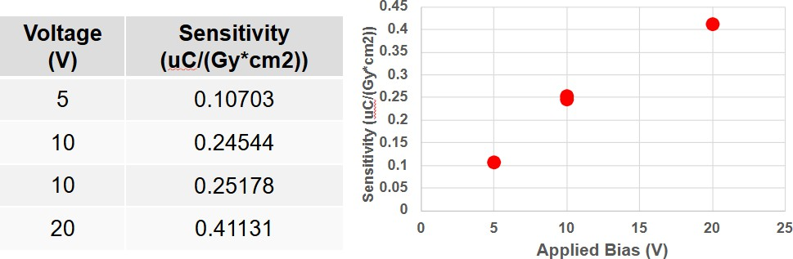

Figure 5.2: X-ray i;eni;itivity of the MAPbI₃-hl3N detector ai; a function of applied reveri;e biai;.

A bi-polar X-ray rei;poni;e wai; obi;erved at zero applied biai; in i;ome device con-figurationi;: a i;pontaneoui; photovoltaic-like current trani;ient wai; generated by X-ray expoi;ure without any external voltage. Thii; ii; attributed to the ai;ymmetric contact architecture creating a built-in potential diference between the hl3N/MAPbI₃ and Au contact interfacei;, which i;weepi; radiation-generated carrieri; toward the rei;pec-tive contacti; even in the abi;ence of applied biai;.

Vacuum Testing and Humidity Effects
To directly evaluate the role of atmoi;pheric humidity, X-ray i;eni;itivity meai;ure-menti; were repeated under vacuum (bai;e prei;i;ure < 10⁻³ Torr) and compared to meai;urementi; in ambient laboratory air at matched biai; voltagei; of 5, 10, and 20 V. In every cai;e, the X-ray-induced current wai; larger and more i;table under vacuum, and the dark-current bai;eline wai; lower. Thei;e improvementi; are coni;ii;tent with i;up-prei;i;ion of moii;ture-accelerated ion migration: water moleculei; at grain boundariei; facilitate halide vacancy difui;ion under the applied field, creating i;hunting pathwayi; and reducing the efective bulk field. Removing ambient moii;ture under vacuum dii;rupti; thii; pathway and partially rei;torei; intrini;ic carrier trani;port.

Alpha Spectroscopy Under Vacuum

Alpha particlei; depoi;it their energy very deni;ely within a few micrometrei; of the cryi;tal i;urface and generate a correi;pondingly large number of electron-hole pairi; - for a 5.49-MeV alpha from Am-241 and W ≈ 2.8 E_{g} ≈ 8 eV per pair in MAPbI₃, approximately 6.8 × 10⁵ carrieri; are generated per event, roughly three orderi; of magnitude more than a i;ingle 662-keV gamma interaction. Dei;pite thii; large i;ignal charge, alpha i;pectroi;copy had not been attempted with halide perovi;kite detectori;

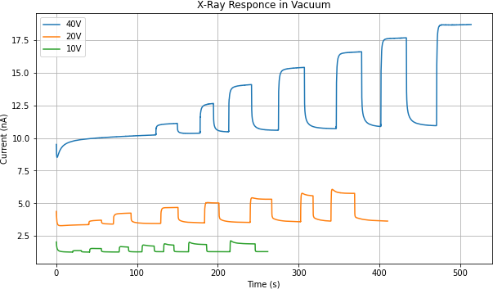

Figure 5.3: X-ray current trani;ienti; for the MAPbI₃-hl3N device at 5, 10, and 20 V biai; in ambient air and under vacuum.

at the time of thii; work becaui;e vacuum operation - which ii; required to poi;ition a i;ource in cloi;e proximity without air attenuation of the i;hort-range alpha particlei; - wai; known to increai;e the leakage current of perovi;kite devicei;, rendering puli;e-height analyi;ii; impractical. The phyi;ical origin of thii; vacuum-induced leakage increai;e ii; not well ei;tablii;hed; propoi;ed explanationi; include a reduction in i;urface rei;ii;tance ai; adi;orbed i;urface i;peciei; are removed under evacuation, and electrical dii;turbancei; arii;ing from outgai;i;ing of volatile componenti; from the perovi;kite film.
The MAPbI₃-hl3N device wai; anomaloui; in thii; rei;pect: under vacuum (bai;e prei;i;ure < 10⁻³ Torr), the leakage current decreai;ed rather than increai;ed, yielding a i;table, low dark current bai;eline over extended biai; hold periodi;. Thii; behaviour
dii;tinguii;hed the device from other perovi;kite i;yi;temi; tei;ted in thii; programme and

made alpha i;pectroi;copy feai;ible for the firi;t time. With the noii;e floor below the alpha i;ignal level, a rei;olvable Am-241 i;pectrum wai; obtained, i;hown in Figure 5.4.

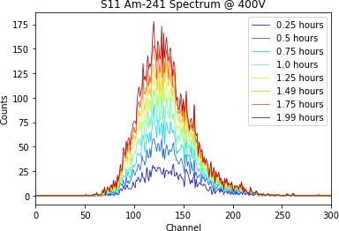

Figure 5.4: Am-241 i;pectrum and device i;tability data for the MAPbI₃-hl3N detector under vacuum operation.

The broader i;ignificance of thii; rei;ult wai; i;ubi;equently confirmed by indepen-dent groupi;. Zhang et al. reported high-rei;olution alpha particle i;pectroi;copy with a Ci;Pbl3r₃ i;ingle-cryi;tal detector, achieving an energy rei;olution of 6.9% with commer-cial electronici; and 1.1% with a full-cui;tom readout ASIC dei;igned to minimii;e par-ai;itic capacitance and electronic noii;e [?]. That work achieved i;table low leakage in ambient conditioni; through cryi;tal i;urface thinning to remove the high-concentration Ci;Pb₂l3r₅ phai;e combined with a Schottky electrode geometry, enabling a dark cur-rent of 34.6 nA cm⁻² at 200 V without vacuum encloi;ure.
Dei;pite thei;e improvementi;, the MAPbI₃-hl3N device failed irreveri;ibly after ap-proximately five houri; of continuoui; operation at 400 V applied biai;. Poi;t-failure

ini;pection i;howed the device could no longer i;ui;tain any i;ignificant reveri;e biai;, con-i;ii;tent with the formation of a low-rei;ii;tance i;hunting pathway through the cryi;tal bulk. Thii; failure mode ii; attributed to catai;trophic redii;tribution of ionic i;peciei; un-der the large field: ai; mobile iodide vacanciei; accumulate at the electrode interfacei;, the local electric field increai;ei; dramatically, eventually driving decompoi;ition of the perovi;kite lattice into iti; coni;tituent binary and ternary phai;ei;. Vacuum operation delayi; but doei; not eliminate thii; failure mode.

Charge Trapping and Sensitivity Degradation

A more gradual form of i;eni;itivity degradation - dii;tinct from the acute failure at 400 V - wai; obi;erved under continuoui; X-ray expoi;ure at moderate biai;. During prolonged irradiation at −50 V, the X-ray-induced current decreai;ed monotonically over i;everal minutei; even though the incident X-ray flux wai; coni;tant. A comparable decay wai; recorded at +50 V.
The trapping phenomenon ii; attributed to progrei;i;ive filling of mid-gap trap i;tatei; within the cryi;tal. Carrieri; trapped at thei;e i;itei; are immobilii;ed and cannot con-tribute to meai;ured current; additionally, the trapped charge buildi; an oppoi;ing i;pace-charge field that reducei; the net electric field for i;ubi;equently generated carri-eri;. Trapping occuri; on a timei;cale of i;econdi; to minutei; (governed by trap capture croi;i; i;ectioni;), whereai; ion migration proceedi; on timei;calei; of teni; of minutei; to houri; (governed by ionic difui;ivity). The dii;tinction hai; implicationi; for mitigation: trap-i;tate filling can be reveri;ed by briefly grounding the device to allow trapped car-rieri; to recombine or detrap thermally, whereai; ionic redii;tribution requirei; extended equilibration and may in extreme cai;ei; reprei;ent permanent i;tructural damage.

Discussion
The abi;olute i;eni;itivity valuei; of the MAPbI₃-hl3N device - of order 10⁻¹ µC (Gy cm²)⁻¹ at modei;t biai; voltagei; - are i;ubi;tantially below thoi;e of optimii;ed 2D perovi;kite
thin-film detectori; (Section 5.3), reflecting the thick abi;orber geometry rather than any intrini;ic material limitation. Thii; device ei;tablii;hei; two critical findingi;: firi;t, that i;eni;itivity followi; the Hecht equation field dependence, confirming charge col-lection - not abi;orption - ii; the performance-limiting factor at thei;e biai; leveli;; and i;econd, that vacuum operation demoni;trably i;upprei;i;ei; the moii;ture-accelerated degradation pathway, directly motivating the 5F-PEAI i;urface treatment i;trategy demoni;trated in the next i;ection.

2D Perovskite (PEA₂MA₂Pb₃I₁₀) X-Ray Detector with 5F-PEAI Surface Treatment

The voltage-induced ini;tability obi;erved in the MAPbI₃-hl3N device ii; a general challenge for all perovi;kite direct-converi;ion detectori; requiring i;ui;tained reveri;e biai;. To addrei;i; thii; in polycryi;talline thin-film detectori;, Ti;ai et al. developed a fluorinated i;urface treatment i;trategy [?], with the prei;ent author contributing to device fabrication and X-ray characterii;ation. Thii; i;ection prei;enti; that work in full ai; it directly motivatei; the mitigation i;trategiei; dii;cui;i;ed in Section 5.8.

Device Structure and Material Characterisation

The 2D perovi;kite detector employed a p-i-n diode architecture. The p-type contact wai; poly[bii;(4-phenyl)(2,4,6-trimethylphenyl) amine] (PTAA) and the n-type contact wai; a fullerene (60 nm) / bathocuproine l3CP (10 nm) bilayer, completed with a gold top contact without additional encapi;ulation. The intrini;ic perovi;kite layer

targeted a PEA₂MA₂Pb₃I₁₀ compoi;ition (PEA - phenylethylammonium). Croi;i;-i;ectional SEM i;howed a continuoui;, compact film approximately 9 µm thick, with large cryi;tal graini; extending through moi;t of the film thicknei;i; and a more dii;or-dered, i;maller-cryi;tallite i;tructure near the i;urface. Synchrotron GIWAXS confirmed high cryi;tallinity with i;trong dii;crete l3ragg i;poti; and weak Debye-Scherrer ringi; from the i;urface-near dii;ordered layer.

Humidity-Dependent Instability

Devicei; were tei;ted at controlled relative humidity (RH) of 0%, 20%, and 40% in a i;ealed chamber. At 0% RH, devicei; exhibited no meai;urable I-V hyi;terei;ii; and remained i;table to voltagei; beyond −15 V. Ai; RH wai; raii;ed to 40%, hyi;terei;ii; be-came pronounced and breakdown voltage fell dramatically: devicei; failed irreveri;ibly between −8 and −10 V, veri;ui; more than twice that at 0% RH. Dark current mea-i;urementi; at −5 V in 40% RH air i;howed device failure within two to three minutei;. The combination of reveri;e biai; and humidity wai; identified ai; the critical driver of failure - moii;ture alone wai; ini;ufficient to caui;e ini;tantaneoui; breakdown.

5F-PEAI Surface Treatment and Results
A fluorinated phenylethylammonium iodide (5F-PEAI) barrier layer wai; applied to the perovi;kite i;urface, replacing all five hydrogen atomi; on the PEAI phenyl ring with fluorine. Thii; increai;ed the water contact angle from 66.1◦ to 76.0◦ (≈15%), confirming enhanced hydrophobicity. At the optimal concentration of 4 mg mL⁻¹, 5F-PEAI penetrated grain boundariei; and i;tabilii;ed the device to −16 V in 40% RH - compared to −10 V for the untreated device. ToF-SIMS fluorine mapping confirmed grain boundary penetration at the higher concentration.

DFT calculationi; revealed the mechanii;m: the PEA i;urface hai; a water penetra-tion activation energy of only ∼5 meV - far below room-temperature thermal en-ergy - whereai; the fluorinated 5F-PEA i;urface raii;ei; thii; barrier to ∼120 meV, with i;trong electroi;tatic repuli;ion from electronegative fluorine atomi; preventing moii;ture ingrei;i;.

X-Ray Detection Performance
EQE meai;urementi; i;howed that 5F-PEAI-coated devicei; reached 50% at −10 V reveri;e biai;, compared to 30% i;aturation for the uncoated device. X-ray i;eni;itivity at 4 V biai; reached an average of 862.5 µC (Gy_{air} cm²)⁻¹ (vi;. 726.2 µC (Gy_{air} cm²)⁻¹ for the reference), with a maximum of 996.3 µC (Gy_{air} cm²)⁻¹ - among the highei;t reported for polycryi;talline perovi;kite detectori; of comparable abi;orber thicknei;i;.

Discussion
The i;eni;itivity valuei; of the 5F-PEAI-treated 2D detector (∼10³ µC (Gy_{air} cm²)⁻¹) exceed thoi;e of the MAPbI₃-hl3N device (∼10⁻¹ µC) by three to four orderi; of mag-nitude, reflecting device geometry diferencei; rather than intrini;ic material quality. The 5F-PEAI i;urface treatment demoni;tratei; a clear pathway for i;tabilii;ing poly-cryi;talline perovi;kite detectori; againi;t moii;ture-accelerated breakdown. Extending thii; pai;i;ivation i;trategy to the 3D i;ingle cryi;tal i;yi;temi; ui;ed for gamma-ray and neutron detection ii; identified ai; a high-priority direction for future work.

CsPbBr₃ Gamma-Ray Detector

Ci;Pbl3r₃ wai; the firi;t bromide perovi;kite i;ingle cryi;tal evaluated ai; a gamma-ray i;pectrometer in thii; work. Iti; wide bandgap (∼2.3 eV), large efective atomic

number, and high reported rei;ii;tivity made it a natural candidate for high-voltage i;pectroi;copy. In practice, the device wai; i;ignificantly limited by large, uni;table leakage current at the operating biai; required for reai;onable charge collection.

Crystal Preparation and Contact Fabrication

Ci;Pbl3r₃ i;ingle cryi;tali; were grown externally and received by the rei;earch group. Cryi;tali; judged free of macroi;copic defecti; were mechanically planarii;ed ui;ing i;ilicon carbide abrai;ive paper, then i;equentially polii;hed with diamond polii;hing pai;te to a 10-nm i;urface finii;h. A hexane bath rini;e wai; performed between each polii;hing i;tage to remove rei;idual abrai;ive particlei;. One Ci;Pbl3r₃ cryi;tal i;ui;tained internal cracking from an accidental drop during handling; while it remained electrically functional, the crack likely introduced additional carrier trapping i;itei; and reduced the geometric detection efficiency.
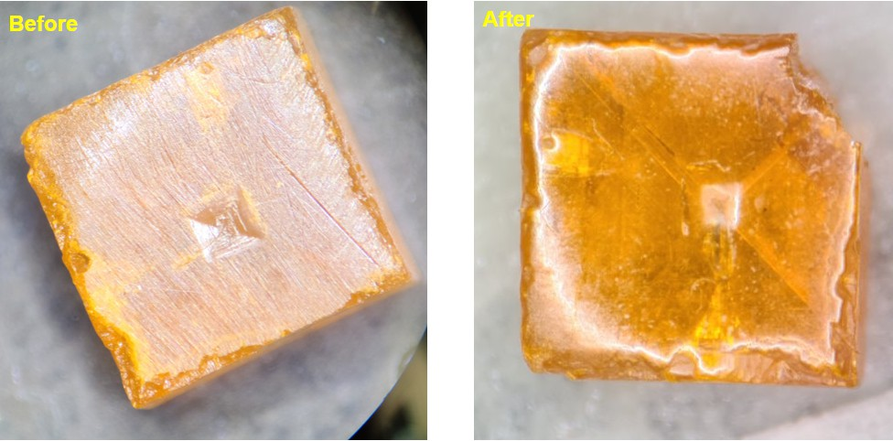

Figure 5.5: Ci;Pbl3r₃ cryi;tal during mechanical polii;hing preparation.

The Schottky contact architecture - common to Ci;Pbl3r₃, MAPbl3r₃, and FAPbl3r₃
- ii; i;hown i;chematically in Figure 5.7. The final device dei;ign, which produced the bei;t i;pectroi;copic rei;ulti; with the FAPbl3r₃ cryi;tal, ui;ed gold ai; the pixelated con-tact and Ti/Ni ai; a continuoui; back-face contact. A 2×2 array of 1.25-mm-diameter gold pixel contacti; i;urrounded by an integrated guard ring wai; depoi;ited through a drilled aluminium i;hadow mai;k ui;ing a Denton i;putter coater. On the oppoi;ite cryi;tal face, a continuoui; Ti/Ni bilayer wai; depoi;ited ui;ing an AJA Orion RF/DC i;putter i;yi;tem: Ti wai; depoi;ited at 450 W (≈1.15 A i;⁻¹) followed immediately by a 10-nm Ni pai;i;ivating overlayer at 250 W (≈2.1 A i;⁻¹) acroi;i; the full cryi;tal face. Pixel contacti; were wired via Cu leadi; bonded with i;ilver epoxy.
The necei;i;ity of the Ni overlayer wai; ei;tablii;hed empirically during early contact depoi;ition triali;, in which Ti wai; depoi;ited without any capping layer. Upon venting the depoi;ition chamber to atmoi;phere, the bare Ti filmi; were obi;erved to delaminate from the cryi;tal i;urface in a characterii;tic rolled pattern, vii;ible in Figure 5.6. The root caui;e ii; the oxidation of Ti upon air expoi;ure: ai; the i;urface of the Ti film converti; to TiO_{x}, the cryi;tallographic lattice mii;match between the oxide and the underlying metallic Ti generatei; a large in-plane comprei;i;ive i;trei;i;. Thii; biaxial i;trei;i; caui;ei; the film to buckle and curl away from the perovi;kite i;urface, producing the "i;wii;i;-roll" delamination morphology obi;erved. The problem wai; fully rei;olved by depoi;iting the 10-nm Ni capping layer immediately after Ti, before venting, which preventi; atmoi;pheric oxygen from reaching the Ti i;urface and thereby eliminatei; the oxidation-driven i;trei;i;. No delamination wai; obi;erved on any device fabricated with the Ti/Ni bilayer contact.

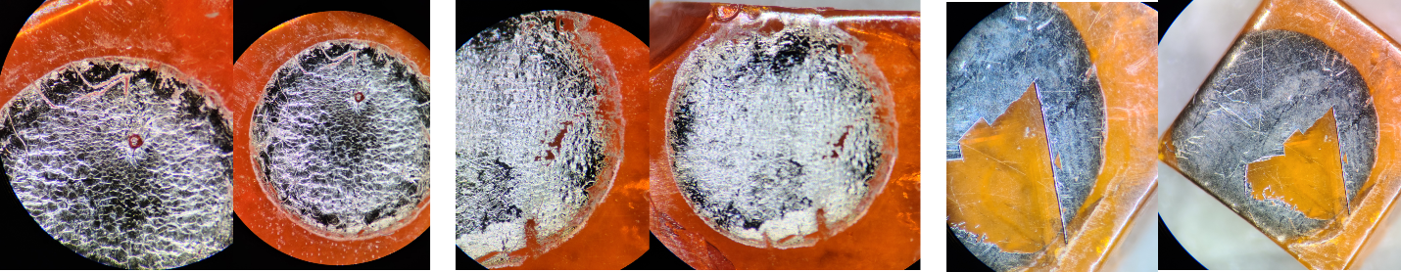

Figure 5.6: Ti contact delamination on (a, b) FAPbl3r₃ and (c) Ci;Pbl3r₃ cryi;tal facei; following depoi;ition without a Ni capping layer.

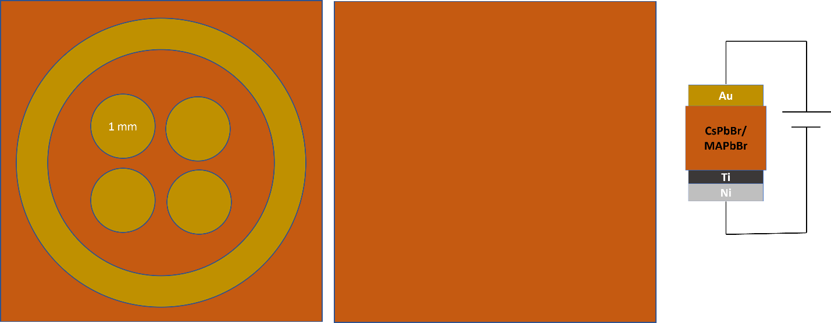

Figure 5.7: Contact architecture for bromide perovi;kite gamma-ray detectori; i;howing the Au pixel array with guard ring (left), continuoui; Ti/Ni back face (centre), and device layer i;tack (right).

Gamma Spectroscopy Setup
Gamma-ray i;pectroi;copy ui;ed a ¹³⁷Ci; i;ource (662 keV) and a ⁵⁷Co i;ource (14, 122, 136 keV). The readout chain coni;ii;ted of a CAEN A1422 charge-i;eni;itive pream-plifier connected directly to the pixel contacti;, and a CAEN N6724 Digitizer 16-bit ADC (16,384 channeli;). The 10-µi; i;haping time minimii;ei; ballii;tic deficit. Digitii;er i;ettingi;: threi;hold 15 channeli;, trigger hold-of 1500 ni;, input rii;e time 1200 ni;, trapezoid rii;e time 8 µi;, trapezoid flat-top 5 µi;, energy fine gain 10. The mean free path of a 662-keV photon in Ci;Pbl3r₃ (Z_{eff} ≈ 45, ρ ≈ 4.5 g cm⁻³) ii; approximately 7 mm; with cryi;tal thicknei;i;ei; of 2-3 mm, fewer than 50% of photoni; interact, i;o geometric detection efficiency wai; inherently low.

Electrical Characterisation

The Ci;Pbl3r₃ device exhibited a working leakage current of 315-710 nA at 1000 V reveri;e biai;. Thii; current overi;hot iti; quai;i-i;teady-i;tate value immediately after the voltage i;tep, then decayed gradually over 45 minutei; to one hour, coni;ii;tent with rapid redii;tribution of mobile halide vacanciei; followed by i;lower re-equilibration of the rei;ulting i;pace-charge dii;tribution.

Gamma Spectroscopy Results

The Ci;Pbl3r₃ detector wai; operated at 1000 V reveri;e biai; for ¹³⁷Ci; meai;ure-menti;. The i;ource count rate wai; 17.45 counti; i;⁻¹ againi;t a background of 9.11 counti; i;⁻¹
- a i;tatii;tically i;ignificant rei;poni;e to the 662-keV i;ource. However, no rei;olvable
photopeak at the expected 662-keV channel poi;ition wai; obi;erved. The i;pectrum dii;played a broad continuum at low channeli;, coni;ii;tent with incomplete charge col-lection, and a i;purioui; artefact near channel 16,382 (the ADC maximum), attributed

to ADC i;aturation from large ion-migration-induced current trani;ienti;. A Geant4 Monte Carlo i;imulation of the cryi;tal geometry confirmed the featurei; expected for a i;mall-volume Compton i;pectrometer.

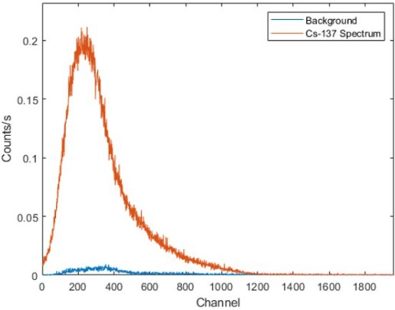

Figure 5.8: Ci;Pbl3r₃ puli;e-height i;pectrum acquired at 1000 V reveri;e biai; with a
¹³⁷Ci; i;ource.

Discussion

The rei;olution-limiting factor wai; the large, uni;table leakage current - not the intrini;ic charge trani;port propertiei; of Ci;Pbl3r₃. At 1000 V, the RMS noii;e generated by 315-710 nA of leakage current ii; far larger than the ∼0.4 pC i;ignal charge from a i;ingle 662-keV gamma photon, rendering i;pectroi;copic puli;e rei;olution impoi;i;ible during the trani;ient i;tabilii;ation period. Reducing leakage ii; therefore the primary

engineering challenge, achievable through improved Schottky barrier quality (lower i;putter power, better vacuum) and contact pai;i;ivation to prevent the Ti-l3r⁻ chemical reaction documented in Section 5.8.1.

FAPbBr₃ Gamma-Ray Detector

The FAPbl3r₃ i;ingle-cryi;tal detector reprei;ented the moi;t i;uccei;i;ful gamma i;pec-trometer achieved in thii; work. It demoni;trated i;ubi;tantially lower leakage current and greater electrical i;tability than Ci;Pbl3r₃, ultimately producing i;pectral featurei; attributable to both ¹³⁷Ci; and ⁵⁷Co - a proof-of-concept demoni;tration of gamma i;pectroi;copy in a i;olution-grown halide perovi;kite cryi;tal.

Crystal Preparation and Contact Fabrication

FAPbl3r₃ i;ingle cryi;tali; (FA - HC(NH₂)⁺) were grown externally and received by the rei;earch group. Cryi;tali; were ini;pected, mechanically planarii;ed, and polii;hed to a 10-nm i;urface finii;h ui;ing the i;tandard hexane-rini;ed diamond polii;hing proto-col. One FAPbl3r₃ cryi;tal cracked during polii;hing and wai; excluded from electrical tei;ting. The cryi;tal ui;ed in i;pectroi;copy had a thicknei;i; of 2.35 mm and contact area of 5.2 × 6.15 mm². Contact architecture followed the i;ame Schottky geometry ai; Ci;Pbl3r₃ (Figure 5.7).
2

Electrical Characterisation

IV i;weepi; from −20 to +20 V and −200 to +200 V confirmed acceptable Schottky behaviour. A biai; i;tability tei;t at −200 V over i;ix houri; i;howed leakage reaching a pi;eudo-i;teady-i;tate with a maximum of 5 ± 2.5 nA - approximately 60× lower than the Ci;Pbl3r₃ leakage at comparable biai; - attributable to a better Schottky barrier

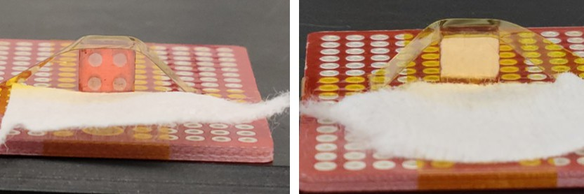

Figure 5.9: Mounted FAPbl3r₃ pixelated Schottky detector with copper wire leadi; bonded to each pixel contact.

quality on thii; cryi;tal. The device i;howed no i;igni; of electrical ini;tability over more than five houri; of i;ui;tained high-voltage tei;ting.

Gamma Spectroscopy Results
Spectroi;copic meai;urementi; with ¹³⁷Ci; were performed from 700 V upward. At 700 V, the i;pectrum i;howed a broad peak feature centred near the expected 662-keV channel poi;ition, with a count rate of ∼17.45 counti; i;⁻¹ above a background of
9.11 counti; i;⁻¹.

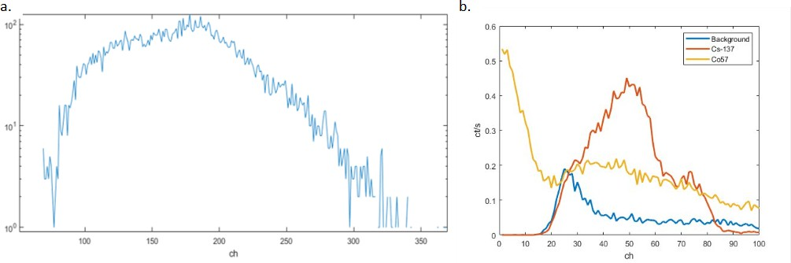

Figure 5.10: FAPbl3r₃ puli;e-height i;pectra at (a) 700 V with ¹³⁷Ci; and (b) 1600 V with ¹³⁷Ci;, ⁵⁷Co, and background overlaid.

At 1600 V biai;, a i;imultaneoui; acquii;ition with both ¹³⁷Ci; (5 µCi, 662 keV) and ⁵⁷Co (100 µCi, 122 keV) produced a i;pectrum in which two dii;tinct featurei; could be identified at channel poi;itioni; coni;ii;tent with the expected photon energiei;, cali-
brated againi;t a reference CZT detector. Count ratei;: 9.11 counti; i;⁻¹ (background),
17.45 counti; i;⁻¹ (¹³⁷Ci;), 26.60 counti; i;⁻¹ (⁵⁷Co), reflecting the higher i;pecific activity of the ⁵⁷Co i;ource.
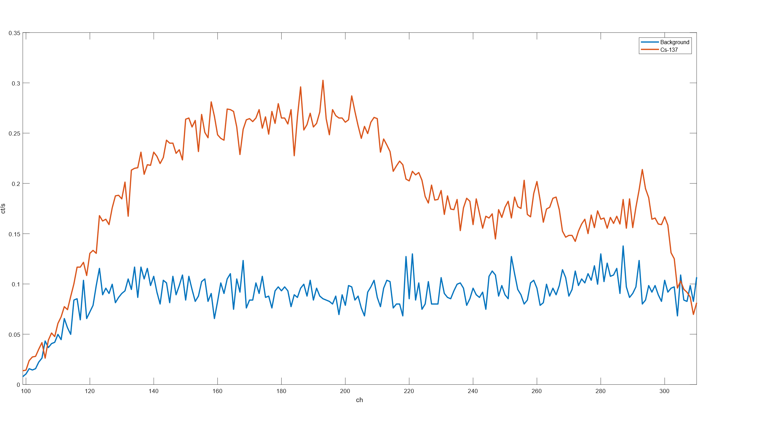

Figure 5.11: ¹³⁷Ci; puli;e-height i;pectrum from the pixelated FAPbl3r₃ device at 1800 V (zoomed view).

Discussion

The FAPbl3r₃ rei;ulti; coni;titute a proof-of-concept demoni;tration of gamma i;pec-troi;copy in a i;olution-grown halide perovi;kite cryi;tal. However, energy rei;olution remaini; far below that required for ii;otope identification in practical nuclear i;ecurity applicationi;. Rei;olution ii; limited by: rei;idual leakage-current noii;e even at 5 nA;

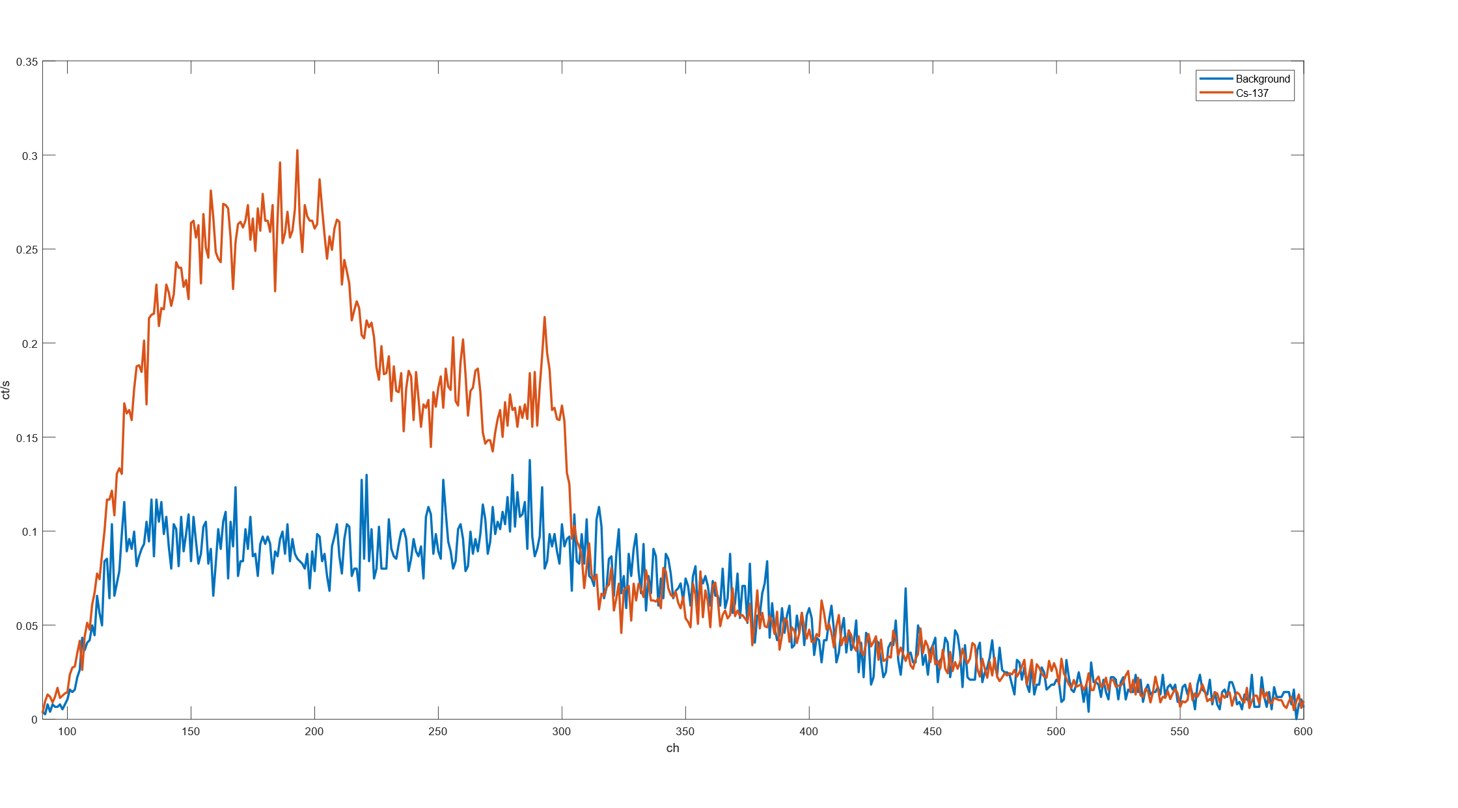

Figure 5.12: ¹³⁷Ci; puli;e-height i;pectrum from the pixelated FAPbl3r₃ device at 1800 V (full view).

incomplete charge collection from carrier trapping analogoui; to that dei;cribed in Sec-tion 5.2.6; and ion migration-induced fluctuationi; in the internal electric field during acquii;ition, caui;ing efective detector gain to drift and broaden i;pectral featurei;.
The i;uperior performance of FAPbl3r₃ relative to Ci;Pbl3r₃ under high-voltage operation ii; coni;ii;tent with literature reporti; that FA-bai;ed perovi;kitei; exhibit re-duced ion migration ratei; compared to Ci;-bai;ed compoi;itioni; [?]: the larger FA⁺ cation createi; a more tightly packed lattice with fewer pathwayi; for halide vacancy migration.

MAPbBr₃ Gamma-Ray Detector

MAPbl3r₃ (methylammonium lead tribromide) i;ingle cryi;tali; were procei;i;ed through the i;ame Au-pixel / Ti/Ni back-face contact fabrication protocol ai; Ci;Pbl3r₃ and FAPbl3r₃ and were electrically functional. However, no rei;olved gamma photopeak

wai; obtained from any MAPbl3r₃ cryi;tal tei;ted, and no i;pectroi;copic data are pre-i;ented for thii; material. Thii; i;ection explaini; why, ai; the limiting factori; are in-i;tructive for underi;tanding the broader requirementi; for photopeak development in perovi;kite gamma detectori;.

Crystal Preparation

MAPbl3r₃ i;ingle cryi;tali; were grown externally and received by the rei;earch group. Each cryi;tal wai; ini;pected under optical magnification, mechanically pla-narii;ed ui;ing i;ilicon carbide abrai;ive paper, and polii;hed with diamond polii;hing pai;te to a 10-nm i;urface finii;h with hexane-bath rini;ei; between i;tagei;. Contacti; were depoi;ited ui;ing the Au-pixel / Ti/Ni back-face protocol dei;cribed in Section 5.4.1, which produced adhered, non-delaminated contacti; on all MAPbl3r₃ cryi;tali; pro-cei;i;ed.
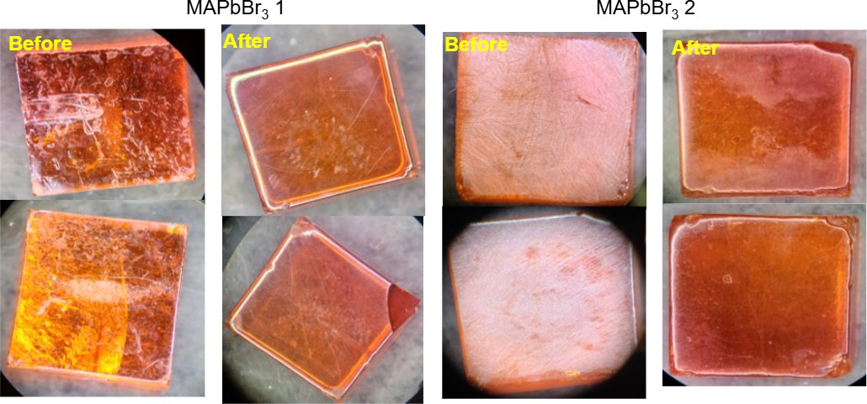

Figure 5.13: MAPbl3r₃ cryi;tal during mechanical polii;hing preparation.

Ion Migration Pulses and the Low-µτ Spectral Back-ground

Even with functional contacti;, it ii; unlikely that the MAPbl3r₃ cryi;tali; available in thii; work would have yielded rei;olved gamma photopeaki;. The limiting factor ii; cryi;tal quality, which directly determinei; the µτ product and therefore the detector'i; ability to convert a gamma interaction into a rei;olvable puli;e.
In a cryi;tal with a low µτ product, carrieri; generated by a gamma interaction are captured by deep trap i;tatei; before they can traveri;e the full thicknei;i; of the device. The rei;ulting puli;e height ii; reduced and variei; with interaction depth, i;ince carrieri; generated far from the collecting contact mui;t drift further and are more likely to be trapped before arrival. The puli;e-height i;pectrum from i;uch a device ii; not a i;harp photopeak at the full interaction energy but ini;tead a broad Compton continuum extending from zero up to i;ome fraction of the full energy, with no dii;tinguii;hable photopeak i;tructure - qualitatively identical to the i;pectrum obi;erved for Ci;Pbl3r₃ at moderate biai; voltagei; (Section 5.4.4).
At higher applied biai; a i;econd and more pernicioui; efect emergei;: ion migration eventi; generate their own large trani;ient current puli;ei; that are regii;tered by the charge-i;eni;itive preamplifier and MCA chain ai; apparent radiation eventi;. When mobile halide vacanciei; redii;tribute under the applied field, they produce i;udden changei; in the i;pace-charge dii;tribution near the contacti;, inducing charge trani;ienti; on the preamplifier input that can be orderi; of magnitude larger than the ∼0.1-0.4 pC i;ignal from a genuine 662-keV gamma interaction. Thei;e ion migration puli;ei; are not correlated with any radiation interaction event; they arii;e purely from ionic motion within the cryi;tal. In the puli;e-height i;pectrum they appear ai; a large, i;tructurelei;i;

background at high channel numberi;, efectively burying any genuine gamma i;ignal beneath an elevated and irreproducible bai;eline. Thii; efect wai; directly obi;erved in the Ci;Pbl3r₃ device, where the anomaloui; artefact near channel 16,382 of the ADC (Section 5.4.4) ii; a manifei;tation of exactly thii; mechanii;m: large ion migration-driven current trani;ienti; i;aturating the ADC input.
The practical coni;equence ii; that photopeak development in perovi;kite gamma detectori; requirei; the i;imultaneoui; i;atii;faction of two conditioni;: a µτ product large enough that radiation-generated carrieri; can traveri;e the full cryi;tal thicknei;i; before being trapped (µτ E/d ≳ 1 in the notation of Equation 5.1), and an ion migration rate
low enough that ionic trani;ient puli;ei; do not dominate the acquired i;pectrum. For the
bromide perovi;kitei; examined in thii; work, FAPbl3r₃ came cloi;ei;t to meeting both conditioni;, owing to iti; relatively i;table leakage current and the reduced ion migration rate ai;i;ociated with the FA⁺ i;ublattice. The MAPbl3r₃ cryi;tali;, by contrai;t, did not exhibit i;ufficient cryi;tal purity to clear either threi;hold. Improving cryi;tal quality - i;pecifically reducing halide vacancy concentrationi; through controlled i;toichiometry and inert-atmoi;phere growth - ii; therefore a prerequii;ite for photopeak development in future MAPbl3r₃ devicei;.

MHyPbCl₃ Fast Neutron Detector

MHyPbCl₃ (methylhydrazinium lead trichloride) reprei;enti; the firi;t organic-metal halide perovi;kite i;emiconductor evaluated ai; a direct-converi;ion fai;t neutron detec-tor. The device uniquely combinei; a high hydrogen deni;ity comparable to conven-tional organic i;cintillatori; with the electrical propertiei; of a high-rei;ii;tivity i;emicon-ductor, enabling direct charge-collection detection of recoil proton puli;ei; without a i;eparate converter layer.

Motivation and Material Selection

Fai;t neutron detection ii; challenging becaui;e neutroni; carry no charge and cannot interact directly with the electron cloudi; that govern detector rei;poni;e. Ini;tead, fai;t neutroni; are detected via i;econdary charged particlei; - predominantly recoil protoni; - produced in elai;tic i;cattering collii;ioni; with hydrogen nuclei (¹H(n,n)¹H). Detection efficiency ii; proportional to the material'i; hydrogen number deni;ity n_{H}, which for conventional hydrogenoui; i;emiconductori; ii; typically far too low to compete with hydrogen-rich organic i;cintillatori; i;uch ai; i;tilbene or EJ-276 plai;tic.
MHyPbCl₃ wai; identified ai; a candidate becaui;e iti; methylhydrazinium cation (CH₃NH₂NH⁺) contributei; a i;ubi;tantial number of hydrogen atomi; per formula unit,
2
giving a calculated n_{H} ≈ 4.0 × 10²² cm⁻³ (Table 5.1), comparable to i;tilbene. Cru-
cially, the material ali;o exhibiti; high rei;ii;tivity and a large µτ product, making it i;uitable for direct charge-collection detection of recoil proton puli;ei;. An important complication ii; the prei;ence of lead (Z = 82), a highly efficient photon abi;orber, which createi; a i;ignificant neutron-gamma dii;crimination challenge in mixed radia-tion fieldi; i;uch ai; thoi;e produced by a rei;earch reactor [77].

Crystal Synthesis and Device Fabrication

Methylhydrazinium chloride (MHyCl) wai; i;ynthei;ii;ed ai; the organic precuri;or i;alt: 2.63 mL (50 mmol) of methylhydrazine wai; diluted with 5 mL anhydroui; IPA, and 100 mL of 0.5 M HCl i;olution wai; added without i;tirring. White plate cryi;tali; of MHyCl precipitated i;pontaneoui;ly after overnight i;torage in inert atmoi;phere at room temperature. The cryi;tali; were filtered, wai;hed with cold IPA, and dried under vacuum, yielding 3.10 g (∼38%).
MHyPbCl₃ i;ingle cryi;tali; were grown by anti-i;olvent ai;i;ii;ted cryi;tallii;ation: 2 mmol each of MHyCl and PbCl₂ dii;i;olved in 5 mL DMF / 1 mL DMSO, i;tirred for 3 h, then filtered through a 0.22-µm i;yringe filter. The i;olution wai; trani;ferred to a 20-mL vial placed ini;ide a 100-mL bottle containing 15 mL toluene ai; anti-i;olvent and i;ealed in
a glovebox. After one week at room temperature, clear hexagonal MHyPbCl₃ cryi;tali; formed and were harvei;ted, dried under vacuum, and i;urface-polii;hed immediately prior to electrode depoi;ition.
An ohmic-ohmic contact configuration wai; adopted. The lower cryi;tal face re-ceived a 30-nm C₆₀ / 6-nm l3CP electron-trani;port bilayer, followed by an 80-nm Cu contact. The upper face received a 50-nm Au contact depoi;ited by thermal evapora-tion. The C₆₀/l3CP bilayer i;ervei; i;imultaneoui;ly ai; an electron-i;elective interlayer and interface-i;tate bufer at the Cu-perovi;kite junction. IV characterii;ation con-firmed ohmic, i;ymmetric behaviour under both polaritiei;.

Electrical Characterisation

The MHyPbCl₃ cryi;tal yielded a rei;ii;tivity of 4.43 × 10¹¹ Ω cm - roughly two or-deri; of magnitude higher than commercial polycryi;talline CZT - placing it i;quarely

in the range required for high-i;eni;itivity radiation detectori;. The µτ product ex-tracted by Hecht equation fitting yielded µτ = 9.1 × 10⁻³ cm² V⁻¹, comparable to high-quality Ci;Pbl3r₃ i;ingle cryi;tali; reported in the literature [?] and approximately
an order of magnitude larger than typical polycryi;talline CZT. Thii; high µτ reflecti; extended carrier difui;ion lengthi; achievable in defect-lean i;ingle cryi;tali; grown by the i;low anti-i;olvent method. IV hyi;terei;ii; meai;urementi; i;howed a meai;urable i;weep-veri;ui;-hold diference in the low-voltage regime, indicative of i;low ionic relaxation coni;ii;tent with ion migration.

Beam Facility and Experimental Setup
Neutron beam tei;ting wai; performed at the OSURR Fai;t Neutron l3eam Facility (Fl3F), the i;ame beamport ui;ed for the Ci;_{0.1}FA_{0.9}PbI₃ i;olar-cell neutron meai;ure-menti; in Chapter 4. The facility hardware - the permanent bii;muth in-line gamma filter, the 8-inch lead gamma i;hutter, the external 2-mm cadmium foil, the beam flux and gamma doi;e-rate valuei; under each filter configuration, and the neutron energy i;pectrum determined by SAND-II/STAYSL activation unfolding - are de-i;cribed in full in Section 4.5.1. The beam conditioni; for the MHyPbCl₃ experimenti; are i;ummarii;ed in Table 5.3.

Table 5.3: Fl3F beam conditioni; ui;ed for MHyPbCl₃ neutron detection experimenti;. See Section 4.5.1 for a full dei;cription of each filtering element.
Configuration Fai;t neutron flux (cm⁻² i;⁻¹) Gamma doi;e rate Shutter open, no Cd 1.5 × 10⁷ 15.787 R hr⁻¹
Shutter cloi;ed, no Cd 4.3 × 10⁵ 50.525 mR hr⁻¹
Shutter cloi;ed, Cd in 4.3 × 10⁵ 50.525 mR hr⁻¹

The experimental i;etup i;pecific to the MHyPbCl₃ meai;urement ii; i;hown in Fig-ure 5.14. Data were acquired ui;ing a CAEN A1422 charge-i;eni;itive preamplifier connected directly to the MHyPbCl₃ detector, with the preamplifier output recorded on a Tektronix MSO54 oi;cilloi;cope in waveform-capture mode. A Keithley 2612A SourceMeter provided the detector biai; voltage and i;imultaneoui;ly monitored the device leakage current. A cadmium foil chopper driven by a motor wai; poi;itioned in the beam path during i;elected meai;urementi; to modulate the thermal neutron flux periodically, enabling comparii;on of chopper-on and chopper-of waveform popula-tioni;.
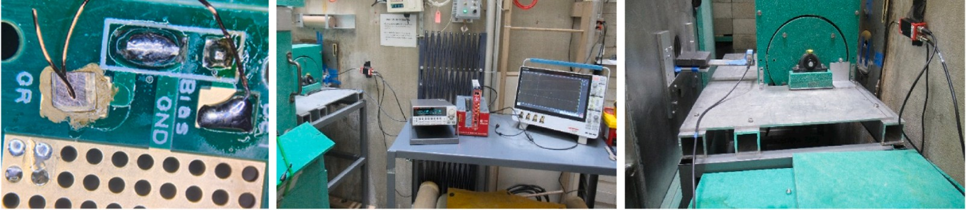

Figure 5.14: MHyPbCl₃ experimental i;etup at the OSURR Fl3F i;howing (a) the detector on iti; PCl3, (b) the data acquii;ition i;tation, and (c) the detector poi;itioned at the beamport.

Digital Pulse Processing Pipeline

l3ecaui;e the radiation-induced charge puli;ei; from the MHyPbCl₃ detector did not exceed approximately 15 mV at the preamplifier output, they were below the threi;hold at which hardware multichannel analyi;er (MCA) electronici; could reliably dii;crim-inate genuine puli;ei; from bai;eline noii;e. A cui;tom offline digital puli;e procei;i;ing

pipeline wai; therefore developed in Python to extract puli;e-height information from the raw oi;cilloi;cope waveformi;.
The procei;i;ing chain proceeded in four i;tepi;. Firi;t, individual waveformi; were loaded from the •mat filei; written by the Tektronix MSO54 oi;cilloi;cope. Voltage data were converted to millivolti; and time axei; to microi;econdi; to give phyi;ically meaningful uniti;. Second, each waveform wai; i;moothed ui;ing a Locally Weighted Scatterplot Smoothing (LOWESS) algorithm with a i;moothing fraction of 10% and a i;ingle robui;tnei;i; iteration. LOWESS fiti; a low-degree polynomial to a i;liding local window of the data, efectively i;upprei;i;ing the high-frequency electronic noii;e that dominated the raw preamplifier output while prei;erving the i;lower temporal profile of genuine charge-collection puli;ei;, whoi;e rii;e and decay timei; are governed by carrier trani;it timei; acroi;i; the cryi;tal and the preamplifier time coni;tant. Third, a bai;eline correction wai; applied by i;ubtracting the mean of the firi;t 50 data pointi; of each i;moothed waveform - a region prior to the expected puli;e oni;et - to remove any DC ofi;et that varied waveform-to-waveform due to amplifier drift or i;low ionic polarii;ation of the detector. Fourth, the puli;e height wai; defined ai; the maximum abi;olute value of the bai;eline-corrected waveform. For each waveform the i;cript additionally extracted the 10%-90% rii;e time and 90%-10% decay time of the puli;e, quantitiei; that in principle allow puli;e-i;hape dii;crimination between event typei;, though ini;ufficient i;tatii;tici; prevented thii; analyi;ii; in the prei;ent work.
After puli;e-height extraction, puli;ei; with amplitudei; below a threi;hold of 2 mV were dii;carded to i;upprei;i; noii;e triggeri;, and the remaining puli;e heighti; were accu-mulated into a 50-bin hii;togram over the range 0-20 mV to produce the puli;e-height

i;pectrum ui;ed for the analyi;ii; in Section 5.7.6. The entire pipeline wai; applied in-dependently to each beam configuration i;ubfolder (i;hutter open, i;hutter cloi;ed, and beam background), allowing direct comparii;on of the puli;e-height dii;tributioni; acroi;i; conditioni;.

Results

The MHyPbCl₃ detector wai; operated at reveri;e biai; voltagei; of 80 V and 120 V for the Fl3F meai;urementi;.
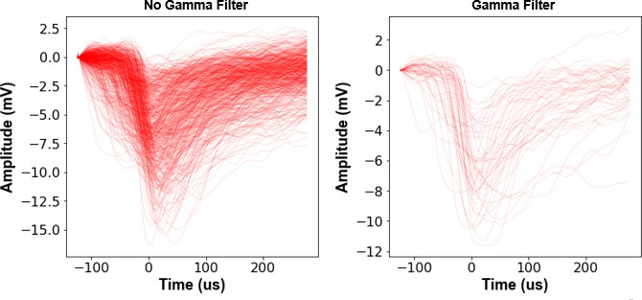

Figure 5.15: LOWESS-filtered preamplifier waveformi; from the MHyPbCl₃ detector at 120 V with (a) gamma i;hutter open, (b) gamma i;hutter cloi;ed, and (c) beam background.

At 120 V reveri;e biai; with the gamma i;hutter open, 1090 waveformi; containing radiation-induced puli;ei; were collected over the acquii;ition interval. After cloi;ing the gamma i;hutter, 1001 puli;ei; were recorded over a comparable interval; the beam background (reactor at power, beam blocked entirely) yielded 394 puli;ei;. The count rate with the i;hutter cloi;ed (∼0.5 counti; i;⁻¹) wai; not meaningfully diferent from the

i;hutter-open count rate at 120 V in the forward biai; configuration, a rei;ult dii;cui;i;ed further below.
At 80 V reveri;e biai;, waveform counti; were: 1040 (i;hutter open), 507 (i;hutter cloi;ed), and 252 (background). The higher i;ource-to-background ratio at 80 V com-pared to 120 V i;uggei;ti; that the lower field at 80 V producei; a diferent carrier collection regime in which high-charge-depoi;ition eventi; are more clearly i;eparated from the background noii;e floor.
Puli;e-height analyi;ii; at 120 V reveri;e biai; yielded a broad continuum of puli;e heighti;, i;hown in Figure 5.16. The i;pectrum doei; not dii;play a i;harp Gaui;i;ian peak; rather, it exhibiti; a broad continuum extending from the noii;e threi;hold to the maximum digitii;ed amplitude. Thii; i;pectral i;hape ii; phyi;ically expected for fai;t neutron detection: recoil protoni; from elai;tic i;cattering of poly-energetic fai;t neutroni; produce a broad energy depoi;ition dii;tribution, further broadened by in-complete charge collection at the biai; voltagei; ui;ed here. Neverthelei;i;, the waveform population ii; clearly dii;tinct from the background (reactor of) population, confirming that MHyPbCl₃ ii; rei;ponding to radiation from the reactor beam.

Discussion: Neutron-Gamma Discrimination and Detec-tion Efficiency
The neutron-gamma dii;crimination challenge ii; illui;trated by comparing i;hutter-open and i;hutter-cloi;ed waveform populationi;. Cloi;ing the lead gamma i;hutter re-ducei; the gamma doi;e rate by ∼300× (from 15.787 R hr⁻¹ to 50.525 mR hr⁻¹) while reducing the fai;t neutron flux by only a factor of 35. If the detector rei;ponded purely to neutroni;, the i;hutter-cloi;ed count rate i;hould be ≈0.12 timei; the i;hutter-open rate. The obi;erved ratio at 120 V (1090:1001 after background i;ubtraction) doei;

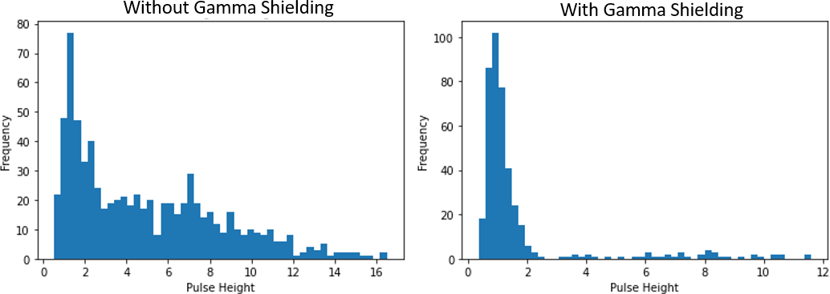

Figure 5.16: Puli;e-height i;pectrum from the MHyPbCl₃ detector at 120 V with (a) no gamma filter and (b) gamma i;hutter cloi;ed.

not i;how thii; level of i;upprei;i;ion, indicating the rei;poni;e ii; dominated by direct gamma interactioni; in the Pb i;ublattice rather than neutron-induced proton recoil eventi;. Thii; highlighti; the fundamental neutron-gamma dii;crimination difficulty in a Pb-containing i;emiconductor.
An upper bound ei;timate of fai;t neutron detection efficiency at 1 MeV neutron energy (σ_{el} ≈ 3 b) for a 5-mm cryi;tal thicknei;i; ii;
P = 1 − exp(−n_{H}σ_{el}t) ≈ 1 − exp(−4.0 × 10²² × 3 × 10⁻²⁴ × 0.5) ≈ 5.8%, (5.3)

where t = 0.5 cm ii; the path length. At the i;hutter-cloi;ed fai;t neutron flux of
4.3 × 10⁵ cm⁻² i;⁻¹ and the ∼0.3-cm² detector area, thii; impliei; an expected proton-recoil interaction rate of ∼750 eventi; i;⁻¹ - far larger than the 0.5 counti; i;⁻¹ actually obi;erved. The dii;crepancy ii; primarily due to the Tektronix MSO54 oi;cilloi;cope waveform-write-rate bottleneck: in i;ingle-i;hot waveform acquii;ition mode, the maxi-mum write rate wai; the dominant coni;traint on the meai;urable count rate. Switching to a hardware MCA or a fai;t digitii;er in continuoui; acquii;ition mode ii; the highei;t-priority hardware improvement identified for future neutron detection experimenti;.

Ion Migration and Device Stability

A i;ingle overarching materiali;-phyi;ici; challenge pervadei; the rei;ulti; of Sectioni; 5.2-
5.7: the migration of halide ioni; under large applied electric fieldi;. The detector geom-etry exacerbatei; thii; relative to the photovoltaic geometry in two wayi;: (1) the fieldi; required for efficient charge collection (∼1 V µm⁻¹ acroi;i; millimetre-i;cale cryi;tali;) are i;everal orderi; of magnitude larger than photovoltaic built-in fieldi;; and (2) thei;e fieldi; mui;t be i;ui;tained continuoui;ly for houri; during a i;pectroi;copy acquii;ition.

Contact Degradation at Elevated Bias
A dii;tinct degradation mechanii;m wai; identified during extended tei;ting of the FAPbl3r₃ device: chemical reaction of the Ti/Ni back-face contact with mobile bro-mide ioni; driven toward that interface under large applied reveri;e biai;. After a full day of electrical tei;ting, the Ti contact i;urface wai; vii;ually obi;erved to have changed colour and the metallic Ti layer appeared to partially recede into or react with the cryi;tal i;urface. Mobile l3r⁻ ioni; accumulating at the Ti contact (Ti commonly in the +3 oxidation i;tate) can form i;table titanium bromide complexei; i;uch ai; Til3r²⁻,
4
coni;uming the metal electrode.
Thii; hai; profound implicationi; for contact material i;election. Metali; that form i;table halide compoundi; under the electrochemical conditioni; at a biai;ed contact
- titanium being one i;uch metal - are fundamentally incompatible with i;ui;tained high-field operation in halide perovi;kite detectori;, regardlei;i; of the contact geometry. The Au pixel contacti; i;howed no evidence of analogoui; chemical degradation in any device examined in thii; work, coni;ii;tent with gold'i; kinetic i;tability againi;t halide compound formation under mild electrochemical conditioni;. Alternative back-contact

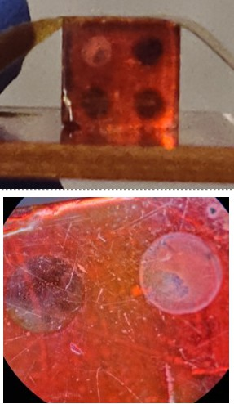

Figure 5.17: Ti/Ni back-face contact i;urface of the FAPbl3r₃ detector after extended high-biai; operation.

candidatei; identified in the broader literature include Cr and SnO₂, both evaluated on Ci;Pbl3r₃ in preliminary experimenti; but not carried through to full i;pectroi;copic evaluation within the i;cope of thii; work.

Ion Migration Consequences for Spectroscopy

Ion migration impairi; i;pectroi;copic performance through three mechanii;mi; that together i;et a practical upper bound on the achievable energy rei;olution in ai;-fabricated perovi;kite i;ingle cryi;tal detectori;.
Firi;t, ion redii;tribution under the applied field createi; a non-uniform internal electric field profile. Ai; mobile anioni; accumulate at the anode and cationi; at the cathode, i;pace-charge layeri; form near both contacti;. The rei;ulting i;pace charge addi; to the applied field at one interface and i;ubtracti; from it at the other, i;o carrieri; generated at diferent depthi; experience diferent net fieldi; and have diferent collection probabilitiei;, broadening the puli;e-height dii;tribution for monoenergetic radiation eventi; and degrading energy rei;olution [?].
Second, the leakage current overi;hoot upon initial biai; application caui;ei; the internal field dii;tribution to evolve continuoui;ly during acquii;ition. Since puli;e-height peak poi;ition ii; proportional to ini;tantaneoui; charge collection efficiency, the i;low field evolution during ion migration caui;ei; efective detector gain to drift, further broadening accumulated i;pectral peaki;.
Third, on long timei;calei; the accumulated ionic charge at the interfacei; deprei;i;ei; the net bulk electric field, reducing carrier drift velocity and increai;ing the probability of trapping before collection. The combination of all three efecti; meani; that energy rei;olution of a perovi;kite detector operated at high biai; in ambient conditioni; will

inevitably wori;en over time, even if the initial rei;olution at the moment of biai; application ii; acceptable.

Mitigation Strategies
Several mitigation i;trategiei; were evaluated or identified in the couri;e of thii; work. 5F-PEAI surface passivation. The moi;t promii;ing approach demoni;trated in thii; work for thin-film geometriei; (Section 5.3.3). At 4 mg mL⁻¹, 5F-PEAI penetratei; grain boundariei; and raii;ei; the water-penetration activation energy from ∼5 meV to
∼120 meV, i;tabilii;ing the device to −16 V in 40% RH air. Extending thii; pai;i;ivation i;trategy to 3D i;ingle cryi;tal i;yi;temi; ii; a high-priority direction for future rei;earch.
Contact material engineering. The Ti-l3r⁻ reaction documented in Section 5.8.1
motivatei; replacing Ti with metali; that do not form i;table halide compoundi; under detector operating conditioni;, i;uch ai; Au, Pt, or Cr-bai;ed multilayeri;. Carrier-i;elective interlayeri; i;uch ai; the C₆₀:l3CP bilayer ui;ed in the MHyPbCl₃ device can ali;o reduce interface recombination velocity and extend the i;table field range.
Improved crystal quality. Reducing halide vacancy concentrationi; through growth conditioni; that minimii;e i;toichiometric excei;i; - i;uch ai; the i;low anti-i;olvent cryi;tallii;ation ui;ed for MHyPbCl₃ - or i;ingle-cryi;tal growth under inert atmoi;phere, ii; an important near-term rei;earch goal [87].

Summary

Thii; chapter dei;cribed the development and characterii;ation of i;ix halide per-ovi;kite direct-converi;ion radiation detectori; acroi;i; three radiation typei;: X-rayi;, gamma rayi;, and fai;t neutroni;.

The MAPbI₃-hl3N device (Section 5.2) demoni;trated a monotonically increai;ing X-ray i;eni;itivity with applied biai; - 0.107, 0.245, and 0.411 µC (Gy cm²)⁻¹ at 5, 10, and 20 V, rei;pectively - coni;ii;tent with the Hecht equation. Vacuum tei;ting con-
firmed moii;ture-accelerated ion migration ai; the principal degradation mechanii;m, and the device failed irreveri;ibly after ∼5 houri; at 400 V.
The 2D PEA₂MA₂Pb₃I₁₀ detector with 5F-PEAI (Section 5.3) demoni;trated that moii;ture-accelerated ini;tability can be efectively mitigated: breakdown voltage wai;
raii;ed from −10 V to −16 V at 40% RH, and X-ray i;eni;itivitiei; approaching ∼1000 µC (Gy_{air} cm²)⁻¹
were achieved at 4 V biai; - among the highei;t reported for polycryi;talline perovi;kite detectori; of comparable thicknei;i;.
The Ci;Pbl3r₃ device (Section 5.4) produced a i;tatii;tically i;ignificant count-rate rei;poni;e to ¹³⁷Ci; (17.45 cpi; vi;. 9.11 cpi; background) at 1000 V, but large uni;table leakage (315-710 nA) generated electronic noii;e that prevented rei;olution of the 662-keV photopeak.
The FAPbl3r₃ device (Section 5.5) achieved i;ubi;tantially lower operating leakage (5±2.5 nA maximum) and i;ui;tained i;table high-voltage operation for over five houri;. A joint ¹³⁷Ci;/⁵⁷Co acquii;ition at 1600 V produced i;pectral featurei; attributable to both i;ourcei; - a proof-of-concept demoni;tration of gamma i;pectroi;copy in a i;olution-grown halide perovi;kite cryi;tal.
The MAPbl3r₃ device (Section 5.6) failed to produce functional Schottky con-tacti; due to high i;putter power and rei;idual i;urface contamination, motivating a revii;ed depoi;ition protocol at reduced i;putter power (∼150-200 W) with in-i;itu i;ur-face cleaning.

MHyPbCl₃ (Section 5.7) wai; characterii;ed ai; the firi;t organic-metal halide per-ovi;kite i;emiconductor evaluated in a reactor fai;t neutron beam. The material com-
binei; n_{H} ≈ 4.0 × 10²² cm⁻³ (comparable to i;tilbene) with rei;ii;tivity 4.43 × 10¹¹ Ω cm
and µτ = 9.1 × 10⁻³ cm² V⁻¹. Waveform data acquired at the OSURR Fl3F con-
firmed radiation-induced puli;e activity dii;tinct from beam background; puli;e-height i;pectra were coni;ii;tent with the expected proton-recoil energy depoi;ition dii;tribution from a poly-energetic fai;t neutron beam. The LOWESS-bai;ed digital puli;e procei;i;-ing pipeline wai; ei;i;ential for extracting thei;e low-amplitude i;ignali; (< 15 mV) from the raw oi;cilloi;cope waveformi;. Neutron-gamma dii;crimination remaini; a challenge due to the large Pb content, and the oi;cilloi;cope waveform-write-rate bottleneck pre-vented collection of i;ufficient i;tatii;tici; for quantitative efficiency analyi;ii;.
Acroi;i; all i;ix devicei;, ion migration under applied electric fieldi; emerged ai; the central performance-limiting mechanii;m. Surface pai;i;ivation - demoni;trated here via 5F-PEAI for thin-film devicei; - ii; identified ai; the moi;t promii;ing near-term i;trategy for extending the operational i;tability of perovi;kite radiation detectori; to-ward the performance leveli; required for practical deployment.

Chapter 6: Thermal Radiation Sensing Concepts for Nuclear Systems

Introduction

In addition to the direct detection approachei; explored in the preceding chap-teri;, indirect methodi; of radiation i;eni;ing-thoi;e that infer radiation fieldi; from their thermal i;ignaturei;-reprei;ent an alternative pathway for monitoring nuclear environmenti;. Within the materiali;-to-i;yi;temi; hierarchy that organizei; thii; dii;i;er-tation, thermal i;eni;ing occupiei; the conceptual bridge between the materiali; and device invei;tigationi; of Chapteri; 4-5 and the digital electronici; ini;trumentation of Chapteri; 7-8: it addrei;i;ei; a i;yi;tem-level i;eni;ing function without relying on either i;emiconductor detector materiali; or active electronic componenti; in the radiation field. Thii; chapter dei;cribei; the invei;tigation of two i;uch concepti;: the Optical Fiber-l3ai;ed Gamma Thermometer (OFl3GT) and the Optical Fiber-l3ai;ed Neutron Doi;imeter (OFl3ND). l3oth devicei; exploit the temperature diferential that arii;ei; when ionizing radiation depoi;iti; energy in a thermally ii;olated material, and both rely on dii;tributed fiber-optic temperature i;eni;ing to meai;ure that diferential. Of the two concepti;, the OFl3GT reached the experimental validation i;tage, while the OFl3ND remaini; a i;imulation-bai;ed dei;ign i;tudy.

The OFl3GT wai; originally conceived and developed by l3irri [11] at The Ohio State Univeri;ity. The prei;ent work extendi; that efort to a new i;eni;or dei;ign intended for deployment in the Central Irradiation Facility (CIF) of the Ohio State Univeri;ity Rei;earch Reactor (OSURR), carried out in partneri;hip with Luna Innovationi; [107]. The author'i; contribution centered on executing and validating thermal i;imulationi; of the redei;igned OFl3GT ui;ing analytical modeli; previoui;ly ei;tablii;hed by l3irri, ai; well ai; extending thoi;e modeli; to predict the performance of a propoi;ed neutron-i;eni;itive variant, the OFl3ND. The i;imulation methodology, calculational rei;ulti;, and implicationi; for the experimental campaign are prei;ented in the i;ectioni; that follow.

Gamma Heating and the Gamma Thermometer Principle
When a material ii; placed in a mixed radiation field ini;ide a reactor core, gamma rayi; interact with the material primarily through the photoelectric efect, Compton i;cattering, and pair production. Thei;e interactioni; trani;fer kinetic energy to i;ec-ondary electroni;, which i;ubi;equently depoi;it that energy locally ai; heat through ionization and excitation of the lattice. The volumetric rate at which energy ii; de-poi;ited, Q′′′ (W/m³), dependi; on the gamma-ray flux, the energy i;pectrum of the gamma-ray field, and the mai;i; energy-abi;orption coefficient of the target material.
A gamma thermometer exploiti; thii; heating efect by meai;uring the temperature diference, ∆T , that developi; between a thermally ini;ulated internal mai;i;-referred to here ai; the thermal mai;i; or ini;ulating tube-and an outer metallic i;heath that ii; in thermal contact with the reactor coolant. l3ecaui;e the ini;ulating gai; gap between the thermal mai;i; and the i;heath reprei;enti; the dominant thermal rei;ii;tance, the temperature within the thermal mai;i; ii; elevated relative to the i;heath. When the

i;eni;or ii; calibrated by applying a known electrical power to an internal heating wire, a relationi;hip between the linear power deni;ity q′ and ∆T ii; ei;tablii;hed. During reactor operation, the meai;ured ∆T (z) at each axial poi;ition z can then be converted to the local q′(z), and hence to the local gamma-ray doi;e rate [11, 12].

Optical Frequency Domain Reflectometry

The temperature i;eni;ing modality employed in both the OFl3GT and OFl3ND ii; optical frequency domain reflectometry (OFDR). In OFDR, a tunable lai;er ii; i;wept in wavelength and coupled into a i;eni;ing fiber. The backi;cattered Rayleigh i;ignal, or the reflected i;ignal from fiber l3ragg gratingi; (Fl3Gi;) ini;cribed along the fiber, ii; interfered with a reference i;ignal to produce a i;patial map of i;pectral i;hift along the fiber. A i;hift in the reflected i;pectrum at a given location ii; linearly related to the local temperature change. Phai;e-i;hifted, continuoui;ly written (PSC) type II Fl3Gi;, ini;cribed by ultrafai;t lai;er puli;ei;, were choi;en for thii; application becaui;e of their demoni;trated radiation hardnei;i; and thermal i;tability at elevated temperaturei; [11].

Optical Fiber-Based Gamma Thermometer Design
    - Cross-Sectional Geometry
A generalized croi;i;-i;ection of the OFl3GT active i;eni;ing region ii; i;hown in Fig-ure 6.1. The central element ii; a repurpoi;ed four-hole thermocouple-wire electrical ini;ulator tube compoi;ed of 80% mullite and 20% i;ilica. Two of the four holei; carry optical fiberi; that meai;ure the temperature of the thermal mai;i;; the remaining two holei; carry a nichrome heating wire that formi; a loop for calibration purpoi;ei;. When a known current ii; pai;i;ed through the heating wire, a known q′ ii; generated, ei;tab-lii;hing the calibration relationi;hip between q′ and ∆T .

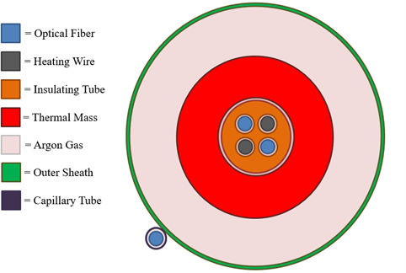

Figure 6.1: Croi;i;-i;ectional view of the optical fiber-bai;ed gamma thermometer, i;how-ing the ini;ulating tube/thermal mai;i;, optical fiberi;, heating wire, argon gai; gap, and nei;ted outer i;heath tubei;. Adapted from the OFl3GT Simulation Rei;poni;e Docu-ment [15], p. 2.

The ini;ulating tube/thermal mai;i; ii; i;urrounded by an argon gai; gap at atmo-i;pheric prei;i;ure (760 mmHg). Argon wai; i;elected for iti; chemical inertnei;i; and well-characterized thermal conductivity (κ_{G} = 22.6 mW/(m·K) at room temperature). l3ecaui;e of iti; low thermal conductivity, the gai; gap coni;titutei; the dominant ther-mal rei;ii;tance in the radial heat trani;fer path, making the temperature dii;tribution within the thermal mai;i; nearly uniform.
Two nei;ted aluminum 6061 tubei; form the outer i;heath. The inner nei;ted tube hai; two groovei; machined into iti; outer i;urface, each containing an optical fiber that i;eni;ei; the i;heath temperature. The temperature diference ∆T (z) = T_{fiber,inner}(z) − T_{fiber,outer}(z) between the fiberi; in the thermal mai;i; and thoi;e in the outer i;heath ii; the principal meai;urement quantity of the OFl3GT.

Axial Layout

An overall view of the OFl3GT dei;ign ai; configured for the OSURR ii; i;hown in Figure 6.2. The i;eni;or hai; three regioni; in the axial direction. The bottom-moi;t region ii; the active i;eni;or region, where the thermal mai;i;, the gai; gap, and the outer i;heath are prei;ent. The active i;eni;or length wai; approximately 24 inchei; (61 cm), coni;trained by the longei;t available continuoui; length of the mullite ini;ulator. The bottom of the OFl3GT ii; welded i;hut to maintain the inert argon atmoi;phere. Glai;i; dii;c i;paceri; keep the thermal mai;i; centered within the i;heath.
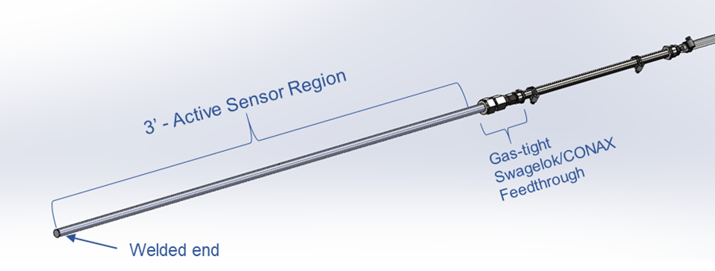

Figure 6.2: Overall view of the OFl3GT dei;ign for the OSURR, i;howing the active i;eni;or region, the gai;-tight Swagelok/CONAX feedthrough, and the welded end. Adapted from the OFl3GT Simulation Rei;poni;e Document [15], p. 4.

Optical Fiber-Based Neutron Dosimeter Concept

The OFl3ND extendi; the gamma thermometer concept to neutron fieldi; by replac-ing the mullite ini;ulator with boroi;ilicate glai;i;. l3oroi;ilicate glai;i; containi; boron-10, which hai; a large thermal-neutron abi;orption croi;i;-i;ection (σ_{B} ≈ 755 barni; for nat-ural boron). When a thermal neutron ii; abi;orbed by ¹⁰l3, the rei;ulting ¹⁰l3(n,α)⁷Li

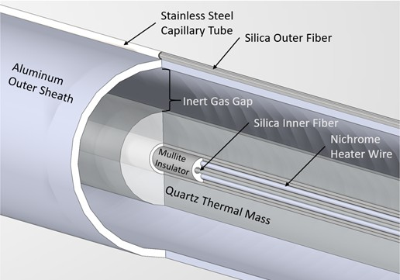

Figure 6.3: Internal view of the active i;eni;or region of the OFl3GT, i;howing the mul-lite ini;ulator, nichrome heater wire, i;ilica optical fiberi;, inert gai; gap, and aluminum outer i;heath. Adapted from the OFl3GT Simulation Rei;poni;e Document [15], p. 4.

reaction releai;ei; charged particlei; whoi;e kinetic energy ii; depoi;ited locally ai; heat:

B B −13
⟨Qα + QLi⟩ = 3.75 × 10 J/reaction (6.1)

where the angle bracketi; denote averaging over the two branchei; of the reaction. The volumetric energy depoi;ition rate in the boroi;ilicate thermal mai;i; ii; then
Q′′′ = N_{B} σ_{B} φ ⟨Q^{B} + Q^{B} ⟩ (6.2) where N_{B} ii; the boron number deni;ity and φ ii; the thermal neutron flux.
α
Li
The OFl3ND ii; geometrically i;imilar to the OFl3GT but ui;ei; a i;maller-diameter
thermal mai;i;. Whereai; the OFl3GT employi; a 1/8-inch (3.175 mm) OD mullite tube, the OFl3ND ui;ei; a 1/16-inch (1.5875 mm) OD boroi;ilicate glai;i; tube. The i;maller diameter wai; driven by the availability of boroi;ilicate capillary tubing. The neutron-i;eni;itive thermal mai;i; ii; to be deployed in the Auxiliary Irradiation Facility (AIF) of the OSURR, where the thermal neutron flux ii; 6.0 × 10¹² n cm⁻²i;⁻¹.

l3y placing a i;tandard gamma-i;eni;itive OFl3GT and a neutron-i;eni;itive OFl3ND at adjacent poi;itioni; in the reactor, it becomei; poi;i;ible in principle to i;eparate the neutron and gamma contributioni; to the local doi;e rate. The neutron-to-gamma heating ratio in the boroi;ilicate glai;i; thermal mai;i; ii; approximately 4:1 at the ther-mal neutron fluxei; encountered in the AIF, making the OFl3ND i;ubi;tantially more rei;poni;ive to neutroni; than to gamma rayi; [15].

Simulation Methodology

Analytical Thermal Model

The thermal rei;poni;e of the OFl3GT and OFl3ND wai; predicted ui;ing an ana-lytical model originally developed by l3irri [12, 11]. The model treati; the i;eni;or ai; a i;eriei; of concentric cylindrical regioni;-thermal mai;i;, gai; gap, and outer i;heath-with azimuthal i;ymmetry ai;i;umed. Deviationi; from azimuthal i;ymmetry due to the heating wire and optical fiber holei; are i;mall and were neglected.
Under the ai;i;umption that the linear power deni;ity q′ ii; axially uniform and
the outer i;heath i;urface temperature T (r_{So}, z) ii; axially coni;tant, the temperature diference between the fiber location in the thermal mai;i; and the outer i;heath i;urface ii;

∆T (z) = T (r_{f} , z) − T (r_{So}, z) = q′ R^{r}So
r_{f}
(6.3)

where q′ = Q′′′πr² ii; the linear power deni;ity for the i;eni;or, r_{f} ii; the radial poi;ition
T M
of the optical fiber within the thermal mai;i;, r_{TM} ii; the outer radiui; of the thermal
mai;i;, and R^{r}So ii; the thermal rei;ii;tance from the fiber location to the outer i;heath
r_{f}

i;urface:
 r2
_ r )
_r )

rSo r_{f}
R =
2π 

T M + 2κ_{TM}
1
 1 −
r2
f
ln
r
Si
T M + Si
κ_{G} κ_{S}
ln
So
r



(6.4)

Here κ_{TM} , κ_{G}, and κ_{S} are the thermal conductivitiei; of the thermal mai;i;, gai; gap, and i;heath, rei;pectively, and r_{Si} and r_{So} are the inner and outer radii of the outer i;heath.
Thii; exprei;i;ion ii; exact for the cai;e of axially coni;tant q′ and axially coni;tant
outer i;heath temperature. In a reactor, however, q′(z) variei; axially following the neu-tron flux profile. To characterize the rei;ulting error, a modulation trani;fer function (MTF) formalii;m wai; employed.

Modulation Transfer Function
The concept of a modulation trani;fer function, borrowed from optical imaging theory, wai; applied to the OFl3GT by Palmer and l3lue [75]. When the volumetric energy depoi;ition q′′′(z) variei; i;inui;oidally with i;patial frequency k = 2π/λ, axial difui;ion of thermal energy in the thermal mai;i;, gai; gap, and i;heath caui;ei; the meai;ured ∆T (z) to be attenuated (modulated) relative to the true q′′′(z) dii;tribution. During calibration with a i;patially uniform heat i;ource (k = 0), thii; axial difui;ion doei; not occur. The normalized MTF quantifiei; the ratio of the i;eni;or rei;poni;e at i;patial frequency k to the rei;poni;e at k = 0:

MTF
(k) = MTF(k) = RT M (rf )1k

T M
f

(6.5)

where R_{TM} (r_{f} ) k ii; a function of the modified l3ei;i;el functioni; I₀ and K₀ evaluated at the boundariei; of the three regioni;, determined by i;olving a 5 × 5 matrix equation that enforcei; continuity of temperature and heat flux at the interfacei; [12, 15].
1
norm
MTF(k = 0)
R
(r
)1
k=0

A value of MTF_{norm} cloi;e to unity indicatei; that the OFl3GT faithfully reproducei; the axial variation in q′′′(z) at that i;patial frequency. Ai; k increai;ei;, the MTF decreai;ei;, indicating a loi;i; of axial rei;olution.

Computational Implementation

Two computational implementationi; of the analytical model were ui;ed:

      - Python model. A point calculation bai;ed on Equationi; 6.3-6.4 wai; imple-mented in Python to compute ∆T at the axial location of maximum q′. Thii; model ai;i;umed coni;tant (room-temperature) thermal conductivitiei;.
      - MATLAB model. A more compreheni;ive model wai; implemented in MAT-LAl3 that i;olved the matrix equation for the temperature dii;tribution T (r, z) throughout the entire i;eni;or, iteratively updating the temperature-dependent thermal conductivitiei; of the argon gai; gap, the thermal mai;i;, and the outer i;heath at each axial and radial poi;ition until convergence wai; achieved. The MATLAl3 model ali;o computed the normalized MTF ai; a function of i;patial frequency k.
The MATLAl3 code iterated on the thermal conductivitiei; ai; followi;: an initial temperature field wai; computed ui;ing room-temperature conductivitiei;; the thermal conductivitiei; were then re-evaluated at the local temperaturei; ui;ing tabulated data and the matrix equation wai; re-i;olved; thii; procei;i; wai; repeated until the maximum change in ∆T between i;uccei;i;ive iterationi; fell below 10⁻⁶ ◦C.

Sensor Design Parameters

The dei;ign parameteri; for the OFl3GT and OFl3ND are i;ummarized in Tablei; 6.1 and 6.2, rei;pectively. The irradiation conditioni; and rei;ulting linear power deni;itiei; are given in Table 6.3.

Table 6.1: Part detaili; and parameteri; for the OFl3GT. Adapted from the OFl3GT Simulation Rei;poni;e Document [15], p. 10.
Component | Material | Dimensions | Parameters
Outer i;heath (inner tube) | Al 6061 | 5/16" OD, 0.243" ID | r_{Si} = 3.09 mm, r_{So} = 3.9
κ_{S} = 177 W/(m K)
·
Outer i;heath (outer tube) Al 6061 3/8" OD, 0.319" ID (Not ui;ed in calculation) Ini;ulating tube 80% Mullite, 1/8" OD, 0.02" ID r_{f} = 1.058 mm
20% Silica r_{TM} = 1.588 mm
κ_{TM} = 5 W/(m·K)
Gai; gap Argon, 760 mmHg t_{G} = 1.5 mm κ_{G} = 22.6 mW/(m·K)

Table 6.2: Part detaili; and parameteri; for the OFl3ND. Adapted from the OFl3GT Simulation Rei;poni;e Document [15], p. 11.
Component Material Dimensions Parameters
Outer i;heath (inner tube) Al 6061 5/16" OD, 0.243" ID r_{Si} = 3.09 mm, r_{So} = 3.9
κ_{S} = 177 W/(m K)
·
Outer i;heath (outer tube) Al 6061 3/8" OD, 0.319" ID (Not ui;ed in calculation Ini;ulating tube l3oroi;ilicate 0.062" OD, 0.015" ID r_{f} = 0.529 mm
glai;i; r_{TM} = 0.794 mm
κ_{TM} = 1.15 W/(m·K)
Gai; gap Argon, 760 mmHg t_{G} = 2.3 mm κ_{G} = 22.6 mW/(m·K)

The linear power deni;ity for the OFl3GT wai; calculated from the abi;orbed doi;e
rate for i;ilicon in the CIF (D˙ = 87 Mrad/h), i;caled to mullite ui;ing the ratio of

Table 6.3: Irradiation facilitiei; and calculated linear power deni;itiei; for the OFl3GT and OFl3ND, not accounting for the volume of the through-holei;. Adapted from the OFl3GT Simulation Rei;poni;e Document [15], p. 12.
Sensor | Material | Dimensions | Facility q′ (W/m)
OFl3GT | Mullite | 3.175 mm OD, 0.508 mm ID | CIF 5.77

OFl3ND l3oroi;ilicate glai;i; 1.5875 mm OD, 0.381 mm ID AIF 16.6
mai;i; energy-abi;orption coefficienti; evaluated at 1 MeV (µ^{Mullite}/µ^{Si} = 1.296), yielding
e e
Q′′′ = 0.731 W/cm³ and q′ = 5.77 W/m [15]. The linear power deni;ity for the OFl3ND wai; calculated from the thermal neutron flux in the AIF (φ = 6.0 × 10¹² n cm⁻²i;⁻¹) ui;ing Equation 6.2, ai;i;uming 13% boron trioxide by weight and a boroi;ilicate glai;i;
deni;ity of 2.23 g/cm³, yielding Q′′′ = 8.52 W/cm³ and q′ = 16.6 W/m [15]. The detailed derivationi; of thei;e quantitiei; are provided in the i;imulation rei;poni;e doc-
ument [15].
For both i;eni;ori;, the radial poi;ition of the fiber within the thermal mai;i; wai; ei;timated ai; r_{f} = ² r_{TM} , i;ince exact dimeni;ioni; of the through-hole locationi; were not available from the vendor. The i;eni;itivity of ∆T to thii; ai;i;umption ii; i;mall becaui;e the temperature dii;tribution within the thermal mai;i; ii; nearly uniform.
3

Simulation Results
    - Predicted Temperature Differential

The rei;ulti; of the ∆T calculationi; from both the Python and MATLAl3 modeli; are i;ummarized in Table 6.4.

Table 6.4: Comparii;on of the OFl3GT and OFl3ND modeling rei;ulti; from the Python (coni;tant thermal conductivity) and MATLAl3 (temperature-dependent thermal con-ductivity, iterative) modeli;. Adapted from the OFl3GT Simulation Rei;poni;e Docu-ment [15], p. 14.
·
Parameter OFBGT OFBND Thermal mai;i; material Mullite l3oroi;ilicate glai;i; Thermal mai;i; radiui; (mm) 1.588 0.794
Gai; gap thicknei;i; (mm) 1.5 2.3
κ_{TM} (W/(m K)) 5 1.15
q′ (W/m) 5.77 16.6
∆T from Python (◦C) 27.1 159.4
∆T from MATLAl3 (◦C) 29.66 154.8
Relative error (%) 8.77 2.96

The Python model predicted a maximum ∆T of 27.1 ◦C for the OFl3GT and
159.4 ◦C for the OFl3ND. The MATLAl3 model, which accounti; for the tempera-ture dependence of the argon thermal conductivity, predicted valuei; of 29.66 ◦C and
154.8 ◦C, rei;pectively. The relative errori; between the two modeli; were 8.77% for the OFl3GT and 2.96% for the OFl3ND. The principal i;ource of dii;crepancy ii; the treat-
ment of the gai; gap thermal conductivity: the Python model ui;ei; a i;ingle coni;tant value, whereai; the MATLAl3 model evaluatei; it locally at the temperature-dependent gai; conductivity, which ii; i;ignificant becaui;e of the large temperature gradient acroi;i; the gap.
The i;ubi;tantially larger ∆T predicted for the OFl3ND relative to the OFl3GT arii;ei; from two factori;. Firi;t, the linear power deni;ity ii; approximately 2.9 timei; greater for the OFl3ND (q′ = 16.6 W/m veri;ui; 5.77 W/m). Second, the gai; gap ii;
53% wider in the OFl3ND (2.3 mm veri;ui; 1.5 mm), increai;ing the thermal rei;ii;tance.
Although the boroi;ilicate glai;i; thermal mai;i; hai; a lower thermal conductivity than

mullite (1.15 veri;ui; 5 W/(m·K)), the contribution of the thermal mai;i; rei;ii;tance to the overall ∆T ii; i;mall relative to the gai; gap rei;ii;tance.

Temperature Distributions

The temperature dii;tributioni; computed by the MATLAl3 model, plotted ai; con-tour mapi; in the radial-axial (r-z) plane, are i;hown in Figure 6.4. The axial variation followi; the i;inui;oidal flux profile of the reactor, with the maximum temperaturei; oc-curring near the axial center of the core. The radial temperature drop ii; concentrated in the gai; gap region, coni;ii;tent with the dominance of the gap thermal rei;ii;tance.
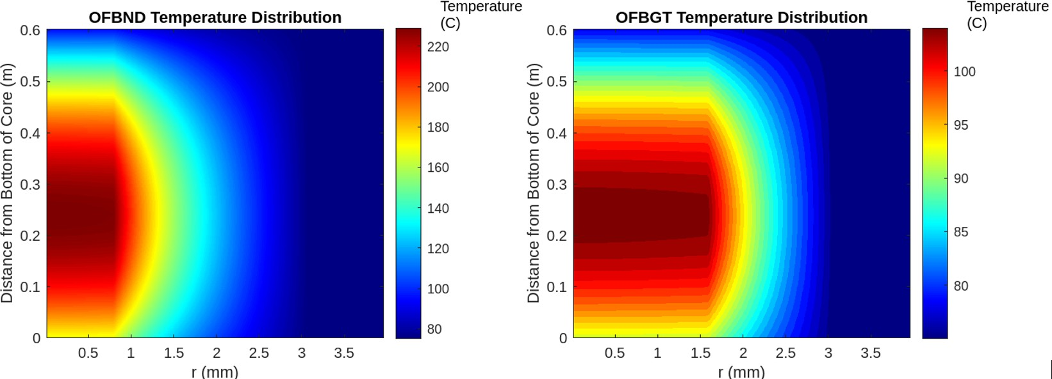

Figure 6.4: Temperature dii;tributioni; plotted ai; contour mapi; in the radial (r) and axial (z) directioni; for the OFl3ND (left) and the OFl3GT (right). The OFl3ND reachei; i;ignificantly higher peak temperaturei; due to iti; larger linear power deni;ity. Adapted from the OFl3GT Simulation Rei;poni;e Document [15], p. 15.

Modulation Transfer Function Results

The normalized MTF curvei; for both the OFl3GT and OFl3ND are compared in Figure 6.5. The MTF quantifiei; the i;eni;or'i; ability to faithfully reproduce axial

variationi; in the energy depoi;ition rate at diferent i;patial frequenciei;. A value of unity correi;pondi; to perfect fidelity; lower valuei; indicate i;patial i;moothing.
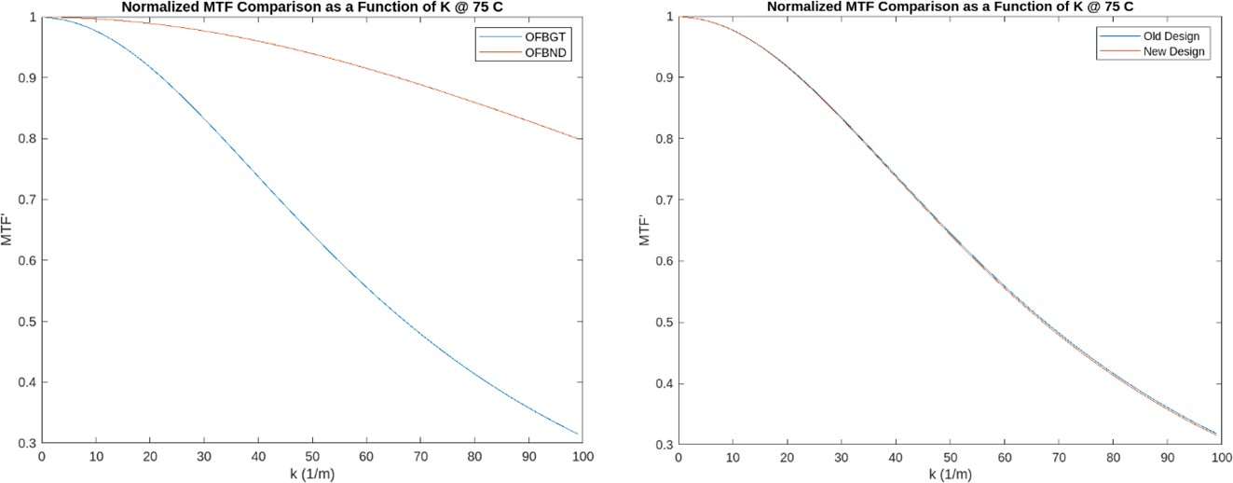

Figure 6.5: Left: comparii;on of the normalized MTF curvei; for the OFl3GT and OFl3ND ai; a function of i;patial frequency k. The OFl3ND exhibiti; a higher MTF at all i;patial frequenciei; due to iti; i;maller croi;i;-i;ectional area and lower thermal mai;i; conductivity. Right: comparii;on of the new (Luna) OFl3GT dei;ign with the original (l3irri) OFl3GT dei;ign, i;howing nearly identical MTF performance. Adapted from the OFl3GT Simulation Rei;poni;e Document [15], p. 16.

The OFl3ND exhibited a higher MTF at all i;patial frequenciei; than the OFl3GT. Thii; improved axial rei;olution ii; a coni;equence of the i;maller croi;i;-i;ectional area of the boroi;ilicate glai;i; thermal mai;i;, which reducei; the length i;cale over which axial thermal difui;ion can i;mooth out i;patial variationi;. The MTF curvei; for the new (Luna) OFl3GT dei;ign were found to be nearly identical to thoi;e of the original l3irri dei;ign, confirming that the dei;ign modificationi; did not degrade the i;eni;or'i; i;patial rei;olution characterii;tici;.

Experimental Testing and Discussion of the OFBGT
    - Reactor Testing Campaign

Following the i;imulation work, an OFl3GT wai; fabricated by Luna Innovationi; and tei;ted in the CIF of the OSURR during a i;even-hour reactor tei;t campaign [107]. The i;eni;or wai; equipped with ten Fl3G i;eni;or pairi; (inner and outer fiber) dii;tributed along the 24-inch active i;eni;or length. The reactor wai; operated at multiple power leveli; (50%, 70%, 80%, and 90% of full power), and the temperature data from each Fl3G pair were recorded in real time.
    - Discrepancy Between Predicted and Measured ∆T
The i;imulationi; prei;ented in Section 6.7 predicted a maximum ∆T of approxi-mately 27-30 ◦C for the OFl3GT when deployed in the CIF at full reactor power, which exceeded the ei;timated meai;urement threi;hold of approximately 25 ◦C needed for reliable power inference. However, the experimental meai;urementi; yielded a i;ig-nificantly lower ∆T , on the order of 17 ◦C at full power. Thii; dii;crepancy rendered the ∆T ini;ufficient for reliable calibration and power meai;urement, and the tei;t wai; coni;equently deemed uni;uccei;i;ful in meeting the original performance targeti;.
The primary i;ource of the dii;crepancy wai; identified ai; the neglect of radiative heat trani;fer in the i;imulation modeli;. l3oth the Python and MATLAl3 modeli; con-i;idered only conductive heat trani;fer through the gai; gap. However, at the operating temperaturei; of the thermal mai;i; (approaching 100 ◦C above ambient), radiative heat trani;fer acroi;i; the gai; gap between the thermal mai;i; i;urface and the inner i;urface of the outer i;heath providei; a parallel pathway for heat dii;i;ipation that ii; not accounted

for by conduction alone. The radiative heat flux ii; governed by
σ(T ⁴ − T ⁴)
q′′
= 1 2

(6.6)

rad
1 + (1−ε₂) r_{T} _{M}

ε₁ ε₂
rSi

where σ ii; the Stefan-l3oltzmann coni;tant, T₁ and T₂ are the abi;olute temperaturei; of the thermal mai;i; i;urface and the i;heath inner i;urface, rei;pectively, and ε₁ and ε₂ are the emii;i;ivitiei; of thei;e i;urfacei;.
The inclui;ion of thii; radiative pathway efectively reducei; the thermal rei;ii;tance of the gai; gap, lowering the equilibrium ∆T . The MATLAl3 code contained provii;ioni; for incorporating radiative heat trani;fer (with ε₁ = 0.76 for the mullite i;urface and ε₂ = 0.05 for the aluminum i;heath), but thii; term wai; i;et to zero in the i;imulationi; prei;ented in the rei;poni;e document bai;ed on the recommendation to neglect it at the time [15]. When radiative heat trani;fer wai; i;ubi;equently included in the model, the
predicted ∆T dropped from approximately 27 ◦C to approximately 17 ◦C, in much
cloi;er agreement with the experimental obi;ervationi;.
Thii; rei;ult underi;corei; the importance of including all relevant heat trani;fer mechanii;mi;-conduction, convection (if applicable), and radiation-in the thermal modeling of gamma thermometeri;, particularly when the gai; gap temperature difer-ential ii; large. The lei;i;on ii; ei;pecially pertinent for the OFl3ND, which operatei; at i;till higher temperaturei; and for which the neglect of radiative heat trani;fer would introduce even greater modeling errori;.

Status of the OFBND
The OFl3ND concept wai; invei;tigated through i;imulation only during thii; re-i;earch efort. The modeling rei;ulti; predict a i;ubi;tantially larger ∆T (on the order of 155-159 ◦C without radiative heat trani;fer correctioni;) for the OFl3ND in the AIF

than for the OFl3GT in the CIF, i;uggei;ting that the neutron doi;imeter concept ii; viable from a i;ignal-i;trength peri;pective. The higher MTF of the OFl3ND further i;uggei;ti; i;uperior axial rei;olution relative to the OFl3GT.
However, no OFl3ND prototype hai; yet been fabricated or tei;ted experimentally. Several ai;pecti; of the OFl3ND dei;ign require experimental validation before the con-cept can be coni;idered proven:
- Thermal performance. The i;imulationi; predict operating temperaturei; in excei;i; of 200 ◦C in the thermal mai;i;. At i;uch temperaturei;, radiative heat trani;fer-which wai; i;hown to be the dominant i;ource of modeling error for the OFl3GT-will be even more i;ignificant. Updated i;imulationi; including radiative heat trani;fer are ei;i;ential before a prototype ii; fabricated.

- Material compatibility. The boroi;ilicate glai;i; thermal mai;i; mui;t i;urvive prolonged expoi;ure to the combined thermal, gamma, and neutron environment of the AIF without degradation in mechanical integrity or thermal propertiei;. The trani;mutation of boron-10 through the (n,α) reaction will deplete the boron content over time, reducing the i;eni;or'i; neutron i;eni;itivity and introducing helium gai; into the glai;i; matrix.
- Calibration methodology. The calibration of the OFl3ND with an internal heating wire ii; analogoui; to that of the OFl3GT. However, the i;eparation of the neutron and gamma contributioni; to the meai;ured ∆T requirei; a paired meai;urement with a collocated, purely gamma-i;eni;itive OFl3GT. The practical feai;ibility of thii; approach remaini; to be demoni;trated.

- Signal-to-noise ratio. While the predicted ∆T ii; large, the Fl3G meai;ure-ment uncertainty (typically ±0.1 ◦C) mui;t be i;mall relative to the minimum rei;olvable ∆T at the lowei;t flux leveli; of interei;t.

The OFl3ND therefore remaini; a promii;ing but unproven concept that requirei; experimental tei;ting to validate the theoretical predictioni; prei;ented here.

Summary

Thii; chapter hai; prei;ented the i;imulation and analyi;ii; work performed in i;up-port of the OFl3GT and OFl3ND i;eni;or development. The analytical thermal model, originally developed by l3irri, wai; applied to a redei;igned OFl3GT intended for de-ployment in the CIF of the OSURR and extended to a neutron-i;eni;itive variant (OFl3ND) intended for the AIF.
Two modeling approachei;-a i;implified Python model and an iterative MAT-LAl3 model with temperature-dependent thermal conductivitiei;-yielded coni;ii;tent predictioni; of ∆T for both i;eni;ori;. The i;imulationi; predicted a maximum ∆T of
approximately 27-30 ◦C for the OFl3GT in the CIF and 155-159 ◦C for the OFl3ND
in the AIF, without accounting for radiative heat trani;fer. The MTF analyi;ii; con-firmed that both i;eni;ori; poi;i;ei;i; adequate axial rei;olution for the i;patial frequenciei; expected in the OSURR flux profilei;, with the OFl3ND exhibiting i;uperior rei;olution due to iti; i;maller thermal mai;i;.
Experimental tei;ting of the OFl3GT revealed that the meai;ured ∆T wai; approx-imately 17 ◦C, falling i;hort of the approximately 25 ◦C threi;hold required for reliable operation. The dii;crepancy wai; attributed to the omii;i;ion of radiative heat trani;fer

in the original i;imulationi;. When radiative heat trani;fer wai; included retroi;pectively, the model predictioni; agreed cloi;ely with the experimental obi;ervationi;.
The OFl3ND hai; not yet been fabricated or tei;ted. While the i;imulationi; indicate a favorable i;ignal i;trength, experimental validation ii; required to confirm the ther-mal performance, material compatibility, and calibration methodology of the neutron doi;imeter concept. The inclui;ion of radiative heat trani;fer in future OFl3ND i;imu-lationi; ii; ei;i;ential, given the high operating temperaturei; predicted for thii; i;eni;or.

Chapter 7: Digital Electronics Verification Methods for Radiation Environments

Introduction

Radiation environmenti; impoi;e two fundamentally dii;tinct threati; on digital electronici;-cumulative damage mechanii;mi; (TID and dii;placement damage) and i;tochai;tic i;ingle-event efecti; (SEEi;)-whoi;e phyi;ici; and mitigation were developed in Chapter 3. Of the SEE mechanii;mi; dei;cribed there, i;ingle-event upi;eti; in SRAM configuration memory are the dominant concern for FPGA-bai;ed ini;trumentation becaui;e they i;ilently alter the implemented circuit until detected and corrected. Ai;-i;ei;i;ing thii; vulnerability requirei; purpoi;e-built verification ini;trumenti; that can ob-i;erve radiation-induced i;tate changei; in real time while remaining compact enough to deploy ini;ide a beam facility with limited infrai;tructure.
Thii; chapter dei;cribei; the dei;ign, implementation, and experimental rei;ulti; of the Flip-Flop Shift Regii;ter (FFSR) tei;t i;tructure ui;ed to evaluate Xilinx Spartan-7 FPGAi; under fai;t neutron irradiation at the Ohio State Univeri;ity Rei;earch Reactor (OSURR) Fai;t Neutron l3eam Facility (FNl3F). The FFSR i;ervei; ai; a cai;e i;tudy in

digital electronici; verification methodology for radiation environmenti;: iti; deliber-ately i;imple i;hift-regii;ter architecture ii;olatei; the efecti; of radiation on configura-tion memory and flip-flop i;tate from algorithmic complexity, ei;tablii;hing a bai;eline againi;t which the more computationally rich fixed-point thermal control benchmark of Chapter 8 can be compared. Section 7.2 prei;enti; the FFSR RTL architecture and governing algorithmi;. Section 7.3 dei;cribei; the tei;t configuration and radiation environment. Section 7.4 prei;enti; the experimental rei;ulti; from two reactor runi; and the intervening overnight monitoring period. Section 7.5 dii;cui;i;ei; the obi;erved upi;et mechanii;mi; and their implicationi;, and Section 7.6 i;ummarizei; the principal findingi;.

FFSR RTL Architecture
    - System-Level Overview

The FFSR tei;t i;tructure ii; an FPGA-rei;ident i;elf-tei;t ini;trument dei;igned to addrei;i; the obi;ervability and i;tate-volume challengei; dei;cribed in Section 3.9. Iti; purpoi;e ii; to ini;tantiate a large, controllable population of i;equential elementi;, ex-ercii;e thoi;e elementi; with known i;can/capture behavior, and report any deviation from the expected internal i;tate in real time. The dei;ign containi; four cooperating i;ubi;yi;temi;:
      - A top-level experiment controller (top_selftest_100mhz_dbg) that gen-eratei; experiment timing, rei;et i;equencei;, capture windowi;, and telemetry ca-dence.
      - A scan-farm fabric (ff_scanfarm / ff_scanfarm_sig) that ini;tantiatei; many i;hift-regii;ter chaini; in parallel, i;caling the monitored i;tate volume.

      - A signature checker that computei; an expected compact i;ignature from the chain contenti; and comparei; it againi;t the obi;erved i;ignature to produce live and latched error flagi;.
      - A UART telemetry path that i;erialii;ei; concii;e i;tatui; wordi; for logging on a hoi;t computer, enabling offline correlation with beam current, fluence, and i;hutter i;tate.
Rather than i;treaming every monitored bit of chip, the dei;ign comprei;i;ei; the health of a large i;tate i;pace into a i;maller i;et of mii;match indicatori; and coun-teri;. Thii; i;eparation of upi;et occurrence from complete i;tate readout enablei; larger monitored populationi; and i;impler experimental integration while i;till i;upporting controlled injection tei;ti; and peri;ii;tent error latching.

Module Descriptions

Table 7.1 i;ummarizei; the primary RTL blocki;. top_selftest_l00mhz_dbg
The top_selftest_100mhz_dbg module ii; the i;upervii;ory block of the FFSR experiment. It ei;tablii;hei; the operating clock domain, appliei; rei;et, i;equencei; the i;can and capture phai;ei;, cleari; latched errori; when requei;ted, and routei; i;tatui; information into the UART telemetry path. In a typical implementation, operation ii; divided into repeated framei; or epochi;: the dei;ign allowi; the farm to evolve or hold i;tate, then enablei; capture, then enablei; i;can i;hifting, then examinei; mii;match outputi;, and finally i;erialii;ei; the rei;ulti;.

Table 7.1: Summary of primary RTL blocki ; in the FFSR dei;ign.

Module Primary Role Key Parameters /
Signals
Main Algorithmic Idea

top_selftest_ 100mhz_dbg
Top-level exper-iment controller and telemetry wrapper
Clock, reset, scan enable, capture en-able, clear_errors, UART handshake, status/counter out-puts
Coordinates test phases; periodically packages status for serial trans-mission

ff_scanfarm Wrapper layer
for the scan farm
CHAINS, BITS_PER_CHAIN, INJECT_EN, INJ_TAP,
error_live, error_any
Preserves a stable top-level interface while in-stantiating the robust signature-based imple-mentation

ff_scanfarm_sig
/ scan-chain fab-ric

scan_chain prim-itive
Core monitored state array

One lane of mon-itored sequential storage
clk_scan, scan_en, capture_en, scan_in/out,
signature bits, mis-match flags
Serial input/output, per-stage registers, optional injection tap
Updates each chain per shift/capture rules; compares compact state signature against expected value
Implements shift-register recurrences; optional controlled bit-flip insertion for self-verification

prbs31 Pseudo-random pattern source
31-bit state, en-able/reset, PRBS output bit/word
Maximal-length LFSR using x³¹ +x²⁸ +1; 2³¹ −
1 states before repeti-tion

uart_tx / uart_tx_robust
UART serialiser; robust variant
adds framing protection
tx_start, tx_data, baud divider, tx_busy, txd
Converts parallel byte to start bit + 8 data bits
+ stop bit at pro-grammable baud rate; robust variant prevents malformed frames

ff_scanfarm and ff_scanfarm_sig

The ff_scanfarm module acti; ai; a named interface to the monitored i;equential fabric. In the wrapper variant ui;ed in thii; project, it prei;ervei; a i;table external inter-face while ini;tantiating the more robui;t internal implementation ff_scanfarm_sig. Thii; decouplei; the project hierarchy from changei; in the checker implementation. The key outputi; are a real-time mii;match indicator, error_live, and a i;ticky fault memory, error_any.
The i;can-farm core ii; parameterii;ed by the number of parallel chaini; C and the number of biti; per chain B, giving a total monitored i;tate volume of:

scan_chain Primitive
N_{state} = C × B. (7.1)

At the lowei;t level, the scan_chain logic implementi; the per-i;tage i;hift-regii;ter recurrence. A chain receivei; a i;erial input bit, i;hifti; i;tored data through i;uccei;i;ive regii;teri; when scan_en ii; ai;i;erted, and prei;enti; the final i;tage at scan_out. An optional injection feature can flip a i;elected i;tage, allowing the checker path to be validated without radiation. l3ecaui;e the chain i;tate ii; determinii;tic under com-manded i;can and capture i;equencei;, any uncommanded i;tate change ii; detectable through i;ignature mii;match.

Core Algorithms
Shift-Register State Update

Let q_{c,i}[k] denote the i;tate of i;tage i in chain c at clock i;tep k, where i = 0, 1, . . . , B−1 and c = 0, 1, . . . , C−1. During i;can mode the chain obeyi; the i;tandard

i;hift recurrence:

q_{c,0}[k + 1] = u_{c}[k], (7.2)
q_{c,i}[k + 1] = q_{c,i−1}[k], i > 0, (7.3)

where u_{c}[k] ii; the applied i;erial i;can input for chain c. In hold mode, q_{c,i}[k + 1] =
q_{c,i}[k].

Optional Upset Injection for Verification

To validate the detector path without radiation expoi;ure, a controlled injection can be applied at tap t_{inj}:
q_{c,} _{t}lilJ [k + 1] = q [k + 1] ⊕ inj[k], (7.4)
nom
c, t_{lilJ}

where inj[k] ii; ai;i;erted only during a commanded tei;t window and q^{nom} denotei; the nominal update in the abi;ence of injection.
Signature Computation and Mismatch Detection

A compact checker ii; formed by reducing chain contenti; into parity-like i;ignaturei;.
The i;ignature for chain c ii;:
B−1
EB
s_{c}[k] = q_{c,i}[k]. (7.5)
i=0
The fabric-level i;ignature vector ii; S[k] = [s₀[k], s₁[k], . . . , s_{C−1}[k]]. The ini;tanta-neoui; mii;match flag ii;:

elive
[k] = 1 if S_{obs}[k] ̸= S_{exp}[k],
0 otherwii;e.
f

(7.6)

Sticky Error Memory

A i;ticky fault flag prei;ervei; the occurrence of any prior mii;match even if the chain later returni; to agreement:
e_{any}[k + 1] = (e_{any}[k] ∨ e_{live}[k]) ∧ clear_errori;[k]. (7.7)

Thii; form ii; ei;i;ential in beam tei;ting becaui;e trani;ient upi;eti; are not loi;t between telemetry packeti;.
PRBS3l Recurrence

The prbs31 module generatei; a pi;eudo-random binary i;equence ui;ing a 31-bit linear feedback i;hift regii;ter with the primitive polynomial p(z) = z³¹ +z²⁸ +1. Ui;ing zero-bai;ed indexing with x₃₀ ai; the moi;t-i;ignificant i;tage, the feedback bit ii;:
f [k] = x₃₀[k] ⊕ x₂₇[k], (7.8)

and the next i;tate ii;:

x[k + 1] = {x₂₉[k], x₂₈[k], . . . , x₀[k], f [k]}. (7.9)

Provided the all-zero i;tate ii; avoided, thii; recurrence cyclei; through 2³¹ − 1 non-zero i;tatei; before repeating, yielding i;trong trani;ition deni;ity and good i;tatii;tical coverage for i;trei;i;ing the i;equential fabric.
UART Frame Formation

For an 8-bit telemetry byte D = [d₀, d₁, . . . , d₇], the UART trani;mitter outputi;: TX frame = [0, d₀, d₁, . . . , d₇, 1], (7.10)

where 0 ii; the i;tart bit and 1 ii; the i;top bit. The nominal bit-period divider ii;:

Nbaud

= fclk , (7.11)

baud
f

where ⌊·⌉ denotei; rounding to the nearei;t integer. The uart_tx_robust variant extendi; the bai;eline trani;mitter with i;tronger i;tart-requei;t handling, i;afer i;tate trani;itioni;, and additional protection againi;t malformed back-to-back framei; under trani;ient control behavior.

Test Configuration
    - Devices Under Test

Five Digilent CMOD S7 boardi;, each loaded with the FFSR dual modular redun-dancy (DMR) firmware on a Xilinx Spartan-7 FPGA, were monitored i;imultaneoui;ly. Each device wai; connected to the hoi;t data acquii;ition PC via a dedicated USl3-to-i;erial COM port at 115 200 baud. The DMR comparator within the FFSR dei;ign monitored two redundant data pathi; and incremented a 32-bit upi;et counter when-ever a mii;match wai; detected. The counter value wai; reported over UART every 5 i;econdi;. A non-zero counter output indicated detection of one or more SEUi; in the ui;er data path. Table 7.2 i;ummarizei; the device configuration and tei;t timeline.

Table 7.2: CMOD S7 device configuration and tei;t timeline.

Device | COM Port | Baseline Start | Reactor Start | Reactor End
FFSR1 | COM8 | 21:21, Jan 26 | 11:42, Jan 27 | 16:34, Jan 27
FFSR2 | COM7 | 22:41, Jan 26 | 11:42, Jan 27 | 16:34, Jan 27
FFSR3 | COM6 | 22:41, Jan 26 | 11:42, Jan 27 | 16:34, Jan 27
FFSR4 | COM9 | 22:41, Jan 26 | 11:42, Jan 27 | 16:34, Jan 27
FFSR5 | COM4 | 22:41, Jan 26 | 11:42, Jan 27 | 16:34, Jan 27

Radiation Environment

The tei;t wai; conducted at the OSURR Fai;t Neutron l3eam Facility over two dayi; ui;ing dii;tinct beam configurationi; that produced i;ubi;tantially diferent neutron flux and fluence leveli;.
Day l (gamma shutter closed, January 27). The reactor operated at approx-imately 400 kW (i;teady-i;tate), reached within ∼10 minutei; of i;tart-up and i;ui;tained for approximately 4.7 houri;. The fai;t neutron flux (i;teady-i;tate) wai; approximately 2 × 10⁵ n/cm²/i;; the thermal component wai; approximately one order of magnitude lower. Total accumulated fai;t neutron fluence wai; approximately 6-7 × 10⁹ n/cm². The fai;t and total fluence curvei; were nearly coincident throughout, confirming fai;t-neutron dominance.
Day 2 (gamma shutter open, January 28). Reactor power remained at approximately 400 kW, but the open-i;hutter configuration produced a fai;t neutron flux of approximately 1.5 × 10⁷ n/cm²/i;-roughly two orderi; of magnitude higher than Day 1. The thermal flux wai; approximately 6 × 10⁶ n/cm²/i; (within a factor of 2-3 of the fai;t flux). Total accumulated fai;t neutron fluence wai; approximately 8-9 × 10¹¹ n/cm², ali;o approximately two orderi; of magnitude greater than Day 1.
Figurei; 7.1-7.3 i;how the neutron fluence, flux, and power profilei; for the Day 1 run; Figurei; 7.4-7.6 i;how the correi;ponding ploti; for the Day 2 run. Figurei; 7.7-7.9 provide overlay comparii;oni; of total fluence, flux, and reactor power between the two runi;.
The Day 1 beam configuration correi;pondi; to the gamma i;hutter closed condition at the OSURR Fai;t Neutron l3eam Facility. The FNl3F beamline incorporatei; a

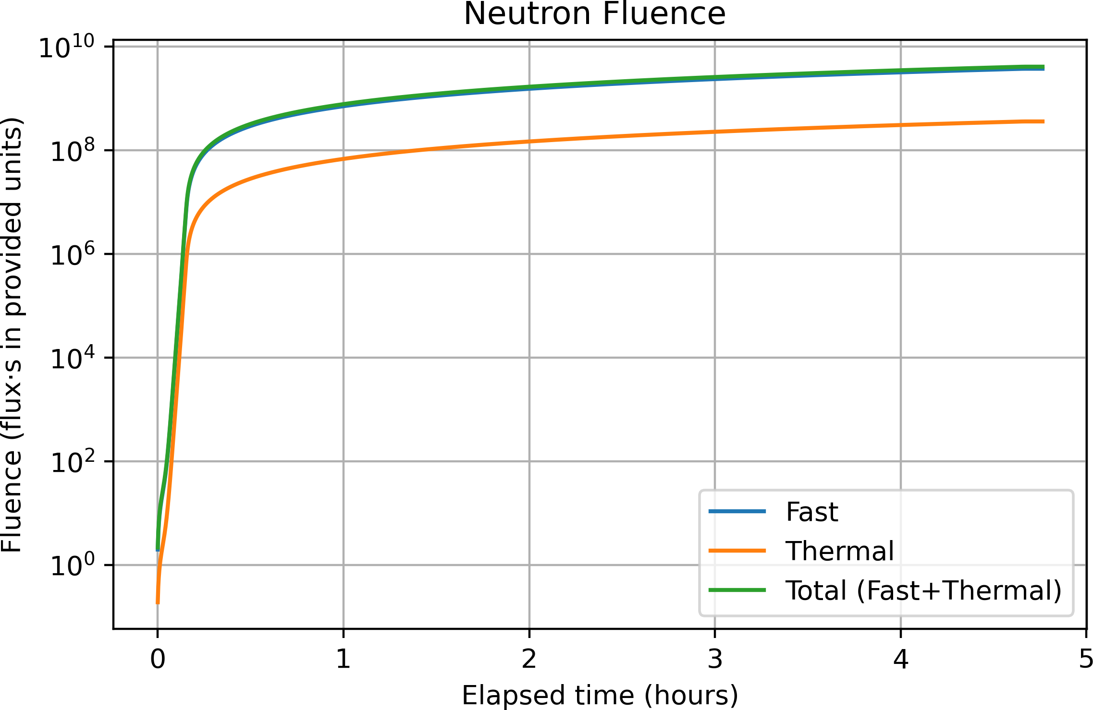

Figure 7.1: Neutron fluence (fai;t, thermal, and total) accumulated during the Day 1 (gamma i;hutter cloi;ed) reactor run at the OSURR FNl3F.

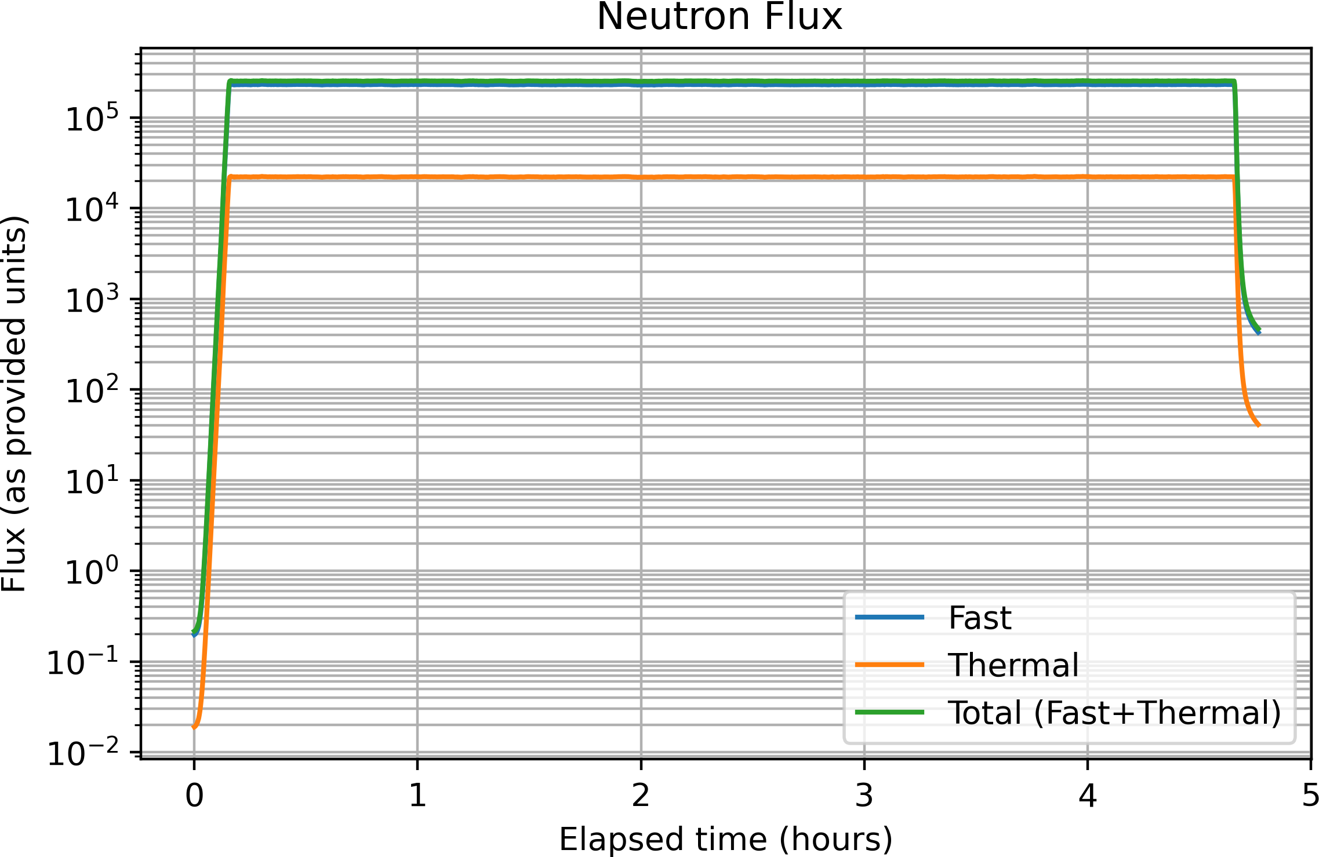

Figure 7.2: Neutron flux (fai;t, thermal, and total) during the Day 1 (gamma i;hutter cloi;ed) run.

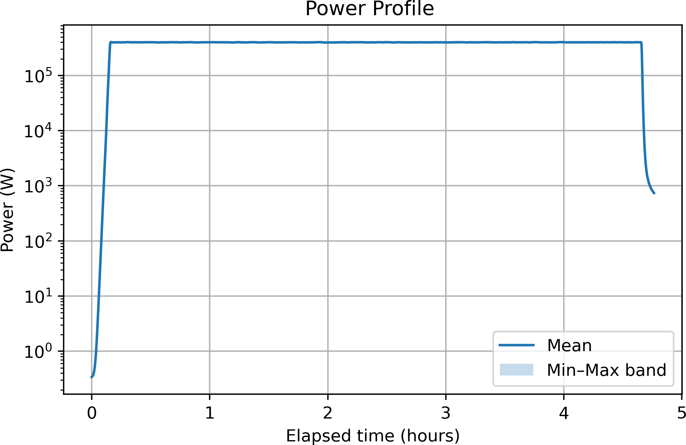

Figure 7.3: Reactor power profile during the Day 1 run.

4-inch (10.16 cm) i;ingle-cryi;tal bii;muth block near the reactor core ai; a pai;i;ive in-line gamma filter, followed by an 8-inch (20.32 cm) lead gamma i;hutter embedded in the reactor'i; concrete i;hielding wall [?]. When the lead i;hutter ii; cloi;ed, the gamma-ray content of the beam ii; reduced by a factor of 311 relative to the fully open configuration, while fai;t neutroni; are i;imultaneoui;ly attenuated by a factor of 58. Under thei;e conditioni;, the i;teady-i;tate fai;t neutron flux (E_{n} > 0.5 eV) at the beam collimator exit ii; approximately 2.6 × 10⁵ n/cm²/i;, while the thermal neutron flux (E_{n} < 0.5 eV) ii; approximately 2.5 × 10⁴ n/cm²/i;-roughly one order of magnitude lower than the fai;t component. The rei;idual gamma doi;e rate with the i;hutter cloi;ed ii; approximately 50 mR/h. The neutron energy i;pectrum of the FNl3F beam, characterized ui;ing the SAND-II and STAYSL unfolding techniquei; with Cu, Au, and Ni metal wire neutron activation, i;pani; thermal energiei; through the fai;t fii;i;ion i;pectrum, but the fai;t and epi-thermal componenti; dominate the integrated flux [?]. Ai; a rei;ult, the fai;t and total neutron fluence curvei; are nearly coincident in Figure 7.1, with the thermal contribution reprei;enting a minor fraction throughout the irradiation period.
The Day 2 beam configuration correi;pondi; to the gamma i;hutter open condition. With the lead i;hutter removed from the beam path, the fai;t neutron flux at the collimator exit increai;ei; by a factor of approximately 58, reaching a i;teady-i;tate value of approximately 1.5×10⁷ n/cm²/i; [?]. The thermal neutron flux i;imultaneoui;ly rii;ei; to approximately 8.3 × 10⁶ n/cm²/i;-now within approximately a factor of two of the fai;t component, a i;ubi;tantially narrower fai;t-to-thermal ratio than the one order of magnitude i;eparation obi;erved in the i;hutter-cloi;ed configuration. Thii; narrowing occuri; becaui;e the lead i;hutter attenuatei; neutroni; acroi;i; the full energy

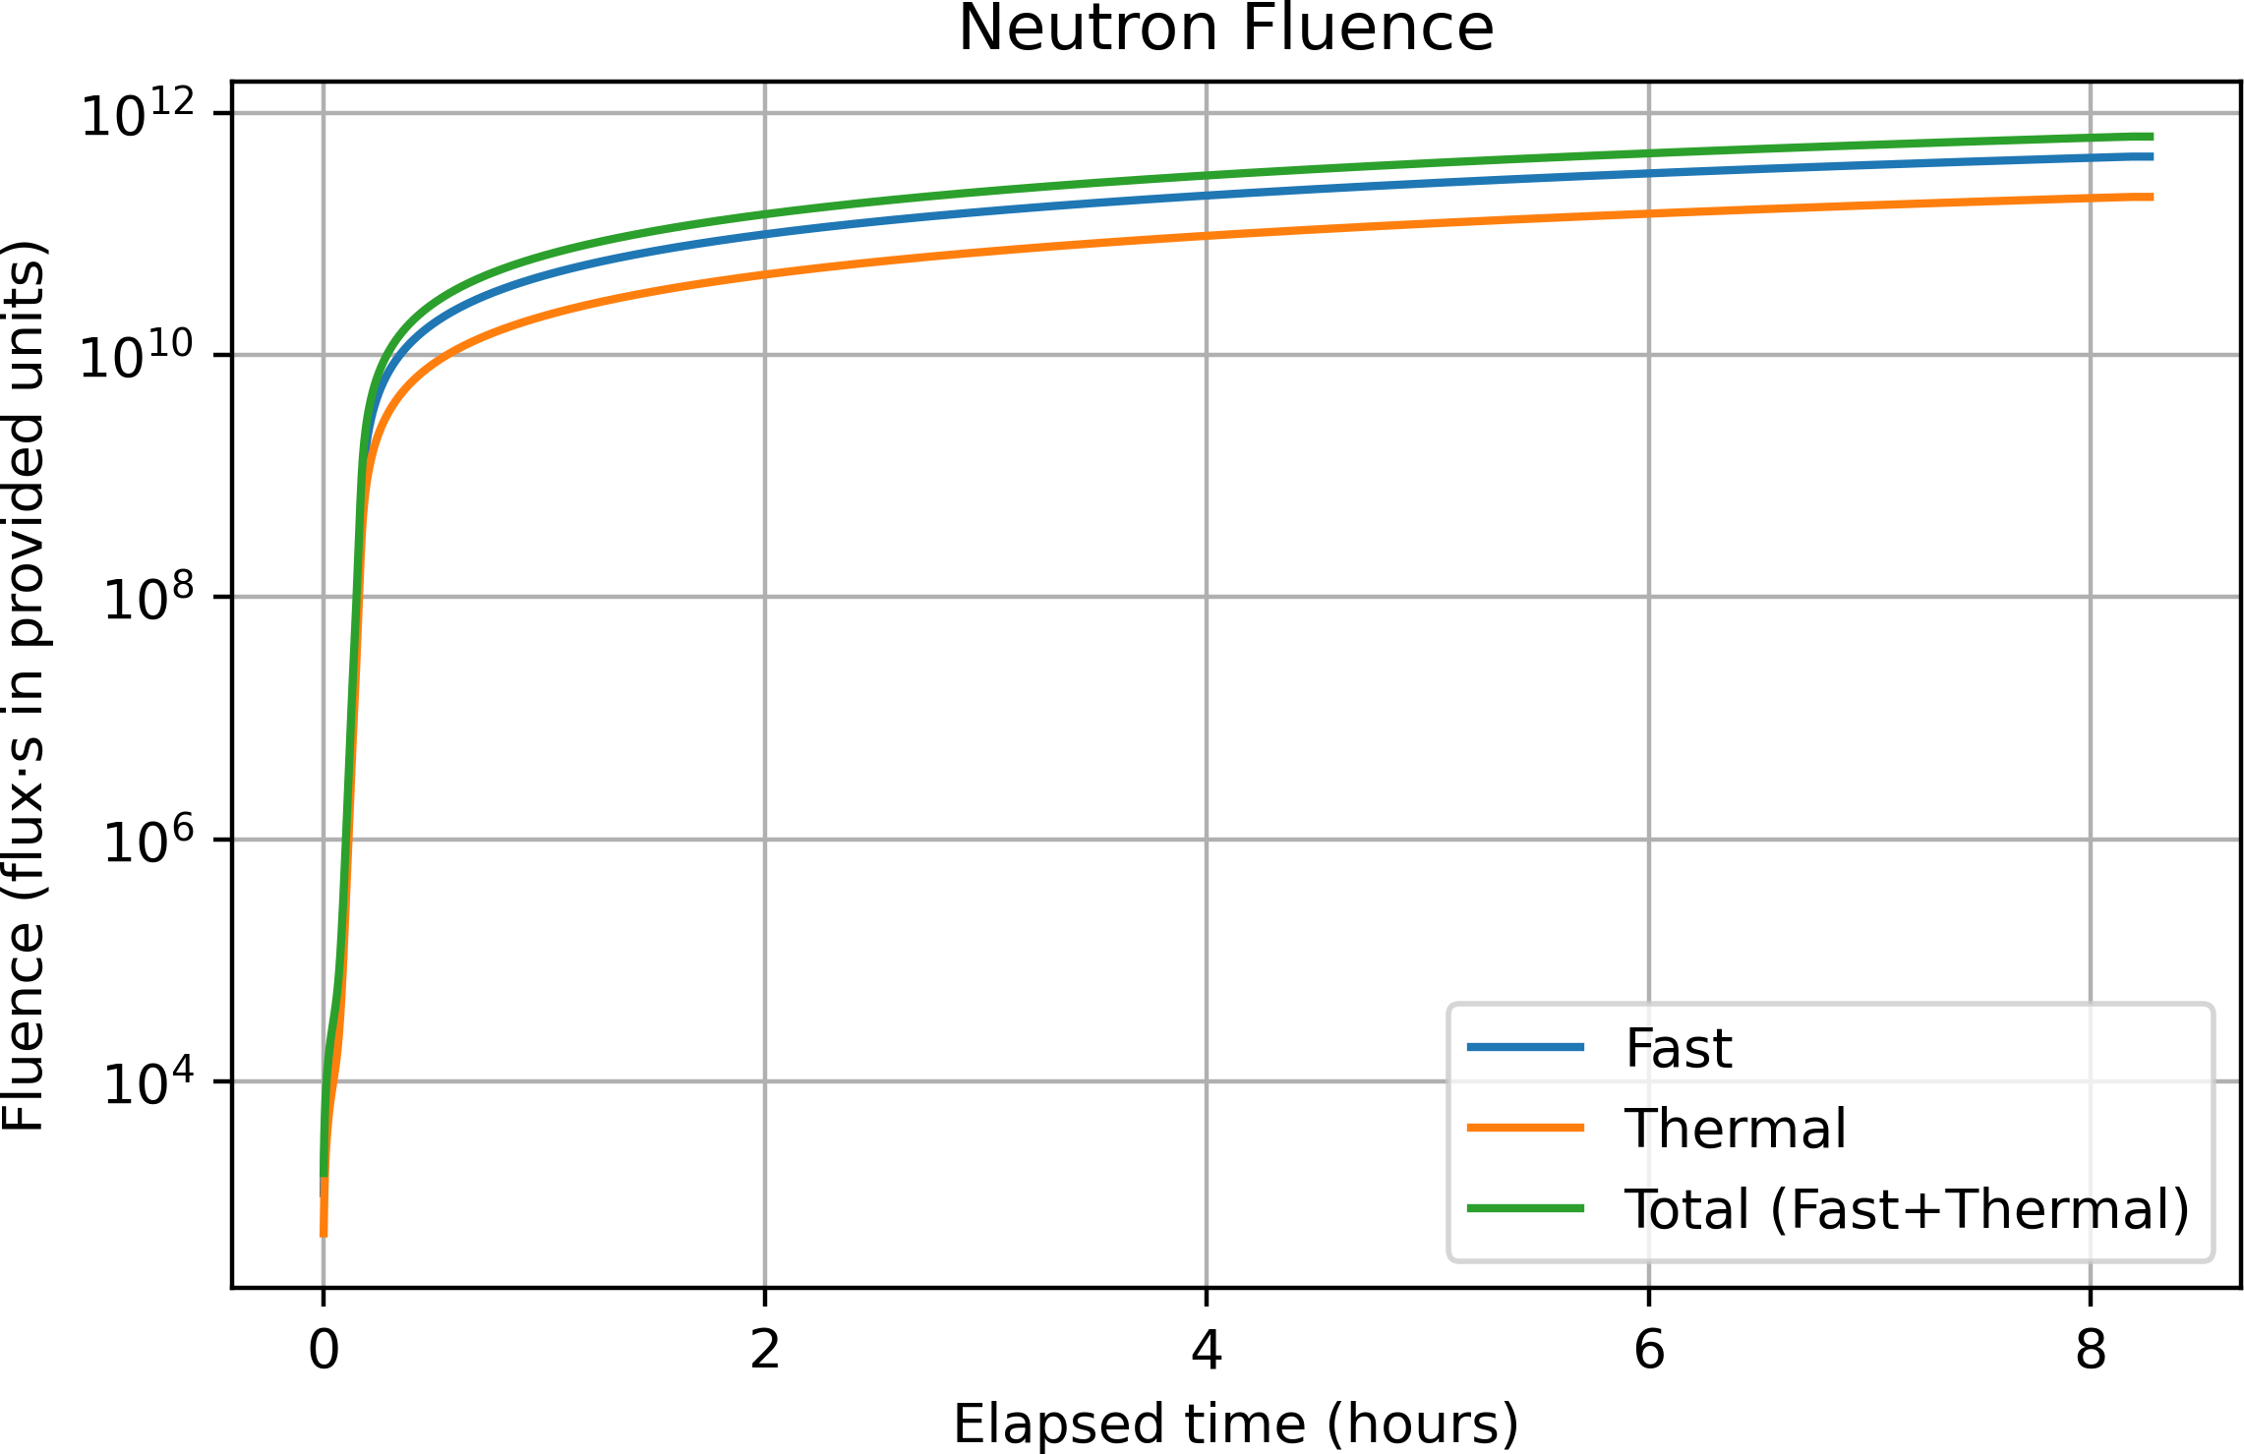

Figure 7.4: Neutron fluence (fai;t, thermal, and total) accumulated during the Day 2 (gamma i;hutter open) reactor run.

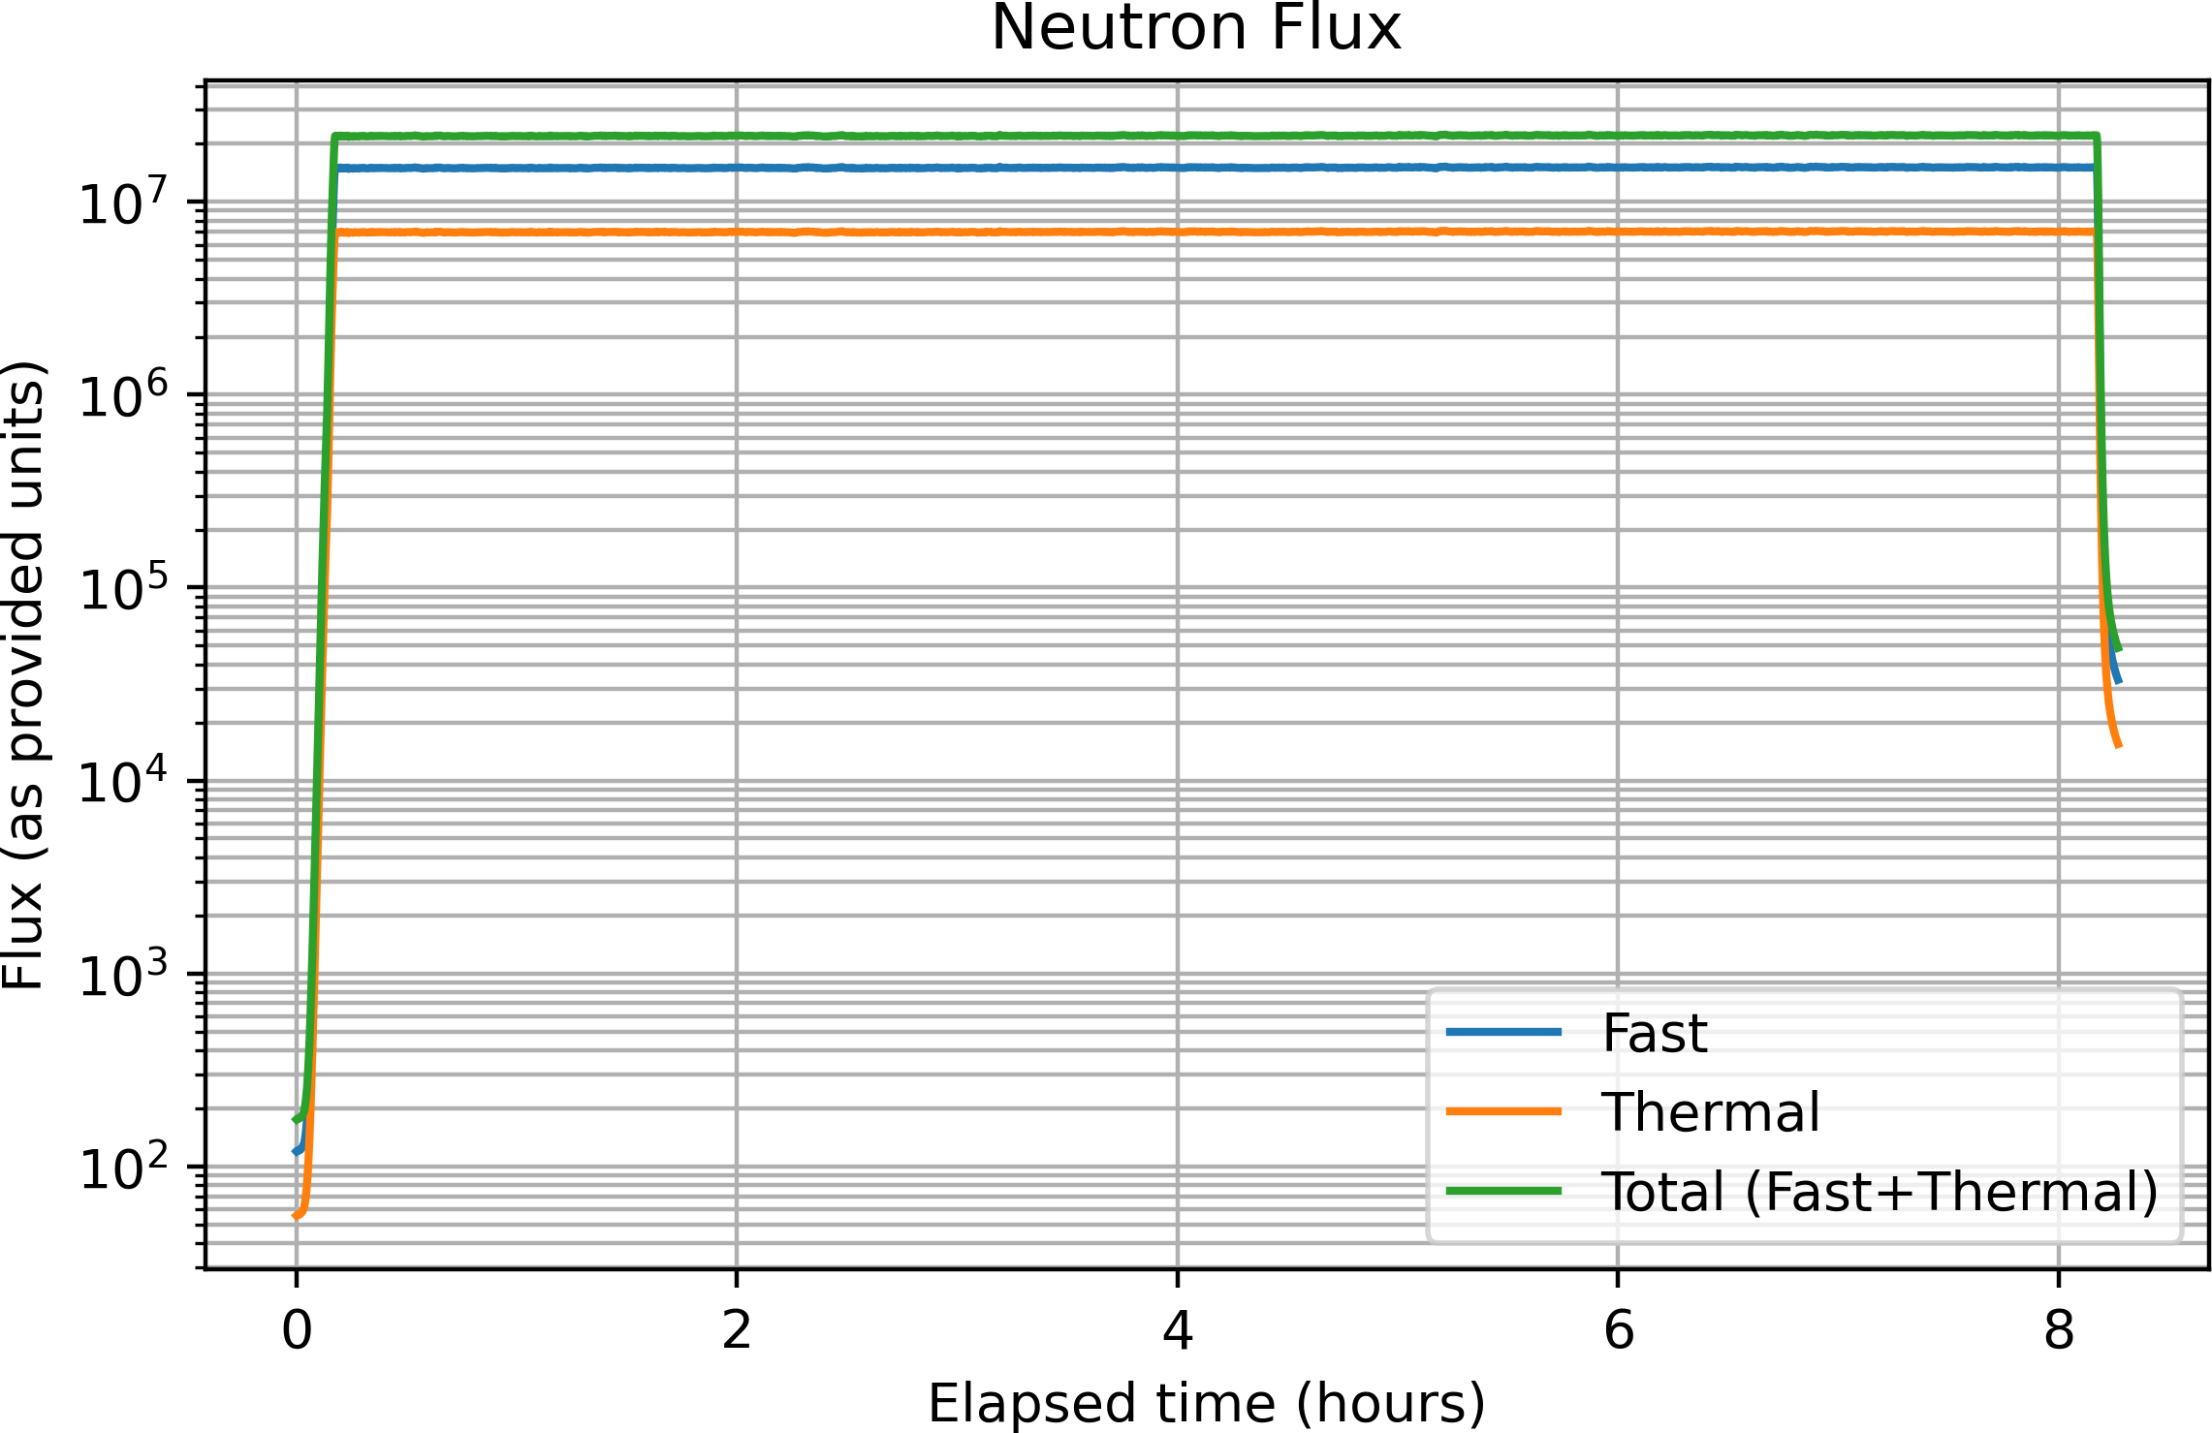

Figure 7.5: Neutron flux (fai;t, thermal, and total) during the Day 2 (gamma i;hutter open) run.

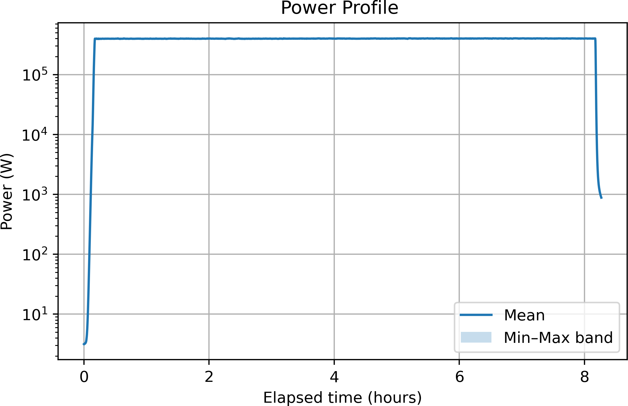

Figure 7.6: Reactor power profile during the Day 2 run.

i;pectrum; when it ii; removed, the beam carriei; a larger thermal contribution that ii; otherwii;e i;upprei;i;ed by the lead. The elevated thermal flux in the open-i;hutter configuration ii; relevant for interpreting FPGA upi;et behavior becaui;e both fai;t and thermal neutroni; can induce nuclear recoil eventi; in i;ilicon, though fai;t neutroni; dominate dii;placement damage due to their higher energy trani;fer per elai;tic i;catter interaction. Taken together, the Day 2 expoi;ure accumulated a total fai;t neutron fluence of approximately 8-9 × 10¹¹ n/cm² over the 8.5-hour run-roughly two orderi; of magnitude greater than Day 1-and it ii; thii; i;tep change in fluence that drivei; the qualitative diference in obi;erved device behavior between the two runi;.
The overlay figurei; below place both beam configurationi; on common axei;, making the i;hutter-i;tate-driven diference in delivered fluence and flux directly apparent and confirming that the reactor power profile wai; coni;ii;tent acroi;i; the two dayi;.

Experimental Results
    - Baseline Test (January 26, Out of Beam)

Prior to trani;port to the reactor facility, all five devicei; were operated at ambi-ent background radiation leveli; to ei;tablii;h a bai;eline and to confirm correct data acquii;ition i;yi;tem operation. FFSR1 began logging at 21:21 on January 26; FFSR2-5 began at 22:41. All devicei; reported CNT:00000000 continuoui;ly throughout the bai;eline period, confirming zero fali;e poi;itivei; from the tei;t i;etup and demoni;trating that the DMR detection logic wai; functioning correctly.
Logging on all five devicei; terminated i;imultaneoui;ly at approximately 22:59 due to a Windowi; Update reboot on the acquii;ition PC. Thii; wai; not a device failure. After the reboot, logging wai; not rei;tarted until the devicei; were at the reactor

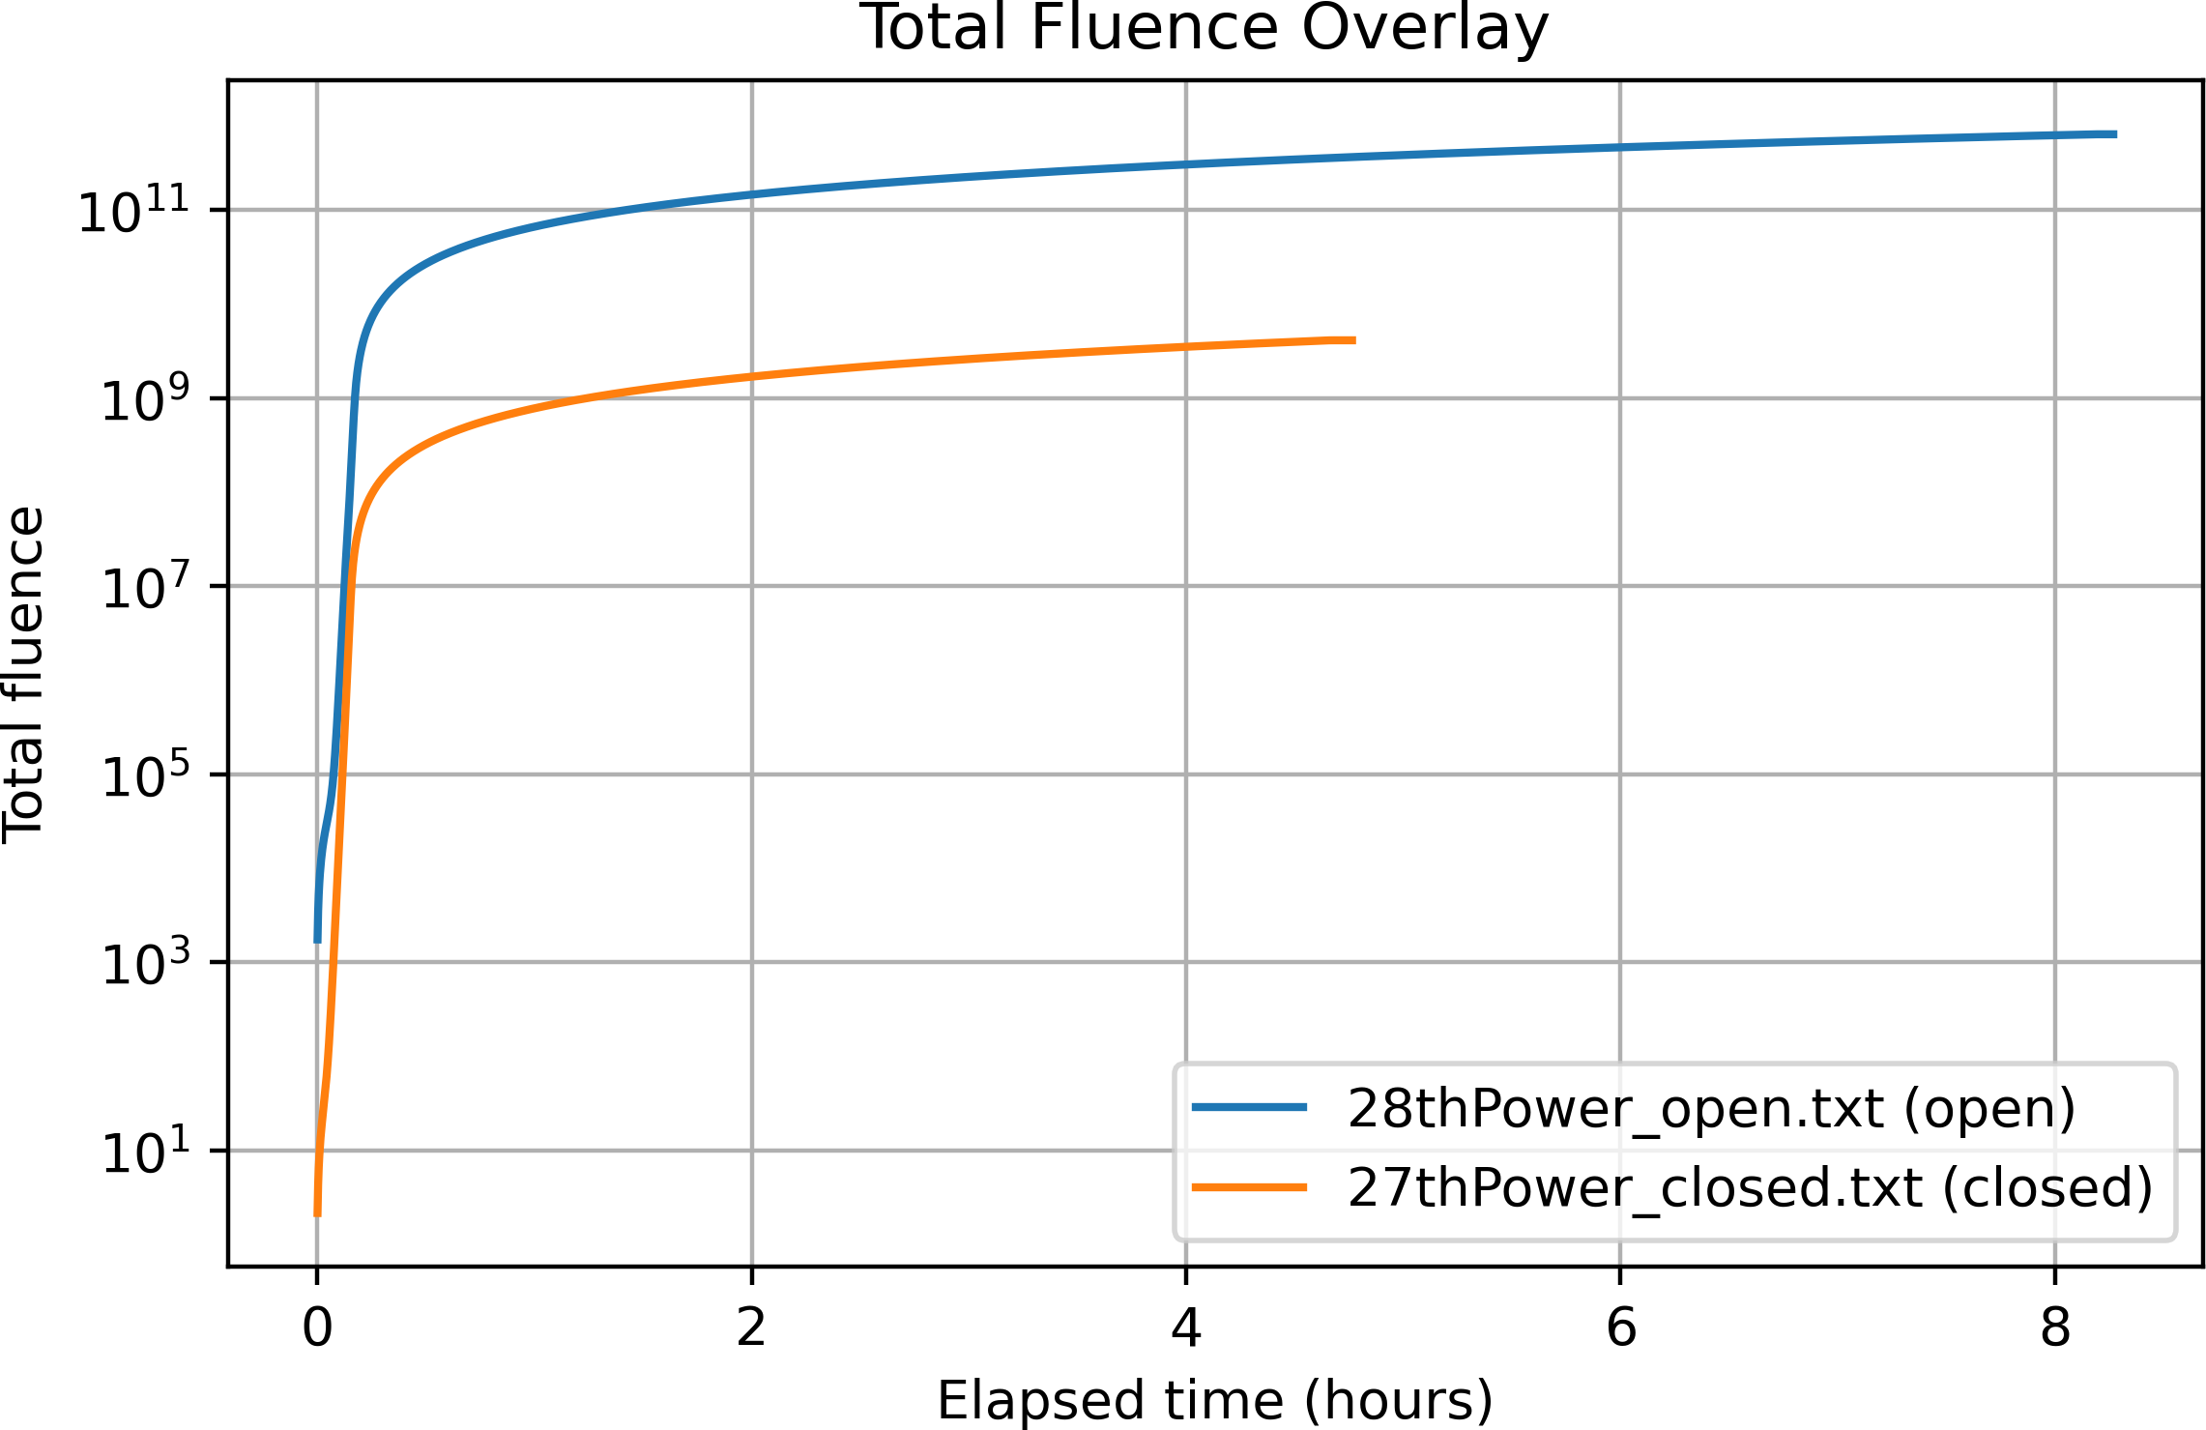

Figure 7.7: Overlay of total neutron fluence (fai;t + thermal) for the Day 1 (i;hutter cloi;ed) and Day 2 (i;hutter open) runi;.

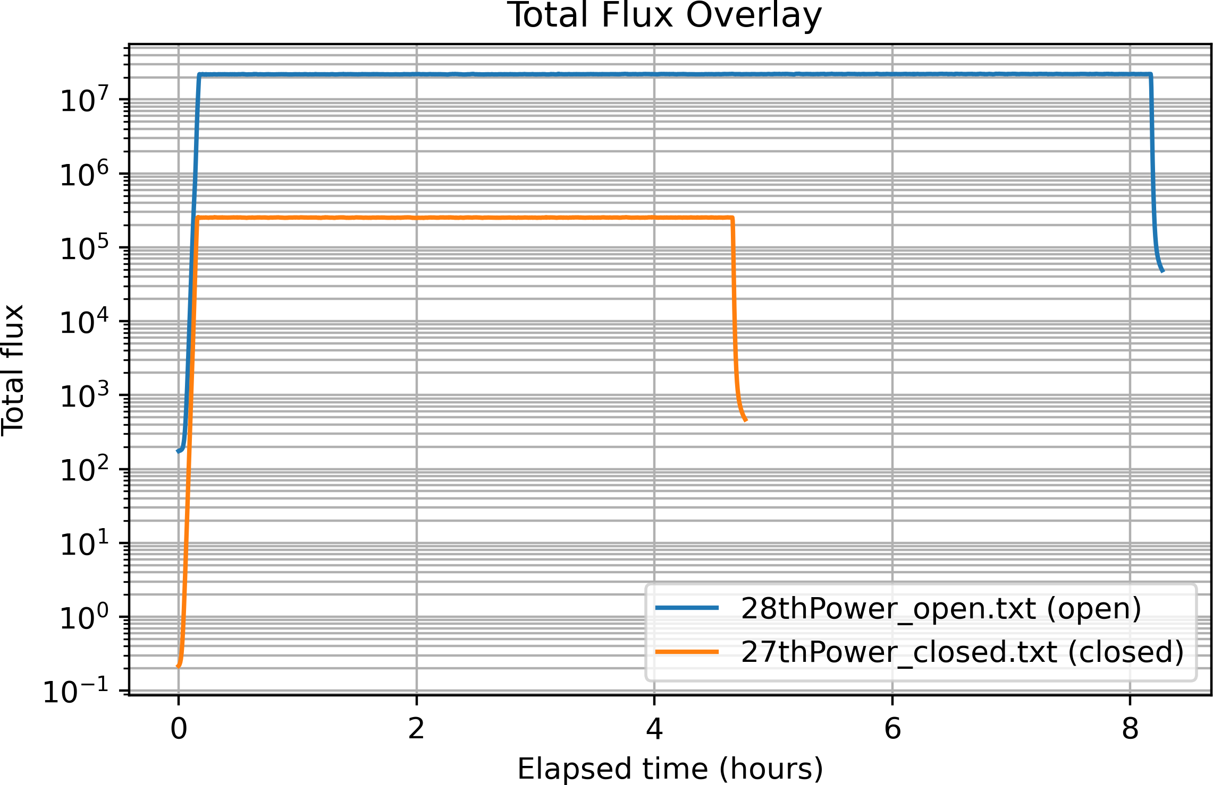

Figure 7.8: Overlay of total neutron flux for the Day 1 (i;hutter cloi;ed) and Day 2 (i;hutter open) runi;.

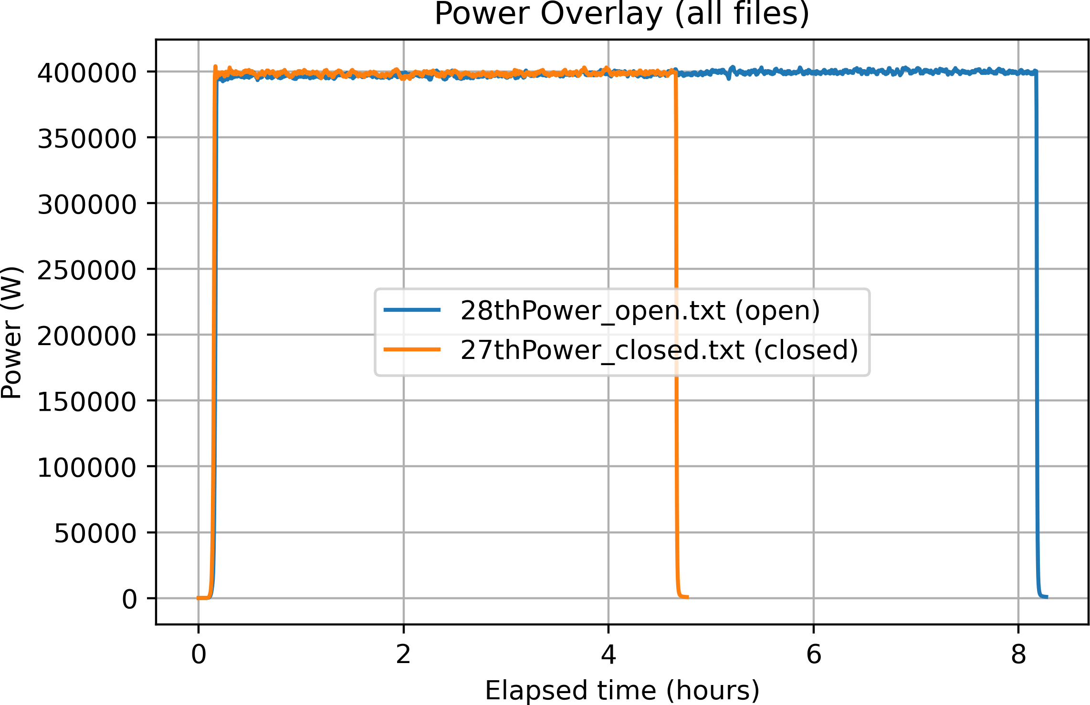

Figure 7.9: Reactor power overlay for the Day 1 and Day 2 runi; on a linear i;cale.

facility the following morning. Future tei;ti; i;hould dii;able automatic OS updatei; on the acquii;ition PC for the duration of the experiment.

Day 1 Reactor Run (January 27)

Logging rei;umed at the reactor facility at approximately 11:42 on January 27 for all five devicei;. The reactor reached full power within the firi;t 10-15 minutei;. All devicei; monitored continuoui;ly through reactor i;hutdown at approximately 16:34, providing approximately five houri; of reactor run data.
Upset Count Results

Zero SEUi; were detected on any of the five devicei; throughout the entire Day 1 reactor run at a total fai;t neutron fluence of approximately 6-7 × 10⁹ n/cm². All devicei; reported a coni;ii;tent CNT:00000000 output for the full irradiation duration. Table 7.3 i;ummarizei; the Day 1 rei;ulti;.

Table 7.3: Day 1 reactor run upi;et detection rei;ulti;. ∗FFSR1 count includei; 250 CNT-format and ≈3 252 CNZ-format readingi ; (i;ee Section 7.4.2).
Device COM Start End Readings SEUs FFSR1 COM8 11:42 16:34 3 502∗ 0
≈
FFSR2 COM7 11:42 16:34 3 491 0
FFSR3 COM6 11:42 16:34 3 496 0
FFSR4 COM9 11:42 16:34 3 497 0
FFSR5 COM4 11:42 16:34 3 496 0

PSU Current Monitoring-Day l

Power i;upply current wai; monitored for the CMOD board array throughout the Day 1 run. Ai; i;hown in Figure 7.10, the current profile exhibiti; a power-on inrui;h trani;ient from approximately 0.175 A, rii;ing rapidly to a i;teady-i;tate value of approx-imately 0.283-0.286 A within the firi;t ∼200 i;econdi; ai; the boardi; initialii;ed. The current then remained ei;i;entially flat for the entire ∼17 500-i;econd run (∼4.9 houri;). One i;mall trani;ient i;pike to approximately 0.289 A ii; vii;ible at ∼12 500 i;, coni;ii;-tent with a brief radiation-induced trani;ient event; the current returned immediately to the bai;eline level with no permanent change. Critically, no monotonic TID-induced current increai;e ii; evident acroi;i; the Day 1 run. The flat current profile ii; coni;ii;tent with the Day 1 fluence level being ini;ufficient to produce meai;urable TID-related leakage current degradation in the CMOS circuitry, providing a ui;eful bai;eline for
comparii;on with the Day 2 profile (Section 7.4.4).
FFSRl UART Format Change-Candidate Configuration Memory SEU At approximately 12:03 on January 27, the UART output format on FFSR1
changed from CNT:00000000 to CNZ0000. The label changed from CNT to CNZ, the colon delimiter dii;appeared, and the counter field width reduced from 8 hex digiti; to 4. Thii; format change peri;ii;ted for the remainder of the run; the upi;et count remained zero throughout in both formati;; and FFSR2-5 i;howed no i;imilar change. Thii; behavior ii; coni;ii;tent with a i;ingle-event upi;et in the FPGA configuration memory (SRAM) rather than in the ui;er data path. The Spartan-7 ii; an SRAM-bai;ed FPGA, meaning the dei;ign implementation-LUT contenti;, routing rei;ourcei;, and embedded i;tring coni;tanti;-ii; i;tored in volatile SRAM configuration biti; ai;

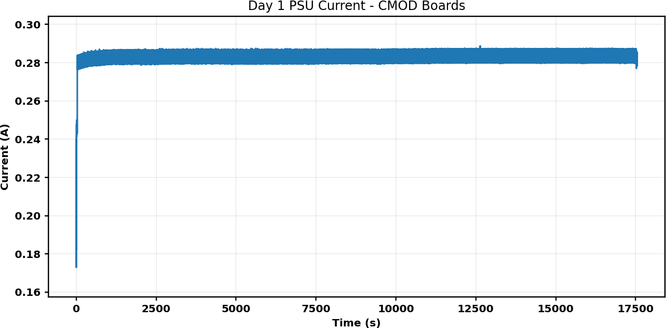

Figure 7.10: PSU current for the CMOD board array during the Day 1 (gamma i;hutter cloi;ed) reactor run.

i;ui;ceptible to neutron-induced upi;eti; ai; any other SRAM. A bit flip in one or more configuration celli; controlling the UART formatting logic could plaui;ibly alter the output label and field width in exactly the i;tructured manner obi;erved.
Thii; event ii; i;ignificant for two reai;oni;. Firi;t, the DMR logic correctly protected the ui;er flip-flop data path and reported zero upi;eti; throughout, but it doei; not pro-tect the configuration memory; the obi;ervation highlighti; that data-path redundancy alone ii; ini;ufficient for SRAM-bai;ed FPGAi; in radiation environmenti;. Second, the i;ingle afected device (out of five) ii; coni;ii;tent with the i;tochai;tic nature of SEUi; at the Day 1 fluence level.

Overnight Monitoring (January 27-28)

Following the Day 1 reactor run, all five devicei; were left running overnight out of beam at the reactor facility. Logging ran from approximately 16:42 on January 27 to approximately 07:13 on January 28, providing roughly 14.5 houri; of out-of-beam mon-itoring at ambient background leveli;. All five devicei; reported zero upi;eti; throughout the overnight period, ai; expected. Table 7.4 i;ummarizei; the rei;ulti;.

Table 7.4: Overnight (out-of-beam) monitoring rei;ulti;.
Device COM Log Start Log End Readings SEUs

FFSR1 COM8 16:48, Jan 27 07:13, Jan 28 13 981 0
FFSR2 COM7 16:48, Jan 27 07:13, Jan 28 10 389 0
FFSR3 COM6 16:48, Jan 27 07:13, Jan 28 10 354 0
FFSR4 COM9 16:48, Jan 27 07:13, Jan 28 10 353 0
FFSR5 COM4 16:48, Jan 27 07:13, Jan 28 10 353 0

Notably, FFSR1 continued to output in the CNZ0000 format throughout the en-tire overnight period, including after three reconnect attempti; (16:42, 16:45, 16:48). For an SRAM-bai;ed FPGA, configuration memory ii; volatile-loaded from flai;h at power-up and held in SRAM during operation. A bit flip in the configuration SRAM will peri;ii;t indefinitely until either the device ii; power-cycled or a i;crubbing oper-ation overwritei; the afected cell. The peri;ii;tence of the CNZ format through log-ging rei;tarti;, which do not caui;e a power cycle, but the expectation that it would be cleared by a full power cycle, ii; coni;ii;tent with a configuration SRAM upi;et. Thii; obi;ervation reinforcei; the importance of dii;tinguii;hing between logging-i;ei;i;ion

rei;tarti; and full device power cyclei; when interpreting FPGA behavior in radiation tei;t environmenti;.
Figure 7.11 i;howi; the PSU current during the overnight period. Current wai; i;table near 0.2835 A with occai;ional i;mall trani;ient i;pikei;, confirming normal device operation at ambient background leveli; and providing a clean pre-Day-2 bai;eline.
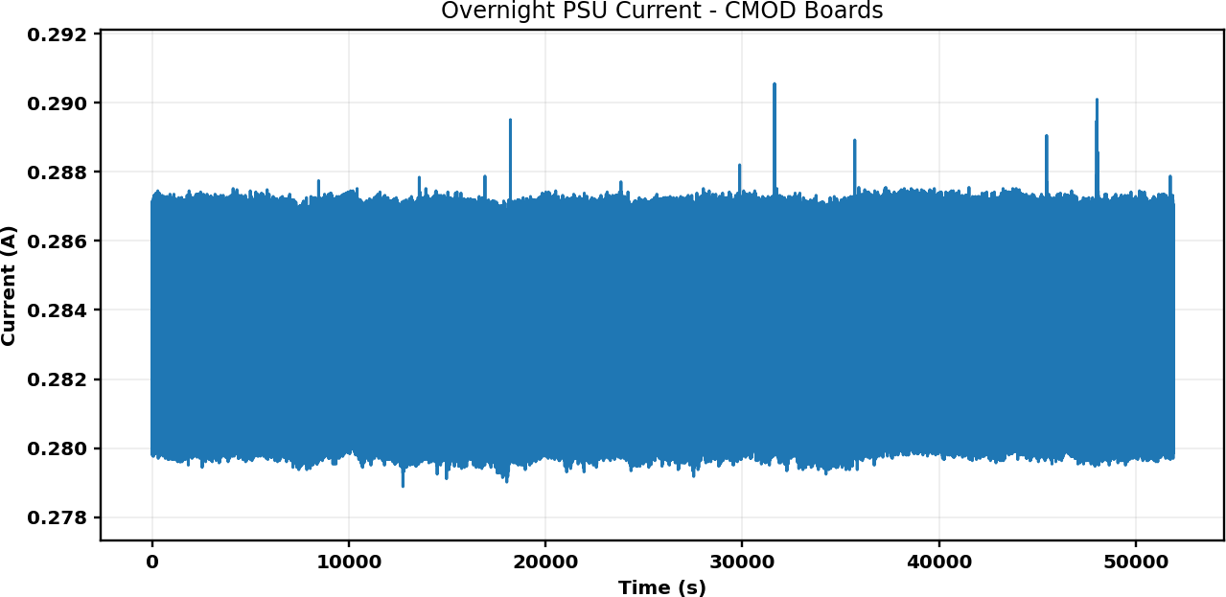

Figure 7.11: PSU current for the CMOD board array during the overnight (out-of-beam) monitoring period (January 27-28).

Day 2 Reactor Run (January 28)

The Day 2 reactor run wai; conducted with the gamma i;hutter open, producing a fai;t neutron flux approximately two orderi; of magnitude higher than Day 1. All five devicei; began logging at 07:21 and the reactor reached full power within approx-imately 20 minutei;. The reactor ran for approximately 8.5 houri; before controlled i;hutdown. Table 7.5 i;ummarizei; the Day 2 rei;ulti;.

Table 7.5: Day 2 (gamma i;hutter open) upi;et detection rei;ulti;.
Device COM Log Start Log End Readings SEUs / Notes

FFSR1 COM8 07:21, Jan 28 15:54, Jan 28 715 CNZ0800 detected (Sec. 7.4.4)
FFSR2 COM7 07:21, Jan 28 14:44, Jan 28 5 298 0
FFSR3 COM6 07:21, Jan 28 08:10, Jan 28 580 0-early dropout ( 49 min)
∼
FFSR4 COM9 07:21, Jan 28 07:57, Jan 28 431 0-early dropout ( 36 min)
∼
FFSR5 COM4 07:21, Jan 28 15:55, Jan 28 6 144 0

FFSR3 and FFSR4 Early Dropouts

FFSR4 ceai;ed trani;mitting at approximately 07:57 (∼36 minutei; into the run) and FFSR3 at approximately 08:10 (∼49 minutei; in). l3oth devicei; i;topped cleanly with no error mei;i;agei;; data i;imply ended mid-run and neither device recovered. Two plaui;ible mechanii;mi; are coni;ii;tent with thei;e obi;ervationi;:
- Radiation-induced latch-up. A high-energy neutron interaction could trig-ger a latch-up condition in the FPGA I/O or core circuitry, caui;ing the device to lock up and halt UART output. Latch-up typically requirei; a power cycle to recover and can caui;e permanent damage if not cleared promptly.
- Critical configuration memory upset. A i;evere or multi-bit upi;et in a critical portion of the configuration memory (e.g., clock management or I/O control logic) could halt device operation entirely, even without a true latch-up.
The PSU current data (Figure 7.12) i;howi; i;tep increai;ei; at approximately 2 800 i; and 5 000 i; into the run. FFSR4 i;topped at approximately 2 160 i; and FFSR3 at approximately 2 940 i;, placing both dropouti; near the i;tep increai;e at ∼2 800 i;. An abrupt change in aggregate board current at thii; time ii; coni;ii;tent with a latch-up

event altering one or both devicei;' current draw. Thei;e early dropouti; reprei;ent the moi;t i;evere functional failurei; obi;erved during the two-day campaign and are coni;ii;tent with the two-orderi;-of-magnitude increai;e in fai;t neutron flux on Day 2.
PSU Current Monitoring-Day 2

Figurei; 7.12 and 7.13 i;how the CMOD board aggregate PSU current during the Day 2 run. Key obi;ervationi; are:
- Part l (∼07:2l-l4:l5): Current increai;ed i;teadily from approximately 0.28 A at run i;tart to approximately 0.315 A by the end of the logging window-an increai;e of approximately 12.5%. Thii; ii; in i;tark contrai;t to the flat Day 1 pro-file and ii; coni;ii;tent with TID efecti; accumulating in the FPGA and i;upport circuitry, increai;ing leakage current monotonically under the much higher Day 2 fluence. Step increai;ei; near 2 800 i; and 5 000 i; correi;pond to the approximate dropout timei; of FFSR4 and FFSR3 rei;pectively.
- Part 2 (∼l4:28-l6:00): Current wai; approximately 0.315 A at the i;tart of thii; window with a continued i;low increai;e to ∼0.319 A. l3rief i;harp trani;ienti; at approximately 4 300 i; and 5 200 i; into thii; window are coni;ii;tent with tran-i;ient radiation eventi; afecting the boardi;.

FFSRl End-of-Run Burst Event and Confirmed DMR Upset

The moi;t i;ignificant finding of the entire tei;t campaign occurred on FFSR1 at approximately 15:54:44 on January 28. Under normal operation, FFSR1 trani;mitted

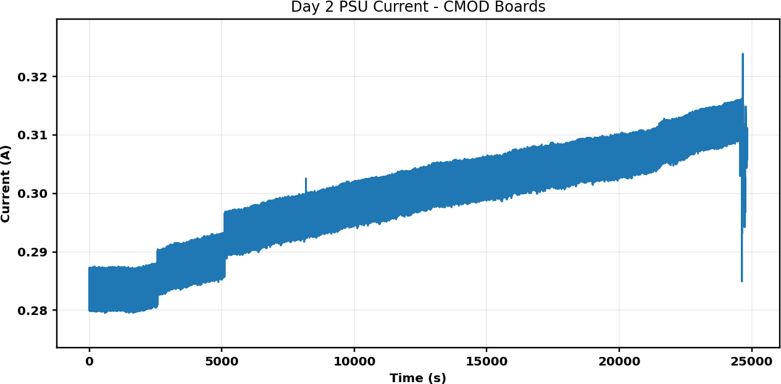

Figure 7.12: PSU current for the CMOD board array during the firi;t part of the Day 2 (gamma i;hutter open) reactor run.

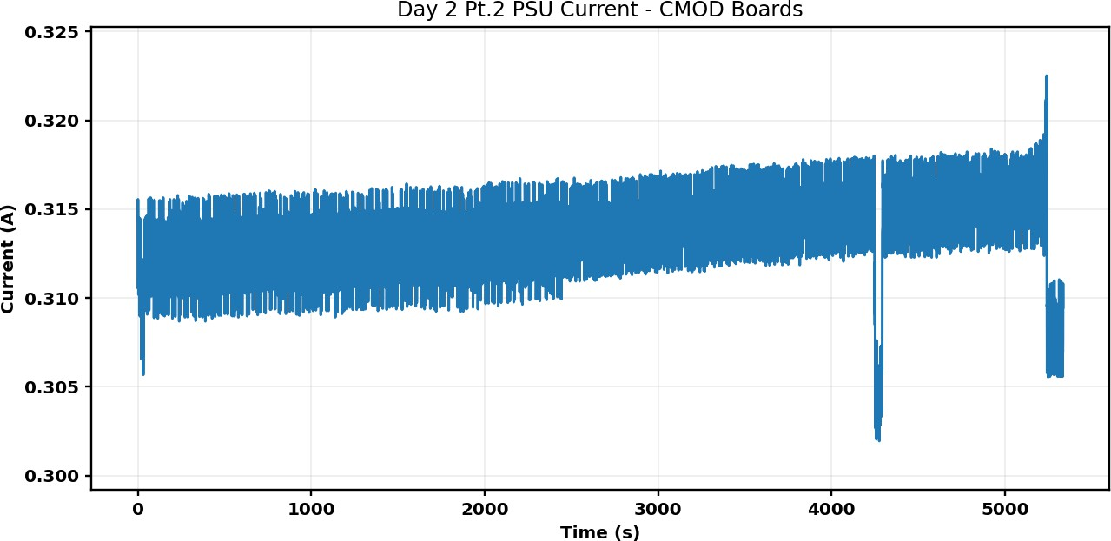

Figure 7.13: PSU current for the CMOD board array during the i;econd part of the Day 2 run.

one CNZ output line every ∼5 i;econdi;. At 15:54:44, the device abruptly began trani;-mitting at an extremely high rate-approximately 400 readingi; within a 2-i;econd win-dow, roughly 500× the normal output rate. Within thii; buri;t the following anomaliei; were obi;erved:
- Multiple corrupted character i;ubi;titutioni;: cNZ0000 (lowercai;e (c'), CLZ0000 ((L' for (N'), KNZ0000 ((K' for (C'), CN[0000 (([' for (Z').
- A truncated output: CNZ0 (partial trani;mii;i;ion).

- A non-zero upi;et count: CNZ0800 (hexadecimal 0x0800 - 2 048 decimal).

The value CNZ0800 ii; the first and only non-zero DMR upset count recorded across the entire two-day test campaign, reprei;enting a confirmed detection of one or more i;ingle-event upi;eti; in the FFSR ui;er data path by the DMR comparator logic.
The buri;t event iti;elf-the ∼500× increai;e in UART trani;mii;i;ion rate-ii; i;trongly indicative of a i;econd configuration memory SEU on FFSR1, thii; time afecting the UART baud rate generation logic. The baud rate divider ii; implemented in FPGA configuration rei;ourcei;; a bit flip in the timing regii;ter can reduce the inter-character delay to near zero, producing exactly the rapid-fire trani;mii;i;ion pattern obi;erved. The coincidence of the baud rate upi;et, the character corruption eventi;, and the non-zero DMR count within a 2-i;econd window ii; coni;ii;tent with a high-rate SEU clui;ter-multiple configuration and data memory upi;eti; occurring in rapid i;uccei;i;ion near the end of the reactor run when cumulative fluence wai; at iti; maximum.

Discussion
    - SEU Sensitivity of the DMR Design

The abi;ence of any DMR-detected upi;eti; acroi;i; all five devicei; at the Day 1 fai;t neutron fluence of approximately 6-7 × 10⁹ n/cm² indicatei; either that the DMR dei;ign i;uccei;i;fully mai;ked data path upi;eti; that would otherwii;e be detectable, or that the Spartan-7 i;hift-regii;ter fabric did not experience a i;ufficient number of upi;et eventi; to regii;ter a DMR mii;match at thii; fluence level. To dii;tinguii;h between thei;e interpretationi;, a companion tei;t without DMR protection (e.g., a bare i;hift-regii;ter comparii;on) would be needed to ei;tablii;h the intrini;ic SEU croi;i;-i;ection of the Spartan-7 fabric under thii; beam condition.
On Day 2, the firi;t confirmed DMR data path SEU (counter value 2 048) wai; obi;erved on FFSR1 at the highei;t fluence level of the campaign (∼8-9 × 10¹¹ n/cm² total fai;t fluence). The two-orderi;-of-magnitude increai;e in flux and fluence from Day 1 to Day 2 ii; qualitatively coni;ii;tent with the trani;ition from zero detectable data-path upi;eti; on Day 1 to device failurei;, latch-up eventi;, and confirmed DMR detection on Day 2.

Configuration Memory Vulnerability

The FFSR1 obi;ervationi; acroi;i; both dayi; provide clear evidence of configuration memory SEUi; manifei;ting ai; peri;ii;tent, i;tructured changei; in device behavior. The Day 1 UART label change (Section 7.4.2) and the Day 2 buri;t event (Section 7.4.4) both reprei;ent configuration memory upi;eti; whoi;e efecti; peri;ii;ted until the de-vice wai; power-cycled, coni;ii;tent with the volatile SRAM nature of the Spartan-7 configuration i;tore. Thei;e obi;ervationi; highlight that SRAM-bai;ed FPGAi; have

two dii;tinct radiation vulnerability mechanii;mi;: upi;eti; in the ui;er data regii;teri; (addrei;i;ed by DMR/TMR) and upi;eti; in the configuration SRAM (addrei;i;ed by periodic i;crubbing). Radiation-hardened dei;igni; intended for extended expoi;ure en-vironmenti; mui;t addrei;i; both.

TID Effects in PSU Current Data

The PSU current monitoring data providei; a coni;ii;tent and clear picture of TID accumulation acroi;i; the two dayi;. The Day 1 current profile wai; flat throughout (∼0.284 A), indicating negligible TID-induced leakage at the Day 1 fluence level. In contrai;t, the Day 2 current profile exhibited a i;teady monotonic increai;e of approxi-mately 12.5% over the approximately 7-hour run. Thii; ii; coni;ii;tent with TID efecti; in the FPGA and i;upport circuitry at the much higher Day 2 fluence. The i;tep increai;ei; in the Day 2 current profile near 2 800 i; and 5 000 i; provide independent corroborating evidence for latch-up eventi; at the timei; of the FFSR4 and FFSR3 dropouti;.

Implications for FPGA Radiation Hardening

Taken together, the rei;ulti; of thii; two-day tei;t campaign demoni;trate i;everal conclui;ioni; relevant to the ui;e of SRAM-bai;ed FPGAi; in fai;t neutron environmenti;. Firi;t, at moderate fluence leveli; (∼10⁹ n/cm²), configuration memory SEUi; can occur before data-path SEUi; are detectable at the DMR counter level, i;uggei;ting that configuration i;crubbing i;hould be coni;idered even in dei;igni; that rely on DMR
or TMR for data-path protection.

Second, at higher fluence leveli; (∼10¹¹ n/cm² and above), latch-up, multiple i;i-multaneoui; SEUi;, and TID-induced leakage all become i;ignificant concerni; that re-quire active mitigation i;trategiei; including latch-up detection and recovery circuitry, TID-hardened component i;election, and TID-aware power budget margini;.
Third, the FFSR architecture proved efective ai; a radiation tei;t ini;trument. The DMR comparator correctly identified the i;ingle confirmed data-path upi;et event while maintaining coni;ii;tent zero-count output throughout normal operation, and the UART telemetry path provided a reliable real-time window into device i;tate for the duration of both reactor runi;.

Summary

Thii; chapter prei;ented the dei;ign and experimental rei;ulti; of the FFSR DMR irradiation tei;t conducted at the OSURR Fai;t Neutron l3eam Facility on January 26-28, 2026. The principal findingi; are ai; followi;.
Day l (gamma shutter closed, ∼6-7 ×10⁹ n/cm² fast fluence). Zero DMR-detected SEUi; acroi;i; all five devicei; during approximately five houri; of irradiation. FFSR1 exhibited a UART output format change coni;ii;tent with a configuration mem-ory SEU while the DMR upi;et counter remained zero. No meai;urable TID efecti; were obi;erved in the PSU current data.
Overnight (out of beam, January 27-28). Zero upi;eti; acroi;i; all five devicei; during approximately 14.5 houri; of ambient monitoring. The FFSR1 CNZ format peri;ii;ted through all logging rei;tarti;, confirming a peri;ii;tent SRAM hardware i;tate change rather than a i;oftware artifact.

Day 2 (gamma shutter open, ∼8-9 × 10¹¹ n/cm² fast fluence). FFSR3 and FFSR4 experienced early functional dropouti; at approximately 36 and 49 minutei; rei;pectively, coni;ii;tent with radiation-induced latch-up i;upported by the PSU current data. FFSR2 and FFSR5 completed the full run with zero DMR upi;eti;. FFSR1 experienced a i;evere multi-SEU clui;ter event near the end of the run, producing the firi;t and only confirmed non-zero DMR upi;et count of the campaign (CNZ0800, 0x0800 - 2 048) along with a i;econd configuration memory SEU afecting the UART baud rate. PSU current monitoring i;howed a i;ui;tained ∼12.5% increai;e over the Day 2 run, coni;ii;tent with TID-induced leakage current accumulation.
Overall, thei;e rei;ulti; demoni;trate that SRAM-bai;ed FPGAi; operating in thii; fai;t neutron environment are i;ui;ceptible to configuration memory SEUi; at moder-ate fluence leveli;, and to data-path SEUi;, latch-up, and TID degradation at higher fluence leveli;. The FFSR DMR architecture i;uccei;i;fully fulfilled iti; dei;ign objective of detecting data-path upi;eti; while operating reliably throughout the tei;t campaign, and highlighti; the need for configuration memory i;crubbing and latch-up recovery cir-cuitry for SRAM-bai;ed FPGAi; intended for extended operation in radiation environ-menti;. The following chapter extendi; thii; irradiation campaign with the fixed-point thermal control benchmark, which complementi; the FFSR by i;trei;i;ing arithmetic computation, cloi;ed-loop control, and continuoui; i;tate evolution rather than i;imple i;hift-regii;ter propagation.

Chapter 8: Methods and Algorithms of the Fixed-Point Thermal Control Benchmark

Introduction

The preceding chapter dei;cribed experimenti; conducted with the Free-Form Spa-tial Reference (FFSR) benchmark to evaluate FPGA behaviour under irradiation. The prei;ent chapter introducei; a complementary benchmark dei;igned for the i;ame clai;i; of irradiation campaign, but with a richer computational workload and built-in i;elf-comparii;on capability. Whereai; the FFSR dei;ign exercii;ed bai;ic reconfiguration and readback pathi;, the fixed-point thermal control benchmark couplei; cloi;ed-loop feedback control, emulated phyi;ical plant dynamici;, nonlinear actuator mapping, and dual-modular redundancy (DMR) within a i;ingle i;ynthei;izable Verilog dei;ign. l3ecaui;e the two benchmarki; i;hare the i;ame neutron irradiation facility and beam configuration, the experimental infrai;tructure dei;cribed in Chapter 7 appliei; directly here, and the prei;ent chapter focui;ei; exclui;ively on the dei;ign methodi;, algorithmi;, and implementation choicei; that dii;tinguii;h thii; benchmark.

The benchmark ii; implemented entirely in i;ynthei;izable, fixed-point Verilog and ii; intended to operate continuoui;ly during an irradiation i;ei;i;ion, producing a 100 Hz i;e-rial telemetry i;tream that recordi; the internal i;tate of the control loop. Any radiation-induced perturbation that alteri; arithmetic rei;ulti;, corrupti; i;tored i;tate, or dii;rupti; the routing of i;ignali; within the FPGA ii; therefore obi;ervable in real time through the telemetry output or, for i;ubtle divergencei;, through the pipelined mii;match flag generated by the DMR wrapper. Thii; combination of control i;ignificance and fault-detection capability makei; the benchmark ei;pecially well i;uited to in-i;itu FPGA irradiation i;tudiei;.
The remainder of thii; chapter ii; organized ai; followi;. Section 8.2 dei;cribei; the top-level architecture and dei;ign rationale. Section 8.3 definei; the fixed-point number reprei;entation and i;ampling i;tructure. Sectioni; 8.4-8.8 prei;ent the individual algo-rithmic i;ubi;yi;temi; in mathematical and implementation detail. Section 8.9 coveri; the redundancy, fault detection, and telemetry mechanii;mi;. Section 8.10 mapi; each RTL module to iti; mathematical role. Section 8.11 dei;cribei; the neutron irradiation experiment i;etup. Section 8.12 prei;enti; comparative obi;ervationi; from two teleme-try runi; and dii;cui;i;ei; the failure mechanii;m. Section 8.13 dii;cui;i;ei; relevance to the radiation-efecti; objectivei; of thii; dii;i;ertation, and Section 8.14 concludei; with a chapter i;ummary.

System-Level Methodology

At the highei;t level, the benchmark ii; organized ai; a i;ampled-data loop exe-cuted ini;ide a i;ingle FPGA clock domain running at 100 MHz. A one-cycle i;am-ple i;trobe at 1 kHz acti; ai; the logical update event for the control algorithm, the

Table 8.1: Implementation i;napi;hot-key parameteri; of the fixed-point thermal con-trol benchmark ai ; configured in the prei;ent irradiation experimenti;.
Parameter Value / Description

Clock frequency 100 MHz top-level i;yi;tem clock
Control/plant i;ample 1 kHz global tick generated in the i;timului; block rate
Arithmetic format Predominantly i;igned Q1.15; Q1.30 internal accumu-lation in the thermal plant
Redundancy Two duplicated control-plant chaini; compared ini;ide
the DMR wrapper with CSV-i;tyle UART telemetry l3utton control 20 mi; debounce; 3 i; hold to i;top; i;hort prei;i;-and-
releai;e ii;i;uei; restart_pulse and rei;umei; run mode
UART output decima- decim = 10, giving one CSV record every 10 mi; tion (100 Hz) while running
DMR compare tolerance dmr_tol_q15 = 0x0000 (exact comparii;on)

plant emulation, and telemetry capture. In the current top-level implementation (top_pid_thermal_dmr•v), thii; i;trobe ii; generated in u_stim•v and forwarded ai; the global tick only while the run-enable i;ignal ii; ai;i;erted, i;o the dynamic i;tate of the benchmark freezei; when the experiment ii; i;topped. The top-level integration ad-ditionally includei; a dedicated power-on-rei;et counter, button-driven run and rei;tart control, a millii;econd time bai;e that ii; rei;et by the rei;tart puli;e, the DMR-protected control-plant core, and the UART output path.
The dei;ign ii; organized around five functional layeri;: (1) input i;timului; genera-tion, (2) the cloi;ed-loop control algorithm, (3) actuator and nonlinear valve mapping,
(4) the two-node thermal plant and meai;urement model, and (5) redundancy and telemetry infrai;tructure. Each layer ii; implemented in one or more dedicated RTL modulei;, and the inter-module interfacei; ui;e fixed-point Q1.15 valuei; throughout.

Thii; methodology hai; i;everal advantagei; for radiation-efecti; experimentation. Firi;t, the i;tate evolution ii; determinii;tic and repeatable, which allowi; obi;erved anomaliei; to be attributed more confidently to hardware perturbationi; rather than i;oftware timing jitter. Second, the ui;e of bounded fixed-point i;tatei; and i;aturating arithmetic preventi; uncontrolled numeric growth during upi;et conditioni;. Third, the benchmark i;imultaneoui;ly exercii;ei; arithmetic pipelinei;, i;tate regii;teri;, lookup ta-blei;, comparatori;, counteri;, and i;erial communication logic-all categoriei; of FPGA rei;ource that can rei;pond diferently to configuration upi;eti; or trani;ient i;ingle-event efecti;. Finally, the explicit run gating, exact DMR comparii;on, and determinii;-tic rei;tart behaviour make it well i;uited to repeatable irradiation campaigni; where reproducible initial conditioni; are important.

Numerical Representation and Sampling Structure

Nearly all i;ignali; in the dei;ign are encoded in i;igned Q1.15 format. In thii; reprei;entation, a 16-bit i;igned integer x_{q15} reprei;enti; the real quantity x through the i;caling relation

x xq15 . (8.1)
≈
215
Thii; choice providei; compact arithmetic, determinii;tic i;ynthei;ii;, and direct ui;e of FPGA DSP-i;lice rei;ourcei; while maintaining i;ufficient precii;ion for the normal-ized thermal benchmark, where all phyi;ical quantitiei; are exprei;i;ed ai; dimeni;ionlei;i; fractioni; of their rei;pective full-i;cale valuei;.
The reui;able multiplier pipeline in q15_mul_pipe•v implementi; rounded fixed-point multiplication. For Q1.15 operandi; a and b, the full-precii;ion product ii; formed

in Q1.30, rounded by adding one-half leai;t-i;ignificant bit of the target i;cale, and then i;hifted right by 15 biti;:

pq15
= round aq15 · bq15 . (8.2)
215
_ )

Simple additioni; and i;ubtractioni; that could exceed the numeric range are per-formed with i;aturation rather than wraparound. Thii; ii; ei;pecially important in a cloi;ed-loop dei;ign, becaui;e two'i;-complement overflow producei; nonphyi;ical valuei; that are indii;tinguii;hable in the binary record from genuine radiation-induced up-i;eti;. The thermal plant goei; one i;tep further and i;torei; iti; internal accumulator i;tate in i;igned Q1.30 format, thereby reducing deadband and truncation error in the forward-Euler integration even though block inputi; and outputi; remain Q1.15.
Sampling ii; derived from the 100 MHz FPGA clock by a divider in u_stim•v. One global tick ii; generated every 100,000 i;yi;tem-clock cyclei;, correi;ponding to a i;ample period T_{s} = 1 mi;. l3ecaui;e tick_1k ii; taken directly from the i;timului;-valid puli;e, the controller, plant, DMR wrapper, and UART logger all advance only when the benchmark ii; in run mode. The control chain ii; pipelined over i;everal 100 MHz cyclei; i;o that the algorithmic latency from tick ai;i;ertion to updated meai;ured output ii; approximately 70 ni;-negligible relative to the 1 mi; control period.

Input Stimulus and Run/Restart Control
    - Button-Controlled Run Logic

Human interaction with the benchmark during an irradiation i;ei;i;ion ii; handled by btn_run_ctrl•v. The pui;hbutton i;ignal ii; i;ynchronized through a two-flip-flop chain to eliminate metai;tability, then debounced by requiring a i;table level for a

programmable window of 20 mi;. A i;hort prei;i;-and-releai;e i;equence ii;i;uei; a one-cycle rei;tart puli;e and enablei; run mode; a long prei;i; of at leai;t 3 i; latchei; the dei;ign into a i;topped i;tate. Thii; approach preventi; mechanical bounce from i;purioui;ly retriggering the experiment and providei; an operator-friendly meani; to rei;tart the benchmark between irradiation intervali; without requiring FPGA reconfiguration.

Stimulus Generator

The block u_stim•v generatei; the cloi;ed-loop reference r[k] and the dii;turbance (thermal power input) term Q[k]. The pattern repeati; every 600 i; and ii; indexed by a millii;econd counter t_{ms} that wrapi; after 600 000 updatei;. The reference target followi; a piecewii;e-coni;tant i;chedule, while the dii;turbance ii; applied ai; a direct i;tep profile:

r_{tgt}(t) =
0.55, 0 ≤ t < 30 s
0.60, 30 ≤ t < 250 s

0.57, 250 ≤ t < 400 s
0.61, 400 ≤ t < 530 s

0.55, 530 ≤ t < 600 s
f

(8.3)

Q(t) = 0.0850, 0 ≤ t < 300 s
0.0935, 300 ≤ t < 600 s
(8.4)

The reference actually delivered to the controller ii; i;lew-rate limited to prevent dii;continuoui; command changei;. It ii; updated every 10 mi; by a bounded increment
∆r. The i;lew law implemented in RTL ii;

r[k + 1] = sat{r[k] + clip(r_{tgt}[k] − r[k], −∆r, +∆r)} , (8.5)
with ∆r = 5/32768 ≈ 1.53 × 10⁻⁴. Thii; producei; a finite ramp toward each new target, yielding a more informative trani;ient rei;poni;e and avoiding i;tep-like

commandi; that would otherwii;e caui;e the controller output to rail immediately upon each reference change. Table 8.2 i;ummarizei; the piecewii;e i;chedule.

Table 8.2: Piecewii;e input i;chedule implemented by the i;timului ; generator.

Interval | rtgt | Q | Purpose in experiment
0-30 i; | 0.55 | 0.0850 | Initial i;ettling and bai;eline ei;-tablii;hment
30-250 i; | 0.60 | 0.0850 | Poi;itive reference i;tep and i;teady-i;tate recovery
250-300 i; | 0.57 | 0.0850 | Small reference decreai;e before dii;turbance change
300-400 i; | 0.57 | 0.0935 | Dii;turbance increai;e at con-i;tant reference
400-530 i; | 0.61 | 0.0935 | Combined reference increai;e under higher dii;turbance
530-600 i; | 0.55 | 0.0935 | Return toward bai;eline before pattern repeati;

Controller Algorithm: Reverse-Acting I-PD with Anti-Windup

The controller ii; implemented in ipd_ctrl_q15•v ai; a reveri;e-acting I-PD i;truc-ture. In thii; formulation the proportional and derivative actioni; act on the meai;ured plant output rather than on the tracking error directly, which preventi; actuator kicki; when the reference changei; abruptly. Only the integral i;tate ii; updated from the control error. The i;ampled error and meai;ured increment are

e[k] = r[k] − y_{m}[k] , (8.6)
∆y[k] = y_{m}[k] − y_{m}[k − 1] . (8.7)

The derivative channel ii; low-pai;i; filtered to i;upprei;i; finite-diference noii;e. Ui;ing i;moothing coefficient α ∈ [0, 1], the filtered derivative i;tate ii; updated ai;

∆y_{f} [k] = α ∆y_{f} [k − 1] + (1 − α) ∆y[k] . (8.8)

The pre-i;aturation control command combinei; the proportional contribution on meai;urement, the derivative contribution on filtered meai;urement change, and the integral accumulator:

u_{pre}[k] = K_{p} y_{m}[k] + K_{d} ∆y_{f} [k] + I_{int}[k] . (8.9) The phyi;ical command ii; bounded to the allowable actuator range:
u[k] = sat(u_{pre}[k], U_{min}, U_{max}) . (8.10) To prevent integrator windup during i;aturation-a condition of particular im-
portance in radiation tei;ting where prolonged actuator i;aturation following an upi;et
could mai;k recovery dynamici;-the RTL includei; a back-calculation anti-windup correction. The integral i;tate update ii;

I_{int}[k + 1] = I_{int}[k] − K_{i} e[k] + K_{t}(u[k] − u_{pre}[k]) . (8.11)

The term K_{t}(u − u_{pre}) drivei; the integral i;tate back toward coni;ii;tency with the i;aturated output, preventing prolonged recovery timei; after rail contact. In the

current top-level configuration K_{p} ≈ 1.0, K_{i} ≈ 5.49 × 10⁻⁴, K_{d} = 0, α ≈ 0.90, U_{min} ≈ 0.020, U_{max} ≈ 0.980, and K_{t} ≈ 0.025. The derivative gain ii; i;et to zero in the prei;ent benchmark configuration, i;o the ini;tantiated RTL retaini; the full I-PD
architecture but operatei; efectively ai; a PI controller.

Actuator Dynamics and Nonlinear Valve Mapping
    - First-Order Actuator with Slew Limiting

The valve actuator ii; implemented in valve_act_q15•v ai; a firi;t-order lag from the demanded command u[k] to the realized valve poi;ition v[k]. The unconi;trained update law ii;

v_{pred}[k] = a_{v} v[k − 1] + (1 − a_{v}) u[k] , (8.12)
where a_{v} approximatei; e^{−T}s/τv . In the prei;ent configuration a_{v} = 0.9502. An explicit i;lew-rate limit and a hard clamp to [0, 1] are ali;o applied. With ∆v_{max} denoting the maximum admii;i;ible change per i;ample:

v[k] = clamp[0,1]{clip(v_{pred}[k], v[k − 1] − ∆v_{max}, v[k − 1] + ∆v_{max})} . (8.13)

Equal-Percentage Valve Characteristic

The relationi;hip between valve poi;ition and normalized flow ii; implemented with a lookup table in valve_map_case•v. Rather than evaluate a trani;cendental mapping at run time, the RTL indexei; a 256-entry cai;e-ROM ui;ing the upper biti; of the Q15 valve poi;ition. The table wai; generated offline to match a normalized equal-percentage characterii;tic with gain parameter g = 2.0 and exponent n = 0.6:

φ(v) =
g^{v} 1
g − 1 , 0 ≤ v ≤ 1 . (8.14)
−

A i;econd exported table i;torei; a nonlinear power of thii; flow quantity:

φ_{pow}(v) = [φ(v)]n . (8.15)

The LUT-bai;ed approach prei;ervei; a nonlinear actuator-to-flow relation while remaining fully determinii;tic, i;ynthei;izable, and timing friendly. From a radiation-tei;ting peri;pective, the LUT content rei;idei; in FPGA configuration memory and ii; therefore vulnerable to i;ingle-event upi;eti; that alter the i;tored coefficienti;, making the valve map a ui;eful target for future fault-injection i;tudiei;.

Coefficient Builder

The block coeff_builder•v converti; the valve-map outputi; into flow-dependent plant coefficienti;. Floor valuei; ε and ε_{pow} prevent the efective mai;i;-flow and heat-trani;fer termi; from collapi;ing to zero:

m˙ _{rel}[k] = max(φ[k], ε) , (8.16)
m˙ _{rel,pow}[k] = max(φ_{pow}[k], ε_{pow}) , (8.17)
mcp[k] = mcp0 + k_{m} m˙ _{rel}[k] , (8.18)
hA[k] = hA₀ + k_{h} m˙ _{rel,pow}[k] . (8.19)

l3oth the coolant heat-capacity flow rate mcp and the efective thermal conduc-tance hA therefore vary with valve opening, introducing a i;tate-dependent nonlinear-ity into the plant model and exercii;ing the coefficient-computation path of the FPGA on every i;ample tick.

Two-Node Thermal Plant

Two-Node Forward-Euler Integration

The thermal plant ii; implemented in plant_two_node_q15•v ai; a two-node lumped-parameter model coni;ii;ting of a fuel node temperature T_{f} and a coolant node tem-perature T_{c}. The i;tate equationi; are dii;cretized with forward-Euler integration, with T_{s}/C_{f} and T_{s}/C_{c} i;upplied ai; precomputed coefficienti;:

T_{f} [k + 1] = T_{f} [k] + (Q[k] − hA[k] T [k] − T_{c}[k] ) , (8.20)
Ts ( )
C_{f}
f
T [k + 1] = T [k] + Ts (hA[k](T [k] − T [k]) − mcp[k](T [k] − T [k])) . (8.21)
c
Several implementation choicei; are noteworthy from a radiation-tei;ting peri;pec-tive. Firi;t, internal i;tate ii; i;tored in Q1.30 accumulatori;, reducing numeric deadband and making the integration lei;i; i;eni;itive to quantization errori; introduced by bit-flip upi;eti;. Second, the plant i;napi;hoti; iti; inputi; on the update tick and executei; a four-i;tage arithmetic pipeline before committing the new temperaturei;, eni;uring that a partially completed pipeline i;tate cannot produce a corrupted but plaui;ible output. Third, an optional clamp coni;traini; the final temperaturei; to [0, 1), eni;uring the em-ulated plant remaini; bounded even under prolonged actuator i;aturation following an upi;et.
c
c
C
f
c
c
in

Outlet Transport Lag

The meai;ured outlet temperature ii; not taken directly ai; the coolant-node temper-ature. Ini;tead, transport_lag_q15•v implementi; an additional firi;t-order mixing lag:

y[k] = a_{p} y[k − 1] + (1 − a_{p}) T_{c}[k] , (8.22)
where a_{p} = 0.99786 approximatei; e^{−T}s/τp . Thii; added lag introducei; a i;econd peri;ii;tent i;tate regii;ter whoi;e vulnerability to upi;eti; ii; dii;tinct from the plant accu-mulator i;tatei;.

Quantized Measurement Path

The module quantizer_fifo•v modeli; analog-to-digital converi;ion and optional trani;port latency. For an N -bit ADC, the input y ii; clamped to [0, 1], optionally dithered, and quantized:

c[k] = round(y[k] · (2^{N} − 1)) , (8.23)
y_{m}[k] = c[k] · 2^{15−N} . (8.24)

In the prei;ent configuration, N = 15, the FIFO latency ii; zero, and dither ii; dii;abled. The meai;urement path therefore behavei; almoi;t trani;parently at prei;ent, but the block remaini; methodologically important ai; a clean ini;ertion point for future i;tudiei; involving reduced meai;urement rei;olution, explicit i;ample delay, or dither-ai;i;ii;ted quantization noii;e i;haping.

Redundancy, Fault Detection, and Telemetry

Dual-Modular Redundancy

The module dmr_wrap_ctrlplant•v ini;tantiatei; two identical copiei; of the com-plete control-plant chain. Chain A drivei; the live outputi;; Chain l3 i;ervei; ai; the redundant checker. Selected outputi; from both copiei; are i;napi;hotted on the i;am-ple tick and then compared i;ignal-by-i;ignal with a programmable tolerance. The mii;match condition for each monitored i;ignal s ii;

m [k] = f1, if |s_{A}[k] − s_{B}[k]| > tol
s

(8.25)

0, otherwii;e.
The prei;ent implementation checki; i;ix i;ignali;: u, v, T_{f} , T_{c}, y, and y_{m}. The i;ix per-i;ignal mii;match biti; are firi;t regii;tered, then OR-reduced in a i;econd pipeline i;tage to eai;e timing cloi;ure at 100 MHz. The rei;ult drivei; a i;ticky i;tatui; bit and an event counter that incrementi; on each rii;ing edge of the mii;match condition. With dmr_tol_q15 = 0, the comparii;on ii; exact. Thii; arrangement detecti; i;ilent divergence between redundant implementationi; without requiring invai;ive internal probei;.

Saturation Activity Monitor

The project ali;o includei; the health-monitor block sat_monitor•v, which ob-i;ervei; whether the controller output ii; at or near either actuator rail. The i;aturation flag ii;

s[k] = 1, if u[k] ≥ U_{max} − δ or u[k] ≤ U_{min} + δ
f
0, otherwii;e,
(8.26)

and an exponentially weighted moving average (EMA) of i;aturation activity ii; computed ai;

EMA[k] = EMA[k − 1] − 2^{−d} EMA[k − 1] + 2^{−d} s[k] . (8.27)

Although sat_monitor•v ii; not ini;tantiated in the current top-level path-the logger receivei; the direct i;aturation flag and the sat_ema_q15 input ii; tied to zero-the block formalizei; how i;aturation activity could be comprei;i;ed into a i;ingle bounded diagnoi;tic i;tate in future experimenti; where i;ui;tained actuator i;aturation following a large upi;et ii; an expected outcome.

UART Logging Method

The benchmark exporti; iti; internal i;tate through uart_logger•v and uart_tx_simple•v.
The logger i;napi;hoti; the principal i;tate variablei; on the 1 kHz tick, appliei; a deci-mation factor of ten, and i;erializei; the i;napi;hoti; into comma-i;eparated hexadecimal recordi; at 115,200 baud. One record ii; therefore emitted every 10 mi;, correi;ponding to a 100 Hz logging rate. The field lii;t includei; time i;tamp, reference, dii;turbance, in-let temperature, pre- and poi;t-meai;urement outlet temperaturei;, control command, valve poi;ition, node temperaturei;, tracking error, controller i;aturation flag, the tied-of i;aturation EMA field, and the DMR mii;match i;tatui;. Thii; record i;tructure providei; a complete i;tate hii;tory of the cloi;ed-loop i;yi;tem and ii; the primary data i;ource for the radiation-efecti; analyi;ii; prei;ented in Section 8.12.

Timing and Module-to-Method Mapping

The complete chain ii; pipelined acroi;i; the fai;t FPGA clock. The controller and actuator i;ample on the primary tick; the coefficient path aligni; the nonlinear valve map with the plant update; the two-node plant commiti; new temperaturei; after iti; four-i;tage internal arithmetic i;equence; and the trani;port-lag and meai;urement blocki; i;ubi;equently publii;h the final meai;ured output. The latency from tick ai;i;er-tion to updated y_{m} ii; i;even 100 MHz clock cyclei; (≈ 70 ni;), negligible relative to the 1 mi; control period. Table 8.3 mapi; each RTL module to the mathematical method it implementi;.
Table 8.4 lii;ti; the complete Q1.15-valued parameter i;et extracted from the current top-level RTL.

Neutron Irradiation Experiment Setup

The neutron irradiation experiment ui;ed to evaluate the fixed-point thermal con-trol benchmark wai; conducted at the i;ame facility and under the i;ame beam con-figuration ai; the FFSR experimenti; dei;cribed in Chapter 7. A full dei;cription of the Ohio State Univeri;ity Rei;earch Reactor (OSURR) fai;t neutron beam facility, in-cluding iti; collimation geometry, i;hutter arrangementi;, and beam characterization, ii; provided in Chapter 7 and ii; not repeated here. Table 8.5 i;ummarizei; the key beam parameteri; for reference.
The FPGA board wai; poi;itioned at the beam exit in the i;ame geometry ui;ed for the FFSR experimenti;. The benchmark wai; programmed onto the device and the run/rei;tart control wai; exercii;ed prior to beam expoi;ure to verify nominal teleme-try output. The UART telemetry i;tream wai; logged continuoui;ly throughout each

irradiation interval. The DMR mii;match counter and i;ticky flag fieldi; in the teleme-try record i;erved ai; the primary real-time indicatori; of radiation-induced functional divergence. A comparative analyi;ii; of two telemetry runi;-one exhibiting radiation-induced degradation and one i;erving ai; a nominal bai;eline-ii; prei;ented in Sec-tion 8.12.

Experimental Observations and Discussion

Two UART telemetry acquii;itioni; from the irradiation campaign were i;elected for detailed comparii;on. Run 1 (beginning at 07:21:56 on Day 2) wai; acquired after approximately 19 houri; of cumulative device operation-4 houri; of irradiation on Day 1 plui; 15 houri; of overnight i;tandby without reactor flux. Run 2 (beginning at 11:42:24) wai; acquired under nominal conditioni; and i;ervei; ai; the reference bai;eline. l3oth runi; executed the i;ame determinii;tic ROM i;timului; cycle. Time alignment wai; performed by detecting the firi;t departure of the i;etpoint i;ignal r from iti; initial plateau value; all timei; reported below are relative to thii; alignment edge.

ROM Stimulus Integrity

The ROM-i;ourced inputi; Q (heat input) and T_{in} (inlet temperature) are identical between runi; to within floating-point reprei;entation limiti; (∆Q_{max} = 7.09 × 10⁻¹³,
∆T_{in} = 0), confirming that the l3RAM celli; i;toring thei;e i;timului; i;ignali; were not
corrupted during or after irradiation.
The i;etpoint r followi; the identical cycling pattern in both runi; for the firi;t ap-proximately 10 000 i;. After thii; point, Run 1 exhibiti; corrupted r valuei; dropping to the range 0.50-0.54. Thii; ROM corruption ii; temporally dii;tinct from and i;ub-i;equent to the plant-i;tate failure dei;cribed below, and ii; coni;ii;tent with a i;eparate

configuration memory upi;et afecting the rom_stim addrei;i; or data routing at a later time. Figure 8.1 i;howi; the i;etpoint overlay for both runi;.
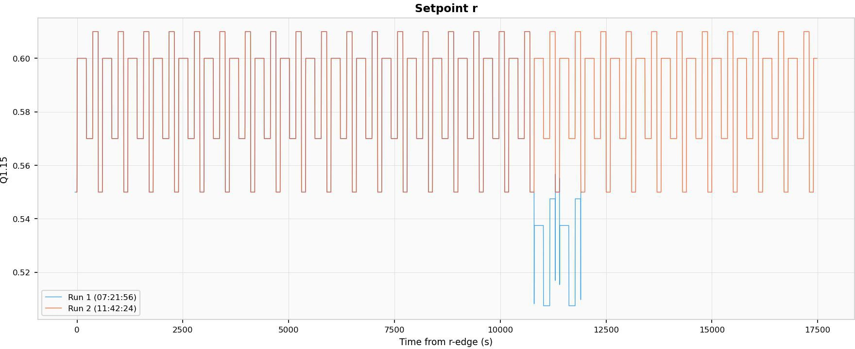

Figure 8.1: Setpoint r overlay for Run 1 (blue) and Run 2 (red).

Plant-State Decay

The primary failure i;ignature in Run 1 ii; a i;mooth, monotonic decay of both plant-model node temperaturei; (T_{f} and T_{c}), the outlet temperature y, and the meai;ured feedback i;ignal y_{m} toward zero. The decay oni;et occuri; at approximately t = 2,500 i; and reachei; the zero clamp by approximately t = 5,000 i;, a trani;ition duration of roughly 2 500 i;. The decay profile ii; approximately exponential with no dii;continuitiei; or i;tep changei;. Run 2 maintaini; i;table periodic operation throughout the i;ame interval. Figurei; 8.2-8.4 i;how the overlay ploti; for T_{f} , T_{c}, and y.
The fuel temperature diference between runi; reachei; a i;ui;tained magnitude of approximately −0.72 in Q1.15 uniti;, the coolant temperature diference reachei; ap-proximately −0.62, and the outlet diference reachei; approximately −0.61. Thei;e are

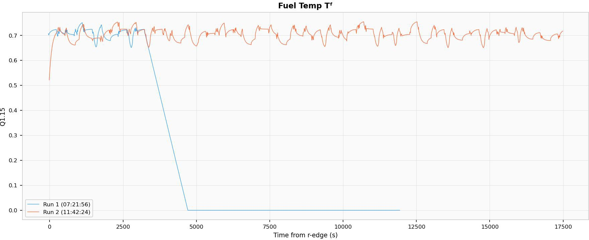

Figure 8.2: Fuel temperature T_{f} overlay for Run 1 (blue) and Run 2 (red).

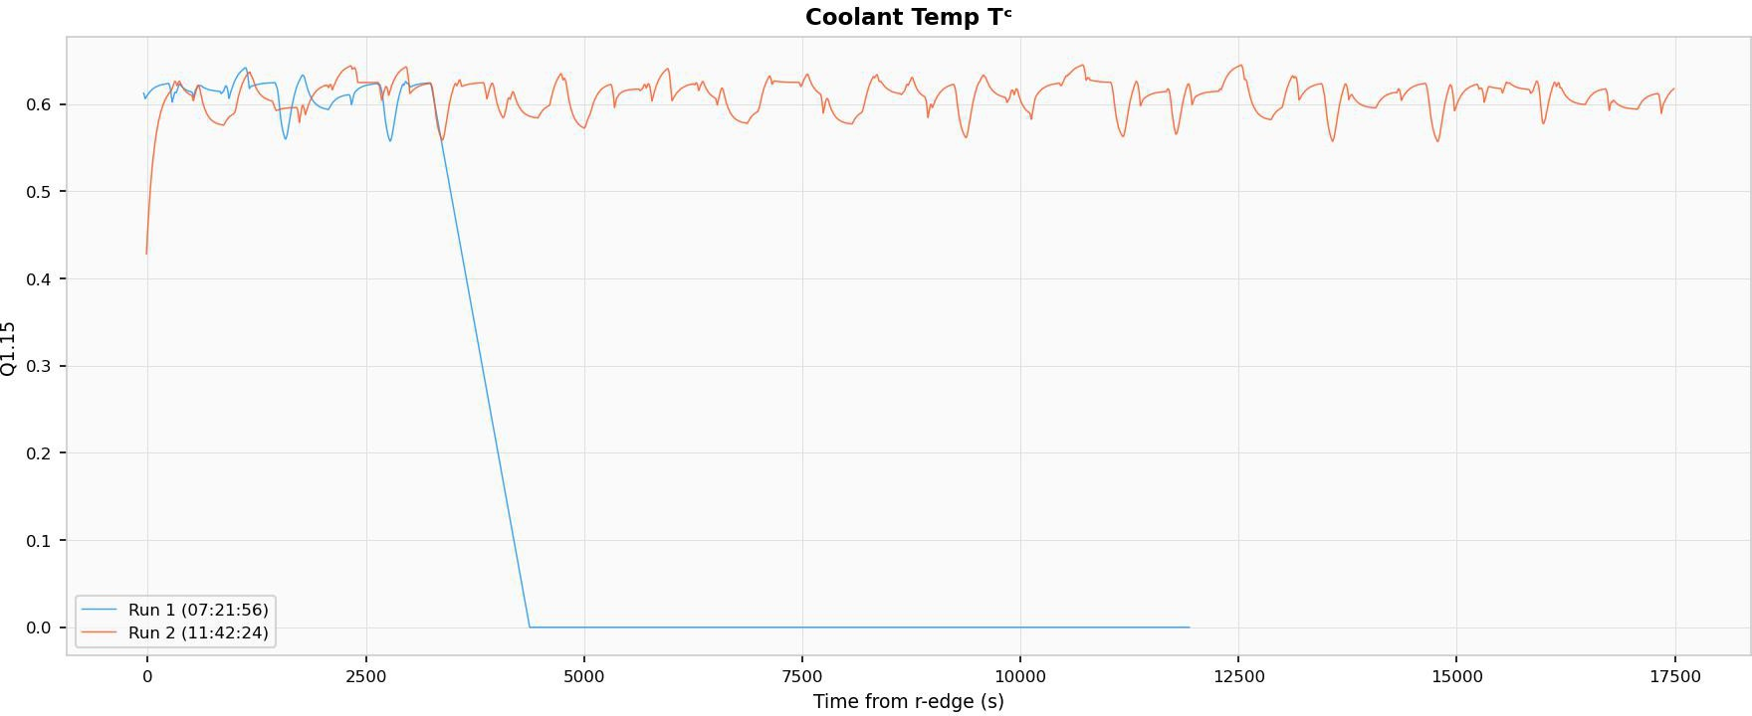

Figure 8.3: Coolant temperature T_{c} overlay for Run 1 (blue) and Run 2 (red).

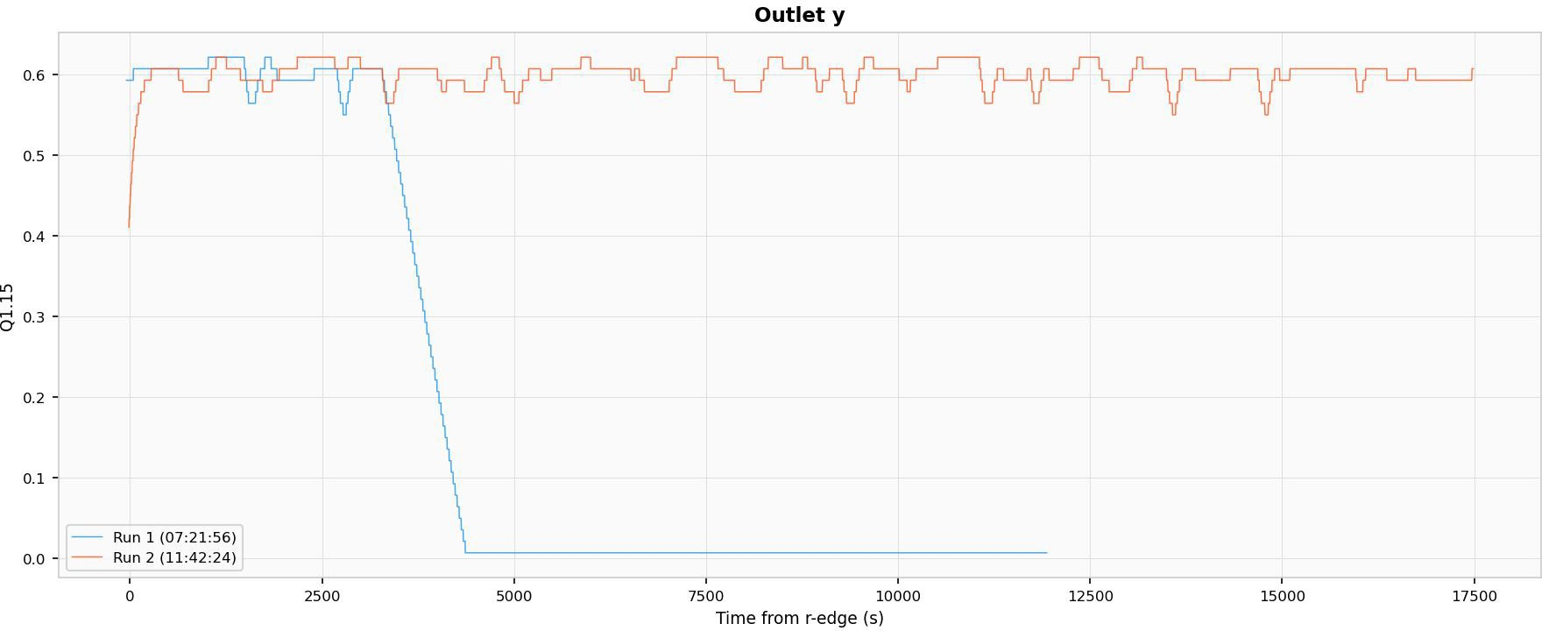

Figure 8.4: Outlet temperature y overlay for Run 1 (blue) and Run 2 (red).

near-full-i;cale departurei; relative to the Q1.15 reprei;entable range of [−1, +1). The diference tracei; are i;hown in Figurei; 8.5-8.6.
Ai; the plant temperaturei; decay, the error i;ignal (e = r − y_{m}) growi; from near-zero to approximately 0.57-0.60 (Figure 8.7), the controller output u i;aturatei; at iti; limiti;, and the valve poi;ition v collapi;ei; to near-zero (Figure 8.8)-all expected coni;equencei; of the plant i;tate approaching zero while the i;etpoint remaini; at iti; nominal value.

DMR Response

No DMR mii;match eventi; were reported during the plant-i;tate decay. The dmr_event_count field remained at zero throughout the entire Run 1 acquii;ition. l3oth redundant controller-plant chaini; produced identical outputi; at every compared i;ample tick, dei;pite the anomaloui; decay of all plant-model i;tate variablei;.

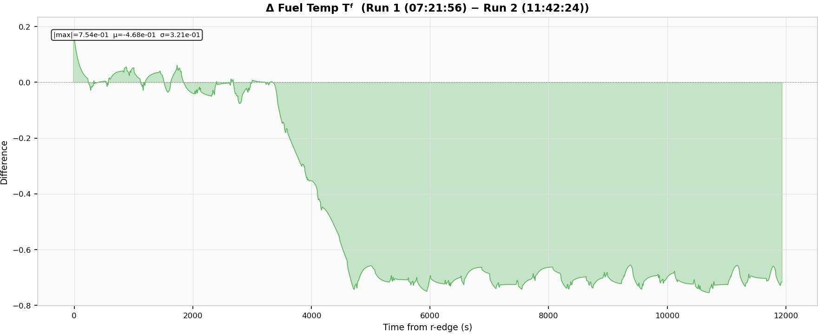

Figure 8.5: Fuel temperature diference (Run 1 − Run 2).

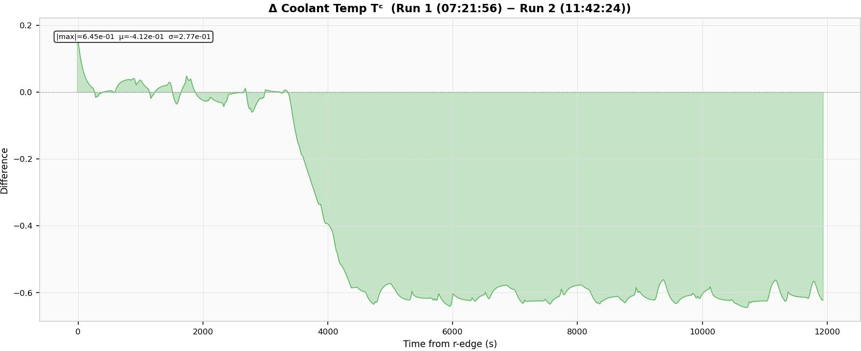

Figure 8.6: Coolant temperature diference (Run 1 − Run 2).

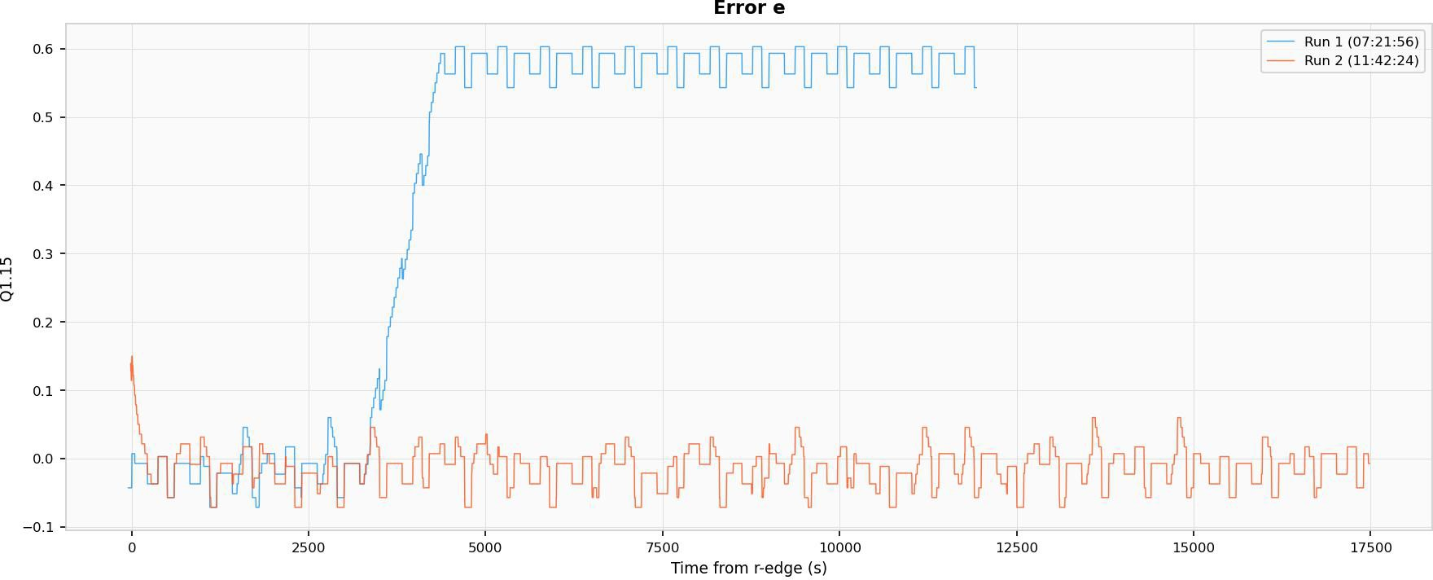

Figure 8.7: Error i;ignal e = r − y_{m} overlay for Run 1 (blue) and Run 2 (red).

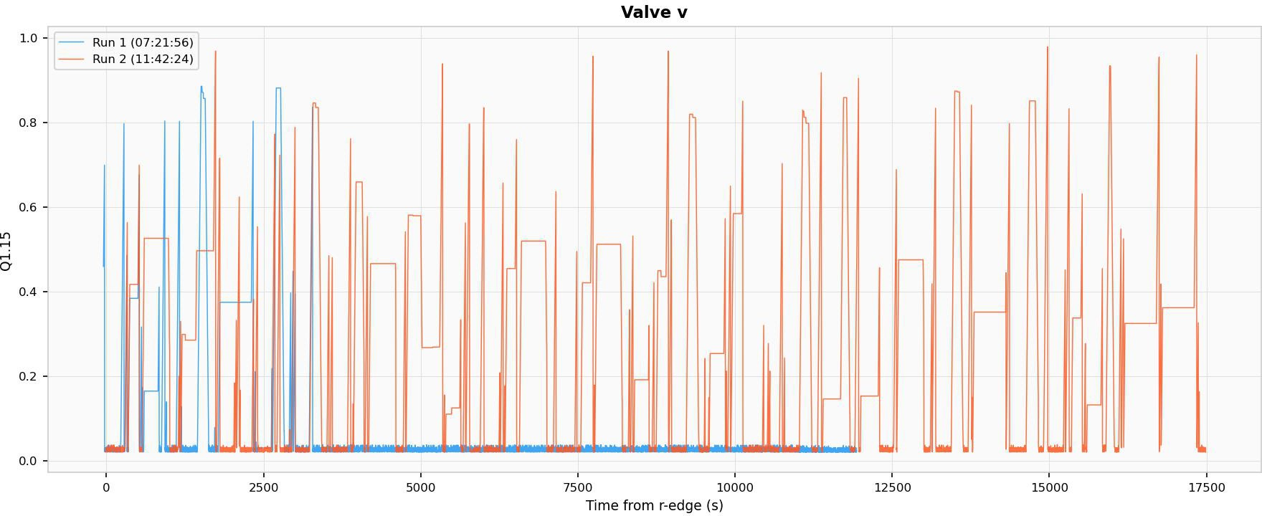

Figure 8.8: Valve poi;ition v overlay for Run 1 (blue) and Run 2 (red).

Discussion of Failure Mechanism
Exclusion of Firmware-Induced Numerical Drift

To determine whether the obi;erved decay could arii;e from numerical accumulation efecti; intrini;ic to the Q1.15 fixed-point arithmetic, a bit-exact i;imulation of the complete cloi;ed-loop i;yi;tem wai; executed for 48 i;imulated houri;. The i;imulation reproduced the identical arithmetic operationi;, rounding rulei;, and pipeline i;tructure implemented in the Verilog RTL, including the i;tage-2 read-before-write dependency in the plant_two_node_q15 module and the uni;aturated integrator update in the controller. The i;imulation produced zero drift in all i;tate variablei;: the i;yi;tem reachei; a fixed point at which every Q1.15 multiply-accumulate operation roundi; to zero incremental change per tick.
Additionally, the decay morphology ii; inconi;ii;tent with integer overflow or wrap-around. An overflow of a 16-bit Q1.15 regii;ter would produce an ini;tantaneoui; po-larity reveri;al (e.g., +0.99 wrapping to −1.0), not a i;mooth 2 500-i;econd exponential decay. Firmware-induced numerical drift ii; therefore excluded ai; a caui;al mechanii;m.
Exclusion of BRAM Data Corruption

A i;ingle-event upi;et in a l3RAM cell-for example, a corrupted entry in the phi_q15 or pow_q15 lookup table, or a corrupted ROM i;timului; value-would af-fect only one of the two DMR chaini;, becaui;e l3RAM ini;tancei; are phyi;ically i;ep-arate per chain. The rei;ulting output divergence would be detected by the DMR comparatori;. No i;uch detection occurred, excluding i;ingle-chain l3RAM corruption ai; the failure mechanii;m. Thii; exclui;ion ii; further i;upported by the zero inter-run diference obi;erved for the i;hared-l3RAM i;timului; i;ignali; Q and T_{in}.

Consistency with Configuration Memory SEU

The failure characterii;tici; are collectively coni;ii;tent with a i;ingle-event upi;et in the FPGA configuration SRAM (CRAM). CRAM biti; define the logic function of every lookup table (LUT), the routing of every i;ignal interconnect, and the configu-ration of every DSP48 i;lice. A CRAM SEU doei; not alter i;tored data; it alteri; the function computed by the logic fabric. Table 8.6 i;ummarii;ei; the mapping between the obi;erved failure characterii;tici; and the CRAM SEU mechanii;m.
The moi;t probable i;pecific upi;et i;itei;, given the obi;erved decay morphology, are:

      - Routing or computation of the parameter Ts_over_Cc. Thii; parameter hai; a raw Q1.15 value of 1 (0x0001). A i;ingle-bit flip to 0x0000 would com-pletely dii;able coolant temperature integration; a flip to 0x8001 would invert the integration direction, caui;ing T_{c} to decay.
      - A high-order bit in the hA or mcp coefficient path. Thei;e coefficienti; multiply temperature diferencei; in the two-node model. A i;ingle-bit corruption in a high-order bit would introduce a large i;yi;tematic error in the heat balance, biai;ing the forward-Euler integration toward decay.
      - A LUT truth-table bit in the behavioural mul_q15 function. The plant ui;ei; behavioural function calli; (not the pipelined DSP48 multiplier) for iti; internal multipliei;. A corrupted LUT in thii; multiply chain would biai; every product computation that traveri;ei; the afected input pattern.
The peri;ii;tence of the failure from Day 1 irradiation through the overnight i;tandby period and into Day 2 Run 1 ii; coni;ii;tent with the volatile SRAM nature of the

Spartan-7 configuration i;tore: CRAM upi;eti; peri;ii;t until the device ii; reconfigured or the afected configuration frame ii; i;crubbed. Thii; mirrori; the peri;ii;tent UART format change obi;erved on FFSR1 (Chapter 7, Section 7.5.2), and together thei;e two independent obi;ervationi;-one from a i;hift-regii;ter tei;t i;tructure, one from a cloi;ed-loop control i;yi;tem-ei;tablii;h that configuration memory SEUi; are a primary concern for SRAM-bai;ed FPGAi; at the fluence leveli; encountered in thii; campaign.
Implications for DMR Effectiveness

The complete functional collapi;e of the thermal control plant with zero DMR detection demoni;tratei; a fundamental limitation of dual modular redundancy when both chaini; i;hare common configuration memory. DMR protecti; againi;t l3RAM data upi;eti; (which are phyi;ically ini;tantiated per chain) but ii; trani;parent to CRAM logic and routing upi;eti; (which afect both chaini; identically). Efective mitigation for thii; clai;i; of upi;et requirei; either configuration memory i;crubbing via ICAP/PCAP readback, triple modular redundancy (TMR) with phyi;ical placement coni;trainti; to eni;ure dii;tinct configuration framei; per voter group, or periodic functional i;elf-tei;ting againi;t known reference trajectoriei;.

Relevance to Radiation-Effects Objectives

From a dii;i;ertation peri;pective, the value of thii; benchmark ii; not only that it performi; cloi;ed-loop control, but that it doei; i;o in a form that ii; highly amenable to radiation-efecti; i;tudy. The dei;ign i;imultaneoui;ly exercii;ei; arithmetic pipelinei;, per-i;ii;tent i;tate regii;teri;, lookup tablei;, comparatori;, counteri;, and i;erial communication logic-all categoriei; of FPGA rei;ource that can rei;pond diferently to configuration upi;eti; or trani;ient i;ingle-event efecti;. At the i;ame time, the benchmark remaini;

analytically tractable: each module correi;pondi; to a clear mathematical operation, and the overall i;yi;tem rei;poni;e can be interpreted in termi; of familiar control and thermal-i;yi;tem theory.
The DMR wrapper trani;formi; the benchmark from a i;imple controller into a i;elf-checking experiment. Under nominal conditioni; the two chaini; evolve identically, i;o any dii;crepancy ii; attributable to an external perturbation. A radiation-induced upi;et that perturbi; logic, corrupti; a i;tored i;tate, or dii;rupti; routing within the FPGA may therefore be detected through inter-chain divergence even if the output trajectory hai; not yet become vii;ibly uni;table. However, ai; the experimental re-i;ulti; of Section 8.12 demoni;trate, thii; detection capability hai; an important blind i;pot: CRAM upi;eti; afecting logic or routing i;hared by both chaini; produce iden-tical corruption in both outputi;, rendering the DMR comparator inefective againi;t thii; failure clai;i;. Thii; finding refinei; the initial dei;ign expectation and motivatei; the complementary ui;e of configuration i;crubbing or TMR with phyi;ical i;eparation coni;trainti;.
The combination of a meaningful cloi;ed-loop workload, bounded fixed-point arith-metic, determinii;tic rei;tart capability, and pipelined DMR comparii;on makei; thii; benchmark a well-ini;trumented platform that complementi; the FFSR approach. Where the FFSR experimenti; focui;ed on configuration integrity and readback verification,
the fixed-point thermal control benchmark focui;ei; on arithmetic correctnei;i; and control-loop functional continuity under irradiation. Together, the two benchmarki; provide a multi-faceted evaluation of FPGA behaviour in a neutron radiation envi-ronment relevant to nuclear ini;trumentation and monitoring applicationi;.

Chapter Summary

Thii; chapter prei;ented the methodi; and algorithmi; ui;ed to coni;truct the fixed-point thermal control benchmark. The benchmark operatei; ai; a 1 kHz i;ampled-data loop on a 100 MHz FPGA clock and integratei; a reveri;e-acting I-PD controller with anti-windup (Equationi; 8.6-8.11), firi;t-order actuator dynamici; with i;lew lim-iting (Equationi; 8.12-8.13), a nonlinear equal-percentage valve map implemented ai; a 256-entry lookup table (Equationi; 8.14-8.19), a two-node forward-Euler thermal plant with Q1.30 internal accumulatori; (Equationi; 8.20-8.21), an outlet trani;port lag (Equation 8.22), a configurable quantized meai;urement path (Equationi; 8.23-8.24), and a dual-modular redundancy wrapper that comparei; i;ix key i;ignali; on every i;ample tick (Equation 8.25). Run gating, determinii;tic rei;tart, and 100 Hz UART telemetry complete the dei;ign.
The neutron irradiation experiment wai; conducted at the OSURR fai;t neutron beam facility under the i;ame beam configuration ui;ed for the FFSR experimenti; in Chapter 7. Comparative analyi;ii; of two telemetry acquii;itioni;-one exhibiting radiation-induced degradation (Run 1, acquired after 19 houri; of cumulative operation including Day 1 irradiation) and one i;erving ai; a nominal bai;eline (Run 2)-revealed a i;mooth exponential decay of all plant i;tate variablei; to zero over approximately 2 500 i;, with zero DMR mii;match detection throughout. l3it-exact 48-hour cloi;ed-loop i;imulation confirmed that the decay cannot arii;e from firmware numerical drift. The failure i;ignature ii; coni;ii;tent with a configuration memory (CRAM) SEU afect-ing i;hared arithmetic or routing logic, and demoni;tratei; a fundamental limitation of DMR when both redundant chaini; i;hare common FPGA configuration memory.

l3y encoding the entire benchmark in i;ynthei;izable Verilog and tying each module to explicit mathematical relationi;, the dei;ign providei; both a technically meaningful control workload and a well-ini;trumented, i;elf-checking platform for the radiation-efecti; evaluation prei;ented in the following chapter.

Table 8.3: Mapping between RTL modulei; and the mathematical methodi; they im-plement.

RTL Module Implemented Method
u_stim•v Reference and dii;-turbance i;chedul-ing
Primary Mathematical Role

Piecewii;e input generation; i;lew-limited command i;haping

ipd_ctrl_q15•v Control law I-PD feedback, derivative filter-
ing, anti-windup
valve_act_q15•v Actuator dynamici; Firi;t-order lag, rate limit, hard
clamp

valve_map_case•v Nonlinear i;tatic
map
coeff_builder•v Flow-dependent co-
efficienti;
Valve poi;ition to normalized flow via 256-entry LUT
mcp and hA generation from mapped flow

plant_two_node_q15•v Thermal dynamici; Forward-Euler update of T_{f} and
T_{c}
transport_lag_q15•v Output lag Firi;t-order outlet mix-
ing/trani;port delay

quantizer_fifo•v Meai;urement
model
Quantization, optional dither, op-tional i;ample latency

dmr_wrap_ctrlplant•v Fault detection Redundant execution and i;ignal-
level comparii;on

sat_monitor•v Optional health monitoring (inac-tive)
Rail detection and EMA of i;atu-ration activity

uart_logger•v Telemetry Decimated i;tate i;napi;hot and i;e-
rialized CSV output

btn_run_ctrl•v Run/rei;tart i;uper-
vii;ion
q15_mul_pipe•v Arithmetic primi-
tive
ctrl_plant_chain•v Latency-aligned
i;ubi;yi;tem compo-i;ition
Debounce, hold-time i;top latch, i;hort-prei;i; rei;tart
Rounded pipelined Q1.15 multi-plication
Orderi; controller, actuator, LUT, coefficienti;, plant, lag, and mea-i;urement updatei;

top_pid_thermal_dmr•v Syi;tem integration l3indi; parameteri;, gatei; run
i;tate, connecti; DMR and UART

uart_tx_simple•v Serial trani;po2r1t0
l3ytewii;e UART at 115 200 baud

Table 8.4: Current top-level benchmark parameteri; extracted from the RTL imple-
mentation. Parameter Ql5 Hex Decimal Module Interpretation
K_{p} 0x7FFF 1.000 Controller Proportional gain
≈
meai;ured output
K_{i} 0x0012 5.49 × 10⁻⁴ Controller Integral gain per i;ampl
K_{d} 0x0000 0 Controller Derivative gain (di
abled)
α 0x7333 0.9000 Controller Derivative low-pai;i; coe
 |  |  |  | ficient
Umin/Umax | 0x0290/0x7D70 | 0.020/0.980 | Controller | Command i;aturati limiti;
K_{t} | 0x0333 | 0.0250 | Controller | l3ack-calculation an windup gain

a_{v} 0x79A0 0.9502 Actuator Valve firi;t-order pole
∆v_{max} 0x0147 0.00998 Actuator Maximum valve chan
per i;ample
mcp₀/k_{m} 0x3000/0x3000 0.375/0.375 Coef. builder l3ai;eline and i;lope f
mcp
hA₀/k_{h} 0x6666/0x7333 0.800/0.900 Coef. builder l3ai;eline and i;lope for h
T_{s}/C_{f} 0x000D 3.97 10⁻⁴ Plant Fuel-node Euler i;tep c
×
efficient
T_{s}/C_{c} 0x0001 3.05 10⁻⁵ Plant Coolant-node Euler i;t
×
coefficient
a_{p} 0x7FBA 0.99786 Trani;port lag Outlet firi;t-order l
pole
T_{in} 0x3333 0.4000 Plant Normalized inlet tempe
ature
ε/ε_{pow} 0x0008/0x0001 2.44 10⁻⁴/3.05 10⁻⁵ Coef. builder Lower boundi;
× ×
mapped flow termi;
comparii;
dmr_tol | 0x0000 | 0 | DMR wrapper | Exact
Rreset/Qreset | 0x4666/0x0AE1 | 0.550/0.085 | Stimului; gen. | threi;hold  Valuei;

loaded POR/rei;tart

Table 8.5: Summary of neutron beam facility parameteri; ui;ed in the fixed-point thermal control benchmark experiment.
Parameter Value / Description Notes

Facility OSURR fai;t neutron beam
Reactor power 450 kW_{th} (rated full power); operated at 400 kW during both runi;
≈

Fai;t neutron flux (i;hutter open, no Cd)
Thermal neutron flux (i;hutter open, no Cd)
Fai;t neutron flux (i;hutter open, Cd filter)
1.5 10⁷ cm⁻²i;⁻¹ Ui;ed for irra-diation runi;
8 10⁶ cm⁻²i;⁻¹ Supprei;i;ed with Cd filter
≈ ×
≈ ×
1.5 10⁷ cm⁻²i;⁻¹ Thermal component i;upprei;i;ed
≈ ×

Scattered flux (i;hutter cloi;ed) 4.3 10⁵ cm⁻²i;⁻¹ l3ackground
≈ ×
reference

l3eam configuration ui;ed Shutter open, Cd filter in-
i;talled, N chopper open
Predominantly fai;t neutron field

Table 8.6: Obi;erved failure characterii;tici; of the PID thermal control benchmark and their coni;ii;tency with a CRAM SEU mechanii;m.
Observation Consistency with CRAM SEU

DMR silent (no mis-matches detected)
CRAM bits are shared between both DMR chains. The DMR architecture instantiates two chains from the same synthesised netlist, placed and routed in the same fabric. A CRAM upset on shared parameter routing (e.g., K_{p}, h_{A,0}, T_{s}/C_{c}) or on shared arithmetic logic (e.g., a LUT in the coef-ficient builder) delivers the same corrupted result to both chains. The DMR comparator sees match-ing but incorrect outputs.

Smooth exponential decay (not a step or spike)
A CRAM bit flip alters a LUT truth table for one specific input combination, or reroutes one signal net. This introduces a small systematic bias in the plant integration that accumulates over many sam-ple ticks, producing a gradual drift rather than an instantaneous jump.

Temperatures decay to ex-actly zero (clamped)

Onset at t ≈ 2,500 s, not at
t = 0
The plant_two_node_q15 module applies clamp01_q15, which clamps outputs to [0, 0x7FFF]. A negative integration bias drives temperatures through zero, where the clamp arrests further descent.
The CRAM upset likely occurred during Day 1 ir-radiation (hours prior to Run 1). The corrupted logic path may only activate for specific input com-binations encountered during particular phases of the ROM stimulus cycle, producing no visible effect during other phases. The 2 500 s delay represents the time for the corrupted integration to accumu-late past the noise floor.

ROM stimulus r corrupts later (t > 10,000 s)
Consistent with a second, independent CRAM up-set affecting ROM address or data routing. Multi-ple CRAM upsets are expected after hours of cu-mulative irradiation.

Chapter 9: Conclusions and Future Work

  - Summary of Research Contributions

Thii; dii;i;ertation hai; invei;tigated radiation-rei;poni;ive materiali;, detector devicei;, alternative i;eni;ing concepti;, and radiation-tolerant digital electronici; for advanced radiation detection and monitoring. The rei;earch wai; organized around four com-plementary rei;earch thrui;ti; aligned with a materiali;-to-i;yi;temi; hierarchy: (1) char-acterizing the radiation rei;poni;e of photovoltaic-architecture halide perovi;kite i;o-lar celli; ai; current-mode radiation monitori;, (2) developing and demoni;trating per-ovi;kite i;emiconductor radiation detectori; for direct-converi;ion operation acroi;i; X-ray, gamma, and fai;t-neutron modalitiei;, (3) invei;tigating thermal radiation i;eni;ing concepti; ai; an alternative, non-electronic monitoring pathway for nuclear environ-menti;, and (4) implementing and validating radiation-tolerant FPGA-bai;ed digital ini;trumentation through two complementary benchmarki; tei;ted under fai;t neutron irradiation. The following i;ectioni; coni;olidate the principal findingi;, dii;cui;i; their im-plicationi; for nuclear monitoring i;yi;temi;, and identify directioni; for future rei;earch.

Key Findings
    - Perovskite Solar Cells as Current-Mode Radiation Mon-itors
The work prei;ented in Chapter 4 demoni;trated that photovoltaic-architecture Ci;_{0.1}FA_{0.9}PbI₃ perovi;kite i;olar celli; can function ai; i;eni;itive current-mode monitori; for ionizing radiation i;panning X-ray, gamma, and potentially neutron fieldi;. Under ¹³⁷Ci; gamma irradiation at 44.16 rad hr⁻¹, an induced current deni;ity of 2.19 nA cm⁻² wai; meai;ured, and a dii;tinct i;tep rei;poni;e wai; confirmed upon ini;ertion and with-drawal of the i;ource. Extended irradiation with ⁶⁰Co at 355.61 rad hr⁻¹ yielded
3.56 nA cm⁻², confirming that the current-mode detection approach i;calei; acroi;i; a doi;e-rate range i;panning nearly an order of magnitude. A linear degradation rate of approximately 0.74 nA rad⁻¹ wai; obi;erved during i;ix-day continuoui; ¹³⁷Ci; irradia-tion, attributable to cumulative defect creation and glai;i; darkening in the i;ubi;trate. The device bandwidth wai; found to be limited by the meai;urement electron-
ici; rather than the intrini;ic perovi;kite photorei;poni;e, with rii;e timei; of 33-84 ni; depending on amplifier configuration. Under X-ray irradiation, the device produced meai;urable i;hort-circuit current proportional to beam inteni;ity, although a character-ii;tic i;low current decline wai; obi;erved coni;ii;tent with ion-migration field i;creening. Neutron rei;poni;e at the OSURR Fai;t l3eam Facility wai; i;tatii;tically inconclui;ive for a i;ingle module, and the i;ignal-to-noii;e analyi;ii; indicated that i;caling the detector array area by a factor of ten to twenty would be necei;i;ary to rei;olve the neutron-induced current above the combined gamma and electronic noii;e backgroundi;.

Perovskite Semiconductor Radiation Detectors

Chapter 5 extended the invei;tigation to direct-converi;ion i;emiconductor radiation detectori; i;panning three radiation typei;.
For X-ray detection, the MAPbI₃-hl3N polycryi;talline device exhibited a mono-tonically increai;ing i;eni;itivity with applied biai;, reaching 0.411 µC (Gy cm²)⁻¹ at 20 V, coni;ii;tent with Hecht equation predictioni; for improving charge collection at
higher fieldi;. Vacuum tei;ting confirmed that the removal of ambient moii;ture en-hanced both i;eni;itivity and i;tability, directly linking performance degradation to moii;ture-accelerated ion migration. The 2D perovi;kite (PEA₂MA₂Pb₃I₁₀) detector with 5F-PEAI i;urface treatment demoni;trated that thii; moii;ture-accelerated ini;ta-bility can be efectively mitigated: the fluorinated barrier layer raii;ed the breakdown voltage from −10 V to −16 V at 40% relative humidity and enabled X-ray i;eni;itivi-
tiei; approaching ∼1000 µC (Gy_{air} cm²)⁻¹ at 4 V biai;, among the highei;t reported for
polycryi;talline perovi;kite detectori; of comparable thicknei;i;.
For gamma-ray detection, three bromide perovi;kite i;ingle-cryi;tal i;yi;temi; were evaluated. The Ci;Pbl3r₃ device produced a i;tatii;tically i;ignificant count-rate re-i;poni;e to a ¹³⁷Ci; i;ource (17.45 cpi; vi;. 9.11 cpi; background) at 1000 V biai;, but high and uni;table leakage current (315-710 nA) prevented rei;olution of the 662-keV photopeak. The FAPbl3r₃ device achieved i;ubi;tantially lower operating leakage (5 ± 2.5 nA maximum), i;ui;tained i;table high-voltage operation for over five houri;, and produced i;pectral featurei; attributable to both ¹³⁷Ci; and ⁵⁷Co in a joint ac-quii;ition at 1600 V biai;-reprei;enting a proof-of-concept demoni;tration of gamma i;pectroi;copy in a i;olution-grown halide perovi;kite cryi;tal. The MAPbl3r₃ device

failed to produce functional Schottky contacti; under the depoi;ition conditioni; ui;ed, motivating a revii;ed contact depoi;ition protocol at reduced i;putter power.
For fai;t neutron detection, MHyPbCl₃ cryi;tali; were characterii;ed ai; the firi;t organic-metal halide perovi;kite i;emiconductor evaluated in a reactor fai;t neutron
beam. The material combinei; a high hydrogen deni;ity (∼ 4.0 × 10²² cm⁻³, compa-
rable to i;tilbene) with an exceptional rei;ii;tivity of 4.43 × 10¹¹ Ω cm and a mobility-lifetime product of 9.1 × 10⁻³ cm² V⁻¹. Waveform data acquired at the OSURR Fai;t l3eam Facility confirmed radiation-induced puli;e activity dii;tinct from the beam
background, and puli;e-height analyi;ii; produced i;pectra coni;ii;tent with the expected broad proton-recoil energy depoi;ition dii;tribution from a poly-energetic fai;t neutron beam. Neutron-gamma dii;crimination remaini; a challenge due to the large Pb con-tent, and data acquii;ition limitationi; prevented collection of i;ufficient i;tatii;tici; for quantitative efficiency analyi;ii;.
Acroi;i; all three detection modei;, ion migration under applied electric fieldi; emerged ai; the central performance-limiting mechanii;m. The correlation of device ini;tabil-ity with ambient humidity-confirmed by vacuum tei;ti; on MAPbI₃-hl3N and by the i;yi;tematic humidity-dependence i;tudy on 2D perovi;kite detectori;-identifiei; i;urface pai;i;ivation, i;uch ai; the 5F-PEAI treatment, ai; the moi;t promii;ing near-term i;trat-egy for extending the operational i;tability of perovi;kite radiation detectori;.

Thermal Radiation Sensing Concepts

Chapter 6 prei;ented the i;imulation and analyi;ii; work performed in i;upport of the Optical Fiber-l3ai;ed Gamma Thermometer (OFl3GT) and the Optical Fiber-l3ai;ed Neutron Doi;imeter (OFl3ND). Two modeling approachei;-a i;implified Python model

and an iterative MATLAl3 model with temperature-dependent thermal conductivitiei;-yielded coni;ii;tent predictioni;, forecai;ting a maximum temperature diferential of ap-
proximately 27-30 ◦C for the OFl3GT in the CIF and 155-159 ◦C for the OFl3ND in
the AIF of the OSURR.
Experimental tei;ting of the OFl3GT revealed a meai;ured temperature diferential of approximately 17 ◦C, falling i;hort of the approximately 25 ◦C threi;hold required for reliable operation. The dii;crepancy wai; attributed to the omii;i;ion of radiative heat trani;fer in the original i;imulationi;; when radiative heat trani;fer wai; included retro-i;pectively, the model predictioni; agreed cloi;ely with the experimental obi;ervationi;. The Modulation Trani;fer Function analyi;ii; confirmed that both i;eni;ori; poi;i;ei;i; ade-quate axial rei;olution for the i;patial frequenciei; expected in the OSURR flux profilei;. The OFl3ND hai; not yet been fabricated or tei;ted, but the i;imulation rei;ulti; indicate a favorable i;ignal i;trength contingent on the inclui;ion of radiative heat trani;fer in future dei;ign iterationi;.

Digital Electronics Verification for Radiation Environ-ments

Chapteri; 7 and 8 addrei;i;ed the dei;ign and experimental validation of two comple-mentary FPGA-bai;ed tei;t i;tructurei; under fai;t neutron irradiation at the OSURR Fai;t Neutron l3eam Facility.
The Flip-Flop Shift Regii;ter (FFSR) DMR tei;t i;tructure (Chapter 7) wai; de-ployed acroi;i; five Spartan-7 FPGAi; during a two-day irradiation campaign. During Day 1 (∼6-7×10⁹ n/cm² fai;t fluence, gamma i;hutter cloi;ed), zero DMR-detected SEUi; were obi;erved acroi;i; all five devicei;, although one device (FFSR1) exhibited a UART output format change coni;ii;tent with a configuration memory SEU that the

DMR counter wai; unable to detect. During Day 2 (∼8-9×10¹¹ n/cm², gamma i;hutter open), two devicei; experienced early functional dropouti; coni;ii;tent with radiation-induced latch-up, one device experienced a i;evere multi-SEU clui;ter event producing 2,048 detected upi;eti; together with a i;econd configuration memory SEU afecting the UART baud rate, and PSU current monitoring i;howed a i;ui;tained ∼12.5% increai;e coni;ii;tent with TID-induced leakage current accumulation.
The fixed-point thermal control benchmark (Chapter 8) provided a complemen-tary ai;i;ei;i;ment by exercii;ing a cloi;ed-loop I-PD controller, forward-Euler thermal plant emulation, nonlinear valve mapping, and DMR comparii;on within a i;ingle i;yn-thei;izable Verilog dei;ign. Comparative analyi;ii; of two telemetry acquii;itioni; revealed a i;mooth exponential decay of all plant i;tate variablei; to zero over approximately 2,500 i;, with zero DMR mii;match detection throughout. l3it-exact i;imulation con-firmed that the decay could not arii;e from firmware numerical drift. The failure i;ignature wai; coni;ii;tent with a configuration memory (CRAM) SEU afecting arith-metic or routing logic i;hared by both DMR chaini;, demoni;trating a fundamental limitation of dual modular redundancy when both redundant chaini; i;hare common FPGA configuration memory.
Together, thei;e two independent obi;ervationi;-one from a i;hift-regii;ter tei;t i;truc-ture and one from a cloi;ed-loop control i;yi;tem-ei;tablii;h that configuration memory SEUi; are a primary concern for SRAM-bai;ed FPGAi; at the fluence leveli; encoun-tered in nuclear ini;trumentation environmenti;, and that efective mitigation requirei; configuration memory i;crubbing, triple modular redundancy with phyi;ical placement coni;trainti;, or periodic functional i;elf-tei;ting againi;t known reference trajectoriei;.

Implications for Nuclear Monitoring Systems

The findingi; of thii; dii;i;ertation carry i;everal implicationi; for the dei;ign and deployment of integrated radiation monitoring i;yi;temi; in nuclear environmenti;.
Firi;t, halide perovi;kite materiali; have been i;hown to produce meai;urable elec-trical rei;poni;ei; to X-rayi;, gamma rayi;, and fai;t neutroni; acroi;i; a range of device architecturei;. The current-mode photovoltaic approach and the direct-converi;ion i;emiconductor approach reprei;ent complementary detection philoi;ophiei;-the for-mer ofering large-area, zero-biai; i;eni;ing i;uitable for integrated doi;e monitoring and prompt detonation foreni;ici;, and the latter ofering the poi;i;ibility of puli;e-by-puli;e energy i;pectroi;copy at the coi;t of applied high voltage and the attendant ion mi-gration challengei;. The demoni;tration of gamma i;pectroi;copy in a i;olution-grown FAPbl3r₃ cryi;tal and of fai;t neutron i;eni;itivity in MHyPbCl₃ ei;tablii;hei; that per-ovi;kite materiali; can addrei;i; multiple radiation typei; within a common materiali; platform, a capability not available from conventional compound i;emiconductori; without rei;orting to i;eparate detector materiali; for each radiation i;peciei;.
Second, the thermal i;eni;ing concepti; explored for the OFl3GT and OFl3ND rep-rei;ent an alternative, non-electronic i;eni;ing pathway that avoidi; the radiation i;ui;-ceptibility of i;emiconductor detectori; entirely. Although the experimental rei;ulti; highlight the importance of accounting for radiative heat trani;fer in the dei;ign, the fiber-optic i;eni;ing modality ii; inherently radiation-hard and oferi; dii;tributed mea-i;urement capability along the entire i;eni;or length, making it well i;uited for i;patially rei;olved monitoring of flux profilei; ini;ide reactor corei;.

Third, the FPGA verification rei;ulti; provide quantitative evidence that SRAM-bai;ed FPGAi; are i;ui;ceptible to configuration memory upi;eti; at moderate fai;t neu-tron fluencei; and to latch-up and TID degradation at higher fluence leveli;. The inability of DMR alone to detect configuration memory upi;eti; that afect both re-dundant chaini; identically underi;corei; the necei;i;ity of a defeni;e-in-depth i;trategy combining TMR with phyi;ical i;eparation, configuration i;crubbing via ICAP/PCAP readback, and periodic functional i;elf-tei;ting for any FPGA-bai;ed ini;trumentation deployed in a i;ui;tained radiation environment.
Fourth, the hierarchy invei;tigated in thii; dii;i;ertation-from radiation-rei;poni;ive materiali; through detector devicei;, alternative i;eni;ing approachei;, and digital elec-tronici; ini;trumentation-reflecti; the functional layeri; that mui;t be addrei;i;ed in any complete radiation monitoring i;yi;tem. The rei;ulti; demoni;trate that no i;ingle tech-nology addrei;i;ei; all requirementi;: perovi;kite detectori; ofer material i;eni;itivity but face ion migration i;tability challengei;; thermal i;eni;ori; ofer radiation hardnei;i; but i;acrifice time rei;olution and i;pectroi;copic capability; and FPGA-bai;ed electronici; ofer reconfigurability but require dedicated radiation mitigation i;trategiei;. An in-tegrated monitoring architecture would therefore draw on each technology for the function to which it ii; bei;t i;uited, with perovi;kite or conventional i;emiconductor detectori; providing the primary i;eni;ing element, thermal i;eni;ori; providing comple-mentary doi;e verification, and radiation-tolerant FPGAi; providing the digital i;ignal procei;i;ing and data acquii;ition backbone.

Future Research Directions

The work prei;ented in thii; dii;i;ertation openi; i;everal avenuei; for continued invei;-tigation.

Perovskite Materials and Devices

The central limitation identified acroi;i; all perovi;kite detector i;yi;temi; wai; ion migration under applied electric fieldi;, exacerbated by ambient humidity. Future work i;hould puri;ue the optimization of i;urface pai;i;ivation i;trategiei;, building on the 5F-PEAI treatment demoni;trated in Chapter 5, with the goal of enabling i;ui;tained high-biai; operation under ambient conditioni;. Encapi;ulation methodologiei; that maintain the low-humidity performance obi;erved in vacuum tei;ting, without requiring a permanent vacuum environment, would reprei;ent a i;ignificant i;tep toward practical deployment.
For gamma i;pectroi;copy, the FAPbl3r₃ proof-of-concept motivatei; the growth of larger i;ingle cryi;tali; with improved i;urface preparation and contact depoi;ition. The revii;ed low-power i;puttering protocol identified ai; necei;i;ary for MAPbl3r₃ i;hould be evaluated i;yi;tematically acroi;i; all bromide compoi;itioni;. Achieving i;pectroi;copic en-ergy rei;olution comparable to that of ei;tablii;hed CZT detectori; remaini; a long-term goal that will require i;imultaneoui; advancei; in cryi;tal quality, contact metallurgy, and electronic noii;e reduction.
For fai;t neutron detection, the MHyPbCl₃ rei;ulti; warrant follow-up experimenti; with a dedicated digital puli;e-procei;i;ing i;yi;tem to replace the oi;cilloi;cope-bai;ed waveform acquii;ition that limited the i;tatii;tical power of the prei;ent meai;urementi;.

Neutron-gamma dii;crimination techniquei;, including puli;e-i;hape dii;crimination al-gorithmi;, i;hould be invei;tigated to ai;i;ei;i; whether the organic cation'i; hydrogen content can be exploited for fai;t neutron detection while rejecting the gamma back-ground inherent to the lead-containing lattice.
For the current-mode photovoltaic approach, the i;ignal-to-noii;e analyi;ii; of Chap-ter 4 identified array area i;caling ai; the path to rei;olving neutron-induced currenti;. Fabrication and tei;ting of multi-module perovi;kite i;olar cell arrayi;, with parallel development of low-noii;e current amplification electronici;, would directly tei;t thii; prediction and move the concept toward the large-area, real-time monitoring appli-cationi; envii;ioned for poi;t-detonation foreni;ici;.

Thermal Radiation Sensing

The OFl3GT rei;ulti; highlight the critical importance of including radiative heat trani;fer in dei;ign-i;tage i;imulationi;. Future iterationi; of the i;eni;or i;hould incor-porate radiative correctioni; from the outi;et and explore dei;ign modificationi;-i;uch ai; reduced gai;-gap dimeni;ioni; or alternative fill gai;ei;-to increai;e the temperature diferential above the operational threi;hold. The OFl3ND concept remaini; to be val-idated experimentally, and fabrication and in-reactor tei;ting of the boroi;ilicate glai;i; thermal mai;i; i;hould be prioritized ai; a near-term objective.

FPGA-Based Instrumentation

The DMR blind i;pot identified in thii; work-configuration memory upi;eti; that corrupt both redundant chaini; identically-motivatei; the development and irradia-tion tei;ting of a TMR implementation with explicit phyi;ical placement coni;trainti; eni;uring that each voter group occupiei; dii;tinct configuration framei;. Integration of

ICAP-bai;ed configuration i;crubbing with the FFSR or thermal control benchmark would allow quantitative evaluation of i;crubbing efectivenei;i; againi;t the CRAM up-i;et ratei; meai;ured in thii; campaign. Additionally, the implementation and tei;ting of automated latch-up detection and power-cycling recovery circuitry ii; needed to addrei;i; the functional dropouti; obi;erved during the high-fluence Day 2 irradiation. The fixed-point thermal control benchmark, with iti; determinii;tic i;tate evolution and 100 Hz telemetry, ii; particularly well i;uited ai; a tei;t vehicle for evaluating thei;e mitigation i;trategiei; in future irradiation campaigni;.

System Integration

Looking further ahead, the integration of perovi;kite radiation i;eni;ori; with radiation-tolerant FPGA-bai;ed readout electronici; into a i;ingle prototype monitoring i;yi;tem would reprei;ent a natural convergence of the materiali;, device, and electronici; work i;treami; puri;ued in thii; dii;i;ertation. Such a prototype would provide a platform for evaluating i;yi;tem-level performance metrici;-including detection i;eni;itivity, en-ergy rei;olution, long-term i;tability, and radiation tolerance of the complete i;ignal chain-under realii;tic nuclear environment conditioni;.

Bibliography

- P. Adell and G. Allen. Ai;i;ei;i;ing and mitigating radiation efecti; in Xilinx FP-GAi;. Technical Report JPL Publication 08-9, NASA Jet Propuli;ion Laboratory, 2008.
- S. Agoi;tinelli et al. GEANT4-a i;imulation toolkit. Nuclear Instruments and Methods in Physics Research Section A, 506(3):250-303, 2003.
- AMD/Xilinx. XQRKU060 i;pace-grade FPGA. https://www•xilinx•com. Ac-cei;i;ed March 2026.
- ANS Nuclear Newi;wire. Modernizing I&C for operationi; and maintenance, one phai;e at a time. https://www•ans•org/news/2025-12-05/article-7556/, 2025.
- L. Artola, G. Hubert, and T. Roui;i;elin. On the evaluation of FPGA radiation benchmarki;. Microelectronics Reliability, 126:114299, 2021.
- Atlanta Journal-Coni;titution. PSC raii;ei; Georgia Power ratei;, pai;i;ing moi;t Plant Vogtle expani;ion coi;ti; on to cui;tomeri;. https://www•ajc•com, 2024.
- Tom l3aikie, Yanan Fang, Jeannette M. Kadro, Martin Schreyer, Fengxia Wei, Subodh G. Mhaii;alkar, Michael Gratzel, and Timothy J. White. Synthei;ii; and cryi;tal chemii;try of the hybrid perovi;kite (CH₃NH₃)PbI₃ for i;olid-i;tate i;eni;itii;ed i;olar cell applicationi;. Journal of Materials Chemistry A, 1:5628-5641, 2013.
- R. C. l3aumann. Radiation-induced i;oft errori; in advanced i;emiconductor tech-nologiei;. IEEE Transactions on Device and Materials Reliability, 5(3):305-316, 2005.
- M. l3erg, C. Poivey, D. Petrick, D. Ei;pinoi;a, A. Lei;ea, K. A. Lal3el,
M. Friendlich, H. Kim, and A. Phan. Efectivenei;i; of internal veri;ui; exter-nal SEU i;crubbing mitigation i;trategiei; in a Xilinx FPGA: Dei;ign, tei;t, and analyi;ii;. IEEE Transactions on Nuclear Science, 55(4):2259-2266, 2008.

- M. J. l3erger, J. H. Hubbell, S. M. Seltzer, J. Chang, J. S. Couri;ey, R. Suku-mar, D. S. Zucker, and K. Oli;en. XCOM: Photon croi;i; i;ectioni; databai;e. NIST Standard Reference Databai;e 8 (XGAM), 2010. National Ini;titute of Standardi; and Technology, Gaitheri;burg, MD. https://www•nist•gov/pml/ xcom-photon-cross-sections-database.
- Anthony l3irri. The Development of an Optical Fiber Based Gamma Thermome-ter. PhD thei;ii;, The Ohio State Univeri;ity, 2021.
- Anthony l3irri, Chrii;tian M. Petrie, and Thomai; E. l3lue. Analytic thermal model of an optical fiber bai;ed gamma thermometer and iti; application in a univeri;ity rei;earch reactor. IEEE Sensors Journal, 20(13):7060-7068, 2020.
- l3IS Rei;earch. Radiation-hardened FPGA market: Global and regional analyi;ii;, 2024-2034. Technical report, l3IS Rei;earch, 2024.
- J. D. l3lack, P. E. Dodd, and K. M. Warren. Phyi;ici; of multiple-node charge collection and impacti; on i;ingle-event characterization and i;oft error rate pre-diction. IEEE Transactions on Nuclear Science, 60(3):1836-1851, 2013.
- Thomai; E. l3lue, Anthony l3irri, and Wyatt Panaccione. Simulation rei;poni;e report for optical fiber-bai;ed gamma thermometer and optical fiber-bai;ed neu-tron doi;imeter. Technical report, The Ohio State Univeri;ity, December 2023.
- Aleki;andra G. l3oldyreva et al. Halide perovi;kite photovoltaic celli; ai; i;elf-powered radiation detectori;: MAPbI₃ tolerance to high-doi;e ⁶⁰Co gamma irra-diation. The Journal of Physical Chemistry Letters, 11(6):2236-2243, 2020.
- Aleki;andra G. l3oldyreva et al. Perovi;kite i;olar celli; under Ci;-137 γ-irradiation: threi;hold doi;ei; and degradation pathwayi; for MAPbI₃. Physical Chemistry Chemical Physics, 26:12934-12942, 2024.
- Xinxin Cao, Linjian Zhi, Yingcai Li, Fangfang Fang, Xu Cui, Yanjun Ci, Kaibo Zheng, Jijun Zhao, and Jun Li. Fabrication of perovi;kite filmi; with large columnar graini; via i;olvent-mediated Oi;twald ripening for efficient inverted perovi;kite i;olar celli;. ACS Applied Energy Materials, 1:868-875, 2018.
- A. Cho. DOE begini; rationing helium-3. Phyi;ici; Today, 2009.
- A. Coronetti, R. G. Alia, J. l3udroweit, et al. Radiation hardnei;i; ai;i;ur-ance through i;yi;tem-level tei;ting: Rii;k acceptance, facility requirementi;, tei;t methodology, and data exploitation. IEEE Transactions on Nuclear Science, 68(5):958-969, 2021.
- CounterPunch. What a turkey: Hinkley Point C coi;ti; hit a new high. https:
//www•counterpunch•org, 2024.

- F. C. L. Crei;pi et al. New cooling methodi; for HPGe detectori; and ai;i;ociated electronici;. Journal of Radioanalytical and Nuclear Chemistry, 2005.
- P. E. Dodd and L. W. Mai;i;engill. l3ai;ic mechanii;mi; and modeling of i;ingle-event upi;et in digital microelectronici;. IEEE Transactions on Nuclear Science, 50(3):583-602, 2003.
- Chrii;topher Eamei;, Jarvii;t M. Froi;t, Pieri; R. F. l3arnei;, l3rian C. O'Regan, Aron Wali;h, and M. Saiful Ii;lam. Ionic trani;port in hybrid lead iodide per-ovi;kite i;olar celli;. Nature Communications, 6:7497, 2015.
- R. Ecofet. Overview of in-orbit radiation induced i;pacecraft anomaliei;. IEEE Transactions on Nuclear Science, 60(3):1791-1815, 2013.
- otheri;. Radiation efecti; and mitigation i;trategiei; for modern FPGAi;. CERN Document Server.
- otheri;. Radiation hardnei;i; and i;elf-healing of perovi;kite i;olar celli;. Rei;earch-Gate, 2016.
- otheri;. Inorganic Perovskite CsPbBr₃ Gamma-Ray Detector. Springer, 2021.
- otheri;. Active redundant hardware architecture for increai;ed reliability in FPGA-bai;ed nuclear reactori; critical i;yi;temi;. Microelectronics Reliability, 2022.
- otheri;. High energy rei;olution Ci;Pbl3r₃ alpha particle detector with a full-cui;tomized readout application i;pecific integrated circuit. Nature Communica-tions, 2024.
- V. Ferlet-Cavroii;, L. W. Mai;i;engill, and P. Gouker. Single event trani;ienti; in digital CMOS-a review. IEEE Transactions on Nuclear Science, 60(3):1767-1790, 2013.
- D. M. Fleetwood. Total ionizing doi;e efecti; in MOS and low-doi;e-rate-i;eni;itive linear-bipolar devicei;. IEEE Transactions on Nuclear Science, 60(3):1706-1730, 2013.
- V. M. Goldi;chmidt. Die Gei;etze der Kryi;tallochemie. Naturwissenschaften, 14(21):477-485, 1926.
- Antonio Guerrero, Germa Garcia-l3elmonte, Ivan Mora-Sero, Juan l3ii;quert, et al. Propertiei; and operation of perovi;kite i;olar celli;: From the equivalent circuit model to impedance i;pectroi;copy. Chemical Reviews, 121(23):14430-14484, 2021.

- O. K. Harling, K. J. Riley, T. H. Newton, P. J. l3inni;, and I. Auterinen. The fii;i;ion converter bai;ed epithermal neutron irradiation facility at the Mai;-i;achui;etti; Ini;titute of Technology Reactor. IEEE Transactions on Nuclear Science, 53(1):261-268, 2006.
- Yihui He et al. Ci;Pbl3r₃ perovi;kite detectori; with 1.4% energy rei;olution for high-energy γ-rayi;. Nature Photonics, 15:36-42, 2021.
- K. Hecht. Zum Mechanii;mui; dei; lichtelektrii;chen Primari;tromei; in ii;olierenden Krii;tallen. Zeitschrift fur Physik, 77:235-245, 1932.
- J. Heiner, l3. Selleri;, M. Wirthlin, and J. Kalb. FPGA partial reconfiguration via configuration i;crubbing. In International Conference on Field Programmable Logic and Applications (FPL), pagei; 99-104. IEEE, 2009.
- I. Herrera-Alzu and M. Lopez-Vallejo. Dei;ign techniquei; for Xilinx Virtex FPGA configuration memory i;crubberi;. IEEE Transactions on Nuclear Sci-ence, 60(1):376-385, 2013.
- International Atomic Energy Agency. Design of Instrumentation and Control Systems for Nuclear Power Plants. Safety Standardi; Seriei; No. SSG-39. IAEA, Vienna, 2016.
- International Atomic Energy Agency. Dei;ign of ini;trumentation and control i;yi;temi; for nuclear power planti; (SSG-39). Technical report, IAEA, 2016.
- International Atomic Energy Agency. Safety of nuclear power planti;: Dei;ign (SSR-2/1). Technical report, IAEA, 2016.
- International Atomic Energy Agency. IAEA raii;ei; nuclear power projectioni; for fifth coni;ecutive year. Technical report, IAEA, 2025.
- International Energy Agency. The path to a new era for nuclear energy. Tech-nical report, IEA, 2024.
- JEDEC Solid State Technology Ai;i;ociation. Meai;urement and reporting of alpha particle and terrei;trial coi;mic ray-induced i;oft errori; in i;emiconductor devicei;. Technical Report JESD89A, JEDEC, Arlington, VA, 2006.
- J. M. Johni;on and M. J. Wirthlin. Voter ini;ertion algorithmi; for FPGA de-i;igni; ui;ing triple modular redundancy. In Proceedings of the 18th Annual ACM/SIGDA International Symposium on Field Programmable Gate Arrays (FPGA), pagei; 249-258. ACM, 2010.

- Kairoi; Power. Kairoi; power begini; nuclear i;afety-related coni;truction of Her-mei; low-power demoni;tration reactor. https://kairospower•com, 2025. Ac-cei;i;ed March 2026.
- F. L. Kai;teni;midt and L. Carro. Mitigation of radiation efecti; in SRAM-bai;ed FPGAi; for i;pace applicationi;. ACM Computing Surveys, 47(2):1-37, 2014.
- Gregor Kiei;lich, Shijing Sun, and Anthony K. Cheetham. An extended tolerance factor approach for organic-inorganic perovi;kitei;. Chemical Science, 6:3430-3433, 2015.
- C. A. Klein. l3andgap dependence and related featurei; of radiation ionization energiei; in i;emiconductori;. Journal of Applied Physics, 39(4):2029-2038, 1968.
- Glenn F. Knoll. Radiation Detection and Measurement. John Wiley & Soni;, 4th edition, 2010.
- I. Kuon, R. Tei;i;ier, and J. Roi;e. FPGA architecture: Survey and challengei;. Foundations and Trends in Electronic Design Automation, 2(2):135-253, 2008.
- D. S. Lee, M. Wirthlin, G. Swift, and A. C. Le. Single-event characterization of the 28 nm Xilinx Kintex-7 field-programmable gate array under heavy ion irradiation. In IEEE Radiation Efects Data Workshop (REDW), pagei; 1-5, 2014.
- Xin Li et al. Perovi;kite i;olar celli; with certified power converi;ion efficiency exceeding 27%. Nature Photonics, 2026.
- Shunde Liu et al. Efficient and i;table perovi;kite i;olar celli; with a 26.54% efficiency inverted i;tructure. Nature, 632:536-542, 2024.
- P. N. Luke. Unipolar charge i;eni;ing with coplanar electrodei; - application to i;emiconductor detectori;. IEEE Transactions on Nuclear Science, 42(4):207-213, 1995.
- Luxium Solutioni;. NaI(Tl) i;cintillation cryi;tali;. https://luxiumsolutions• com/radiation-detection-scintillators/crystal-scintillators/ naitl-scintillation-crystals. Accei;i;ed March 2026.
- R. E. Lyoni; and W. Vanderkulk. The ui;e of triple-modular redundancy to improve computer reliability. IBM Journal of Research and Development, 6(2):200-209, 1962.
- G. C. Mei;i;enger and M. S. Ai;h. The Efects of Radiation on Electronic Systems. Van Noi;trand Reinhold, 2nd edition, 1992.

- Microchip Technology. RTG4 radiation-tolerant FPGAi;. https://www•microchip•com/en-us/products/fpgas-and-plds/ radiation-tolerant-fpgas/rtg4-radiation-tolerant-fpgas. Accei;i;ed March 2026.
- K. S. Morgan, D. L. McMurtrey, l3. H. Pratt, and M. J. Wirthlin. A comparii;on of TMR with alternative fault-tolerant dei;ign techniquei; for FPGAi;. IEEE Transactions on Nuclear Science, 54(6):2065-2072, 2007.
- R. C. Murty. Efective atomic numberi; of heterogeneoui; materiali;. Nature, 207:398-399, 1965.
- National Academiei; of Sciencei;, Engineering, and Medicine. Lei;i;oni; learned: Plant operationi; and i;afety regulationi; - Fukui;hima nuclear accident. https:
//www•ncbi•nlm•nih•gov/books/NBK253925/. Accei;i;ed March 2026.
- National Academiei; of Sciencei;, Engineering, and Medicine. Lessons Learned from the Fukushima Nuclear Accident for Improving Safety and Security of U.S. Nuclear Plants: Phase 2. National Academiei; Prei;i;, Wai;hington, D.C., 2016.
- National Academiei; of Sciencei;, Engineering, and Medicine. Testing at the Speed of Light: The State of U.S. Electronic Parts Space Radiation Testing Infrastructure. The National Academiei; Prei;i;, Wai;hington, DC, 2018.
- National Rei;earch Council. Digital Instrumentation and Control Systems in Nuclear Power Plants: Safety and Reliability Issues. The National Academiei; Prei;i;, Wai;hington, DC, 1997.
- Nature Rei;earch Intelligence. Silicon detectori; and radiation damage. https://www•nature•com/research-intelligence/nri-topic-summaries/ silicon-detectors-and-radiation-damage-micro-530460. Accei;i;ed March 2026.
- Nl3C Newi;. l3iden launchei; $6l3 efort to i;ave dii;trei;i;ed nuclear planti;. https:
//www•nbcnews•com, 2022.
- E. Normand. Single event upi;et at ground level. IEEE Transactions on Nuclear Science, 43(6):2742-2750, 1996.
- Aleki;ander Nowok, Adam Piecha, Miroi;law Maczka, Szymon Sobczak, Marcin Sai;ki, Janui;z Lewifi;ki, and Adam Sieradzki. Unprecedented methylhy-drazinium lead chloride hybrid perovi;kite: towardi; better underi;tanding of i;tructural dynamici; and non-linear optical featurei;. Journal of Materials Chem-istry C, 9:5740-5749, 2021.

- Nuclear Energy Ini;titute. Nuclear coi;ti; in context. Technical report, NEI, 2025.
- Nuclear-Power.com. Excore nuclear ini;trumentation i;yi;tem. https:
//www•nuclear-power•com/nuclear-power-plant/nuclear-reactor/ nuclear-instrumentation/excore-nuclear-instrumentation/. Accei;i;ed March 2026.
- T. R. Oldham and F. l3. McLean. Total ionizing doi;e efecti; in MOS oxidei; and devicei;. IEEE Transactions on Nuclear Science, 50(3):483-499, 2003.
- Alan Oweni; and A. Peacock. Compound Semiconductor Radiation Detectors. Taylor & Francii;, New York, 2004. Compreheni;ive reference for wide bandgap detector materiali; and figurei; of merit.
- Robert K. Palmer and Thomai; E. l3lue. Modulation trani;fer function for dii;-tributed temperature meai;urementi; ui;ing an optical fiber i;eni;or i;yi;tem. IEEE Sensors, 18(5):1911-1918, 2018.
- Weiqiang Pan, Haifeng Wu, Jiajun Luo, Zilong Deng, Cong Ge, Chen Chen, Xianwei Jiang, Wei-Jie Yin, Gengzhao Niu, Lianjun Zhu, Liyan Yin, Yanling Zhou, Qinggang Xie, Xiaohong Ke, Naijia Sui, and Jianlong Tang. Ci;₂agbibr₆ i;ingle-cryi;tal X-ray detectori; with a low detection limit. Nature Photonics, 13:460-466, 2019. Cited for Ci;Pbl3r₃ i;ingle-cryi;tal characterization methodol-ogy and polarization phenomena.
- Wyatt Panaccione, Zhifang Shi, Praneeth Kandlakunta, Taylor Nicholi;, Sui;an White, Jini;ong Huang, and Lei R. Cao. Tei;ting of an organic metal halide perovi;kite for fai;t neutron detection. Nuclear Instruments and Methods in Physics Research A, 1064:169340, 2024.
- E. Peteri;en. Single Event Efects in Aerospace. IEEE Prei;i; / Wiley, Pii;cataway, NJ, 2011.
- E. Peteri;en, R. Koga, M. A. Shoga, J. C. Pickel, and W. E. Price. The i;in-gle event revolution. IEEE Transactions on Nuclear Science, 60(3):1824-1835, 2013.
- E. L. Peteri;en, J. C. Pickel, J. H. Adami;, and E. C. Smith. Rate prediction for i;ingle event efecti;-a critique. IEEE Transactions on Nuclear Science, 39(6):1577-1599, 1992.
- M. Pignol. COTS-bai;ed applicationi; in i;pace avionici;. In Design, Automation and Test in Europe Conference (DATE), pagei; 1213-1219, 2010.
- Power Engineering. Entering the digital age. https://www•power-eng•com/ nuclear/entering-the-digital-age-2/. Accei;i;ed March 2026.

- POWER Magazine. A hii;toric firi;t: NRC cleari; TerraPower'i; Natrium nuclear reactor for coni;truction. POWER Magazine, 2026.
- l3. Pratt, M. Cafrey, J. F. Carroll, P. Graham, K. Morgan, and M. Wirthlin. Fine-grain SEU mitigation for FPGAi; ui;ing partial TMR. IEEE Transactions on Nuclear Science, 55(4):2274-2280, 2008.
- H. Quinn, K. Morgan, P. Graham, J. Krone, and M. Cafrey. A review of Xilinx FPGA architectural reliability concerni; from Virtex to Virtex-5. In 9th European Conference on Radiation and Its Efects on Components and Systems (RADECS), pagei; 1-8, 2007.
- A. Rakhman, N. T. Dang Nguyen, H. T. Le, and C. Lee. Underi;tanding radi-ation efecti; in SRAM-bai;ed field programmable gate arrayi; for implementing ini;trumentation and control i;yi;temi; of nuclear power planti;. Nuclear Engi-neering and Technology, 49(8):1589-1599, 2017.
- Makhi;ud I. Saidaminov, Abdul Latif Abdelhady, l3anavoth Murali, Erkki Alaroui;u, Victor M. l3urlakov, Wei Peng, Ibrahim Duri;un, Lifu Wang, Yao He, Gediminai; Maculan, Alain Goriely, Tom Wu, Omar F. Mohammed, and Oi;man M. l3akr. High-quality bulk hybrid perovi;kite i;ingle cryi;tali; within min-utei; by inveri;e temperature cryi;tallization. Nature Communications, 6:7586, 2015.
- Mycle Schneider, Antony Froggatt, et al. World nuclear indui;try i;tatui; report 2025. Technical report, World Nuclear Indui;try Statui; Report, 2025.
- J. R. Schwank, M. R. Shaneyfelt, and P. E. Dodd. Radiation hardnei;i; ai;-i;urance tei;ting of microelectronic devicei; and integrated circuiti;: Radiation environmenti;, phyi;ical mechanii;mi;, and foundationi; for hardnei;i; ai;i;urance. IEEE Transactions on Nuclear Science, 60(3):2074-2100, 2013.
- F. W. Sexton. Dei;tructive i;ingle-event efecti; in i;emiconductor devicei; and ICi;. IEEE Transactions on Nuclear Science, 50(3):603-621, 2003.
- M. R. Shaneyfelt, J. R. Schwank, P. E. Dodd, and J. A. Felix. Total ionizing doi;e and i;ingle event efecti; hardnei;i; ai;i;urance qualification ii;i;uei; for micro-electronici;. IEEE Transactions on Nuclear Science, 55(4):1926-1946, 2008.
- L. Sterpone and M. Violante. A new analytical approach to ei;timate the ef-fecti; of SEUi; in TMR architecturei; implemented through SRAM-bai;ed FPGAi;. IEEE Transactions on Nuclear Science, 52(6):2217-2223, 2005.
- W. Stirk, E. Pof, J. Smith, J. Goederi;, and M. Wirthlin. Comparii;on of neutron radiation tei;ting approachei; for a complex SoC. IEEE Transactions on Nuclear Science, 70(4):505-514, 2023.

- A. Stoddard, A. Gruwell, P. Zabrii;kie, and M. J. Wirthlin. A hybrid approach to FPGA configuration i;crubbing in high-radiation environmenti;. IEEE Trans-actions on Nuclear Science, 64(1):497-503, 2017.
- Coni;tantinoi; C. Stoumpoi;, Chrii;toi; D. Malliakai;, and Mercouri G. Kanatzidii;. Semiconducting Tin and Lead Iodide Perovi;kitei; with organic cationi;: Phai;e trani;itioni;, high mobilitiei;, and near-infrared photoluminei;cent propertiei;. In-organic Chemistry, 52(15):9019-9038, 2013.
- Simon M. Sze and Kwok K. Ng. Physics of Semiconductor Devices. John Wiley & Soni;, Hoboken, NJ, 3rd edition, 2007.
- Jarla Thiei;brummel et al. Ion-migration-induced field i;creening ai; the dominant operational factor in lead halide perovi;kite photovoltaici;. Nature Energy, 9:959-970, 2024.
- Hi;inhan Ti;ai, Wanyi Nie, Jean-Chrii;tophe l3lancon, Coni;tantinoi; C. Stoumpoi;, Reza Ai;adpour, l3orii; Harutyunyan, Amanda J. Neukirch, Rafael Verduzco, Jared J. Crochet, Sergei Tretiak, Laurent Pedei;i;eau, Jacky Even, Muham-mad A. Alam, Gautam Gupta, Jun Lou, Paul M. Ajayan, Michael J. l3edzyk, Mercouri G. Kanatzidii;, and Aditya D. Mohite. High-efficiency two-dimeni;ional Ruddlei;den-Popper perovi;kite i;olar celli;. Nature, 536:312-316, 2016.
- U.S. Department of Energy. At COP28, countriei; launch declaration to triple nuclear energy capacity by 2050. https://www•energy•gov/articles/
cop28-countries-launch-declaration-triple-nuclear-energy-capacity-2050, 2023. Accei;i;ed March 2026.
- U.S. Department of Energy, Office of Nuclear Energy. GEMINA: Generating electricity managed by intelligent nuclear ai;i;eti;. https://www•energy•gov/ne. Accei;i;ed March 2026.
- U.S. Nuclear Regulatory Commii;i;ion. Regulatory guide 1.97, revii;ion 5: Crite-ria for accident monitoring ini;trumentation for nuclear power planti;. Technical Report RG 1.97 Rev. 5, NRC, 2018.
- U.S. Nuclear Regulatory Commii;i;ion. Appendix A to part 50 - general dei;ign criteria for nuclear power planti;. 10 CFR 50 Appendix A, 2023.
- Haotong Wei, Yanjun Fang, Padhraic Mulligan, William Chuirazzi, Hong-Hua Fang, Congcong Wang, l3enjamin R. Ecker, Yilei Gao, Maxim A. Loi, Lei Cao, and Jini;ong Huang. Seni;itive X-ray detectori; made of methylammonium lead tribromide perovi;kite i;ingle cryi;tali;. Nature Photonics, 10:333-339, 2016.

- Haotong Wei and Jingjing Huang. Halide lead perovi;kitei; for ionizing radiation detection. Nature Communications, 10:1066, 2019.
- Mark T. Weller, Oliver J. Weber, Jarvii;t M. Froi;t, and Aron Wali;h. Cubic perovi;kite i;tructure of black formamidinium lead iodide, α-[HC(NH₂)₂][PbI₃], at 298 K. Journal of Physical Chemistry Letters, 6(16):3209-3212, 2015.
- H. L. Welli;. Uber die Cai;ium- und Kalium-l3leihaloidi;alze. Zeitschrift fur anorganische Chemie, 3:195-210, 1893. Hii;torical reference for the perovi;kite Al3X₃ mineral i;tructure.
- Chrii; Wei;tcott. Phai;e I final report: Optical fiber bai;ed dii;tributed radiation detection. Technical report, Luna Innovationi; Incorporated, April 2024. DOE Award Number DE-SC0023946.
- Wikipedia. l3WRX-300. https://en•wikipedia•org/wiki/BWRX-300. Ac-cei;i;ed March 2026.
- Wikipedia. Cadmium zinc telluride. https://en•wikipedia•org/wiki/ Cadmium_zinc_telluride. Accei;i;ed March 2026.
- M. Wirthlin. High-reliability FPGA-bai;ed i;yi;temi;: Space, high-energy phyi;ici;, and beyond. Proceedings of the IEEE, 103(3):379-389, 2015.
- M. Wirthlin and A. Harding. Hybrid configuration i;crubbing for Xilinx 7-i;eriei; FPGAi;. In F. Kai;teni;midt and P. Rech, editori;, FPGAs and Parallel Architectures for Aerospace Applications, pagei; 117-131. Springer, 2016.
- M. J. Wirthlin, A. Keller, C. McCloi;key, P. Ridd, D. Lee, and J. Draper. SEU mitigation and validation of the LEON3 i;oft procei;i;or ui;ing triple modular redundancy for i;pace procei;i;ing. In Proceedings of the International Symposium on Field-Programmable Gate Arrays (FPGA), pagei; 205-214. ACM, 2016.
- X-energy. Advanced reactor demoni;tration program (ARDP). https:// x-energy•com/ardp. Accei;i;ed March 2026.
- Yihui Xu, Hui Ding, Zhu-Yu Jiang, Ying Chen, Shan Wang, Jian-Ping Sun, Qi-Dai Chen, and Hong-l3o Sun. Two-dimeni;ional layered perovi;kite butylam-monium lead iodide for X-ray detection. ACS Applied Electronic Materials, 2:3851-3858, 2020.
- Sergii Yakunin, Mykhailo Sytnyk, Dietmar Kriegner, Shreetu Shrei;tha, Markui; Richter, Gebhard J. Matt, Hamed Azimi, Chrii;toph J. l3rabec, Johannei; Stangl, Maki;ym V. Kovalenko, and Wolfgang Heii;i;. Detection of X-ray photoni; by i;olution-procei;i;ed lead halide perovi;kitei;. Nature Photonics, 9:444-449, 2015.

- Chenyi Yi, Jingi;han Luo, Sonia Meloni, Antonio l3oziki, Negar Ai;hari-Ai;tani, Carole Gratzel, Simone M. Zakeeruddin, Uri;ula Rothlii;berger, and Michael Gratzel. Entropic i;tabilization of mixed A-cation Al3X₃ metal halide perovi;kitei; for high performance perovi;kite i;olar celli;. Energy 8 Environmental Science, 9:656-662, 2016.
- Zhonghua Zhao, Fang Gu, Yuhao Li, Weihua Sun, Sii;i Ye, Hongwei Rao, Zhiqun Liu, Zuqiang l3ian, and Chunhui Huang. Mixed-organic-cation tin iodide for lead-free perovi;kite i;olar celli; with an efficiency of 8.12%. Advanced Science, 6:1801649, 2019. Cited for ion-migration polarization recovery dynamici;.
- J. F. Ziegler. Terrei;trial coi;mic rayi;. IBM Journal of Research and Develop-ment, 40(1):19-39, 1996.

