GaiaVario versus PPPHVA on live UPC10Z data: first 10-minute comparison
Panagiotis Elias, Deforming Gaia Lab, Department of Geology, University of Patras. Run of 2026-10-29, 15:11–15:21 UTC (GPS seconds of day 47512–48098). Development tree GaiaSeis_v0.4.b, branch dev-0.4.b.

1. Purpose and scope
GaiaVario.jl is the in-house variometric engine started on 2026-10-29 as a rewrite from the public sources (GNSS interface control documents, IERS Conventions 2010, Niell 1996, Wu et al. 1993); PPPHVA.jl is the Julia translation of PPPH-VA that GaiaSeis has used since 0.1 and that runs in production. This note reports the first live comparison of the two engines on the same observations. It grew over two days: three 10-minute runs with the ionosphere-free observable (3.1–3.4), replayed option variants on identical bytes (3.5–3.6), and a 14-hour overnight run with the single-frequency L1 observable through a GPS day boundary (3.7). Real ground motion is covered by the separate shaking-table note (GaiaVario_continuity_options_2026-10-29.md).

2. Set-up
Both engines received the same bytes: the receiver stream of UPC10Z through the local relay (127.0.0.1:2199, mount B, MSM5 at 10 Hz, GPS, GLONASS, Galileo and BeiDou) and the BKG broadcast-ephemeris stream through the second relay (127.0.0.1:2198, BCEP00BKG0). The receiver saw no additional client and the production session on port 7777 and the SeedLink feed were not touched.
 | PPPHVA (via the GaiaSeis bridge) | GaiaVario
observable | ionosphere-free carrier phase, mode DFV | ionosphere-free carrier phase
constellations | G, R, E, C | G, R, E, C
elevation cut-off | 10° | 10°
signals (from the stream) | as packed by the bridge | first signal per frequency slot in message order: GPS 1C + 2W, GLONASS 1C + 2C, Galileo 1X + 5X, BeiDou 2I + 7I (BDS-2) or 1D + 7D (BDS-3)
antenna model | ANTEX STHCR3-G3 | none (phase-centre terms change by micrometres between epochs)
troposphere | GPT3 grid + VMF3 | standard atmosphere, Saastamoinen + Niell
tide, wind-up | yes | yes
weights | engine default | sin² of elevation
rejection | engine 2.5 σ gate; bridge quality gate and flags | 4 robust σ (MAD of the signed weighted residuals), per satellite
epochs solved | 5951 of 5953 (2 blank) | 5856 of 5857 (1 blank, the first)
The PPPHVA session ran as a GaiaSeis NtripSession with the production settings and blank outputs; GaiaVario ran in the same process from a second connection to the relays (GaiaVario.jl/tools/compare_live.jl). The statistics come from GaiaVario.jl/tools/compare_report.py, which aligns the two per-epoch logs by second of day.

3. Results

3.1 Per-epoch displacement noise (quiet period, no motion expected)
component | engine | epochs | robust σ [mm] | std [mm] | max abs [mm] | epochs > 1 cm
N | PPPHVA | 5951 | 0.96 | 0.96 | 3.7 | 0
N | GaiaVario | 5856 | 1.27 | 1.24 | 4.7 | 0
E | PPPHVA | 5951 | 0.76 | 0.76 | 3.2 | 0
E | GaiaVario | 5856 | 0.87 | 0.87 | 3.1 | 0
U | PPPHVA | 5951 | 2.40 | 2.45 | 9.8 | 0
U | GaiaVario | 5856 | 3.27 | 3.23 | 12.1 | 15
No epoch of either engine exceeded 5 cm; no spike of any of the four families of the October analysis occurred in the window (none was expected: the window contains no hour or half-hour changeover of GPS and no day boundary).

3.2 Agreement between the engines (5856 epochs solved by both)
component | σ of (GaiaVario − PPPHVA) [mm] | mean [mm] | max abs [mm] | correlation
N | 1.03 | −0.03 | 4.1 | 0.58
E | 0.73 | −0.01 | 2.7 | 0.60
U | 2.85 | −0.01 | 11.9 | 0.53
The two engines agree in the mean to better than 0.05 mm in every component, and no epoch differs by more than 12 mm. The correlation of about 0.55–0.60 means that roughly half of each engine's per-epoch variance is common to both (the measurement noise they share) and half is specific to each engine.

3.3 Fit diagnostics of GaiaVario
- Satellites in the fit: median 32 of 32 offered (PPPHVA: 31); four systems in every epoch; PDOP median 1.04.
- Weighted post-fit RMS median 1.7 mm; formal σ median 1.20 / 1.00 / 3.00 mm (N / E / U), consistent with the empirical 1.27 / 0.87 / 3.27 mm.
- Epochs with at least one satellite rejected at 4 σ: 586 (10 %); with a slip-flagged satellite: 114 (2 %). At 4 σ a Gaussian residual population would give about 10 rejections in the whole run, so the real residuals have heavier tails than the sin² weight model assumes (multipath, low-elevation noise of the 2W signal).
- Solve time per epoch: median 0.20 ms, 95th percentile 0.69 ms, in a process that also ran the PPPHVA session (PPPHVA: about 2 ms after the VMF3 memoisation of 0.4.0).
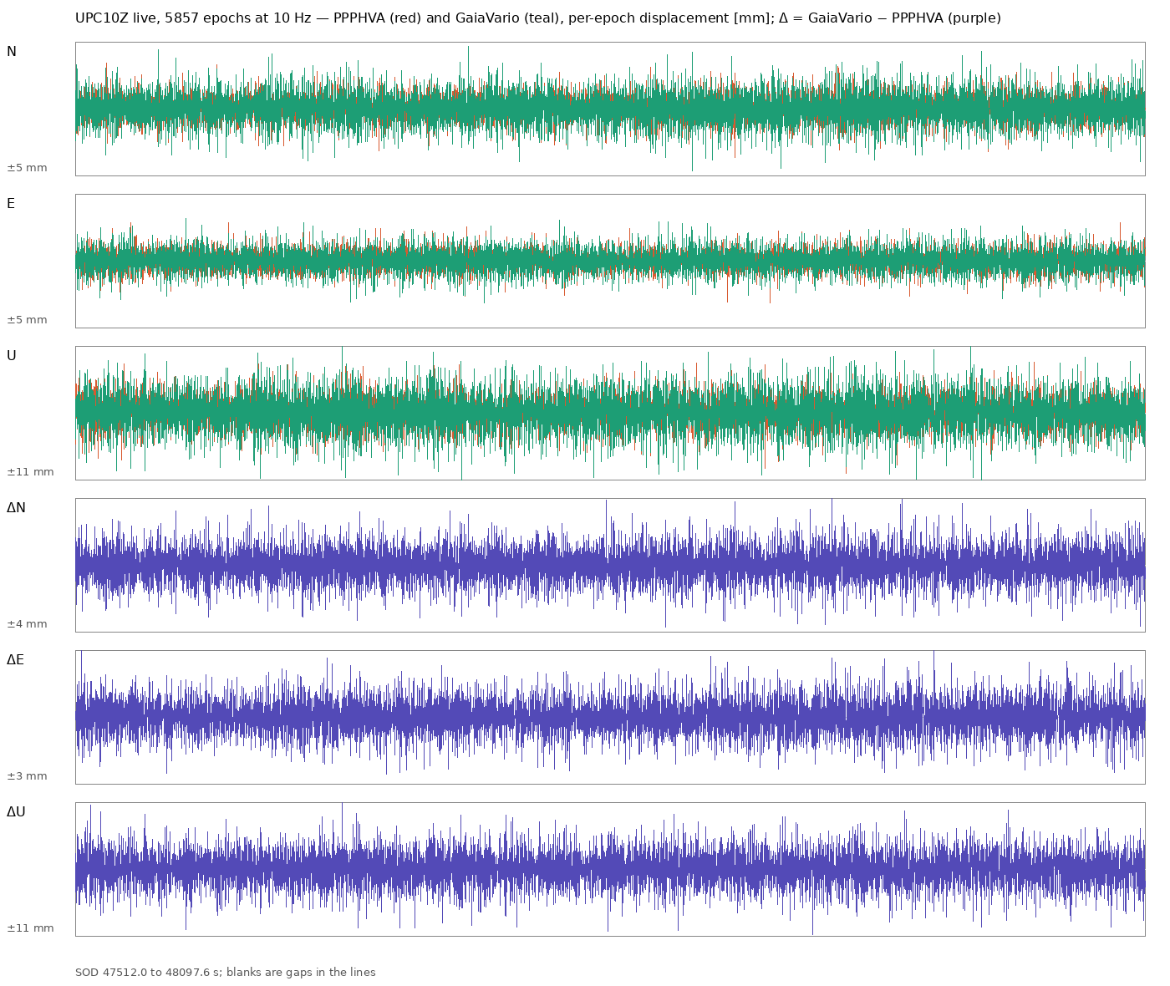
Figure: N, E, U per epoch of PPPHVA (red) and GaiaVario (teal), and the difference GaiaVario − PPPHVA (purple), in millimetres, 5857 epochs at 10 Hz.

3.4 Second run with GPS L2 = 2X (13:27–13:37 UTC, 5897 common epochs)
The adapter was changed to prefer the civil codes inside a frequency slot (GPS 2X before 2W, GLONASS 2C before 2P) and the run was repeated. Everything else was unchanged. The two runs are at different times, so PPPHVA's own numbers move too; the ratio GaiaVario / PPPHVA is the quantity to compare.
component | PPPHVA σ [mm] | GaiaVario σ [mm] | ratio run 2 | ratio run 1 | σ of difference [mm] | correlation
N | 1.02 | 1.14 | 1.12 | 1.32 | 1.06 | 0.54
E | 0.80 | 0.99 | 1.24 | 1.14 | 0.93 | 0.50
U | 2.66 | 3.05 | 1.15 | 1.36 | 2.82 | 0.55
Mean difference again below 0.05 mm in every component; maximum single difference 11.8 mm (U). GaiaVario used 32 satellites, PDOP 1.04, 0.23 ms per epoch; epochs with a rejected satellite 389 (7 %, was 10 %), with a slip-flagged satellite 240 (4 %, was 2 %: the 2X lock-time indicator resets more often than 2W on this receiver).
The L2C choice closed about half of the gap in N and U (from +32 / +36 % to +12 / +15 %) and nothing in E. The remaining 12–24 % is therefore not the signal; the weight model and the frequency pairs are next (section 5).
An interactive viewer of both runs with zoom, pan and per-window σ is in docs/GaiaVario_vs_PPPHVA_interactive.html (one self-contained file; GaiaVario.jl/tools/compare_html.py).

3.5 Weight models and frequency pairs, replayed on identical bytes (run 3, 13:43–13:53 UTC)
Run 3 repeated the live comparison and recorded the relay bytes (logs/rtcm_raw_20261029_154332.bin, 589 s). The recording was then replayed through GaiaVario with one option changed at a time (GaiaVario.jl/tools/replay_gaiavario.jl, variant_table.py); a replay of the unchanged options reproduces the live solutions bit for bit. PPPHVA over the same 5909 epochs: σ = 0.97 / 0.90 / 2.98 mm (N / E / U). The ratios below are GaiaVario / PPPHVA.
variant (one change from the base) | GaiaVario σ N / E / U [mm] | ratio N / E / U | σ of difference [mm] | sats | rejected
base: sin² weights, 2X, Galileo E1+E5a, BeiDou B1C+B2b or B1I+B2I | 1.11 / 1.03 / 2.90 | 1.14 / 1.15 / 0.97 | 1.01 / 1.01 / 2.21 | 31 | 0.5 %
weights sin(el) | 1.11 / 1.05 / 3.02 | 1.15 / 1.17 / 1.01 | 1.05 / 1.01 / 2.36 | 31 | 5.4 %
weights sin² capped above 30° | 1.13 / 1.09 / 3.20 | 1.17 / 1.21 / 1.07 | 1.07 / 1.04 / 2.36 | 31 | 0.3 %
weights sin² capped above 20° | 1.18 / 1.13 / 3.40 | 1.21 / 1.26 / 1.14 | 1.14 / 1.04 / 2.69 | 31 | 0.1 %
weights from C/N0 | 1.67 / 1.32 / 3.58 | 1.72 / 1.46 / 1.20 | 1.67 / 1.39 / 3.75 | 31 | 9.4 %
weights sin² × C/N0 | 1.81 / 1.35 / 4.19 | 1.87 / 1.49 / 1.41 | 1.82 / 1.41 / 4.27 | 31 | 0.4 %
Galileo E1+E5b | 1.09 / 1.03 / 2.87 | 1.12 / 1.14 / 0.96 | 1.04 / 1.04 / 2.33 | 31 | 0.4 %
Galileo E1+E5 (AltBOC) | 1.09 / 1.03 / 2.88 | 1.13 / 1.15 / 0.96 | 1.02 / 1.04 / 2.33 | 31 | 0.5 %
Galileo E1+E6 | 1.12 / 1.02 / 2.93 | 1.15 / 1.13 / 0.98 | 1.04 / 1.03 / 2.36 | 31 | 0.4 %
BeiDou B1I+B3I for all | 1.10 / 1.03 / 2.87 | 1.13 / 1.14 / 0.96 | 0.96 / 0.96 / 2.08 | 31 | 0.5 %
BeiDou B1I+B2 (B2I or B2a) | 1.14 / 1.11 / 3.02 | 1.17 / 1.24 / 1.01 | 1.03 / 1.07 / 2.12 | 28 | 0.2 %
BeiDou B2a before B2b | 1.10 / 1.04 / 2.87 | 1.14 / 1.15 / 0.96 | 1.01 / 1.02 / 2.18 | 31 | 0.5 %
GPS L1+L5 instead of L1+L2 | 1.26 / 1.13 / 3.19 | 1.30 / 1.26 / 1.07 | 1.16 / 1.10 / 2.66 | 26 | 0.4 %
no rejection (k = 100) | 1.11 / 1.04 / 2.92 | 1.14 / 1.15 / 0.98 | 1.01 / 1.01 / 2.21 | 31 | 0 %
elevation mask 15° | 1.12 / 1.03 / 2.97 | 1.15 / 1.15 / 1.00 | 1.01 / 1.02 / 2.24 | 30 | 0.5 %
single frequency (L1 / E1 / B1 only) | 0.70 / 0.58 / 2.39 | 0.72 / 0.65 / 0.80 | 0.68 / 0.67 / 1.86 | 31 | 0.4 %
What the table says:
- The weight model is not the cause. sin² (the 1/sin noise model) is the best of the six tried; capping the weights, sin(el) and any use of C/N0 are worse. The receiver's reported C/N0 carries no useful weighting information for this purpose.
- The frequency pairs are not the cause either. The Galileo choices differ by 1 %; B1I+B3I for all BeiDou satellites improves the agreement with PPPHVA (difference σ down 5–6 %) at the same noise, which suggests PPPHVA uses that pair, and is adopted as the new default. L1+L5 is worse (fewer satellites).
- Rejection and the mask do not matter in this quiet period.
- In run 3 GaiaVario's vertical is already at PPPHVA's level (ratio 0.97), and the horizontal excess is 14–15 %. That residual is not explained by any option tested here; the remaining differences are inside the estimator (treatment of the receiver clock per constellation and the a-priori weights per system) and are the next thing to study.
- Single-frequency is 20–35 % quieter than either dual-frequency engine. The ionosphere-free combination multiplies the phase noise by about three, while the ionospheric delay changes by far less than that between two epochs 0.1 s apart. For 10 Hz variometric work the combination costs more than it removes, which agrees with the GPS-only single-frequency choice made for UPA10Z in 2026. The price is a slow ionospheric drift that the seismic band does not see but an integrated displacement would, and sensitivity to scintillation. Whether a multi-frequency average gains a further √2 is tested in section 3.6 (it does not, on this receiver).

3.6 Observable: ionosphere-free, single frequency, or the mean of two (run 3 replay)
A third observable was added to the engine, the plain average of the two phases (mode = :mean), which keeps the single-frequency noise and would gain √2 if the two frequencies' noise were independent. Same recording, same 5909 epochs; PPPHVA σ = 0.97 / 0.90 / 2.98 mm.
observable | GaiaVario σ N / E / U [mm] | ratio to PPPHVA | σ of difference to PPPHVA [mm]
ionosphere-free (B1I+B3I default) | 1.10 / 1.03 / 2.87 | 1.13 / 1.14 / 0.96 | 0.96 / 0.96 / 2.08
single frequency, L1 civil code (1C / 1X / 2I) | 0.70 / 0.57 / 2.36 | 0.72 / 0.64 / 0.79 | 0.67 / 0.65 / 1.78
single frequency, L1 P code where present (1W) | 0.71 / 0.58 / 2.36 | 0.73 / 0.65 / 0.79 | 0.59 / 0.57 / 1.58
mean of the two frequencies | 0.72 / 0.59 / 2.37 | 0.75 / 0.66 / 0.80 | 0.73 / 0.71 / 1.97
- The mean brings nothing over L1 alone. The expected √2 does not appear, so the per-epoch noise of L1 and L2 is strongly correlated in this receiver (consistent with L2 tracking aided by L1, and with the ionosphere-free combination being only 1.6× noisier than L1 instead of the 3× that independent noise would give). The dominant per-epoch noise is therefore common to both carriers and no frequency combination removes it.
- The L1 P-code variant has the same noise and agrees better with PPPHVA (difference σ down 10–12 %), which indicates PPPHVA uses the 1W/2W observations.
Low-frequency behaviour. Integrating the per-epoch displacements over the 591 s of the window (a blank epoch adds nothing):
series | integrated N / E / U at the end [mm] | trend [mm/min] | max detrended excursion [mm] | σ of 60-s mean velocity [mm/s]
PPPHVA | +151 / −32 / +272 | +17.5 / −1.8 / +26.0 | 18 / 17 / 64 | 0.151 / 0.136 / 0.450
GaiaVario ionosphere-free | +62 / −17 / +33 | +8.2 / 0.0 / +1.6 | 16 / 17 / 37 | 0.110 / 0.120 / 0.246
GaiaVario single L1 | −117 / +12 / +69 | −10.2 / +2.6 / +6.4 | 18 / 12 / 34 | 0.103 / 0.109 / 0.204
GaiaVario mean | −182 / +28 / +69 | −16.9 / +4.2 / +6.8 | 20 / 11 / 33 | 0.106 / 0.108 / 0.196
Every variometric series drifts by tens to hundreds of millimetres in ten minutes; this is the known inability of the method to constrain low frequencies, not a property of one engine. PPPHVA drifts most in this window (+27 mm/min in U). The single-frequency series adds an ionospheric rate of the order of 0.1–0.3 mm/s with respect to the ionosphere-free one (opposite sign of the N trend), which is of the same size as the drift from the other error sources. At the periods of the seismic band (below about 100 s) none of this is visible; for an integrated displacement over minutes all of them need the PPP-AR fusion already planned.

3.7 Overnight run, 29 October 17:41 to 30 October 08:00 local (14.3 h, 514 713 epochs)
Same set-up as run 3, GaiaVario in single-frequency L1 mode (GV_MODE=single), through the GPS day boundary at 01:59:42 local (23:59:42 UTC). Both engines solved 99.99 % of the epochs (PPPHVA 2 blank, GaiaVario 1).
 | PPPHVA σ N / E / U [mm] | GaiaVario L1 σ N / E / U [mm] | ratio | σ of difference | correlation
whole night | 1.03 / 0.92 / 2.34 | 0.75 / 0.69 / 1.74 | 0.73 / 0.75 / 0.74 | 0.63 / 0.58 / 1.50 | 0.78 / 0.77 / 0.75
Hour by hour the ratio of the vertical σ stayed between 0.68 and 0.80; there was no hour in which the single-frequency solution was noisier than the ionosphere-free one, by day or by night. Mean difference below 0.02 mm in every component. GaiaVario used 31 satellites (PPPHVA 29), PDOP 0.93, 0.22 ms per epoch, no slip flagged all night, 0.2 % of epochs with a rejected satellite.
 | epochs with abs(d) > 1 cm (N / E / U) | largest single epoch
PPPHVA | 0 / 1 / 46 | +7 / +21 / −49 mm at GPS second-of-day 0.0
GaiaVario L1 | 0 / 0 / 0 | 9.9 mm (U)
GPS day boundary. At the first epoch of the new GPS day PPPHVA produced a one-epoch step of +7 / +21 / −49 mm (N / E / U); the epochs before and after are normal. GaiaVario gave +0.1 / −0.3 / −2.7 mm at the same epoch. This is the residue of spike family D (the 0.4.2 change removed the 72 km bursts of 0.4.1; a 5 cm step remains and passes the quality gate, whose step limit is 0.5 m). It is in the production stream every night at 23:59:42 UTC and is worth a Causes entry and a fix in the bridge or the engine. GaiaVario, which has no second-of-day arithmetic, is unaffected by construction.
Integrated displacement over the night. Summing the per-epoch increments, PPPHVA drifts +12.6 m / +0.5 m / +0.5 m (N / E / U) and GaiaVario L1 +2.3 m / +4.7 m / +0.1 m in 14.3 h; detrended excursions are 0.6–2.8 m for both. Neither series is a displacement at periods beyond minutes; this is the variometric method, not an engine property, and the reason for the PPP-AR fusion.
Interactive viewer of the whole night: docs/GaiaVario_vs_PPPHVA_overnight_interactive.html; figure docs/assets/GaiaVario_vs_PPPHVA_overnight_2026-10-30.png.

3.8 Post-fit residuals compared like for like, and PPPHVA in single-frequency mode (run 3 replay, 30 October)
The per-epoch log now carries, for either engine, the number of satellites kept and the post-fit RMS of their residuals, weighted (each engine's own unit-weight figure) and unweighted (comparable across engines). The run 3 recording was replayed through the same bridge, the same epoch grouping and the same 5950 epochs with four configurations:
configuration | sats kept | weighted RMS [mm] (p90) | unweighted RMS [mm] (p90) | σ N / E / U per epoch [mm] | epochs abs(U) > 1 cm | σ of 10-s sums N / E / U [mm]
PPPHVA DFV (ionosphere-free) | 30 | 1.70 (2.20) | 2.10 (2.80) | 0.97 / 0.90 / 2.98 | 11 | 2.9 / 3.2 / 6.9
GaiaVario dual (ionosphere-free) | 31 | 2.10 (2.70) | 2.60 (3.40) | 1.09 / 1.03 / 2.87 | 1 | 3.1 / 4.0 / 6.6
PPPHVA SFV (L1) | 31 | 1.40 (1.90) | 1.80 (2.50) | 0.83 / 0.70 / 2.55 | 0 | 2.1 / 2.8 / 5.3
GaiaVario single (L1) | 31 | 1.40 (1.80) | 1.80 (2.50) | 0.70 / 0.57 / 2.36 | 0 | 2.7 / 3.6 / 5.9
Agreement within an observable: GaiaVario dual − PPPHVA DFV σ 0.96 / 0.96 / 2.08 mm (correlation 0.52–0.75); GaiaVario single − PPPHVA SFV σ 0.30 / 0.27 / 0.69 mm (correlation 0.93–0.96).
- Residuals. With the ionosphere-free observable GaiaVario's post-fit residuals are 24 % larger than PPPHVA's (2.6 against 2.1 mm unweighted), the same excess as in the displacement noise; with L1 the two engines have identical residuals (1.8 mm) and agree epoch by epoch at the 0.3 mm level. The PPPHVA σ̂ shown in the status line (2.4 mm) is a windowed statistic of a different kind and must not be compared with GaiaVario's RMS.
- PPPHVA in SFV mode was not part of the earlier comparisons. Per epoch it is 15–20 % noisier than GaiaVario single, but when the increments are summed over 10 s it is quieter (2.1 / 2.8 / 5.3 against 2.7 / 3.6 / 5.9 mm): PPPHVA's successive increments cancel better, which is the telescoping effect the shaking-table work found on other receivers for the ionosphere-free observable, now visible on the NET-G5 in L1. Switching the production profile from DFV to SFV would alone have removed most of the difference between the engines; the GPS day-boundary step would have remained.
- Consequences: (1) the comparison on the shaking table should be repeated with PPPHVA SFV; (2) GaiaVario's low-frequency behaviour in L1 is the next thing to improve (which satellites enter and leave the fit, and how the weights change between consecutive epochs), with the summed-increment noise as the metric, not the per-epoch σ.

4. Reading of the results
The sections above were written as the work progressed; this section reads them together.
- GaiaVario works on real data for all four constellations. Formal and empirical σ agree, the ephemeris adapter and the epoch grouping are right, and it solves 99.99 % of the epochs at 0.2 ms each.
- The noise comparison depends on the observable, not on the engine. (Qualification added 30 October: every "PPPHVA" figure in sections 3.1 to 3.7 is PPPHVA in its production DFV mode; PPPHVA in SFV mode, measured in 3.8 and on the shaking table, is as quiet as GaiaVario L1 and integrates better over 10 s.) With the same ionosphere-free observable as PPPHVA (runs 1–3), GaiaVario was 14–35 % noisier; the GPS L2C choice removed half of that, the weight model and the frequency pairs changed nothing, and a 14 % horizontal excess remained (section 3.5). With the single-frequency L1 observable (section 3.6 and the overnight run of section 3.7) GaiaVario is 25–27 % quieter than PPPHVA in every component and every hour of the night, and produced no epoch above 1 cm in 14 hours against 47 for PPPHVA. The two statements are not in contradiction: the ionosphere-free combination multiplies the receiver's phase noise by 1.6–3 while removing an ionospheric change that is negligible between epochs 0.1 s apart. GaiaVario can use L1 alone because its design does not rely on the combination; PPPHVA as translated runs in the dual-frequency mode.
- The remaining dual-frequency excess (14 % horizontal) is unexplained and no longer matters for production if the L1 observable is used; it stays an open question about the estimator (receiver-clock and inter-system handling).
- Failure modes that motivated GaiaVario. The overnight run covered one GPS day boundary and fourteen hourly GPS changeovers: PPPHVA still steps by 5 cm vertically at the day boundary (family D residue), GaiaVario does not; no changeover spike was seen in either engine. The σ̂ poisoning and the Galileo 10-minute family need a disturbed period to be tested.
- Low frequencies. Both engines drift by metres over a night when their increments are summed. This is the method; the PPP-AR fusion remains the plan for displacement at periods beyond a minute.

5. Next steps
- Observable: single-frequency L1 for the seismic channel (default mode = :single of GaiaVario, decided 2026-10-29; superseded on 2026-10-30 by :l1gf, L1 with the smoothed geometry-free correction, which equals L1 in a quiet ionosphere); the ionosphere-free mode stays available. Confirm on a disturbed-ionosphere day.
- Production: decide whether to gate the GPS day-boundary epoch in the bridge (one-epoch withhold at second-of-day 0.0) while PPPHVA is the production engine.
- Plug-in API in the platform (engine = "ppphva" | "gaiavario"), the GaiaVario adapter and a private PPPHVA adapter, so both engines run from one decoder and one epoch grouping with side-by-side logging.
- 48-hour dual-engine run through the relays (two day boundaries, the hourly GPS and 10-minute Galileo changeovers), then the comparison report of the plan (section 3 of GaiaVario_Engine_Plan.md) and the decision on the production engine.
- Open questions kept: the 14 % horizontal excess of the dual-frequency GaiaVario; the horizontal amplitude deficit of all engines on the shaking table (separate note).

6. Files
- NtripClient.jl/logs/UPC10Z_cmp_20261029_151117.txt, PPPHVA per-epoch log (SOD, satellites, dX dY dZ, clocks).
- NtripClient.jl/logs/gaiavario_cmp_20261029_151116.csv, GaiaVario per-epoch solutions (N E U, satellites, PDOP, RMS, formal σ, solve time, rejected and slipped satellites, clocks).
- GaiaVario.jl/tools/compare_live.jl, GaiaVario.jl/tools/compare_report.py, the run and the statistics.
- docs/assets/GaiaVario_vs_PPPHVA_live_2026-10-29.png, the figure.

