# COMP1003 – Lab2 – Template

**Team Name:**

## 2) Diagram Chosen: Sequence diagram

**Describe what this diagram is trying to represent:**

In the diagram we are trying to show the approval process for a single student module application, including all of the optional approvals. We chose to use a sequence diagram for this because this part of the system requires a large number of actors and systems to interact in a specific order. Modelling that and ensuring that we don’t miss out any important systems and interactions is important to ensure that we fully understand the approval process and don’t have to worry later on in the process on missing out a step.

**Diagram(s):**

*[You can expand each section to be as big as you like/need, for e.g. including multiple diagrams of the same type. It doesn’t have to stay to one page per type of diagram.]*

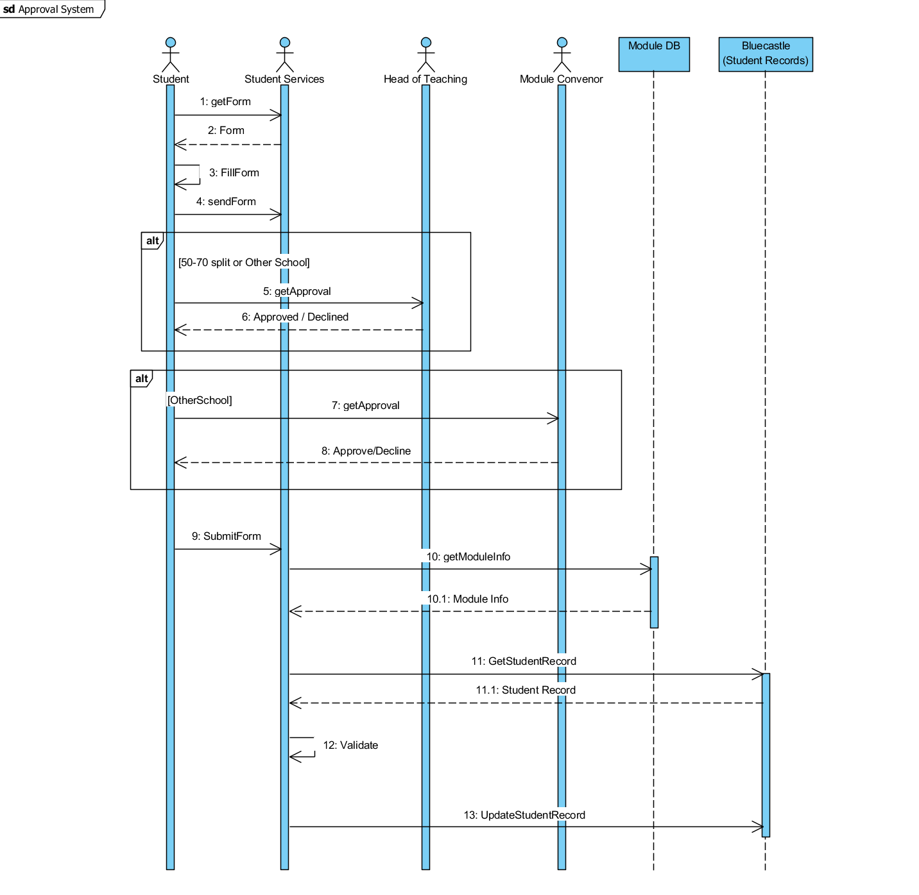

**Notes/Explanations/Unanswered Questions/Most Important Details:**

We start this sequence diagram assuming that the current approval process handles the student’s application in the steps shown by the activity diagram. From there, it must get approval from the necessary student services.

We have some unanswered questions and assumptions we made while making our diagram

* Where is all the data necessary to work out what approvals are needed for a student’s application? We assumed that all of the student data is in bluecastle and the data for the modules are in a separate module database.
* The text used in the textual analysis explains what happens during the approval process, but doesn’t explain what happens if an application is not approved by head of teaching or a module convenor. What should happen in this case?
* Can Student Services decline an application for other reasons like timetabling? We assumed no.

## 2) Diagram Chosen:

**Describe what this diagram is trying to represent:**

In the activity diagram we were trying to do a more general overview of the entire process. Because we are trying to make it more general, we decided to abstract away the approval process because we have already done that area in the sequence diagram.

**Diagram(s):**

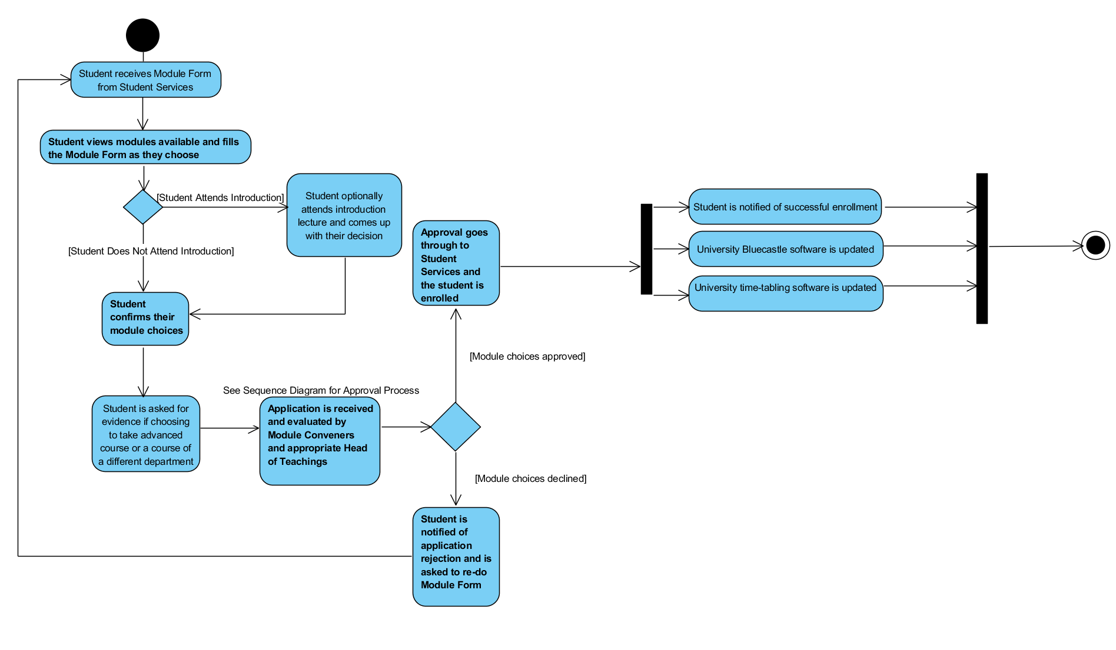

**Notes/Explanations/Unanswered Questions/Most Important Details:**

We assumed that the student knows already if there are any documents they need for proof of competency. Is this the case or do they go for a meeting, find out and then bring the proof at another meeting?

We again assumed that student services cannot decline a request, is this the case?

Should the student be notified of approval at the end of the process? We assumed so.

Are there any other services that need to be updated with enrolment for a module? We assumed that the two mentioned are the only ones that need to be updated.

We also assumed that there is a way to contact the student if further proof is needed as well as when refusal/approval is made. On top of this, we assumed that the student simply restarts the process on refusal.

## 3) Diagram Chosen: Use case diagram

**Describe what this diagram is trying to represent:**

**Diagram(s):**

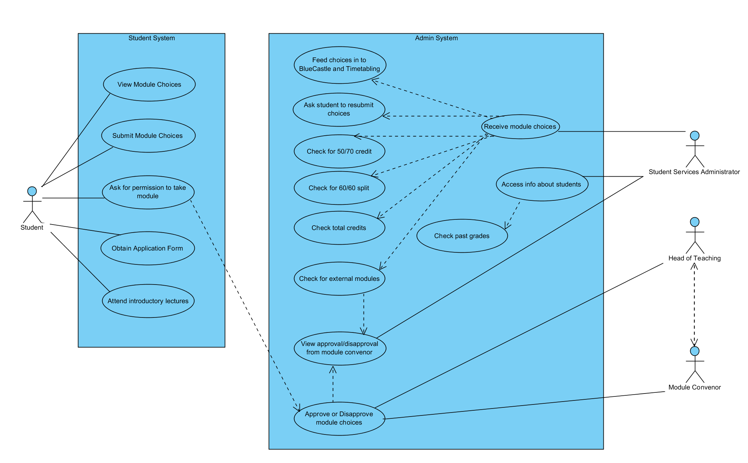

**Notes/Explanations/Unanswered Questions/Most Important Details:**