# COMP1003 – Coursework 01 - Final document

**Team Name: SegFault**

**1) Textual Analysis (Actors and use cases)**

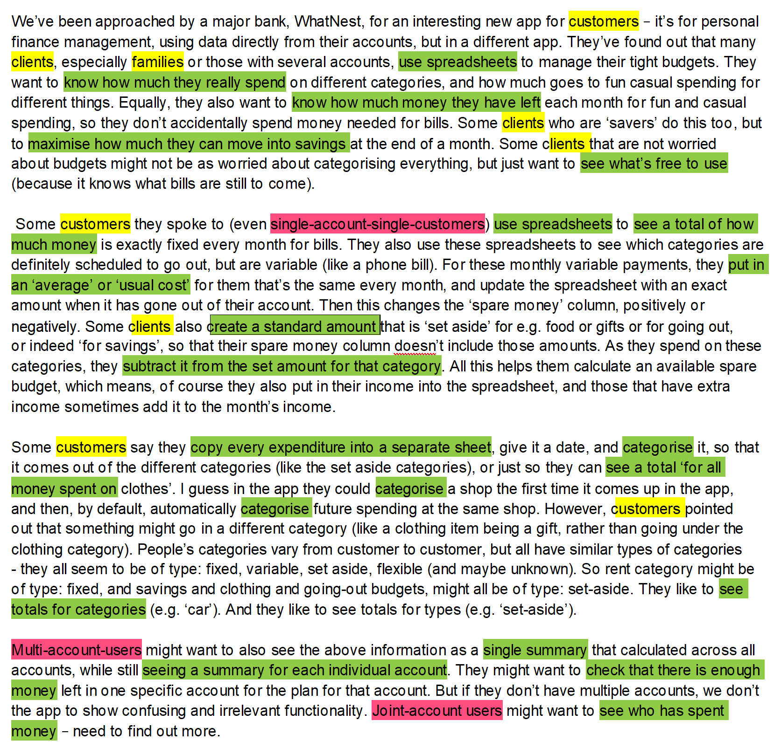

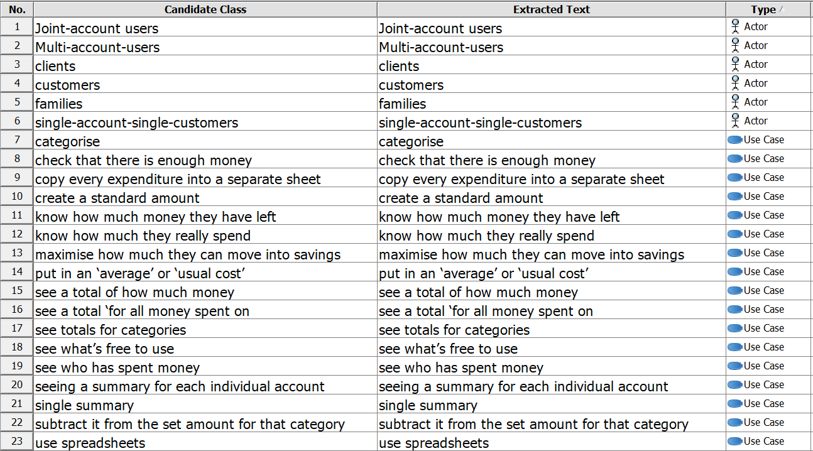

**Notes/Explanations/Unanswered Questions/Most Important Details:**

**Notes**

* Actors are highlighted in yellow, types of actors in magenta and use-cases in light green.
* Customers and clients are the same thing. Family is just a type of multi account user.
* The actors highlighted in pink aren’t actors but types of actors (types of users). So multi-account-users, joint-account-users and single-account-users are all used as actors to improve the use case diagram.
* Many use cases can possibly be combined as one but we left several of them in to give us the option to remove any unnecessary ones in the future.

**Unanswered**

* Need to know what else do users want to do. Joint-account-users probably also want to know other things such as how much money is in each account and/or where did they spent it.
* Will the app have any impact on the user accounts (i.e set a hard limit on spending within a certain category)? Does it have access to accounts or is it purely a read-only to see their spending.

**Assumptions**

* We assumed that the app is only for statistics. The clients can’t send/receive money through the app.
* Assumed the app has access to certain details from the users banking app i.e money movement within their account(s).

## 2) Diagram Chosen: User Story

**Reason for choice:**

Looking at the brief given, there are a large number of varying types of user, and they all have different reasons for tracking their finances. User stories ensure that we keep these wide number of use cases in mind during specification, development and onwards, and do not forget an important use case/reason for using the system

**Diagram(s):**

* As a customer, I want to be able to get overviews on how much I have spent on different categories, as it lets me know if I have to balance my spending on a particular section of my lifestyle.
* As a customer, I want to know how much money I have left over after upcoming expenditures as it lets me know if I have extra spending money or not.
* As a customer, I want to add my spending to the tracking sheet so that the sheet is kept up to date and there aren’t any issues with me running out of money. (budget)
* As a customer, I want to automatically have expenditures categorized where possible because it means the process is faster for me, as it is one less piece of information for me to fill in.
* As a customer, I want my spending categorized so that I can easily maintain a balance between different expenditures such as groceries, clothing, etc.
* As a customer, I want to be able to add upcoming expenditures to the tracking sheet so that they are accounted for in how much money I have left over, preventing overspending.
* As a customer, I want to be able to track future variable spending by providing average costs because it means that I can get an estimate of what is left over.
* As a customer, after I know the exact amount of my variable spending I may want to update it in the sheet so that I know more accurately what I have left.
* As a customer, I want to be able to add new custom categories because I may have different spending habits to the average person.
* As a customer, I may not want to categorize spending at all, because I find it has no benefits to my budgeting abilities for the time spent.
* As I customer I want to quickly be able to check how much money I have to spend after money for bills goes out of my account.
* As a multi-account-user I want to be able to categorize spending between multiple accounts - bills can be coming out of multiple accounts.
* As a multi-account-user I want to be able to see my total expenditure between my accounts as it helps me see how much money I’m spending.
* As a multi-account-user I want to be able to see a summary for each individual account such that I can find out where the money was spent.
* As a joint-account user I want to be able to see how much total money we have as a family (and how much is able to be saved monthly) in order effectively plan for a summer vacation.

**Notes/Explanations/Unanswered Questions/Most Important Details:**

How are secondary income streams like mileage/business expenditure handled? For example, if they spend £50 on fuel for a business trip but they are going to be given that money back, how would the system know that it shouldn’t be taken out of their budget, or does it?

How does the current system know their income? This may change depending on the type of employee, for example self-employed, hourly and salaried jobs all have wildly different types of income and may need to be handled differently.

What should be tracked for joint-account users. How do you know who spent what, is it an honour system or is there another method at play? Should you be able to change the spender or have it as a shared expenditure rather than a discrete expenditure for one person? For example, if there were Two people living together and the sink broke, would they be able to have it as a shared expenditure between the two of them or would it be marked down as being an expenditure of the person who paid the plumber?

Should the customer be able to create their own categories? If they want a “hobby” category, or similar. Should the software come pre-built with a wide variety of options, or have the ability to have custom “create-your-own” style?

Will the software be able to categorize based on who spent money in a joint-account? If card x spend £xyz vs if card y spent £xyz.

## 3) Diagram Chosen: Use case diagram

**Reason for choice:**

We chose to use a use-case diagram because there are a large number of actions that are done by multiple actors. Furthermore, some actors are supersets of others, and as such inherit actions. Rather than repeating ourselves, we decided to use a diagram that allows for us to see this inheritance.

In addition to this, it gives us very discrete and separated requirements that can be easily tabulated further down the line.

**Diagram(s):**

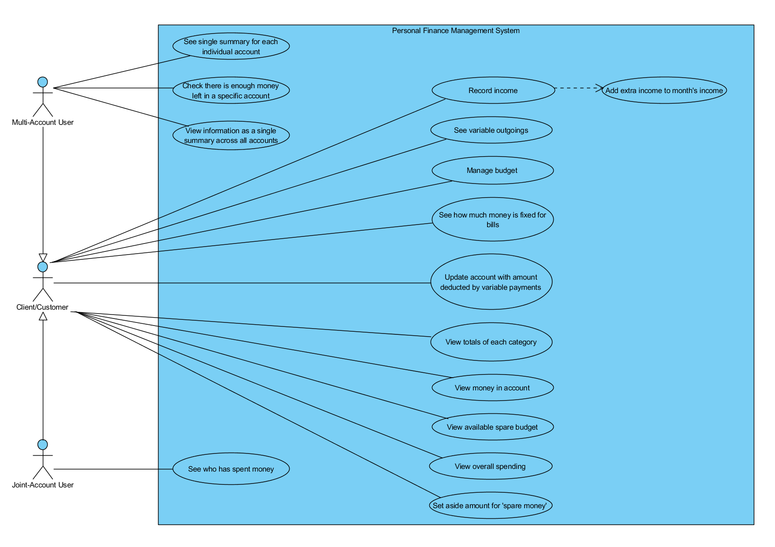

**Notes/Explanations/Unanswered Questions/Most Important Details:**

* We assumed that the system would be able to record income as it is essential for budgeting and calculating spare money. Different types of income may need to be handled differently, how should this be done? It has been left intentionally vague so as to allow extrapolation in further discussions with the client.
* We have represented a single-account-single-user by labelling the actor as a ‘Client/Customer’. Other ones have the same functionality as this type of account, with additional features.
* We assumed that joint-account users can see who spent how much money
* How does the current system know their income? This may change depending on the type of employee. For example, self-employed, hourly and salaried jobs all have wildly different types of income and may need to be handled differently.