# **Access Control Lists**

* An ACL identifies traffic based on characteristics of the packet such as source IP address, destination IP address, port number
* The router or switch can take an action based on the result of the ACL
* ACL’s are supported on both routers and switches. I will refer to ‘routers’ throughout this section

**Security**

* The original use of ACLs was as a security feature to decide if traffic should be allowed to pass through the router
* By default a router will allow all traffic to pass between its interfaces
* When ACLs are applied the router identifies traffic and then decides if it will be allowed or not
* ACL’s are also used in other software policies when traffic has to be identified, for example:
  + Identify traffic to give better service to in a QoS Quality of Service policy
  + Identify traffic to translate to a different IP address in a NAT Network Address Translation policy
* Access Control Lists are made up of Access Control Entries which are a series of permit or deny rules
* Each ACE is written in a separate line

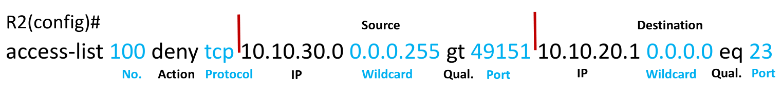

*R1(config)# access-list 100 deny tcp 10.10.10.10 0.0.0.0*

*gt 49151 10.10.50.10 0.0.0.0 eq 23*

*R1(config)# access-list 100 permit tcp 10.10.10.0*

*0.0.0.255 gt 49151 10.10.50.10 0.0.0.0 eq 23*

*R1(config)# access-list 100 deny tcp 10.10.20.10 0.0.0.0*

*gt 49151 10.10.50.10 0.0.0.0 eq 23*

*R1(config)# access-list 100 permit tcp 10.20.10.0*

*0.0.0.255 gt 49151 10.10.50.10 0.0.0.0 eq 23*

# **Standard vs Extended ACLs**

R1(config)#access-list ?

<1-99> IP standard access list

<100-199> IP extended access list

<1300-1999> IP standard access list (expanded range)

<2000-2699> IP extended access list (expanded range)

* Standard ACLs reference the source address only
* Extended ACLs check based on the protocol, source address, destination address, and port number
* Standard ACL Range: 1 – 99
* Extended ACL Range: 100 - 199
* Cisco expanded the original ACL Ranges
* Standard: 1-99, 1300-1999
* Extended: 100-199, 2000-2699

*R1(config)# access-list 1 deny 10.10.10.10 0.0.0.0*

*R1(config)# access-list 1 permit 10.10.10.0 0.0.0.255*

* The default wildcard mask for a Standard ACL is 0.0.0.0, meaning an individual host address.
* *R1(config)# access-list 1 deny 10.10.10.10*
* Do not forget to enter the wildcard when specifying an IP subnet
* *R1(config)# access-list 1 deny 10.10.10.0*

Extended  
*R1(config)# access-list 100 deny tcp 10.10.10.10 0.0.0.0*

*gt 49151 10.10.50.10 0.0.0.0 eq 23*

*R1(config)# access-list 100 permit tcp 10.10.10.0*

*0.0.0.255 gt 49151 10.10.50.10 0.0.0.0 eq telnet*

There is no default wildcard mask for Extended ACLs

# **Named ACLs**

* You can now reference ACLs by number or by a name
* Named ACLs begin with the command ‘ip access-list’ instead of ‘access-list

*R1(config)#ip access-list standard Flackbox-Demo*

*R1(config-std-nacl)#deny 10.10.10.10 0.0.0.0*

*R1(config-std-nacl)#permit 10.10.10.0 0.0.0.255*

# **ACL Syntax**

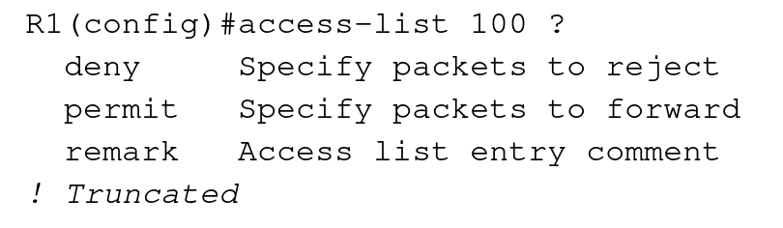

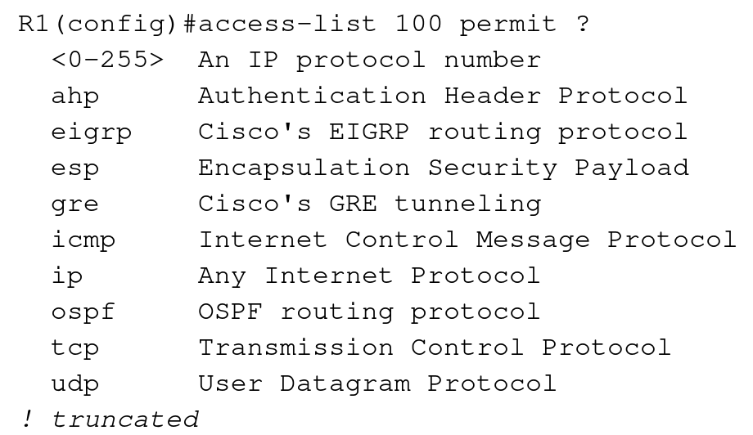

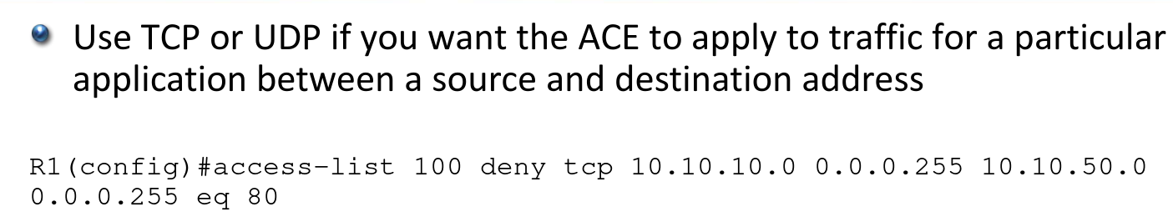

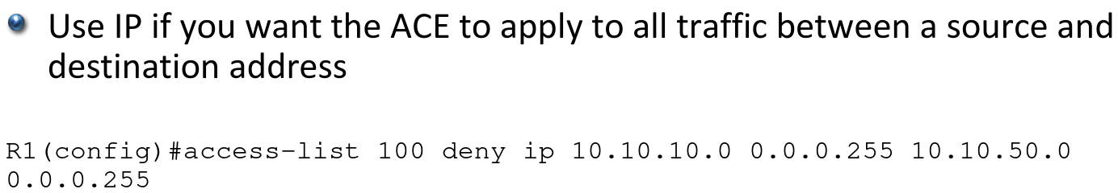

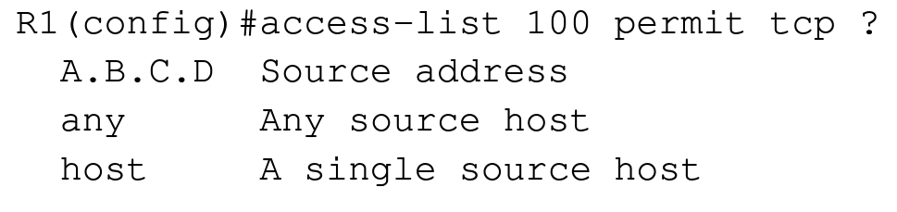

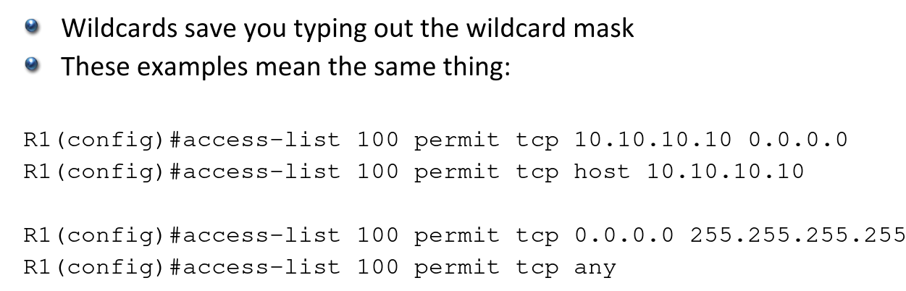

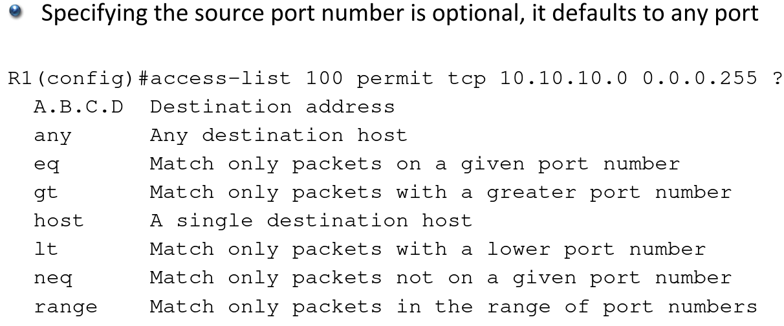

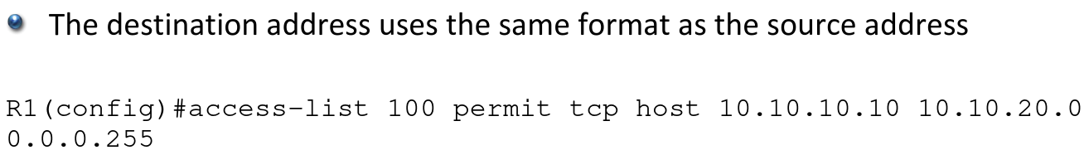

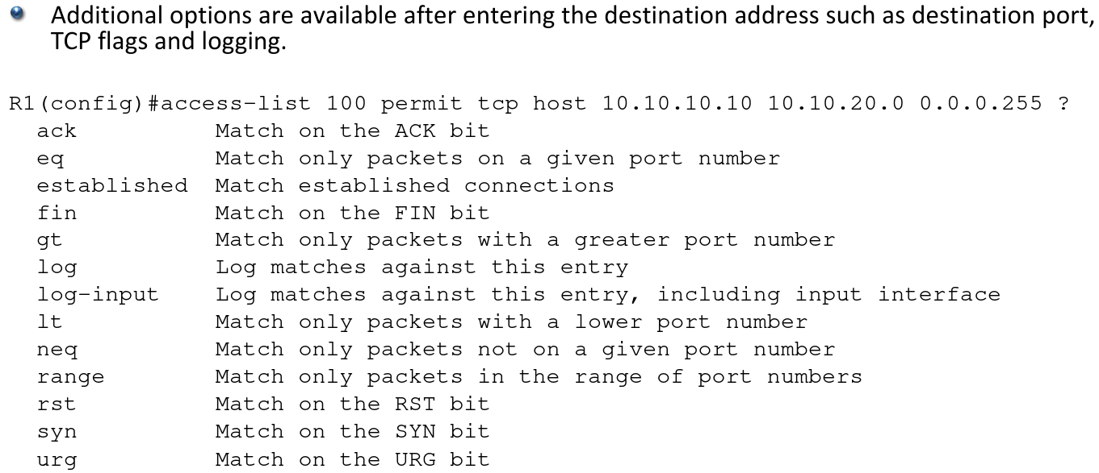

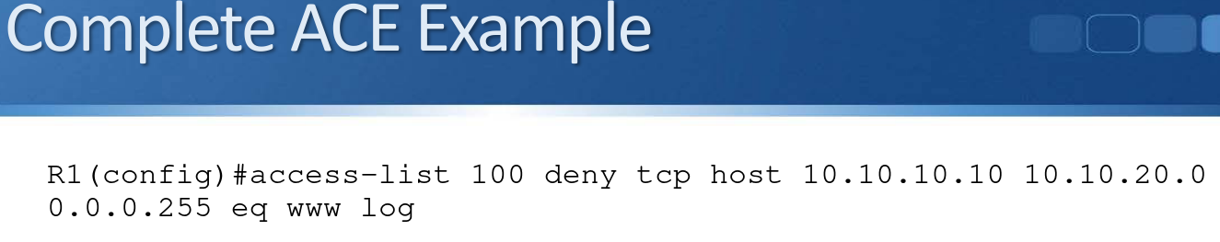

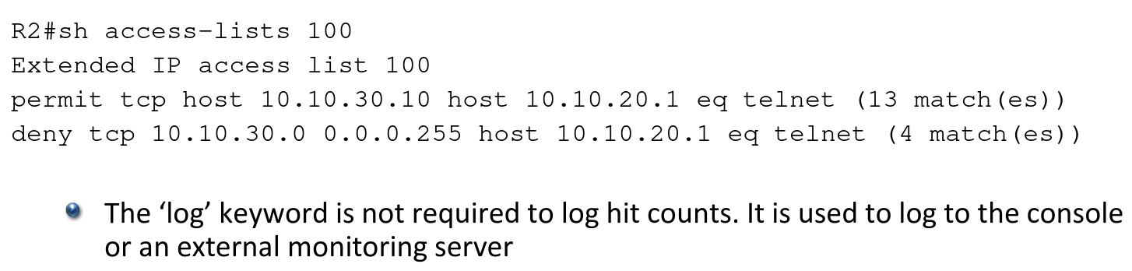

# **ACL Operations/Groups**

* ACLs are applied at the interface level with the Access-Group command
* ACLs can be applied in the inbound or outbound direction
* You can have a maximum of one ACL per interface per direction
* You can have both an inbound and an outbound ACL on the same interface, but not 2 inbound or outbound ACLs
* An interface can have no ACL applied, an inbound ACL only, an outbound ACL only, or ACLs in both directions

Access-Group Configuration

*R1(config)# interface GigabitEthernet0/1*

*R1(config-if)# ip access-group 100 out*

*R1(config-if)# ip access-group 101 in*

*R3#show ip interface f1/0 | include access list*

*Outgoing access list is 100*

*Inbound access list is 101*

(‘not set’ if ACL is not applied)

* The ACL is read by the router from top to bottom
* As soon as a rule matches the packet, the permit or deny action is applied and the ACL is not processed any further
* The order of rules is important

**This will deny 10.10.10.10 but permit the rest of the 10.10.10.0/24 subnet**

*R1(config)# access-list 1 deny host 10.10.10.10*

*R1(config)# access-list 1 permit 10.10.10.0 0.0.0.255*

**This will permit all of the 10.10.10.0/24 subnet including 10.10.10.10**

*R1(config)# access-list 1 permit 10.10.10.0 0.0.0.255*

*R1(config)# access-list 1 deny host 10.10.10.10*

ACEs are automatically numbered in increments of 10

*R1#sh access-lists 110*

*Extended IP access list 110*

*10 deny tcp host 10.10.10.10 host 10.10.50.10 eq telnet*

*20 permit tcp 10.10.10.0 0.0.0.255 host 10.10.50.10 eq telnet*

*30 deny tcp host 10.10.20.10 host 10.10.50.10 eq telnet*

*40 permit tcp 10.20.10.0 0.0.0.255 host 10.10.50.10 eq telnet*

**Injecting ACEs in an Existing ACL**

Support for injecting ACEs in an existing ACL started in Named ACLs but is

also supported in Numbered ACLs now

*R1(config)#ip access-list extended 110*

*R1(config-ext-nacl)#15 deny tcp host 10.10.10.11 host 10.10.50.10 eq telnet*

*R1#sh access-lists 110*

*Extended IP access list 110*

*10 deny tcp host 10.10.10.10 host 10.10.50.10 eq telnet*

*15 deny tcp host 10.10.10.11 host 10.10.50.10 eq telnet*

*20 permit tcp 10.10.10.0 0.0.0.255 host 10.10.50.10 eq telnet*

*30 deny tcp host 10.10.20.10 host 10.10.50.10 eq telnet*

*40 permit tcp 10.20.10.0 0.0.0.255 host 10.10.50.10 eq telnet*

**Implicit Deny All**

* There is an implicit ‘deny any any’ rule at the bottom of ACLs
* If an ACL is not applied to an interface, all traffic is allowed
* If an ACL is applied, all traffic is denied except what is explicitly allowed
* Traffic from 10.10.10.0/24 will be permitted, everything else is denied

*R1(config)# access-list 1 permit 10.10.10.0 0.0.0.255*

Many organisations include an explicit deny all at the end of ACLs to

log illegal traffic

*R1(config)# access-list 1 permit 10.10.10.0 0.0.0.255*

*R1(config)# access-list 1 deny any log*

**Explicit Permit All**

* If an ACL is applied, all traffic is denied except what is explicitly allowed
* If you want to reverse this so that all traffic is permitted except what is explicitly denied, add a permit all statement to the end of the ACL
* Traffic from 10.10.10.0/24 is denied, everything else is permitted

*R1(config)# access-list 1 deny 10.10.10.0 0.0.0.255*

*R1(config)# access-list 1 permit any*

**Traffic Sourced from Router**

* ACL’s applied to an interface do not apply to traffic which originates from the router itself
* The hosts in the 10.1.1.0/24 subnet cannot Telnet to R2
* An administrator can Telnet to R2 from the CLI on R1

*R1(config)# access-list 100 deny tcp any any eq 23*

*R1(config)# interface f1/0*

*R1(config)# ip access-group 100 out*