# **LAN, WAN and MAN Definitions**

* A Local Area Network (LAN) is a network that connects computers and other devices in a relatively small area, typically a single building or a group of buildings.
* A Wide Area Network (WAN) is a geographically distributed network that connects multiple Local Area Networks together.
* A Metropolitan Area Network (MAN) is a network that connects computers and other devices in a geographic area larger than a LAN but smaller than a WAN.

# **Private vs VPN Connections – Private Networks**

* A private network uses links which are dedicated for an individual organisation.
* Local Area Networks are private networks.
* Wide Area Networks can also use physical links which are dedicated for an individual organisation.
* A **Virtual Private Network (VPN)** provides a virtual tunnel between private networks across a shared public network such as the Internet.
* Traffic travelling over the tunnel is encrypted and only readable by the authorised users on both sides.
* Users can share data over the tunnel as if they were connected with a dedicated private link.
* VPNs allow an organisation to use the same physical links for connectivity to the Internet and between offices.
* Because they use shared infrastructure, VPN connections are typically less expensive than dedicated physical links.

## **Site-to-Site VPN**

* Site to Site VPN connections are terminated on a router or firewall in each office.
* Software does not need to be installed on user desktops.
* IPsec is typically used for encryption.

## **Remote Access VPN**

* Remote Access VPN connections are between a router or firewall in the office and VPN software installed on an individual user’s device.
* The user can access the VPN from anywhere with Internet connectivity.
* They usually use SSL (sometimes IPsec) for encryption.

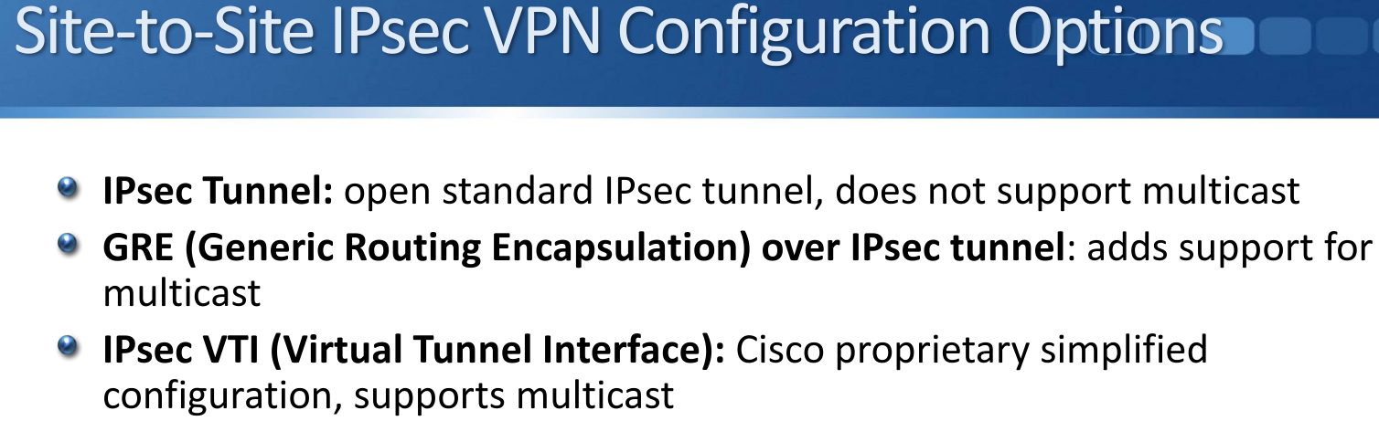

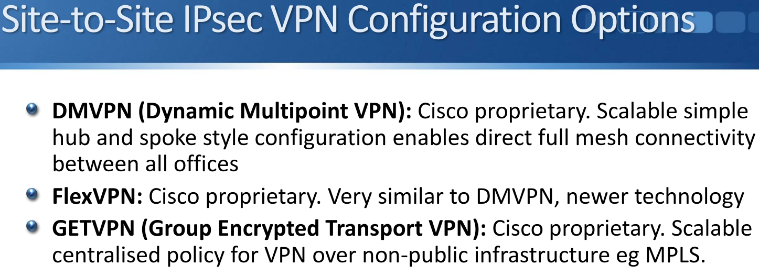

# **WAN Connection Options**

* Multiple options are available for connecting geographically dispersed offices together.
* Not all options are available in all locations.
* What is commonly used in one region may be considered legacy in another.
* Different providers may use different terminology. I’ll use the terminology used by Cisco for the CCNA exam

**Primary WAN Connectivity Options**

* Leased Line
* MPLS Multi Protocol Label Switching
* Satellite
* The service provider will typically provide an SLA (Service Level Agreement) with guarantees for uptime and traffic delay and loss on the link.
* Leased lines and Satellite can be used for connectivity to the Internet, for direct connectivity between offices, and/or connectivity between offices over VPN.
* MPLS uses a shared core infrastructure at the service provider. It can be used for connectivity to the Internet and/or connectivity between offices over VPN.

**Optical Fiber**

* Optical fiber is more suitable for long distances than copper wire
* It is commonly used for service provider backhaul connections, but can also be offered to their customers
* FTTx services:
  + Fiber to the Home
  + Fiber to the Premises
  + Fiber to the Building
  + Fiber to the Neighborhood

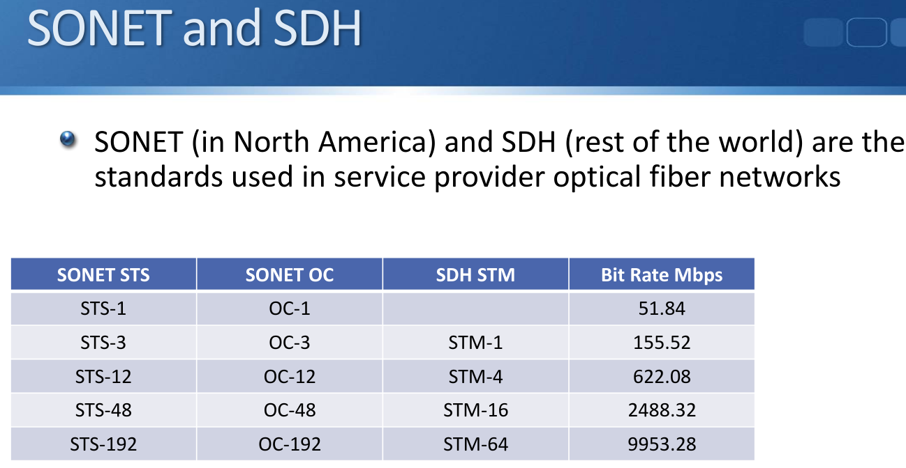

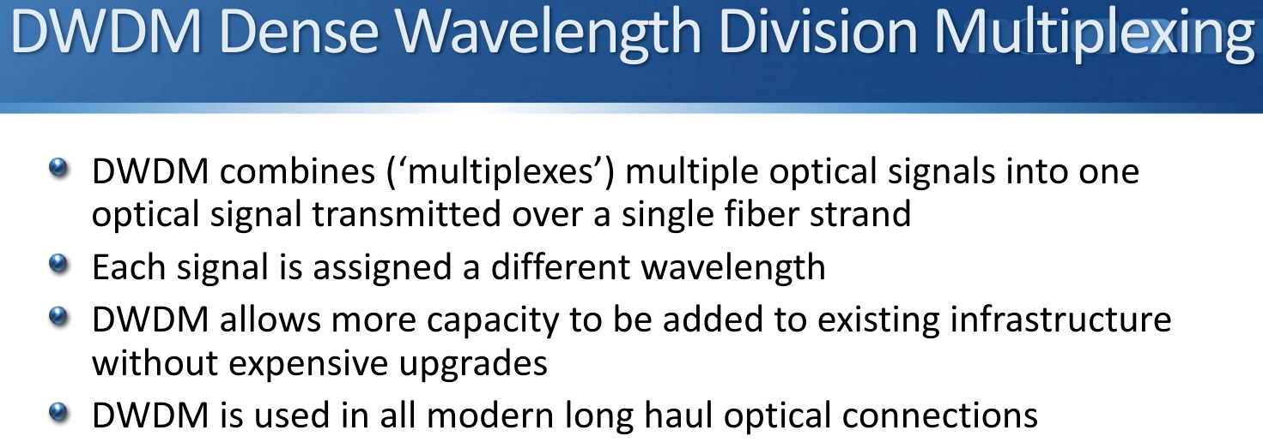

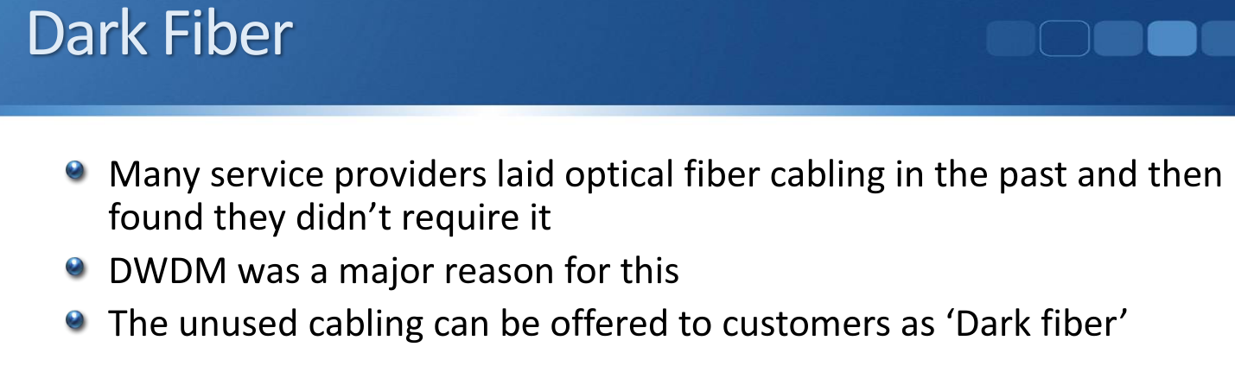

**WAN Backup and Small Office Solutions**

* Less expensive options often aimed at home user Internet access can be used as Internet VPN WAN backup options in corporate environments
* There will typically be no corporate level SLA with these services
* These can be used as the primary WAN connection method to the corporate network from smaller offices and for home users
  + DSL Digital Subscriber Line
  + Cable
  + Wireless eg 4G

**Legacy WAN Connectivity Options**

* PSTN Public Switched Telephone Network
* ISDN Integrated Services Digital Network
* Frame Relay
* ATM Asynchronous Transfer Mode
* X.25

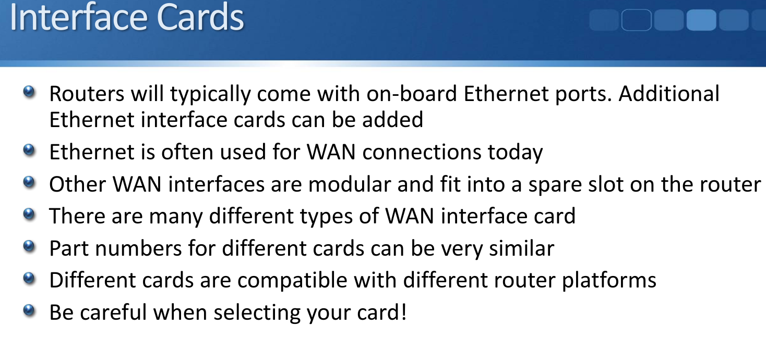

# **Leased Lines**

* A leased line is a dedicated physical connection between two locations.
* It has fixed, reserved bandwidth which is not shared with anyone else.
* The same bandwidth is available in both directions.
* The company may own the cable infrastructure but more commonly it is leased from a service provider for a monthly fee, hence the name ‘leased-line’.
* The first location is typically a corporate office.
* The second location is typically:
  + Another corporate office, providing point to point connectivity between the two offices
  + A data centre that’s connected to the company’s existing Wide Area Network, providing multipoint connectivity between offices
  + A data centre that’s connected to the Internet, providing Internet connectivity, and optionally corporate office connectivity over Internet VPN

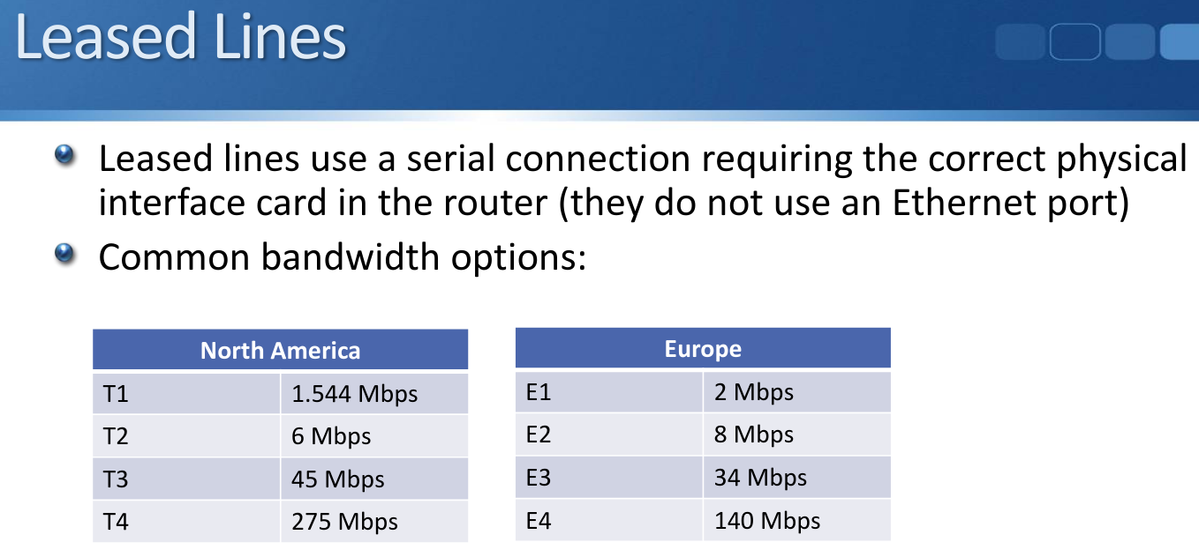

**Leased Line Benefits and Drawbacks**

* Leased lines have fixed, reserved bandwidth which is not shared with anyone else.
* The service provider will typically provide an SLA (Service Level Agreement) with guarantees for uptime and traffic delay and loss on the link.
* Leased lines are typically more expensive than the other options.
* There is usually a longer lead time for installation.
* Copper or fiber Ethernet connectivity options to the CPE (Customer Premises Equipment) are becoming more common than serial leased lines

# **Satellite**

* Satellite connections share the same characteristics as cabled leased lines
* They are typically expensive and low bandwidth
* They may be the only option in hard to reach areas

# **Phone Lines**

(Not asked in CCNA)

* T1 and E1 links were also commonly used for connections to the PSTN (Public Switched Telephone Network)
* The analog phone cable to your house is capable of carrying one call
* A T1 digital line is capable of carrying 24 concurrent TDM calls, an E1 can carry 30 calls
* VoIP (Voice over IP) using SIP (Session Initiation Protocol) signalling over Ethernet WAN connections to the Telco are popular today

# **MPLS (Multi Protocol Label Switching) VPN**

* WAN connectivity can be provided over an MPLS infrastructure, usually operated by a service provider
* Traffic from multiple customers can travel over the provider’s shared MPLS network, so this is a VPN service
* Different levels of SLA for uptime and traffic delay and loss are often available at different price points
* Ethernet connections are typically used to the customer router
* MPLS VPNs provide a full mesh topology by default

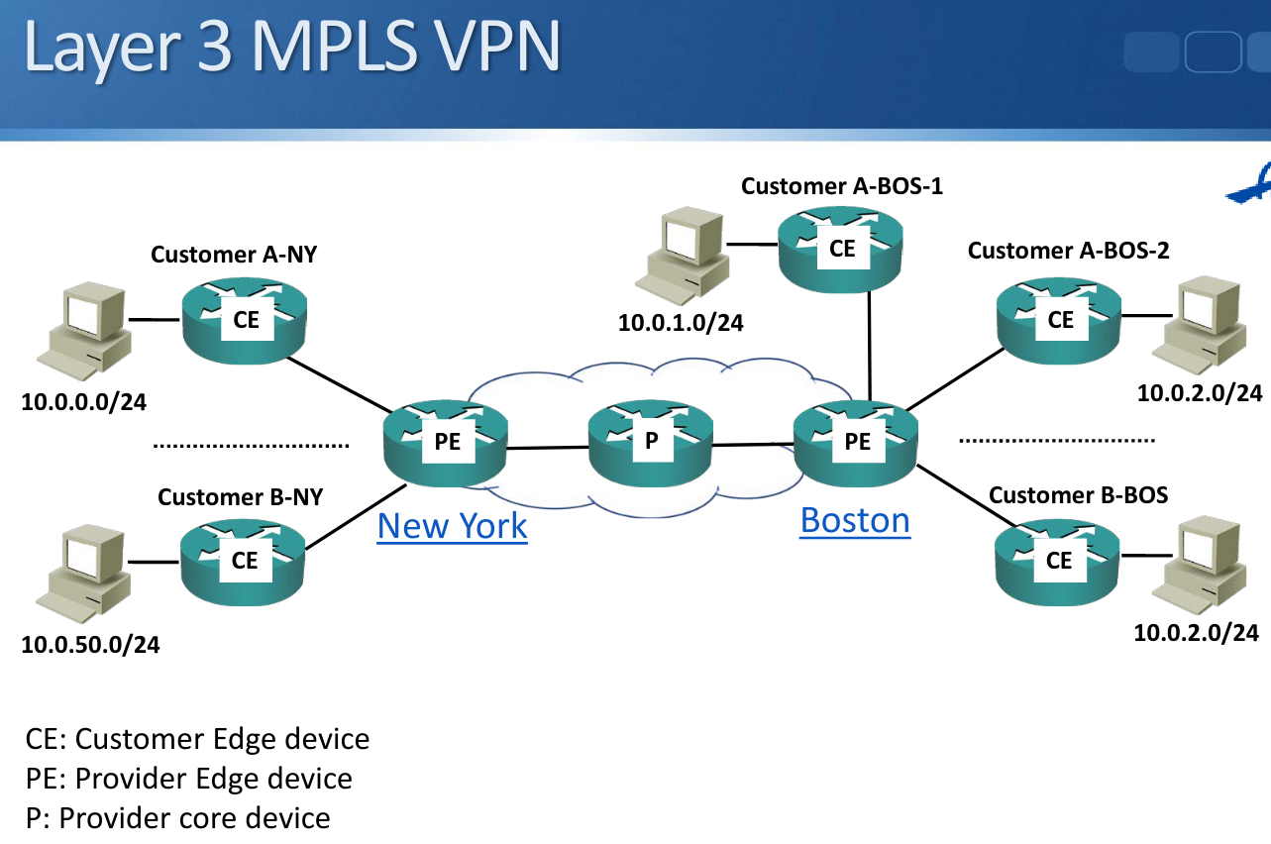

## **Layer 3 MPLS VPN**

* MPLS runs across the providers core on the PE and P routers
* The customer CE routers do not run MPLS
* The customer CE routers peer at Layer 3 with the provider PE routers
* Static routes or a routing protocol runs between the CE and PE
* The PE router looks like another customer router to the customer
* The provider’s core routers are transparent to the customer
* The customer sites are in different IP subnets

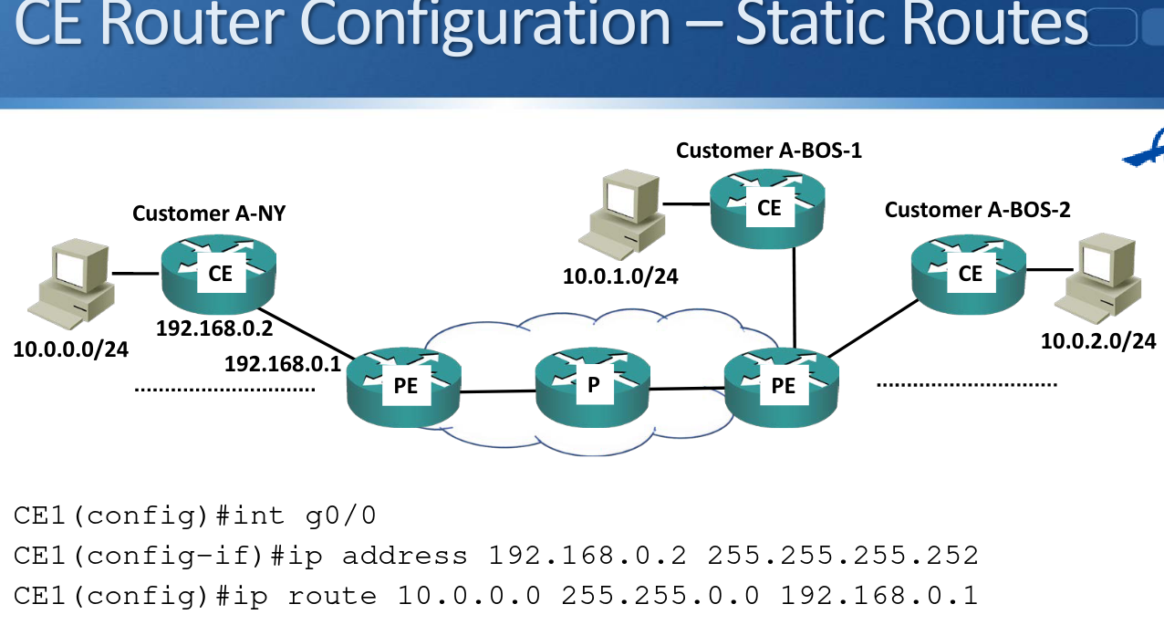

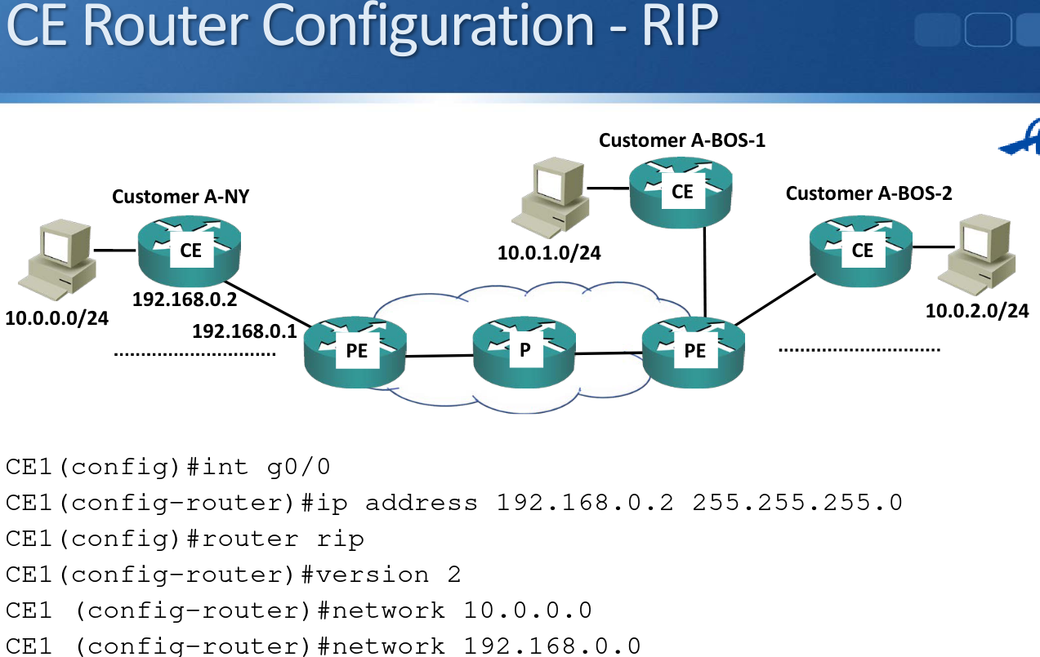

## **Layer 2 MPLS VPN**

* The CE devices do not peer with the PE devices. The entire provider network is transparent to the customer
* The provider network acts like a giant switch
* The customer sites are in the same IP subnet(s)

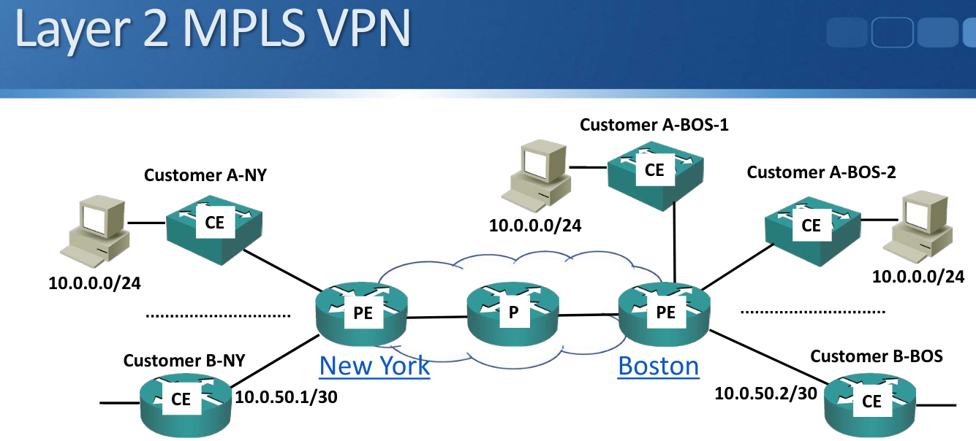

* This may be required for clustering an application over the WAN
* It can also be useful for migrating hosts during Disaster Recovery

Layer 2 MPLS VPN Terminology

* VPLS (Virtual Private LAN Service): Multipoint Layer 2 VPN
* VPWS (Virtual PseudoWire Service): Point to point Layer 2 VPN

# **Topology Options**

## **Hub and Spoke (Star)**

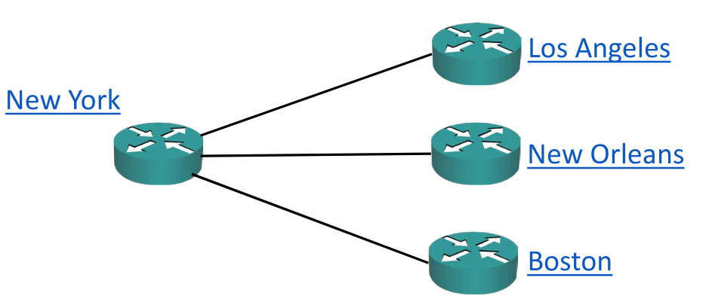

* Advantages: Simplicity, centralised security policy
* Disadvantages: Single point of failure, suboptimal traffic flow

## **Redundant Hub and Spoke**

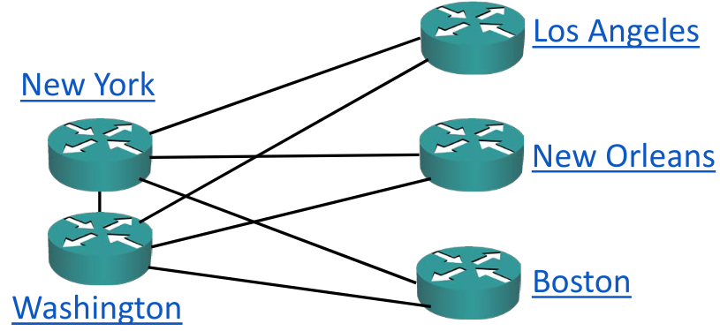

* Advantages: Removes single point of failure, centralised security policy
* Disadvantages: Higher cost, suboptimal traffic flow

## **Full Mesh**

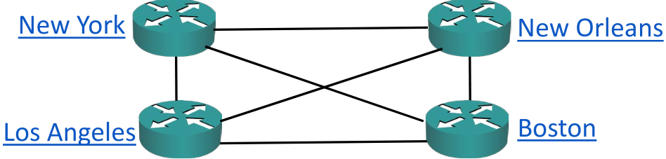

* Advantages: Optimal traffic flow
* Disadvantages: Higher complexity and cost

## **Partial Mesh**

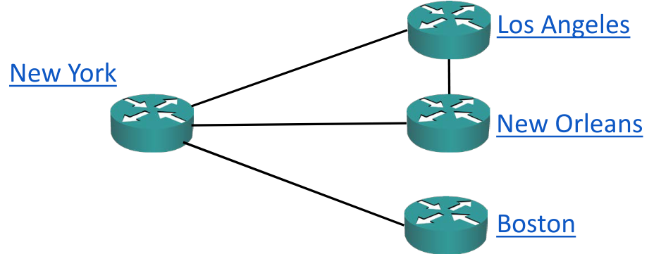

# **Internet Redundancy Options**

