During this prove milestone and the next prove assignment, you will write a Python program that draws a semi-realistic outdoor scene in a computer window. Your program can draw any outdoor scene that you like as long as it meets these requirements:

1. The scene must be outdoor and include part of the sky.
2. The sky must have clouds.
3. The scene must include repetitive objects, such as blades of grass, trees, leaves on a tree, birds, flowers, insects, fish, pickets in a fence, dashed lines on a road, buildings, bales of hay, snowmen, snowflakes, or icicles.

Your program must be divided into functions such as draw_sky, draw_cloud, draw_ground, draw_bird, draw_flower, draw_insect, draw_fish, or draw_snowman. Each of the objects in your scene should be drawn in its own function. To draw the shapes in the scene, your program will call functions in a Python library named Draw 2-D.

During this milestone, you will write code that draws the sky, the ground, and clouds in your scene. During the next prove assignment, you will write code that completes your scene. As you write your program, write it so that it draws objects in the order of farthest away to nearest. For example, you program should draw the sky first, then clouds, then the ground, then trees, then insects in the trees. Be creative.

**Scene Gallery**

The following example scene was drawn by a student's Python program and fulfills the requirements of this assignment.

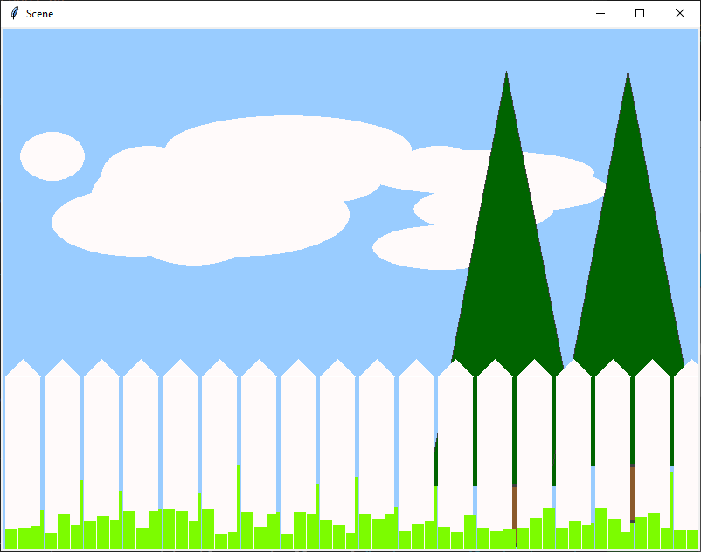

Do the following:

1. Download the [draw2d.py](https://byui-cse.github.io/cse111-course/lesson03/draw2d/draw2d.py) file and save it in the same folder where you will save your program.
2. Using VS Code, create a new file and copy and paste the following code into your new file. This beginning code imports the functions from the Draw 2-D library and creates a window and a canvas that your program will draw into.
3. Starting at line 31 of your new program, write your functions to draw the sky, ground, and clouds.
4. Starting at line 21, write calls to your drawing functions.
5. Read the [documentation for the Draw 2-D library](https://byui-cse.github.io/cse111-course/lesson03/draw2d.html).
6. Starting at line 31 of your new program, write your functions to draw the sky, ground, and clouds.
7. Starting at line 21, write calls to your drawing functions.