陈麒至2019091601015

# 习题2 P75

6．二进制：1001011.1

八进制：113.4

十六进制：4B.8

8.（备注：相同的数字这里假设为先出现的为正，后出现的为负，即1，3，5为正，2，4，6为负）

|  |  |  |
| --- | --- | --- |
| 题号 | 原码 | 补码 |
| 1 | 0．0000000 | 0．0000000 |
| 2 | 1．0000000 | 0．0000000 |
| 3 | 0.1010000 | 0.1010000 |
| 4 | 1.1010000 | 1.0110000 |
| 5 | 00001010 | 00001010 |
| 6 | 10001010 | 11110110 |

16



18.

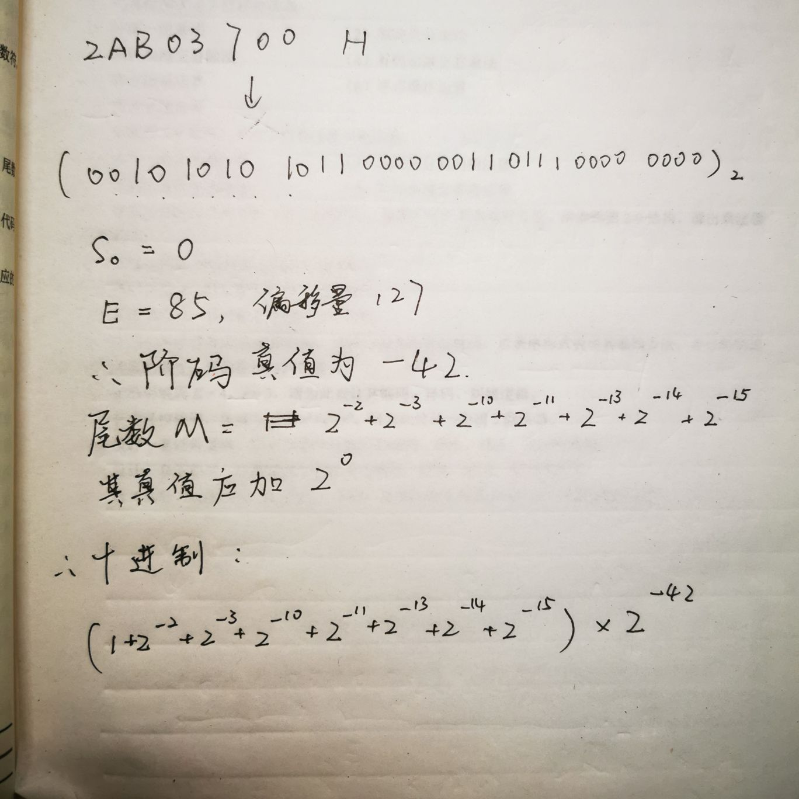

# 习题3 P232

3.（1）1200H

（2）A307H，1001H

（3）1200H，1002H

（4）F03CH

6.由于立即数寻址、寄存器直接寻址、自减型寻址在ST2~ST4无操作，这里不再讨论。

|  |  |  |  |  |
| --- | --- | --- | --- | --- |
|  | 类型 | 操作 | 电位型微命令 | 脉冲型微命令 |
| ST2 | I/( R )+ | Ri + 1-> Ri | Ri -> A  1 -> B  A + B  DM | CPRi |
| @( R )+ | Ri + 1-> Ri |
| X( R ) | PC + 1-> PC | PC -> A  1 -> B  A + B  DM | CPPC |
| ST3 | I/( R )+ | \ | \ | \ |
| @( R )+ | C -> MAR | C -> A  A->ALU  DM | CPMAR |
| X/( R ) | C + Ri-> MAR | Ri -> A  C-> B  A+B  DM | CPMAR |
| ST4 | I/( R )+ | \ | \ | \ |
| @( R )+ | M->MDR->C | EMAR  R  SMDR  MDR->B  B->ALU, DM | CPC |
| X/( R ) | M->MDR->C |

7. (4)

|  |  |  |  |
| --- | --- | --- | --- |
| FT | M->IR  PC + 1 -> PC | EMAR,R,SIR  PC->A, 0->B  A+B  DM | CP  CPPC |
| ST | R3->MAR  M->MDR->C | EMAR, R3->A, A->ALU, DM,T+1  EMAR, R, SMDR, MDR->B, B->ALU, DM , 1->DT | CPMAR  CPC |
| DT | SP-1->SP,MAR | SP->A, A-1, DM, T+1, 1->ET | CPSP  CPMAR |
| ET | C->MDR  MDR->M  PC->MAR | C -> A, A->ALU, DM  EMAR, EMDR, W, T+1  PC->ALU, DM | CPMDR  CPMAR |

(6)

|  |  |  |  |
| --- | --- | --- | --- |
| FT | M->IR  PC + 1 -> PC | EMAR,R,SIR  PC->A, 0->B  A+B  DM | CPIR  CPPC |
| ST | R2->MAR  M->MDR->C | EMAR,R2->A, A->ALU, DM,T+1  EMAR, R, SMDR, MDR->B, B->ALU, DM , 1->DT | CPMAR  CPC |
| DT | R1->MAR  M->MDR->D  R1+1->R1 | EMAR,R1->A, A->ALU, DM,T+1  EMAR, R, SMDR, MDR->B, B->ALU, DM ,  R1->A, A+1, DM, 1->ET | CPMAR  CPD  CPR1 |
| ET | C-D -> MDR  MDR -> M  PC->MAR | C->A, D->B, A-B, DM  EMAR, W, T+1,  PC->A, A->ALU, DM | CPMDR  CPMAR |

(18)

|  |  |  |  |
| --- | --- | --- | --- |
| FT | M->IR  PC + 1 -> PC | EMAR,R,SIR  PC->A, 1->B  A+B  DM | CPIR  CPPC |
| ST |  |  |  |
| DT |  |  |  |
| ET | R0->PC,MAR | R0->A, A-> ALU, DM | CPPC  CPMAR |

(19)

|  |  |  |  |
| --- | --- | --- | --- |
| FT | M->IR  PC + 1 -> PC | EMAR,R,SIR  PC->A, 1->B  A+B  DM | CPIR  CPPC |
| ST |  |  |  |
| DT |  |  |  |
| ET | SP->MAR  SP+1->SP  M->MDR->PC,MAR | SP -> A, A->ALU, DM  SP->A, A+1, DM,  EMAR, R, SMDR, MDR->B, DM | CPMAR  CPPC,CPMAR |

(20)

|  |  |  |  |
| --- | --- | --- | --- |
| FT | M->IR  PC + 1 -> PC | EMAR,R,SIR  PC->A, 1->B  A+B  DM | CPIR  CPPC |
| ST |  |  |  |
| DT |  |  |  |
| ET | SP-1->SP, MAR  PC->MDR  MDR-M  R1->MAR  M->MDR->PC,MAR | SP -> A, A-1 , DM  PC->A, A->ALU , DM,  EMAR, W, T+1  R1->A, A->ALU, DM  EMAR, R, SMDR, MDR->B, DM | CPSP,CPMAR  CPMDR  CPMAR  CPPC,CPMAR |