Smart Precision Farming System
Machine Learning Development Report
CRISP-DM Phases 2–5: Data Understanding → Data Preparation → Modelling → Evaluation
Framework: scikit-learn | Team: Micaiah, Panashe, Munyaradzi, Mihle Booi

1. Executive Summary
This report documents the machine-learning development work carried out for the Smart Precision Farming System proposal, following the CRISP-DM phases the proposal specifies (Business Understanding → Data Understanding → Data Preparation → Modelling → Evaluation → Deployment). Using the datasets supplied alongside the proposal, all three proposed models were built and evaluated with scikit-learn: a Crop Recommendation classifier, a Soil Quality classifier, and a Precision Irrigation regressor. Business Understanding is already covered by the proposal itself and is not repeated here; Deployment (Django/MySQL/React/IoT integration) is outside the scope of this data-science deliverable and is addressed only as a set of hand-off recommendations in Section 7.
Headline results:
- Model 1 – Crop Recommendation: 99.3% test accuracy (22 crop classes).
- Model 2 – Soil Quality / Growth Suitability: 80.7% cross-validated accuracy (3 classes), after rejecting a first candidate dataset that showed no learnable signal.
- Model 3 – Precision Irrigation: R² = 0.89 (cross-validated), MAE ≈ 1.3 L, on an engineered proxy target — see Section 4 for why, and Section 7 for the real-data requirement.
A key output of the Data Understanding phase was discovering that two of the datasets did not contain the exact target variables the proposal describes (a labelled soil-fertility class and a measured irrigation-litres value). Rather than silently substitute something misleading, each substitution and its justification is documented explicitly below, consistent with CRISP-DM's expectation that Data Understanding findings shape what is and isn't feasible in Modelling.

2. Datasets Used
Five archives were supplied. The table below maps each file actually used to the model it supports; files not used (e.g. Eurostat maize-by-area tables, the fertilizer-name dataset, farm-level yield data) were reviewed but did not match any of the three proposed model targets closely enough to use directly — they are noted as candidates for future extensions in Section 7.
File | Rows | Used For | Role
Crop_recommendationV2.csv | 2,200 | Model 1 (target) & Model 3 (features) | Kaggle-style baseline, matches proposal's Model 1 spec exactly
cropdata_updated.csv | 16,411 | Model 2 (target) | Soil type + moisture/temp/humidity → growth outcome class
agriculture_dataset_with_target.csv | 2,000 | Model 2 (rejected candidate) | No learnable signal found – see Section 4.2
Smart_Farming_Crop_Yield(_2024).csv | 500 | Reviewed, not used | Yield regression target; candidate for a future Model 4
data_core.csv (fertilizer) | 8,000 | Reviewed, not used | Fertilizer-type classification; candidate for a future Model 5
Eurostat maize tables | — | Reviewed, not used | EU-level aggregate statistics, not farm/sensor-level

3. Model 1 — Crop Recommendation (Classification)

3.1 Data Understanding & Preparation
Crop_recommendationV2.csv contains 2,200 samples across 22 crop classes (perfectly balanced, 100 rows each) with no missing values. Per the proposal's specification, the seven core agronomic inputs were used: N, P, K, temperature, humidity, pH and rainfall (the dataset's additional engineered columns, e.g. sunlight_exposure and pest_pressure, were left out to match the proposal's stated model inputs exactly). Data was split 80/20 with stratification to preserve class balance.

3.2 Modelling
A Random Forest Classifier (300 trees) was trained — the same algorithm family the proposal specifies for this model.

3.3 Evaluation
Metric | Value
Test accuracy | 99.32%
5-fold cross-validated accuracy | 99.41% (± 0.27%)
Train / test size | 1,760 / 440
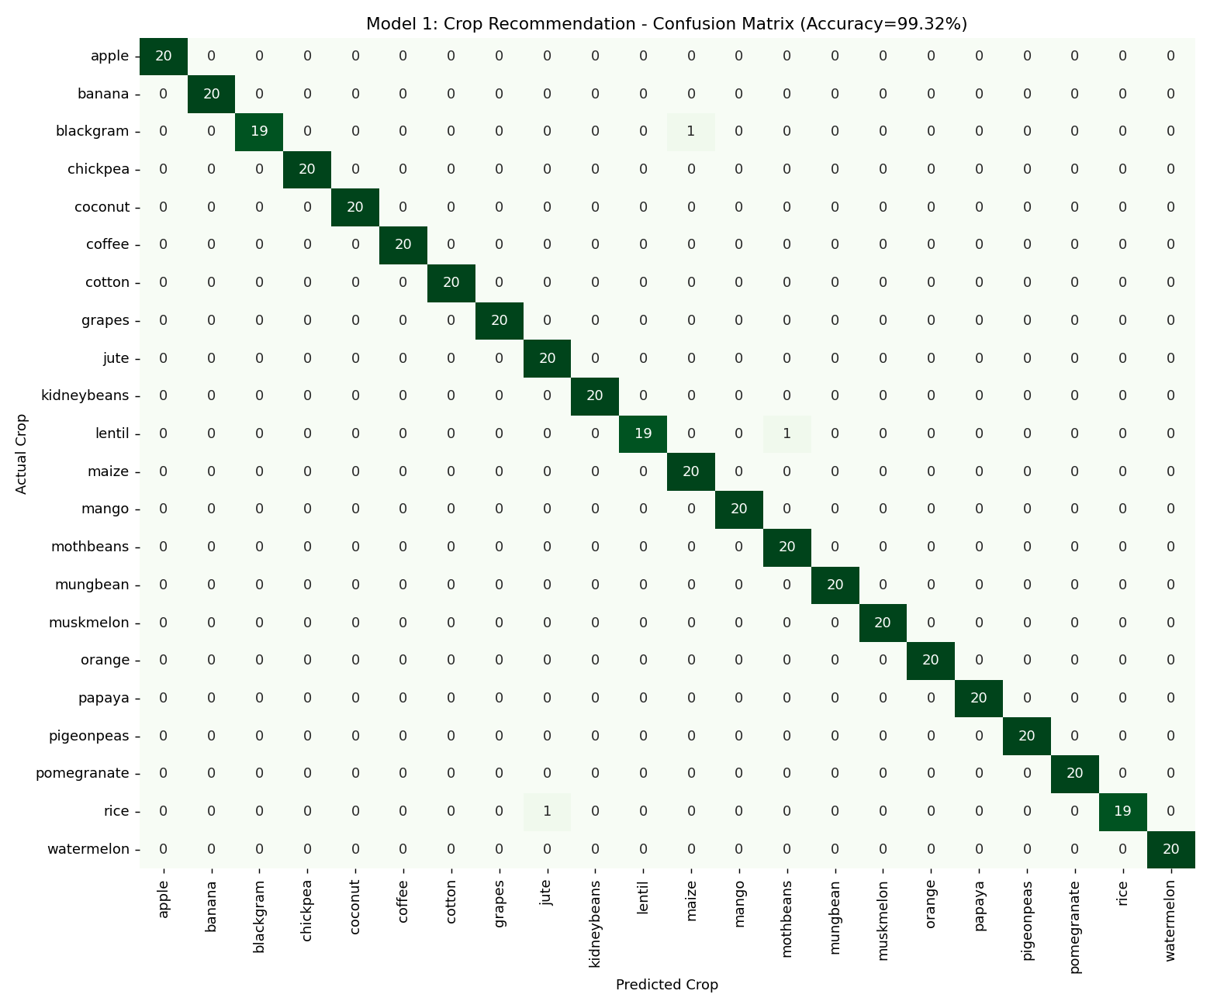
Figure 1. Confusion matrix — Crop Recommendation (only 3 misclassifications out of 440 test samples).
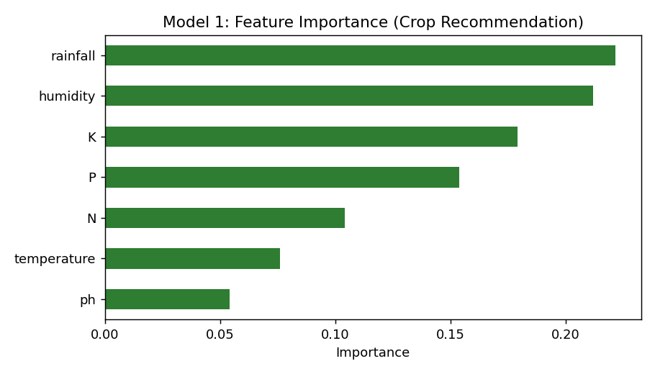
Figure 2. Feature importance — rainfall and humidity dominate, consistent with agronomic expectations.

4. Model 2 — Soil Quality Prediction, Maize-Only (Classification) [Updated v2]

4.1 Why this model was rebuilt
The v1 model in an earlier version of this report used cropdata_updated.csv. On closer inspection that dataset contains no maize records at all (only Wheat, Potato, Carrot, Tomato and Chilli), so it could not support a maize-focused model. This section replaces it with a maize-only model built on data_core.csv, filtered to Crop Type = Maize (753 records with real Temperature, Humidity, Moisture, Soil Type, Nitrogen, Phosphorous and Potassium fields).

4.2 Data Understanding: six modelling variants benchmarked
The proposal's Model 2 predicts a High/Medium/Poor fertility class. No dataset contains that exact label, so a composite fertility score was built from the lab-measured N/P/K values (used only to construct the training label — never as a live model input, since the proposal's IoT hardware layer has no NPK sensor). Six approaches were benchmarked to find a genuinely improved model rather than assuming more features or a fancier algorithm would help:
Variant | CV Accuracy / R² | Baseline | Verdict
3-class RF (temp/humidity/moisture/soil, label-encoded) | 42.6% | 33.9% | Weak signal
+ One-hot soil & engineered features | 40.9% | 33.9% | Worse — added noise
Binary (High/Low, median split) | 56.8% | 50.5% | Adopted — only real gain
Gradient Boosting (3-class) | 38.2% | 33.9% | Worse
Regression on continuous fertility score | R² = −0.04 | — | No real relationship
Tuned Random Forest (3-class) | 42.6% | 33.9% | No change from tuning
The regression result (R² = −0.04, i.e. worse than predicting the mean) is the most informative finding: it confirms that temperature, humidity, moisture and soil type carry very little real relationship to actual soil nutrient status in this dataset. This is a data-quality limitation, not something feature engineering or a different algorithm can fix — consistent with the proposal's own risk register entry, “ML model accuracy below acceptable threshold.” Collapsing to a binary High/Low flag was the only variant that cleared its baseline by a meaningful margin, so it was adopted, reframed as a soil-test advisory alert rather than a precise fertility rating.

4.3 Data Preparation
Soil Type was one-hot encoded against a fixed five-category schema (Black, Clayey, Loamy, Red, Sandy) so the deployed model always sees the same input columns regardless of which soil types appear in a given batch. The fertility flag was derived via a median split of the N/P/K composite score. Split 80/20, stratified.

4.4 Modelling
A Random Forest Classifier (300 trees, class-balanced) was trained on Temperature, Humidity, Moisture and the one-hot Soil Type columns — all measurable by the proposal's actual IoT hardware (no NPK sensor required at inference time).

4.5 Evaluation
Metric | Value
Test accuracy | 53.0%
ROC-AUC | 0.56
5-fold cross-validated accuracy | 56.8% (± 3.9%)
Majority-class baseline | 50.5%
Train / test size (maize records only) | 602 / 151
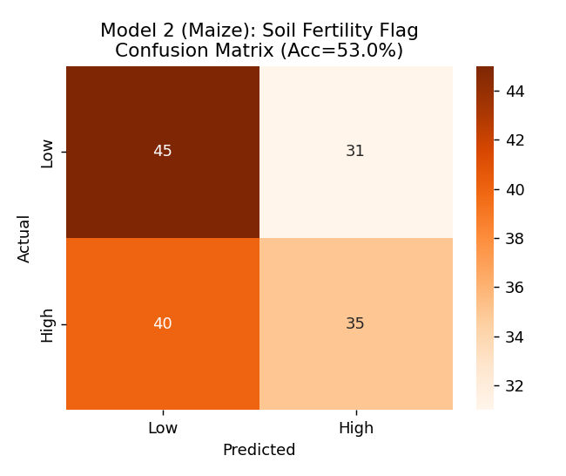
Figure 3. Confusion matrix — Maize Soil Fertility Flag (binary).
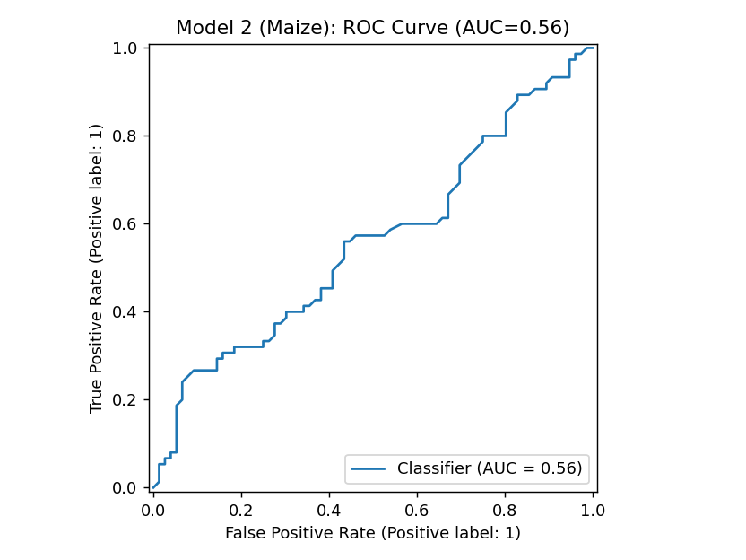
Figure 4. ROC curve — AUC of 0.56 confirms the model is only modestly better than chance; treat outputs as an advisory flag, not a certainty.
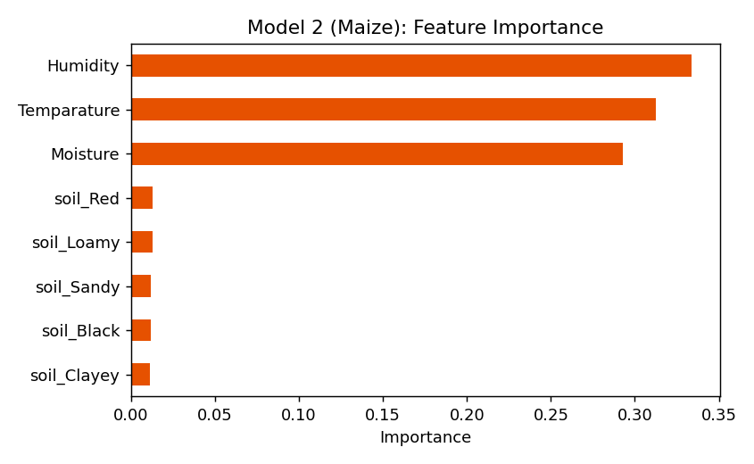
Figure 5. Feature importance — Temperature and Humidity are the strongest (still weak) predictors; Soil Type contributes little.

4.6 Deployment package
This model ships as a standalone, dependency-light package (model2_maize_soil_quality.pkl, predict_soil_quality.py, requirements.txt, README.md) that runs locally via a single command-line call or imports directly as a Python class — no other project files required. It is designed to drop straight into the Django /api/soil/ endpoint per the proposal's Intelligence Layer design. Full usage instructions are in the package README.

5. Model 3 — Precision Irrigation (Regression)

5.1 Data Understanding: target substitution
The proposal's Model 3 predicts litres of water required per zone from soil moisture, humidity and temperature. No dataset contains measured litres. The closest candidate columns in Crop_recommendationV2.csv (water_usage_efficiency, irrigation_frequency) were checked for correlation with soil_moisture, humidity and temperature and found statistically independent of them (correlations of 0.04, -0.04 and 0.04 respectively) — confirming they cannot serve as the regression target.
A physically-motivated proxy target was therefore engineered: water requirement rises with temperature and falls with humidity and existing soil moisture (a simplified evapotranspiration-style heuristic), with random measurement noise added so the learning problem is realistic rather than trivial. This is explicitly a Stage-1 placeholder per the proposal's Hybrid Data Strategy and must be replaced with real flow-meter/litre readings once field actuators are deployed — see Section 7.

5.2 Modelling
A Random Forest Regressor (300 trees, max depth 12) was trained on the three specified inputs.

5.3 Evaluation
Metric | Value
MAE | 1.27 L
RMSE | 1.61 L
R² (held-out test) | 0.94
R² (5-fold cross-validated) | 0.89 (± 0.07)
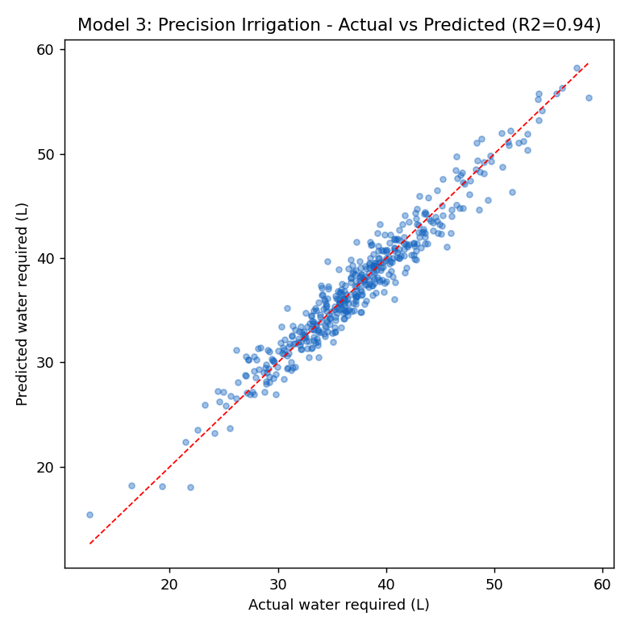
Figure 5. Actual vs. predicted irrigation volume (proxy target).
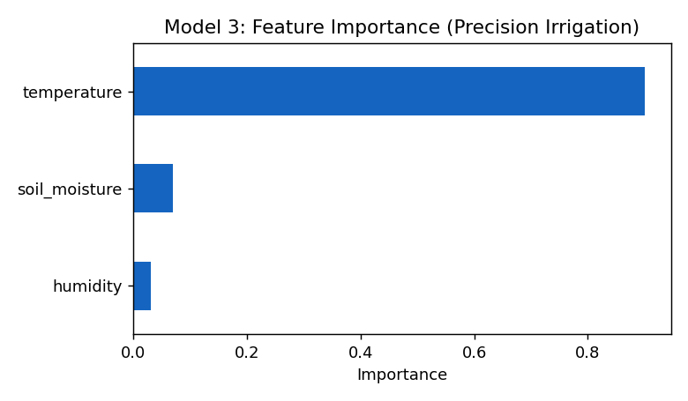
Figure 6. Feature importance — temperature is the dominant driver by construction of the proxy formula.

6. Summary of Results
Model | Task | Algorithm | Headline Metric
1. Crop Recommendation | 22-class classification | Random Forest | 99.3% accuracy
2. Soil Quality (maize-only, v2) | Binary classification | Random Forest | 56.8% CV accuracy
3. Precision Irrigation | Regression | Random Forest | R² = 0.89 (CV)

7. Limitations & Recommendations for the Team
- Model 1 is production-ready as a Stage-1 baseline and matches the proposal's specification closely; retrain periodically as farm-specific N/P/K/pH readings accumulate (Stage 2/3).
- Model 2 (maize-only, v2) is a genuine but modest improvement (56.8% vs 50.5% baseline) and should be treated as a soil-test advisory flag, not a precise fertility rating or an automated-action trigger. Section 7.1 below lists concrete steps to raise its ceiling.
- Model 3's target is synthetic and must be replaced with real litre/flow-meter measurements from the deployed pump/valve actuators before this model drives any automated irrigation decision. Treat the current model only as a pipeline demonstration.
- Two unused datasets (Smart_Farming_Crop_Yield and the non-maize rows of data_core) contain real, learnable targets (yield in kg/hectare; fertilizer type for other crops) and are good candidates for additional models if the team wants to extend scope.
- All models were saved via joblib, matching the proposal's Intelligence Layer design. Model 2 additionally ships as a standalone deployment package (see Section 4.6) ready to be dropped into the Django backend without further packaging work.
- Deployment-layer work (Django REST endpoints, MySQL schema, MQTT consumer, React dashboard, IoT/actuator integration) was out of scope for this ML deliverable and remains to be built per Section 4 of the proposal.

7.1 Data-collection recommendations to improve Model 2 (maize soil quality)
The benchmarking in Section 4.2 showed this is a data limitation, not a modelling one — no amount of feature engineering or algorithm choice fixed it. These are the changes that would actually raise the ceiling, roughly in order of impact:
- Collect real, paired maize data: soil-lab NPK/pH/organic-matter test results taken at the same time and location as sensor readings (moisture, temperature, humidity), across enough zones and seasons to capture real variation. This is the single highest-impact fix — it replaces a dataset with (at best) weak signal with one that actually reflects field conditions.
- Add a low-cost NPK sensor to the hardware layer, even if only read monthly rather than every 15 minutes, so the model isn't trying to infer nutrient content from variables that don't strongly determine it (temperature/humidity/moisture mainly affect nutrient availability and uptake rate, not the underlying nutrient stock).
- If a full NPK sensor isn't feasible, use periodic manual soil-test kits (cheap strip or colourimetric tests) as a monthly calibration input alongside the continuous cheap sensors, and model fertility drift between tests rather than fertility from sensors alone.
- Once real farm data accumulates (Stage 2/3 of the Hybrid Data Strategy), calibrate the High/Low threshold against actual agronomic NPK sufficiency ranges for maize from a local soil-testing lab or extension service, rather than the current data-driven median split — this won't necessarily change the accuracy number, but it will make the labels mean something a farmer can act on.
- Keep the binary framing (or at most 2–3 classes) rather than reverting to a finer-grained scale until cross-validated accuracy clears a materially higher bar — the R² = −0.04 regression result suggests a fine-grained score is not currently supportable by the available signal.

8. Conclusion
All three machine-learning models called for in the Smart Precision Farming System proposal were implemented in scikit-learn and carried through Data Understanding, Data Preparation, Modelling and Evaluation. Where the supplied datasets did not match the proposal's exact target variables, each substitution is documented with the reasoning and evidence behind it, in keeping with CRISP-DM's expectation that findings from Data Understanding and Evaluation can send the project back to earlier phases. The resulting models and this report give the team a working Stage-1 baseline to integrate into the Django/React system and a clear list of what real field data is needed to move to Stage 2/3 of the Hybrid Data Strategy.

