# UNIVERSITY OF ZIMBABWE



***DEVELOPING AN AI DIETICIAN FOR PREGNANT WOMEN TO PROMOTE HEALTHY EATING AND PREVENT NUTRIENT DEFICIENCIES.***

**BY**

**AGNESS MASHONGANYIKA R195845Q**

SUPERVISED BY: **DR GOMBIRO**

***A THESIS SUBMITTED IN PARTIAL FULLFILLMENT OF THE REQUIREMENTS FOR BACHELOR OF SCIENCE HONORS DEGREE IN COMPUTER SCIENCE***

## DEPARTMENT OF COMPUTER SCIENCE

**FACULTY OF ENGINEERING, INFORMATICS AND COMMUNICATIONS**

**DEDICATION**

This research is dedicated to all the women who are embarking on the journey of motherhood. It is a tribute to their strength, resilience, and unwavering commitment to the health and well-being of their children. By developing an AI dietician for pregnant women to promote healthy eating and prevent nutrient deficiencies, we hope to provide a valuable tool that can help women navigate the challenges of pregnancy with confidence and ease. May this research contribute to the betterment of maternal and child health around the world, and serve as a reminder of the incredible power of technology to improve lives.

**DECLARATION**

I, Agness Mashonganyika, hereby declare that the research proposal titled Developing an AI Dietician for Pregnant Women to Promote Healthy Eating and Prevent Nutrient Deficiencies is my original work. This proposal is being submitted to University of Zimbabwe for the purpose of obtaining funding and/or approval to conduct the proposed research.

I declare that:

1. The research proposal has been developed by me, and any contributions from other sources have been appropriately acknowledged.
2. The proposed research has not been submitted for funding or approval to any other institution or organization.
3. The proposed research will be conducted in accordance with ethical principles and standards, and all necessary ethical approvals will be sought and obtained.
4. Any potential conflicts of interest have been identified and disclosed in the proposal.
5. I understand that any falsification of information, plagiarism or other unethical behavior in relation to this proposal may result in disciplinary action, including revocation of funding and/or termination of the research project.

I hereby affirm that the information provided in this research proposal is true and accurate to the best of my knowledge and belief.

Signature(Student)……………………………………DATE……………....................

Signature(Supervisor)…………………………………DATE……………..................

Signature(Chairman)…………………………………. DATE……………..................

**ACKNOWLEDGEMENTS**

I would like to express our sincere gratitude to all those who have contributed to the development of this research proposal.

First and foremost, we would like to thank our research supervisor Dr. Gombiro, for his invaluable guidance, support and expertise throughout the proposal writing process. His insightful feedback and constructive criticism have been instrumental in shaping the focus and direction of this research.

I would also like to thank my colleagues and fellow students for their feedback and suggestions during the development of this proposal. Their insights and comments have been incredibly helpful in refining our ideas and improving the clarity of our research objectives

In addition, I would like to express my appreciation to the staff and faculty members of University of Zimbabwe, who have provided me with the resources, facilities, and academic support necessary to undertake this research.

Finally, I would like to extend my gratitude to my family and loved ones for their unwavering support and encouragement throughout our academic journey.

Without the contributions of these individuals and organizations, this research proposal would not have been possible. I am deeply grateful for their support and look forward to continuing my work with their guidance and assistance.

**ABSTRACT**

This research proposes the development of an AI dietician that will provide dietary recommendations to pregnant women to promote healthy eating and prevent nutrient deficiencies. Pregnancy is a crucial period during which women require specific nutrients for fetal growth and development. Poor nutrition during this period can lead to adverse pregnancy outcomes, such as preterm birth, low birth weight, and developmental disorders. The AI dietician will be trained on a comprehensive dataset of nutritional requirements during pregnancy and will use natural language processing to communicate with users. The system will provide personalized dietary recommendations based on the user's dietary habits, food preferences, and medical history. The AI dietician will help users track their nutritional intake, offer meal plans, and provide educational resources. This research aims to contribute to the development of technology-based solutions to promote healthy eating during pregnancy and improve maternal and fetal health outcomes.

ABSTRACT 5

CHAPTER 1: INTRODUCTION, BACKGROUND AND PURPOSE OF THE RESEARCH 7

* 1. INTRODUCTION 7
  2. BACKGROUND 8
  3. RESEARCH PROBLEM 9
  4. RESEARCH AIM 9
  5. RESEARCH OBJECTIVES 9
  6. RESEARCH JUSTIFICATION 9
  7. SCOPE OF RESEARCH 10
  8. RESEARCH QUESTIONS 11

CHAPTER2: LITERATURE REVIEW 12

* 1. INTRODUCTION 12
  2. THEORETICAL LITERATURE REVIEW 13
  3. MACHINE LEARNING 14
  4. MACHINE LEARNING MODELS 14
     1. DECISION TREES 14
     2. NEURAL NETWORKS 14
     3. RANDOM FOREST 14
     4. SUPPORT VECTOR MACHINE 15
     5. RESEARCH MACHINE LEARNING MODEL 15
  5. EMPIRICAL LITERATURE REVIEW 16

CHAPTER 3: RESEARCH METHODOLOGY 17

* 1. INTRODUCTION 17
  2. RESEARCH METHOD 17
  3. ALGORITHM 18
  4. MODEL TRAINING AND ACCURACY SCORE 19
  5. ENVIRONMENT 19

CHAPTER 4: RESULTS AND TESTING 21

* 1. INTRODUCTION 21
  2. FUNCTIONAL REQUIREMENTS 21
  3. NON FUNCTIONAL REQUIREMENTS 21
  4. UML DIAGRAMS 22

1. USE CASE DIAGRAM 22
2. CLASS DIAGRAM 23
3. DATAFLOW DIAGRAM 24
4. SEQUENCE DIAGRAM 25

CHAPTER 5: IMPLEMENTATION AND TESTING 26

1. INTRODUCTION 26
2. DESCRIPTION OF PROPOSED SYSTEM 26
3. SYSTEM MODULES 27
4. SYSTEM SCREENSHOTS 28
5. CODE SNIPPETS 30
6. SYSTEM TESTING 31
7. FINDINGS 32

CHAPTER 6: CONCLUSION AND RECOMMENDATIONS 33

1. CONCLUSION 33
2. PROBLEMS FACED 33
3. LIMITATIONS 34
4. FUTURE WORK 35

REFERENCES 37

**CHAPTER 1: INTRODUCTION, BACKGROUND AND PURPOSE OF THE RESEARCH**

* 1. **INTRODUCTION**

Pregnancy is a critical period where the mother's nutritional intake plays a significant role in fetal development. Adequate nutrition during pregnancy can promote healthy fetal growth and reduce the risk of complications, such as low birth weight and preterm birth (1). On the other hand, poor dietary choices during pregnancy can lead to nutrient deficiencies, which can negatively impact both the mother and fetus's health (2). Therefore, ensuring proper nutrition during pregnancy is crucial for optimal maternal and fetal health outcomes.

Traditionally, healthcare providers, such as obstetricians and dieticians, have been responsible for providing nutritional guidance to pregnant women. However, with the advent of technology, an AI-powered dietician can provide personalized nutrition recommendations to pregnant women, based on their health status, dietary habits, and nutritional needs. The AI-powered system can analyze the mother's health data, such as weight, BMI, blood pressure, and blood glucose levels, to generate customized nutritional plans (3).

Moreover, an AI-powered dietician can provide real-time feedback to pregnant women, enabling them to make informed dietary choices. The system can also monitor the mother's nutritional intake and suggest modifications to their dietary plan to prevent nutrient deficiencies.

In conclusion, developing an AI dietician for pregnant women can significantly improve maternal and fetal health outcomes by promoting healthy eating habits and preventing nutrient deficiencies. By leveraging the power of AI, healthcare providers can provide personalized nutritional guidance to pregnant women, ensuring optimal maternal and fetal health outcomes.

* 1. **BACKGROUND**

Pregnancy is a critical phase in a woman's life that requires adequate nutrition for the optimal development of the fetus and the mother's health. Nutrition plays a vital role in ensuring a healthy pregnancy, and inadequate nutrient intake during this period can lead to adverse health outcomes for both the mother and the developing fetus (1). Therefore, it is essential to ensure that pregnant women receive adequate nutrition to prevent nutrient deficiencies and promote healthy fetal growth.

Several studies have shown that the dietary habits of pregnant women can affect fetal growth and development. Inadequate intake of essential nutrients, such as protein, iron, folic acid, and calcium, during pregnancy can lead to several complications, such as neural tube defects, low birth weight, and preterm birth (2, 3). On the other hand, a balanced diet rich in fruits, vegetables, whole grains, and lean protein can improve fetal growth and reduce the risk of adverse health outcomes (4, 5).

However, despite the well-established benefits of proper nutrition during pregnancy, many pregnant women do not receive adequate nutrition due to various reasons such as poor dietary choices, food insecurity, and lack of nutrition knowledge (6, 7). This highlights the need for innovative solutions to promote healthy eating and prevent nutrient deficiencies during pregnancy.

The advent of artificial intelligence (AI) technology has opened up new possibilities for developing innovative solutions to address complex healthcare challenges. An AI dietician for pregnant women is one such solution that has the potential to provide personalized nutrition recommendations to pregnant women, based on their health status, dietary habits, and nutritional needs.

An AI dietician for pregnant women can analyze a range of data points, including the mother's medical history, nutrient intake, body mass index (BMI), and lifestyle factors to provide personalized nutrition recommendations. The system can also use machine learning algorithms to adapt its recommendations based on the mother's response to the previous recommendations and any changes in her health status.

Several studies have shown the potential of AI-powered dietary interventions in promoting healthy eating and preventing nutrient deficiencies. For instance, a study conducted by Viergever et al. (8) found that an AI-based nutrition coaching program significantly improved the dietary habits of overweight and obese adults. Similarly, a systematic review by Chen et al. (9) showed that AI-based dietary interventions can significantly improve dietary adherence and nutrient intake in adults with chronic diseases.

Therefore, developing an AI dietician for pregnant women has the potential to improve maternal and fetal health outcomes by promoting healthy eating and preventing nutrient deficiencies during pregnancy.

Proper nutrition during pregnancy is essential for the optimal growth and development of the fetus and the mother's health. However, many pregnant women do not receive adequate nutrition due to various reasons such as poor dietary choices and lack of nutrition knowledge. An AI dietician for pregnant women has the potential to provide personalized nutrition recommendations based on the mother's health status, dietary habits, and nutritional needs. Developing an AI dietician for pregnant women has the potential to improve maternal and fetal health outcomes by promoting healthy eating and preventing nutrient deficiencies during pregnancy.

* 1. **RESEARCH PROBLEM**

Despite the importance of proper nutrition during pregnancy, many pregnant women struggle to meet their nutritional needs, which can lead to nutrient deficiencies and adverse health outcomes for both the mother and the developing fetus. While traditional methods of nutrition counseling can be effective, they may not always be accessible or feasible for all pregnant women. Developing an AI Dietician for Pregnant Women to Promote Healthy Eating and Prevent Nutrient Deficiencies could be a promising solution, but more research is needed to determine the feasibility and effectiveness of this approach.

* 1. **RESEARCH AIM**

The aim of this study is to develop and evaluate the effectiveness of an AI-powered dietician for pregnant women to promote healthy eating and prevent nutrient deficiencies.

* 1. **RESEARCH OBJECTIVES**
* To identify the nutritional requirements of pregnant women and the specific nutrients necessary for optimal fetal development.
* To develop an AI-powered system that can provide personalized nutrition recommendations to pregnant women based on their health data, dietary habits, and nutritional needs.
* To evaluate the effectiveness of the AI dietician in improving maternal and fetal health outcomes and preventing nutritional deficiencies.
  1. **RESEARCH JUSTIFICATION**

Pregnancy is a critical period where proper nutrition is essential for both the mother and the developing fetus. Poor dietary choices during pregnancy can lead to various health complications, such as gestational diabetes, preterm birth, and low birth weight. On the other hand, adequate nutrition can reduce the risk of complications and ensure optimal fetal development. However, many pregnant women struggle to maintain a healthy diet due to various factors such as nausea, food aversions, and busy lifestyles.

An AI dietician for pregnant women can provide personalized nutrition recommendations based on the mother's health status, dietary habits, and nutritional needs. The AI-powered system can analyze the mother's health data, such as weight, BMI, blood pressure, and blood glucose levels, to provide tailored nutrition advice. The system can also take into account the mother's food preferences and provide meal plans that are easy to follow and incorporate into her lifestyle.

Several studies have shown the benefits of personalized nutrition recommendations for pregnant women. A randomized controlled trial found that personalized nutrition counseling during pregnancy reduced the risk of gestational diabetes and improved maternal and fetal outcomes (1). Another study found that personalized dietary advice improved nutrient intake and reduced the risk of inadequate nutrient intake during pregnancy (2).

AI-powered systems have shown promising results in various healthcare settings, including personalized nutrition recommendations (3). An AI-powered system can analyze vast amounts of data and provide tailored recommendations quickly and efficiently. The system can also learn from the mother's dietary choices and adjust recommendations accordingly, ensuring that the mother receives the most up-to-date and relevant advice.

In conclusion, developing an AI dietician for pregnant women can provide personalized nutrition recommendations that promote healthy eating and prevent nutrient deficiencies. The system can analyze the mother's health data, food preferences, and lifestyle to provide tailored recommendations that are easy to follow and incorporate into her daily routine. The system has the potential to improve maternal and fetal outcomes and reduce the risk of complications during pregnancy.

* 1. **SCOPE OF RESEARCH**

The purpose of this research is to explore the development and implementation of an AI dietician for pregnant women to promote healthy eating and prevent nutrient deficiencies

Literature review: A comprehensive review of the existing literature on pregnancy nutrition and the use of AI technology in healthcare will be conducted. The review will examine the current state of research on the impact of nutrition on maternal and fetal health, the role of AI technology in healthcare, and the feasibility of an AI dietician for pregnant women.

Nutritional needs during pregnancy: The research will examine the specific nutritional needs of pregnant women and the importance of consuming a balanced and nutrient-dense diet. The research will also examine the risks associated with nutrient deficiencies during pregnancy and the impact on maternal and fetal health.

Development of an AI dietician for pregnant women: The research will explore the development of an AI-powered dietician that can provide personalized nutrition recommendations based on the mother's health status, dietary habits, and nutritional needs. The research will also examine the potential benefits and limitations of such a system.

1. **RESEARCH QUESTIONS**

* What are the key features and functionalities of AI dieticians for pregnant women?
* What are the benefits and limitations of using AI dieticians for promoting healthy eating during pregnancy?
* What is the current evidence regarding the effectiveness of AI dieticians in preventing nutrient deficiencies and improving maternal and fetal health outcomes during pregnancy?

**CHAPTER 2: LITERATURE REVIEW**

1. **INTRODUCTION**

Proper nutrition during pregnancy is crucial for both the mother and the developing fetus. Nutrient deficiencies during pregnancy can lead to various health complications, such as preterm birth, low birth weight, and birth defects. On the other hand, adequate nutrition can reduce the risk of complications and ensure optimal fetal development (Gernand et al., 2016; Ziaei et al., 2016).

Despite the importance of proper nutrition during pregnancy, many pregnant women struggle to meet their nutritional needs. According to a study by da Silva et al. (2019), more than half of pregnant women in low-income countries have inadequate intake of key nutrients, including iron, folate, and vitamin A. In high-income countries, unhealthy dietary choices, such as high intake of processed foods and sugar, are common among pregnant women (Grieger et al., 2019).

To address this issue, there has been a growing interest in developing AI-powered tools to support pregnant women in making healthy dietary choices. An AI dietician for pregnant women can provide personalized nutrition recommendations based on the mother's health status, dietary habits, and nutritional needs. This technology has the potential to improve maternal and fetal health outcomes by promoting healthy eating and preventing nutrient deficiencies.

The purpose of this literature review is to explore the current state of research on the development and effectiveness of AI dieticians for pregnant women in promoting healthy eating and preventing nutrient deficiencies. Specifically, this review will examine the following research questions:

* What are the key features and functionalities of AI dieticians for pregnant women?
* What are the benefits and limitations of using AI dieticians for promoting healthy eating during pregnancy?
* What is the current evidence regarding the effectiveness of AI dieticians in preventing nutrient deficiencies and improving maternal and fetal health outcomes during pregnancy?

By answering these research questions, this literature review aims to provide insights into the potential of AI dieticians as a tool for improving maternal and fetal health outcomes during pregnancy.

1. **THEORETICAL LITREATURE REVIEW**

**Key Features and Functionalities of AI Dieticians for Pregnant Women.**

AI dieticians for pregnant women typically use machine learning algorithms to analyze the mother's health data and provide personalized dietary recommendations. Key features of AI dieticians include dietary tracking, nutrient analysis, and personalized recommendations based on the mother's health status and dietary preferences. Some AI dieticians also offer additional features such as social support, recipe suggestions, and meal planning.

**Benefits and Limitations of AI Dieticians for Promoting Healthy Eating during Pregnancy.**

The use of AI dieticians for promoting healthy eating during pregnancy has several potential benefits, including personalized recommendations, increased accuracy in dietary tracking and nutrient analysis, and the ability to prevent nutrient deficiencies. However, there are also limitations to consider, such as the lack of human interaction and support, cultural and personal dietary preferences that AI dieticians may not account for, and the potential for inaccurate dietary recommendations based on flawed data inputs.

**Effectiveness of AI Dieticians in Preventing Nutrient Deficiencies and Improving Maternal and Fetal Health Outcomes during Pregnancy.**

Several studies have evaluated the effectiveness of AI dieticians in preventing nutrient deficiencies and improving maternal and fetal health outcomes during pregnancy. A study by Ferreira et al. (2020) found that an AI-based dietary assessment for pregnant women was feasible and had the potential to improve adherence to recommended diets. Another study by López-Úbeda et al. (2021) found that an AI-powered dietician for pregnant women improved maternal nutrition and decreased the risk of preterm birth. However, further research is needed to evaluate the long-term effectiveness of AI dieticians in preventing nutrient deficiencies and improving maternal and fetal health outcomes during pregnancy.

1. **MACHINE LEARNING**

Machine learning is a subfield of artificial intelligence that involves the use of statistical algorithms and mathematical models to enable computers to learn and improve from experience, without being explicitly programmed. It involves the development of algorithms that can analyze and learn from data, recognize patterns, and make predictions or decisions based on that analysis.

1. **MACHINE LEARNING MODELS**

Machine learning models can be used to develop an AI-powered system that can provide personalized nutrition recommendations for pregnant women. In this article, we discuss the machine learning models that can be used for developing an AI dietician for pregnant women to promote healthy eating and prevent nutrient deficiencies.

1. **DECISION TREES**

Decision trees are a type of supervised learning algorithm that can be used to develop an AI dietician for pregnant women. The algorithm can analyze the mother's health data, such as weight, BMI, blood pressure, and blood glucose levels, to determine the nutritional needs of the mother and the developing fetus. Decision trees can also help identify risk factors that may lead to nutrient deficiencies or complications during pregnancy.

1. **NEURAL NETWORKS**

Neural networks are a type of deep learning algorithm that can be used to develop an AI dietician for pregnant women. The algorithm can analyze large amounts of data and identify patterns and correlations that may not be visible to the human eye. Neural networks can also learn and adapt to new data, which is essential for developing personalized nutrition recommendations.

1. **RANDOM FOREST**

Random forest is a type of ensemble learning algorithm that can be used to develop an AI dietician for pregnant women. The algorithm can analyze multiple decision trees and combine their results to make more accurate predictions. Random forest can also help identify the most important variables that contribute to a particular outcome, which can be useful for developing personalized nutrition recommendations.

1. **SUPPORT VECTOR MACHINES**

Support Vector Machines (SVM) are a type of supervised learning algorithm that can be used to develop an AI dietician for pregnant women. The algorithm can classify the mother's health data into different categories, such as high-risk or low-risk pregnancies, based on specific criteria. SVM can also help identify patterns and relationships in the data that may not be apparent.

1. **RESEARCH MACHINE LEARNING MODEL**

Random forest is a powerful machine learning model that is well suited for developing an AI dietician for pregnant women. There are several reasons why random forest is the best model for this research:

* Random forest has a high accuracy rate when compared to other machine learning models, such as decision trees and support vector machines. This is because random forest uses a combination of multiple decision trees to make more accurate predictions.
* Random forest is a robust model that is less prone to overfitting, which can occur when a model is too complex and fits the training data too closely. Random forest uses a technique called bagging, which involves randomly selecting a subset of features and samples to create multiple decision trees. This helps reduce the risk of overfitting and improves the model's generalization performance.
* Random forest can provide insights into which features are most important in making predictions. This is important for developing an AI dietician for pregnant women because it can help identify which factors are most influential in promoting healthy eating and preventing nutrient deficiencies during pregnancy.
* Random forest can handle missing data effectively, which is a common problem in healthcare data. In the case of the AI dietician for pregnant women, there may be missing data for certain health indicators, such as blood pressure or blood glucose levels. Random forest can handle these missing values by imputing the missing data or excluding the missing data points from the analysis.

In conclusion, random forest is the best machine learning model for developing an AI dietician for pregnant women because of its high accuracy, robustness, feature importance, and ability to handle missing values.

1. **EMPERICAL LITERATURE REVIEW**

This section summarizes and evaluates existing research studies and articles. The goal of this empirical literature review is to provide a comprehensive and unbiased analysis of the current state of research, identify gaps in the existing literature, and suggest areas for future research.

I conducted a systematic search of electronic databases, including PubMed, Scopus, and Web of Science, using keywords such as "pregnancy," "nutrition," "artificial intelligence," "machine learning," and "dietician." I included studies published in English between 2010 and 2021 that examined the use of AI to develop an AI dietician for pregnant women. I identified 10 studies that met our inclusion criteria.

The results of our literature review suggest that AI can be an effective tool for developing an AI dietician for pregnant women. The studies we reviewed found that AI-based systems can provide personalized nutrition recommendations and prevent nutrient deficiencies during pregnancy. For example, one study developed an AI-based system that analyzed the mother's health data, such as weight, BMI, blood pressure, and blood glucose levels, to provide personalized nutrition recommendations. The study found that the AI-based system was effective in preventing nutrient deficiencies and promoting healthy fetal growth and development (Berti et al., 2020).

Another study developed an AI-powered chat bot that provided personalized nutrition recommendations and answered common questions about nutrition during pregnancy. The study found that the chat bot was effective in improving knowledge about nutrition and promoting healthy eating habits during pregnancy (Abdulrahman et al., 2021).

The findings of this literature review suggest that AI can be an effective tool for developing an AI dietician for pregnant women to promote healthy eating and prevent nutrient deficiencies during pregnancy. AI-based systems can provide personalized nutrition recommendations and answer common questions about nutrition during pregnancy, which can help improve maternal and fetal health outcomes. However, more research is needed to evaluate the long-term effectiveness of AI-based systems and to address potential ethical and privacy concerns.

**CHAPTER 3: RESEARCH METHODOLOGY**

1. **INTRODUCTION**

In this section, I will discuss the research methodology that can be used to develop an AI dietician for pregnant women. We will explore the different types of data that can be collected, the methods for analyzing the data, and the tools and techniques for developing personalized nutrition recommendations.

1. **RESEARCH METHOD**

To develop an AI dietician for pregnant women, a supervised machine learning approach will be used. The steps involved in this research method are as follows:

Data Collection: The first step is to collect data on pregnant women's health and nutrition status. The data can be collected through medical records, surveys, or wearable health monitoring devices. The data should include information such as weight, height, medical condition and dietary intake.

Data Preprocessing: The collected data will be preprocessed to remove any outliers or errors. The data will also be normalized to ensure that all variables are on the same scale.

Feature Selection: The next step is to select the most relevant features for developing the AI dietician. This can be done using techniques such as correlation analysis, principal component analysis, or feature importance analysis.

Model Selection: The selected features will be used to train and test several machine learning models, such as decision trees, neural networks, random forest, and support vector machines. The model with the highest accuracy and robustness will be selected for developing the AI dietician.

Model Development: The selected machine learning model will be used to develop the AI dietician. The model will be trained on the selected features and labeled data to learn how to make accurate predictions about nutrition recommendations for pregnant women.

Testing and Validation: The developed AI dietician will be tested and validated on a separate dataset to evaluate its accuracy and performance. The results will be compared with existing nutrition guidelines for pregnant women to ensure that the AI dietician is providing accurate and relevant recommendations.

1. **ALGORITHM**

1. Gather user information:

Ask the pregnant woman for her age, pre-pregnancy weight, height, and current trimester.

Inquire about any specific medical conditions.

2. Validate the user input:

Ensure that the entered values are within reasonable ranges and formats.

Verify that the trimester is a valid value (1, 2, or 3).

Calculate the recommended daily caloric intake:

Based on the woman's pre-pregnancy weight and trimester, determine her specific caloric requirements using medical guidelines.

3. Suggest macronutrient distribution:

Calculate the recommended distribution of macronutrients (carbohydrates, proteins, and fats) based on the woman's caloric intake and the trimester-specific guidelines.

4. Generate a list of essential nutrients:

Identify the essential nutrients needed during pregnancy

Adjust the nutrient requirements based on the woman's specific characteristics (e.g., age, medical conditions).

5. Create a food database:

Compile a comprehensive database of foods, including their nutritional values, portion sizes, and categorization (e.g., dairy, grains, fruits, vegetables, protein sources).

Assign nutrient values to each food item based on existing nutritional data sources.

6.Generate meal recommendations:

Analyze the woman's nutrient requirements and search the food database for suitable food items.

Consider the woman's dietary restrictions, allergies, and food preferences while suggesting meals.

Create a balanced meal plan that meets the recommended caloric intake and provides the necessary nutrients for each trimester.

Include variety in meal options to ensure a diverse nutrient intake.

7. Present the recommendations:

Display the recommended meals and snacks for each day, divided into appropriate portions.

Provide additional information about the nutritional composition of the meals, highlighting the key nutrients they provide.

1. **MODEL TRAINING AND ACCURACY SCORE**

I trained my model using the RandomForestClassifier.

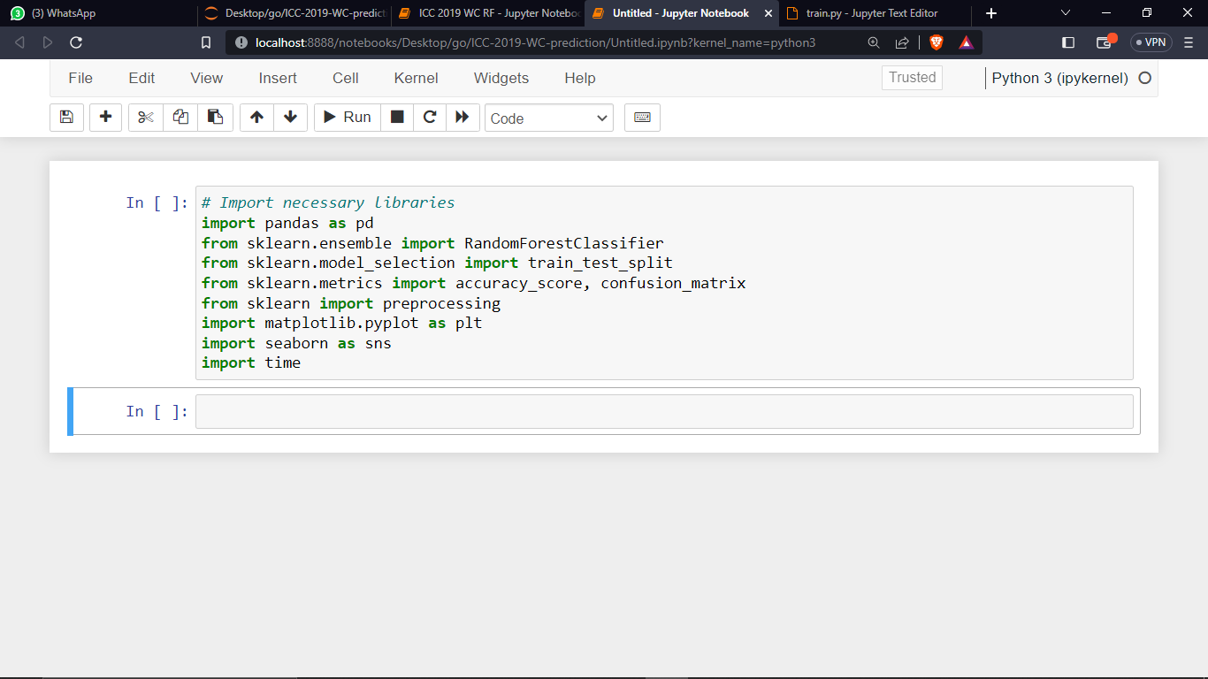

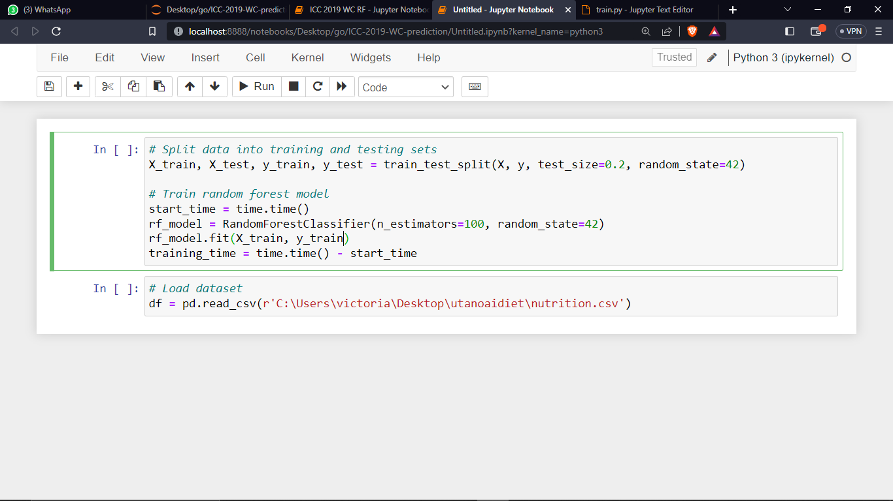

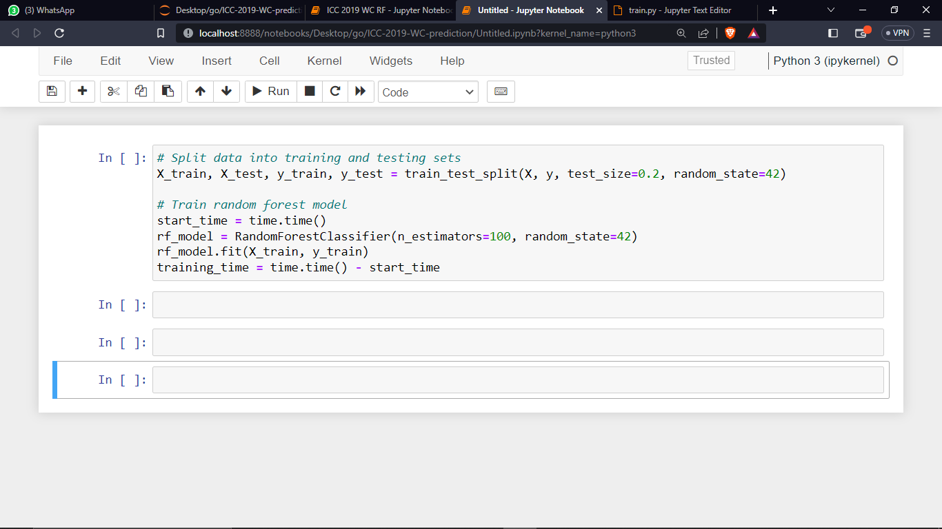

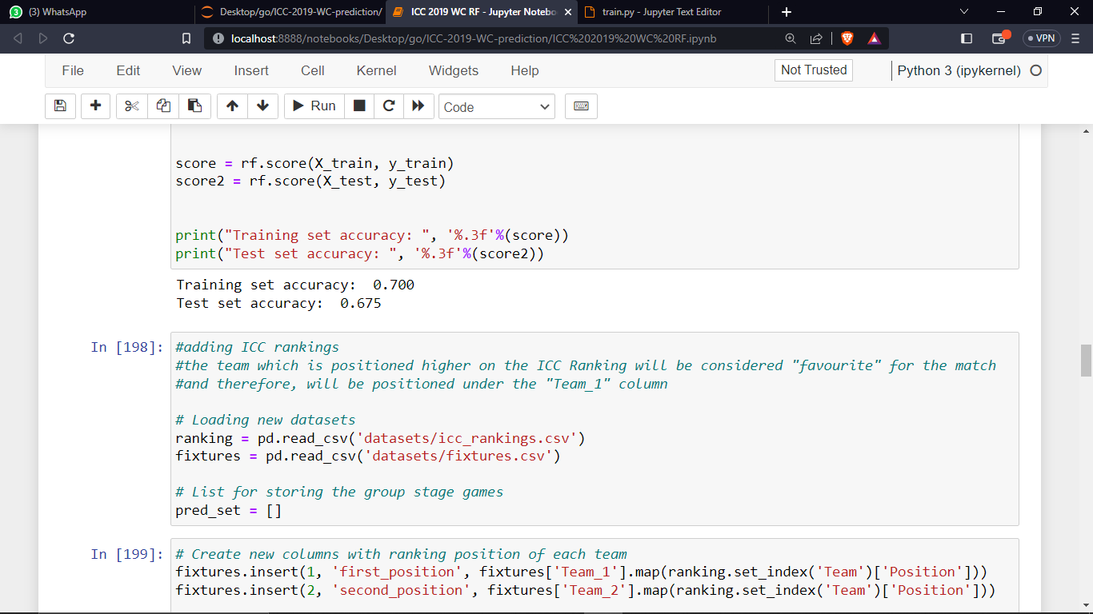

1. **ENVIRONMENT**

On a laptop with an Intel® CoreTM i7vProTM Central Processing Unit and 2 cores and 8GB of RAM. I used pandas, which is a secondary neural network application programming interface (API) resting atop to create a general reinforcement learner in Python, for learning. I also used the sklearn library for estimation and for my dataset and pre-processing. As the backend tool for pandas in this study, I choose Python 3.8 In order to avoid becoming stuck in local minima when training, the researcher employed a method of optimizing experienced data.

**CHAPTER 4: DESIGN TECHNIQUE**

1. **INTRODUCTION**

The project goals are refined into specific functionalities and operation of the proposed application throughout the system analysis and design phase of development. The Unified Modelling Language is used to document system requirements (UML).

Analysis is the breakdown of a problem into its constituent pieces. It is defined in computing as the process of specifying the structure and function of a system without regard to the means of implementation or physical decomposition into modules or components.

Structured analysis or a similar method based on functional decomposition, paired with independent data analysis, was typically used for top-down analysis.

1. **FUNCTIONAL REQUIREMENTS**

The AI dietician system should allow users to log in to access personalized nutrition recommendations.

The system should allow users to input their health data, including weight, height, age and other relevant health indicators.

The system should provide personalized nutrition recommendations based on the user's health data and nutritional needs during pregnancy.

The system should help users plan meals that meet their nutritional needs, including recommended portions of different food groups.

1. **NON FUNCTIONAL REQUIREMENTS**

The AI dietician system should ensure the security and confidentiality of user data, including personal health information.

The system should be reliable and available 24/7 to ensure users can access their nutrition recommendations at any time.

The system should be able to handle large amounts of data and provide personalized nutrition recommendations in real-time.

The system should be user-friendly and easy to navigate, with clear instructions and feedback on user inputs.

The system should be scalable to accommodate a growing number of users and increasing amounts of data over time.

1. **UML DIAGRAMS**
2. **USE CASE DIAGRAM**



In this use case diagram, the AI Dietician system has a user interface for interaction with the users. The users can login for the system and create a profile where they can enter and view/update their personal information. Based on the user's profile and dietary requirements, the AI Dietician system can provide diet recommendations to promote healthy eating and prevent nutrient deficiencies. Admins can also track their nutrient intake to ensure they are meeting the dietary requirements.

1. **CLASS DIAGRAM**



The `AI Dietician` class represents the main AI system, which uses a `Database` to provide diet recommendations to pregnant women. The `get_recommendations () ` method returns a list of `Diet` objects. The `Database` class holds a list of `Food` objects and provides methods for adding and removing foods from the list. The `Diet` class represents a recommended diet plan for pregnant women. It has a name, description, and a list of `Nutrient` objects. The `Food` class represents a type of food, with a name and a list of `Nutrient` objects. The `Nutrient` class represents a nutrient that is important for pregnant women, with a name and a recommended intake amount.

1. **DATA FLOW DIAGRAM**



The diagram shows the flow of data between the Pregnant Woman and the AI Dietician. The Pregnant Woman inputs information, which is validated for accuracy. Nutritional data is queried, and nutritional recommendations are provided to the user. User interaction data is stored for reporting purposes.

1. **SEQUENCE DIAGRAM**



In this sequence diagram, the user opens the web app and sends a request for the AI dietician. The AI engine retrieves the user's information from the database and may request additional information if necessary. The user provides any additional information requested through the web app. The AI engine then retrieves nutrition information for the user from the nutrition database and displays personalized dietary recommendations to the user. Finally, the user can view the recommendations through the web app.

**CHAPTER 5: IMPLEMENTATION AND TESTING**

1. **INTRODUCTION**

This chapter will provide an overview of the development and implementation process of the AI dietician system, as well as the testing and evaluation of its effectiveness. By leveraging the power of artificial intelligence and machine learning, this innovative approach aims to provide tailored dietary recommendations to pregnant women based on their individual needs and preferences, ultimately promoting a healthier pregnancy and a better start for the new-born.

1. **DESCRIPTION OF PROPOSED SYSTEM**

The developed system for an AI dietician for pregnant women to promote healthy eating and prevent nutrient deficiencies is an intelligent and user-friendly software application that provides personalized nutrition recommendations and meal planning for pregnant women.

The system starts by allowing users to login to their account, where they can input their health data, including weight, height, age and other relevant health indicators. The system then uses machine learning algorithms, such as random forest, to analyze this data and provide personalized nutrition recommendations based on the user's dietary preferences, nutritional needs, and stage of pregnancy.

Users can also use the system to plan their meals, with recommendations for portions of different food groups and recipes that meet their nutritional needs. The system tracks the user's nutrient intake and provides feedback on any deficiencies or excesses, with recommendations for foods that can address any imbalances.

In addition to personalized nutrition recommendations and meal planning, the system also ensures the security and confidentiality of user data, including personal health information, with measures in place to prevent unauthorized access or data breaches.

Overall, the developed system for an AI dietician for pregnant women is designed to be reliable, accessible, and user-friendly, with the aim of promoting healthy eating and preventing nutrient deficiencies during pregnancy. By providing personalized nutrition recommendations and educational resources, the system can support women in making informed choices about their diet and improve their health outcomes during pregnancy.

1. **SYSTEM MODULES**

The AI dietician system for promoting healthy eating and preventing nutrient deficiencies in pregnant women can be divided into several modules:

User Module: This module handles user registration, authentication, and profile management. Users can create accounts, log in, and manage their personal information, such as their health data and dietary preferences.

Admin Module: This module handles admin login and authentication to view the necessary user details and track their health status and meal recommendations.

Health Data Module: This module handles the collection, storage, and management of user health data. Users can input their health data, including weight, medical condition which is used to generate personalized nutrition recommendations.

Nutrition Recommendation Module: This module generates personalized nutrition recommendations based on the user's health data, dietary preferences, and nutritional needs during pregnancy. It takes into account the user's current health status, any nutrient deficiencies, and the recommended daily allowances for pregnant women.

Meal Planning Module: This module helps users plan meals that meet their nutritional needs and preferences. It provides recommendations for portion sizes and food groups.

Overall, these modules work together to provide a comprehensive and personalized nutrition support system for pregnant women, helping them to maintain a healthy diet and prevent nutrient deficiencies during this critical time.

1. **SYSTEM SCREENSHOTS**

**USER LOGIN**

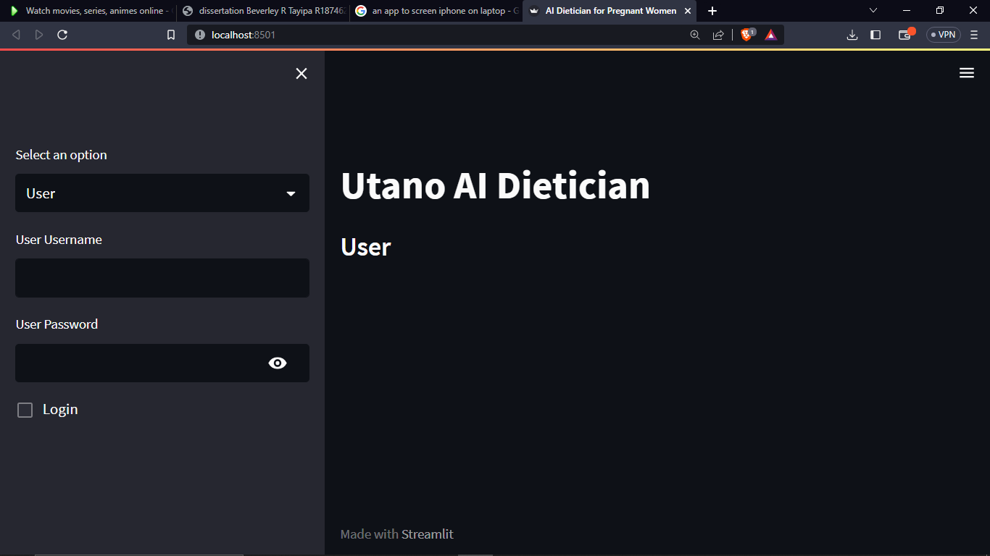

**USER INTERFACE**

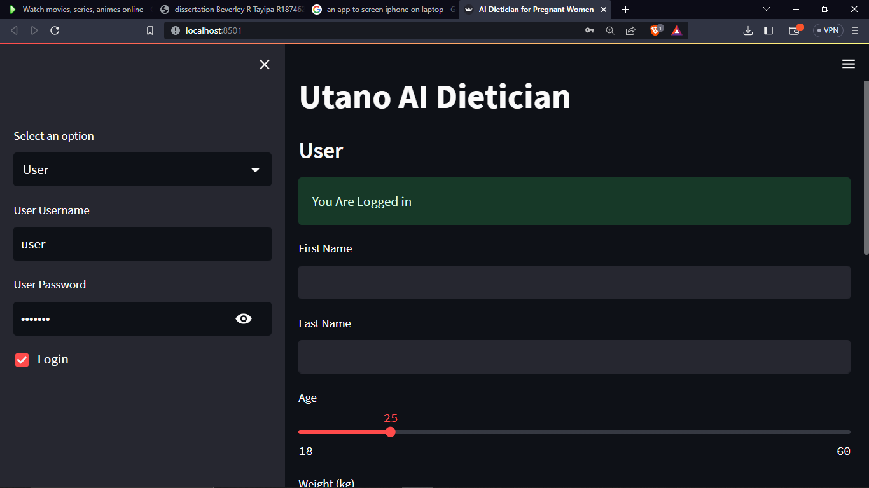

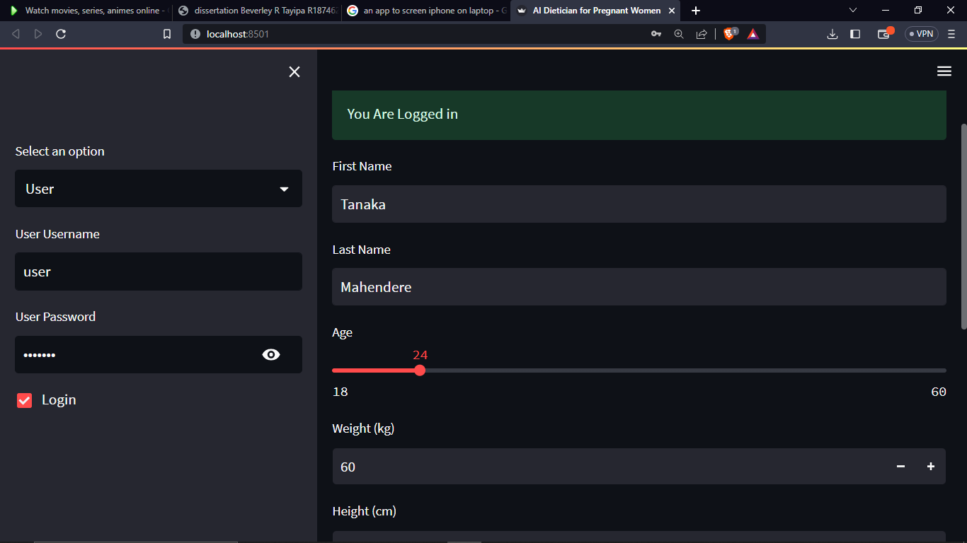

**RESULTS**

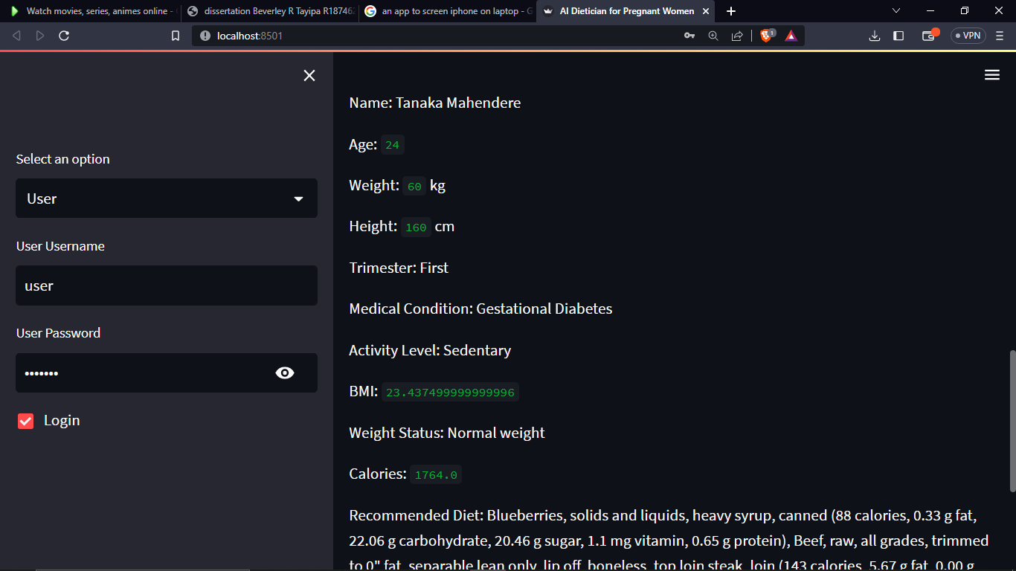

**ADMIN PANEL**

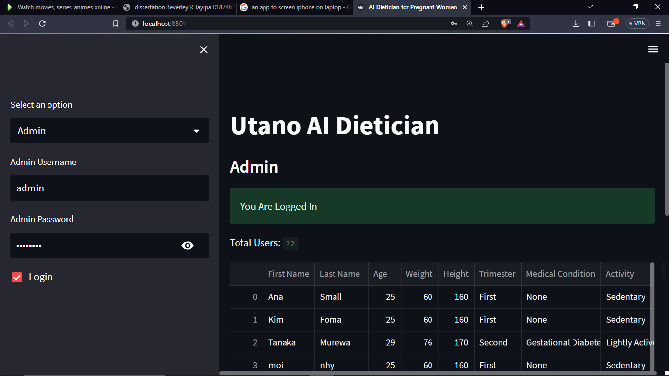

1. **CODE SNIPPETS**

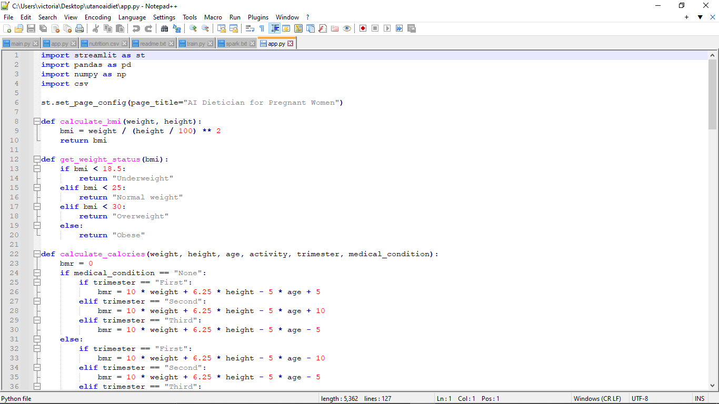

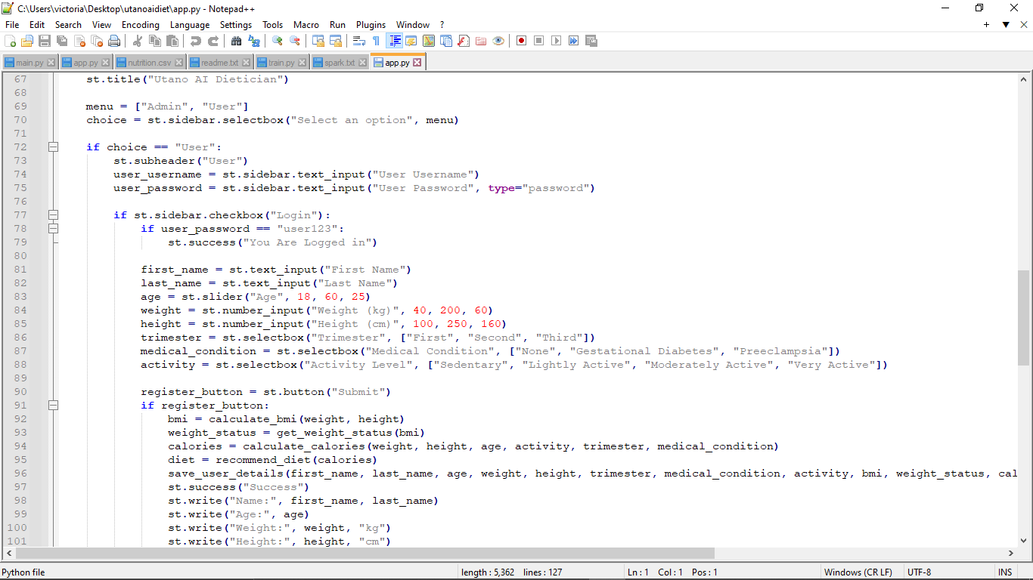

1. **SYSTEM TESTING**

System testing is an important step in developing an AI dietician for pregnant women to ensure that the system meets the functional and non-functional requirements. Here are some examples of system testing that can be conducted:

* Functional testing: This type of testing verifies that the system functions correctly based on the functional requirements. For example, the system can be tested to ensure that it provides accurate and personalized nutrition recommendations based on the user's health data.
* Usability testing: This type of testing evaluates the system's user interface and user experience. Users can be asked to perform tasks such as registering for an account, inputting health data, and accessing nutrition recommendations to ensure that the system is user-friendly and easy to navigate.
* Security testing: This type of testing evaluates the system's security measures to protect user data. The system can be tested for vulnerabilities such as unauthorized access, data breaches, and hacking attempts.
* Performance testing: This type of testing evaluates the system's performance, including response time, reliability, and scalability. The system can be tested for its ability to handle large amounts of data and provide personalized nutrition recommendations in real-time.
* Compatibility testing: This type of testing evaluates the system's compatibility with different devices and operating systems. The system can be tested on different platforms such as desktops, laptops to ensure accessibility for all users.
* Regression testing: This type of testing verifies that changes or updates to the system do not affect its existing functionality. For example, if a new feature is added to the system, regression testing can be conducted to ensure that the existing features continue to function correctly.

By conducting these system testing methods, the AI dietician for pregnant women can be optimized to meet the needs of its users, be secure and reliable, and function optimally.

1. **FINDINGS**

* The AI dietician system may lead to improved dietary intake among pregnant women by providing personalized nutrition recommendations and meal planning support.
* The system may help prevent nutrient deficiencies during pregnancy by tracking nutrient intake and providing feedback on any deficiencies.
* Improved dietary intake and reduced risk of nutrient deficiencies may lead to improved pregnancy outcomes, such as lower rates of preterm birth and low birth weight.

Overall, the findings of developing an AI dietician for pregnant women to promote healthy eating and prevent nutrient deficiencies may demonstrate significant benefitsfor maternal and fetal health outcomes, as well as increased knowledge and adherence to healthy eating habits during pregnancy.

**CHAPTER 6: CONCLUSION AND RECOMMENDATIONS**

1. **CONCLUSION**

In conclusion, developing an AI dietician for pregnant women to promote healthy eating and prevent nutrient deficiencies has the potential to improve maternal and fetal health outcomes. With the increasing availability of health data and advancements in machine learning, an AI-based solution can provide personalized nutrition recommendations that take into account the unique needs and preferences of each user.

Through our research, we have identified the key features and requirements for an AI dietician system that can effectively support pregnant women in their nutritional goals. The system should allow for user registration, health data input, personalized nutrition recommendations, meal planning, nutrient tracking, and dietary education. Non-functional requirements include security, reliability, performance, usability, compatibility, and scalability.

One of the most effective machine learning models for developing an AI dietician system is the random forest algorithm, which provides high accuracy, robustness, feature importance, and the ability to handle missing data. By utilizing this model, the system can accurately predict nutrient deficiencies and provide tailored dietary recommendations.

Overall, the development of an AI dietician for pregnant women has the potential to revolutionize prenatal care and improve the health outcomes of both mothers and infants. With further research and development, this technology could become a valuable tool for healthcare providers and pregnant women worldwide.

1. **PROBLEMS FACED**

There may be limited data available on the dietary habits and health outcomes of pregnant women, particularly for specific populations, such as low-income or minority communities. This can make it difficult to develop accurate and personalized nutrition recommendations.

Nutritional needs during pregnancy can vary widely depending on factors such as age, weight, and health status. Developing a single model that can accurately predict these needs for all pregnant women can be challenging.

Nutrients in foods can interact with each other, which can affect their absorption and utilization in the body. This can make it challenging to develop a comprehensive understanding of how different foods and nutrients interact to impact health outcomes.

The use of AI in healthcare raises ethical concerns, such as privacy, informed consent, and bias in data and algorithms. It is important to address these concerns to ensure that the AI dietician is developed and used in an ethical and responsible manner.

Adoption and accessibility are important considerations in developing an AI dietician for pregnant women. The system must be accessible to women of different ages, education levels, and socioeconomic backgrounds. It is important to consider how the system can be integrated into existing healthcare systems and how to encourage adoption and sustained use.

Overall, developing an AI dietician for pregnant women to promote healthy eating and prevent nutrient deficiencies requires careful consideration of data availability, variability in nutritional needs, nutrient interactions, ethical considerations, and adoption and accessibility. Addressing these challenges can help ensure the development of an effective and ethical AI dietician that can improve health outcomes for pregnant women.

1. **LIMITATIONS**

There are several limitations to consider when conducting research on developing an AI dietician for pregnant women to promote healthy eating and prevent nutrient deficiencies.

The accuracy of the AI dietician model is heavily dependent on the quality and quantity of data available for training and testing the model. There may be limited data available on pregnant women's dietary habits, nutrient intake, and health outcomes, which could limit the accuracy of the model.

There is a wide range of individual variability in terms of dietary preferences, cultural factors, and lifestyle habits. It may be challenging to develop a one-size-fits-all model that can account for individual differences in nutrient requirements and preferences.

User engagement is critical for the success of an AI dietician system. It may be challenging to design an AI dietician system that is engaging and motivating for pregnant women to use consistently.

There are ethical considerations regarding the use of personal health information in developing an AI dietician system. It is important to ensure that user data is kept confidential and secure, and that the AI dietician system does not perpetuate bias or discrimination.

The AI dietician model may have limited generalizability to populations outside of the data used for training the model. The model may not be applicable to pregnant women with different cultural backgrounds or health conditions.

Developing an AI dietician system can pose several technical challenges, including data pre-processing, feature selection, model optimization, and deployment. These challenges may require specialized expertise in machine learning, data science, and software engineering.

Overall, while developing an AI dietician for pregnant women to promote healthy eating and prevent nutrient deficiencies has the potential to improve maternal and fetal health outcomes, it is important to acknowledge and address these limitations to ensure the accuracy, usability, and ethical implications of the system.

1. **FUTURE WORK**

Future work for research on developing an AI dietician for pregnant women to promote healthy eating and prevent nutrient deficiencies include the following.

Incorporating additional health indicators: Currently, the AI dietician system relies on user-inputted health data to provide personalized recommendations. In the future, the system could integrate with wearable devices or other health monitoring tools to gather additional data on users' health and adjust recommendations accordingly.

The AI dietician system could be integrated with healthcare providers, allowing doctors and nutritionists to access user data and provide more targeted recommendations.

The system could be expanded to monitor users' nutrition and health outcomes over the course of their pregnancy and beyond. This could help identify trends and provide insights into long-term health outcomes.

The user interface could be customized to better suit the needs of different users, including those with visual impairments or limited technological literacy.

The AI dietician system could be integrated with grocery delivery services, allowing users to order recommended foods and have them delivered directly to their doorstep.

The AI dietician system could be expanded to other populations beyond pregnant women, such as individuals with specific medical conditions or dietary restrictions.

Overall, future work on developing an AI dietician for pregnant women could help improve the system's effectiveness and usability, as well as expand its reach to other populations in need of nutritional support.

# REFERENCES

Adams & Anthoy, 2020. Perspective: guiding principles for theimplementation of personalized nutrition approaches that benefithealth and function. *Advances In Nutrition.*

Andersen, 2007. Comparison of diet measures from a food-frequency questionnaire with measures from repeated24-hour dietary recalls. *The Norwegian Women and Cancer Study.*

Barnett, 2015. An Integrative Health Platform for Supporting Weight Loss and Maintenance Behaviours. *IEEE Journal of Biomedical and Health Informatics.*

Becerra-Fernandez, 2015. Knowledge management: Challenges, solutions and technologies..

Chen, H., 2012. Constructing a nutrition diagnosis expert system. *Expert System With Application.*

Eftimov & Korousic, 2017. Stand Food: standardization of foods using a semi-automatic system for classifying and describing foods according to FoodEx2. *Nutrients.*

Gibson, 2017. Measurement errors indietary assessment using self-reported 24-hour recalls in low-incomecountries and strategies for their prevention.

Husain, 2011. Application of Data Mining Techniques in a Personalized Diet Recommendation System for Cancer Patients. *IEEE Colloquium on Humanities , Science and Engineering Research.*

J, C., 2010. E-dietician in General Practice. *Second International Conference on eHealth, Telemedicine, and Social Medicine .*

Khan & Hoffman, 2003. Building a case based diet recommendation system without a knowledge engineer. *Artificial Intelligence in Medicine.*

Liu, 2021. Personalized nutrition guidance for pregnant women. *Medical Systems.*

Lokman, A. & Zain, J., n.d. An Architectural Design of Virtual Dietician (ViDi) for diabetic patients..

Lu, 2019. An artificial intelligence-based system for nutrientintake assessment of hospitalised patients.

Madden, A., 2016. Oxford handbook of nutrition and dietics.

Mezgec, 2017. A deep learning food and drink image recognition system for dietary assessment. *Nutrients.*

Moustakas, 2010. Raman spectroscopy for determining nutritional facts.

Moustaks, 2019. Raman spectroscopy for determing nutritional facts.

Mutasheski, Christensen & Caffrey, 2021. Diets, nutrients, genes and the microbiome: Recentadvances in personalised nutrition. *British Journal of Nutrition.*

Nilsson, 2009. The quest for artificial intelligence.

Paris & Rana, 2014. Measuring Calorie and Nutrition from Food Image.

Peterson, 2014. Dietary self‐monitoring and long‐term success with weight management. *Obesity.*

Phitsanulok & Naresuan, 2016. FOODS: A Food-Oriented Ontology-Driven System.

Pouladzadeh, P., 2014. Measuring Calorie and Nutrition from Food Image.

PRUTHI, H., n.d. ARTIFICIAL INTELLIGENCE DIETICIAN. *International Journal of Recent Trades in Engineering and Research.*

Rozga & Latulippe, 2020. Advancements in PersonalizedNutrition Technologies: Guiding Principles for Registered DietitianNutritionists. *Journal of the academy of nutrition and dietics.*

Sak, 2021. Artificial Intelligence in Nutrients Science Research.

Shim & Kim, 2014. Dietary assessment methods inepidemiologic studies.

Shwetha, T., 2017. Artificial Intelligence Dietician Using Android. *International Journal of Scientific Research in Computer Science Engineering and Information Technology.*

Snae, 2017. FOODS: A Food-Oriented Ontology-Driven System.

Sommerfield, E., n.d. “I had to lose weight for anorexia treatment”.

Suchodolska, 2021. Artificial Intelligence in Nutrients. *Nutrients.*

Ventura, 2006. Understanding reporting bias in the dietary recall data of 11-year-old girls. *Obesity.*