**Experiment-1**

**Title:** DML commands with constraints

**Objective: -** To understand the concept of different DML commands.

**Aim:**

To perform DML operations with constraints like NOT NULL, UNIQUE, CHECK.

**Theory:**

DML allows manipulation of data within tables. Constraints enforce data integrity.

**1.Exercises on retrieving the data from**

**a.** Find out the names of all the clients.

**Code and output:**

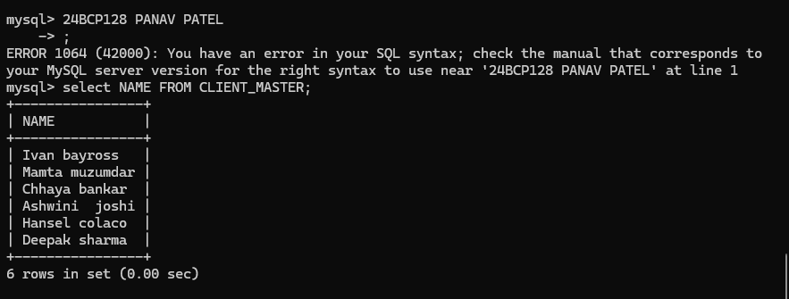

**b.** Retrieve the entire contents of the Client_Master table.

**Code and output:**

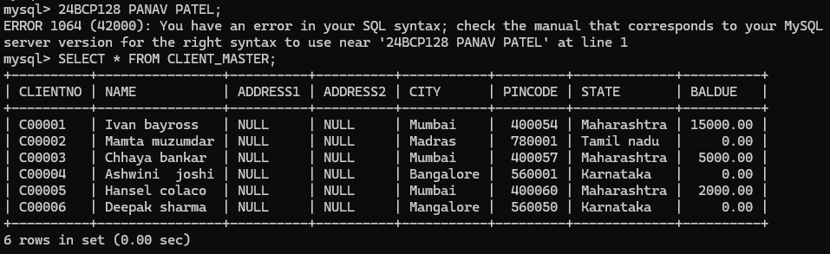

**c.** Retrieve the list of names, city and the state of all the clients.

**Code and output:**

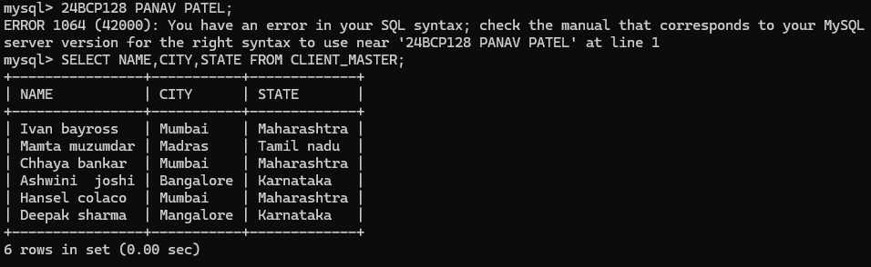

**d.** List the various products available from the Product_Master table.

**Code and output:**

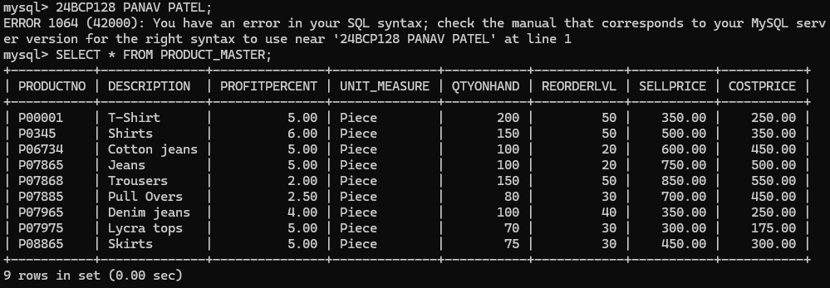

**e.** List all the clients who are located in Mumbai.

**Code and output:**

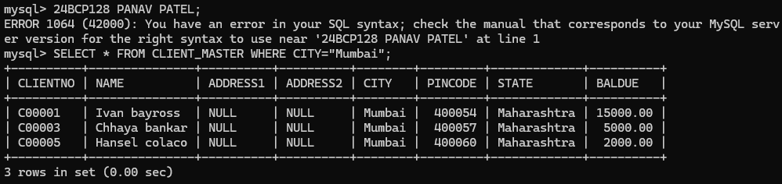

**f.** Find the names of salesman who have a salary equal to Rs.3000.

**Code and output:**

