Practical-8
1. Level order traversal.
Aim:
To implement trees and traversing it in level order.
Theory:
Implemented tree using linked list also we used queue using linked list for level order traversal.
Code:
#include<stdio.h>
#include<stdlib.h>

struct node
{
int data;
struct node * right,* left;
};

struct queueNode
{
struct node *treeNode;
struct queueNode *next;
};

struct queueNode *forw=NULL,*rear=NULL;

void enqueue(struct node *treeNode)
{
struct queueNode *newQ=(struct queueNode *)malloc(sizeof(struct queueNode));
newQ->treeNode=treeNode;
newQ->next=NULL;
if(rear==NULL)
{
forw=rear=newQ;
}
else
{
rear->next=newQ;
rear=newQ;
}
}

struct node* dequeue()
{
if(forw==NULL)
return NULL;
struct queueNode *temp=forw;
struct node *treeNode=temp->treeNode;
forw=forw->next;
if(forw==NULL)
rear=NULL;
return treeNode;
}

int isEmpty()
{
return (forw==NULL);
}

struct node* createNode(int data)
{
struct node* newNode=(struct node *)malloc(sizeof(struct node));
newNode->data=data;
newNode->left=newNode->right=NULL;
return newNode;
}

struct node* createTree()
{
int data;
printf("Enter data (-1 for no node): ");
scanf("%d",&data);
if(data==-1) return NULL;
struct node* root=createNode(data);
printf("Enter left child of %d\n",data);
root->left=createTree();
printf("Enter right child of %d\n",data);
root->right=createTree();
return root;
}

void displayLevelOrder(struct node *root)
{
if(root==NULL)
{
printf("Tree is empty!\n");
return;
}
enqueue(root);
printf("\nLevel Order Traversal: ");
while(!isEmpty())
{
struct node *current=dequeue();
printf("%d ",current->data);
if(current->left!=NULL)
enqueue(current->left);
if(current->right!=NULL)
enqueue(current->right);
}
printf("\n");
}
int main()
{
struct node *root=NULL;
int a;
while(1)
{
printf("\nEnter the number for following choices \n1.Create Tree \n2.Display level order \n3.Exit\n");
scanf("%d",&a);
switch(a)
{
case 1:
root=createTree();
break;
case 2:
displayLevelOrder(root);
break;
case 3:
exit(0);
break;
default:
printf("Invalid Choice");
break;
}
}
return 0;
}
Output:
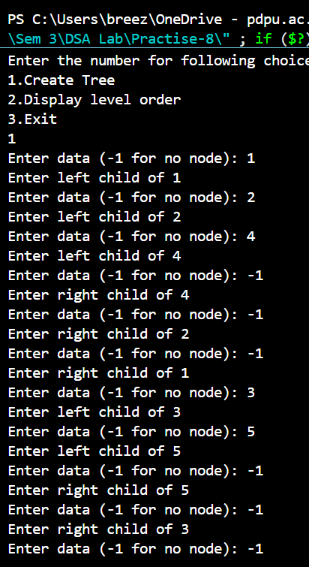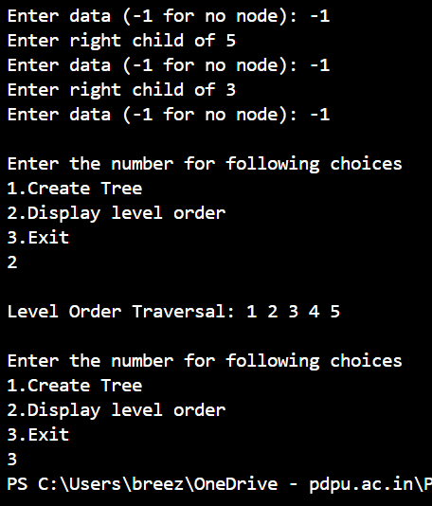
Link for all codes:
https://github.com/PanavPatel06/DSA-Lab/tree/main/Practise-8

