Test Awal Praktikum Basis Data(3) Pancar wahyu setiabi

H1D024018 SHIFT D

* Copy syntax SQL pembuatan database ‘PENJUALAN BARANG’ dan pembuatan tabel ‘PELANGGAN’

MariaDB [(none)]> use penjualan_barang; Database changed

MariaDB [penjualan_barang]> CREATE TABLE pelanggan(

-> id_pelanggan CHAR(5) NOT NULL PRIMARY KEY,

-> nama VARCHAR(25) NOT NULL,

-> alamat VARCHAR(100),

-> pekerjaan VARCHAR(20),

-> no_ktp INT(20),

-> no_telp INT(15));

Query OK, 0 rows affected (0.017 sec)

* Screenshots syntax SQL pembuatan database ‘PENJUALAN BARANG’ dan pembuatan tabel ‘PELANGGAN’

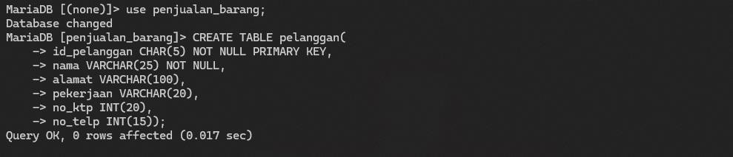

* Copy syntax desc tabel ‘PELANGGAN’

MariaDB [penjualan_barang]> desc pelanggan;

+--------------+--------------+------+-----+---------+ +

| Field | Type | Null | Key | Default | Extra |

+--------------+--------------+------+-----+---------+ +

| id_pelanggan | char(5) | NO | PRI | NULL | |

| nama | varchar(25) | NO | | NULL | |

| alamat | varchar(100) | YES | | NULL | |

| pekerjaan | varchar(20) | YES | | NULL | |

| no_ktp | int(20) | YES | | NULL | |

| no_telp | int(15) | YES | | NULL | |

+--------------+--------------+------+-----+---------+ +

6 rows in set (0.024 sec)

* 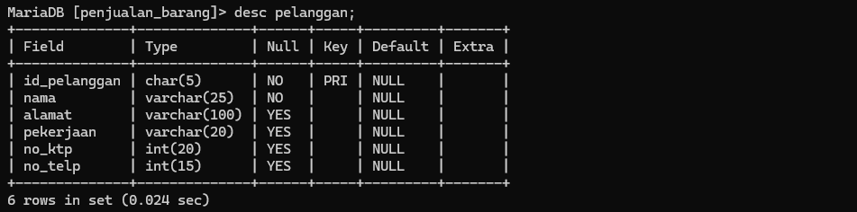Screenshots syntax desc tabel ‘PELANGGAN’
* Copy syntax SQL pembuatan tabel ‘BARANG’ MariaDB [penjualan_barang]> CREATE TABLE barang(

-> id_barang CHAR(5) NOT NULL PRIMARY KEY,

-> nama VARCHAR(25) NOT NULL,

-> harga VARCHAR(50),

-> stok VARCHAR(30));

Query OK, 0 rows affected (0.032 sec)

* Screenshots syntax SQL pembuatan tabel ‘BARANG’

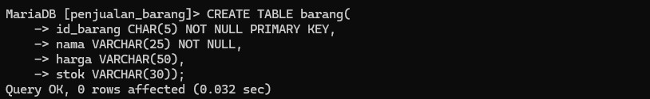

* Copy syntax desc tabel ‘BARANG’

MariaDB [penjualan_barang]> desc barang;

+-----------+-------------+------+-----+---------+ +

| Field | Type | Null | Key | Default | Extra |

+-----------+-------------+------+-----+---------+ +

| id_barang | char(5) | NO | PRI | NULL | |

| nama | varchar(25) | NO | | NULL | |

| harga | varchar(50) | YES | | NULL | |

| stok | varchar(30) | YES | | NULL | |

+-----------+-------------+------+-----+---------+ +

4 rows in set (0.203 sec)

* Screenshots syntax desc tabel ‘BARANG

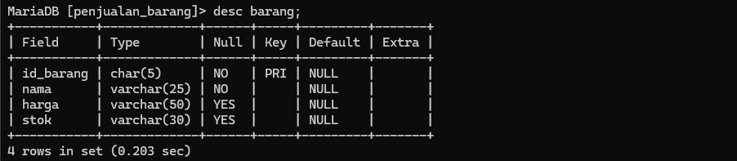

* Copy syntax SQL pembuatan tabel ‘NOTA_PENJUALAN’ MariaDB [penjualan_barang]> CREATE TABLE nota_penjualan(

-> id_nota CHAR(5) NOT NULL PRIMARY KEY,

-> id_pelanggan VARCHAR(25) NOT NULL,

-> tgl_nota DATE,

-> total INT(50),

-> FOREIGN KEY (id_pelanggan) REFERENCES pelanggan (id_pelanggan)); Query OK, 0 rows affected (0.056 sec)

* Screenshots syntax SQL pembuatan tabel ‘NOTA_PENJUALAN’

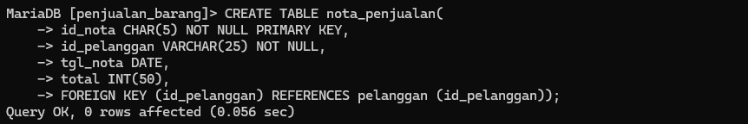

* Copy syntax desc tabel ‘NOTA_PENJUALAN’

MariaDB [penjualan_barang]> desc nota_penjualan;

+--------------+-------------+------+-----+---------+ +

| Field | Type | Null | Key | Default | Extra |

+--------------+-------------+------+-----+---------+ +

| id_nota | char(5) | NO | PRI | NULL | |

| id_pelanggan | varchar(25) | NO | MUL | NULL | |

| tgl_nota | date | YES | | NULL | |

| total | int(50) | YES | | NULL | |

+--------------+-------------+------+-----+---------+ +

4 rows in set (0.042 sec)

* 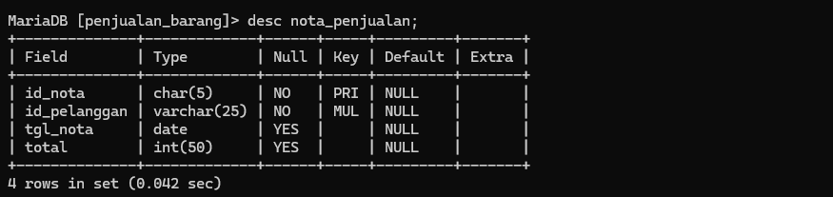Screenshots syntax desc tabel ‘NOTA_PENJUALAN’
* Copy syntax SQL pembuatan tabel ‘DETAIL_JUAL’ MariaDB [penjualan_barang]> CREATE TABLE detail_jual(

-> id_nota CHAR(5) NOT NULL,

-> id_barang CHAR(5) NOT NULL,

-> jumlah INT,

-> harga INT,

-> PRIMARY KEY (id_nota, id_barang),

-> FOREIGN KEY (id_nota) REFERENCES nota_penjualan (id_nota),

-> FOREIGN KEY (id_barang) REFERENCES barang (id_barang)); Query OK, 0 rows affected (0.041 sec)

* Screenshots syntax SQL pembuatan tabel ‘DETAIL_JUAL’

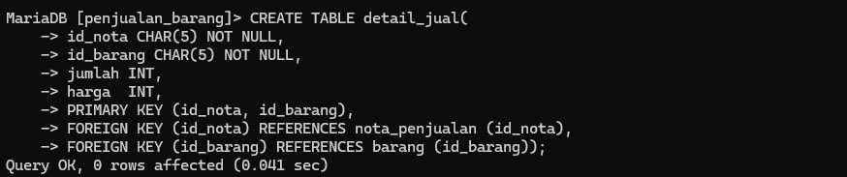

* Copy syntax desc tabel ‘DETAIL_JUAL’

MariaDB [penjualan_barang]> desc detail_jual;

+-----------+---------+------+-----+---------+ +

| Field | Type | Null | Key | Default | Extra |

+-----------+---------+------+-----+---------+ +

| id_nota | char(5) | NO | PRI | NULL | |

| id_barang | char(5) | NO | PRI | NULL | |

| jumlah | int(11) | YES | | NULL | |

| harga | int(11) | YES | | NULL | |

+-----------+---------+------+-----+---------+ +

4 rows in set (0.038 sec)

* Screenshots syntax desc tabel ‘DETAIL_JUAL’

