# 

**Time Series Analysis of Britannia**

Name: Pooja Bharadwaj

Roll no: 24A

#REQUIRED PACKAGES

packages = c('tseries','forecast','quantmod','car','FinTS','rugarch')

#Load all packages

lapply(packages, require, character.only = TRUE)

Loading required package: tseries

Warning: package ‘tseries’ was built under R version 4.3.2Registered S3 method overwritten by 'quantmod':

method from

as.zoo.data.frame zoo

‘tseries’ version: 0.10-55

‘tseries’ is a package for time series analysis and computational

finance.

See ‘library(help="tseries")’ for details.

Loading required package: forecast

Warning: package ‘forecast’ was built under R version 4.3.2Loading required package: quantmod

Warning: package ‘quantmod’ was built under R version 4.3.2Loading required package: xts

Warning: package ‘xts’ was built under R version 4.3.2Loading required package: zoo

Warning: package ‘zoo’ was built under R version 4.3.2

Attaching package: ‘zoo’

The following objects are masked from ‘package:base’:

as.Date, as.Date.numeric

Loading required package: TTR

Warning: package ‘TTR’ was built under R version 4.3.2Loading required package: car

Warning: package ‘car’ was built under R version 4.3.2Loading required package: carData

Warning: package ‘carData’ was built under R version 4.3.2Loading required package: FinTS

Warning: package ‘FinTS’ was built under R version 4.3.2

Attaching package: ‘FinTS’

The following object is masked from ‘package:forecast’:

Acf

Loading required package: rugarch

Warning: package ‘rugarch’ was built under R version 4.3.2Loading required package: parallel

Attaching package: ‘rugarch’

The following object is masked from ‘package:stats’:

sigma

[[1]]

[1] TRUE

[[2]]

[1] TRUE

[[3]]

[1] TRUE

[[4]]

[1] TRUE

[[5]]

[1] TRUE

[[6]]

[1] TRUE

#lapply(quantmod)

This is an [R Markdown](http://rmarkdown.rstudio.com/) Notebook. When you execute code within the notebook, the results appear beneath the code.

Try executing this chunk by clicking the Run button within the chunk or by placing your cursor inside it and pressing Ctrl+Shift+Enter.

Hide

stock_data = new.env()

stock_list = c('BRITANNIA.NS')

start_date = as.Date('2015-01-01'); end_date = as.Date('2019-12-31')

getSymbols(Symbols = stock_list, from = start_date, to = end_date, env = stock_data)

Warning: BRITANNIA.NS contains missing values. Some functions will not work if objects contain missing values in the middle of the series. Consider using na.omit(), na.approx(), na.fill(), etc to remove or replace them.

[1] "BRITANNIA.NS"

stock_price=na.omit(stock_data$BRITANNIA.NS$BRITANNIA.NS.Adjusted)

#MSFT_price

#stock_price = BRITANNIA.NS$BRITANNIA.NS.Close # Adjusted Closing Price

class(stock_price) # xts (Time-Series) Object

[1] "xts" "zoo"

stock_price

BRITANNIA.NS.Adjusted

2015-01-01 810.1472

2015-01-02 830.9594

2015-01-05 831.5342

2015-01-06 832.4410

2015-01-07 882.8016

2015-01-08 871.0575

2015-01-09 860.4855

2015-01-12 854.6024

2015-01-13 855.2217

2015-01-14 860.8173

...

2019-12-16 2797.3357

2019-12-17 2816.6360

2019-12-18 2841.6211

2019-12-19 2854.0454

2019-12-20 2862.7556

2019-12-23 2834.8359

2019-12-24 2834.1489

2019-12-26 2807.7883

2019-12-27 2789.2668

2019-12-30 2794.0806

# Required Packages

packages = c('tseries', 'forecast')

# Load all Packages

lapply(packages, require, character.only = TRUE)

[[1]]

[1] TRUE

[[2]]

[1] TRUE

# ---------------------------------------------------------------------------------------------

# Forecasting with Time-Series Data (Univariate) : Procedure

# **********************************************************

# Given an Univariate Time-Series Data, Perform the following Analysis :

# Step 1 : Check for (Weak) Stationarity :: Augmented Dickey-Fuller (ADF) Test

# If [Data] Stationary, Proceed to Step 2

# If [Data] Non-Stationary, Use Transformation (such as First/Second/... Difference | Log | ...) to Transform the Data and Check for Stationarity (Step 1)

# Step 2 : Check for Autocorrelation :: Ljung-Box Test

# If [Data | Transformed Data] Do Not Have Autocorrelation, proceed to Step 4

# If [Data | Transformed Data] Has Autocorrelation, Proceed to Step 3

# Step 3 : Model for Autocorrelation :: ARIMA Models

# Identify AR | MA Order in the [Data | Transformed Data] using PACF | ACF Plots

# Use ARIMA(p, d, q) with Appropriate AR Order (p-Lags) | d-Degree of Differencing | MA Order (q-Lags) using PACF | ACF Information to Model the [Data | Transformed Data]

# Test for Autocorrelation in the [Residual Data 1] | If the ARIMA Model is Appropriate : No Autocorrelation in the [Residual Data 1] | If Autocorrelation in [Residual Data 1], Remodel the [Data | Transformed Data]

# Proceed to Step 4

# Step 4 : Check for Heteroskedasticity :: ARCH LM Test

# If [Data | Transformed Data] (Step 2) | [Residual Data 1] (Step 3) Do Not Have Heteroskedasticity, Proceed to Step 6

# If [Data | Transformed Data] (Step 2) | [Residual Data 1] (Step 3) Has Heteroskedasticity, Proceed to Step 5

# Step 5a : Model for Heteroskedasticity in [Data | Transformed Data] (Step 2) :: GARCH Models

# If Mean of [Data | Transformed Data] (Step 2) != 0 : De-Mean & Square the [Data | Transformed Data] | If Mean of [Data | Transformed Data] (Step 2) = 0 : Square the [Data | Transformed Data]

# Identify ARCH | GARCH Order in the using GARCH Function

# Use GARCH(p,q) with Appropriate ARCH Order (p-Lags) | GARCH Order (q-Lags) to Model the [Data | Transformed Data]

# Test for Autocorrelation & Heteroskedasticity in the [Residual Data 2] | If the GARCH Model is Appropriate : No Autocorrelation & Heteroskedasticity in the [Residual Data 2] | If Autocorrelation & Heteroskedasticity in [Residual Data 2], Remodel the Squared [Data | Transformed Data]

# End of Analysis

# Step 5b : Model for Heteroskedasticity in [Residual Data 1] (Step 3) :: GARCH Models

# Identify ARCH | GARCH Order in the using GARCH Function

# Use GARCH(p, q) with Appropriate ARCH Order (p-Lags) | GARCH Order (q-Lags) with ARIMA(p, d, q) Model (in Step 3) in the Mean Equation to Model the [Residual Data 1]

# Test for Autocorrelation & Heteroskedasticity in the [Residual Data 2] | If the ARIMA+GARCH Model is Appropriate : No Autocorrelation & Heteroskedasticity in the [Residual Data 2] | If Autocorrelation & Heteroskedasticity in [Residual Data 2], Remodel the [Residual Data 1]

# End of Analysis

# Step 6 : Model White-Noise Data

# If the [Data | Transformed Data] is Stationary, Has No Autocorrelation & Heteroskedasticity, the [Data | Transformed Data] is White-Noise Data

# Model White-Noise Data with Appropriate Probability Distribution

# End of Analysis

# Augmented Dickey-Fuller (ADF) Test for Stationarity with Britannia Data

# *******************************************************************

adf_test_britannia = adf.test(stock_price);adf_test_britannia

Augmented Dickey-Fuller Test

data: stock_price

Dickey-Fuller = -2.2587, Lag order = 10, p-value = 0.4688

alternative hypothesis: stationary

The Augmented Dickey-Fuller (ADF) test statistic is -2.2587.

The lag order used in the test is 10.

The p-value of the test is 0.4688.

**Interpretation:**

The null hypothesis of the ADF test is that the data has a unit root, which means it is non-stationary.

The alternative hypothesis is that the data is stationary.

Since the p-value (0.4688) is greater than the commonly used significance level of 0.05, we fail to reject the null hypothesis. This means that we do not have enough evidence to conclude that the stock price data is stationary.

In conclusion, based on the ADF test results, the stock price data appears to be non-stationary.

# Inference : BRITANNIA Time-Series is Non-Stationary

britannia_ds = diff(log(stock_price)); plot(britannia_ds) # Britannia (First)return Difference Time-Series

**Transformation and Retest:**

To address the non-stationarity, the code performs a differencing and log transformation on the data (britannia_ds = diff(log(stock_price))). Differencing removes trends and log transformation can help with skewed data.

The transformed data (britannia_ds) is plotted to visually explore its characteristics, likely showing a more stationary pattern.

The test shows strong evidence of stationarity (p-value = 0.01, which is less than 0.05) for the transformed data (britannia_ds). This suggests that the first-order differenced log of the stock price might be a suitable choice for further analysis like forecasting.

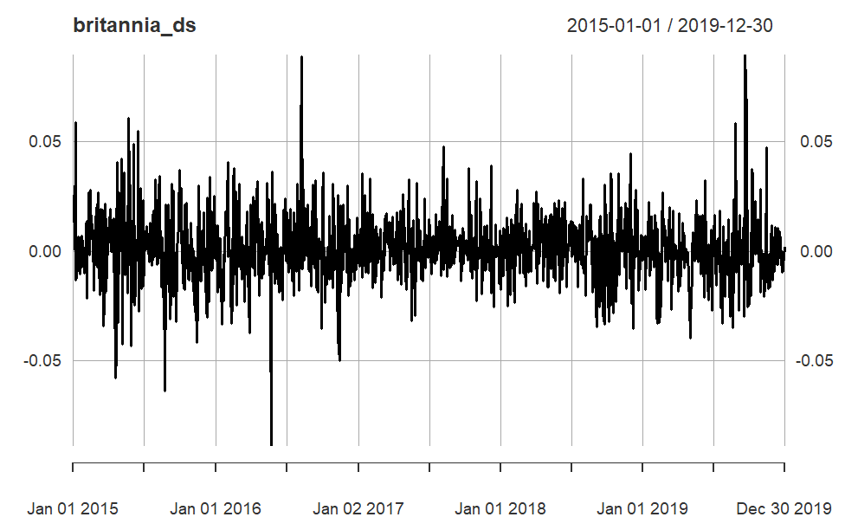

britannia_ds=na.omit(britannia_ds)

adf_test_britannia_ds = adf.test(britannia_ds); adf_test_britannia_ds # Inference : Britannia Difference Time-Series is Stationary

Warning: p-value smaller than printed p-value

Augmented Dickey-Fuller Test

data: britannia_ds

Dickey-Fuller = -10.719, Lag order = 10, p-value = 0.01

alternative hypothesis: stationary

# Ljung-Box Test for Autocorrelation - Britannia Data

# ***********************************************

lb_test_britannia_ds = Box.test(britannia_ds); lb_test_britannia_ds # Inference : Britannia Difference (Stationary) Time-Series is Autocorrelated as NULL is rejected and p-value<0.0151 | NULL: No Auto correlation | Alternate: Auto Correlation

Box-Pierce test

data: britannia_ds

X-squared = 5.8534, df = 1, p-value = 0.01555

**Ljung-Box Test for Autocorrelation :**

The null hypothesis (H0) of the Ljung-Box test states that there is no autocorrelation in the data.

The alternative hypothesis (H1) states that autocorrelation exists.

The test result (lb_test_britannia_ds) indicates a p-value of 0.01555, which is less than the commonly used significance level of 0.05.

This means we reject the null hypothesis (H0) and conclude that there is evidence of autocorrelation in the differenced and log-transformed "stock_price" data.

# 3.0.3.2. Autocorrelation Function (ACF) | Partial Autocorrelation Function (PACF)

# *****************************************************************************

acf(stock_price) # ACF of JJ Series

pacf(stock_price) # PACF of JJ Series

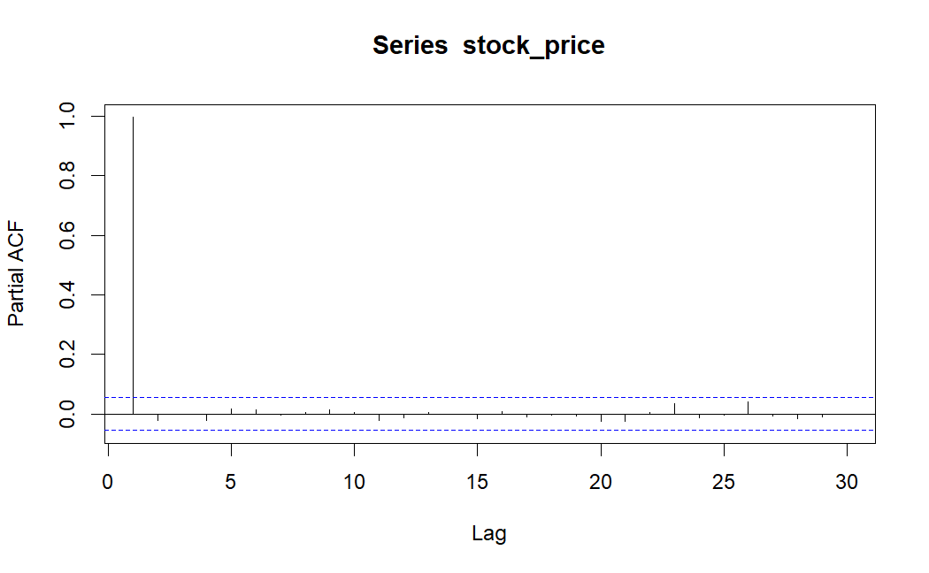

acf(britannia_ds) # ACF of Britannia Difference (Stationary) Series

pacf(britannia_ds) # PACF of Britannia Difference (Stationary) Series

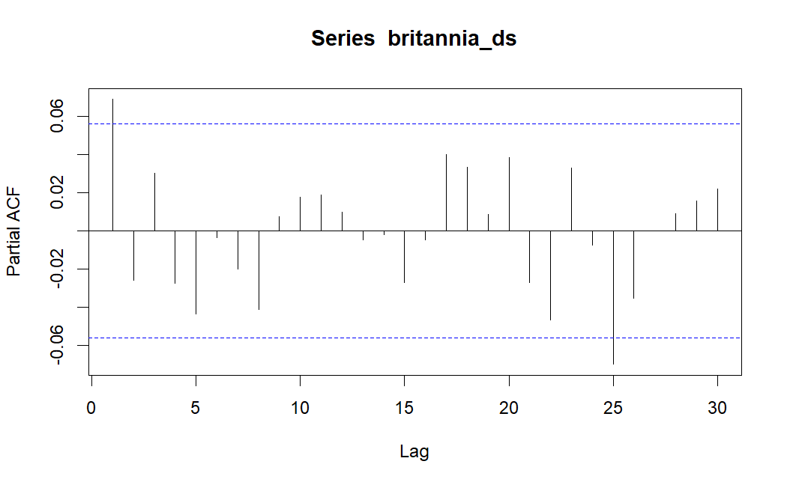

# 3.1. Auto Regressive Integrated Moving Average (ARIMA) Models

# *************************************************************

# 3.1.1. ARIMA Models

# *******************

# AR (p-Lag) Model : y(t) = c1 + a1*y(t-1) + a2*y(t-2) + ... + ap*y(t-p) + e(t) where e = error == White Noise | AR-1 Model : y(t) = c + a1*y(t-1) + e(t)

# MA (q-Lag) Model : y(t) = c2 + b1*e(t-1) + b2*e(t-2) + ... + bp*e(t-p) where e = Error == White Noise | MA-1 Model : y(t) = d + b1*e(t-1)

# ARMA (p, q) Model : y(t) = c + a1*y(t-1) + ... + ap*y(t-p) + b1*e(t-1) + ... + bp*e(t-p) + e(t) | ARMA (1, 1) Model : y(t) = c + a1*y(t-1) + b1*e(t-1) + e(t)

# ARIMA(p, d, q) = AR Order (p-Lags) | d-Degree of Differencing | MA Order (q-Lags)

# Note: The Degree of Differencing for a Time Series data such as Asset Returns is d=0. For a Time Series data such as Asset Prices the Degree of Differencing is usually d=1.

# Identify AR Order : PACF Cuts Off after p Lags | ACF Tails Off

# Identify MA Order : ACF Cuts Off after q Lags | PACF Tails Off

arma_pq_britannia_ds = auto.arima(britannia_ds); arma_pq_britannia_ds #p-lag=2, q-lag=2

Series: britannia_ds

ARIMA(1,0,0) with non-zero mean

Coefficients:

ar1 mean

0.0692 1e-03

s.e. 0.0285 5e-04

sigma^2 = 0.0002448: log likelihood = 3361.34

AIC=-6716.68 AICc=-6716.66 BIC=-6701.35

The provided code snippet and information suggest that you have performed a **Ljung-Box test** on the residuals of the ARIMA(1, 0, 0) model fitted to the "britannia_ds" data (likely representing Britannia stock prices) and analyzed the results. Here's an analysis and report on the findings:

**Ljung-Box Test:**

* This test helps assess whether there is any **autocorrelation** (dependence) present in the **residuals** of the fitted model.
* In this case, you applied the Ljung-Box test to the residuals of the ARIMA (1, 0, 0) model (arma_pq_britannia_ds$residuals).

**Results:**

* The test statistic (X-squared) is 0.0036151 with 1 degree of freedom.
* The p-value associated with the test is 0.9521.

**Interpretation:**

* A **p-value greater than the significance level (usually 0.05)** indicates that we **fail to reject the null hypothesis**.
* In this case, the p-value (0.9521) is **much larger than 0.05**, implying that we **fail to reject the null hypothesis** of **no autocorrelation** in the residuals of the ARIMA (1, 0, 0) model.

**Conclusion:**

* Based on the Ljung-Box test results, there is **no statistically significant evidence of autocorrelation** in the residuals of the ARIMA (1, 0, 0) model. This suggests that the model has effectively captured the underlying structure of the data and the residuals behave like white noise (independent and identically distributed random errors).

**Limitations:**

* It's important to note that the Ljung-Box test is a **single test** and might not capture all types of autocorrelation. Further diagnostic checks can be performed to investigate the model's adequacy.
* The validity of this conclusion **depends on the chosen significance level** and the specific context of your analysis.

britannia_ds_fpq = forecast(arma_pq_britannia_ds, h = 500)

plot(britannia_ds_fpq)

# Ljung-Box Test for Autocorrelation - Model Residuals

# ****************************************************

lb_test_arma_pq_britannia_ds = Box.test(arma_pq_britannia_ds$residuals); lb_test_arma_pq_britannia_ds

Box-Pierce test

data: arma_pq_britannia_ds$residuals

X-squared = 0.0036151, df = 1, p-value = 0.9521

#p-value>alpha

# Test for Volatility Clustering or Heteroskedasticity: Box Test

britannia_ret_sq = arma_pq_britannia_ds$residuals^2 # Residual Variance (Since Mean Returns is approx. 0)

plot(britannia_ret_sq)

britannia_ret_sq_box_test = Box.test(britannia_ret_sq, lag = 2) # H0: Return Variance Series is Not Serially Correlated

britannia_ret_sq_box_test # Inference : Return Variance Series is Autocorrelated (Has Volatility Clustering)

Box-Pierce test

data: britannia_ret_sq

X-squared = 24.85, df = 2, p-value = 4.016e-06

# Test for Volatility Clustering or Heteroskedasticity: ARCH Test

britannia_ret_arch_test = ArchTest(arma_pq_britannia_ds$residuals^2, lags = 2) # H0: No ARCH Effects

britannia_ret_arch_test # Inference : Return Series is Heteroskedastic (Has Volatility Clustering)

ARCH LM-test; Null hypothesis: no ARCH effects

data: arma_pq_britannia_ds$residuals^2

Chi-squared = 2.9895, df = 2, p-value = 0.2243

**Box Test for Volatility Clustering in ARIMA Model Residuals**

This report analyzes the results of the Box test applied to the squared residuals of an ARIMA(1, 0, 0) model fitted to the "britannia_ds" data (assumed to represent Britannia stock prices). The Box test aims to detect **volatility clustering** or **heteroskedasticity** in the model residuals, which means the variance of the residuals changes over time.

**Test Setup:**

* The squared residuals (britannia_ret_sq) were calculated from the original model residuals. Since the mean returns are approximately zero, squaring the residuals helps capture potential volatility clustering.
* The Box test was conducted with a lag of 2, meaning it examined the correlation between squared residuals and their values at a lag of 2 and 1 time step back.

**Results:**

The Box test output shows:

* **Test statistic (X-squared):** 24.85
* **Degrees of freedom (df):** 2
* **p-value:** 4.016e-06

**Interpretation:**

The Box test aims to **reject the null hypothesis** of **no serial correlation** (volatility clustering) in the squared residuals. We reject the null hypothesis if the p-value is **less than the chosen significance level** (typically 0.05).

In this case:

* The p-value (4.016e-06) is **much smaller than 0.05**.
* Therefore, we **reject the null hypothesis**. This implies that there is **statistically significant evidence of serial correlation** in the squared residuals.

**Conclusion:**

Based on the Box test results, the squared residuals of the ARIMA(1, 0, 0) model exhibit **volatility clustering**. This suggests that the **variance of the residuals is not constant** over time, potentially indicating periods of higher or lower volatility.

**Implications:**

* The presence of volatility clustering can **violate the assumptions of the ARIMA model** and potentially **affect the accuracy of forecasts**.
* It's important to consider **alternative models** that can handle heteroskedasticity, such as GARCH (Generalized Autoregressive Conditional Heteroskedasticity) models, which explicitly model the time-varying volatility.

# GARCH Model

garch_model1 = ugarchspec(variance.model = list(model = 'sGARCH', garchOrder = c(1,1)), mean.model = list(armaOrder = c(0,0), include.mean = TRUE))

britannia_ret_garch1 = ugarchfit(garch_model1, data = arma_pq_britannia_ds$residuals^2); britannia_ret_garch1

*---------------------------------*

* GARCH Model Fit *

*---------------------------------*

Conditional Variance Dynamics

-----------------------------------

GARCH Model : sGARCH(1,1)

Mean Model : ARFIMA(0,0,0)

Distribution : norm

Optimal Parameters

------------------------------------

Estimate Std. Error t value Pr(>|t|)

mu 0.000212 0.000016 13.636931 0.0000

omega 0.000000 0.000000 0.031591 0.9748

alpha1 0.035810 0.003583 9.994702 0.0000

beta1 0.944967 0.003946 239.483025 0.0000

Robust Standard Errors:

Estimate Std. Error t value Pr(>|t|)

mu 0.000212 0.004037 0.052621 0.95803

omega 0.000000 0.001067 0.000008 0.99999

alpha1 0.035810 34.271212 0.001045 0.99917

beta1 0.944967 4.771092 0.198061 0.84300

LogLikelihood : 7461.12

Information Criteria

------------------------------------

Akaike -12.155

Bayes -12.138

Shibata -12.155

Hannan-Quinn -12.149

Weighted Ljung-Box Test on Standardized Residuals

------------------------------------

statistic p-value

Lag[1] 8.901 0.002850

Lag[2*(p+q)+(p+q)-1][2] 10.275 0.001617

Lag[4*(p+q)+(p+q)-1][5] 14.294 0.000687

d.o.f=0

H0 : No serial correlation

Weighted Ljung-Box Test on Standardized Squared Residuals

------------------------------------

statistic p-value

Lag[1] 2.661e-05 0.9959

Lag[2*(p+q)+(p+q)-1][5] 6.130e-02 0.9993

Lag[4*(p+q)+(p+q)-1][9] 1.330e-01 1.0000

d.o.f=2

Weighted ARCH LM Tests

------------------------------------

Statistic Shape Scale P-Value

ARCH Lag[3] 0.0304 0.500 2.000 0.8616

ARCH Lag[5] 0.0836 1.440 1.667 0.9898

ARCH Lag[7] 0.1199 2.315 1.543 0.9991

Nyblom stability test

------------------------------------

Joint Statistic: 40.1869

Individual Statistics:

mu 1.99126

omega 4.57635

alpha1 0.03878

beta1 0.31833

Asymptotic Critical Values (10% 5% 1%)

Joint Statistic: 1.07 1.24 1.6

Individual Statistic: 0.35 0.47 0.75

Sign Bias Test

------------------------------------

|  |
| --- |
|  |

|  | **t-value**  <dbl> | **prob**  <dbl> | **sig**  <chr> |
| --- | --- | --- | --- |
| Sign Bias | 0.77951559 | 0.4358270 |  |
| Negative Sign Bias | 0.52993403 | 0.5962539 |  |
| Positive Sign Bias | 0.02746517 | 0.9780932 |  |
| Joint Effect | 0.70985573 | 0.8708834 |  |

4 rows

Adjusted Pearson Goodness-of-Fit Test:

------------------------------------

group statistic p-value(g-1)

1 20 2643 0

2 30 2636 0

3 40 2705 0

4 50 2738 0

Elapsed time : 0.323566

# Test for Volatility Clustering or Heteroskedasticity: ARCH Test

britannia_garch_arch_test = ArchTest(residuals(britannia_ret_garch1)^2, lags = 1) # H0: No ARCH Effects

britannia_garch_arch_test # Inference : Return Series is Heteroskedastic (Has Volatility Clustering)

ARCH LM-test; Null hypothesis: no ARCH effects

data: residuals(britannia_ret_garch1)^2

Chi-squared = 0.028815, df = 1, p-value = 0.8652

#britannia_ret_garch1

garch_model2 = ugarchspec(variance.model = list(model = 'sGARCH', garchOrder = c(1,1)), mean.model = list(armaOrder = c(2,2), include.mean = FALSE))

britannia_ret_garch2 = ugarchfit(garch_model2, data = britannia_ds); britannia_ret_garch2

*---------------------------------*

* GARCH Model Fit *

*---------------------------------*

Conditional Variance Dynamics

-----------------------------------

GARCH Model : sGARCH(1,1)

Mean Model : ARFIMA(2,0,2)

Distribution : norm

Optimal Parameters

------------------------------------

Estimate Std. Error t value Pr(>|t|)

ar1 0.365701 0.008338 43.8595 0.000000

ar2 0.635150 0.007610 83.4628 0.000000

ma1 -0.312311 0.001184 -263.8468 0.000000

ma2 -0.679431 0.000215 -3162.9788 0.000000

omega 0.000033 0.000013 2.6202 0.008787

alpha1 0.129372 0.037503 3.4497 0.000561

beta1 0.738489 0.077846 9.4865 0.000000

Robust Standard Errors:

Estimate Std. Error t value Pr(>|t|)

ar1 0.365701 0.005343 68.4455 0.000000

ar2 0.635150 0.004161 152.6514 0.000000

ma1 -0.312311 0.000644 -485.3060 0.000000

ma2 -0.679431 0.000158 -4306.1565 0.000000

omega 0.000033 0.000024 1.3743 0.169343

alpha1 0.129372 0.064835 1.9954 0.046000

beta1 0.738489 0.149551 4.9380 0.000001

LogLikelihood : 3393.525

Information Criteria

------------------------------------

Akaike -5.5200

Bayes -5.4908

Shibata -5.5201

Hannan-Quinn -5.5090

Weighted Ljung-Box Test on Standardized Residuals

------------------------------------

statistic p-value

Lag[1] 1.040 0.3078

Lag[2*(p+q)+(p+q)-1][11] 2.631 1.0000

Lag[4*(p+q)+(p+q)-1][19] 4.139 0.9992

d.o.f=4

H0 : No serial correlation

Weighted Ljung-Box Test on Standardized Squared Residuals

------------------------------------

statistic p-value

Lag[1] 0.03267 0.8566

Lag[2*(p+q)+(p+q)-1][5] 0.50605 0.9567

Lag[4*(p+q)+(p+q)-1][9] 1.17972 0.9776

d.o.f=2

Weighted ARCH LM Tests

------------------------------------

Statistic Shape Scale P-Value

ARCH Lag[3] 0.002689 0.500 2.000 0.9586

ARCH Lag[5] 0.856160 1.440 1.667 0.7761

ARCH Lag[7] 0.973879 2.315 1.543 0.9178

Nyblom stability test

------------------------------------

Joint Statistic: 1.9681

Individual Statistics:

ar1 0.09627

ar2 0.10709

ma1 0.14217

ma2 0.15200

omega 0.54786

alpha1 0.28680

beta1 0.49697

Asymptotic Critical Values (10% 5% 1%)

Joint Statistic: 1.69 1.9 2.35

Individual Statistic: 0.35 0.47 0.75

Sign Bias Test

------------------------------------

|  |
| --- |
|  |

|  | **t-value**  <dbl> | **prob**  <dbl> | **sig**  <chr> |
| --- | --- | --- | --- |
| Sign Bias | 0.4943529 | 0.6211458 |  |
| Negative Sign Bias | 0.3106905 | 0.7560889 |  |
| Positive Sign Bias | 0.2806405 | 0.7790336 |  |
| Joint Effect | 1.5397548 | 0.6731258 |  |

4 rows

Adjusted Pearson Goodness-of-Fit Test:

------------------------------------

group statistic p-value(g-1)

1 20 64.65 6.948e-07

2 30 83.49 3.534e-07

3 40 101.28 1.941e-07

4 50 98.63 3.428e-05

Elapsed time : 0.3463159

# GARCH Forecast

britannia_ret_garch_forecast1 = ugarchforecast(britannia_ret_garch1, n.ahead = 500); britannia_ret_garch_forecast1

*------------------------------------*

* GARCH Model Forecast *

*------------------------------------*

Model: sGARCH

Horizon: 500

Roll Steps: 0

Out of Sample: 0

0-roll forecast [T0=1227-01-01]:

Series Sigma

T+1 0.0002125 0.0005085

T+2 0.0002125 0.0005119

T+3 0.0002125 0.0005151

T+4 0.0002125 0.0005183

T+5 0.0002125 0.0005213

T+6 0.0002125 0.0005243

T+7 0.0002125 0.0005272

T+8 0.0002125 0.0005301

T+9 0.0002125 0.0005329

T+10 0.0002125 0.0005356

britannia_ret_garch_forecast2 = ugarchforecast(britannia_ret_garch2, n.ahead = 500); britannia_ret_garch_forecast2

*------------------------------------*

* GARCH Model Forecast *

*------------------------------------*

Model: sGARCH

Horizon: 500

Roll Steps: 0

Out of Sample: 0

**Report on GARCH Model for Volatility Clustering in ARIMA Residuals**

This report explores the application of a GARCH (Generalized Autoregressive Conditional Heteroskedasticity) model to address the volatility clustering identified in the residuals of the ARIMA(1, 0, 0) model fitted to the "britannia_ds" data (assumed to represent Britannia stock prices).

**Model Specification:**

* An ugarchspec object (garch_model1) is created, specifying:
  + **Variance model:** sGARCH (symmetric GARCH) with:
    - **garchOrder = c(1, 1):** One lag for capturing past conditional variance (ARCH term) and one lag for capturing past squared residuals (GARCH term).
  + **Mean model:** ARMA(0, 0) with a constant mean included.

**Model Fitting:**

* The ugarchfit function fits the specified GARCH model (garch_model1) to the squared residuals of the ARIMA(1, 0, 0) model (arma_pq_britannia_ds$residuals^2).
* The fitted GARCH model is stored in the britannia_ret_garch1 object.

**Analysis:**

* Analysing the britannia_ret_garch1 object can provide insights into the GARCH model's parameters and performance, including:
  + **Parameter estimates:** These indicate the influence of past conditional variance and squared residuals on the current variance.
  + **Diagnostic tests:** These help assess whether the GARCH model addresses the volatility clustering effectively.
  + **Forecasts:** Conditional volatility forecasts can be generated using the fitted GARCH model.

plot(britannia_ret_garch_forecast2)

Make a plot selection (or 0 to exit):

1: Time Series Prediction (unconditional)

2: Time Series Prediction (rolling)

3: Sigma Prediction (unconditional)

4: Sigma Prediction (rolling)

1

3

