WEEK-2

AIM:

Write a program to initialize an integer array and print the sum and average of the array.

Program:

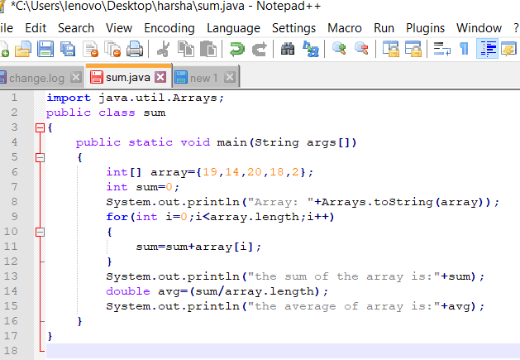

Output:

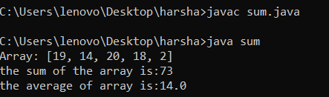

Result:

The above java program is executed successfully.

AIM:

Write a program to initialize an integer array and find the maximum and minimum value of the array.

Program:

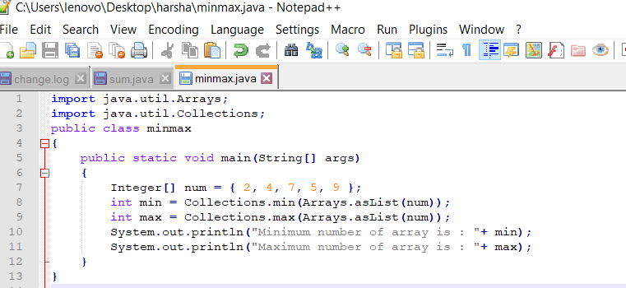

Output:

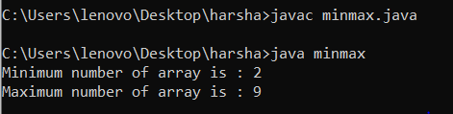

Result:

The above java program is executed successfully.

AIM:

Write a program to initialize an integer array with values and check if a given number is present in the array or not.

If the number is not found, it will print -1 else it will print the index value of the given  number in the array.

Program:

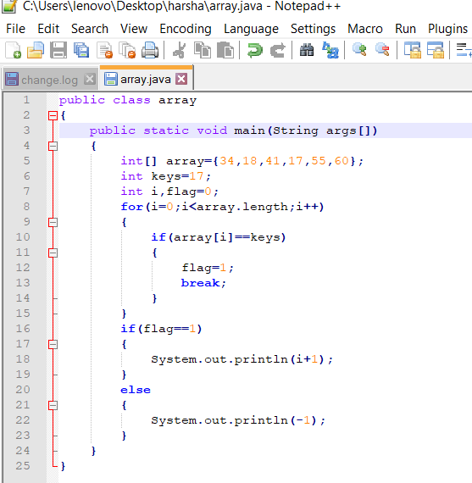

Output:

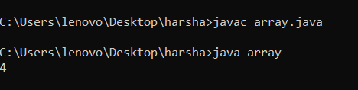

Result:

The above java program is executed successfully.

AIM:

Initialize an integer array with ascii values and print the corresponding character values in a single row.

Program:

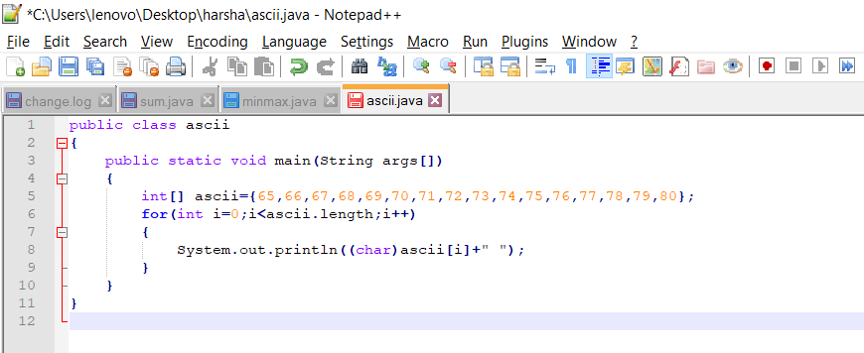  
Output:

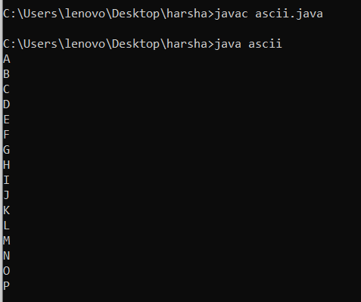

Result:

The above java program is executed successfully.

AIM:

Write a program to find the largest 2 numbers and the smallest 2 numbers in the given array.

Program:

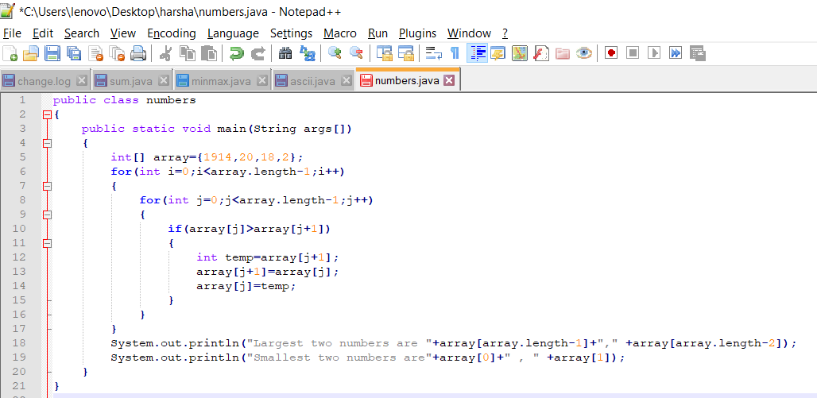

Output:

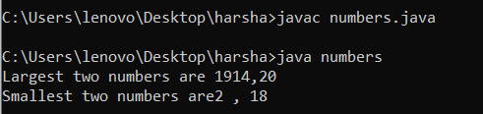

Result:

AIM:

Write a program to initialize an array and print them in a sorted order.

Program:

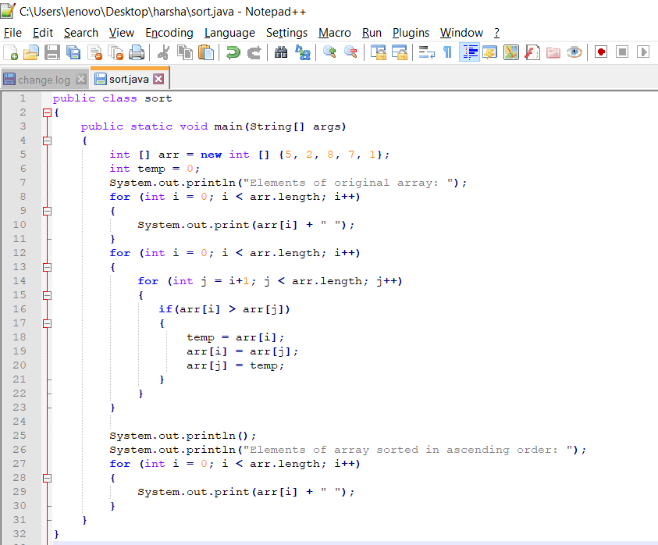

Output:

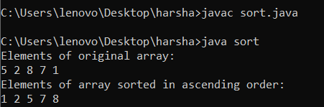

Result:

The above java program is executed successfully.

AIM:

 Write a program to remove the duplicate elements in an array and print the same.

Program:

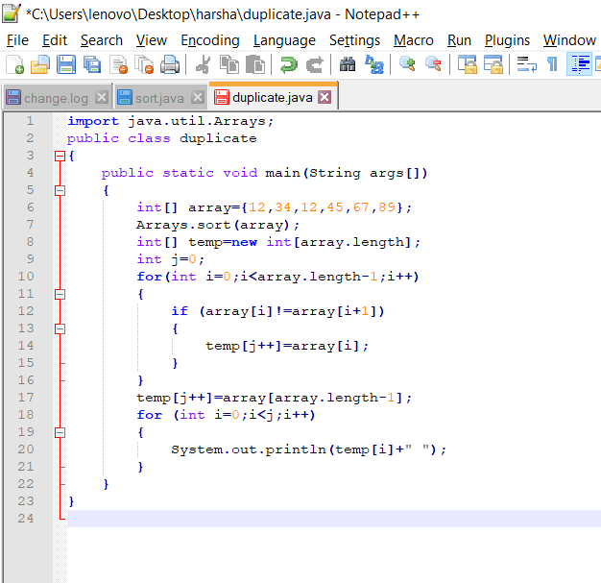

Output:

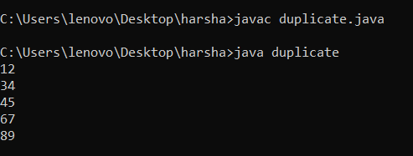

AIM:

Write a program to print the sum of the elements of an array following the given below condition.  
If the array has 6 and 7 in succeeding orders, ignore the numbers between 6 and 7 and consider the other numbers for calculation of sum.

Program:

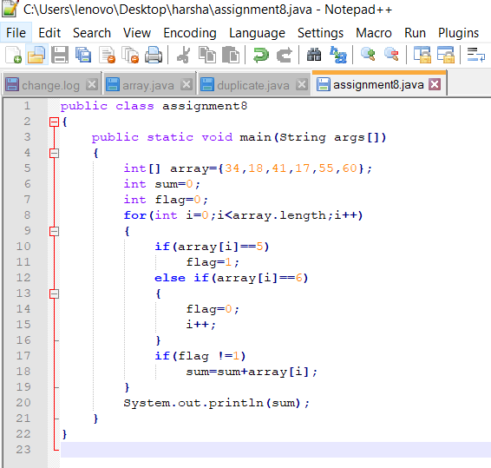

Output:

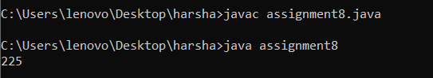

Result:

The above java program is executed successfully.

AIM:

Write a program to reverse the elements of a given 2\*2 array. Four integer numbers needs to be passed as Command Line arguments.

Program:

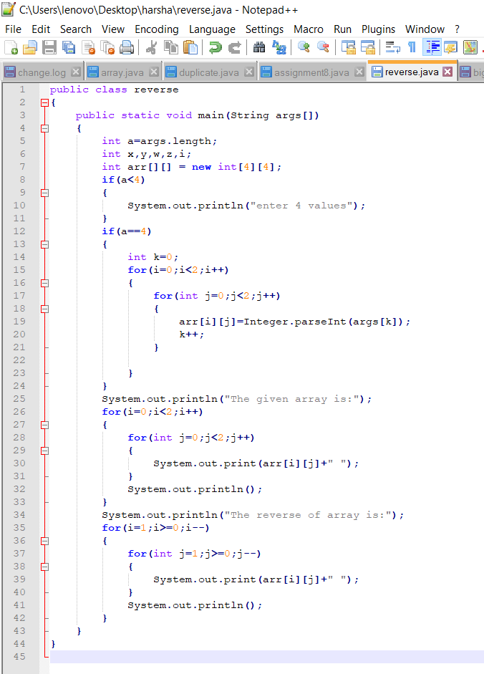

Output:

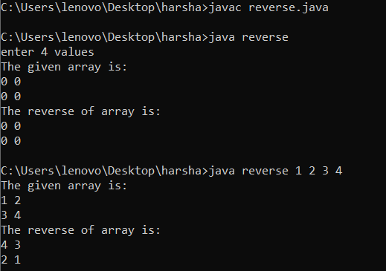

Result:

The above java program is executed successfully.

AIM:

Write a program to find the biggest number in a 3\*3 array. The program is supposed to receive 9 integer numbers as command line arguments.

Program:

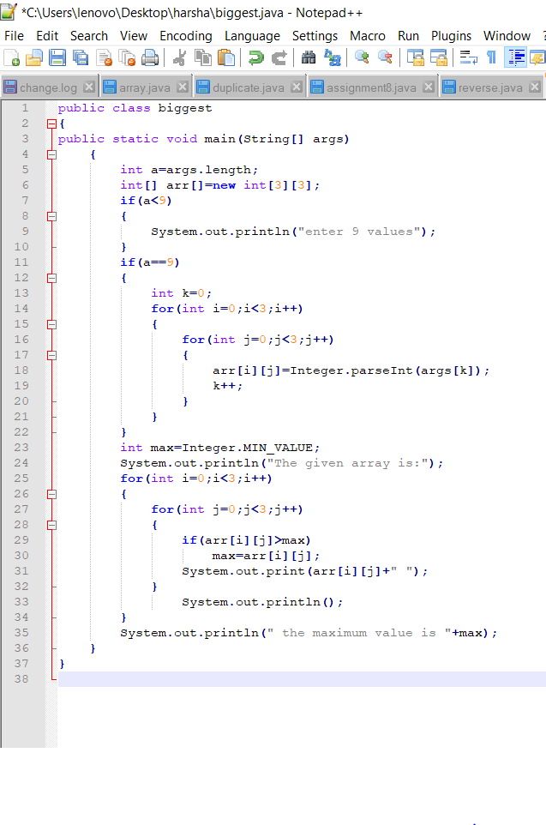

Output:

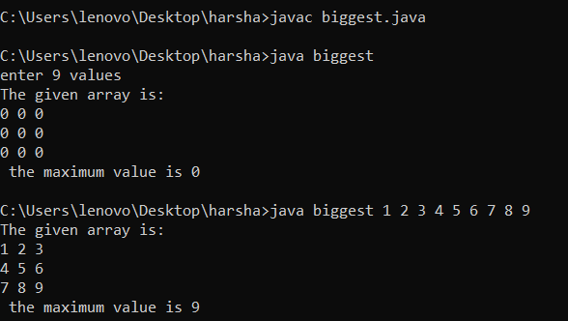

Result:

The above java program is executed successfully.