Together We Fight

This is a simple online based web application which was designed to complete the gap between the needy patients suffering during the lockdown and the Suppliers to directly contact with the needy poor people.

Features of the Application

* Easy to use Web Based Application
* Provides Volunteer registrations
* Volunteer can choose the services which he/she can provide
* Any user can directly access the website without Login or signIn
* Designed to simplify the user interface with all kind of user Who maybe be literate or illiterate
* Anyone can access the Platform to find the Real Supplier or Donor to receive the service
* Users can also Filter the suppliers available based on their locality.
* This application is flexible and responsive for both smart phone or desktop users.

Description:

Our idea is a web-based solution i.e a website developed to solve various problems in this fight against COVID-19. It works on a volunteer system ( Volunteers include several people like Medical suppliers, Oxygen suppliers, Hospital Administrators, Doctors, Medical interns, Food and essentials Donors, etc.) which actively provides various services such as Supply of Medicines and Medical equipment, Hospital beds admissions, Oxygen supply, Home treatment, Health suggestions, Food and Daily essentials distribution, Vaccination registration to rural and remote areas, Plasma donation, etc. (Services include both commercial and free providers). The volunteers (service providers) register on the website and create a descriptive profile about their services so that service seekers can approach them.

In the present situation, the availability of various services and resources is not readily accessible to the people/patients who need them. So this system creates a centralized environment where direct contact establishes between the service providers and seekers such that everyone can get what they need to fight against COVID-19.

Technology’s Used:

For frontend design,

* HTML (Hyper Text Markup Language) was used to design the application overall structure of the web site.
* To make it responsive and look better for User Interface CSS (Cascading Style Sheets) was used along with html.
* The main goal is to make it responsive in both the Desktop devices as well as the Smart Phone devices.
* Bootstrap frame work was added to make responsive design can be used in both desktop and smart phones,
* Javascript plays a key role to add animation to this application

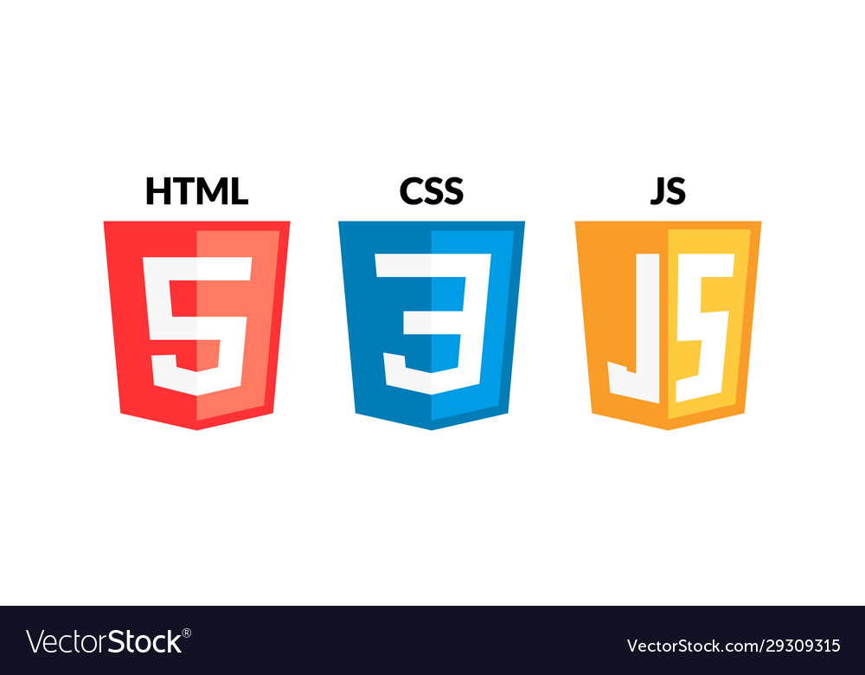

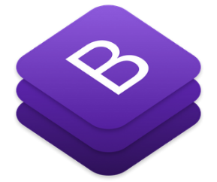

For Backend,

Client Side:

* JavaScript was used to handle client side data and display data to the users,

Server Side:

* To store the large amount of data and handle that data , we needed to use the Mysql Database.
* Mysql is an easy to use and can store very large amount of services data.
* Php Was used to perform the backend functionalities , to handle auth login , registration, retrieving data from data base, managing user data, working along with Mysql Data base.



Services Available:

* Supply of Medicines
* Medical equipment,
* Hospital beds Availability
* Oxygen supply
* Home treatment Suggestions
* Health suggestions
* Food and Daily essentials distribution for needy
* Vaccination registration to rural and remote areas
* Ambulance service
* Transportation Services

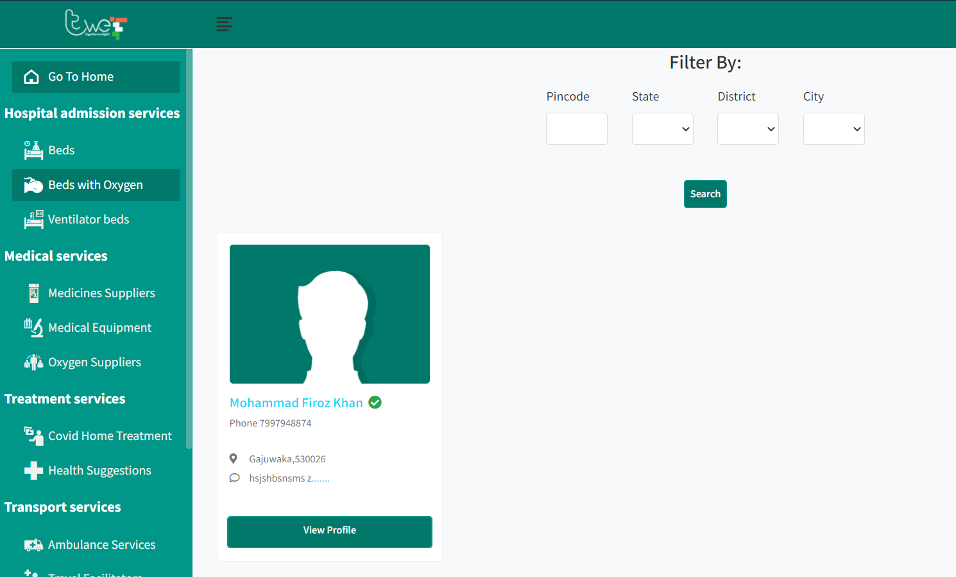

The DataBase Design:

Mysql was used as Data Base to store data , the overall design of data base is simplified in the below diagram, to make consistency, data redundancy, this data base approach was used by decomposing various data base tables and interconnected using foreign keys.

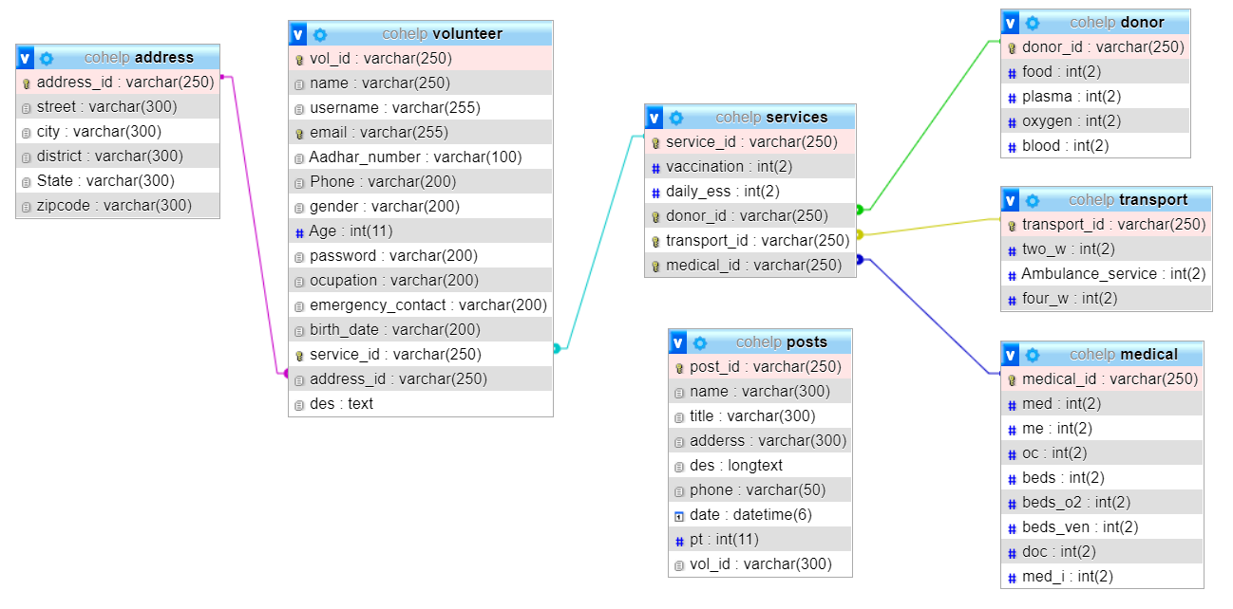

User Registration:

The volunteers who are willing to provide help and medical services can register into our platform. The registration page allows them to Mention all the services which they are providing. Separate Dashboard has been provided for the doctors who register as volunteer to help. It is an easy to use and register immediately into this platform to provide services during this Covid-19 pandemic situation. The main theme is to provide very easy to use interface for any person to be able to use this application easily.

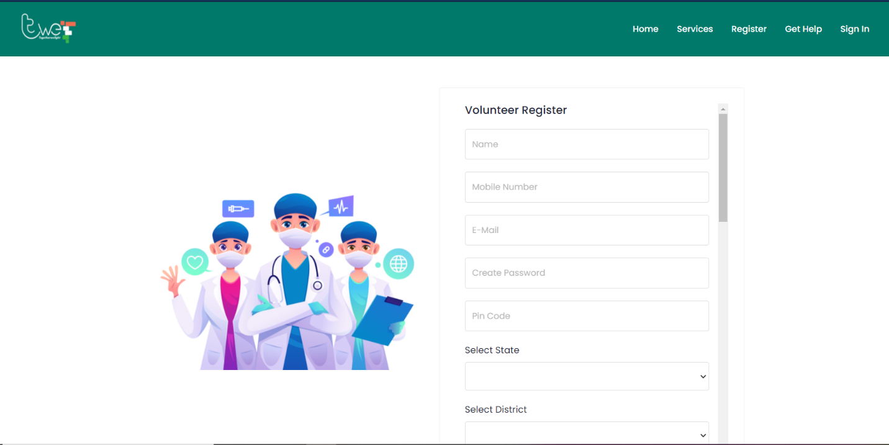

With the list to select the services a volunteer can provide.

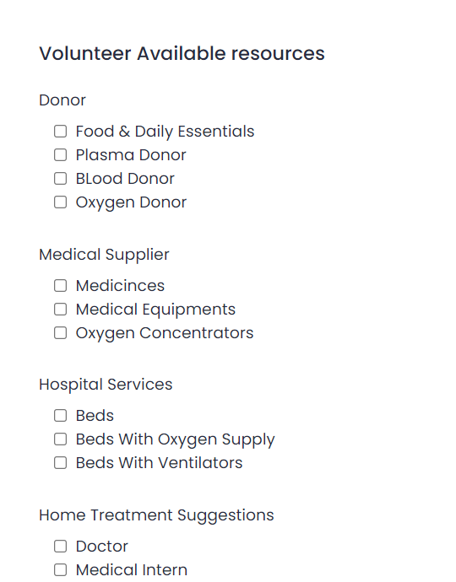

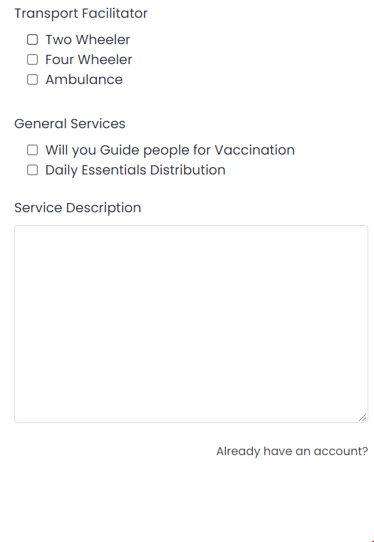

Immediate need of Help:

Sometimes there can be situation’s which requires immediate help for the issues, since many poor people are running out of basic need during the lockdown imposed by the government. Many poor families are suffering from hunger, running out of water not able to buy medicines. The team of TWF( Together We Fight ) applications provides an unique solution similar to social media. We have came up with an Get Help Service tab. This tab provides any user from any place can ask for help, using the service the user not even required to login or sign up, he/she can easily access directly and post their request to all the volunteers who are willing to help.

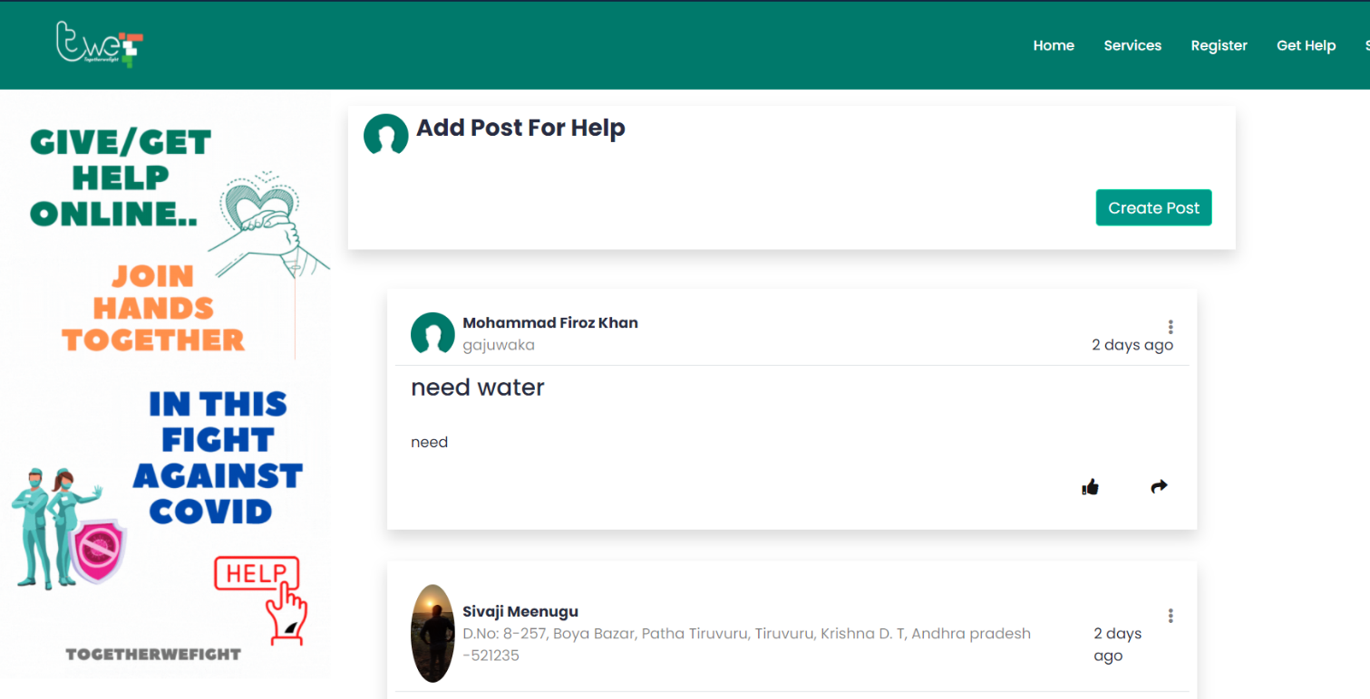 This post request will let the user request to all the volunteers and help providers getting notified by an instant telegram notification message with all the details of the needy family, so instantly the volunteers can contact the suffering family and can provide the helping hand. This is a crucial service which let any remote user to come forward and ask for the help.

By clicking on the Create Post button user can provide the in the dialogue box

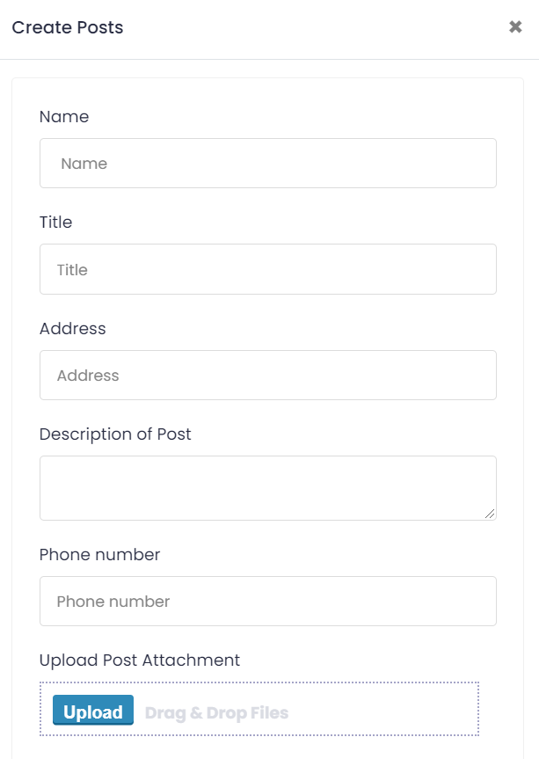

This will result in sending the telegram request to all the volunteers. So the volunteer can provide immediate service to the needy people

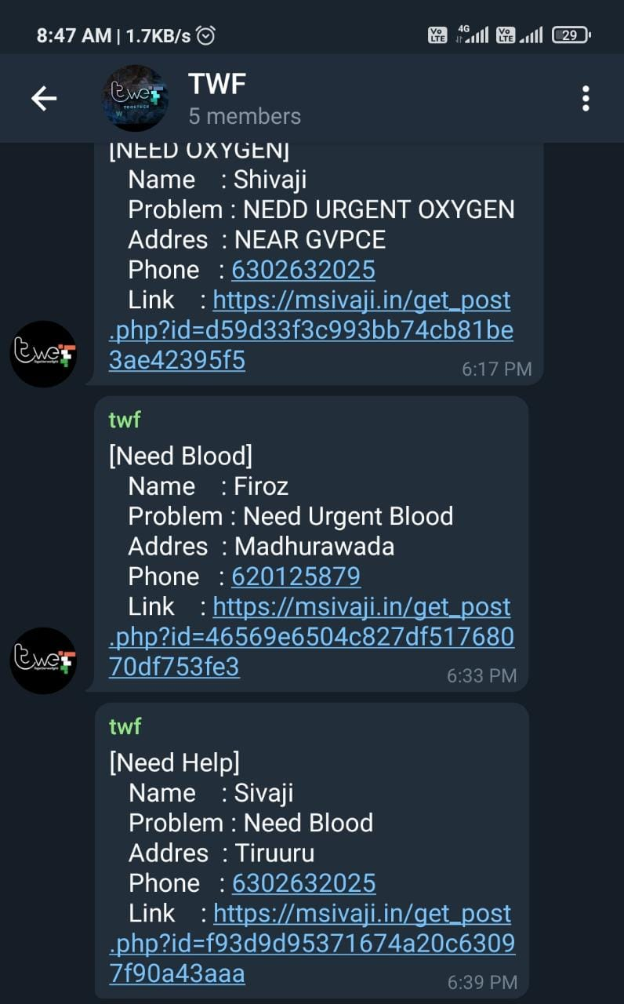

The overall Process Flow Chart:

Since our goal was easy to use web application for every user to provide instant services and reach out to the needy people. This process flow chart will help us to understand the over all function of the application with all the functions and structure in details.

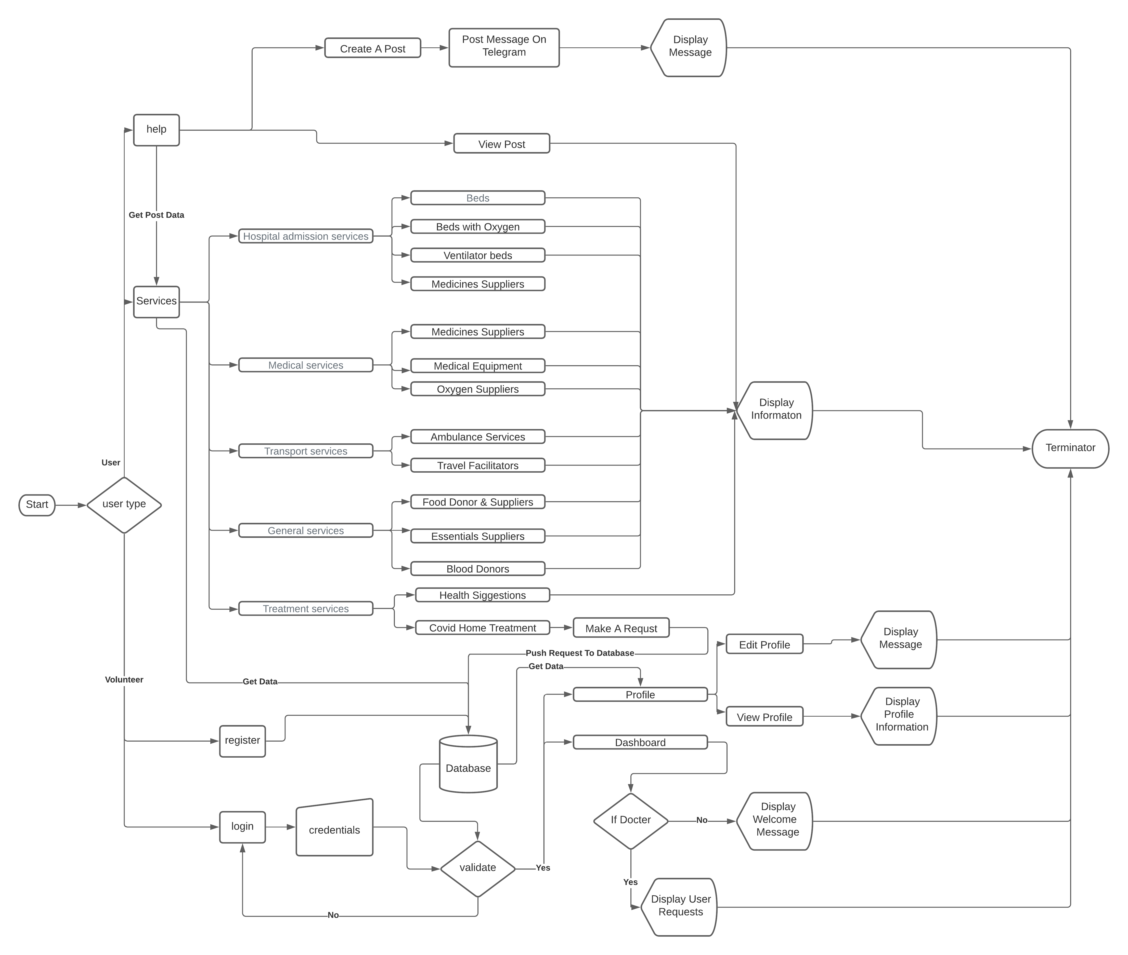**Together We Fight**

**Software To run this Application:**

* To run this web application with php backend functionality we used xampp server.
* Hosting of the application was made easy with the xampp server to run and also manage Mysql database
* Xampp provides fully functional hosting environment for php based web applications.

