**(A.Y. 2024-25)**

**MCA FY Sem I - Assessment 4 Programming Test**

**Course code – IT 13 Course Name Advance Database Management System**

**Roll No:2401068**

**Name – Jadhav Shreyas Ganpat**

**SET Name :B**

**create database Exam;**

**use Exam;**

**create table Property(pno int primary key,p_desc varchar(100),area varchar(100) ,rate int);**

**desc Property;**

**create table owner(pno int,owener_name varchar(100) primary key,city varchar(100),phno varchar(100),foreign key(pno) references Property(pno));**

**desc owner;**

**insert into Property(pno,p_desc,area,rate) values(1,'2BHK','Mumbai',50000),(2,'1BHK','Pune',300000),(3,'1RK','Satara',20000),(4,'ROOM','Baramati',10000);**

**SELECT * FROM Property;**

**insert into owner(pno,owener_name,city,phno)values(1,'Mr.Patil','Mumbai',8446082945),(2,'Mr.Joshi','Pune',9881762951),(3,'Mr.Jadhav','Kolhapur',7653423567),(4,'Mr.Shreyas','Baramati',9881762951);**

**Q1**

**select * from Property where area='Pune';**

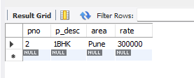

**Q2**

**select * from**

**Property as p**

**join owner as o**

**on p.pno=o.pno**

**where o.owener_name='Mr.Patil' and (select min(Property.rate) from Property);**

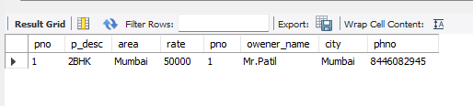

**Q3**

**select owener_name,max(pno) from owner**

**group by owener_name limit 1;**

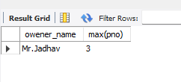

**Q4.**

**select * from**

**Property as p**

**join owner as o**

**on p.pno=o.pno**

**where o.owener_name='Mr.Patil';**

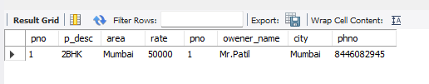

**Q5.**

**delete from Property where area='pune' AND owener_name='Mr.Joshi';**



**-------------------------------------------MONGODB------------------------------------------**

**test> use Inventory**

**switched to db Inventory**

**Inventory> db.createCollection('Items')**

**{ ok: 1 }**

**Inventory> db.Items.insertMany([**

**... {ID:1,Name:'Fan',category:'Electronics',Price:5000,quantity:2,instock:True},**

**... {ID:2,Name:'Laptop',category:'Electronics',Price:50000,quantity:5,instock:False},**

**... {ID:3,Name:'Mixer',category:'HomeAppliances',Price:2000,quantity:2,instock:True},**

**... {ID:4,Name:'Chair',category:'HomeAppliances',Price:500,quantity:4,instock:True}**

**... ]);**

**ReferenceError: True is not defined**

**Inventory> db.Items.insertMany([**

**... {ID:1,Name:'Fan',category:'Electronics',Price:5000,quantity:2,instock:true},**

**... {ID:2,Name:'Laptop',category:'Electronics',Price:50000,quantity:5,instock:false},**

**... {ID:3,Name:'Mixer',category:'HomeAppliances',Price:2000,quantity:2,instock:true},**

**... {ID:4,Name:'Chair',category:'HomeAppliances',Price:500,quantity:4,instock:true}**

**... ]);**

**1.**

**db.Items.find({category:'Electronics'})**

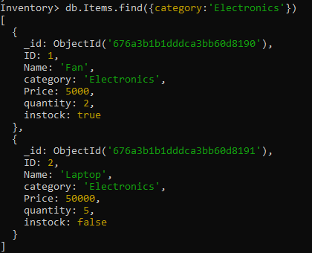

**2.**

**db.Items.find({instock:true})**

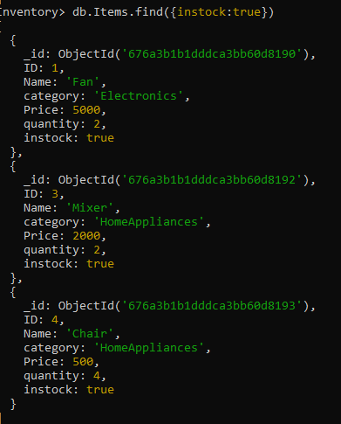

**3.**

**db.Items.updateOne({Name:'Laptop'},{$set:{Price:80000}})**

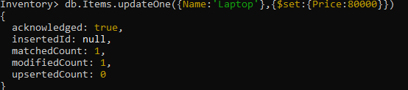

**4.**

**db.Items.updateOne({Name:'Chair'},{$inc:{quantity:50}})**

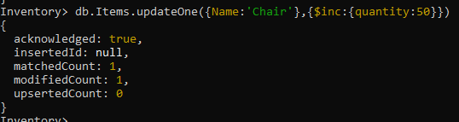

**5.**

**db.Items.find({Price:{$gt:2000,$lt:10000}})**

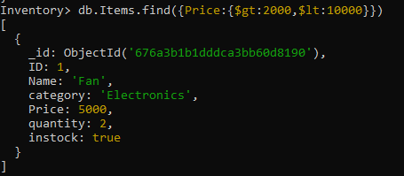

**--------------------------------------Graph Database-----------------------------------------**

**1.**

**CREATE (c1:Club { title: 'Art Club'})**

**CREATE (b2:Club {title: 'Chess Club'})**

**CREATE (b3:Club {title: 'Sports Club' })**

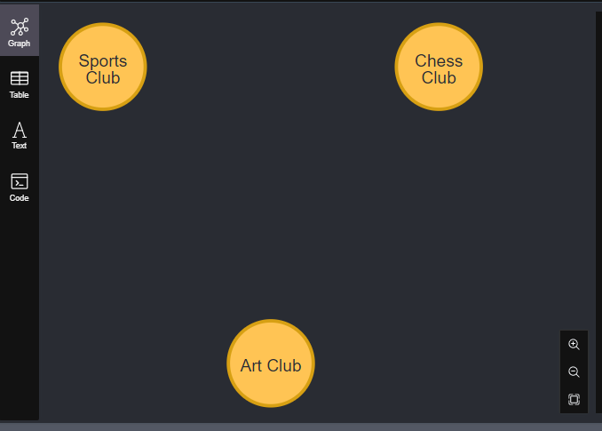

**2.**

**CREATE (s1:Student {name: 'Amy'})**

**CREATE (s2:Student {name: 'Ben'})**

**CREATE (s3:Student {name: 'Chris'})**

**CREATE (s4:Student {name: 'Diana'})**

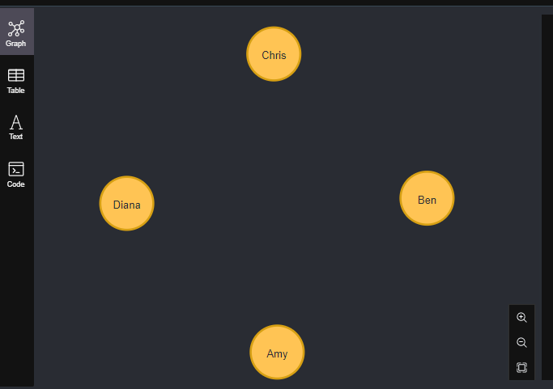

**3.**

**MATCH**

**(m1:Student{name: 'Amy'}),**

**(c1:Club { title: 'Art Club'})**

**CREATE (m1)-[:President]->(c1)**

**MATCH**

**(m1:Student{name: 'Amy'}),**

**(c1:Club { title: 'Chess Club'})**

**CREATE (m1)-[:Member]->(c1)**

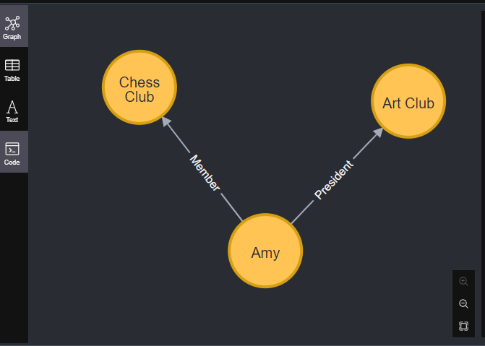

**4.**

**MATCH**

**(m2:Student{name: 'Ben'}),**

**(c2:Club { title: 'Sports Club'})**

**CREATE (m2)-[:Member]->(c2)**

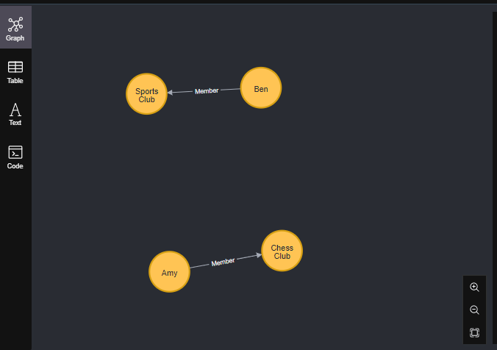

**5.**

**MATCH**

**(m3:Student{name: Chris}),**

**(c3:Club { title: ‘Chess Club'})**

**CREATE (m3)-[: President]->(c3)**

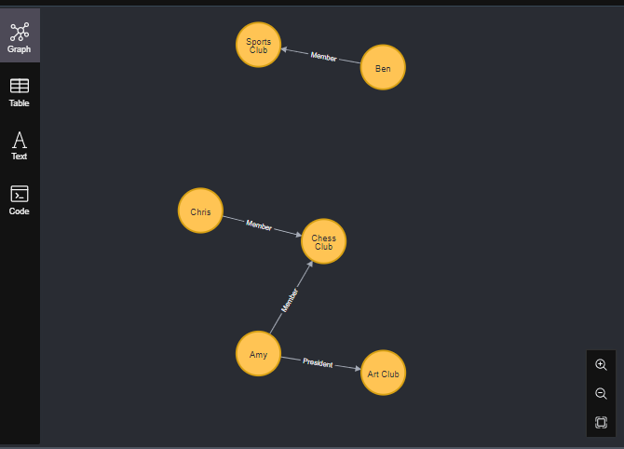

**6.**

**MATCH**

**(m3:Student{name: 'Diana'}),**

**(c1:Club { title: 'Art Club'})**

**CREATE (m3)-[:Member]->(c1)**

**MATCH**

**(m3:Student{name: 'Diana'}),**

**(c3:Club { title: 'Sports Club'})**

**CREATE (m3)-[:Member]->(c3)**

