**(A.Y. 2024-25)**

**MCA FY Sem I - Assessment 4 Programming Test**

**Course code – IT 13 Course Name Advance Database Management System**

**Roll No. 2401055**

**Name – Ghatmal Prathmesh Jalindar**

**SET Name A**

**Q1**

**1.SELECT * FROM sales WHERE total_price>100;**

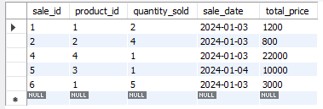

**2.** **SELECT sale_id,total_price,sale_date**

**FROM sales**

**WHERE sale_date="2024-01-03";**

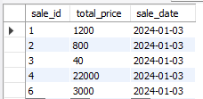

**3.** **SELECT sale_id,product_id,total_price**

**FROM sales**

**WHERE quantity_sold>4;**



**4.** **SELECT category,AVG(unit_price) AS average_price**

**FROM products**

**GROUP BY(category);**

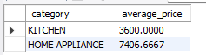

**5.** **SELECT**

**s.sale_id,s.total_price,s.sale_date,p.product_name**

**FROM sales AS s JOIN PRODUCTS AS p**

**ON s.product_id=p.product_id;**

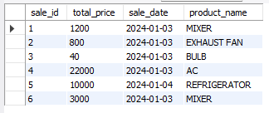

**Q2**

1. **db.Scientist.find({DOB:{$gt:"1970-01-01"}})**

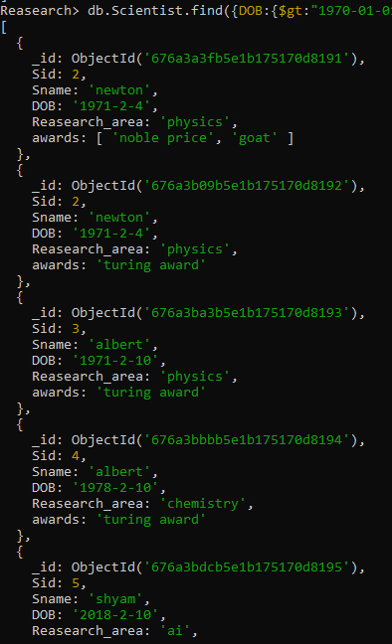

1. **db.Scientist.find({Reasearch_area:"physics"})**

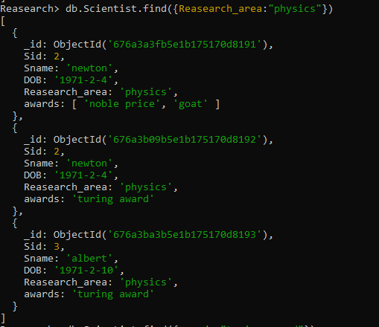

**3.db.Scientist.find({awards:"turing award"})**

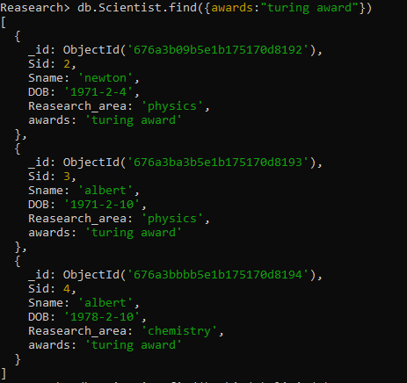

**5. db.Scientist.find().skip(3).limit(5);**

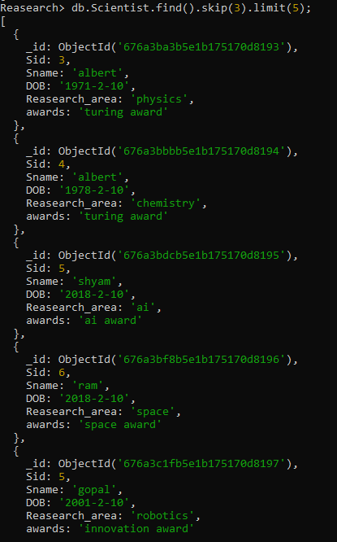

**Q3**

1. create (d1:Dishes{name:"Pizza"})

create (d2:Dishes{name:"Burger"})

create (d3:Dishes{name:"Pasta"})

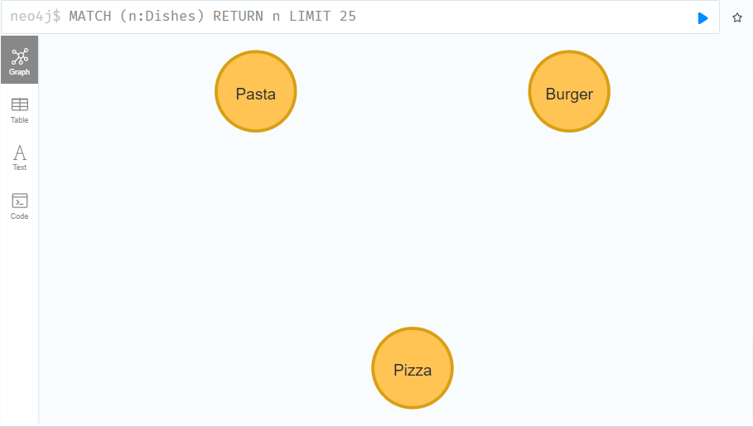

2.create(c1:Customer{name:"Alex"})

create(c2:Customer{name:"Emma"})

create(c3:Customer{name:"Tom"})

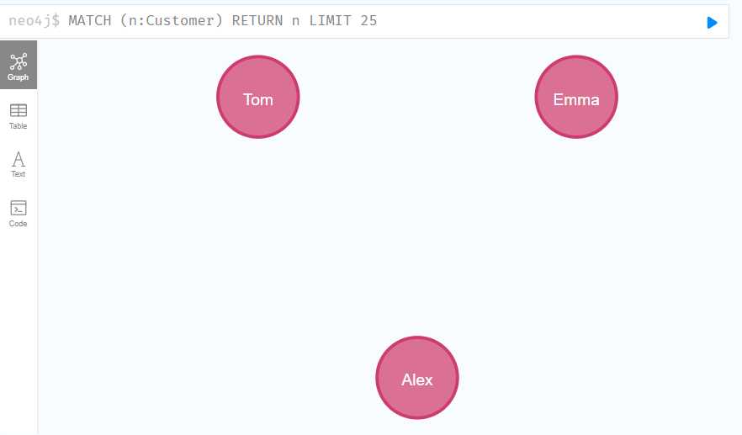

3.match(u:Customer{name:"Alex"}),(d1:Dishes{name:"Burger"}),(d2:Dishes{name:"Pizza"})

create(u)-[:ORDERED{time:"10am",price:"100",quantity:2}]->(d1)

create(u)-[:ORDERED{time:"10am",price:"100",quantity:2}]->(d2)

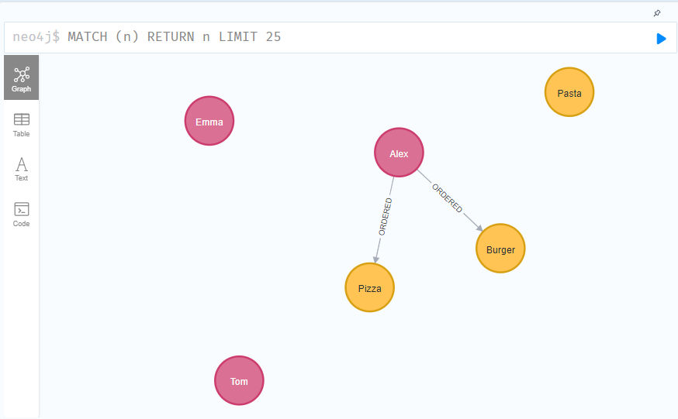

4.match(u:Customer{name:"Emma"}),(d1:Dishes{name:"Pasta"}),(d2:Dishes{name:"Pizza"})

create(u)-[:ORDERED{time:"11am",price:"100",quantity:1}]->(d1)

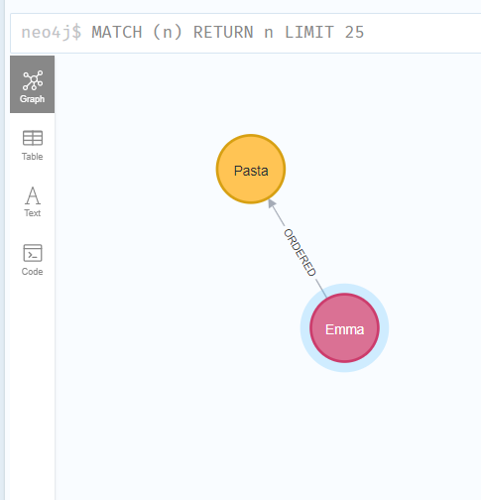

5. match(u:Customer{name:"Tom"}),(d1:Dishes{name:"Pizza"}),(d2:Dishes{name:"Pizza"})

create(u)-[:ORDERED{time:"12am",price:"200",quantity:1}]->(d1)

