INTRODUCTION
1.1.1 ABOUT OUAT
The Orissa University of Agriculture & Technology has been established by the Parliament under the Central Universities Act, 2009 (No. 3C of 2009). It is one of the 15 new Central Universities established by the Government of India during the UGC XI Plan period to address the concerns of "equity and access" and as per the policy of the Government of India to increase the access to quality higher education by people in less educationally developed districts which have a Graduate Enrollment Ratio of less than the national average of 11%. Koraput District of Orissa comes within the KBK region (Koraput, Bolangir and Kalahandi) which is still considered as an extremely as underdeveloped region of the State of Orissa .These three districts of the State are known for tribal culture, because majority of the people here belong to ST and SC categories. Since there is no University or any other national level educational set up in this region the Central University is proposed to be established here so that it may widen the access to quality higher education in the country.
1.1.2 About Department of Computer Science and Application

The department of Computer Science was started in the year 2015. The department currently holds regular programme for Master of Computer Application (MCA).
Vision, Mission and Goal:
- To develop quality professionals who are able to compete in the recent trends of Information Technology.
- To make our department a hub for research and development so that the department can grab projects from govt./private agencies.
- To impart training to the students and faculties from other departments of our University.
- To open new academic programmes like MCA, M.Tech (CSE), M.Sc.(CS) etc.

1.1.3 About Project

School/college/university Management Module which is used by Schools as well as Colleges to manage their daily activities which include the management of Employees, Students, Books and Library Records, Parents details, Assignments, Admission Process, Results and Reports, Exams, Events, Attendance, Timetable, Fees and Other Reports. It provides one-point access to manage these wide range of activities both effectively and efficiently.
- The system will be used by four people, which are Admin, Teacher, Librarian and Student.
- Admin can login using valid credentials and perform various task such as Adding a Teacher, and Librarian and also can view them.
- Admin can also add event and view books which is requested by the librarian. System allows admin to view book request received from librarian.
- Teacher can login and perform various task such as add assignment, mark attendance, upload result and view event.
- Librarian can login and perform task such as adding a single or multiple book, view added books, request a book, issue a book to students, return issued book from student and view event.

SYSTEM ENVIRONMENT

  - Hardware Specification
CPU : Dual Core
Speed : 1 GHz
Coprocessor : BUILT IN
Total RAM : 512 MB
Hard Disk : 50 GB
Display : SGVA COLOR

2.2 Software Specification

FRONT END : HTML, CSS, JAVASCRIPT
BACK END : PHP, MySQL
SERVER : APACHE SERVER
OPERATING SYSTEM : WINDOWS XP 7/8/8.1/10/11

SYSTEM ANALYSIS
3.1 Existing System
Existing system refers to the system that is being followed till now. Currently, the website used by the university does not provide detailed information about the student, faculty and librarian provided by the university. This website also does not provide detailed informations about the admission procedure and academic information used by the interested applicant directly. This website does not contain any registration proress for new and old student.

Draw backs of existing system.
- Students can not see their profile and detailed info.
- Students can not view their timetables, assignments, attendance etc.
- Student, Faculty, Librarian Login are not provided
- Provide less information.
- Not Faster.
- Admin panel is not provided.
- Not Secure (Existing user can view the activity and data).

To avoid all these limitations and make the working more accurately the system needs to be computerized.

3.2 Proposed System

The aim of proposed system is to develop a system of improved facilities where all the members of university can connect with each other. The system provides data accuracy and save disc space. The existing system has several disadvantages and many more difficulties to work well. The proposed system tries to eliminate or reduce these difficulties up to some extent. The proposed system will help the user to consume time. The system requires very low system resources.

Advantages of Proposed SystemUniveristy

The system is very simple in design and to implement. The system requires very low system resources and the system will work in almost all configurations. It has got following features

- This system is very easy to understand and user friendly.
- This website helps the users to view their profile and detailed info.
- Teacher, Student, Librarian are connected with each other on one system.
- This website provides online admission procedure.
- This system is saving the time for student and teacher too.
- In this system user can connect any time whenever he/she wants.
- This system is secure.
- This System retrieves data faster.

SYSTEM DESIGN
4.1 Context Digram

Registration pages

1.0
User Details
Registered user

4.2 Data Flow Digram

Registered_Data

User Details
User_Login

1.2
User _Profile

Registration Page

1.1
User_Info

4.3 ER -Diagram

User Sign up
password
User name
Password
User Login
User name
Email
State
DOB

Catagoryy
Mobile No.
City

Roll no.

Program

Amount

Semester
Id
Gender
Name
Email

Sign_Up

Log_in

Student_Registation_form

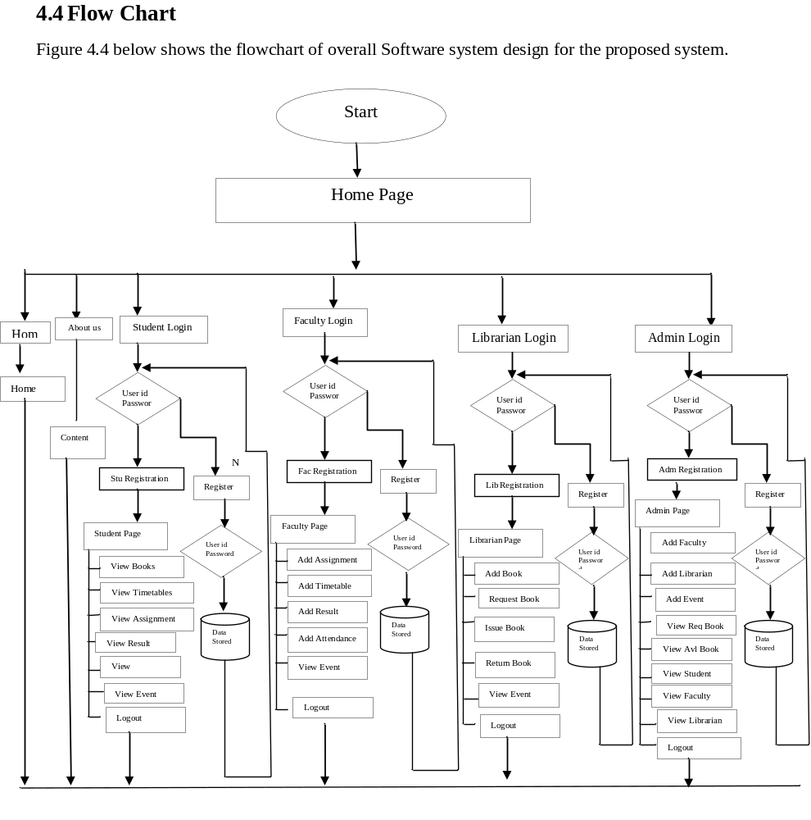

4.5 .1 Data Dictionary

Table Name: - Student_Registration

Field Name | Data Type | Field Size | Field Description
Id | Id | 20 | Primary
DP | LONGBLOB | - | -
First_Name | Varchar | 20 | -
Last_Name | Varchar | 7 | -
Department | Varchar | 10 | -
Year | Varchar | 10 | -
Btach | Varchar | 30 | -
Contact_No | Int | 10 | -
Email | Varchar | 30 | -
Password | Varchar | 20 | -
Total_Fee | Varchar | 15 | -
Paid_Fee | Varchar | 30 | -
Gender | Varchar | 10 | -

4.5 .2 Table Name: - Faculty_Registration

Field Name | Data Type | Field Size | Field Description
Id | Int | 20 | Primary
DP | LONGBLOB | - | -
First_Name | Varchar | 20 | -
Last_Name | Varchar | 7 | -
Gender | Varchar | 10 | -
Department | Varchar | 10 | -
Designation | Varchar | 30 | -
Qualification | Int | 10 | -
Contact | Varchar | 30 | -
Email | Varchar | 20 | -
Password | Varchar | 15 | -

4.5 .3 Table Name: - Librarian_Registration

Field Name | Data Type | Field Size | Field Description
Id | Int | 20 | Primary
DP | LONGBLOB | - | -
First_Name | Varchar | 20 | -
Last_Name | Varchar | 7 | -
Gender | Varchar | 10 | -
Contact | Varchar | 10 | -
Email | Varchar | 30 | -
Password | Int | 10 | -
4.5 .4 Table Name: - Admin_Registration

Field Name | Data Type | Field Size | Field Description
Id | Int | 20 | Primary
First_Name | Varchar | 20 | -
Last_Name | Varchar | 7 | -
Gender | Varchar | 10 | -
Contact | Varchar | 10 | -
Email | Varchar | 30 | -
Password | Int | 10 | -

4.5 .5 Table Name: - Issue_Book

Field Name | Data Type | Field Size | Field Description
Id | Int | 20 | Primary
Departmnt | Varchar | 20 | -
Enrollment_No | Varchar | 7 | -
Book_Name | Varchar | 10 | -
Author_Name | Varchar | 10 | -
Price | Varchar | 30 | -
Student_Name | Int | 10 | -

4.5 .6 Table Name: - Add_Book

Field Name | Data Type | Field Size | Field Description
Id | Int | 20 | Primary
Departmnt | Varchar | 20 | -
Book_Name | Varchar | 7 | -
Author_Name | Varchar | 10 | -
Price | Int | 8 | -

4.5 .7 Table Name: - Request_Book

Field Name | Data Type | Field Size | Field Description
Id | Int | 20 | Primary
Departmnt | Varchar | 20 | -
Book_Name | Varchar | 7 | -
Author_Name | Varchar | 10 | -
Price | Int | 10 | -
Quantity | Int

4.5 .8 Table Name: - Time_Table

Field Name | Data Type | Field Size | Field Description
Id | Int | 20 | Primary
File | LONGBLOB | - | -
Departmnt | Varchar | 20 | -
Year | Varchar | 7 | -
Name | Varchar | 10 | -

4.5 .9 Table Name: - Assignment

Field Name | Data Type | Field Size | Field Description
Id | Int | 20 | Primary
File | LONGBLOB | - | -
Departmnt | Varchar | 20 | -
Year | Varchar | 7 | -
Name | Varchar | 10 | -

4.6.0 Table Name: - Result

Field Name | Data Type | Field Size | Field Description
Id | Int | 20 | Primary
File | LONGBLOB | - | -
Departmnt | Varchar | 20 | -
Year | Varchar | 7 | -
Name | Varchar | 10 | -

4.6.1 Table Name: - Attendence

Field Name | Data Type | Field Size | Field Description
Id | Int | 20 | Primary
File | LONGBLOB | - | -
Departmnt | Varchar | 20 | -
Year | Varchar | 7 | -
Name | Varchar | 10 | -

4.6.2 Table Name: - Add_Event

Field Name | Data Type | Field Size | Field Description
Id | Int | 20 | Primary
File | LONGBLOB | - | -
Event_Name | Varchar | 20 | -
Event_Date | Varchar | 7 | -

APPENDIX
5.1 Software Description

PHP

PHP is a server side scripting language. that is used to develop Static websites or Dynamic websites or Web applications. PHP stands for Hypertext Pre-processor, that earlier stood for Personal Home Pages. It is widely-used open source general-purpose scripting language that is especially suited for web development and can be embedded into HTML.

PHP code may be embedded into HTML code, or it can be used in combination with various web template systems, web content management systems, and web frameworks. PHP code is usually processed by a PHP interpreter implemented as a module in the web server or as a Common Gateway Interface (CGI) executable.

Basics of PHP:
- Basic PHP Syntax
- A PHP script can be placed anywhere in the document.
- A PHP script starts with <?php and ends with ?>:
Eg:
<?php
echo "HelloWorld!";
?>

Creating (Declaring) PHP Variables
In PHP, a variable starts with the $ sign, followed by the name of the variable:
Eg:
<?php
$txt = "Hello world!";
$x = 5;
$y = 10.5;
?>

PHP - A Simple HTML Form
The example below displays a simple HTML form with two input fields and a submit button:
Eg:
<html>
<body>
<form action="welcome.php" method="post">
Name: <input type="text" name="name"><br>
E-mail: <input type="text" name="email"><br>
<input type="submit">
</form>
</body>
</html>

PHP Form Validation Example

Valid URL
Below code shows validation of URL
$website = input($_POST["site"]);

if (!preg_match("/\b(?:(?:https?|ftp):\/\/|www\.)[-a-z0-9+&@#\/%?=~_|!:,.;]*[-a-z0-9+&@#\/%=~_|]/i",$website)) {
$websiteErr = "Invalid URL";
}

Valid Email
Below code shows validation of Email address
$email = input($_POST["email"]);

if (!filter_var($email, FILTER_VALIDATE_EMAIL)) {
$emailErr = "Invalid format and please re-enter valid email";
}

Selection list Validation

if (isset($_POST['submit'])) {
if(empty($_POST['package']))
$msg_package = "You must select a package";
}

Validation for non-empty, alphabets and whitespace only

if (isset($_POST['submit'])) {
//checking name
if(empty($_POST['full_name']))
$msg_name = "You must supply your name";
$name_subject = $_POST['full_name'];
$name_pattern = '/^[a-zA-Z ]*$/';
preg_match($name_pattern, $name_subject, $name_matches);
if(!$name_matches[0])
$msg2_name = "Only alphabets and white space allowed";
}

- PHP Database Connectivity
<?php
$servername = "localhost";
$username = "username";
$password = "password";
// Create connection
$conn = new mysqli($servername, $username, $password);
// Check connection
if ($conn->connect_error) {
die("Connection failed: " . $conn->connect_error);
}
echo "Connected successfully";
?>

HTML
Hypertext Markup Language (HTML) is the standard markup language for creating web pages and web applications. With Cascading Style Sheets (CSS) and JavaScript it forms a triad of cornerstone technologies for the World Wide Web.Web browsers receive HTML documents from a web server or from local storage and render them into multimedia web pages. HTML describes the structure of a web page semantically and originally included cues for the appearance of the document.
Basic HTML Tag:
- Image tag
- You can insert any image in your web page by using <img> tag.
- A simple syntax to use HTML <img> tag is as follows-
<img src = "Image URL" ... attributes-list/>
- The <img> tag is an empty tag, which means that, it can contain only list of attributes and it has no closing tag.
- Div tag
- The <div> tag defines a division or a section in an HTML document.
- The <div> tag is used to group block-elements to format them with CSS.
- Marquee tag
- An HTML marquee is a scrolling piece of text displayed either horizontally across or vertically down your webpage depending on the settings.
- A simple syntax to use HTML <marquee> tag is as follows –
<marquee attribute_name = "attribute_value"....more attributes>
One or more lines or text message or image
</marquee>
- Div tag
- The <div> tag defines a division or a section in an HTML document.
- The <div> tag is used to group block-elements to format them with CSS.
- A simple syntax to use HTML <img> tag is as follows-
<div>
Div element
</div>

Anchor
- The HTML anchor tag defines a hyperlink that links one page to another page. The "href" attribute is the most important attribute of the HTML a tag.
- The href attribute is used to define the address of the file to be linked. In other words, it points out the destination page.
- The syntax of HTML anchor tag is given below.
<a href = “…………….”> Link Text </a>
Cascading Style Sheets (CSS)
Cascading Style Sheets (CSS) is a style sheet language used for describing the presentation of a document written in a markup language. Although most often used to set the visual style of web pages and user interfaces written in HTML and XHTML, the language can be applied to any XML document, including plain XML, SVG and XUL, and is applicable to rendering in speech, or on other media. Along with HTML and JavaScript, CSS is a cornerstone technology used by most websites to create visually engaging webpages, user interfaces for web applications, and user interfaces for many mobile applications.

Basic CSS Syantax:

The element Selector
- The element selector selects elements based on the element name.
- You can select all <p> elements on a page like this (in this case, all <p> elements will be left-aligned, with a blue text color.
- Example

p {
text-align: left;
color: blue;
}

CSS Margins

- The CSS margin properties are used to create space around elements, outside of any defined borders.
- With CSS, you have full control over the margins. There are properties for setting the margin for each side of an element (top, right, bottom, and left).
- Example
p {
margin-top: 100px;
margin-bottom: 100px;
margin-right: 150px;
margin-left: 80px;
}

CSS Padding
- The CSS padding properties are used to generate space around an element's content, inside of any defined borders.
- With CSS, you have full control over the padding. There are properties for setting the padding for each side of an element (top, right, bottom, and left).
- Example
div {
padding-top: 50px;
padding-right: 30px;
padding-bottom: 50px;
padding-left: 80px;
}
JAVASCRIPT
JavaScript, often abbreviated as JS, is a high-level, dynamic, weakly typed, prototype-based, multi-paradigm, and interpreted programming language. Alongside HTML and CSS, JavaScript is one of the three core technologies of World Wide Web content production. It is used to make webpages interactive and provide online programs, including video games. The majority of websites employ it, and all modern web browsers support it without the need for plug-ins by means of a built-in JavaScript engine.

Basics of JavaScript:

The <script> Tag
- In HTML, JavaScript code must be inserted between <script> Eg:
<script>
document. getElementById("demo"). innerHTML = "My First JavaScript";
</script>

JavaScript in <head> or <body>
- You can place any number of scripts in an HTML document.
- Scripts can be placed in the <body>, or in the <head> section of an HTML page, or in both.

JavaScript Display Possibilities
JavaScript can "display" data in different ways:
- Writing into an HTML element, using innerHTML.
- Writing into the HTML output using document.write().
- Writing into an alert box, using window.alert().
- Writing into the browser console, using console.log().

JavaScript Functions
- A JavaScript function is a block of code designed to perform a particular task.
- A JavaScript function is executed when "something" invokes it (calls it).
Eg 1:
function myFunction(p1, p2) {
return p1 * p2; // The function returns the product of p1 and p2
}
Eg 2:
var x = myFunction(4, 3); // Function is called, return value will end up in x
function myFunction(a, b) {
return a * b; // Function returns the product of a and b
}

JavaScript Validation

Regular Expressions
The following is how regular expressions can be used
- [abc] – find any character in the brackets a, b or c
- [a-z] – find the range of characters within brackets i.e. a to z lowercase. Can also be used with numbers [0-9]
- [^xyz] – find any character other than the ones specified in the brackets i.e. x,y and z
- (word) – find the “word” specified in the round brackets
- [abc|xyz] – find either the characters a,b,c or x,y,z

Javascript Validation Numeric
We’ll start first with validating a textbox that accepts only numbers. So the condition is we check whether the textbox contains anything ELSE other than numbers and display a message
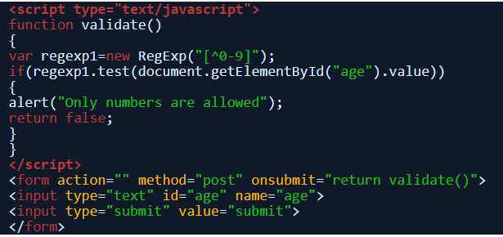

Javascript Validation Alphabets
From numbers we’ll move to alphabets first an example for validation lowercase alphabets and then to validate both uppercase and lowercase.
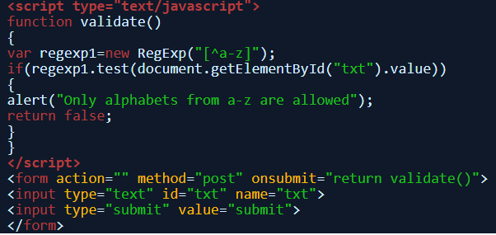

Javascript validation check for a word
This type of javascript validation will check if the entered text contains a particular word round brackets are used to find out complete words
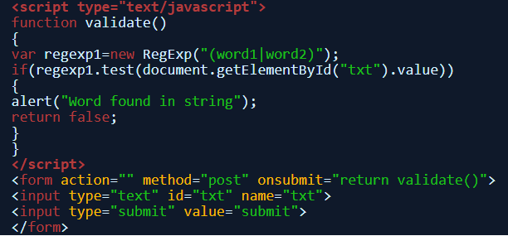

Javascript Validation whitespace
Validate a string against any whitespaces including tab and carriage return using the pattern and match function
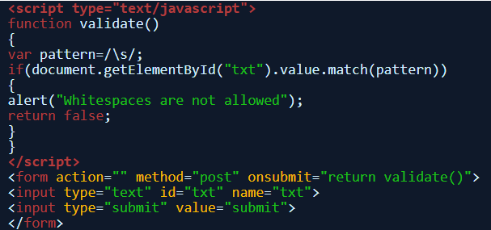

MySQL

Microsoft SQL server is a relational database management system (RDBMS). As a database server, it is a software product with the primary function of storing and retrieving data as requested by other software applications—which may run either on the same computer or on another computer across a network (including the Internet).
MySQL is the world's most popular open source database. With its proven performance, reliability and ease-of-use, MySQL has become the leading database choice for web-based applications, used by high profile web properties including Facebook, Twitter, YouTue, Yahoo and many more.

Highlighted Query

SQL Create Table Statement
- The CREATE TABLE statement is used to create a new table in a database.
- Syntax
CREATE TABLE table_name (
column1 datatype,
column2 datatype,
column3 datatype,
....
);

- SQL insert Statement
- The INSERT INTO statement is used to insert new records in a table.
- Insert Syntax
INSERT INTO table_name (column1, column2, column3, ...)
VALUES (value1, value2, value3, ...);

Apache Web Server

Apache Web Server is an open-source web server creation, deployment and management software. Initially developed by a group of software programmers, it is now maintained by the Apache Software Foundation. Apache Web Server is designed to create web servers that have the ability to host one or more HTTP-based websites. Notable features include the ability to support multiple programming languages, server-side scripting, an authentication mechanism and database support. Apache Web Server can be enhanced by manipulating the code base or adding multiple extensions/add-ons.

It is also widely used by web hosting companies for the purpose of providing shared/virtual hosting, as by default, Apache Web Server supports and distinguishes between different hosts that reside on the same machine.

5.3 SCREEN LAYOUTS

Home Page


Fig 5.3.1

Login

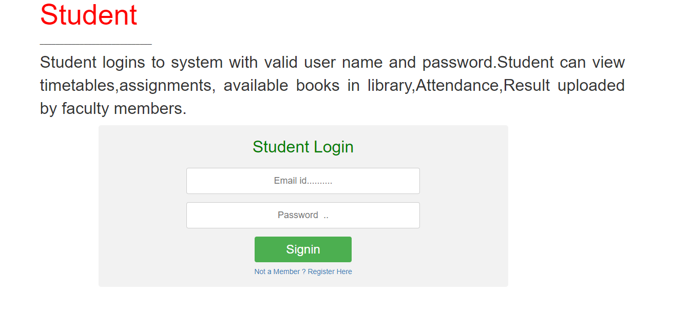
Fig 5.3.2

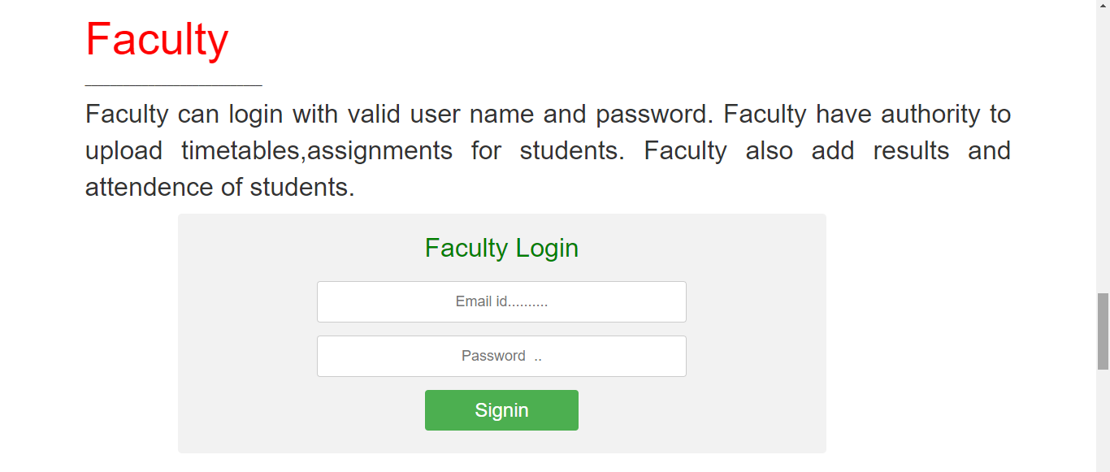

Fig 5.3.3

Student Registration

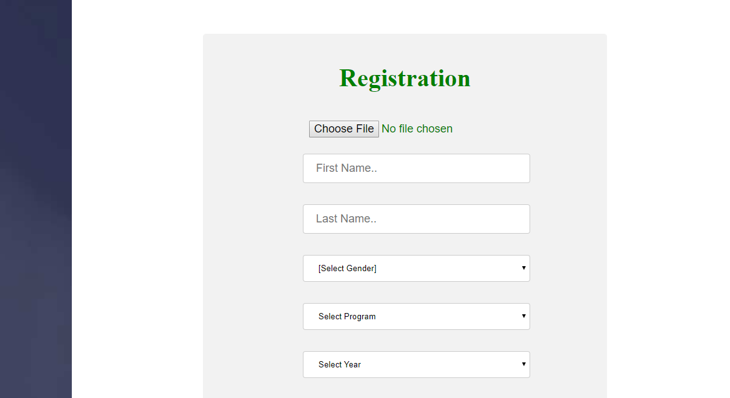
Fig 5.3.4
Studen Profile 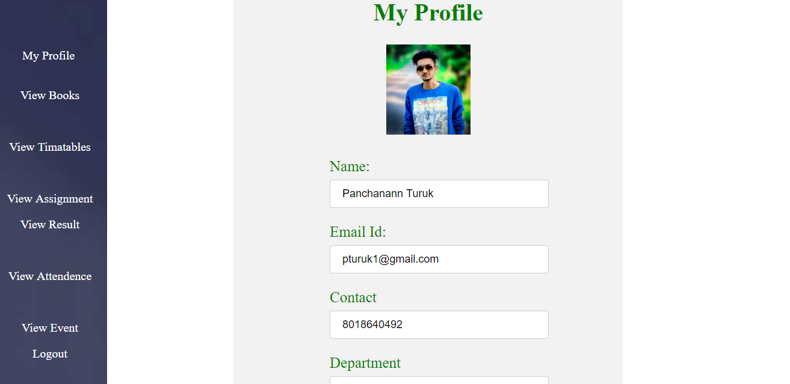
Fig 5.3.5

Faculty Profile

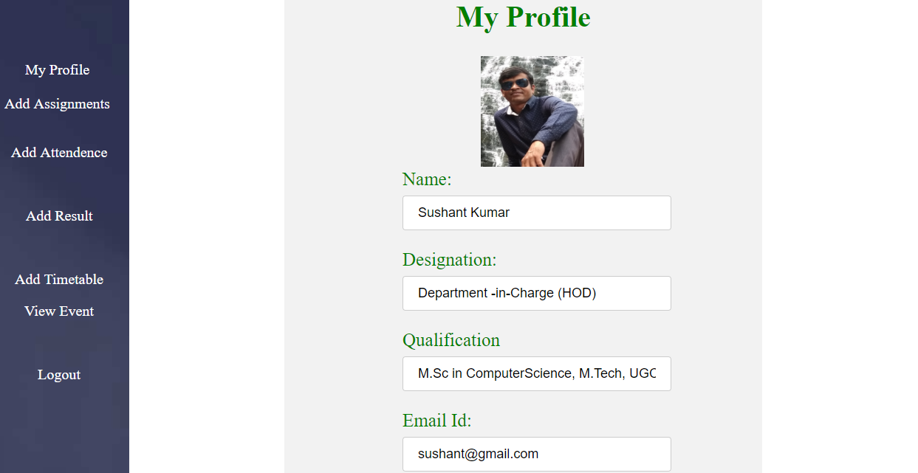
Fig 5.3.6
Librarian Profile
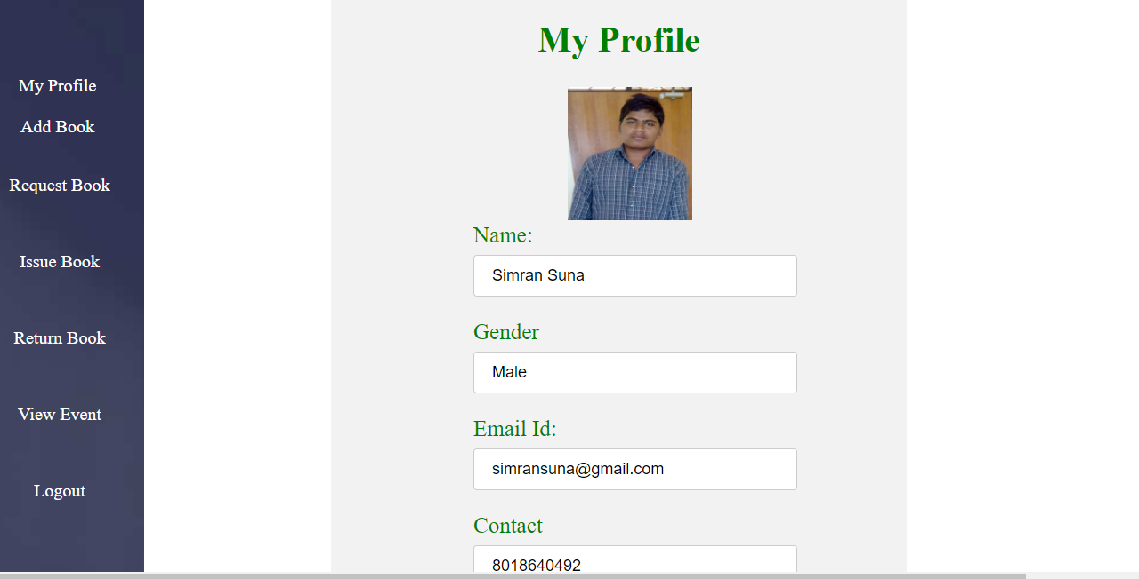
Fig 5.3.7

Events

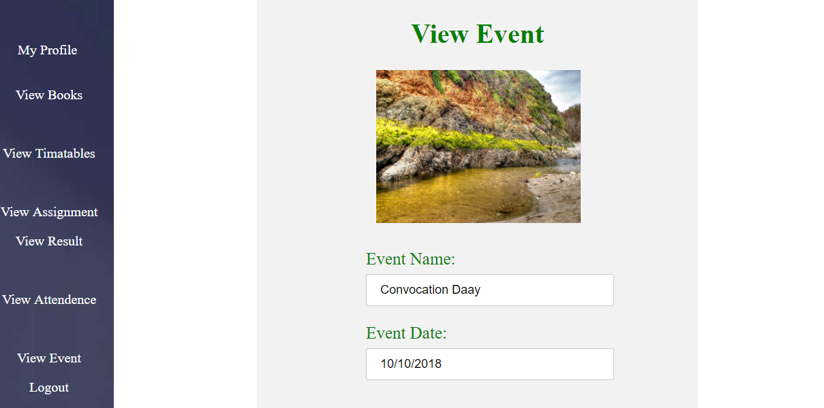

Fig 5.3.8

5.4 CONCLUSION

The website College Mangement System is completed, satisfying the required design specification. The system provides a user-friendly interface. This website is developed with modular approach. All modules in the project have been tested with appropriate data. The developed system runs successfully when the constraints are taken into consideration. There fore the developed system will give a new flavor to the users who are interested to keep in touch with the sites. Along with another related website.

5.4 REFERENCES
- Nevon Projects
- W3School
- JavaTpoin
- PhpTpoint
- TutorialPoint
- Wikipedia
- Web Technology Black Book
- PHP The Complte Reference
- Kudvenkat
- Tutorial Point
- Stack Overflow
- OUAT

