Initial screen
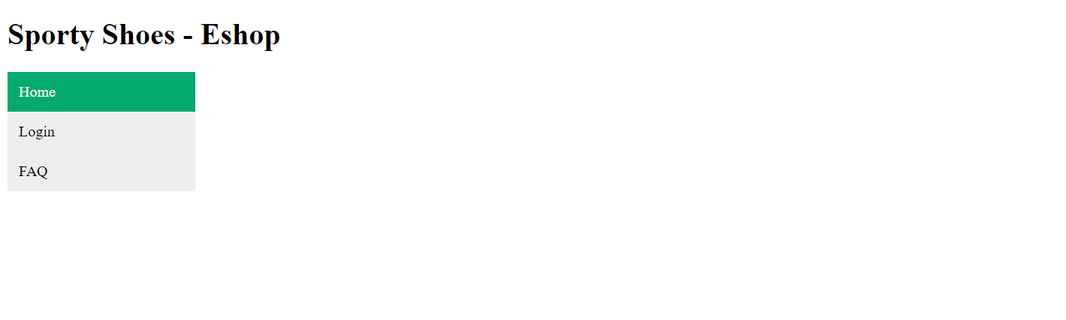

Selecting Home , a view of all the shoes is displayed
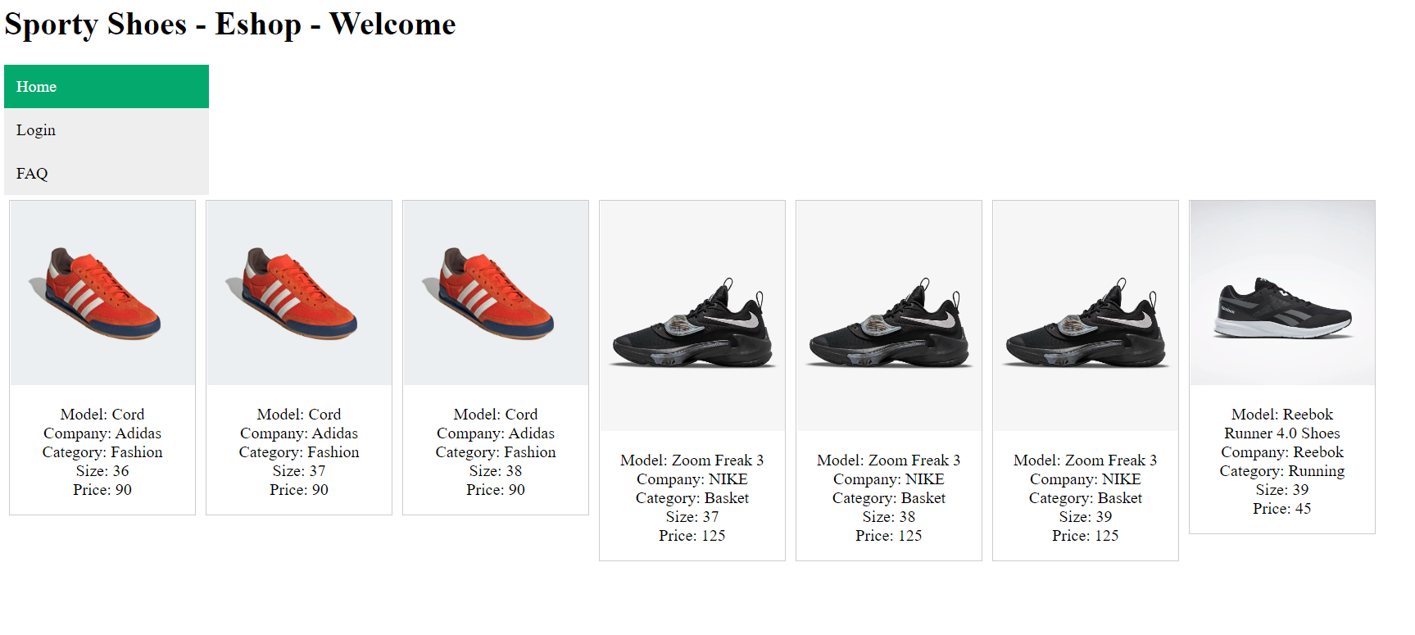
Selecting a particular shoe by clicking it’s image we are asked to log in to purschase it.
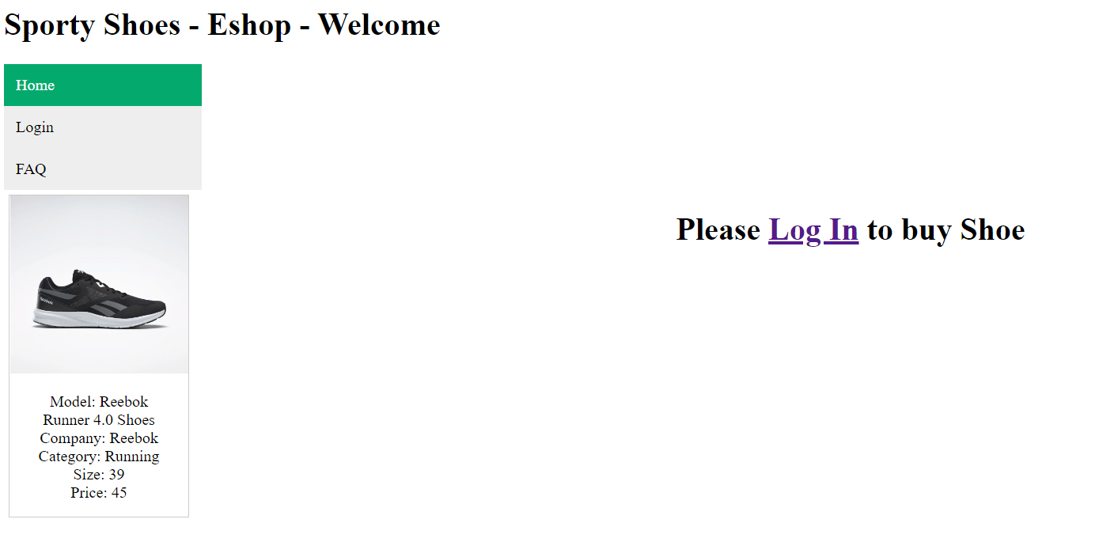
Clicking Login in the right menu or the Link in the previous page takes us to the login screen
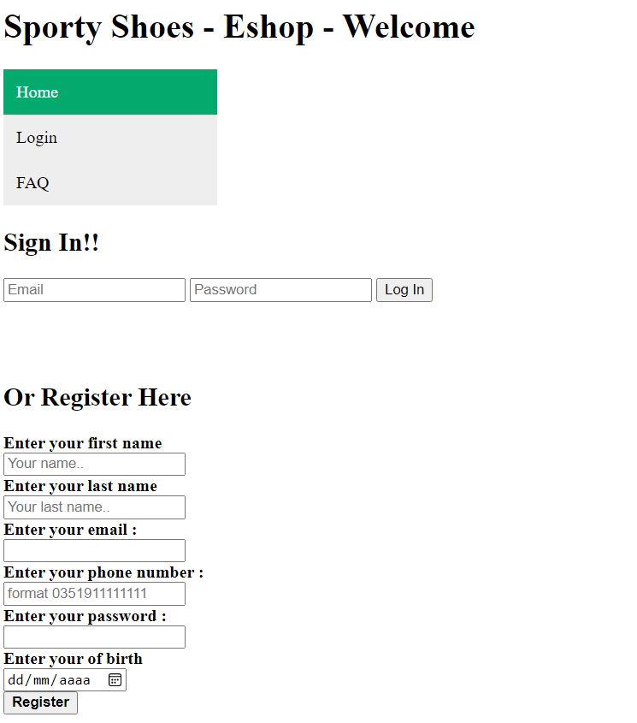

Signing in with an invalid combination of user or password results in a warning

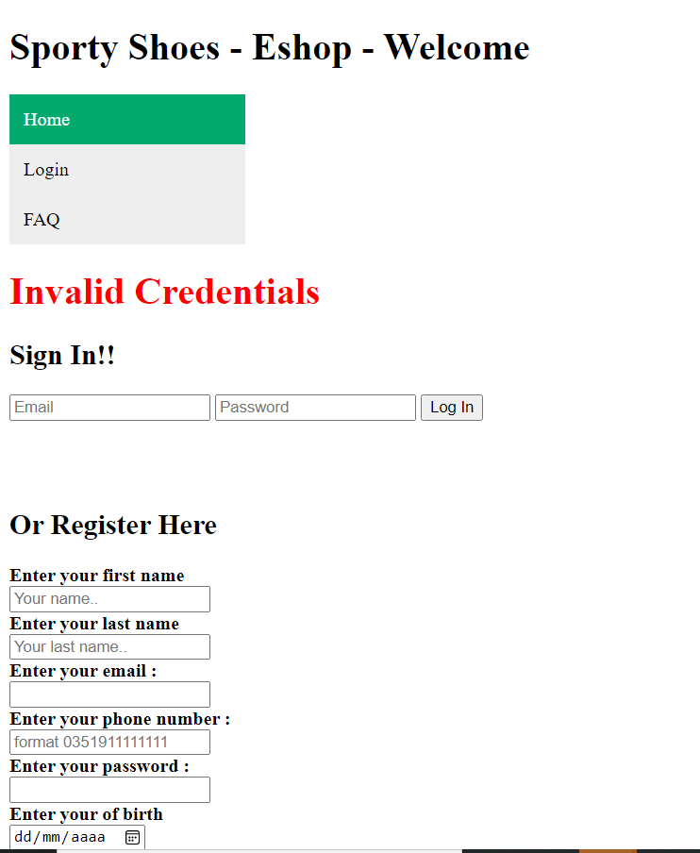

Using valid credentials takes us to the gallery view with user details displayed
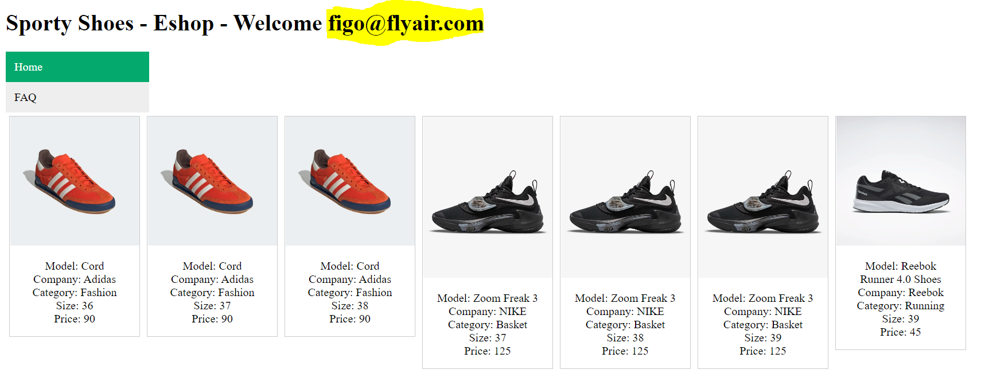

Selecting a particular shoe by clicking it’s image we are able to select how many we want to buy.
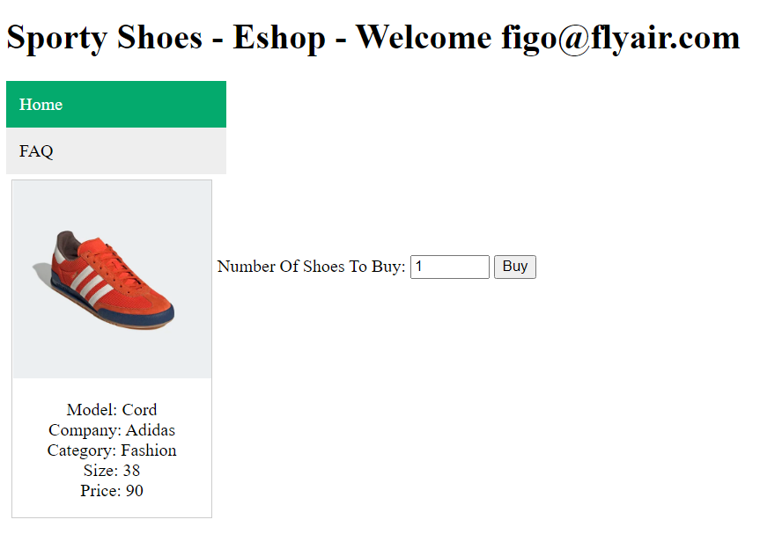

Hitting the buy button we are presented with the total amount to pay and the number of (pairs of)shoes that will be bought.
We can add payment info (not validated)
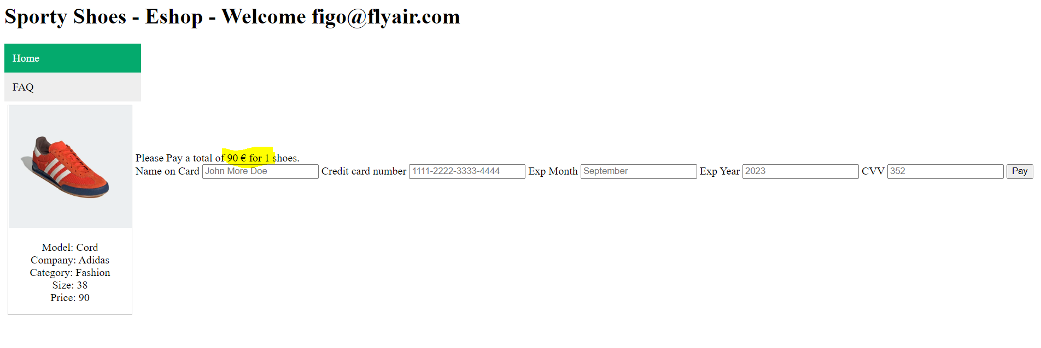
Hitting the pay Button we are presented with a confirmation (and order is added to the “orders” table)
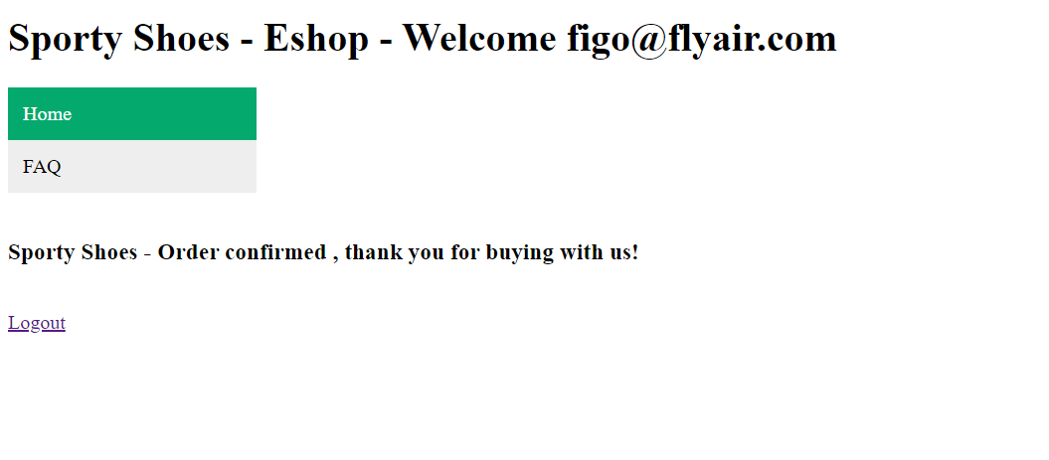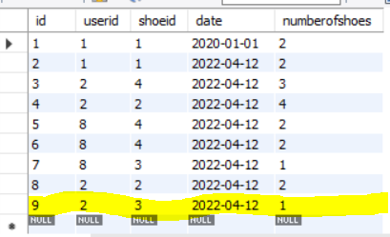
Clicking Logout (we can do it anytime that we are logged in since link is always visible in the footer ) we are directed to the log in page … note the absence of user email after the “Welcome”
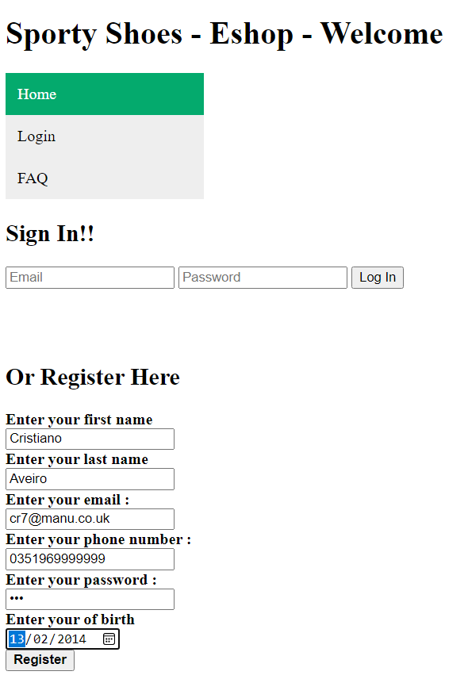
Registering a new user results in a message of successfull registration and user is added to users table
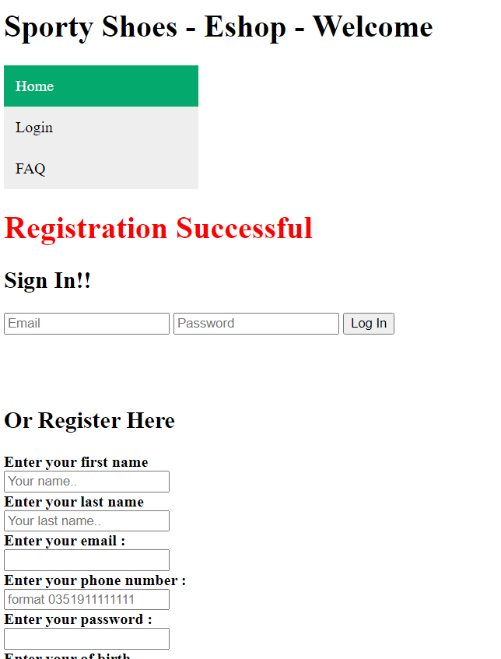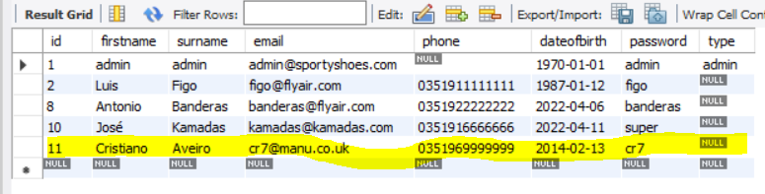

Trying to register with duplicated data (email or phone) results in error and no user is added to the user tables
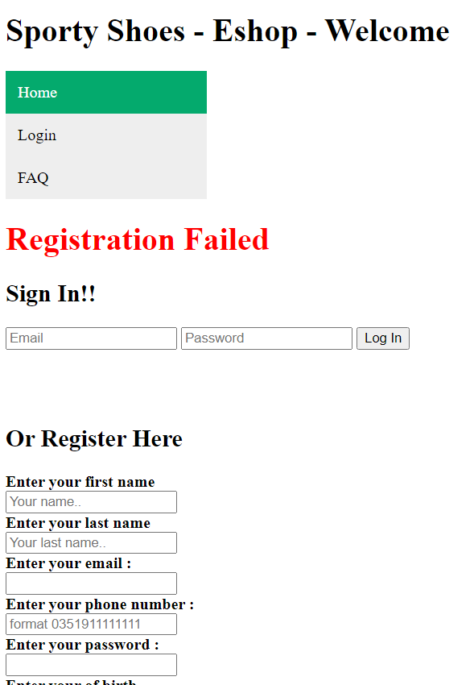

Selecting “FAQ” from the menu just provides a link to the github repository
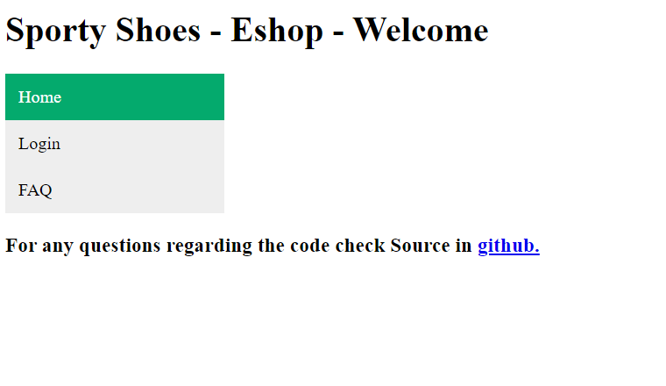

ADMIN VIEW

Login in with an admin user (defined by users.type) will display the admin page
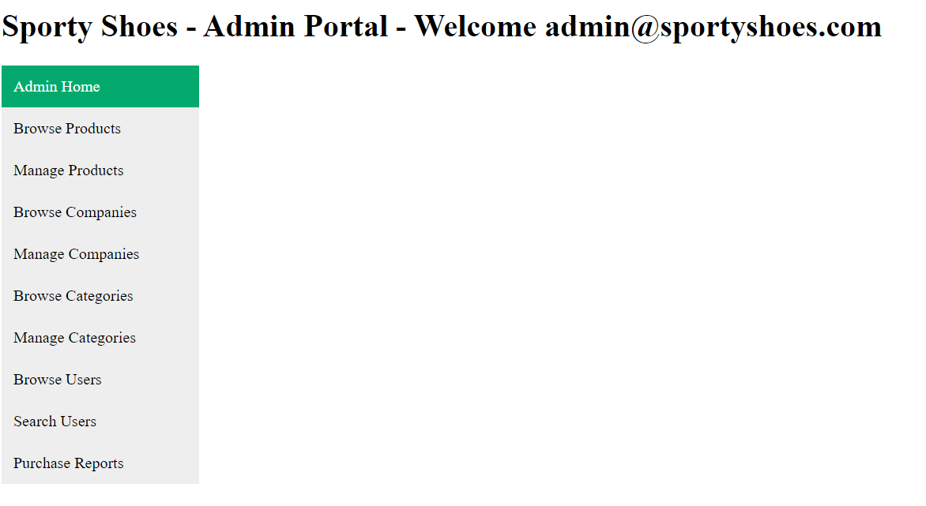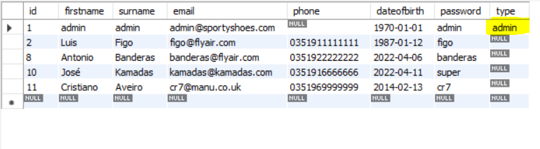
Selecting Browse product from the Menu displays the info of all the available shoes from table shoes
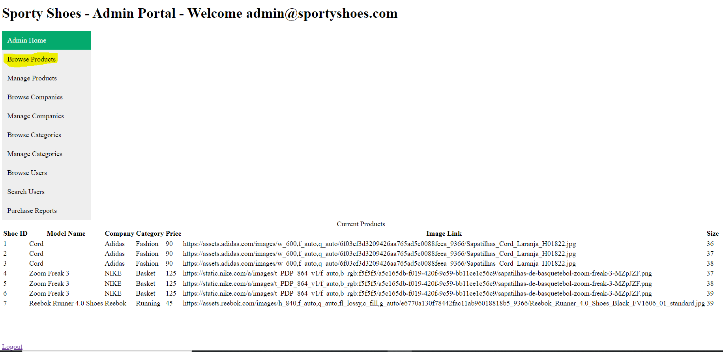

Selecting Manage products 2 forms are presented, one to add a shoe , another one to delete it
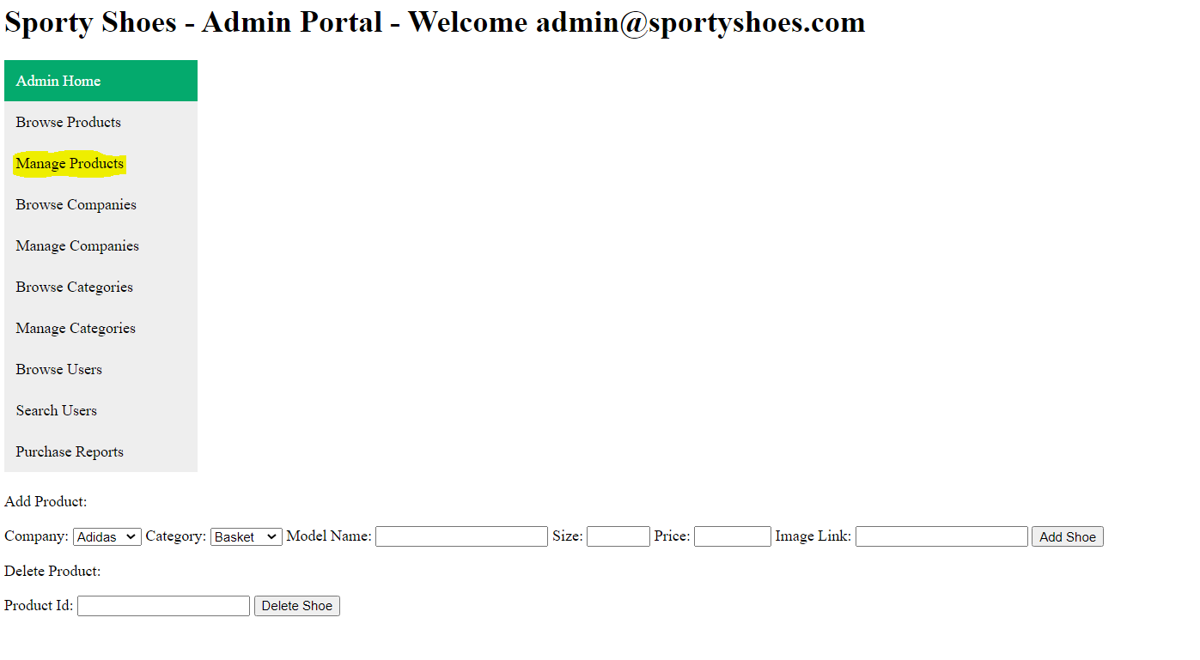
Adding the data for a new shoe (Company and Category are option from those tables) and selecting the button “Add Shoe” we are presented with a Success message and shoe is added to the DB (and is shown in the gallery to be bought) .
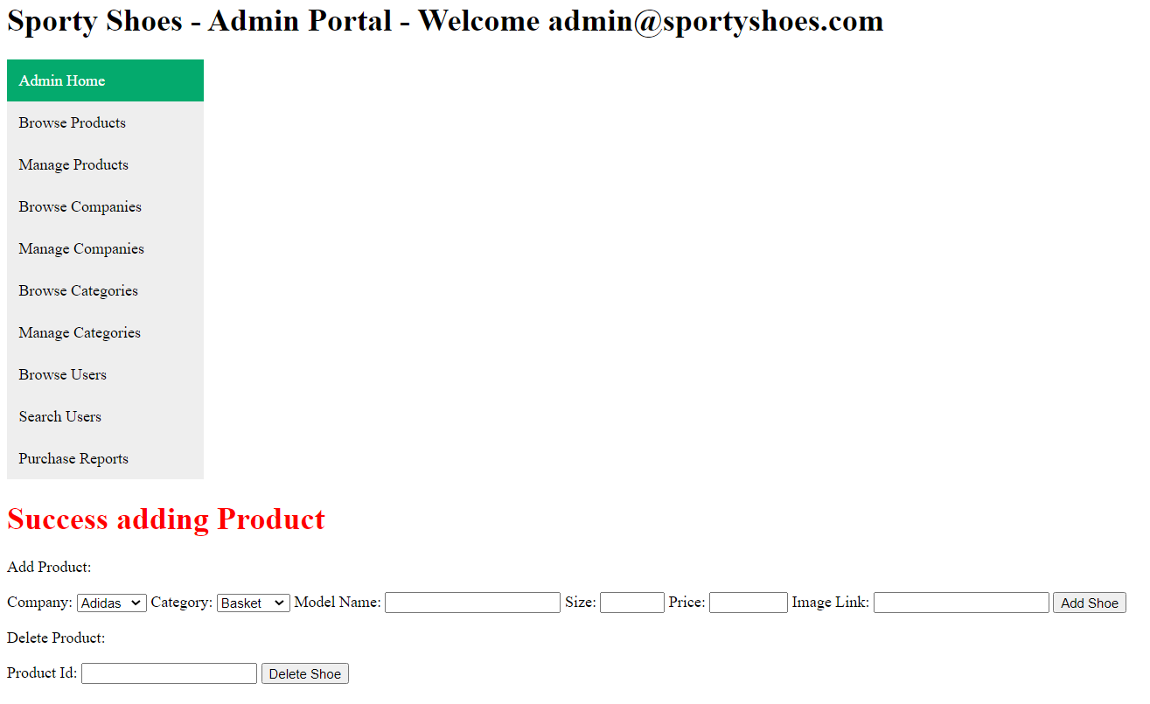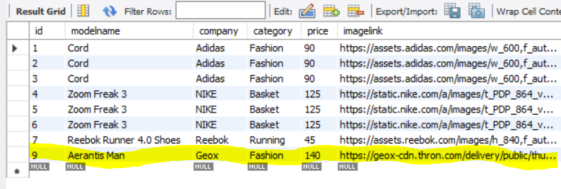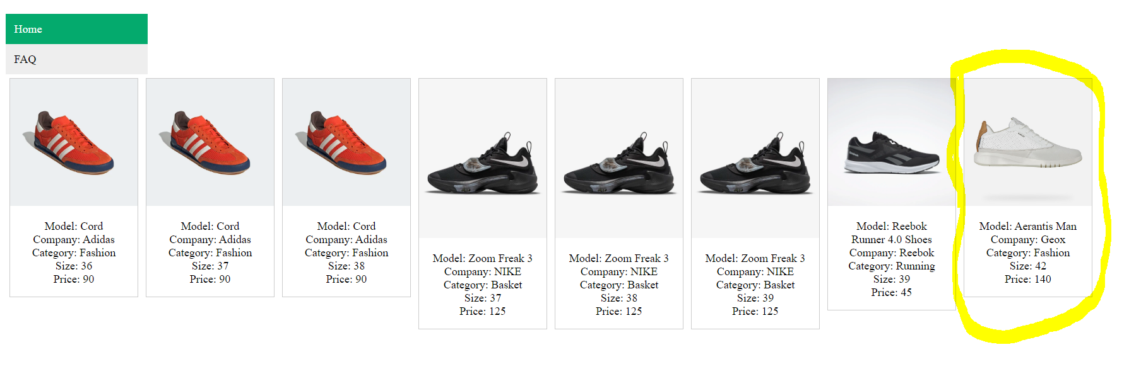

In the other option adding the ID of the shoe to delete results in error if Id doesn’t exist (15 for instance) or if product is already associated with orders (id=4 for instance) results in a sucess message and row removed from table if id exists (notice that row with id=6 was removed)
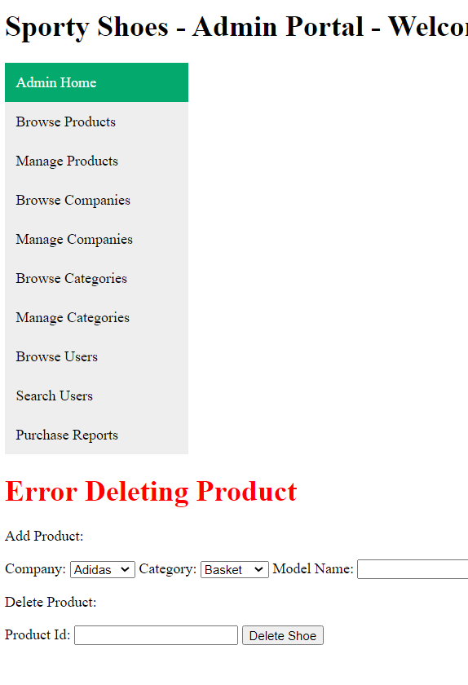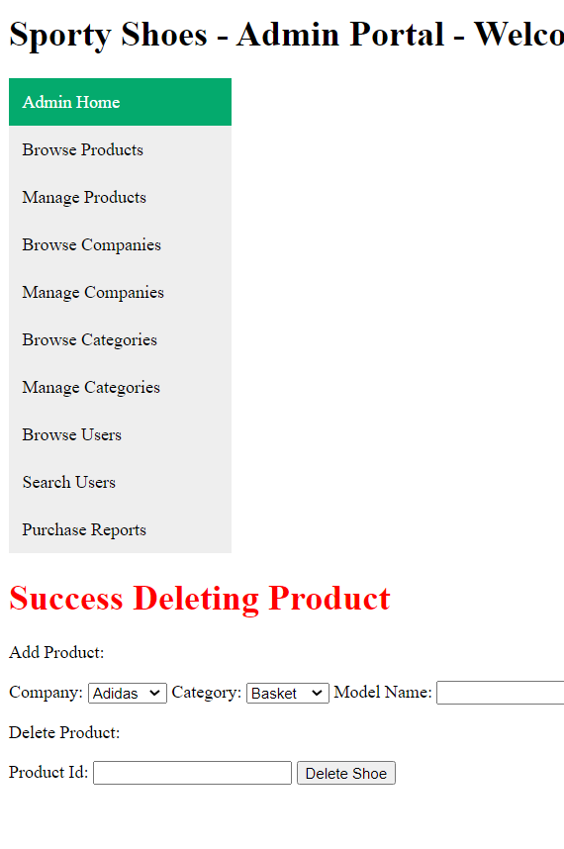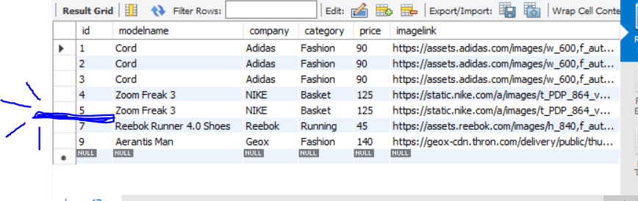

Selecting Browse companies from the Menu displays the info of all the available companies from table companies
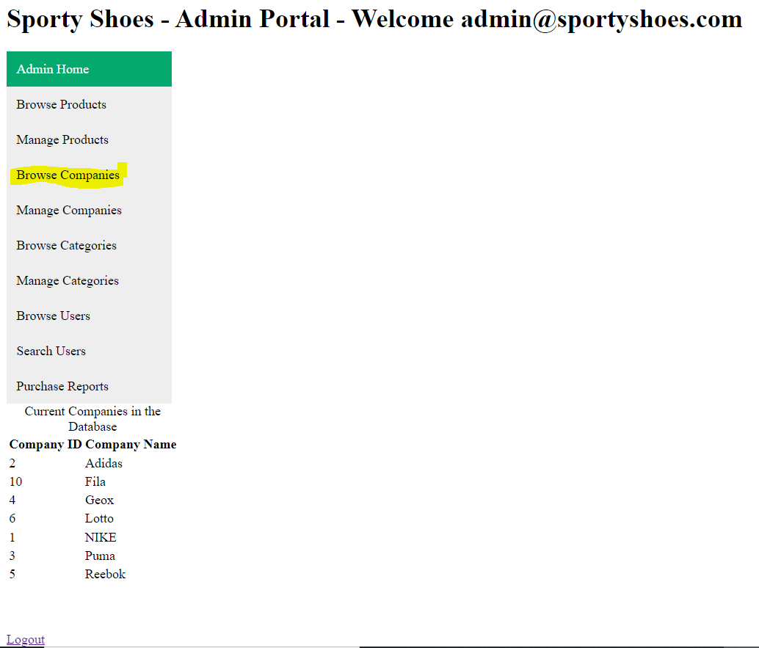

Selecting Manage Companies a form is presented, one to add another Company , if company was not part of the db a success message is displayed and company is added to table companies, if it existed previously na error message is displayed
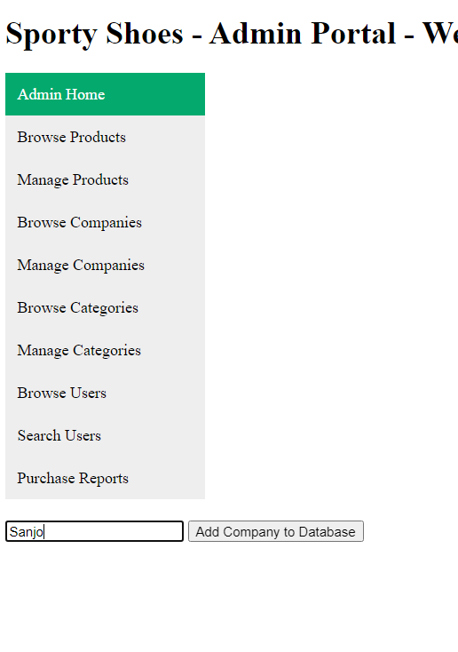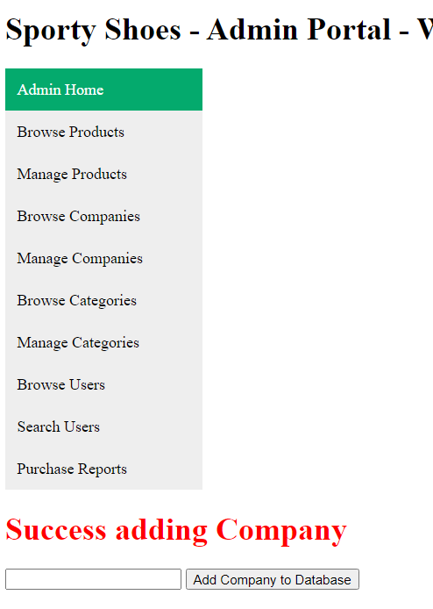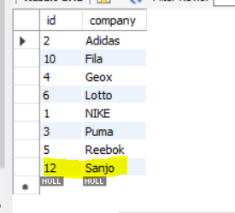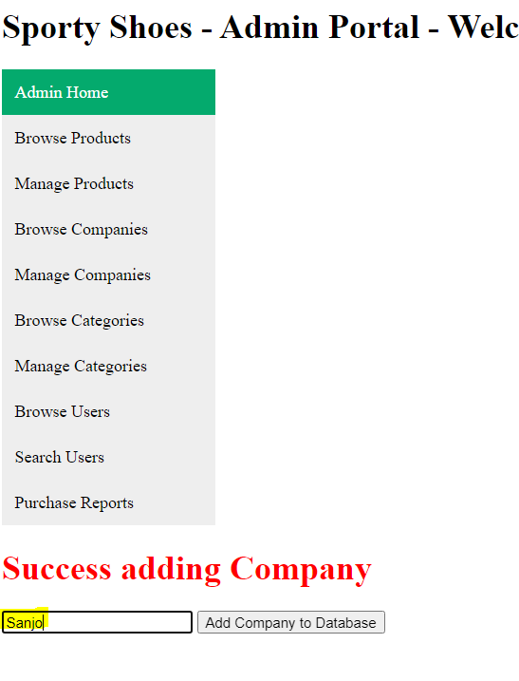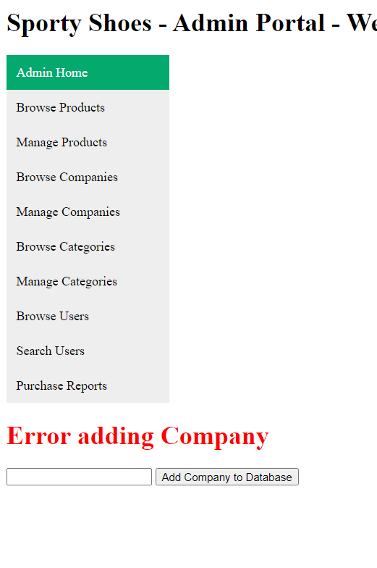

Selecting Browse Categories from the Menu displays the info of all the available categories from table categories
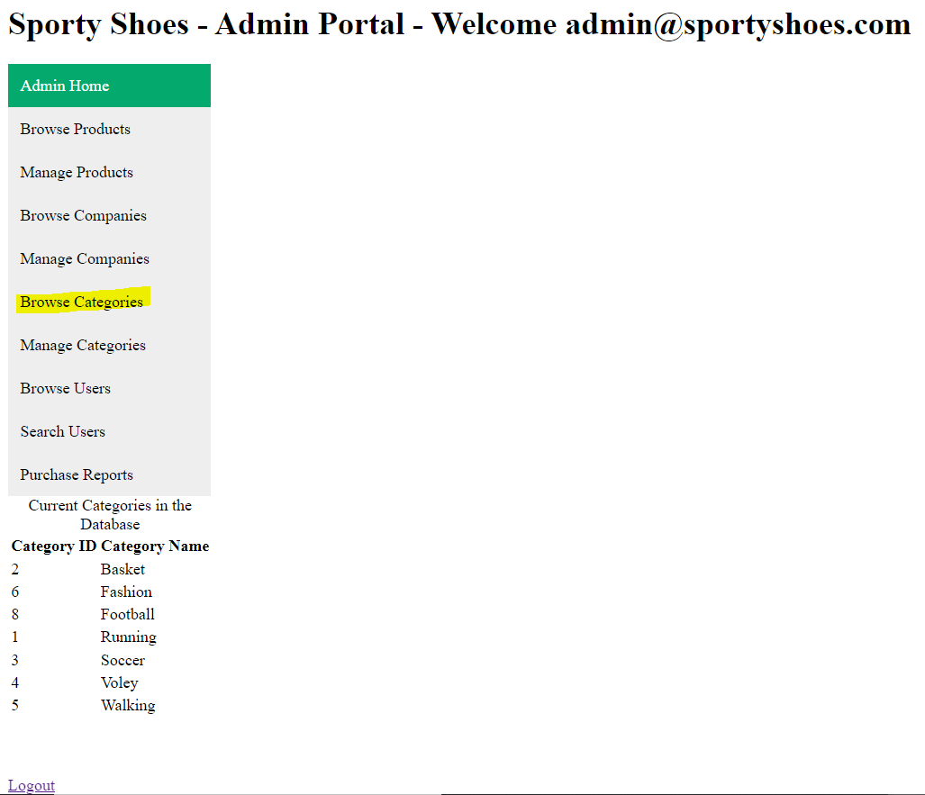

Selecting Manage Categories a form is presented to add another Category , if category was not part of the db a success message is displayed and category is added to table categories, if it existed previously na error message is displayed
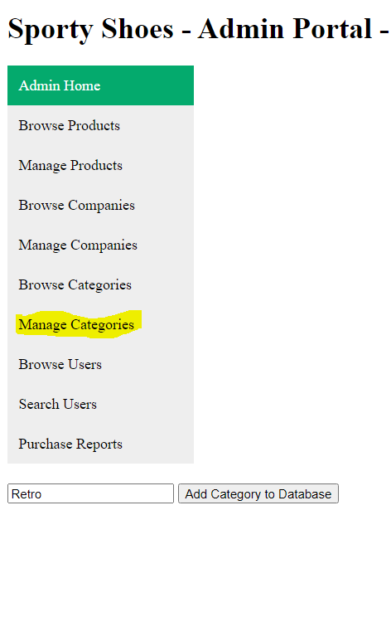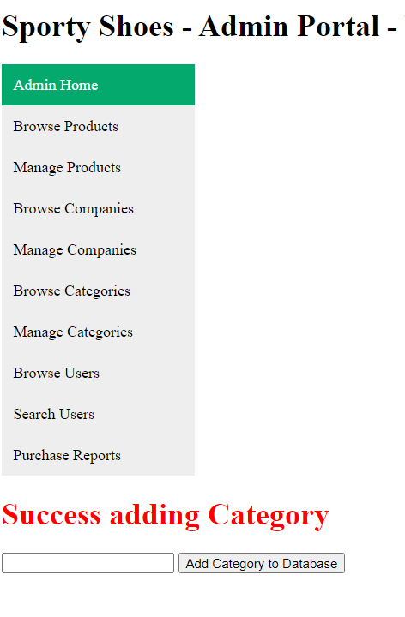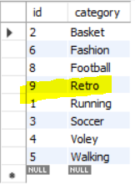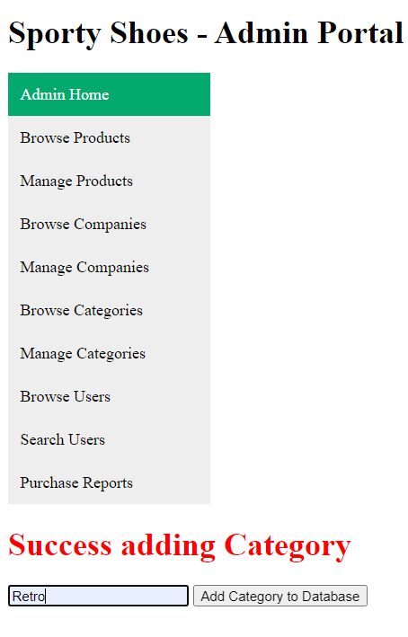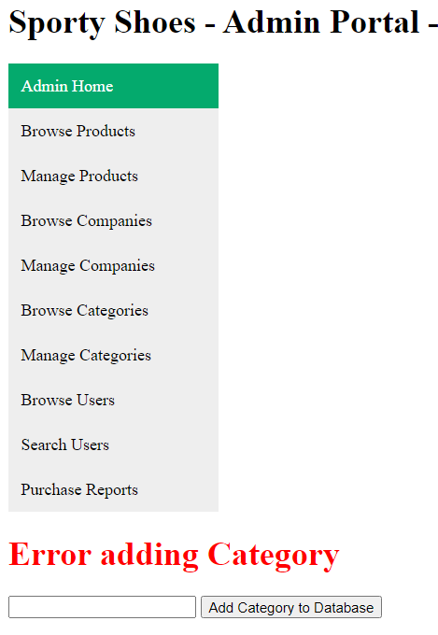

Selecting Browse Users from the Menu displays the info of all the available users from table users
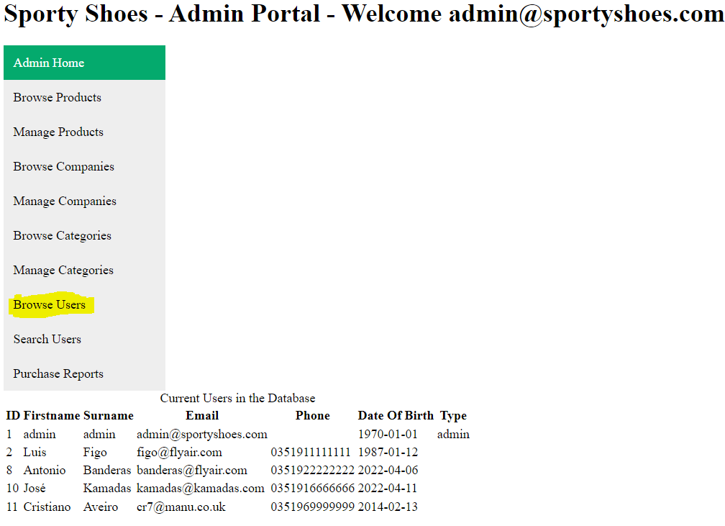

Selecting Search Users provides a form to search the users via email – The result is the user if found or nothing if user doesn’t exist
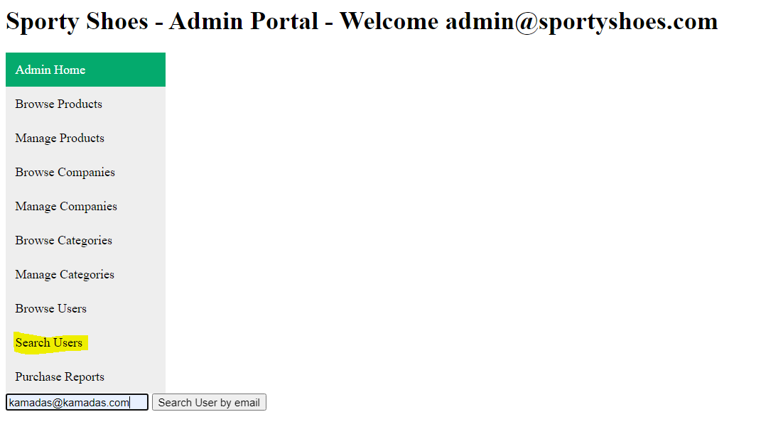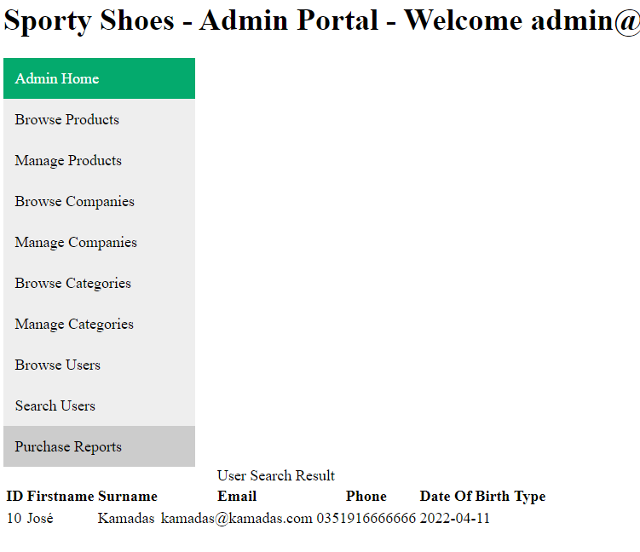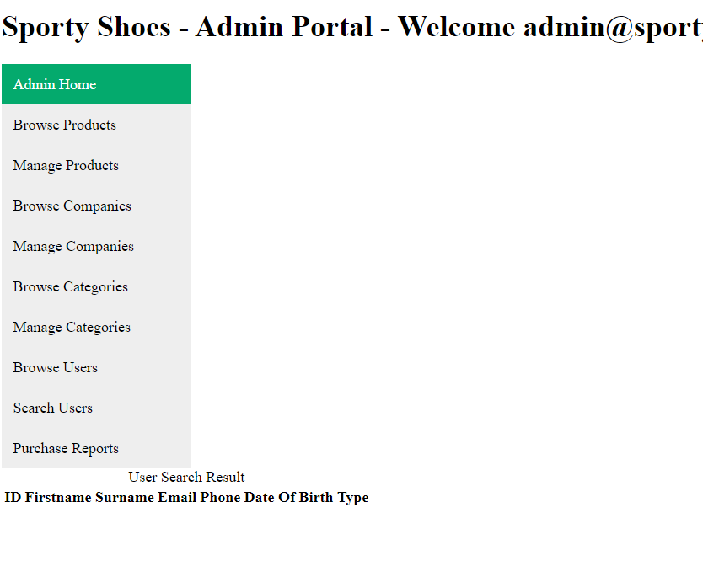

Selecting Purchase Reports , the total of orders is displayed , and 2 forms are also presented, one to filter the orders by category , another one to filter by date.
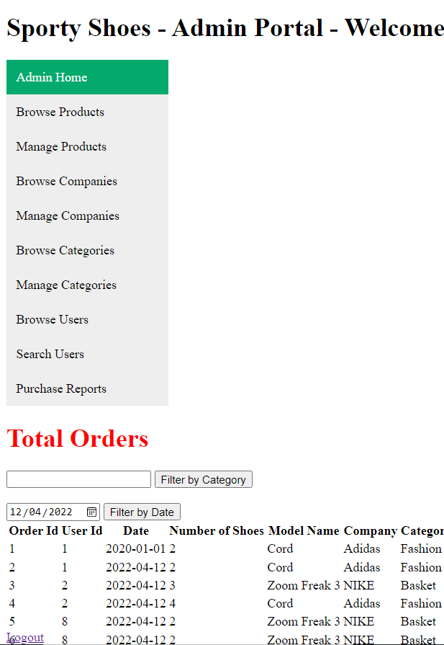

Filtering by Category , if the input is an existing category the orders associated with shoes from that category are displayed , if the category doesn’t exist (or there are no orders for those type of shoes) no result is displayed.
Below results for inputs “Basket” and “old”
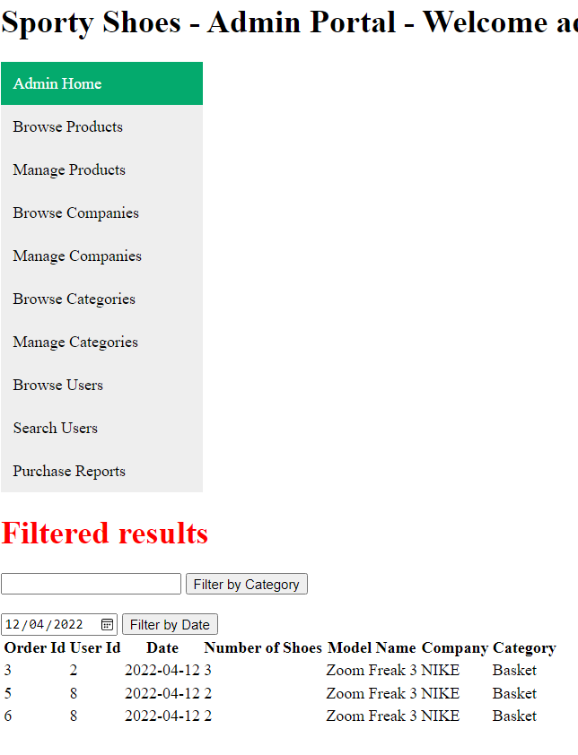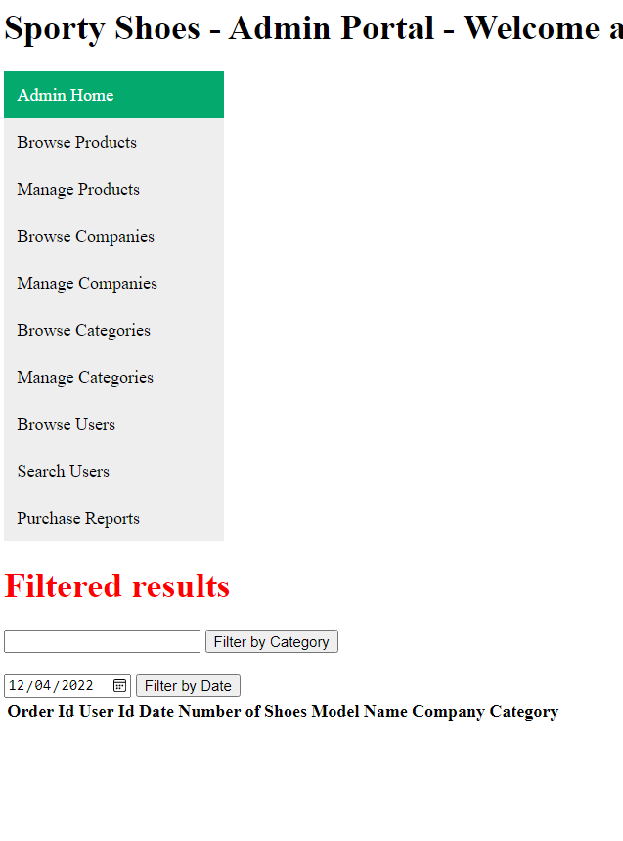

The same behaviour is displayed filtering by data , if there are orders with the same date as the one provided , those will be displayed …. If there are none , no ordes are displayed.
Below 2022-04-12 vs 2022-03-03
