Conteúdo
Initial screen 1
Searching 1
Adding products from search result 2
Checking the cart 2
Selecting register and creating a new user 3
Adding items from list of groceries 3
Selecting the cart to review current status and checking out 4
Loging out: 4
Registering a duplicated user 4
Login in with inexisting user: 5
Login with wrong password: 5
Login with admin user: 5
Selecting Product Management option 5
Deleting Products 5
Editing Products 6
Adding Products 6
Selecting User Management option 7
Deleting users 7
Adding users 8
Editing users 8
Selecting Password Management : 9
Providing 2 different passwords 9
Providing the same password in both fields 9
Loging out: 9

Initial screen – Essencial options visible
Search
Groceries
Lohin
Register
Cart
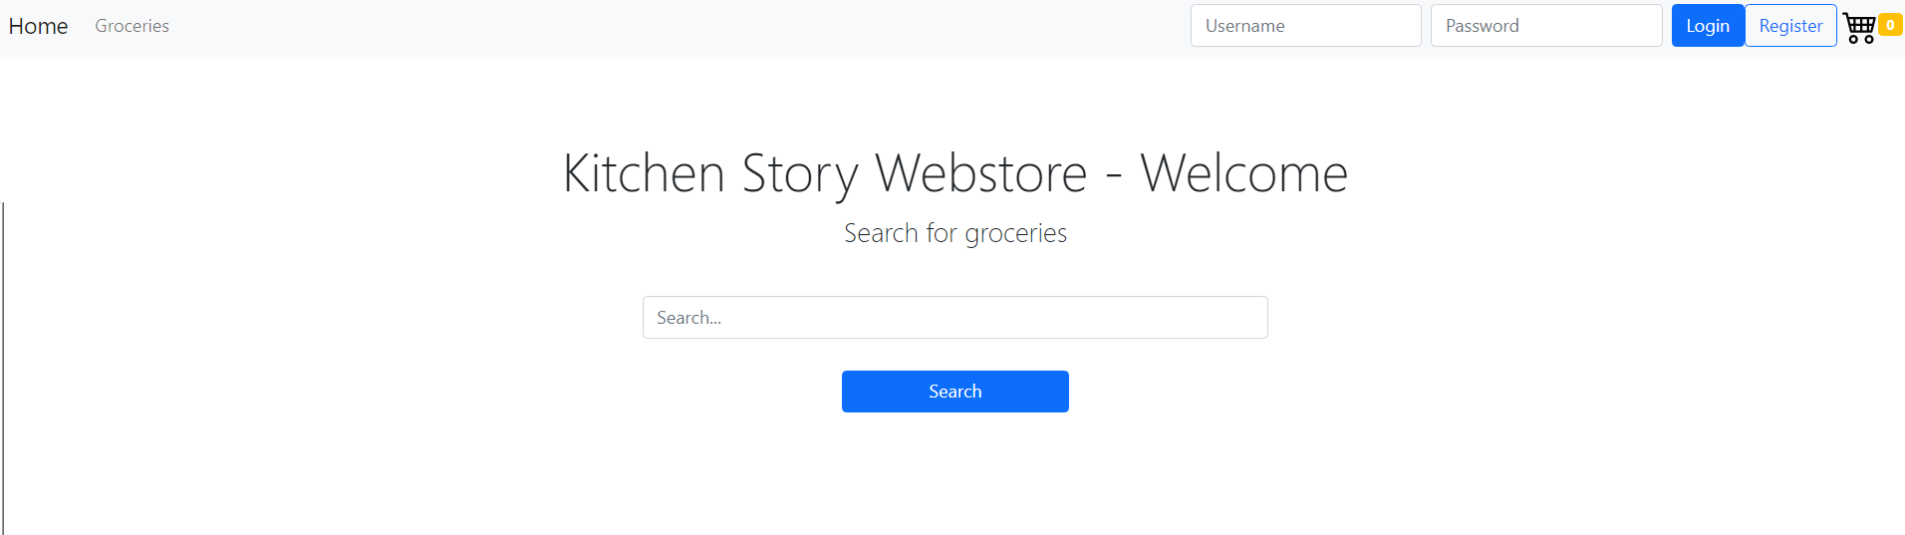

Searching for “a” , the groceries that have “a” in the name are displayed
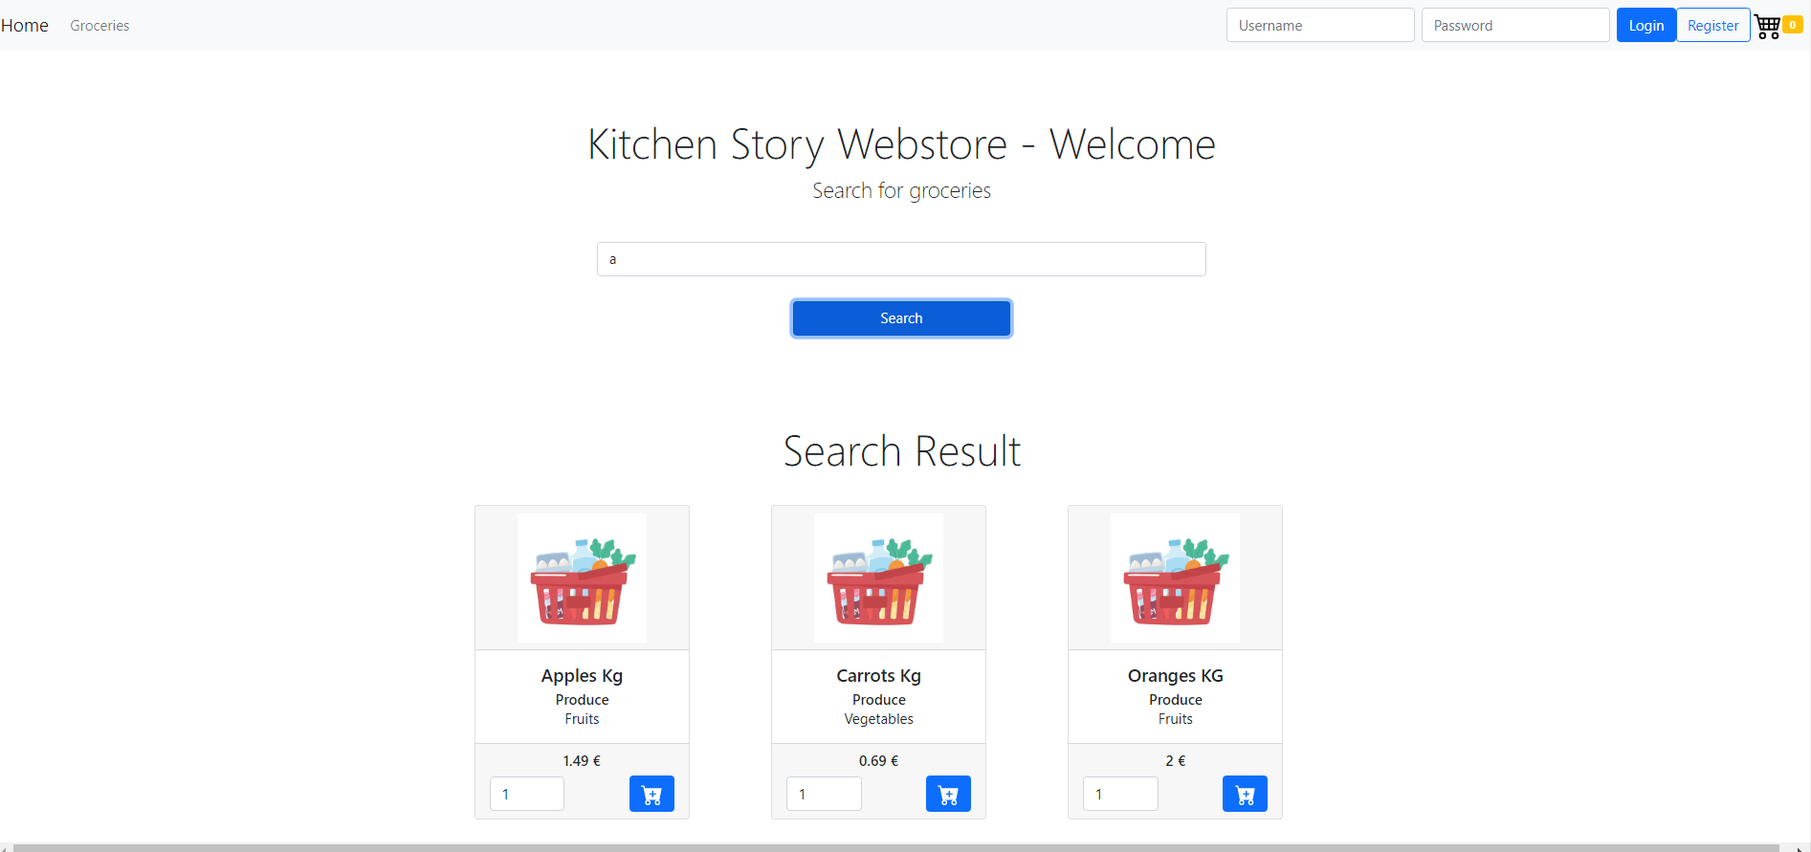
Adding products from search result – adding each of the 3 available products the cart is updated:
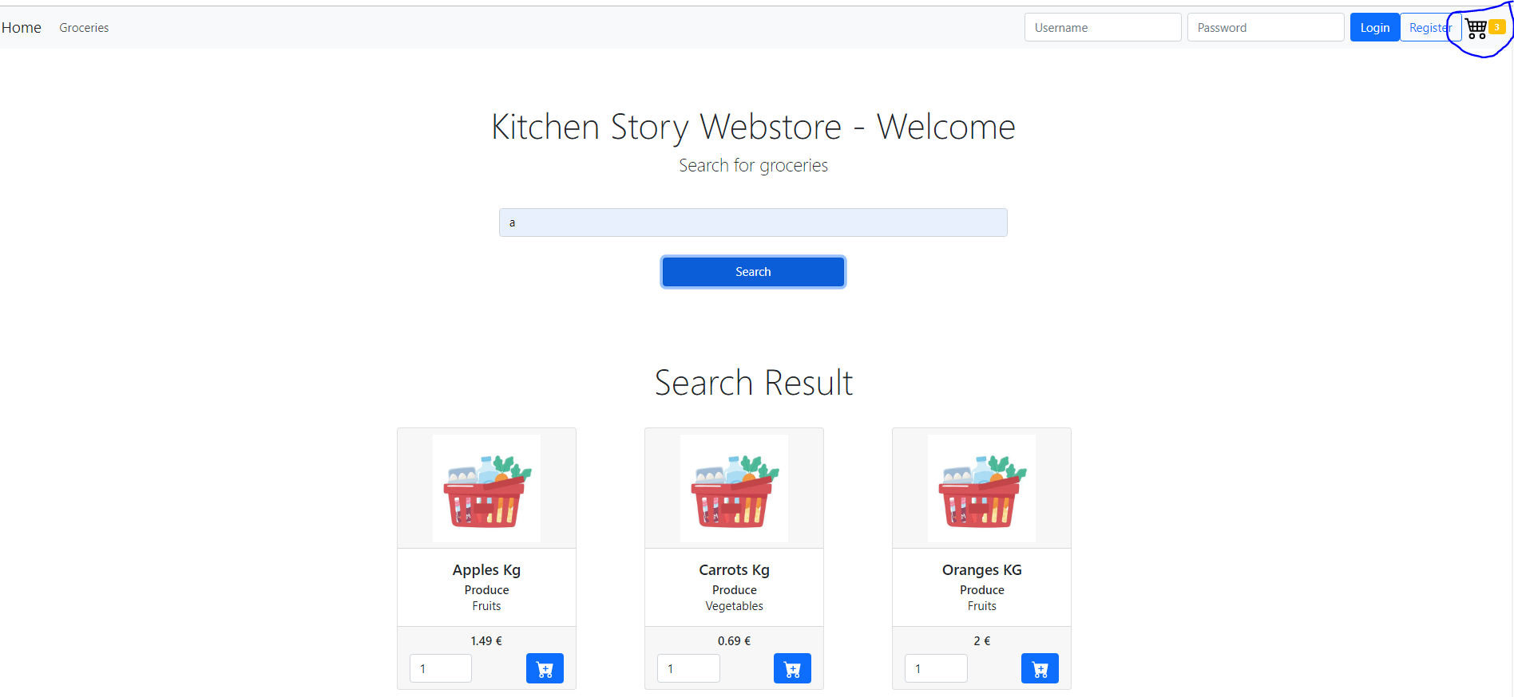
Checking the cart details are displayed
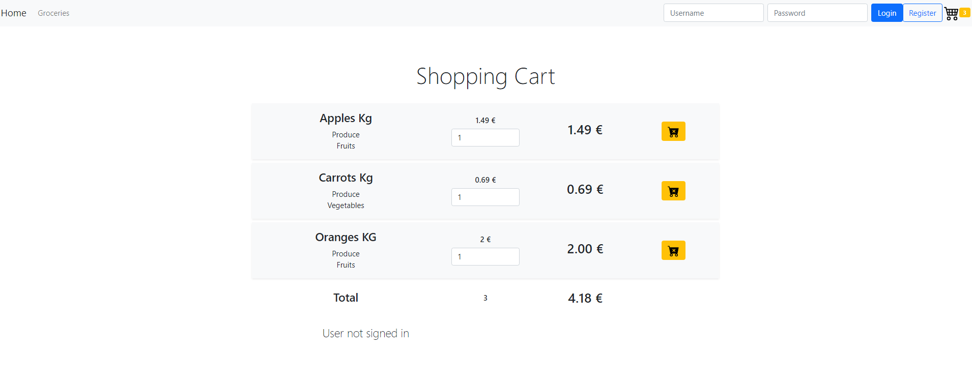

Selecting register and creating a new user , after completion the user is instantly logged in
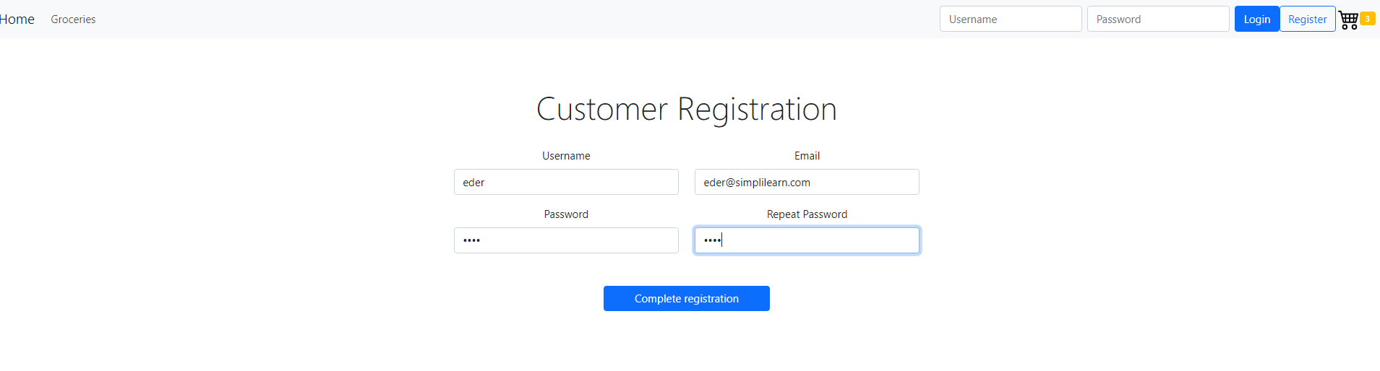
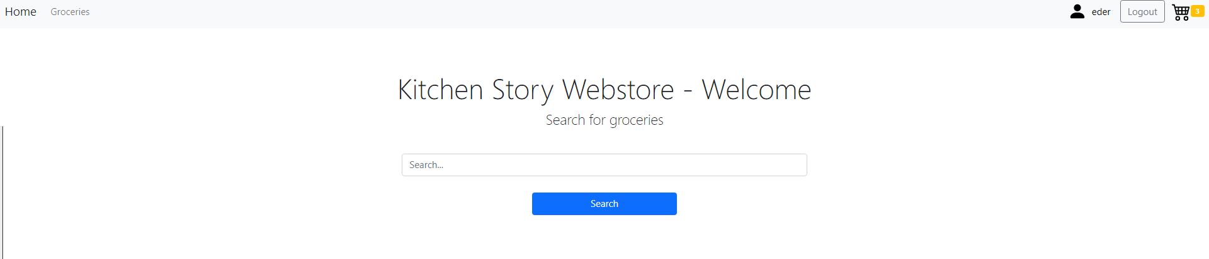

Adding items from list of groceries(items) -Selecting the grocery list to search for items that were not part of the search result and adding cheese
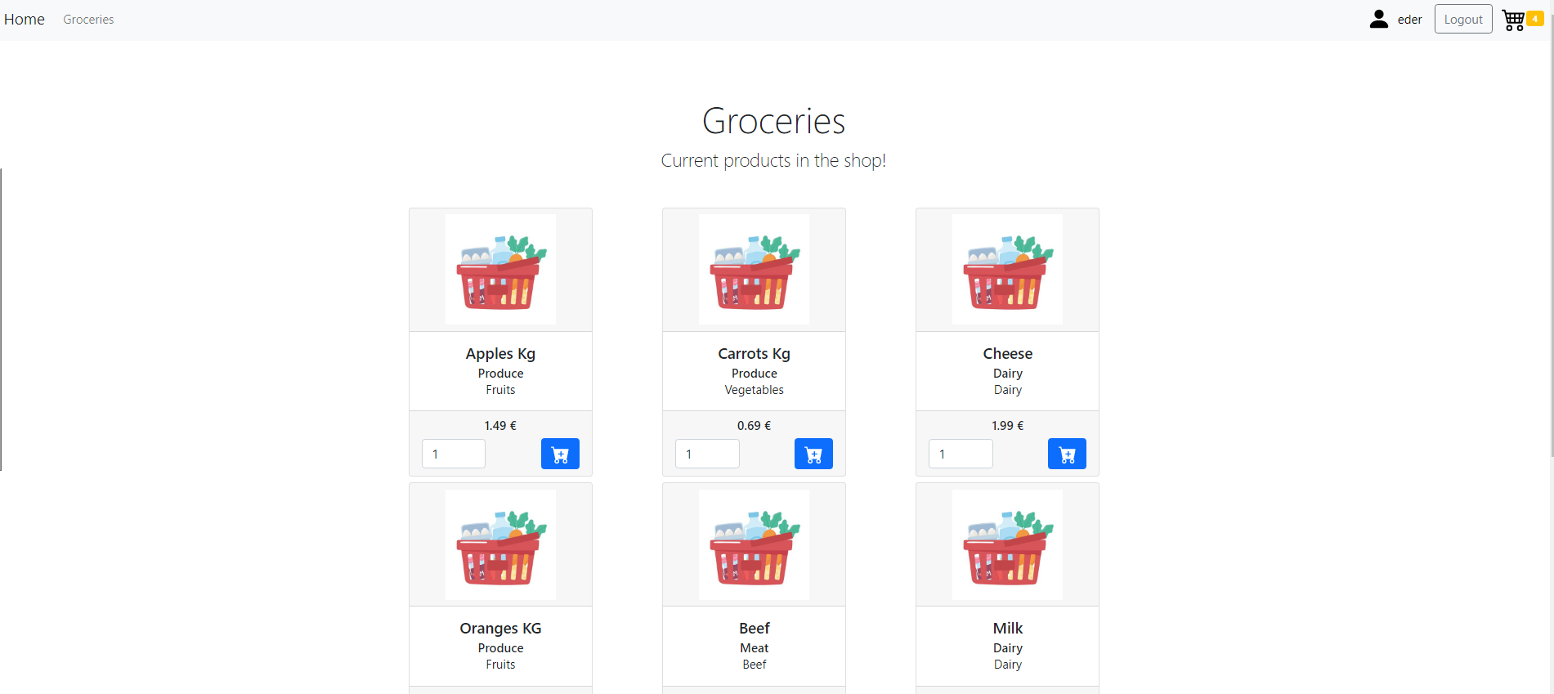

Selecting the cart to review current status and checking out
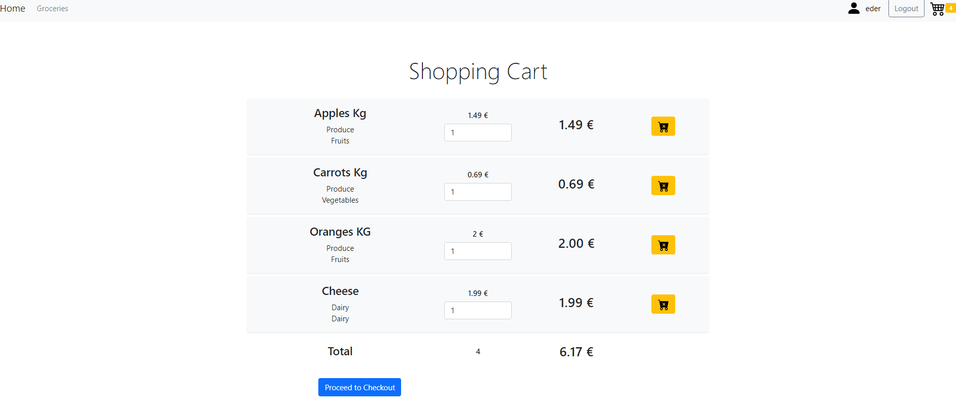
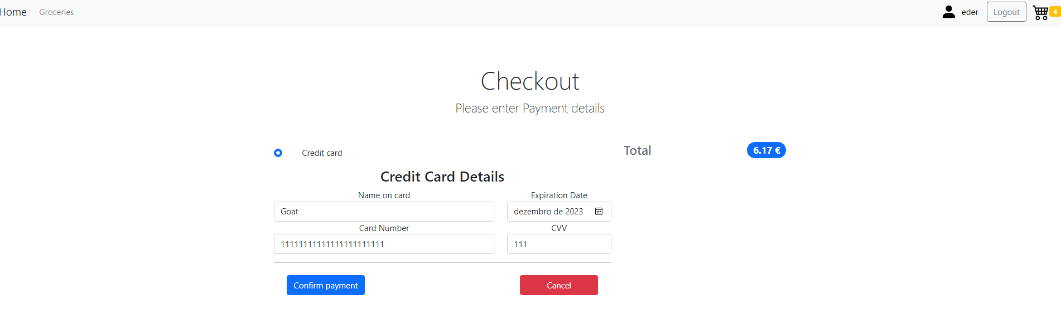

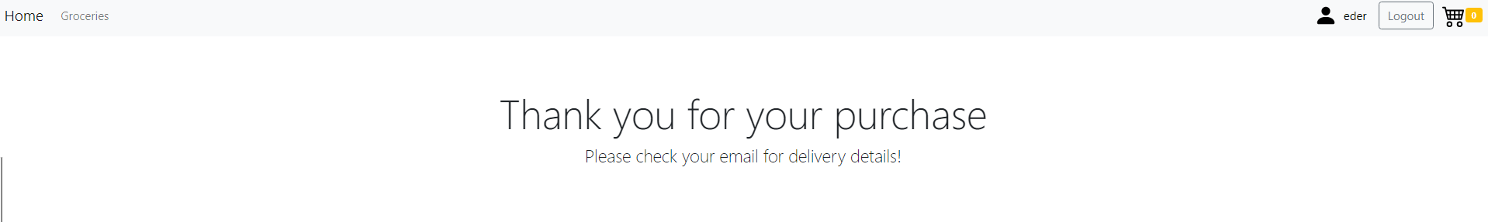

Loging out:
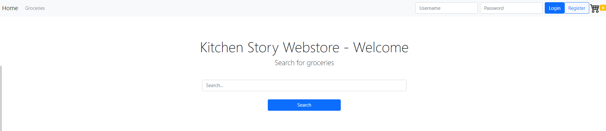

Registering a duplicated user – a warning pops up without duplicating the users
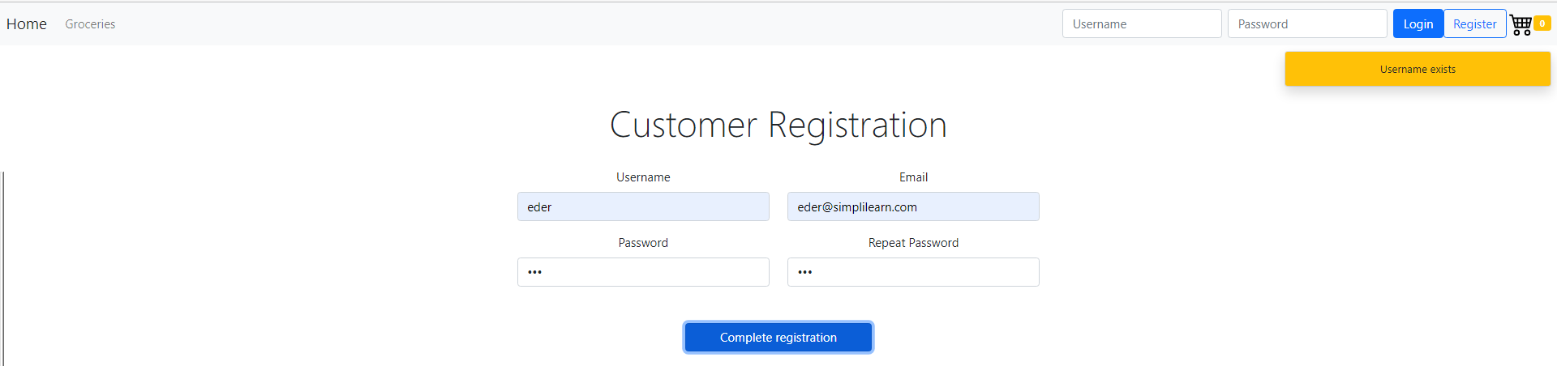

Login in with inexisting user:

Login with wrong password:

Login with admin user:
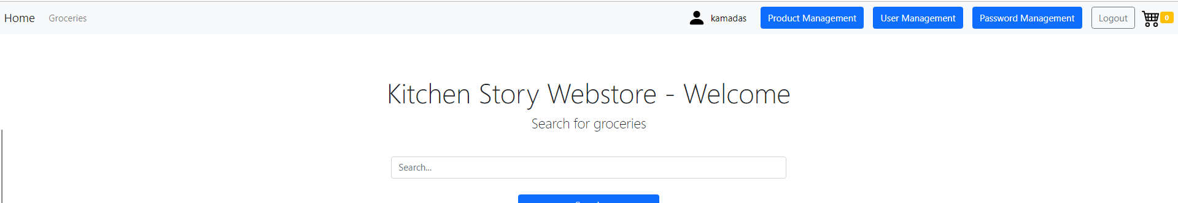
Selecting Product Management option:
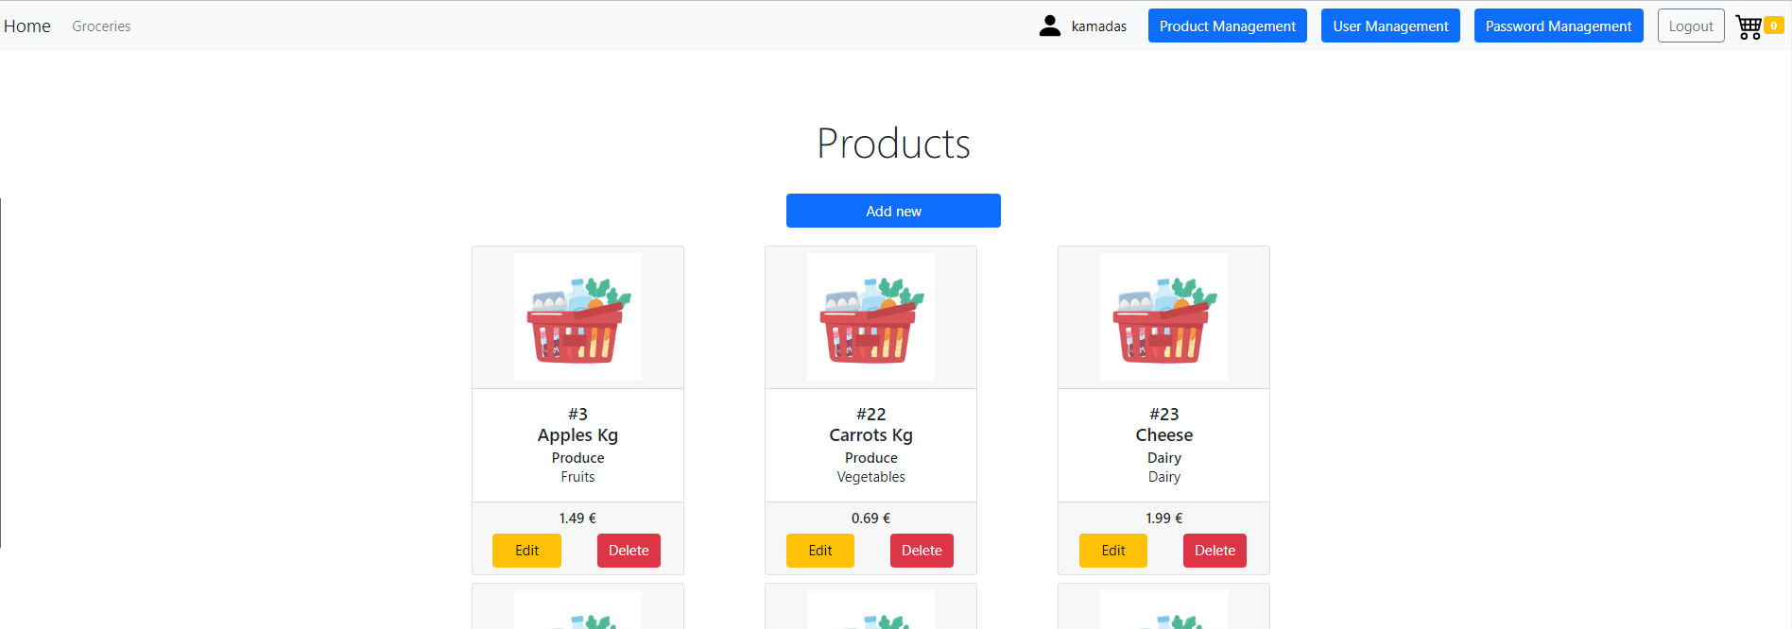

Deleting Products - Deleting Beef (Id25):
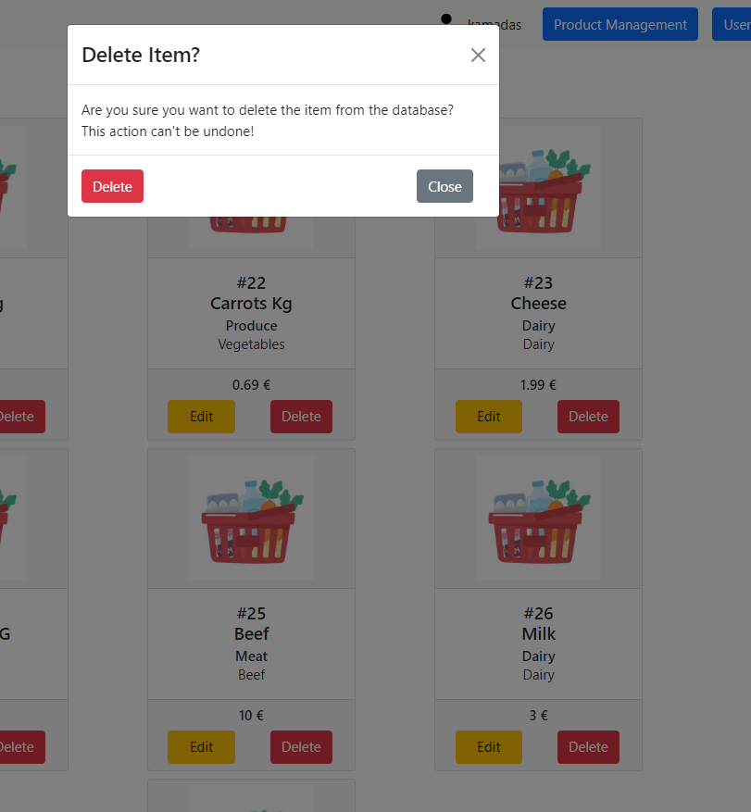 ->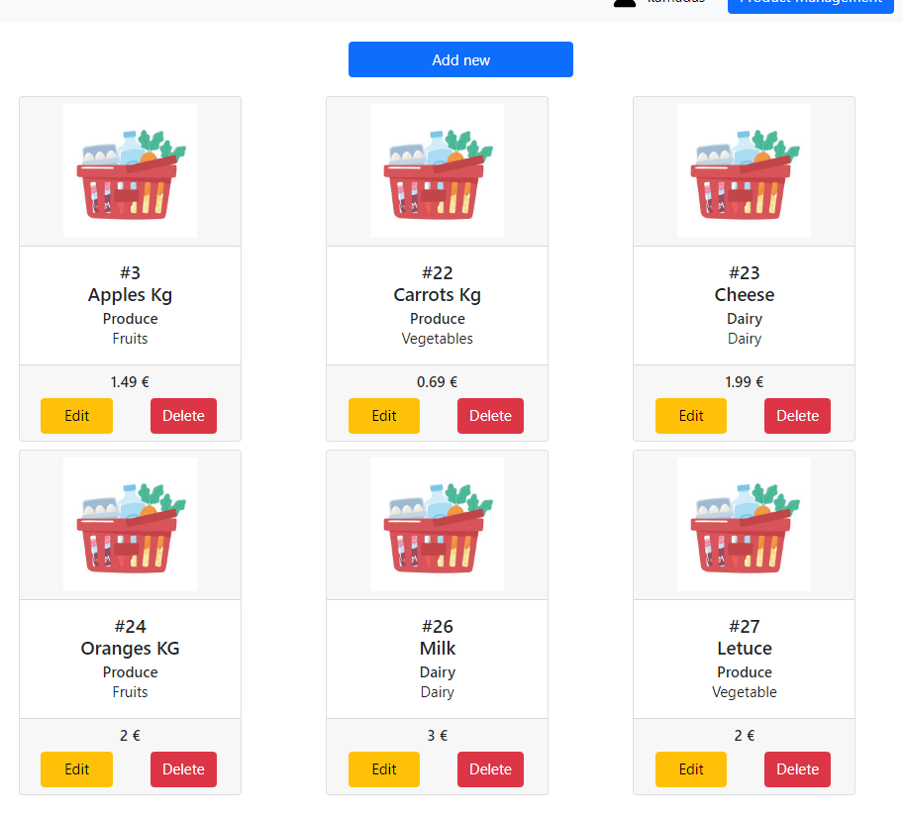
Editing Products - Editing Oranges (Id 24):
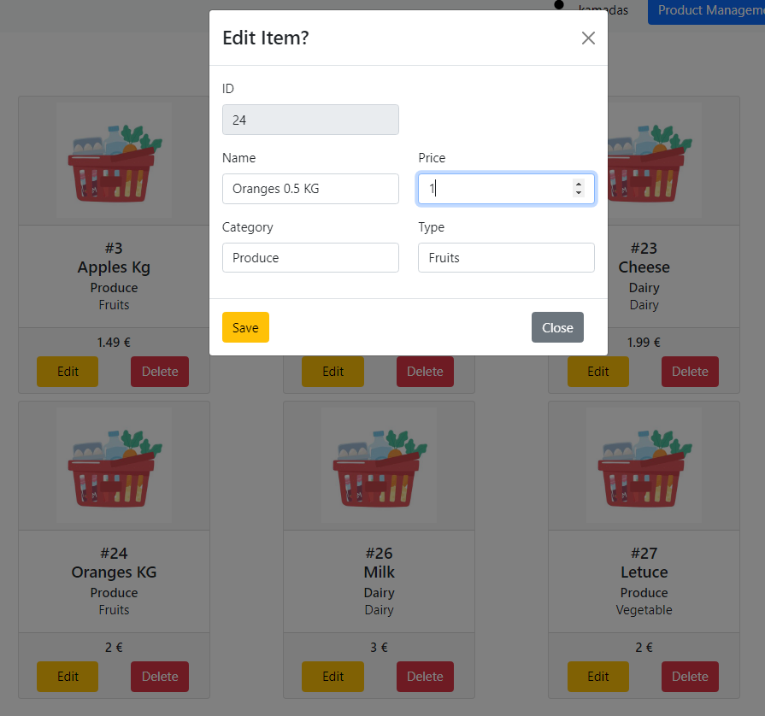->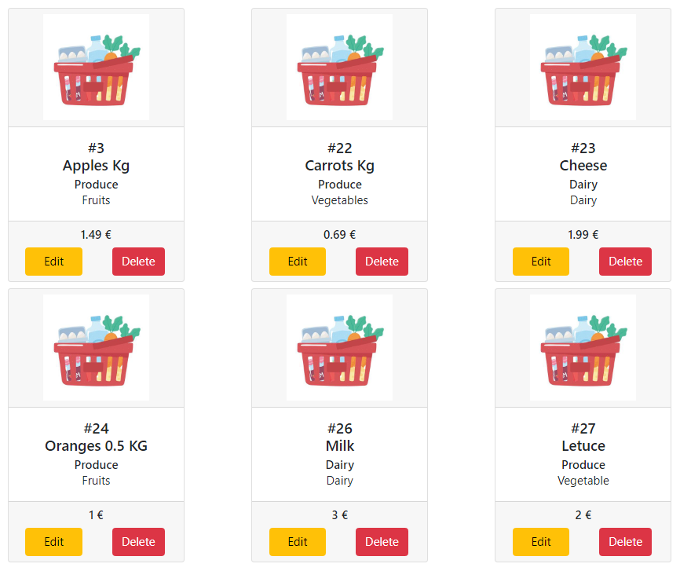
Adding Products - Adding Beef:
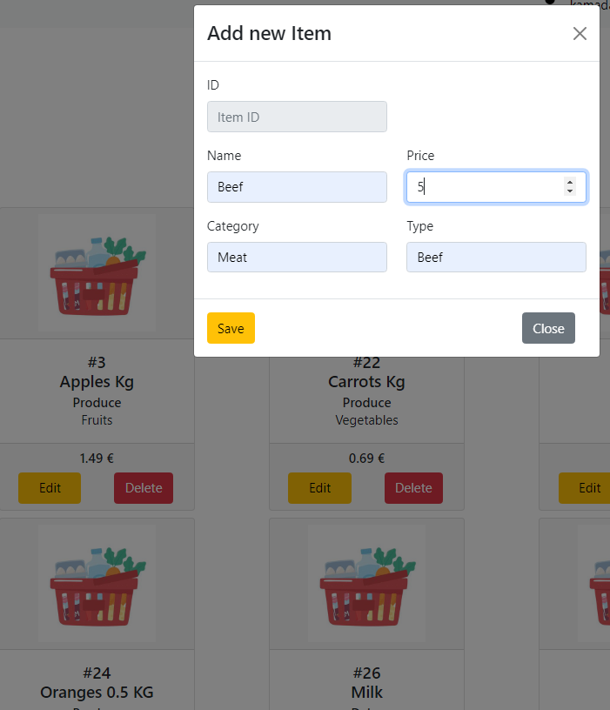->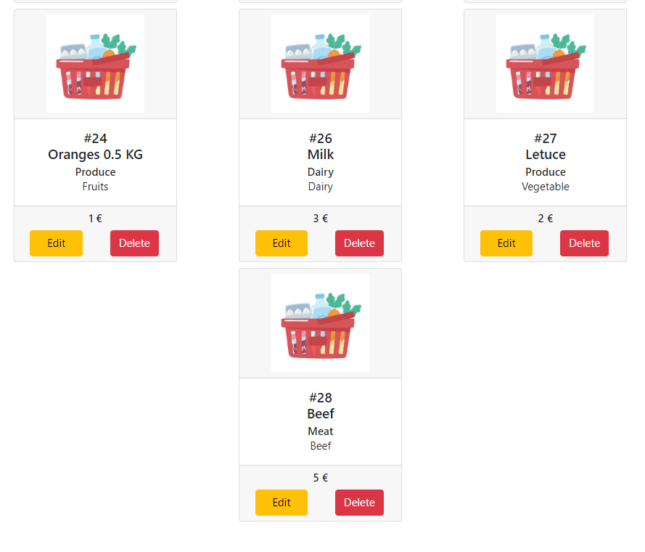

Selecting User Management option:
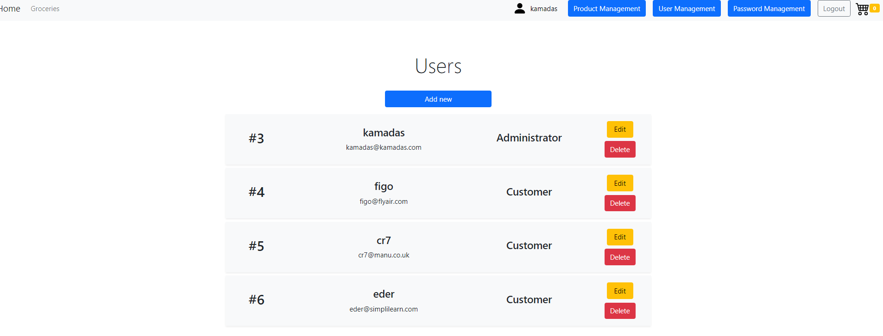
Deleting users - Deleting eder:
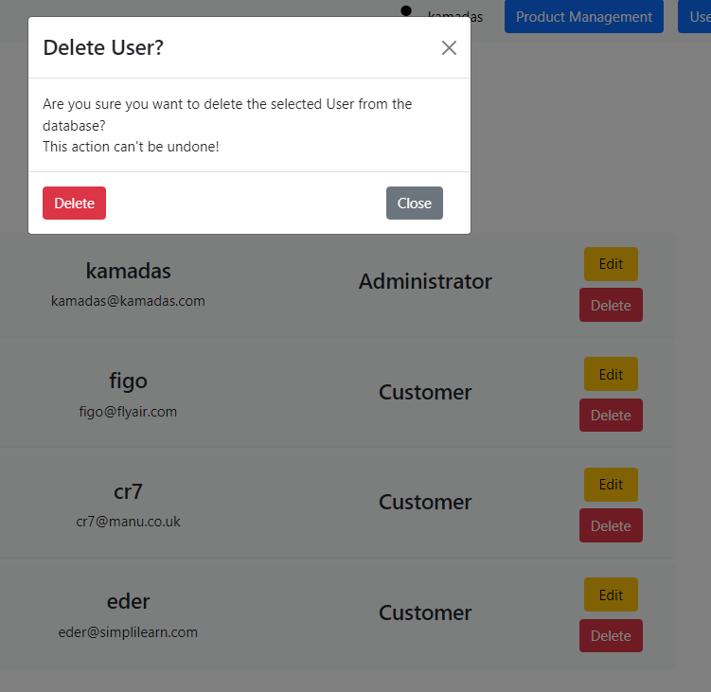->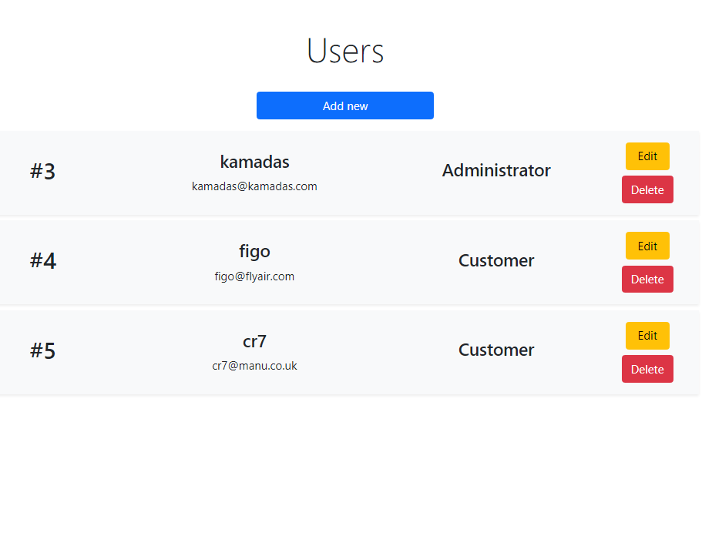

Adding users - Adding new user:
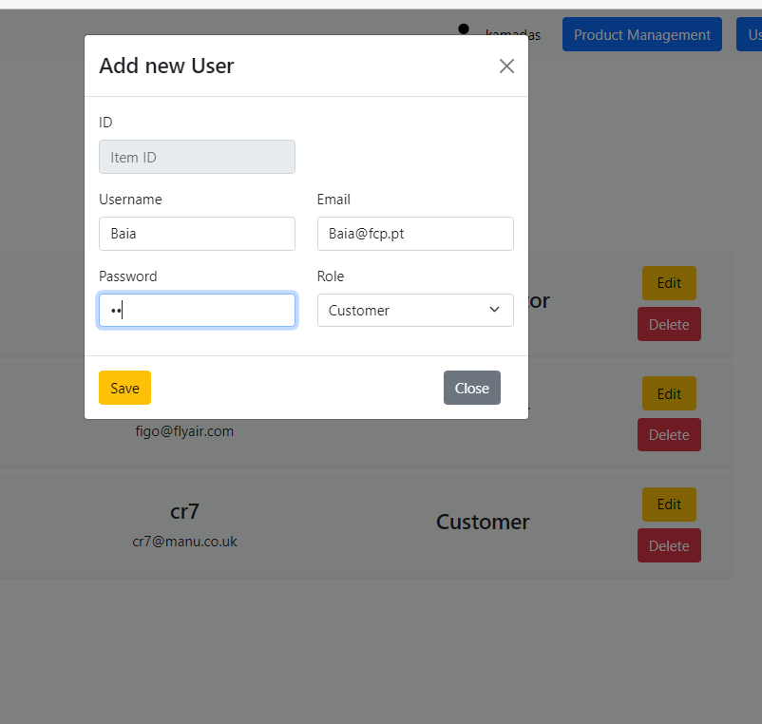->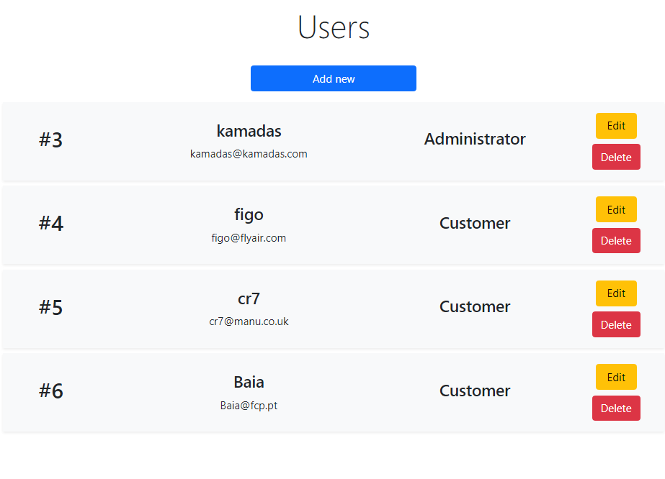

Editing users - Editing Baia (ID6) Role:
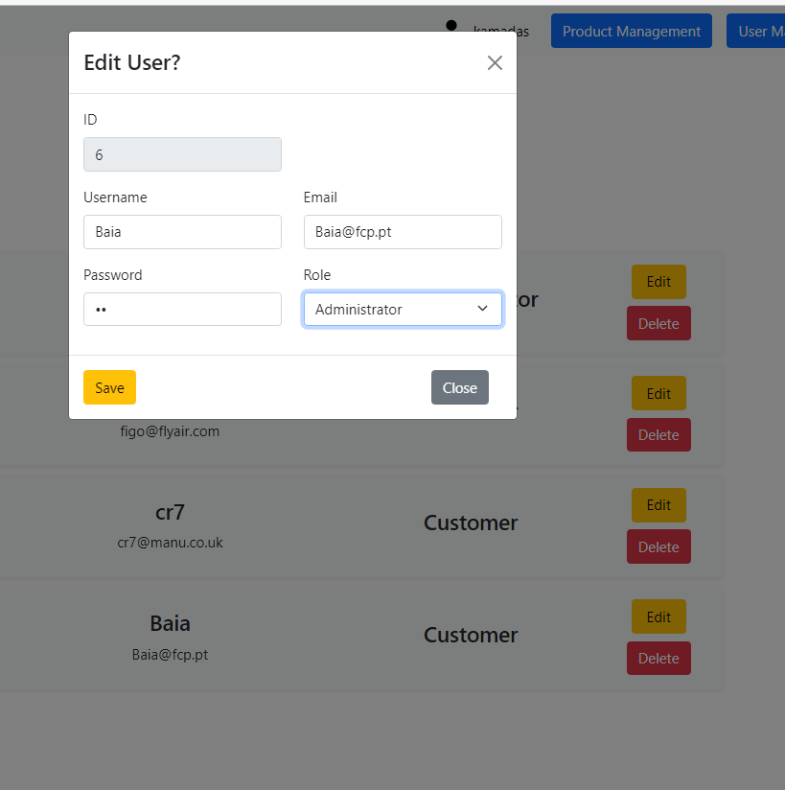->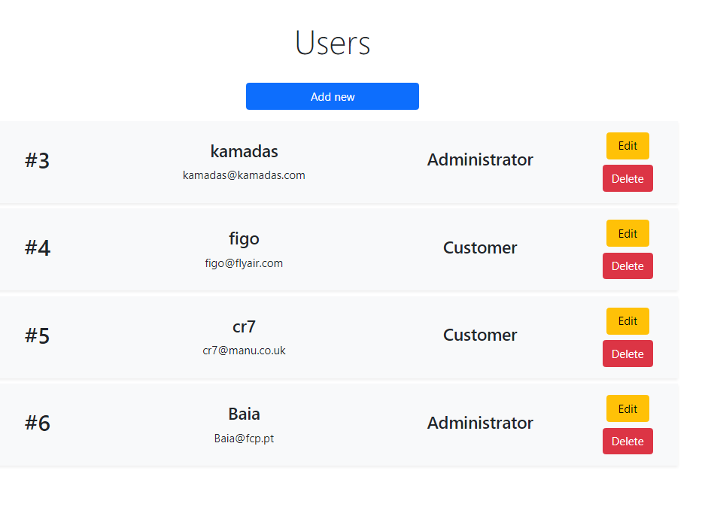

Selecting Password Management :
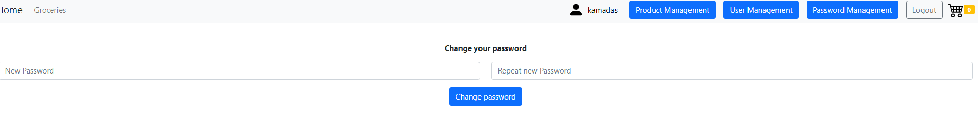
Providing 2 different passwords: warning appears , password is not updated
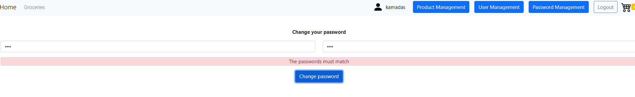
Providing the same password in both fields: Password is updated
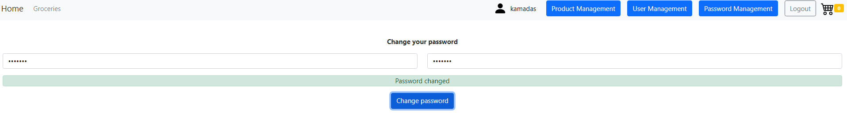

Loging out:
