EduSphere
ONE PLATFORM. EVERY ACADEMIC NEED.
MULTI-INSTITUTION EDUCATIONAL PORTAL
PROJECT REPORT
A unified platform for student learning, faculty teaching, and academic administration
NAME OF STUDENT: __________________________________________
REGISTRATION NO.: ___________________________________________
SECTION: ____________________________________________________
COURSE / SUBJECT: ___________________________________________
PROJECT TITLE: EduSphere — Multi-Institution Educational Portal
FACULTY SIGNATURE: _________________________________________
Prepared from the current EduSphere repository and setup documentation

AIM
To design and develop EduSphere, a multi-institution educational platform that brings academic learning resources, classroom activity, attendance, marks, scheduling, and campus communication together through dedicated Student, Faculty, and Admin portals.

SOFTWARE REQUIREMENTS
• Frontend: React 19, TypeScript, Vite, Tailwind CSS, React Router, Axios, Recharts
• Backend: Node.js 22, TypeScript, Express, Zod, JWT access and rotating refresh tokens
• Database and ORM: MongoDB 8 replica set with Prisma ORM (relationMode = prisma)
• File storage: S3-compatible object storage when configured; local server/uploads fallback for development
• Email: Nodemailer using SMTP-compatible providers; local log-only mode is supported
• Testing and quality tools: Vitest, Supertest, Node test runner, Oxlint, TypeScript compiler
• Development tools: npm, Git, Docker Compose; a browser and code editor

OBJECTIVE
The objective is to support everyday academic workflows while keeping each institution’s records isolated. Students can review authorized course content and academic progress; faculty can teach, record attendance, and manage marks; administrators can configure academic structure, users, schedules, reporting, and audit review.

PROJECT ABSTRACT
EduSphere is organized as a React client and an Express API backed by MongoDB through Prisma. The application models institutions, users, academic structures, learning materials, saved canvas lessons, attendance sessions and records, assessments and marks, notifications, schedules, calendar events, and community content. Authentication, role checks, tenant scope, resource assignment checks, input validation, and audit logging protect sensitive operations.

PROJECT STRUCTURE
Repository layout (selected folders)
Edusphere/
├── client/ React + Vite web application
│ └── src/
│ ├── api/ API client and token refresh handling
│ ├── components/ Shared UI and portal features
│ ├── context/ Authentication context
│ └── pages/ Landing, login, Student, Faculty, Admin
├── server/
│ ├── prisma/ MongoDB schema and seed helper
│ └── src/
│ ├── routes/ Express route registration
│ ├── controllers/ HTTP handlers
│ ├── middleware/ Auth, roles, tenant, validation
│ ├── services/ Domain logic and data access
│ └── utils/ Prisma client and shared utilities
├── docker-compose.yml
└── .github/workflows/ci.yml

HIGH-LEVEL ARCHITECTURE
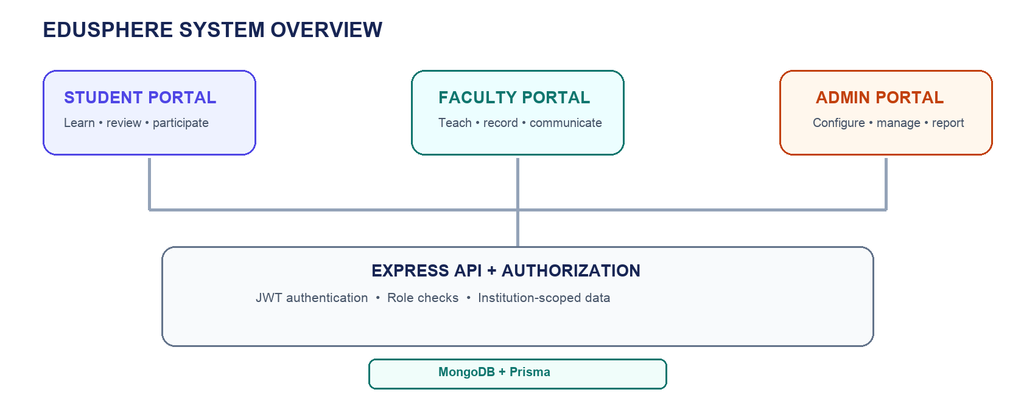
Figure 1. EduSphere portal-to-API-to-database overview. This is an original architecture diagram, not a screenshot.

CORE DATA AREAS
The Prisma schema defines Institution and User records alongside departments, programs, academic years, semesters, sections, subjects, enrollments, and faculty assignments. Learning and activity data include study materials and versions, classroom sessions and canvas pages, attendance sessions and per-student attendance records, assessments and student marks, notifications, doubts, community posts, announcements, timetable slots, periods, calendar events, and dated timetable overrides.

PORTALS AND FUNCTIONAL MODULES

1. Student portal
• Browse study materials and completed classroom lessons according to publication, section, subject, and download permissions.
• Review subject attendance and published marks; request corrections through the available workflow.
• Receive academic notifications and use institution-scoped community and anonymous doubts features where permitted.

2. Faculty portal
• Use assigned subjects and sections to upload learning materials and organize classroom canvas content.
• Write on the digital canvas and save classroom pages as lessons for student access after class completion.
• Record session-based attendance, manage assessments and marks, and communicate through supported announcements and community features.

3. Admin portal
• Configure institutions’ departments, programs, years, semesters, sections, subjects, periods, and timetable.
• Manage accounts, enrollment, faculty assignments, imports, and progression of sections.
• Review analytics, reports, audit activity, data retention settings, and institution operations.

TYPICAL ACADEMIC WORKFLOW
• An institution administrator creates its academic hierarchy and provisions users or imports supported student and faculty records.
• Faculty receive assignments for subjects and sections, then share learning resources and prepare canvas lessons.
• Faculty record attendance for a class session and enter marks for assessments; students see attendance summaries and marks according to publication state.
• The timetable and calendar surface classes and academic events; notifications and community tools support communication.

DATA DESIGN AND SECURITY

Institution-scoped data
Institution-owned models carry an institution identifier, and authenticated requests establish tenant scope from the signed-in user. Queries and resource access are expected to remain within that institution. The API uses authentication, role-based authorization, and resource-level assignment guards on protected academic operations.

Academic integrity
• Attendance is represented by individual records associated with a session and student; percentages are calculated from records rather than saved as a source of truth.
• Student marks are filtered by publication state. Changes to published marks use an authorized edit with a reason and create an audit record.
• Faculty actions on a subject or section require the applicable assignment; authorized administrative roles can use their configured override permissions.

Privacy and controlled access
• Students have read-only access to learning materials and saved canvas lessons, with server-side visibility and download checks.
• The API uses Zod for request validation, JWT access tokens with rotating refresh tokens, secure environment configuration, and rate limits on sensitive operations.
• The project includes user data export and account anonymization flows, guardian-consent records for minors, and institution-configurable retention settings.
• Community scopes and announcement targeting constrain which users can view content. Audit records are available for sensitive administrative actions.

Files and email
Materials and uploads use S3-compatible storage when configured. The development fallback is the server/uploads directory; deployments using ephemeral filesystems should configure durable object storage. Email jobs use a Nodemailer transport with retry and failure tracking; local development can log email content without sending.

IMPLEMENTATION AND LOCAL SETUP

Technology flow
React pages call the Express API through the shared client API layer. Express routes apply authentication, tenant scoping, roles, resource checks, and validation before controllers and services perform business operations through Prisma. MongoDB runs as a replica set because transaction workflows depend on replica-set support.
Local setup (from repository root)
cd client && npm ci
cd ../server && npm ci
cd .. && cp server/.env.example server/.env
cp client/.env.example client/.env
docker compose up -d mongo
cd server && npm run prisma:generate
npm run prisma:push && npm run seed
# Terminal 1: cd server && npm run dev
# Terminal 2: cd client && npm run dev
The local client is served by Vite at http://localhost:5173 and the API listens on port 5000 by default. Use a separate DATABASE_URL_TEST ending in _test for integration tests. MongoDB schema changes are synchronized with Prisma db push; Prisma Migrate is not used for MongoDB.

Key implementation example
The route configuration applies authentication and tenant scoping across attendance endpoints, then adds role and resource-level assignment checks to write operations. The example below is adapted directly from the current attendance route file.
server/src/routes/attendance.routes.ts (excerpt)
router.use(authenticate, scopeTenant);
router.put(
'/sessions/:sessionId',
authorize(RoleType.SUPER_ADMIN, RoleType.ADMIN, RoleType.HOD,
RoleType.CLASS_INCHARGE, RoleType.FACULTY),
requireResourceAssignment('attendance-session'),
AttendanceController.submitAttendance
);

ENVIRONMENT SAFETY
The server reads database connection details, JWT secrets, CORS origins, email settings, and optional S3 credentials from environment variables. Example files document variable names; populated .env files and secrets must remain private and outside version control.

TESTING AND VERIFICATION
The repository provides backend integration tests with Vitest and Supertest, backend unit tests using Node’s test runner, and a Vitest render test for the client landing page. Integration tests require a separate disposable MongoDB test database and check that its database name ends in _test.

Available checks
• Backend: npm run typecheck, npm run lint, npm run test:unit, npm test, npm run build
• Frontend: npm run typecheck, npm run lint, npm test, npm run build

Latest recorded check results
The latest full project checks recorded for this repository passed both backend and frontend type checks, backend and frontend builds, backend integration tests (35 tests across 2 files), backend unit tests (26 tests), and the frontend landing-page test (1 test). Both lint commands completed with existing warnings. The frontend build also emitted a bundle-size warning for some large portal chunks; it did not fail the build.
These results describe the latest recorded run and can change as the codebase changes. Re-run the commands above before submitting or deploying a new revision.

QUALITY AND LIMITATIONS
• MongoDB does not use Prisma Migrate. Review schema changes and back up data before applying prisma db push outside local development.
• For durable production materials, configure object storage; local server/uploads is a development fallback.
• SMTP delivery requires provider configuration. Log-only mode is intended for local development.
• No customer counts, testimonials, certifications, or production deployment claims are included in this report.

OUTPUTS
The following original illustration summarizes implemented portal areas. It is a module overview, not a capture of the running application.
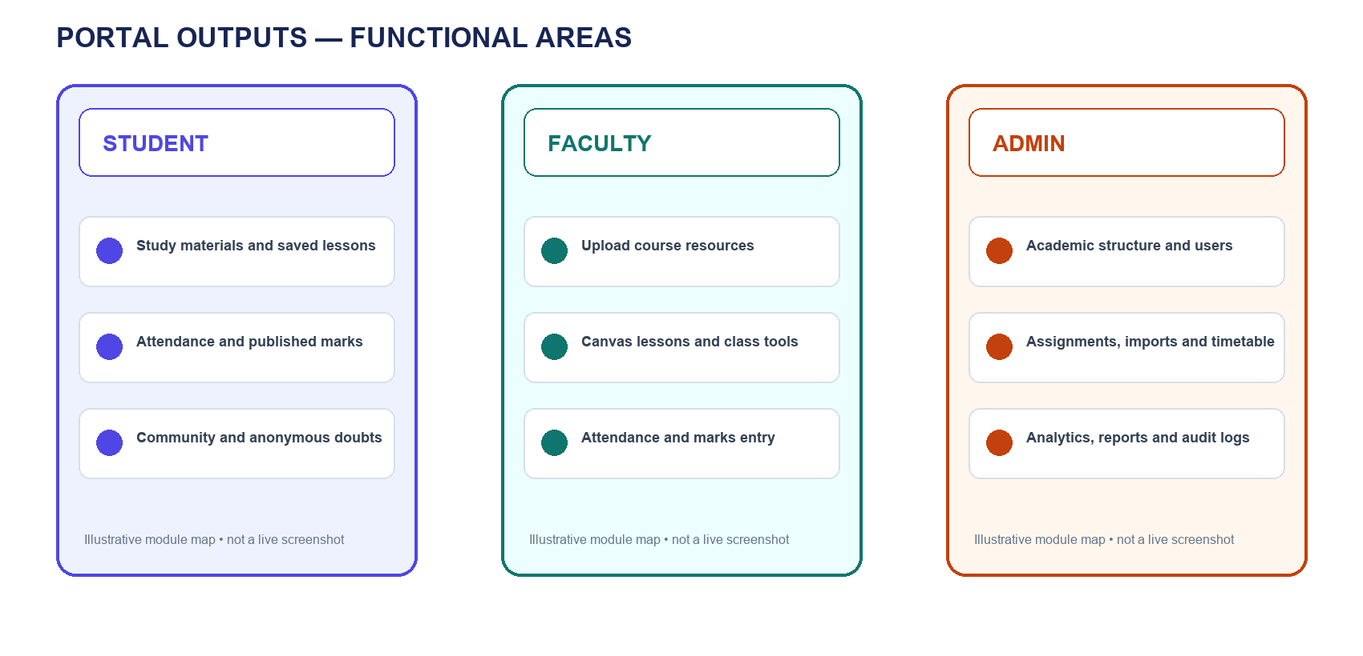
Figure 2. Student, Faculty, and Admin portal functional areas.

CONCLUSION
EduSphere brings student learning, faculty classroom tasks, academic administration, and institution communication into one multi-tenant web application. Its design combines role-specific portals with shared academic data, tenant-aware access controls, audit trails, and a MongoDB/Prisma backend.

FUTURE SCOPE
The product roadmap identifies an AI study assistant, online exams, live classes, and a mobile app as upcoming. These are roadmap items and are not described here as completed features.
Contact email: [Institution/project contact email to be supplied]

