|  |  |  |  |
| --- | --- | --- | --- |
| R:\General Documents\Image Library\Logos\GCLP_logo.jpg | Liverpool GCLP FacilityStandard Operating Procedure | | |
| CYTOF phenotyping of leukocytes from the PBRU acute pancreatitis biobank | | |
| **SOP Number:** | GCLP | **Issue Date:** |  |
| **Effective Date:** |  | **Review Date:** |  |

|  |  |  |
| --- | --- | --- |
| **Author: (all signatures must be in red ink)** | | |
| **Print Name:**  V. Elliot / A. Sud / J. Armstong / D. Latawiec | **Position:**  **Clinical Fellow/ Post-doctoral Research Associate/Laboratory Manager** | Signature: **Date:** |
| **Approved by: (all signatures must be in red ink)** | | |
| **Print Name:**  **Diane Latawiec** | **Position:** | **Signature:**  **Date:** |
| **Print Name:** | **Position:**  **Reader** | **Signature:**  **Date:** |
| **Reviewed by:** | | |
| **Print Name:** | **Position:** | **Signature:**  **Date:** |
| **Copyholder** | | |
| **Copyholder No:** | **Position: Document Controller** | |

|  |  |  |  |  |
| --- | --- | --- | --- | --- |
| **Revision History** | | | | |
| **Version Number** | **Effective Date** | **Revision Date** | **Reason for Change** | **Change Control No:** |
|  |  |  |  |  |
|  |  |  |  |  |
|  |  |  |  |  |
|  |  |  |  |  |

**Contents**

|  |  |
| --- | --- |
| **Section** | **Title** |
| **1.** | **who?** |
| **2.** | **background** |
| **3.** | **Purpose** |
| **4.** | **SCOPE** |
| **5.** | **Procedure** |
| **5.1** | **RESPONSIBILITY** |
| **5.2** | **ProTOCOL** |
|  | **5.2.1 – Procedures to be followed to minimise risk to staff when processing samples** |
|  | **5.2.2 – pHENOTYPING OF LEUKOCYTES FROM ap BIOBANK (PANELS 1 AND 2)**  **5.2.3 – pHENOTYPING OF LEUKOCYTES FROM AP BIOBANK (pANEL 3)** |
|  |  |
| **6.** | **ABBREVIATIONS** |
| **7.** | **other related procedures and documents** |
| **8.** | **appendix** |
| |  |  | | --- | --- | | **8.1** | **ProTOCOL** | | |  |  | | --- | --- | | **List of Kit Contents** |  | |

**1. WHO?**

This Standard Operating Procedure (SOP) applies to all staff involved in the project analysis and processing of ‘CyTOF of phenotyping of leukocytes from the PBRU acute pancreatitis biobank’ samples (GCLPTSS049/6).

**2. BACKGROUND**

Inflammation plays a key role in acute pancreatitis (AP), early and sustained activation of inflammatory signalling is responsible for the intense local and systemic inflammatory response seen in acute pancreatitis. We postulate that the response to pancreatitis and potentially the prognostic indicator of disease severity rests in the peripheral blood leukocytes. Potential therapeutics clinical trials aimed at ameliorating the over-exuberant inflammatory response in acute pancreatitis may well demonstrate quantifiable ‘normalisation’ of leukocyte phenotypes. To investigate further, leukocytes from mild and severe acute pancreatitis patients will be phenotypically analysed in blood with CyTOF analysis.

A bespoke simultaneous rare metal tagged antibody staining peripheral blood phenotyping kit analysing innate and adaptive (B and T-cell) immunity antigens and functional intracellular labels will be used. These metal antibody samples will enable single cell phenotyping utilising Helios (CyTOF) mass cytometer instrument.

Initial contact to patients will be made by a PBRU research fellow or nurse on the AP Biobank study delegation log who will explain in detail, to the patient, the purpose of the biobank, the process of recruitment and various issues surrounding it. Please refer to SOP GCLPTSS116/1 ‘Collection of Samples for the PBRU Acute Pancreatitis Biobank’.

**3. PURPOSE**

The purpose of this SOP is to describe the procedure for processing of samples in the PBRU laboratory room 3.302B UCD Building, Royal Liverpool University Hospital staining the samples with both cell surface and intracellular antigens and then analysing these samples on the CyTOF mass cytometer, located in the MARIAC (Magnetic Resonance and Image Analysis Research Centre) institute, Cell Sorting and Mass Cytometry facility and Laser Micro-dissection facility, Technology Directorate, University of Liverpool.

**4. SCOPE**

This SOP applies to specific staff involved in processing samples for the PBRU Acute Pancreatitis Biobank when processing the samples in the PBRU Research Laboratories and when storing the samples in the GCLP Facility.

**5. PROCEDURE**

**5.1 RESPONSIBILITY**

It is the responsibility of all staff to process samples for the Acute Pancreatitis Biobank to follow this SOP and enter all processing information into the Laboratory Information Management System (LIMS).

It is the responsibility of PBRU staff to complete the analysis of the processed sample tubes in a timely manner and to destroy all the material once the analysis has been completed and to record on the checklist sheets.

**5.2 PROTOCOL**

**5.2.1 Procedures to be followed to Minimise Risk to Staff when Processing Samples:**

Hazard: Biological contaminants in human blood

Chemical and biologically active reagents

Risk: Possible exposure to the above biological contaminants present in human blood/urine

**Procedures to minimise risk:**

* **ALL** sample processing should be performed in Class II cabinets, except where equipment is located outside the cabinets. The staff member processing the samples should wear Howie style laboratory coat and gloves at all times.
* All plastics should be soaked in 1% virkon (using buckets/waste pots) for at least 1 hour to remove biological contamination.
* Decontaminated plastics (from buckets) should be placed into yellow clinical waste bags for incineration.
* Biological waste from human blood/urine should be placed in yellow bio-bins and then autoclaved.
* Pipette tips and sharps (needles, etc) should be placed into yellow sharps bins for incineration. (**NO RESHEATHING of SHARPS**).
* Any spills must be cleaned thoroughly first with 1% virkon, then water to remove the virkon.

**5.2.2** Phenotyping of Leukocytes from AP Biobank

BUFFERS

Maxpar® Cell Staining Buffer (500 mL)

Maxpar® Fix and Perm Buffer (25 mL)

Maxpar® Water (500 mL)

#### Flow Cytometry Human Lyse Buffer (10X) (rnd systems)

Maxpar® Nuclear Antigen Staining Buffer Concentrate

Maxpar® Nuclear Antigen Staining Buffer Diluent

Maxpar® Nuclear Antigen Staining Perm 1X

Maxpar® Fix I Buffer (x5)

Maxpar® PBS

Fetal Calf Serum + 10% DMSO

Ficoll

RPMI-1640+10% FCS

REAGENTS

Cell-IDTM Intercalator-Ir (125 µM; 25 µL)

Calibration Beads, 151/153Eu

Cell-ID™ Cisplatin

ANTIBODIES

Maxpar® Antibodies - Maxpar® Human Regulatory T Cell Phenotyping Panel Kit

**5.2.3 Work Instructions: Thawed Crypreserved White Blood Cells or whole blood for Mass Cytometry.**

1. Preparation and storage of PBMC

Follow the GCLP SOP GCLPTSS049/4 Processing of Samples for the PBRU Acute Pancreatitis Biobank.

* 1. Take the 4ml or 6ml EDTA tube and dilute blood 2X with a phosphate buffered saline 15 ml falcon tube labelled ‘Falcon Q1’
  2. With a pasteur pipette layer diluted blood on the top of the Ficoll. Be careful to minimize any mixing of blood with the Ficoll.
  3. Centrifuge tube(s) at room temperature (i.e. 15-25°C) for 30 minutes at 600xg, with the deceleration (brake in the 1) position. Whilst the sample is undergoing centrifugation, enter the processing information into LIMS, to confirm these steps have been taken and that the 4-6ml EDTA tube has been deleted from the AP Biobank LIMS Flow.
  4. Using a clean pasteur pipette, carefully transfer the mononuclear / lymphocyte cell layer to a clean centrifuge tube labelled ‘Falcon Q2’. It is important to remove the entire interface but a very minimum amount of Ficoll. Taking too much Ficoll will result in granulocyte contamination.

Add 3x volumes of PBS cells in the centrifuge tube.

* 1. Mix the cells by drawing them in and out of a Pasteur pipette.
  2. Centrifuge at 600xg for 10 minutes at room temperature, deceleration (9).
  3. Re-suspend the cell pellet in 10 ml of PBS.
  4. Perform a cell count, as described in SOP GCLPTSS161 - Cell counting in the PBRU
  5. Pour off supernatant and pipette off excess supernatant and re-suspend with warmed cryopreservant (10% DMSO in FCS). Then quickly transfer to a Mr Frosty freezing container and place at -80oC. Transfer vials into a storage box (-150) within the next 2 weeks.

1. Retrieval of PBMC
   1. Remove the cryovial containing the frozen cells from liquid nitrogen storage and **immediately** place it into a 37°C water bath.
   2. Quickly thaw the cells (< 1 minute) by gently swirling the vial in the 37°C water bath until there is just a small bit of ice left in the vial.
   3. Transfer the vial it into a laminar flow hood.  Before opening, wipe the outside of the vial with 70% ethanol.
   4. Transfer the thawed cells into a Pasteur pipette and then add drop wise to a 50ml falcon tube of pre-warmed (37oC) 30ml complete medium (RPMI-1640+10% FCS)
   5. Centrifuge the cell suspension at 600 × g for 10 minutes.
   6. Gently re-suspend the cells in complete growth medium (10mls) and perform a cell count, as described in SOP GCLPTSS161 - Cell counting in the PBRU, assess the cell viability using this technique. Rest cells in media for at least 4 hours in the incubator at 37oC.

**2. Cell-ID Cisplatin Viability Stain.**

**2.1** Centrifuge at 600xg for 10 minutes and discard supernatant by aspiration.

**2.2** Re-suspend cells in to 1ml of PBS (max 1x107cells/mL) and add Cell-ID™ Cisplatin to a final concentration of 5μM (1000X dilution of 5mM stock solution, ie. 1μL Cell-ID Cisplatin added to 1 mL of cell suspension).

**2.3** Mix well and incubate at room temperature for 5 minutes.

**2.4** Quench staining with MaxPar® Cell Staining Buffer using 5X the volume of the cell suspension (ie. add 5mL to 1mL of cell suspension), centrifuge and discard supernatant by aspiration.

**4. Cell Surface Staining**

**4.1** For resuspend cells in Maxpar Cell Staining Buffer, work with multiples of aliquots between 1 to 3 million cells, in a volume of 50μL, into 5 mL tubes for each sample to be stained.

**4.2** Add 50 μL of the surface antibody cocktail (see Table attached) to each tube so the total staining volume is the equivalent of 100 μL per sample. (50μl of cell suspension + 50μl antibody cocktail **per sample**).

**4.3** Gently vortex sample and incubate for 30 minutes at room temperature.

**4.4** Wash by adding 2mL Maxpar Cell Staining Buffer to each tube, centrifuge 600g and discard supernatant by aspiration.

**4.5** Vortex sample to thoroughly disrupt the pellet. **Note:** It is essential to thoroughly disrupt the pellet by vortexing before adding Nuclear Antigen Staining Buffer working solution at this step.

**Prepare Maxpar® Nuclear Antigen Staining Buffer working solution:**

Dilute the 4X Nuclear Antigen Staining Buffer Concentrate (1 part) with Nuclear Antigen Staining Buffer Diluent (3 parts). You will need 1 mL of the working solution for each sample.

**4.6** Add 1 ml of the Nuclear Antigen Staining Buffer working solution to each sample followed by a gentle vortex.

**4.9** Incubate at room temperature for 30 minutes.

**4.10** Wash cells with 2 ml (per number of samples) of Nuclear Antigen Staining Perm, centrifuge (800g) and discard supernatant.

**4.11** Repeat step 4.10 for a total of 2 washes.

**4.12** Resuspend pellet in residual volume with gentle vortexing.

**5. Intracellular Staining**

**5.1** Add intracellular antibody cocktail (50μL per no. of samples as per table) directly to residual volume and stain for 30-45 minutes at RT.

**5.2** Wash 2X with 2 mL (per number of samples) Maxpar Cell Staining Buffer.

**5.3** Vortex sample to disrupt cell pellet.

**6. Maxpar® Intercalation Solution:**

Prepare 1 mL of cell intercalation solution for each sample by adding Cell-ID Intercalator-Ir into Maxpar Fix and Perm Buffer to a final concentration of 125nM (a 1000X dilution of the 125μM stock solutions) and mix by vortexing.

**6.1** Add 1 ml of the intercalation solution to each tube and gently vortex.

**6.2** Incubate for 1 hour at room temperature or leave overnight at 4°C.

**6.3** Wash cells by adding 2ml of Maxpar Cell Staining Buffer centrifuge and discard supernatant by aspiration.

**6.4** Wash cells with 2ml of Maxpar Water, centrifuge and discard supernatant by aspiration.

**6.5** Repeat for a total of 2 washes with Maxpar Water.

**6.6** Leave cells pelleted until ready to run on mass cytometer.

**7. EQ Four Element Calibration beads**Immediately prior to data acquisition, adjust cell concentration to 2.5-5 x 105/ml with Maxpar Water and EQ beads as follows.

**7.1 Directions for Use - Shake beads vigorously** to re-suspend – or use a sonicator bath

**7.3** Prepare sufficient volume of 0.1X beads to re-suspend all samples in the experiment by diluting 1 part beads to 9 parts deionized water (18MΩ, ultrapure).

**7.4** Re-suspend the cell pellet in 0.1X bead solution (~33,000 EQ beads per mL).

**7.5** Filter the cell-bead suspension through a 35 to 45 μm mesh (FACS tube cap) immediately prior to injection into the instrument.   
  
**8. Acquire data on mass cytometer (Helios)**

**8.1.** Collect the following channels in addition to the channels corresponding to the antibody panel: • Barcodes (102, 104, 105, 106, 108, and 110) [If used]

• EQ beads (140, 151, 153, 165, and 175)

• Cell-ID (dead cells) (195 for cisplatin; 103 for rhodium) Barcoding Protocol 8 User Guide

• Cell-ID Intercalator-Ir (191) and Ir (193)

Need a minimum of 100-200 events for the cell rarest subset population

**8.2.** Collect at least 300 events of the rarest population in the multiplexed sample. NOTE If performing barcoding on the CyTOF instrument the mass range must be adjusted to 102-192.

**Regulatory T-cell antibody metal conjugate grid**

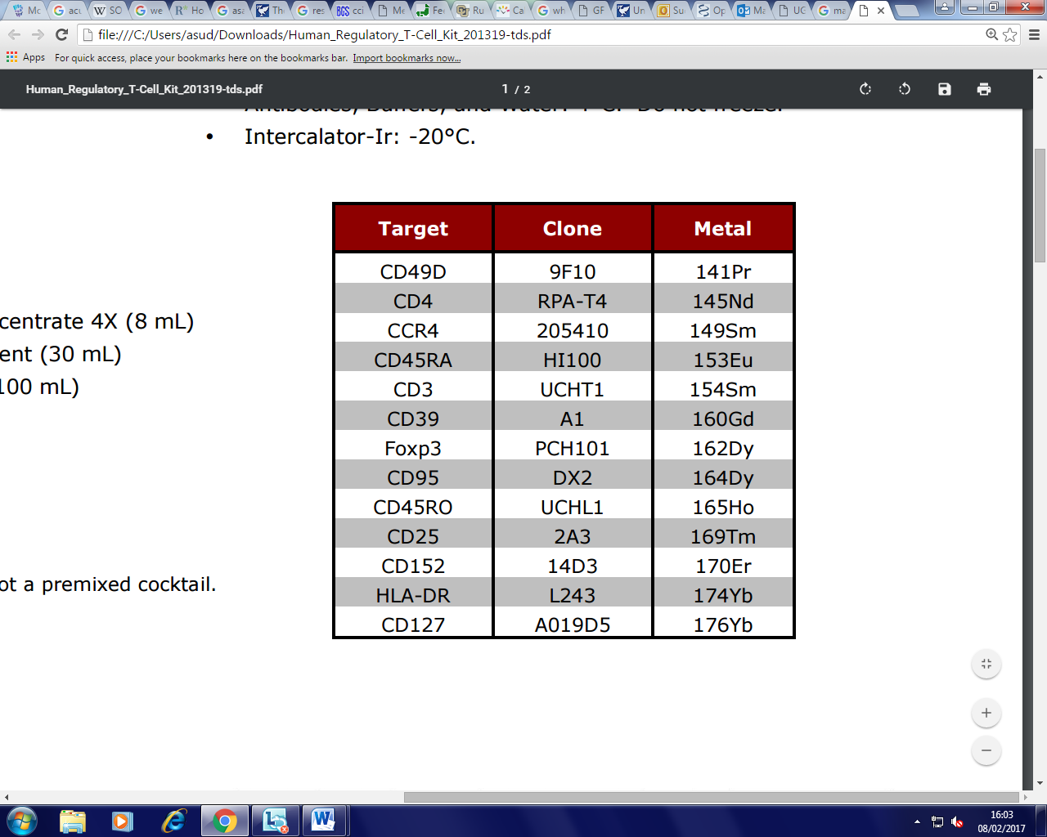

**Antibody Cocktail Preparation Guide:**

The following guide can be used to prepare the Maxpar Metal Conjugated Antibody cocktail in Maxpar Cell Staining Buffer. Prepare the antibody cocktail in a 1.5 ml tube by first adding Cell Staining Buffer and then adding each of the antibodies. Combine 50 μl of the complete antibody cocktail with each sample to be stained.

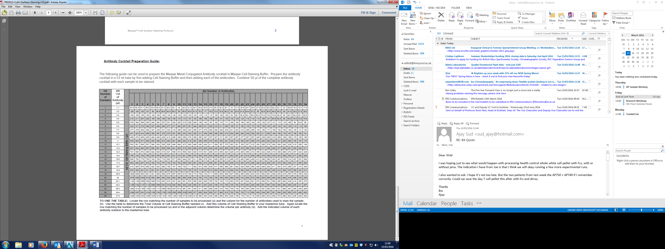

TO USE THE TABLE: Locate the row matching the number of samples to be processed (a) and the column for the number of antibodies used to stain the sample (b). Use the table to determine the Total Volume of Cell Staining Buffer needed (c). Add this volume of Cell Staining Buffer to your mastermix tube. Again locate the row matching the number of samples to be processed (a) and in the adjacent column determine the volume per antibody (d). Add the indicated volume of each antibody solution to the mastermix tube.

**6. ABBREVIATIONS**

**EDTA** Ethylenediaminetetraacetic acid

**GCLP** Good Clinical Laboratory Practice

**PBRU** Liverpool NIHR Pancreas Biomedical Research Unit

**7. OTHER RELATED PROCEDURES AND DOCUMENTS**

|  |  |
| --- | --- |
| **SOPs:** |  |
|  |  |
|  |  |
|  |  |
| GCLPTSS116/1 | Collection of Samples for the Acute Pancreatitis Biobank in the PBRU |
| GCLPEQU005 | Testing and Calibration of Pipettes |
| GCLPTSS116  GCLPTSS158  GCLPTSS049  GCLPTSS161  GCLPEQU037  GCLPEQU038  GCLPEQU040  GCLPRPS024  GCLPPPD011  GCLPTSS088 | Collection of samples for the PBRU Acute Pancreatitis Biobank  Processing of samples for Leukocyte phenotyping from PBRU Acute Pancreatitis Biobank  Processing of samples for the PBRU Acute Pancreatitis Biobank  Cell counting in the PBRU  The Use of Pipettes  Use of centrifuges in the PBRU  Use of PBRU Biological Safety Cabinets  Disposal of Hazardous waste in the PBRU  Computerised System validation and LIMS change Control  Reporting of laboratory adverse events on the matrix LIMS |
|  |  |

**8. APPENDIX**

8.1 List of Contents of Kit A and Kit B

Kits for the sample collection for PBRU Acute Pancreatitis Biobank are kept in the PBRU laboratory room 3.302A situated on the 3rd floor, UCD building, RLUH.

* Kit A (24hrs) contains:
* Collection Set
  + BD Vacutainer® Safety-LokTM Blood Collection Set
  + PAXgene Blood RNA tube (BRT) 2.5ml
  + BD Vacutainer® K2 EDTA Tube (purple top) 10ml
  + BD Vacutainer® K2 EDTA Tube (purple top) 4ml
  + BD Vacutainer® SSTTM Tube (golden top) 3.5 ml
  + BD Vacutainer® K2 EDTA Tube (purple top) 4ml
  + Consent Form
  + Patient Information Sheet
  + Sample Collection Worksheet
* Processing Set (Part 1, including AP-biobank)
  + Falcon Tube 15 ml, blood x2; B1, B2, C1, C2, H1, H2
  + Falcon Tube 15 ml, plasma
  + Bijou Tube 7 ml x1
  + Microcentrifuge Eppendorf tubes (erythrocyte; E) 2 ml x 5
  + Microcentrifuge Eppendorf tubes (pellet; P) 2 ml x 5
  + 2 ml cryovials x 8 (Red Top)
  + 2 ml cryovials x 2 (White Top)
  + 2 ml cryovials x 5 (Green Top)
  + 2ml cryovial x 1 (yellow Top)
* Kit B (24hrs) contains:
* Collection Set
  + BD Vacutainer® Safety-LokTM Blood Collection Set
  + PAXgene Blood RNA tube (BRT) 2.5ml
  + BD Vacutainer® K2 EDTA Tube (purple top) 10ml
  + BD Vacutainer® K2 EDTA Tube (purple top) 4ml
  + BD Vacutainer® SSTTM Tube (golden top) 3.5 ml
  + BD Vacutainer® Sodium Citrate Tube (blue top) 4.5 ml
  + Sample Collection Worksheet
* Processing Set (Part 1)
  + Falcon Tube 15 ml, blood x2; B1, B2, C1, C2, H1, H2
  + Falcon Tube 15 ml, plasma
  + Bijou Tube 7 ml x1
  + Microcentrifuge Eppendorf tubes (erythrocyte; E) 2 ml x 5
  + Microcentrifuge Eppendorf tubes (pellet; P) 2 ml x 5
  + 2 ml cryovials x 8 (Red Top)
  + 2 ml cryovials x 2 (White Top)
  + 2ml cryovial x 1 (yellow Top)