Alexander Baldree
Module 6 Assignment 6.2
11-20-25
CSD-310

SQL Script ran:
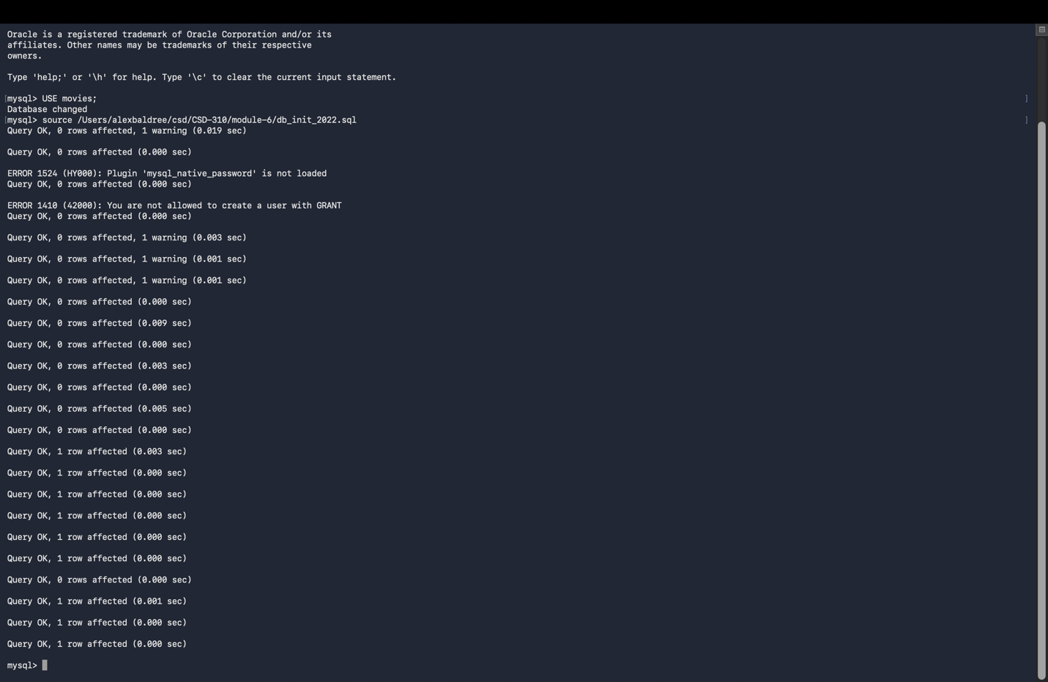

Shown Tables:
