Alexander Baldree
CSD310
11/5/25
Module 3
Assignment 3.2

Assumptions:
1. A publisher can publish many books, but each book is associated with only one publisher.
2. Authors can write multiple books, and books can have multiple authors (many-to-many relationship).
3. A junction table is required to represent the many-to-many relationship between books and authors.
1NF
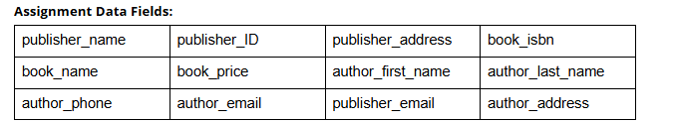
3NF
