Alexander Baldree
Module 5
Assignment 5.2
CSD310
11/13/25

Function 1: Current_Time()
SELECT Current_Time() AS CurrentTime;
CURRENT_TIME() returns the current system time in HH:MM:SS format.
It is useful for logging event times, creating audit trails, or verifying server time during testing.

Alias for column header:
CurrentTime
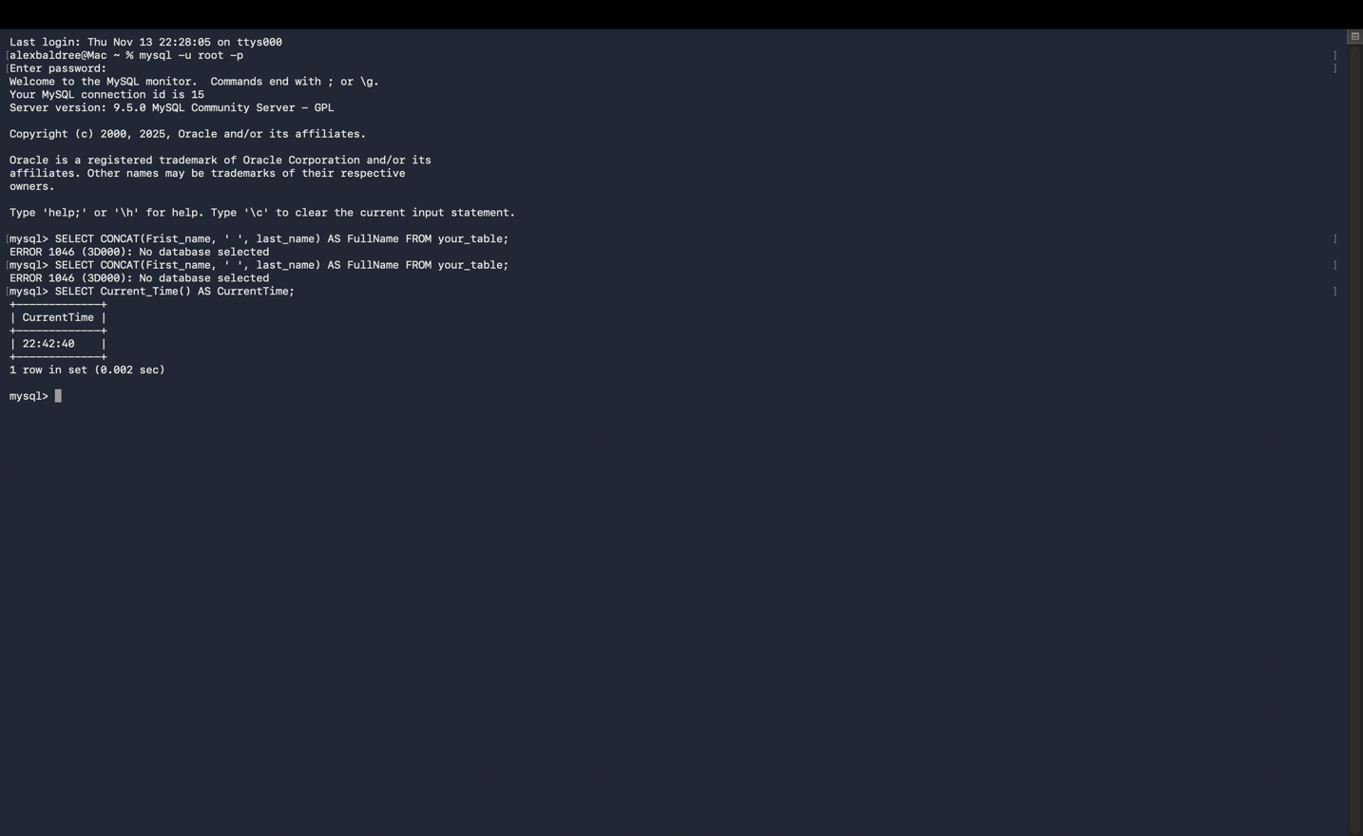
Function 2: UPPER()
SELECT UPPER(‘alex baldree’) AS UpperName;
UPPER() converts text to uppercase.
This is useful when you want to normalize user input, compare strings without worrying about case, or format output consistently.

Alias for column header:
UpperName

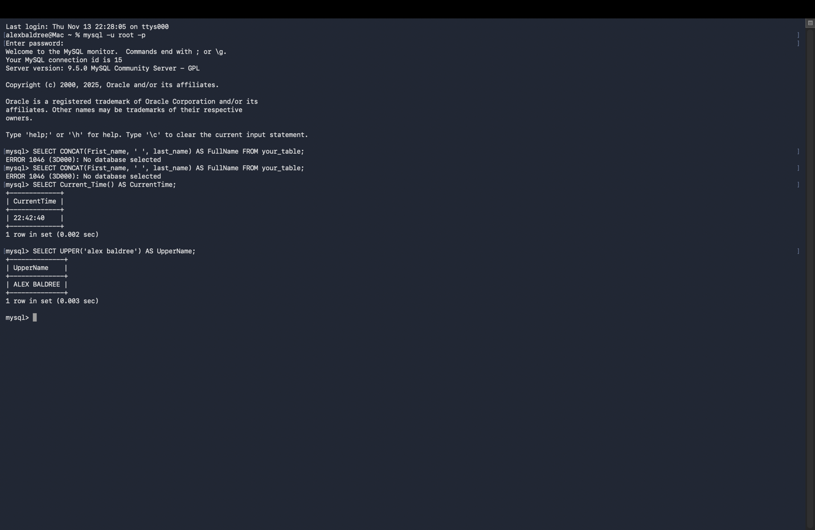

Function 3: LENGTH()
SELECT LENGTH(‘Database Systems’) AS NameLength;
LENGTH() returns the number of bytes in a string.
It helps validate data sizes, check input length, and ensure values fit within column limits.

Alias for column header:
NameLength

