Alexander Baldree
Week 4
Module 4
CSD-310
11/13/2025

Connected to MySQL Server:
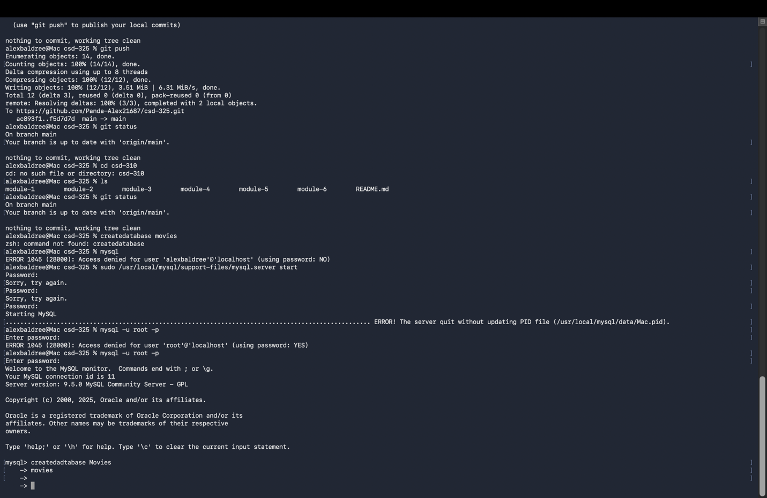

Created Database MOVIES:
