Alexander Baldree
Module 8 Assignment 8.2
11-26-25
CSD-310

GitHub Link:
https://github.com/Panda-Alex21687/CSD-310/tree/main/module-8

--Display Films—
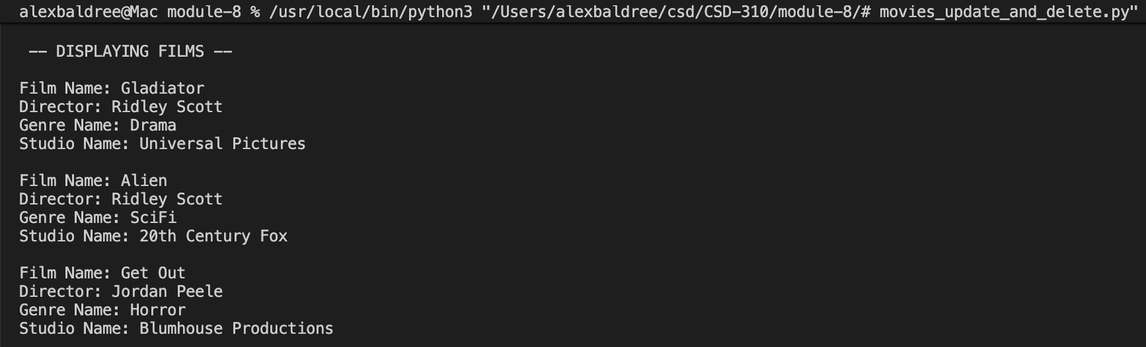
--Display Films After Insert—
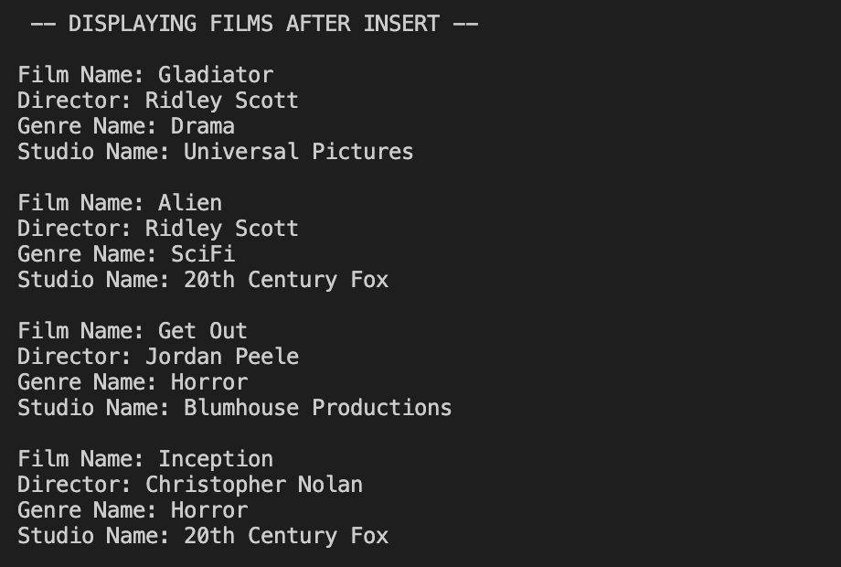
--Display Films After Update-- Changed Alien to Horror—
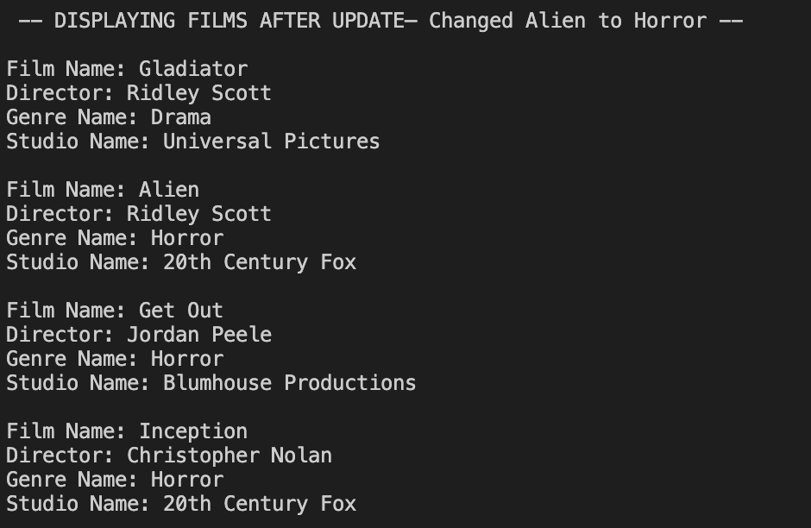
--Display Films After Delete—
