Alexander Baldree
1-13-26
Module 1.3 Assignment
CSD340

GitHub Link:
https://github.com/Panda-Alex21687/CSD340

W3C Validator with errors:
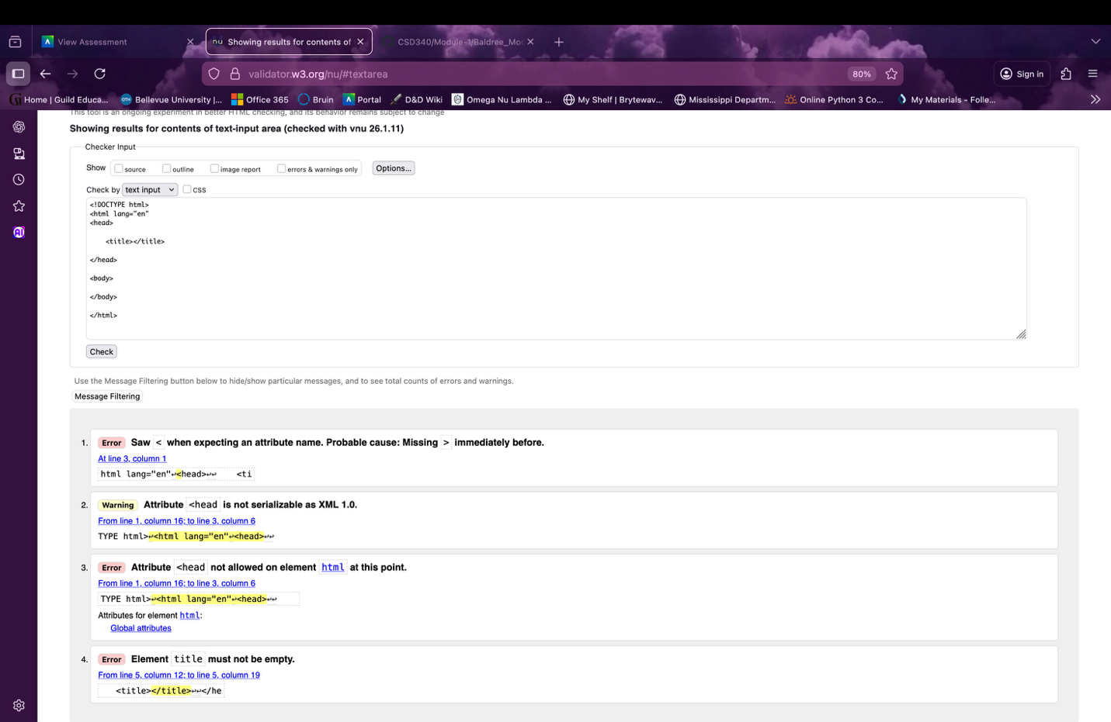

W3C Validator Fixed Errors:
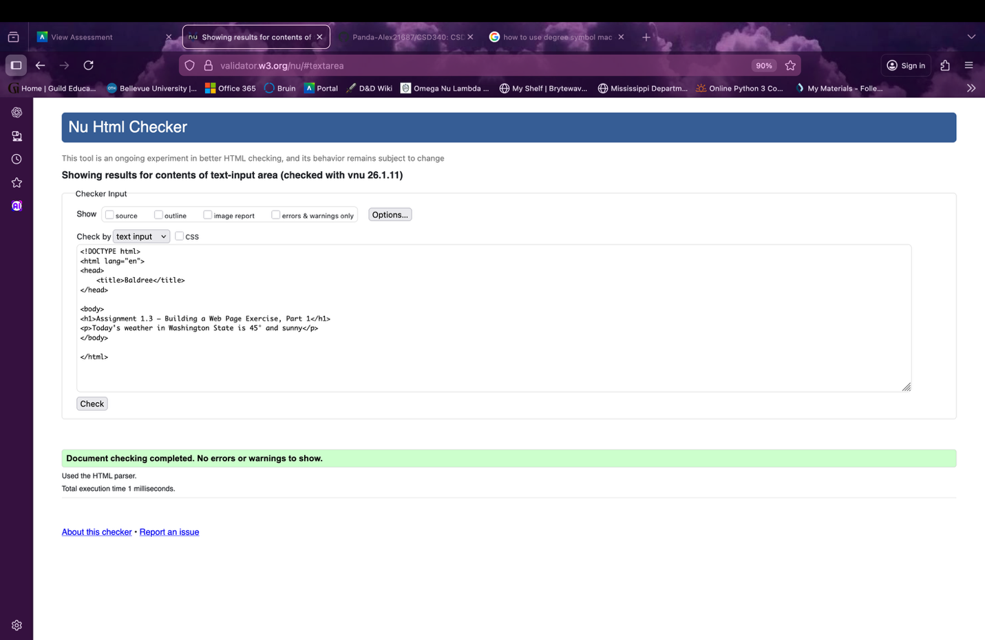

Output of Fixed Code:
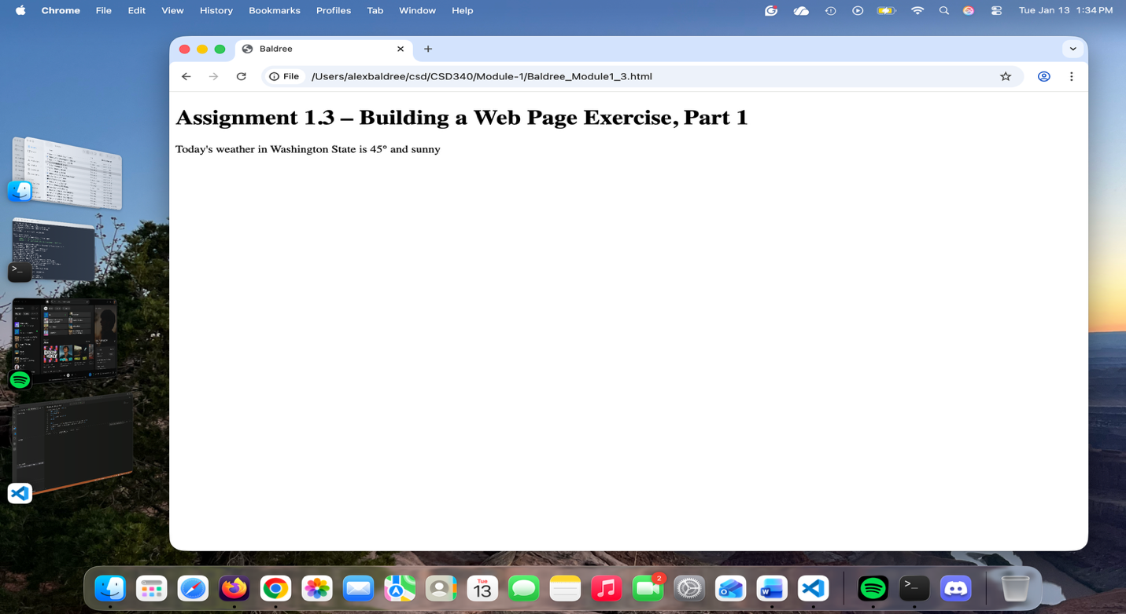
Visual Studios Code:
