Alexander Baldree
1-13-26
Module 1.2 Assignment
CSD340

GitHub Link:
https://github.com/Panda-Alex21687/CSD340

Screenshot Directory:
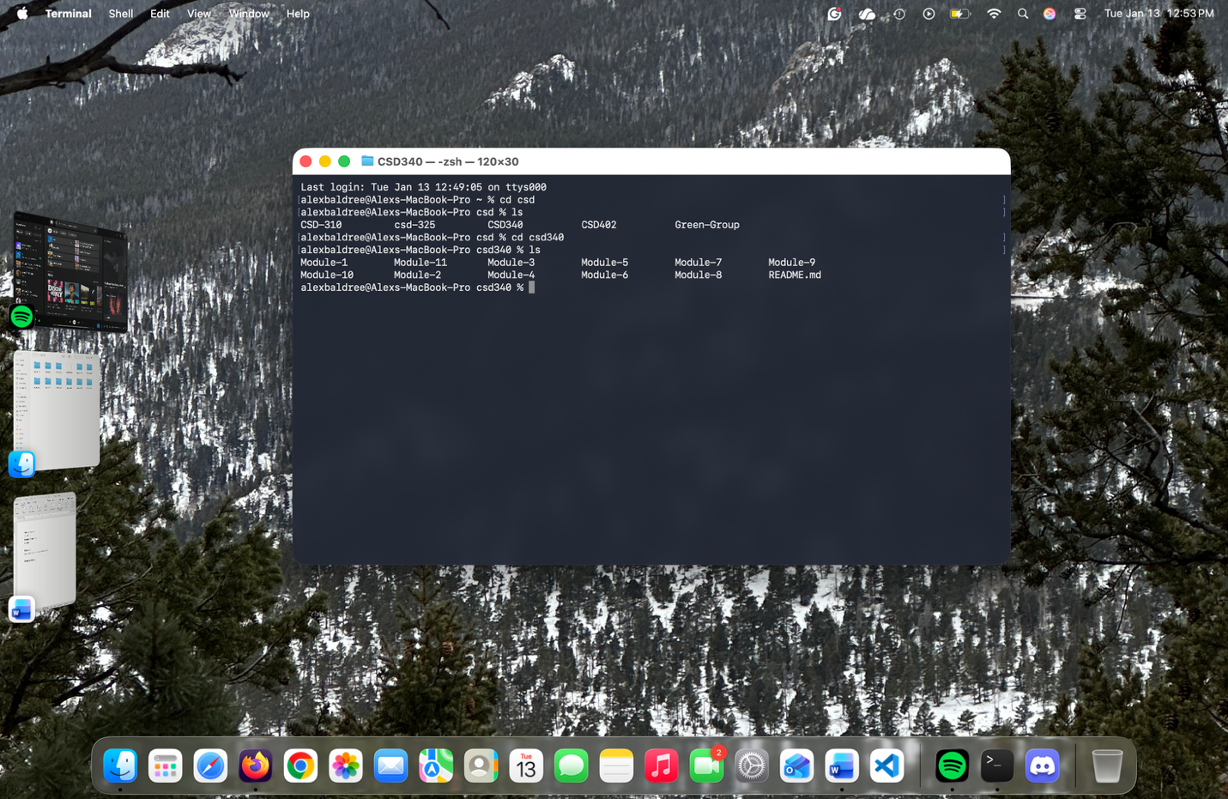

GitHub Repository:

