Alexander Baldree
1-13-26
CSD402
Assignment 1_2

GitHub Link:
https://github.com/Panda-Alex21687/CSD402

Local Terminal GitHub Clone of repository
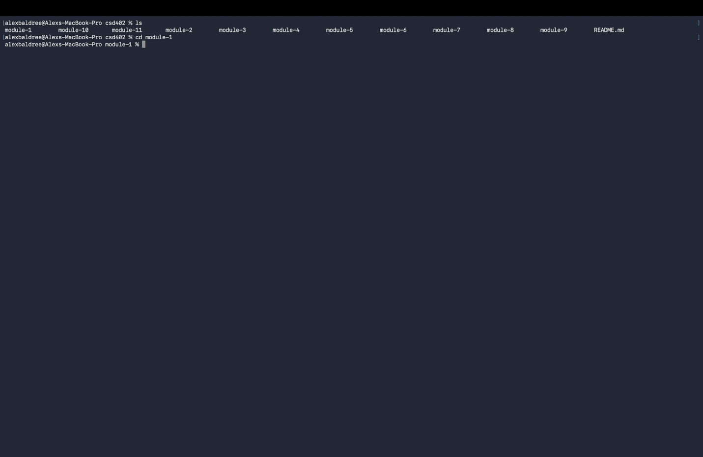

Local Directory on my Machine:
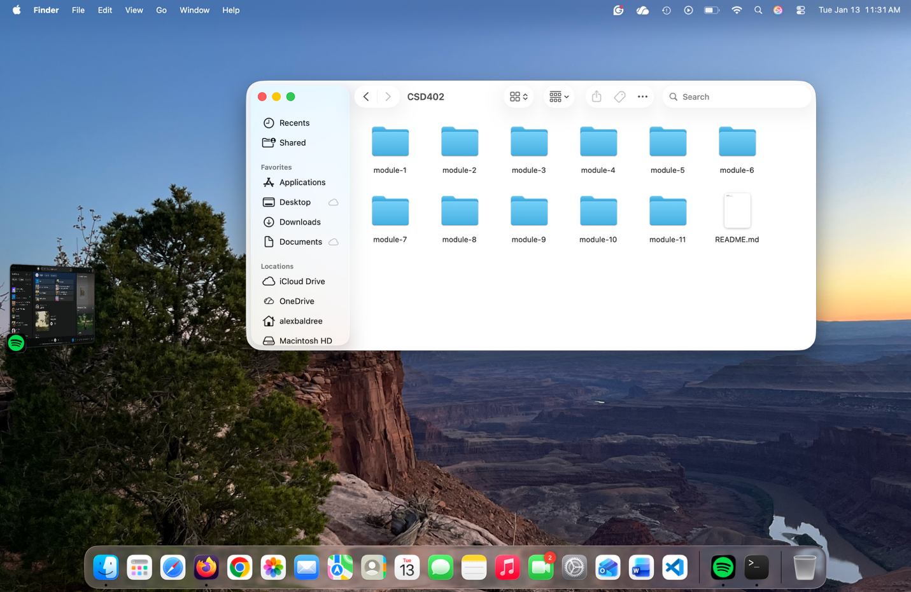

GitHub Repository with Module 1 Added Assignment 1_2
