Project: Moffat Bay Marina | Alexander- Team Leader
Course: CSD 460 | Max- Developer 1
Description: Functional test plan for the Landing Page, Login Page, and User Registration Page, with two functional tests per page. | Aftab- Developer 2
Date: 2026/09/01 | Jordan- Developer 3
To complete the test case plan, fill out the information for Project, Course, Description and Date in the header below.

TABLE OF CONTENTS
Landing Page - Public Access and Page Load 2
Landing Page - Navigation Links 3
Login Page - Valid User Login 4
Login Page - Invalid Login Rejection 5
User Registration - Successful Registration 6
User Registration - Duplicate Email Rejection 7

For each test, the developer should: provide a test description, a test objective, the developer name and date tested. For each step, fill out the actions to be taken and describe the expected results, and indicate yes or no for each step depending upon the result. The peer tester should provide their name, date tested, indicate yes or no for each step depending upon the result, and a screenshot (thumbnail) of the result.

Test 1 | Landing Page - Public Access and Page Load
 | Test Objective: Verify that the landing page loads successfully and is accessible without logging in. | Developer:  Green Team  Date tested: 2026/09/03 | Peer tester:  Jordan Dardar  Date tested: 2026/09/03
Step | Action | Expected results: | Developer pass/fail | Tester pass/fail  + Screenshot
1 | Start Tomcat and open the Moffat Bay Marina application URL in a web browser. | The server responds and the Moffat Bay Marina landing page opens without an error. | Yes | Yes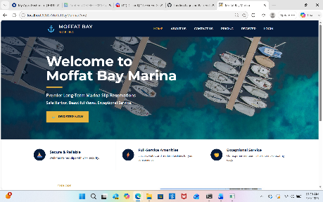
2 | Verify that no login or registration is required to view the landing page. | The visitor can view the public landing page without authentication. | Yes | Yes
3 | Review the marina name, introductory content, main navigation, and calls-to-action. | The expected landing-page content is visible and readable. | Yes | Yes
4 | Verify that page styling, images, navigation, and footer load correctly. | The page displays with its intended CSS and no broken images or missing layout elements. | Yes | Yes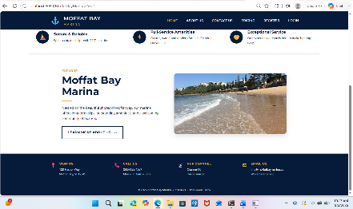
5 | Refresh the browser page. | The landing page reloads successfully and remains publicly accessible. | Yes | Yes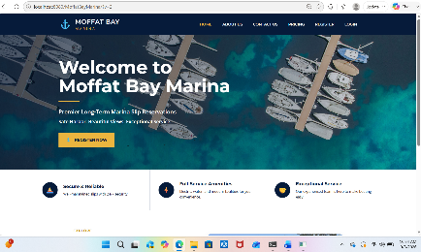
Comments | The Moffat Bay Marina landing page loaded successfully through Tomcat and remained accessible without requiring authentication. All expected content, navigation, styling, images, and footer elements displayed correctly after correcting the image resource paths. The page also reloaded successfully and remained fully functional after refresh.

Test 2 | Landing Page - Navigation Links
 | Test Objective: Verify that the primary landing-page navigation links take the visitor to the correct pages. | Developer:  Green Team  Date tested: <yyyy/mm/dd> | Peer tester:  Jordan Dardar  Date tested: 2026/09/03
Step | Action | Expected results: | Developer pass/fail | Tester pass/fail  + Screenshot
1 | Open the Moffat Bay Marina landing page. | The landing page loads and the navigation menu is visible. | Yes | Yes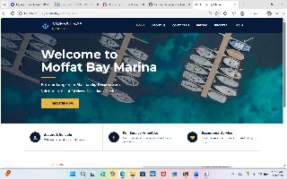
2 | Select the About Us navigation link. | The About Us page opens successfully. | Yes | Yes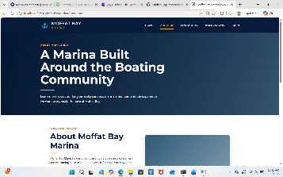
3 | Return to the landing page and select the Contact Us link. | The Contact Us page opens successfully. | Yes | Yes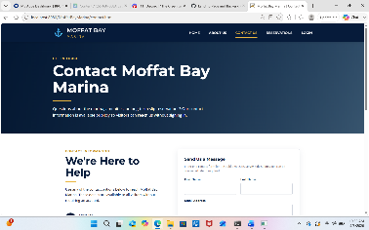
4 | Return to the landing page and select the Pricing or slip-information link. | The intended pricing or slip-information page opens successfully. | Yes | Yes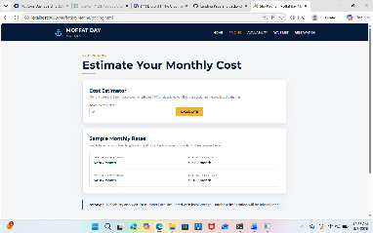
5 | Return to the landing page and select the Login or Register link. | The selected account page opens and no broken link or 404 error appears. | Yes | Yes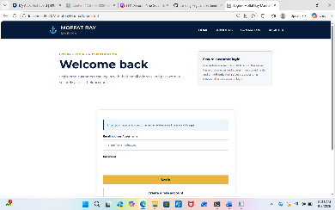
Comments | The landing page navigation links functioned as expected during testing. The About Us, Contact Us, Pricing, and Login pages all opened successfully from the landing page without broken links or 404 errors. The navigation provided clear and reliable access to the expected areas of the Moffat Bay Marina application.

Test 3 | Login Page - Valid User Login
 | Test Objective: Verify that a registered, verified customer can log in using valid credentials. | Developer:  Green Team  Date tested: 09/04/2026 | Peer tester:  Aftabur Rahman  Date tested: 09/04/2026
Step | Action | Expected results: | Developer pass/fail | Tester pass/fail  + Screenshot
1 | Open the Login page. | The Login page displays email and password fields and a login control. | yes | Yes 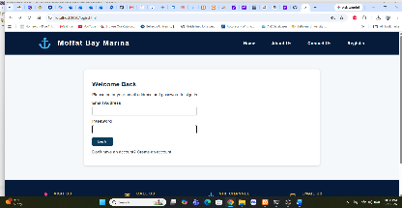
2 | Enter the email address for a known verified test customer. | The email value is accepted by the form. | yes | yes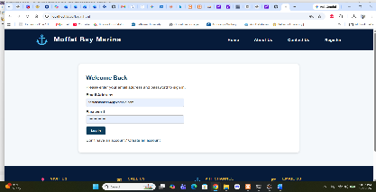
3 | Enter the correct password for that customer. | The password is accepted and remains masked in the browser. | yes | yes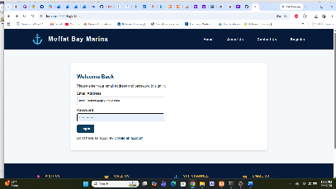
4 | Select the Log In button. | The credentials are submitted to the backend LoginServlet and are accepted. | yes | yes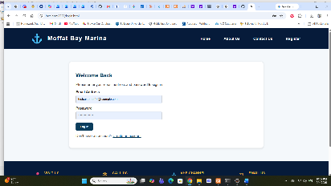
5 | Verify the page displayed after login. | The customer is redirected to the authenticated post-login page and an active session is created. | yes | yes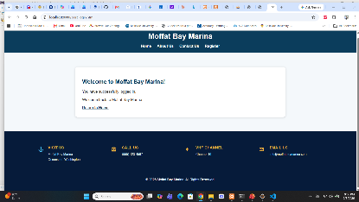
Comments | The valid login test was successful. The registered customer entered valid credentials and was authenticated by the Java/Spring Boot backend. The application redirected the user to the post-login page, confirming that the login process and authenticated navigation worked as expected.

Test 4 | Login Page - Invalid Login Rejection
 | Test Objective: Verify that an incorrect password is rejected and does not create an authenticated session. | Developer:  Green Team  Date tested: 09/04/2026 | Peer tester:  Aftabur Rahman  Date tested: 09/04/2026
Step | Action | Expected results: | Developer pass/fail | Tester pass/fail  + Screenshot
1 | Open the Login page. | The login form loads and is ready for input. | yes | yes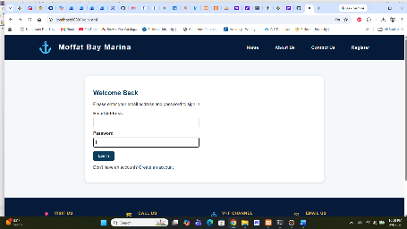
2 | Enter a valid registered email address. | The email field accepts the registered email address. | yes | yes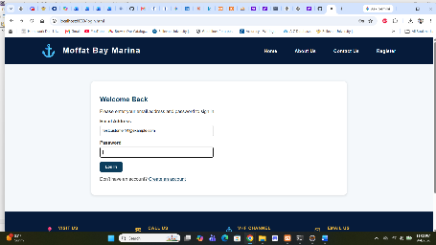
3 | Enter an intentionally incorrect password. | The password field accepts the value while keeping it masked. | yes | yes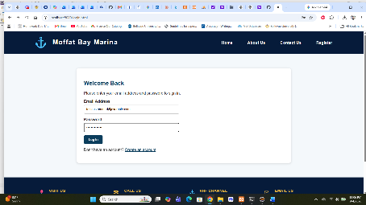
4 | Select the Log In button. | The backend rejects the credentials and returns an invalid email/password message. | yes | yes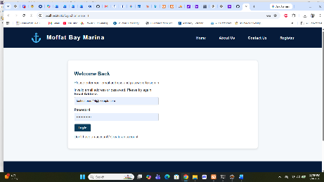
5 | Attempt to continue to an authenticated feature. | The user remains unauthenticated and protected functionality is not made available. | yes | yes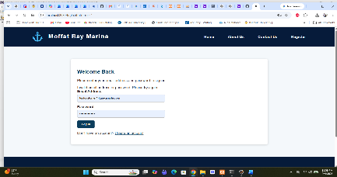
Comments | The invalid login test was successful. An intentionally incorrect password was rejected by the Java/Spring Boot login backend, and the user was returned to the login page with an appropriate error message. No authenticated post-login page was displayed, confirming that an invalid login did not create an authenticated session.

Test 5 | User Registration - Successful Customer and Boat Registration
 | Test Objective: Verify that valid customer and boat information is accepted and stored by the registration backend. | Developer:  Green Team  Date tested: <2026/09/04> |  | Peer tester:  <Max Jankowski>  Date tested: <2026/09/04>
Step | Action | Expected results: |  | Developer pass/fail |  | Tester pass/fail  + Screenshot
1 | Open the User Registration page. | The registration page loads with the required customer, account, and boat fields. |  | Yes |  | Yes  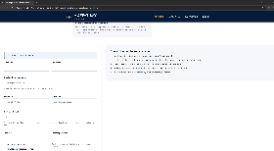
2 | Enter valid customer information using a new email address. | The customer fields accept the data without validation errors. |  | Yes |  | yes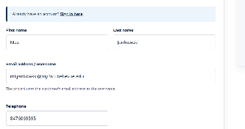
3 | Enter a password that meets the requirements and valid boat information. | The password and boat fields accept the valid input. |  | Yes |  | Yes  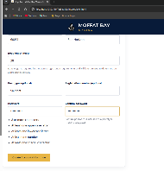
4 | Submit the registration form. | The RegisterServlet validates the request and reports a successful registration. |  | NO, corrected |  | Yes  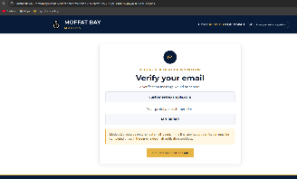
5 | Verify the database result or verification step. | One customer record and its associated boat record are created, and the user is directed to email verification. |  | yes |  | Yes  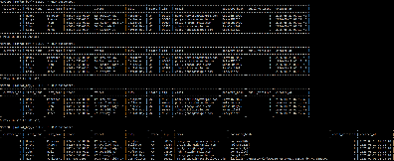
Comments | Need to perform corrections to the HTML files. Needed to add fields for the users address that the servlet for registration required. As these were required fields. I added scripts to the client-side html file. Removed the JS link. Also added fields for the boat info. There is also prmpts now if something was incorrectly entered.
Test 6 | User Registration - Duplicate Email Rejection
 | Test Objective: Verify that registration does not create a second customer record when the email address already exists. |  | Developer:  Green Team  Date tested: <2026/09/04> |  | Peer tester:  Max Jankowski  Date tested: <2026/09/04>
Step | Action |  | Expected results: |  | Developer pass/fail |  | Tester pass/fail  + Screenshot
1 | Open the User Registration page. |  | The registration form loads successfully. |  | yes |  | yes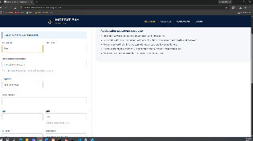
2 | Enter an email address that already exists in the customers table. |  | The existing email address can be entered for this negative test. |  | yes |  | yes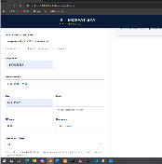
3 | Complete all other required customer, password, and boat fields with valid data. |  | No unrelated validation error prevents the duplicate-email condition from being tested. |  | yes |  | Yes: see image above. A different address was entered and the duplicate email was the only fault that trigger none duplication.
4 | Submit the registration form. |  | The RegisterServlet detects the duplicate email and rejects the registration. |  | yes |  | yes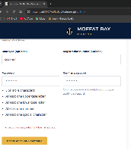
5 | Verify the displayed result and customer data. |  | A duplicate-account message is shown and no second customer or associated boat record is created. |  | yes |  | yes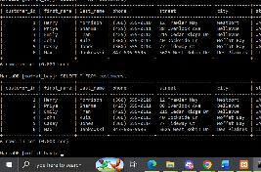
Comments | This test went smoothly and didn’t require anymore changes to html or java code.

