Alexander Baldree
Module 8
Assignment 8.2
11-20-25

FlowChart:
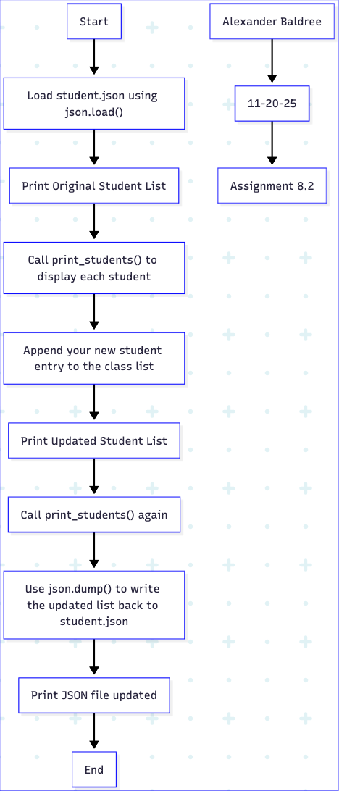
Module8_students.py file
# module8_students.py
# Author: Alexander Baldree
# Assignment: Module-8
# Date: 2025-11-20

import json

# ------------------------------
# Function to print each student
# ------------------------------
def print_students(student_list):
for student in student_list:
print(f"{student['L_Name']}, {student['F_Name']} : "
f"ID = {student['Student_ID']} , Email = {student['Email']}")
print() # blank line

# ------------------------------
# Main Program
# ------------------------------
def main():
# Load JSON file
with open("/Users/alexbaldree/csd/csd-325/module-8/student.json", "r") as file:
students = json.load(file)

print("Original Student List:")
print_students(students)

# Adds a student entry
new_student = {
"F_Name": "Alexander",
"L_Name": "Baldree",
"Student_ID": 21400194,
"Email": "alex.baldree@example.com"
}

students.append(new_student)

print("Updated Student List:")
print_students(students)

# Write back to JSON
with open("student.json", "w") as file:
json.dump(students, file, indent=4)

print("The JSON file has been updated.")

# Run program
if __name__ == "__main__":
main()

Student.json file
[
{
"F_Name": "Ellen",
"L_Name": "Ripley",
"Student_ID": 45604,
"Email": "eripley@gmail.com"
},
{
"F_Name": "Arthur",
"L_Name": "Dallas",
"Student_ID": 45605,
"Email": "adallas@gmail.com"
},
{
"F_Name": "Joan",
"L_Name": "Lambert",
"Student_ID": 45714,
"Email": "jlambert@gmail.com"
},
{
"F_Name": "Thomas",
"L_Name": "Kane",
"Student_ID": 68554,
"Email": "tkane@gmail.com"
},
{
"F_Name": "Alex",
"L_Name": "Baldree",
"Student_ID": 99999,
"Email": "alex.baldree@example.com"
}
]

Results:
