Alexander Baldree
CSD-325
11/19/25
Module 7 Assignment 7.2

City_functions.py (No Population)
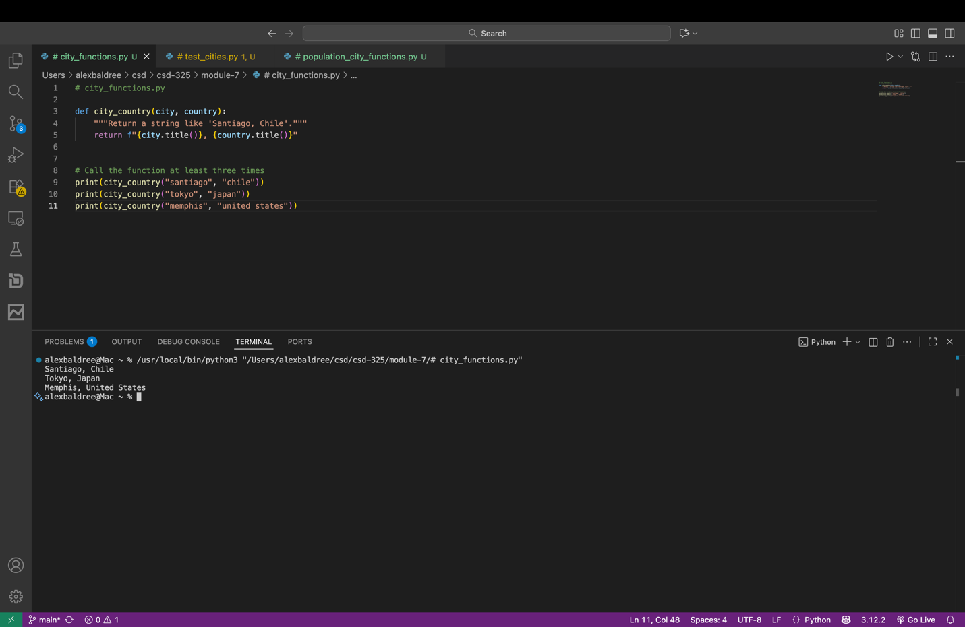

test_cities.py
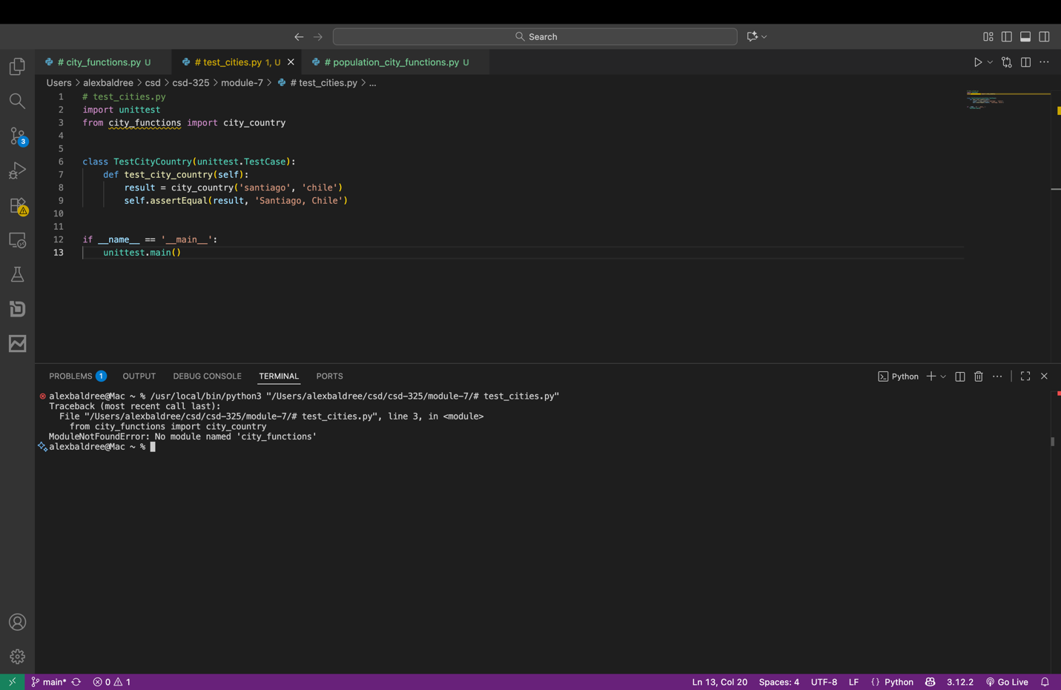

Failure of city_country() to require population
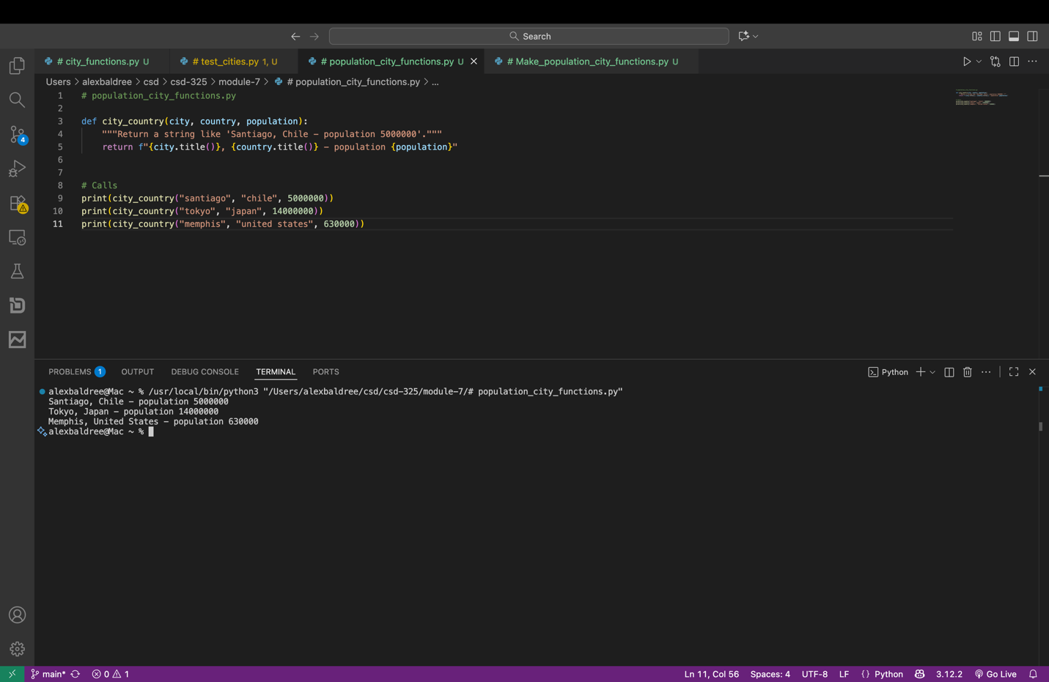

Full Population of city_function
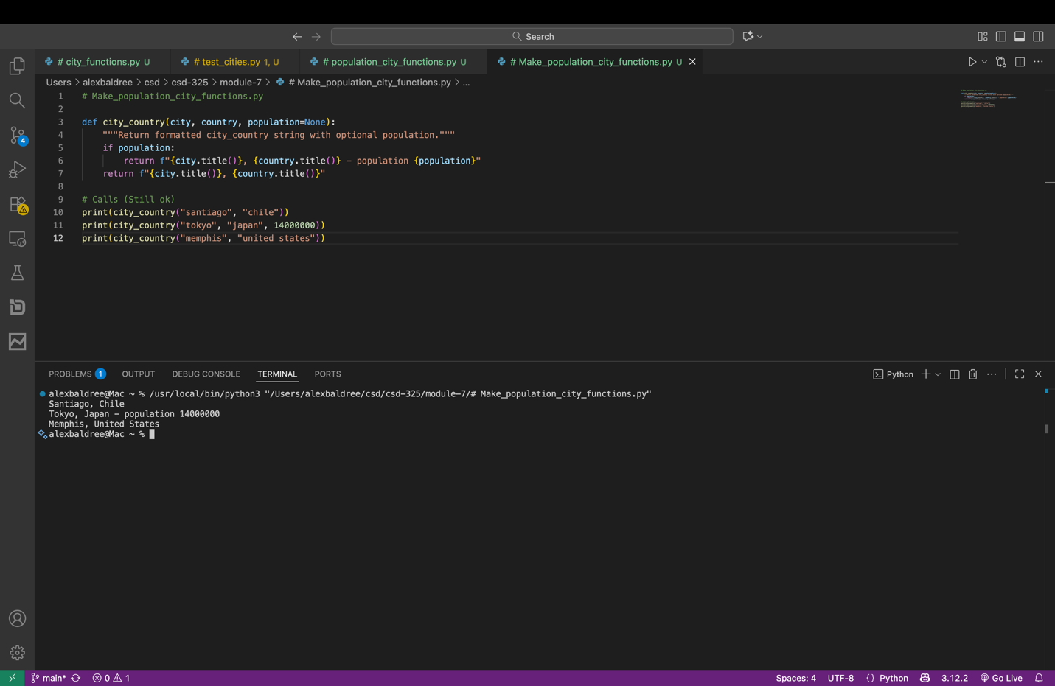

Modified Function to require language city_functions.py with failure
