Alexander Baldree
Module 10 Assignment 10.2
12/01/25
CSD325

GitHub Link:
https://github.com/Panda-Alex21687/csd-325/tree/main/module-10

Added Task:
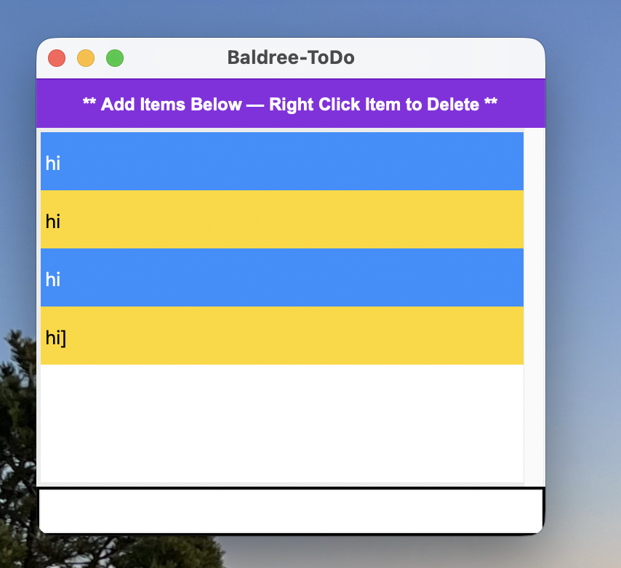

Deleted task Menu:
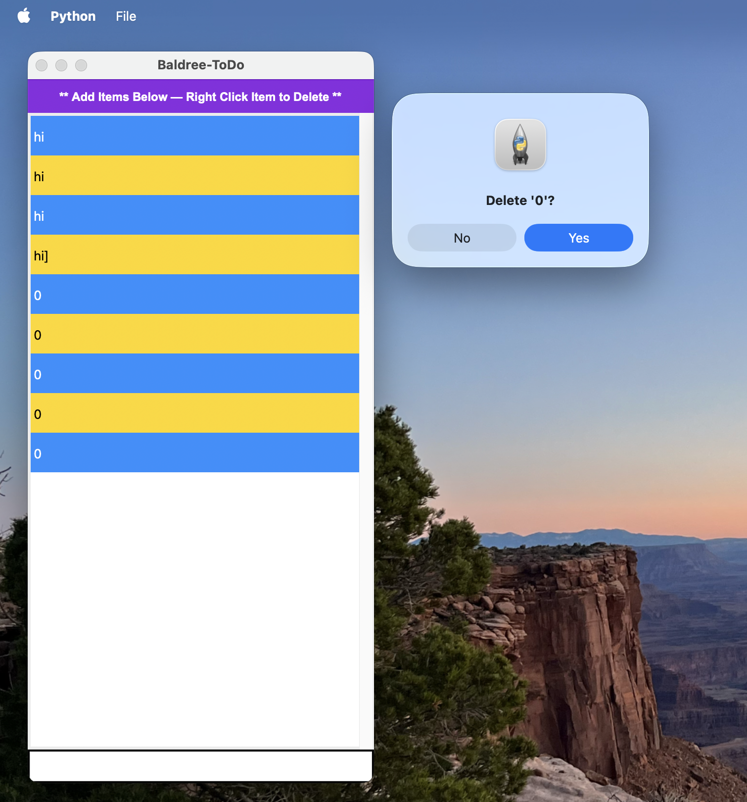

Exit Menu:
