Alexander Baldree
CSD-325
12/17/25
Module 7 Assignment 7.2 REDO

City_functions.py (No Population)
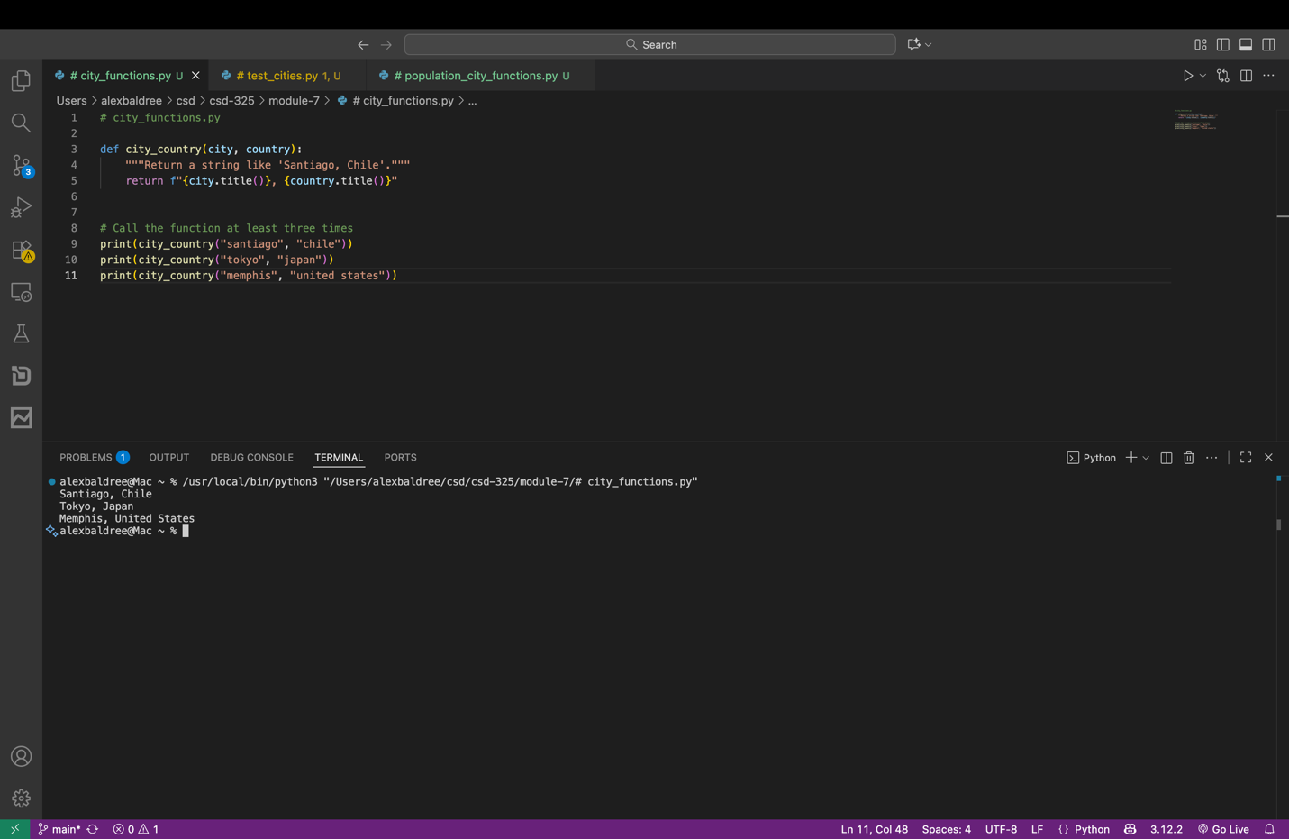

test_cities.py
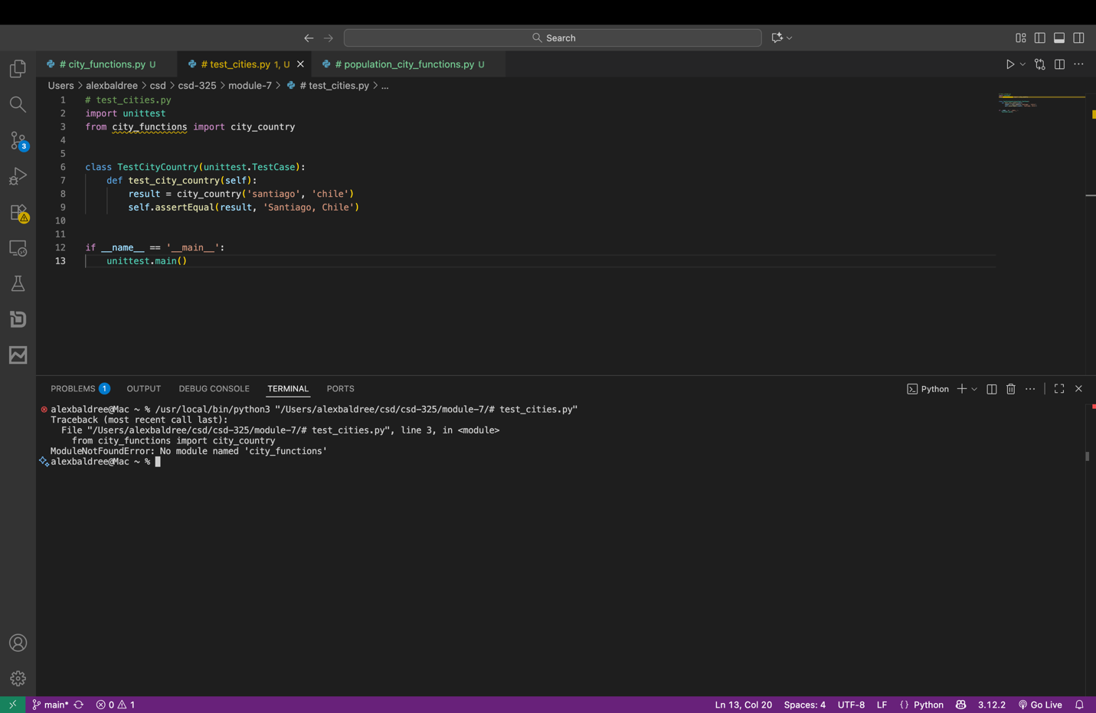

Failure of city_country() to require population
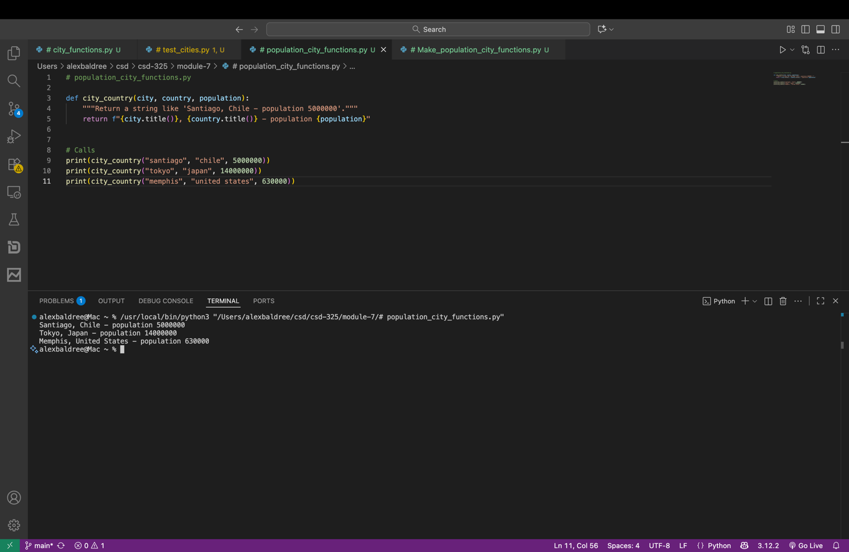

Full Population of city_function
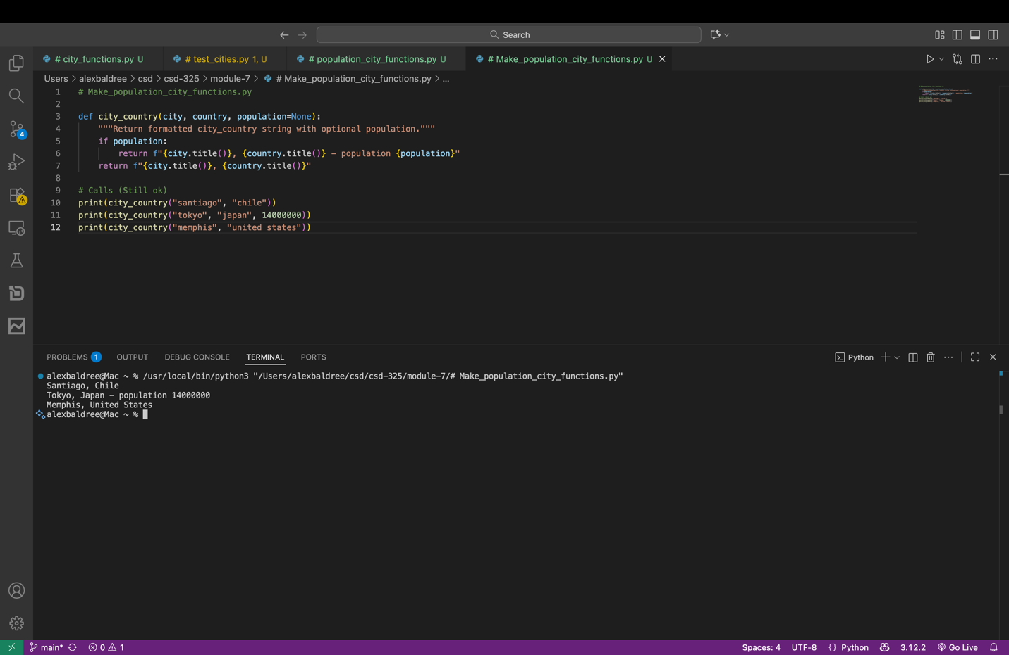

Modified Function to require language city_functions.py with failure
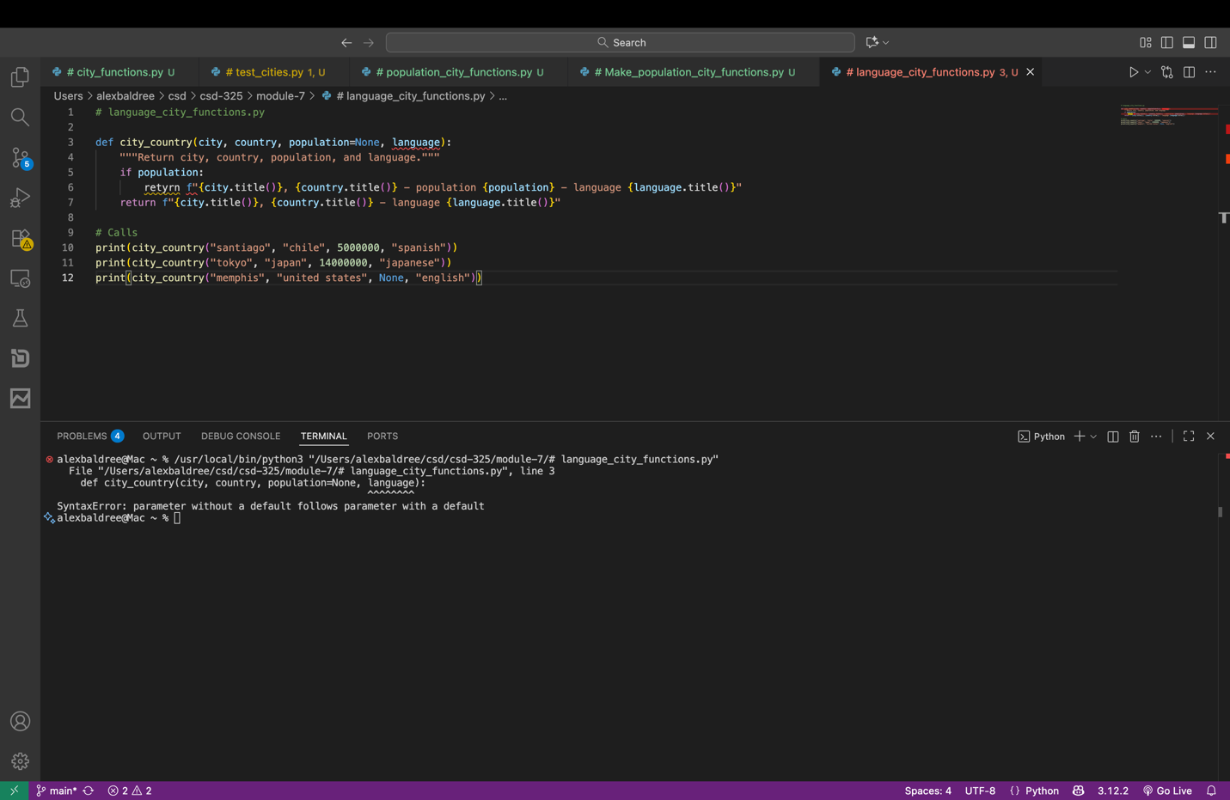

city_function.py Language optional with pass
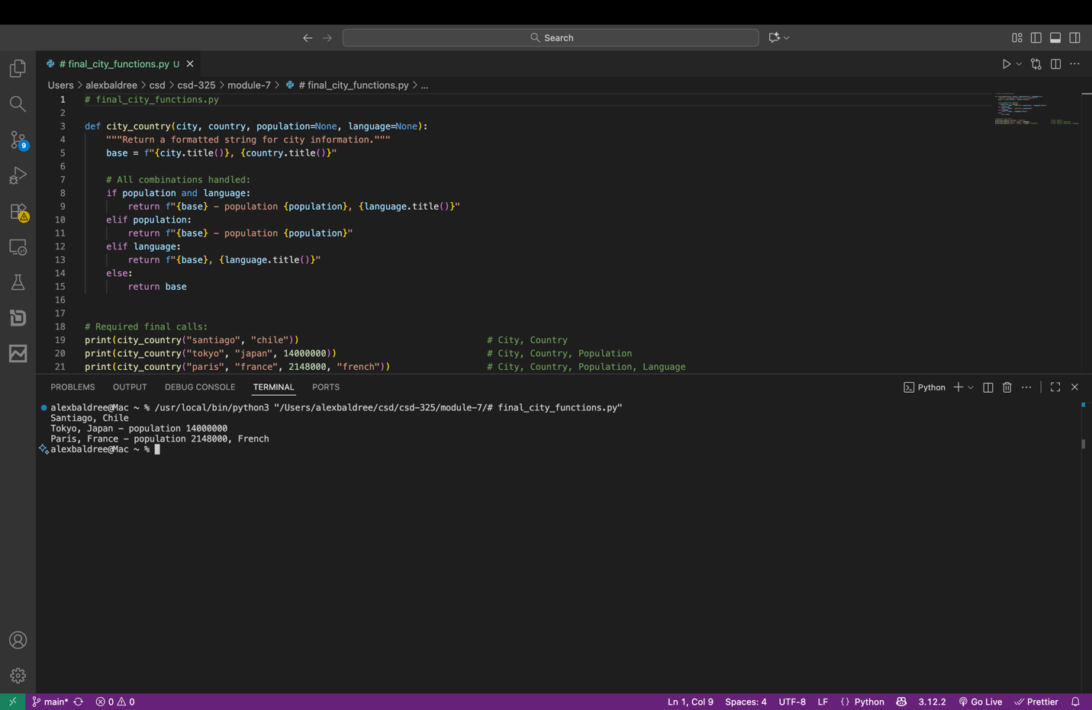

Final city_function (Using three sets of variables)

