Alexander Baldree
CSD-325
Module 11: Django Basics
12/12/25

GitHub Link:
https://github.com/Panda-Alex21687/csd-325

Manage.py Screenshot:
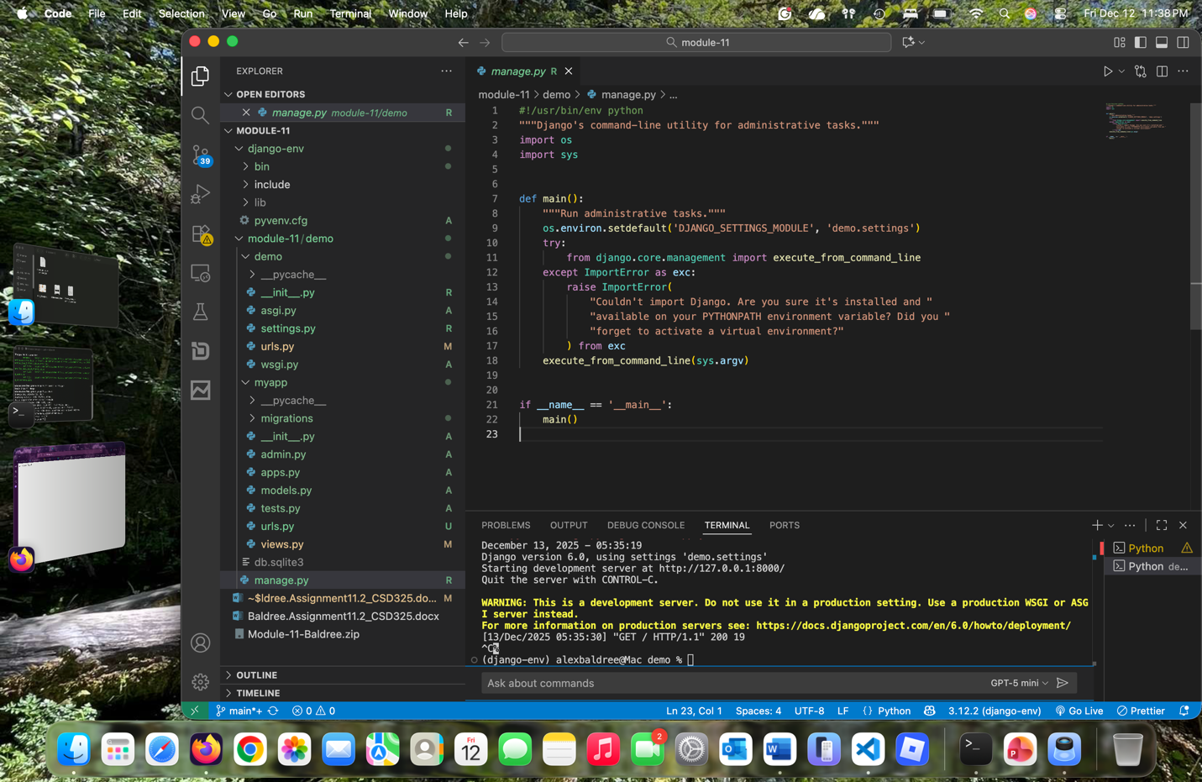

Terminal showing RunServer:
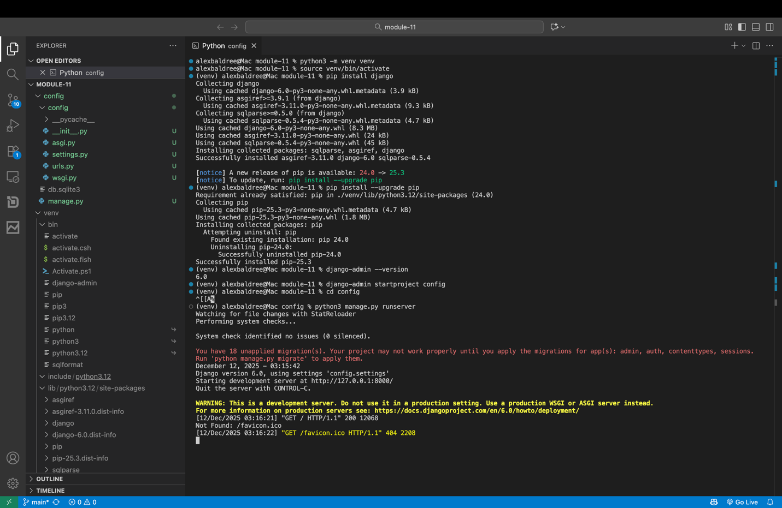

Browser Showing Django Welcome Page:
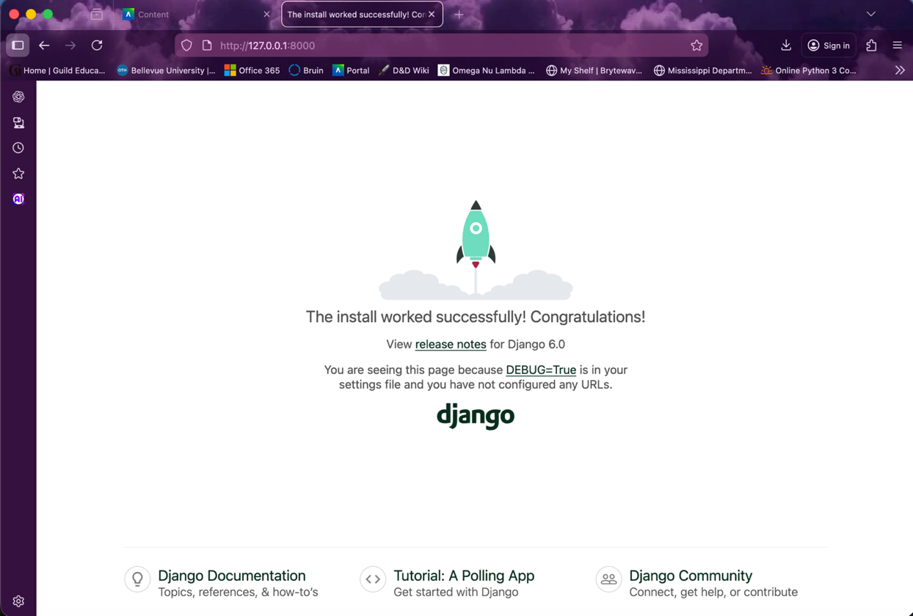
Django Displays last_name hello:
