We broke the flowchart into sections for each function. One for the main flow of the program, and one for each major function: main, createForest, and displayForest. This prevented the flowchart from getting too long.
Main Flow:
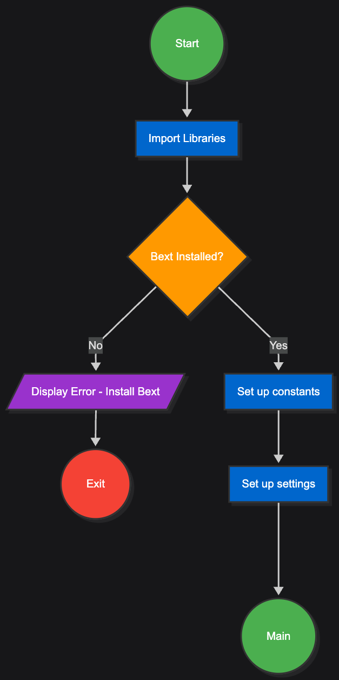
main Function:
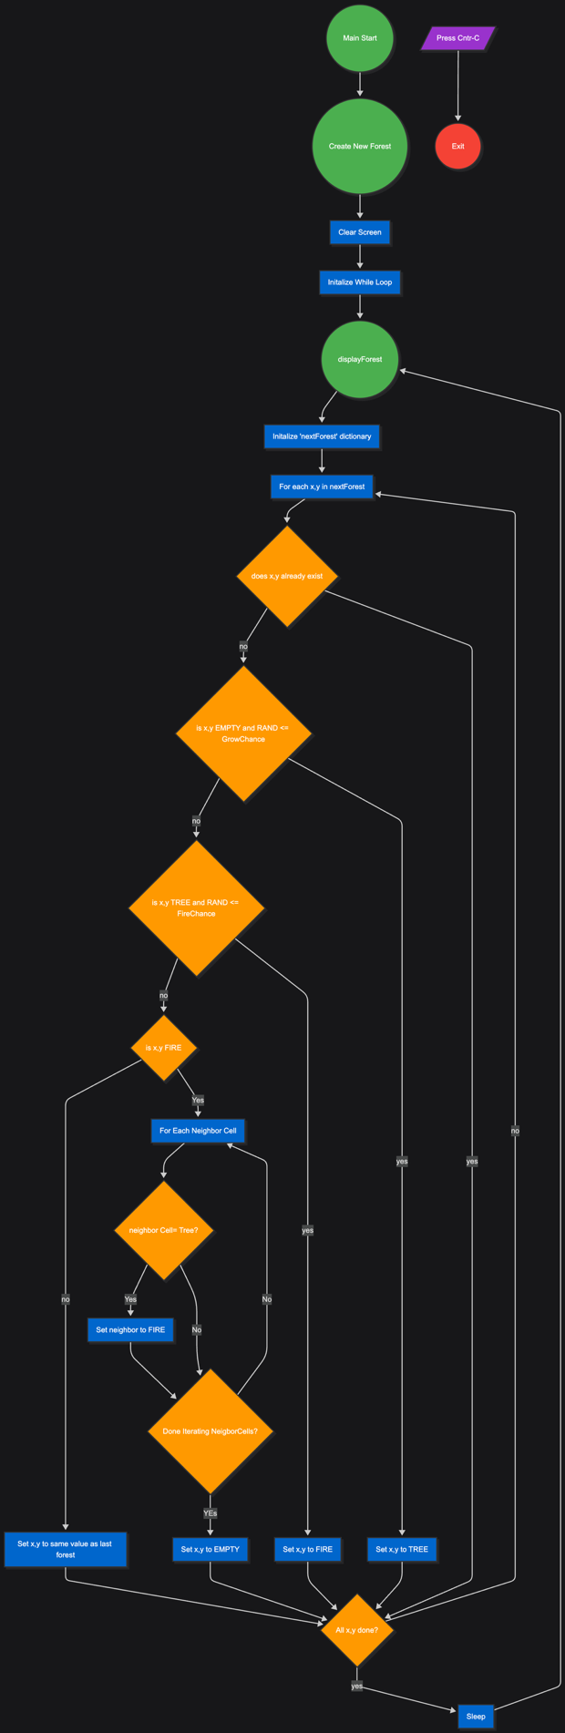
createForest Function
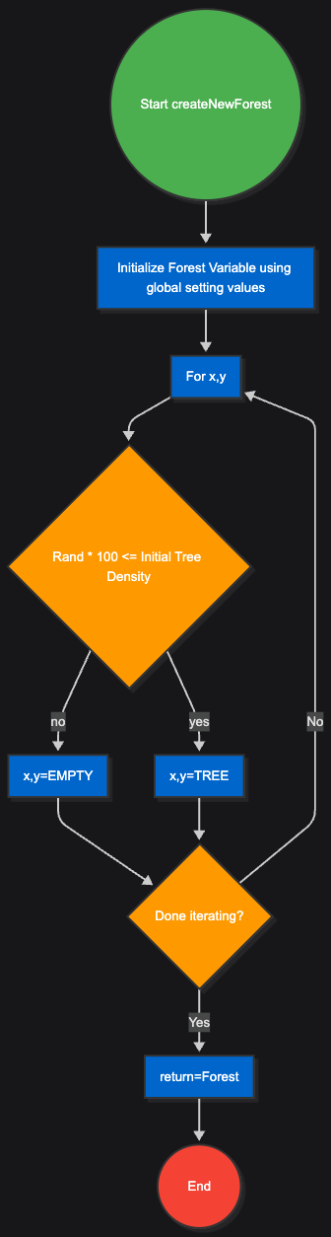

displayForest Function
