Alexander Baldree
Module 9 Assignment 9.2
11-26-25
CSD-325

GitHub Link:
https://github.com/Panda-Alex21687/csd-325/tree/main/module-9

--API Program Full Overview:
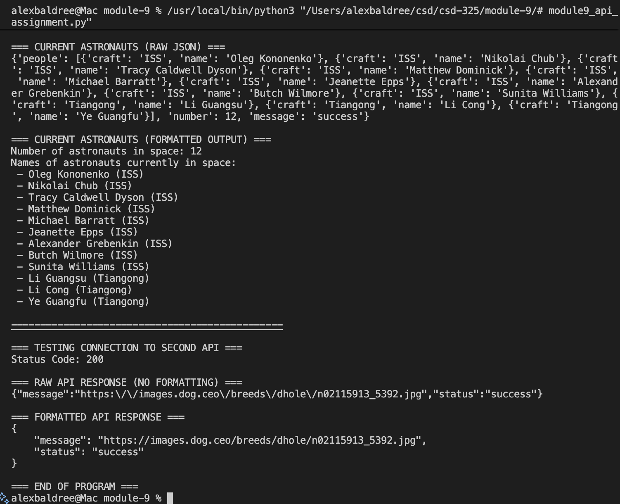

--Current Astronauts Raw JSON:
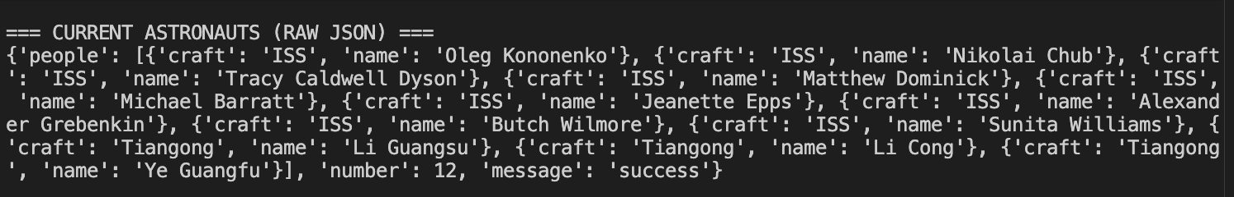
--Current Astronauts Formatted Output:
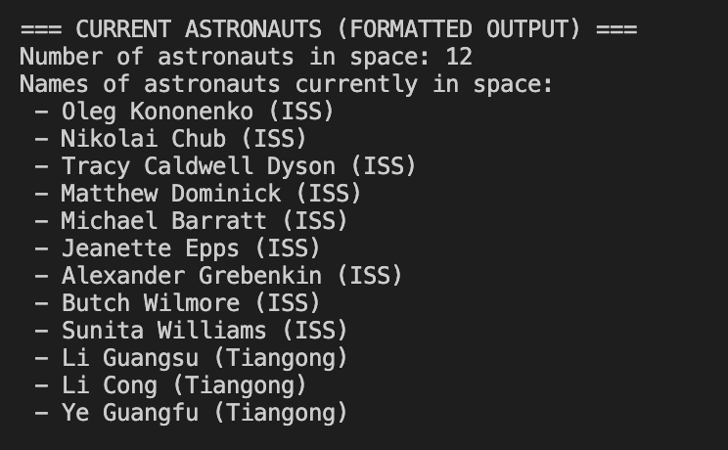
--Testing Connection:
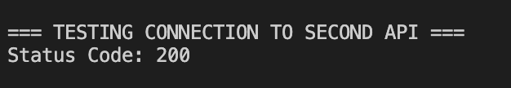
--Raw API Response No Formatting:

--Formatted API Response:
