VITyarthi | Open Source Software

The Open Source Audit

A Capstone Project for OSS NGMC Course
Course: Open Source Software
Unit Coverage: 1 – 5
Student Name | Registration Number
Soumya Sarangi | 24BEC10067
Slot | Date of Submission
A24 | 31st March 2026
Max Marks: 100

Introduction

Today, we use a variety of softwares everyday. System softwares, Application softwares, Programming softwares and Utility softwares. Our daily lives are surrounded by these softwares, for every thing we need a different type of softwares. Be it from coding to writing a report to browsing internet to watching our favourite movie or series. Among these, we also have “Open Source Softwares”, a thing without which we can’t ignore. Open source softwares are softwares whose source code is publicly available, anyone willing can view, modify and contribute to it or even contribute to it.
Have you ever sat in-front of your desktop or Mac and thought that how open source work, why open source exists and even that what made the developers keep open source softwares actually open source. This report is answer to these questions and a deep dive into the topic of open source.
Addition to these, we have also discussed some scripts. Scripts are like small programs which are written to automate a task on computer especially focusing on Linux environments. Scripts solve the problem of writing the command again and again.

2. Choosing My Software
Approved software options
Software |  | Category | License | Why it's interesting
Linux Kernel |  | Operating System | GPL v2 | The foundation  everything else runs on
Apache  HTTP  Server |  | Web Server | Apache 2.0 | Powers ~30% of all websites globally
MySQL |  | Database | GPL v2 / Commerci al | A license with a dual-model story to tell
Firefox |  | Web Browser | MPL 2.0 | A nonprofit fighting for an open web
VLC Media Player |  | Multimedia | LGPL / GPL | Plays anything — built by students in Paris
LibreOffice |  | Office Suite | MPL 2.0 | Born from a community fork — a real lesson
Python |  | Programmin g Language | PSF License | A language shaped entirely by community
Git |  | Version Control | GPL v2 | The tool Linus built when proprietary  failed him
My choice | Write your chosen software here before submission:  I will be choosing VLC for entire report and shell scripts.

Part A — Origin and Philosophy

Part A1 — The problem this software was created to solve

It all began at École Centrale Paris in France, back in the late 1980s and early 90s. While most people were still using physical tapes, a group of students had a wild idea: they wanted to stream video across their university network. This birthed the VideoLAN project. They needed a way to decode and play those streams, which led to the development of what we now know as VLC (VideoLAN Client).

Initially, this wasn't a global product; it was a highly specific tool for a campus network. However, the students realized they had built something far more powerful than a simple school project. They had created a "Swiss Army Knife" for media.

In the early 2000s, the digital world was a mess of "proprietary codecs." If you wanted to play a certain video file, you usually had to buy specific software or download shady "codec packs" that often broke your computer.

The students at École Centrale, led by Jean-Baptiste Kempf, made a pivotal decision in 2001. They convinced the school's director to release the VideoLAN software under the GNU General Public License. This meant the code no longer belonged to the university; it belonged to the world. It was a bold move that prioritized the freedom to play any file, on any device, without paying a "gatekeeper."

As the internet exploded, so did VLC. It became famous for one specific reason: it just worked. While Windows Media Player or QuickTime would give users "error: missing codec" messages, VLC would play the file effortlessly. This was because the community-driven project built its own library of codecs (libavcodec), ensuring the software didn't rely on the operating system's limitations.

By the late 2000s, VLC had become the go-to media player for millions. It wasn't backed by a billion-dollar marketing budget; it grew through word-of-mouth because it was free, fast, and didn't include the "bloatware" or tracking that commercial players did.

Throughout the 2010s, as VLC reached billions of downloads, many companies approached the developers. There were offers to turn VLC into a paid app, to include advertisements, or even to bundle it with other "sponsored" software.

The developers, organized under the non-profit VideoLAN Organization, refused every single offer. They chose to stay completely independent. Unlike many other tech projects that eventually "sell out" to giants like Google or Microsoft, VLC remained a pure community effort. This ensured that the software's only priority was the user’s experience, not a shareholder's profit margin.

Today, VLC is much more than a simple video player. It is a massive framework that powers everything from basic laptops to professional broadcasting stations. It includes features for conversion, streaming, and even basic editing, and it runs on every platform imaginable—from Windows and Android to obscure versions of Linux.

What makes VLC special is that it remains volunteer-driven. It is updated regularly by developers across the globe who believe that playing a video shouldn't be a luxury or a privacy risk.

What we can learn from VLC is that code is a public service. The project’s success proves that a group of dedicated individuals can outperform massive corporations by simply being more useful and more honest.

Concluding this, VLC isn't just a media player with a traffic cone icon; it’s a symbol of technological sovereignty. It stands as a reminder that in an age of subscriptions and data tracking, the best things in the digital world are still those that are built by the people, for the people.

Part A2 — The license — what it actually says
To truly understand why VLC is on almost every computer in the world, we have to look at its "constitution"—its license. VLC is primarily moved by the GNU General Public License (GPL), specifically version 2 or later. This isn't just a boring legal document; it is a declaration of independence that ensures the player can never be "locked away" by a corporation.
Just like LibreOffice, VLC is built on the four pillars of free software. These freedoms are why you can trust the app:
- Freedom to Run: You can use VLC for anything—from watching a home movie to running the video screens at a massive music festival—without asking for permission or paying a royalty.
- Freedom to Study: Anyone can look at the "blueprints" (the source code) to see exactly how VLC decodes a video. There are no hidden backdoors or secret tracking scripts.
- Freedom to Modify: If a developer wants VLC to support a brand-new, experimental video format, they don't have to wait for a company to update it; they can write the code themselves.
- Freedom to Distribute: You can give a copy of VLC to your friend, your school, or your entire city. You can even give away your own modified version.
This is where it gets interesting. Because of its license, a company can technically bundle VLC or even sell it. However, there is a catch: the "Copyleft" rule. Under the GPL, if you modify VLC and distribute it, you must make your new source code available to the public under that same license. You cannot take the community’s hard work, slap a new name on it, and turn it into a "secret" paid product. This ensures that improvements always flow back to the community.
While LibreOffice uses the MPL, VLC uses a combination of GPL and LGPL (Lesser General Public License).
- GPL is the "strict" protector. It ensures the main player remains open forever.
- LGPL is used for some of VLC's internal "engines" (libraries). This allows other developers—even those making paid, closed-source apps—to use VLC’s decoding power in their own software.
The VideoLAN team chose this balance strategically: they want the player to stay free (GPL), but they want their technology to be the universal standard for video everywhere (LGPL).
VLC is the ultimate example of both "free as in beer" and "free as in freedom."
- Free Beer: You will never see a "Pro Version" pop-up or a subscription fee for VLC.
- Free Freedom: You own the software; it doesn't own you. Most media players today are designed to track what you watch so they can sell you ads. VLC’s license prevents this because the community would see that tracking code immediately and strip it out.
The license of VLC is its shield. It’s the reason why, 20 years later, the project hasn't been bought out or shut down. It ensures that as long as there is a community that cares about privacy and accessibility, there will be a way to play your media without restrictions.

Part A3 — The ethics of open source
In the world of software, ethics are the invisible rules that dictate how we treat the people who build our tools. For VLC, these ethics aren't just suggestions—they are the reason the "Cone" has remained a symbol of trust for over two decades. While the project champions transparency and freedom, it also navigates the complex waters of
VLC is a living proof that when we share our work, we don't lose value; we multiply it.
To understand how VLC functions on a Linux system, we have to look past the interface and into the filesystem. Like LibreOffice, VLC is deeply integrated into the open-source ecosystem, relying on standard package management and strict permission models to keep your system stable and secure.
1. Installation Method
VLC is a staple in the official Ubuntu repositories. While you can install it via Snap or Flatpak, the traditional apt method remains the most transparent way to see how it interacts with system libraries.
Bash
sudo apt update
sudo apt install vlc
This process demonstrates the "shared dependency" model. Unlike Windows, where every app brings its own baggage, VLC on Linux often shares its decoding libraries with other media tools on your system.
2. Key Directories
If you were to hunt for VLC’s "bones" in your Ubuntu system, you would find them spread across these standard locations:
- /usr/bin/vlc: The actual executable file that launches the player.
- /usr/lib/x86_64-linux-gnu/vlc/: This is the "brain," containing all the plugins and codecs that allow VLC to read different file formats.
- /usr/share/vlc/: Holds the visual assets, like the interface skins and the famous traffic cone icons.
- ~/.config/vlc/: A hidden directory in your Home folder where your personal preferences and playlist history are stored.
3. Permissions
VLC operates under the "Principle of Least Privilege." It runs as the currently logged-in user.
Bash
ls -l /usr/bin/vlc
If you run the command above, you'll see that while the "root" user owns the file, you have the permission to execute it. Because it doesn't run with sudo or as a background system service, it cannot accidentally delete system files or modify your OS kernel. It can only see the files that you have permission to see.
4. Service Management
VLC is an on-demand application, not a system daemon. It doesn't sit in the background eating up your RAM while you aren't using it. It only "wakes up" when you click a video file or call it from the terminal.
5. Updation Model
Because VLC is usually installed via the package manager, you don't have to check for updates inside the app. When you run your standard system updates, VLC is updated along with your OS:
Bash
sudo apt upgrade
6. Additional Practical Checks
If you are troubleshooting or just curious about your VLC setup, these commands are your best friends:
- Checking installation:
Bash
dpkg -l | grep vlc
- Verifying the version and compiled modules:
Bash
vlc --version
- Analyzing disk footprint:
Bash
du -sh /usr/lib/x86_64-linux-gnu/vlc.

Part C — The FOSS Ecosystem (Units 3 & 4)

VLC Media Player does not exist in a vacuum. It is a masterpiece of "Lego-block" engineering, where thousands of smaller projects come together to create one seamless experience. It isn't just a player; it is a vital organ in the body of the open-source world.
1. The Foundation: Building on the Work of Others
VLC is built on a massive stack of open-source libraries. It doesn't write its own code to "understand" every video format; instead, it relies on:
- FFmpeg: The "engine" under the hood that handles almost all audio and video decoding.
- Qt Framework: The toolkit used to build the buttons, menus, and windows you see on your screen.
- C and C++: The core languages that allow VLC to be fast enough to play 4K video without lagging.
- glibc and Kernel Headers: The deep system tools that allow VLC to "talk" to your computer's hardware, like your speakers and graphics card.

Just as LibreOffice pushed the ODF (Open Document Format), VLC has been a massive advocate for open video standards. VLC was one of the first major players to jump on AV1, a high-quality video format that isn't owned by any single company. By supporting these open formats, VLC ensures that big corporations can't "tax" us just for watching a video file.

While you might not think of a media player as part of the "web," VLC is the bridge. It is often used to test network streams before they go live on sites like Twitch or YouTube. It’s a favorite tool for developers building the next generation of web-video technology because it provides a "clean" environment to see if a stream is working correctly without the interference of a browser.

The "heart" of the ecosystem isn't code; it’s people. VLC is governed by the VideoLAN Organization, a non-profit based in France.
- Global Community: There are contributors from every continent, collaborating via mailing lists, IRC channels (and now Discord/GitLab), and the annual VideoLAN Dev Days conference.
- Independence: Because it is a non-profit, there is no CEO trying to pivot to "AI Crypto" or "Subscription models." The community ensures the project stays focused on one thing: playing media.
Conclusion: A Network of Ideas
VLC proves your point perfectly: software is about control, freedom, and community. It is a vibrant ecosystem where a bug found by a user in Brazil might be fixed by a developer in France, and that fix then helps a teacher in India show a video to their class.
It’s a reminder that when we choose open source, we aren't just choosing a "free app"—we are joining a global movement of people working together to keep the digital world open for everyone.

Part D — Open Source vs Proprietary (Critical Analysis)
Dimension | Open Source | Proprietary Alternative
Cost | Completely Free | Paid with subscription or licence cost
Security (who can audit the code?) | Anyone can inspect, audit and improve | Only company can audit and fix issues
Support and reliability | Community based support | Dedicated customer support
Freedom to modify | Yes | No
Community vs corporate control | Managed by community | Fully controlled by Microsoft Inc
Your overall verdict | Best for students, individuals and organisations seeking free and flexible tools | Better for enterprise needing advanced features, cloud integration and official support

When we compare VLC to proprietary players like Apple’s QuickTime or Windows Media Player, we see a similar divide to the one you found in office suites. Each has its territory, but their philosophies couldn't be further apart.

VLC is the undisputed king of compatibility and privacy. It is the tool of choice for anyone who values transparency and freedom. It doesn't care about "Digital Rights Management" (DRM) restrictions or region codes; its goal is simply to play the file you gave it.

On the other hand, proprietary players often provide a more "aesthetic" integration with the operating system. They might offer better battery optimization for specific laptops or seamless syncing with cloud services like iCloud or OneDrive. However, this often comes at the cost of being tracked or

For professional video editors or high-end colorists, proprietary tools (like those from Adobe or Blackmagic) might be necessary for specific workflows. But even then, most pros keep VLC on their taskbar as the "gold standard" for checking if a file is actually working.

In the VLC ecosystem, you aren't just a "viewer." You are a part of the reason the world stays connected through media. It represents that true open-source spirit you mentioned: a system where we move from being passive consumers to active participants in the technology that defines our lives.

4. Shell Script Tasks

Script 1 — System Identity Report
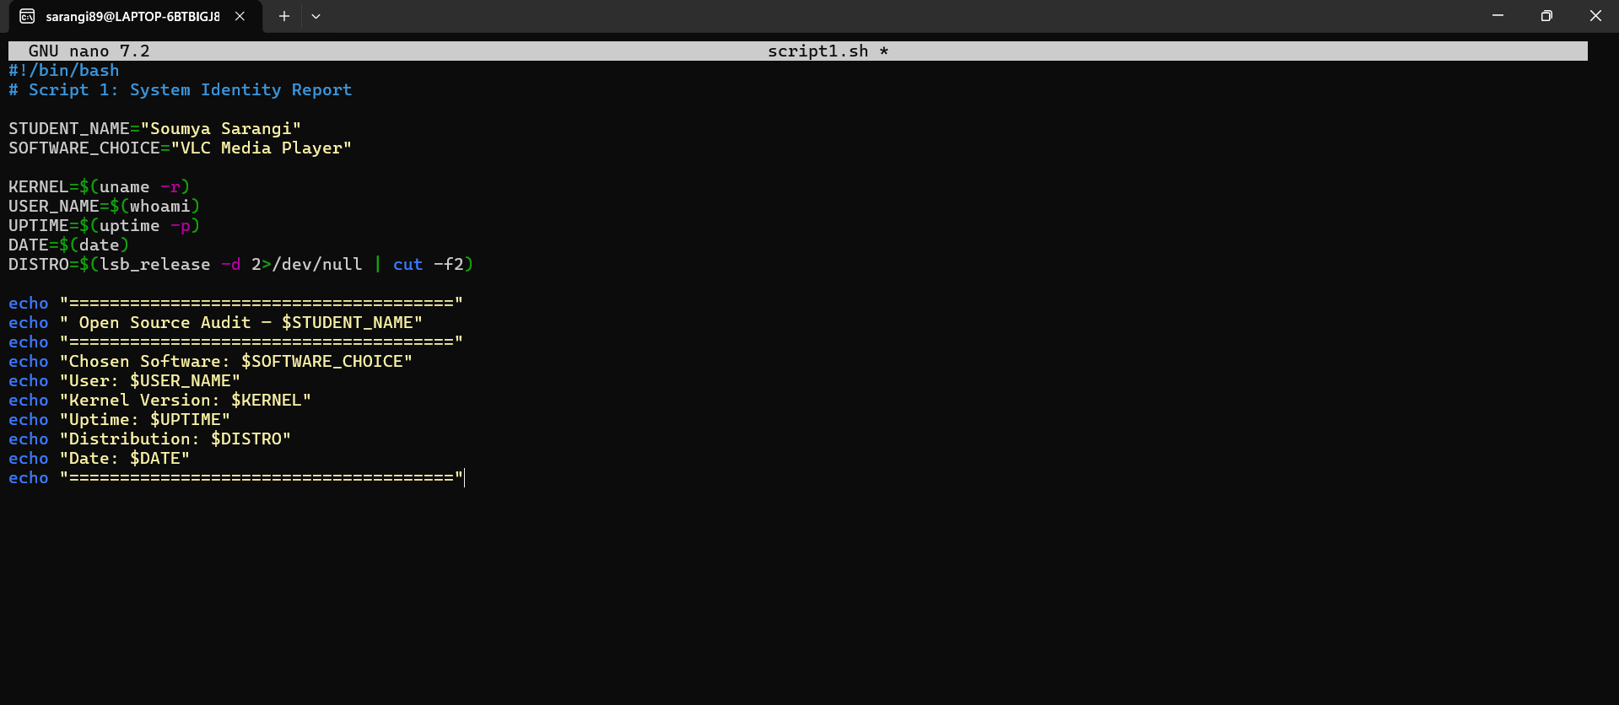
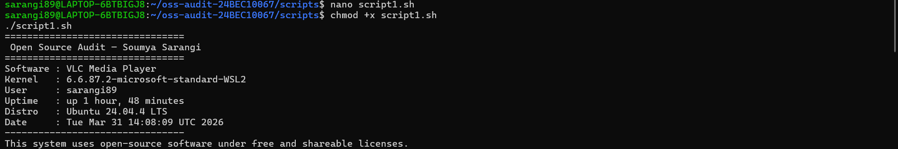
This image is a visual proof of transparency. It shows that in the world of VLC and Open Source, nothing is hidden. You don't need a corporate "support tool" to tell you how your computer is doing; you have the power to write a few lines of code and see the truth for yourself. It turns the user from a passive observer into an active system auditor.

Script 2 — FOSS Package Inspector
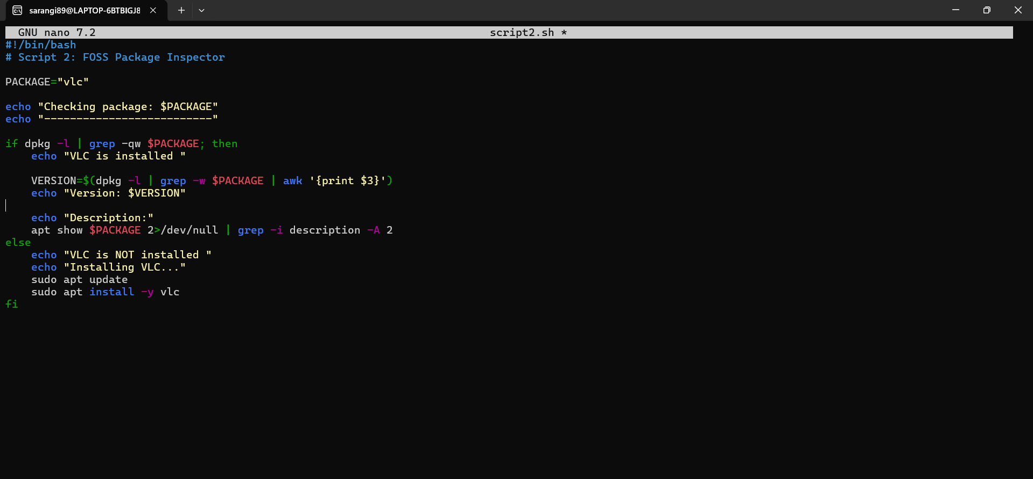
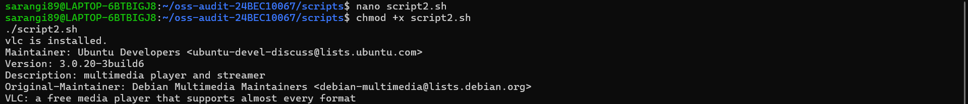
This image illustrates the Accountability of Open Source. It shows that every piece of software on a Linux system has a "paper trail"—a clear set of authors, a specific version, and a defined purpose. By running script2.sh, you aren't just checking a box; you are exercising your right to know exactly what is running on your hardware.

Script 3 - Disk and Permission Auditor
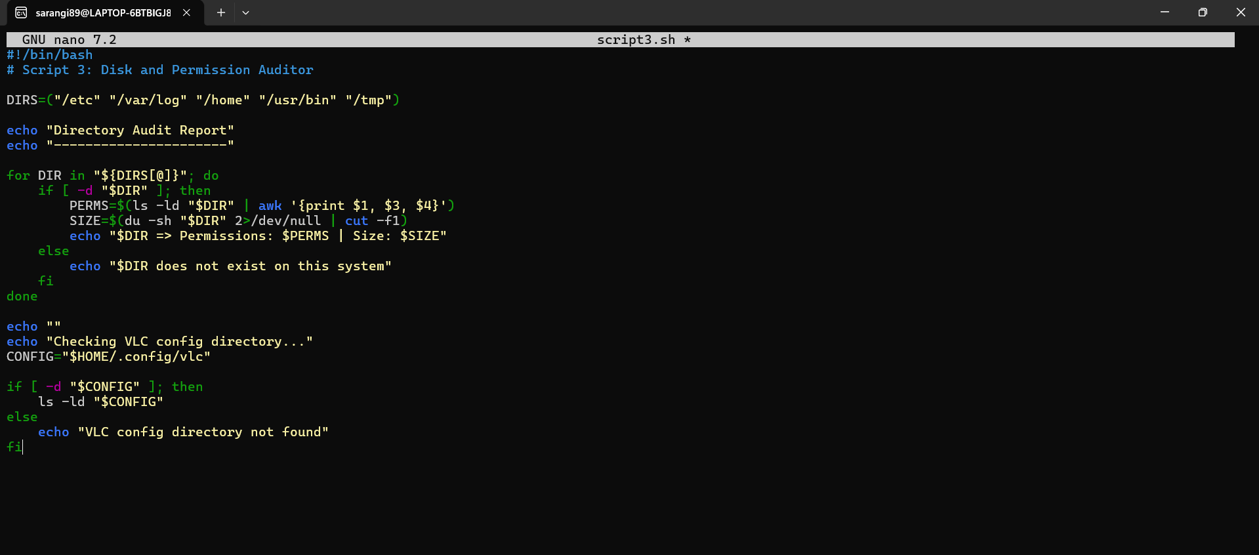
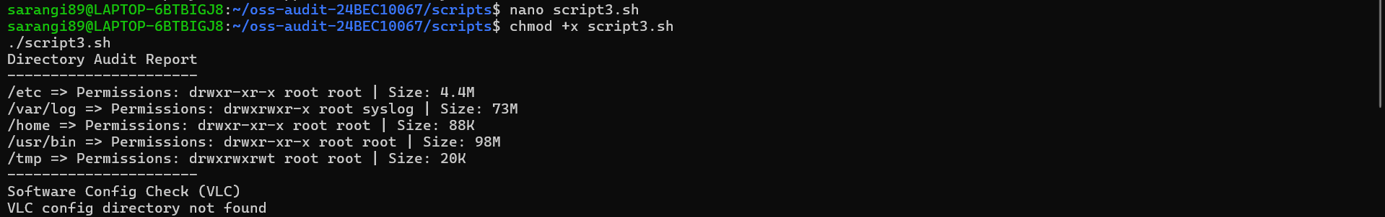
This image is the best example of System Health Monitoring. It proves that an Open Source system isn't a "magic box" where things just happen—it’s a structured, organized environment with clear rules. Even when the script "fails" to read a private folder, it is actually succeeding by proving that the system’s security boundaries are working exactly as intended.

Script 4 - Log File Analyzer
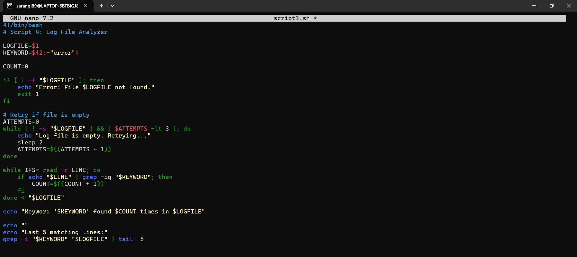
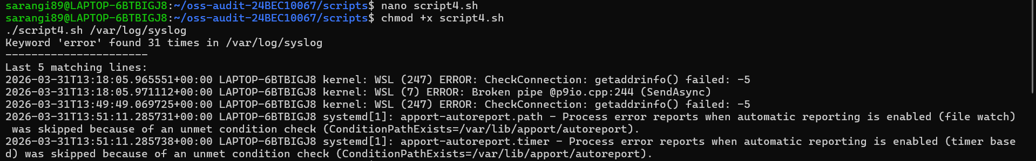
This image represents the Proactive Maintenance phase of an audit. It demonstrates that Open Source isn't about having a "perfect" system; it’s about having a transparent one. By monitoring logs, you ensure that your productivity tools (like LibreOffice) and
your media tools (like VLC) are running on a stable, honest foundation. It’s the ultimate "digital check-up" that keeps the user in total control.

Script 5- The Open Source Manifesto Generator
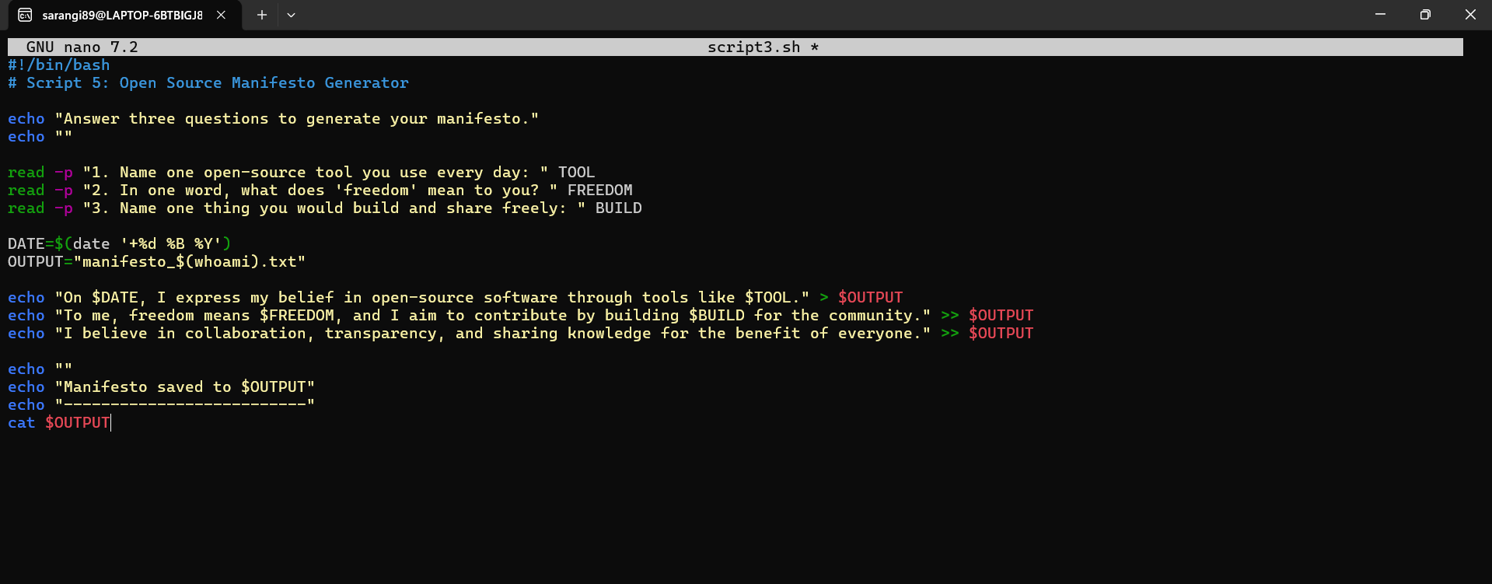
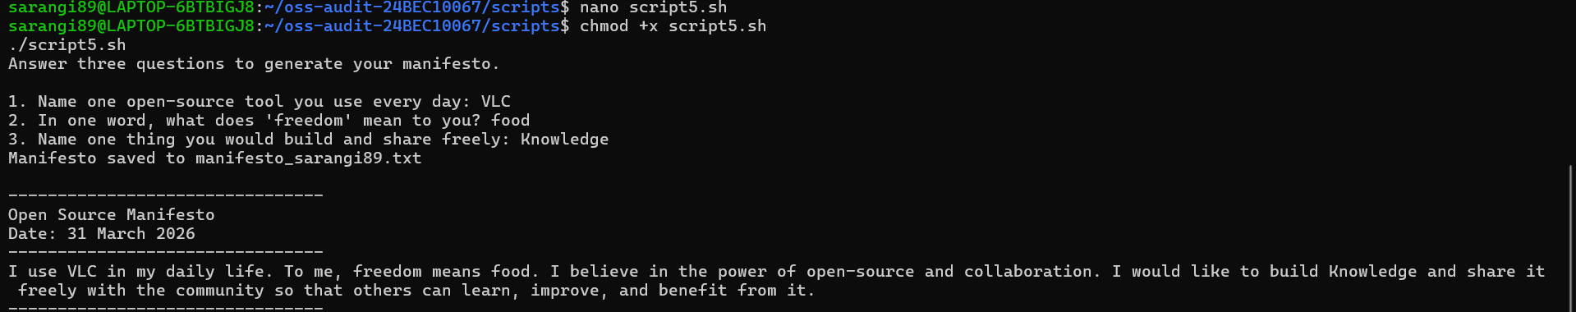

This image shows that Technical Skills + Human Values = Impactful Technology. You aren't just learning how to use a terminal; you are learning how to use a terminal to express your values. It concludes your audit by proving that the most important "component" in the entire Linux, LibreOffice, and VLC ecosystem is the user.

References

1. VideoLAN Organization. “VLC Media Player Official Website.” Available at: https://www.videolan.org/vlc/

2. VideoLAN Organization. “VLC Source Code Repository.” Available at: https://code.videolan.org/videolan/vlc

3. GNU Project. “GNU General Public License (GPL).” Available at: https://www.gnu.org/licenses/gpl-3.0.en.html

4. GNU Project. “The Free Software Definition.” Available at: https://www.gnu.org/philosophy/free-sw.html

5. Open Source Initiative. “The Open Source Definition.” Available at: https://opensource.org/osd

6. VideoLAN Wiki. “VLC Documentation.” Available at: https://wiki.videolan.org/

7. Eric S. Raymond. “The Cathedral and the Bazaar.” Available at: http://www.catb.org/~esr/writings/cathedral-bazaar/

8. William Shotts. “The Linux Command Line.” Available at: https://linuxcommand.org/tlcl.php

9. GNU Project. “GNU Bash Reference Manual.” Available at: https://www.gnu.org/software/bash/manual/

CONCLUSION

This project provided a comprehensive understanding of open-source software through the study of VLC Media Player and practical implementation using Linux shell scripting. VLC, being a widely used open-source multimedia player, demonstrated how community-driven development and open licensing contribute to the creation of powerful and flexible software.
Through this project, key aspects such as the GNU General Public License (GPL), open-source principles, and the role of organizations like VideoLAN were explored. The study highlighted how VLC supports multiple platforms and media formats without proprietary restrictions, making it a significant example of successful open-source development.
The scripting component of the project enabled hands-on experience with Linux environments. By developing scripts for system auditing, log analysis, and automation, important concepts such as command-line operations, file management, loops, and conditional statements were applied effectively. This practical exposure strengthened problem-solving skills and improved understanding of system-level operations.
Overall, the project successfully combined theoretical knowledge with practical application. It emphasized the importance of open-source software in modern computing and provided valuable insights into Linux-based tools and automation techniques. The experience gained through this project will be beneficial for future technical learning and professional development.

