INTRODUCTION
Counterfeit goods are increasing worldwide, affecting sectors such as clothing, cosmetics, food, and medicine, with countries like Bangladesh heavily impacted. Blockchain technology offers a secure, tamper-proof way to verify product authenticity through blockchain-based QR codes and ownership tracking. This project aims to use blockchain to reduce counterfeit products and improve supply chain transparency and trust.​
​
Existing System.
The existing system for counterfeit product detection often relies on conventional methods that are susceptible to manipulation and error. Typically, manufacturers employ holograms, serial numbers, or physical labels on their products to establish authenticity. Consumers are then required to manually verify these features, which can be cumbersome and subject to human error. Moreover, counterfeiters have become increasingly skilled at replicating these physical attributes, making it challenging for consumers to differentiate genuine from counterfeit goods.
Disadvantages
- Lack of Transparency
- Data Tampering:
- Inefficient Tracking:
- Limited Visibility

LITERATURE SURVEY
1.Title: “A comparative study: Blockchain technology utilization benefits, challenges, and functionalities”
Author: Ali, Omar, et al
Year: 2021
Publisher: IEEE Access 9
2. Title: “Identifying Fake Product Through a QR Code Based Blockchain System”
Author: P.LokeshReddy, A.MuniKarthik, M.Pavitra, Mrs.M.S.Soundarya,M.E.,
Year: 2022
Publisher : IRJET
3. Title: “QR based Fake Product Detection using Blockchain”
Author: Rivaa Vadher, Rishith Vadher
Year: 2024
Publisher: IJIRT
2.1 Proposed System:
The proposed application system aims to combat the increasing prevalence of counterfeit goods by utilizing blockchain and QR codes. The system will store the product's source chain and maintain ownership histories, allowing buyers to access comprehensive product details and make informed purchasing decisions. QR codes will be used to validate products and add product information, while blockchain technology ensures the integrity of the stored data, preventing unauthorized alterations. By leveraging these technologies, the system will effectively identify counterfeit products, enhancing trust and transparency in the market place.

Advantages
Immutable Product History
Real-time Tracking
Tamper-Proof
Increased Transparency
Objectives of the Project
- Ensure Product Authenticity:
- Establish a Transparent Supply Chain
3. Provide Tamper-Proof Data Storage
4. Enable Real-Time Verification
5. Improve Trust Between Manufacturer & Consumers

CHAPTER 3
SYSTEM REQUIRMENT SPECIFICATION
3.1 Functional Requirements
3.1.1 Product Registration:
3.1.2 Blockchain Entry Creation:
3.1.3 Authenticity Verification:
3.1.4 Immutable Ledger:
3.1.5 User Roles and Access Control:
3.1.6 Transaction Logging:
3.1.7 Ownership Transfer:
3.1.8 Counterfeit Reporting:

3.2 Non-Functional Requirements
3.2.1 Hardware Requirements
• Processor: Intel Core i5
• RAM: 4GB
3.2.2 Software Requirements:
1. Operating System
• Windows 11
2.Blockchain Development Tools
• Ganache
• Solidity:
• MetaMask:

3. Integrated Development Environment (IDE)
• Visual Studio Code (VS Code):.
4. Backend Framework
• Flask:
5. Frontend Technologies
• HTML/CSS/JavaScript:
• ReactJS:

6. Database
• SQLite:
7. Additional Tools
• Anaconda:
• MySQL

SOFTWARE ENVIRONMENT
1. Ganache:
Ganache is a personal blockchain software that allows users to create their own Ethereum blockchain network for development and testing purposes.

2. Truffle Suite

Truffle Suite is a development framework for building decentralized applications (DApps) and smart contracts on various blockchain platforms, including Ethereum. It offers a suite of tools that simplify the development, testing, deployment, and management of blockchain-based applications. Here are some of the basic functions and components of Truffle Suite:

3.Metamask
Metamask is a web browser extension that serves as a bridge between the browser and the Ethereum blockchain. It provides a user-friendly interface for interacting with blockchain networks and managing Ethereum accounts. Here are its functionalities in reference to Ganache and Truffle: Product Authentication System Using Blockchain

4. NodeJs

Node.js is an open-source, server-side runtime environment that allows you to run JavaScript code outside of a web browser. It uses the V8 JavaScript engine, which is the same engine used by Google Chrome, to execute JavaScript code on the server. Node.js enables you to build scalable and high-performance web applications, command-line tools, and server-side APIs.

5. Solidity

Solidity is a programming language specifically designed for writing smart contracts on blockchain platforms, with Ethereum being the most prominent one. Smart contracts are self-executing contracts with the terms of the agreement directly written into code. Solidity allows developers to create these contracts, define their rules, and deploy them on the Ethereum Virtual Machine (EVM) or other compatible blockchain platforms.

PROGRAMMING TECHNIQUES

1. Modular Programming
The system is divided into multiple modules such as:
- Manufacturer module
- Seller module
- Consumer module
- Blockchain verification module
Each module performs specific functions, making the code easier to maintain, debug, and extend.

2. Object-Oriented Programming (OOP)

3. Event-Driven Programming

4. Client–Server Architecture
The system follows a client-server model, where:
The frontend (HTML, CSS, JavaScript) interacts with users.
The backend (Node.js, Web3.js, Truffle) communicates with the blockchain network.

5. Blockchain Programming

6. Asynchronous Programming

7. Form Handling and Validation

8. QR Code Integration

IMPLEMENTATION
The system is divided into multiple modules such as:
- Manufacturer module
- Seller module
- Consumer module
- Blockchain verification module
Each module performs specific functions, making the code easier to maintain, debug, and extend.

7.1 Algorithm
Step 1: Signup to blockchain as manufacturer or seller or consumer. Step 2: Login to blockchain if user is manufacturer then register product and generate QR code scan the QR along with location deduct ETH for each product registration record the transaction Step 3: if user is seller scan the QR along with location deduct ETH from wallet for each scanning update the details in blockchain
Step 4: if user is consumer
Verify the received product
By scanning the QR code if image is QR code and generated by blockchain than product details are shown else
product details are not available Step 6: Logout of the transactions.

7.2 Pseudo code
Manufacturer Module:
<!doctype html>
<html lang="en">
<head>
<title>Fake Product Identification</title>
<meta charset="utf-8">
<meta name="viewport" content="width=device-width, initial-scale=1, shrinktofit=no">
<!-- Navbar -->
<nav class="navbar navbar-expand-lg navbar-dark">
<div class="container-fluid">
<a class="navbar-brand" href="index.html">Fake Product Identification
<span>through Blockchain</span>
</a>
<button class="navbar-toggler" type="button" data-toggle="collapse" datatarget="#ftco-nav">
<span class="fa fa-bars"></span>
</button>
<div class="collapse navbar-collapse" id="ftco-nav">
<ul class="navbar-nav m-auto">
<li class="nav-item"><a href="index.html" class="nav-link">Home</a></li>
<li class="nav-item"><a href="addProduct.html" class="nav-link">Add Product</a></li>
<li class="nav-item"><a href="addSeller.html" class="nav-link">Add Seller</a></li>
<li class="nav-item"><a href="sellProductManufacturer.html" class="navlink">Sell Product</a></li>
<li class="nav-item"><a href="querySeller.html" class="nav-link">Query Seller</a></li>
</ul>
</div>
</div>
</nav>
</body>
</html>
Seller Module:
<!doctype html>
<html lang="en">
<head>
<title>Seller Dashboard</title>
<body>
<!-- Navbar -->
<nav class="navbar navbar-expand-lg navbar-dark">
<div class="container-fluid">
<a class="navbar-brand" href="index.html">Fake Product Identification <span>through Blockchain</span></a>
<button class="navbar-toggler" type="button" data-toggle="collapse" datatarget="#ftco-nav">
<span class="fa fa-bars"></span>
</button>
<div class="collapse navbar-collapse" id="ftco-nav">
<ul class="navbar-nav m-auto">
<li class="nav-item"><a href="index.html" class="nav-link">Home</a></li>
<li class="nav-item"><a href="sellProductSeller.html" class="nav-link">Sell Product To Consumer</a></li>
<li class="nav-item"><a href="queryProducts.html" class="nav-link">Products For Sale</a></li>
</ul>
</div>
</div>
</nav>
Consumer Module:
<!doctype html>
<html lang="en">
<head>
<meta charset="utf-8">
<meta name="viewport" content="width=device-width, initial-scale=1, shrink-tofit=no">
<title>Fake Product Identification</title>
<body>
<!-- Navbar -->
<nav class="navbar navbar-expand-lg navbar-dark bg-dark">
<div class="container">
<a class="navbar-brand font-weight-bold" href="index.html">Fake Product ID</a> <button class="navbar-toggler" type="button" datatoggle="collapse" datatarget="#navbarNav">
<span class="fa fa-bars"></span>
</button>
<div class="collapse navbar-collapse" id="navbarNav">
<ul class="navbar-nav ml-auto">
<li class="nav-item"><a class="nav-link" href="index.html">Home</a></li>
<li class="nav-item"><a class="nav-link"
href="consumerPurchaseHistory.html">Purchase History</a></li>
<li class="nav-item"><a class="nav-link" href="verifyProducts.html">Verify Product</a></li>
</ul>
</div>
</div>
</nav>
Blockchain verification Module:
// SPDX-License-Identifier: MIT pragma solidity >=0.4.22 <0.9.0; contract Migrations { address public owner = msg.sender; uint public last_completed_migration; modifier restricted() { require( msg.sender == owner,
"This function is restricted to the contract's owner"
);
_;
}
function setCompleted(uint completed) public restricted {
last_completed_migration = completed;

TESTING

8.1 Scope Of Testing

Testing is the process of systematically evaluating a system, application, or component to identify any discrepancies between the expected and actual behaviour.The primary goal of testing is to ensure that the software or system meets specified requirements, functions correctly, and delivers the desired outcomes.

8.2 Types Of Testing
1 Unit Testing:

Unit Testing Definition: Verifies individual code units, usually functions or methods, to ensure correct behavior.

2 Integration Testing
Integration Testing Definition: Verifies interfaces between software components against the design.

3 Validation Testing
Validation testing ensures software functions meet customer expectations Also known as software quality control

4 User Acceptance Testing
User Acceptance Testing (UAT) is the final phase of the software testing process where the actual users validate the system to ensure it meets their requirements and works as expected in real-world scenarios

8.3 Test Cases
Test Case | 1
Name of Test | Manufacturer
Input | Takes the data from the manufacturer
Expected output | Will generate code
Actual output | Gives the information to the following gives to distributer
Result | Successful

Table 8.3.1 Manufacturer Test case

Test Case | 2
Name of Test | Seller
Input | Takes the data from the manufacturer
Expected output | It will access and provide its information respectively
Actual output | Takes the input and provide the information to the next part
Result | Successful
Table 8.3.2 Seller Test case

Test Case | 3
Name of Test | Consumer
Input | Get the output from the retailer and family gives
Expected output | QR code will be generated and all information will be given
Actual output | QR code is generated and the consumer will get history
Result | Successful

Table 8.3.3 Consumer Test case

CHAPTER 4
SYSTEM DESIGN
4.1 SYSTEM ARCHITECTURE
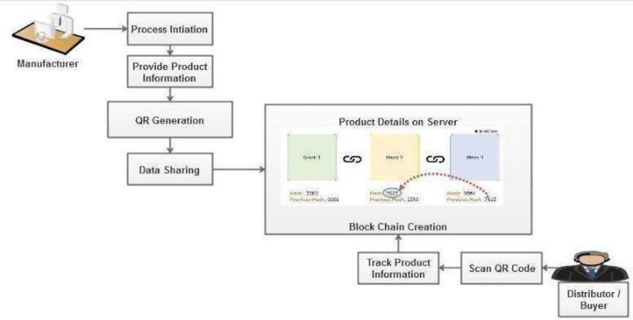
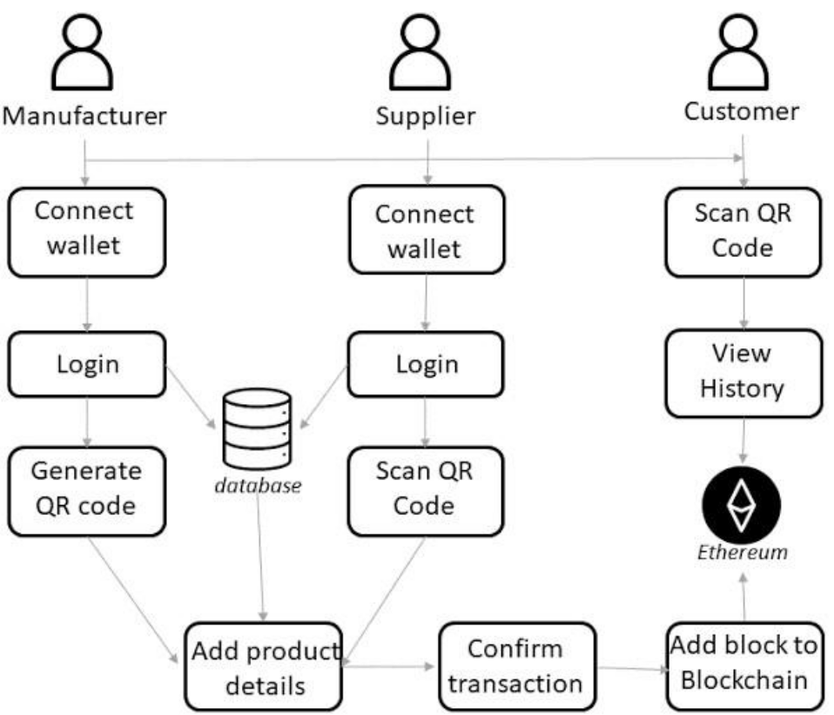

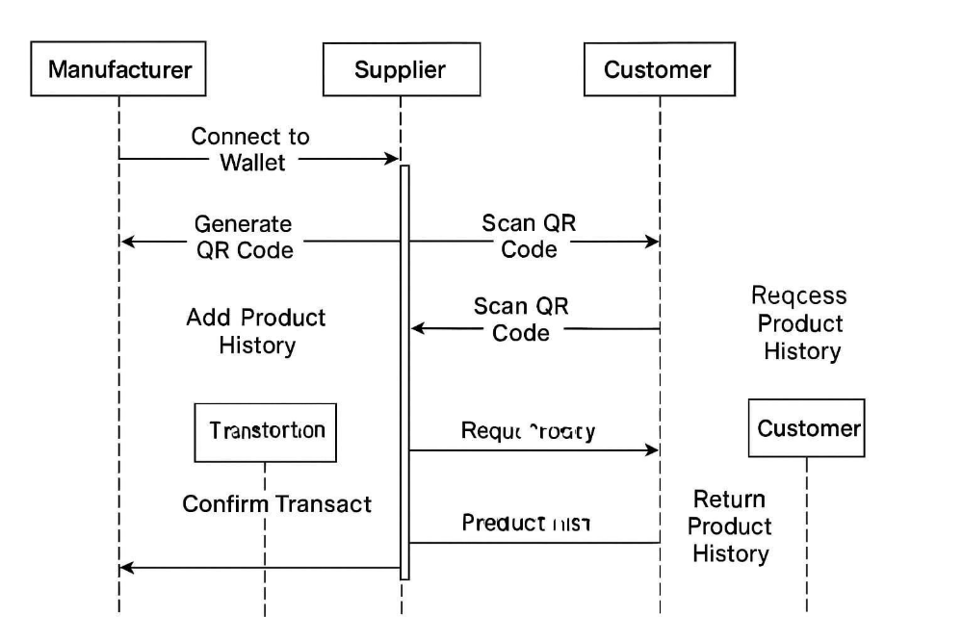

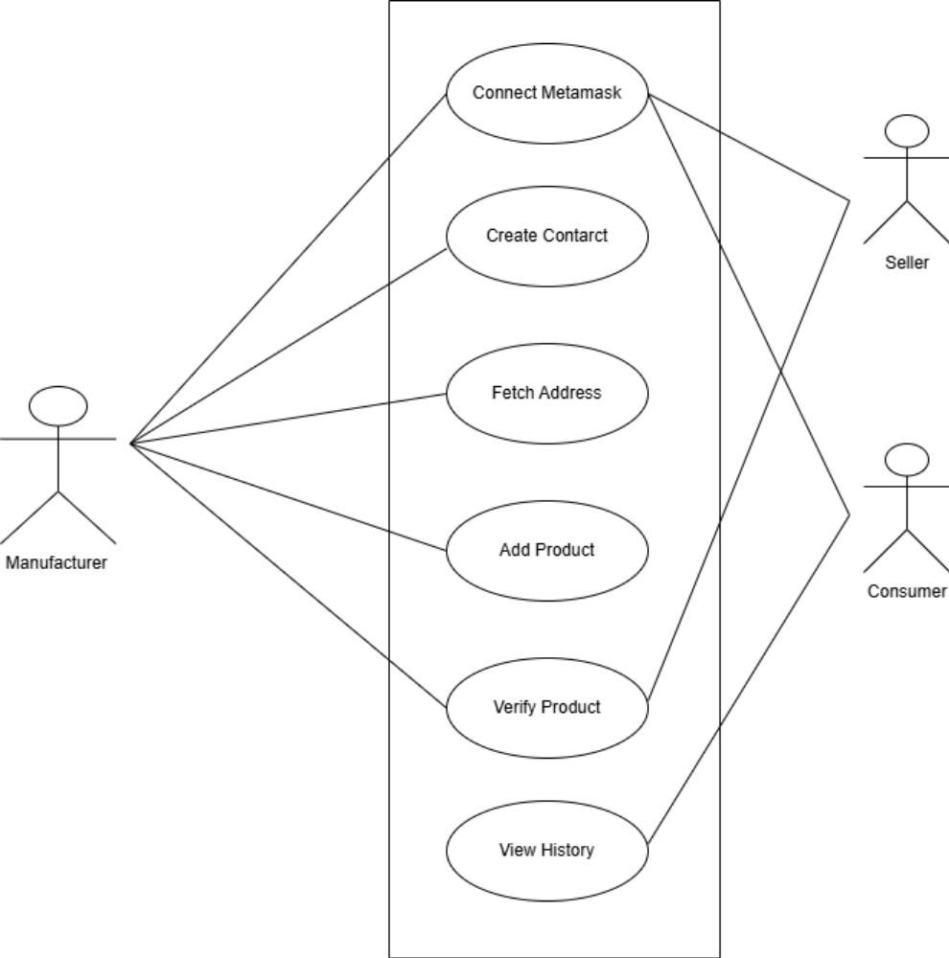

- MANUFACTURER
1.Adding Seller:
2.Adding Product:
3.Sale Product:
4.Query Seller:

- SELLER
1.Checking Available Products:
2.Selling the Product to Consumers:

- CONSUMER
1.Verifying the Product:
2.Checking Product History:

