Dayso

Solonnhat_day_bit

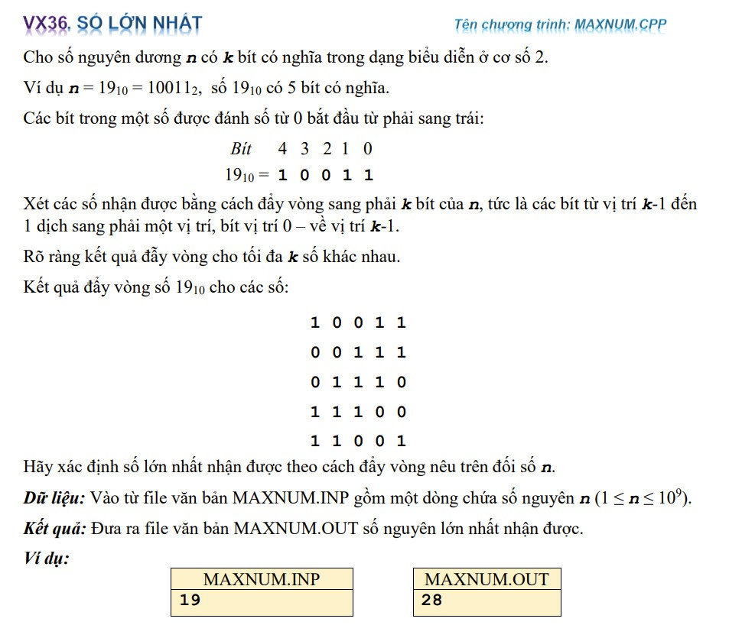

[1498. Number of Subsequences That Satisfy the Given Sum Condition](https://leetcode.com/problems/number-of-subsequences-that-satisfy-the-given-sum-condition/)