STRAIN Client – Sterner communication v0.1

You – the player that is logged in at the moment
Active game – a game that You are a part of and it has already started (game might still be in deployment phase), i.e. all players accepted this game
Unaccepted game – a game You were invited to, but did not accept yet
Waiting game – a game You created but other players did not accept yet
Public game – a game someone created with a public flag, which means anyone can join

Client log in process:

- Client needs to call ClientMsg. setupAddress( ip_address, port )
- Client calls ClientMsg.login( username, password ), this method returns None if logging in was a success, or an error message (string), which would be great if it can be displayed in a mesagebox?!
- Immediately after logging in, client will receive couple of messages, details of these messages can be found in later section Sterner messages to Client:
  - ALL_PLAYERS – a list of all players currently present in Sterners database, so client can add them to game invites and such
  - ALL_LEVELS – a list of all maps currently available to play on (their names in string format only for now)
  - MY_ACTIVE_GAMES – list of Your active games
  - MY_UNACCEPTED_GAMES – list of Your unaccepted games
  - MY_WAITING_GAMES – list of games Your waitinggames
  - EMPTY_PUBLIC_GAMES – list of empty public games
  - NEWS_FEED – list of last 3 news items

After client has logged in (and received these messages) it can now start to send and receive messages normally.

Client messages to Sterner:
After the client has logged in, he can send following „Sterner“ messages (as opposed to “engine” messages which are used to communicate with each game engine seperately) each has its own ClientMsg function:

getAllFinishedGames(): after sending this message Sterner will return a list of your finished games (used to get game list for replays)

startNewGame( map, budget, players, public_game, game_name ): used for creating a new game, after sending this message Sterner will return a message telling the new game has started and its id (NEW_GAME_STARTED, game_id)
map - string u got from Sterner after logging in
budget - number – budget for buying a squad
players – list of player ids that will be int he game (the sequence will correspond to player order in game, i.e. the first player int his list will have the first turn). If the game is public you can put 0 for empty slots
public_game – True is this game will be public, False if it is private
game_name – string – name of the game, or empty string if you want Sterner to automatically generate the name for you

acceptGame( game_id ): You accept a game invite, after sending this message Sterner will send you a message confirming your acceptance and new active game list, new unaccepted game list and waiting game list if needed

declineGame( game_id ): You decline a game, after sending this message Sterner will send you new unaccepted game list

refreshGameLists(): After sending this message you will receive all the lists as when you logged in (not just games , but players, levels and news feed as well)

Sterner messages to Client:

Sterner can send following messages to Client, so Client must be able to handle all of them.

Each Game has following attributes:
0:id – number –game id
1:map – string – map name
2:budget – number – player budget
3:turn – what turn the game is in
4:active_player_id – id of player currently on turn
5:status - (0=waiting,1=in progress, 2=finished)
6:date created – python date (float number f seconds since...)
7:date finished – python date (float number f seconds since...)
8:version – current game is being played in this version
9:public – number - 0/1 – is the game public or private
10:name – game name

Each News item has the following attributes:
0: id
1: date
2: title
3: text

(ALL_PLAYERS, all_players)
all_players – list of tupples (player_id, player_name)

(ALL_LEVELS, all_levels)
all_levels – list of strings containing all available maps that server can host

(MY_ACTIVE_GAMES, active_games)
active_games - list of Your active games

(MY_UNACCEPTED_GAMES, unaccepted_games)
unaccepted_games – list of your unaccepted games

(MY_WAITING_GAMES, waiting_games)
waiting_games – list of your waiting games

(EMPTY_PUBLIC_GAMES, empty_public_games)
empty_public_games – list of empty public games

(NEWS_FEED, news_list)
news_list - list of 3 News items

(NEW_GAME_STARTED, game_id)
game_id – id of a new game started

(ERROR, error_msg)
error_msg – string containing an error message

(ALL_FINISHED_GAMES, finished_games)
finished_games - list of Your finished games

(ACCEPT_GAME, game_id)
game_id – id of game You just accepted

(PONG, timestamp)
timestamp – timestamp of a moment Sterner put this message in send queue, not really usefull for anything ☺

Handling of messages

Client can and will receive messages in no particular order, and in undetermined times, so Client should be able to handle them. For instance when client receives a message containing his active games, client should update his internal list and, if in game browser screen, displayed list immediately.

Login screen

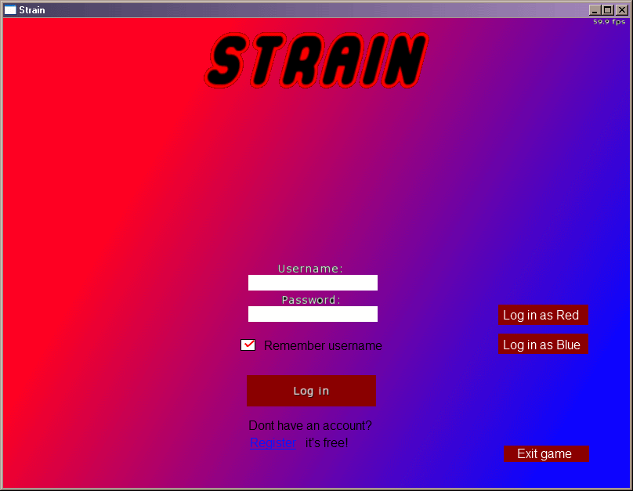

- username and password textboxes (password should be password box, not displaying letters only stars)
- ‘Remember username’ checkbox
- ‘Log in’ button
- ‘Log in as Red’ and Blue – debug buttons (calls login with username ‘Red’ or ‘Blue’ and with empty password)
- ‘Exit game’ button
- ‘Register’ link

When entered focus should be on username textbox, TAB should move focus to password textbox, TAB should move focus to ‘Remember username’ checkbox, and TAB should move focus to ‘Log in’ button.
If enter pressed while typing in password, it should do the same action as pressing ‘Log in’ button.

Game browser screen

Main view when not in game.

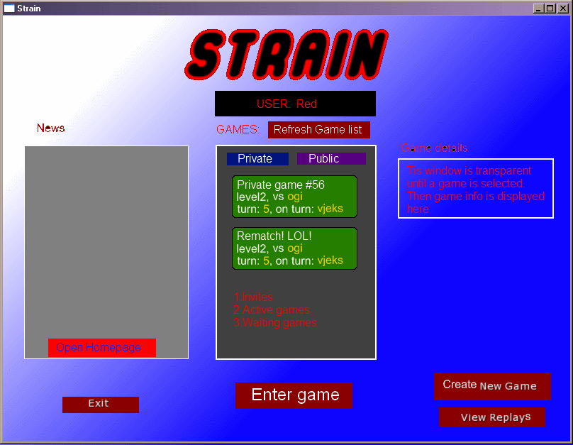

- News Box – contains news, and ‘Open homepage’ button
- ‘Exit game’ button
- User box – name of user
- ‘Refresh Game List’ – calls clientMsg.refreshGameLists()
- Game list:
  - ‘Private ‘ and ‘Public’ tab
  - Buttonlike entries with short text about the game
  - Order of games: invites, active, waiting
- ‘Enter Game’ button
- Game details – only appears when a game is selected in game list, it displays all info about game
- ‘Create new game’ button – leads to ‘New game screen’
- ‘View Replays’ button – leads to ‘Replay Viewer screen’

New game screen

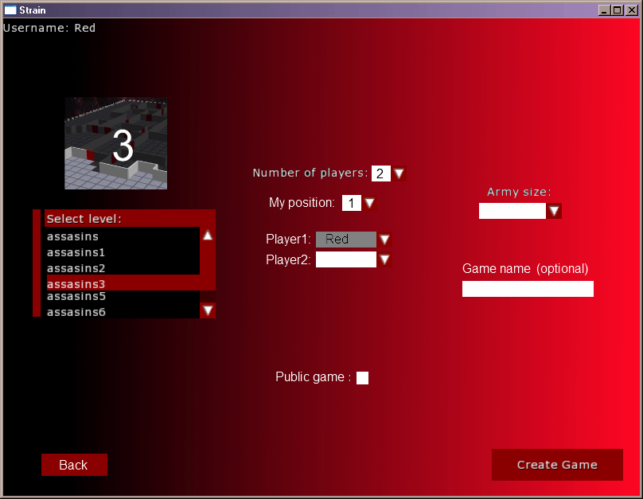

- Map list – filled in when client gets ALL_LEVELS message (pictures not included yet)
- ‘Number of players’ dropdown menu – this number dictates how many player positions there will be, and also max number of options for ‘My position’ dropdown menu (you cannot be 3rd in 2 player game)
- ‘My position’ – my position in game, this determines the order in which the players will play, perhaps needs a better name
- ‘Player X:’ – dropdown menus to select players (display player name from ALL_PLAYERS list, do not display current player)
- ‘Public game’ – checkbox, if checked, change all Player names to empty (client will need to send 0 as player id for those players) except the creators
- ‘Army size’ – dropdown menu (for now 500, 100, 1500)
- ‘Game name’ – this is optional
- ‘Back’ button – leads to Game browser screen
- ‘Create Game’ – sends create game message, but waits for confirmation (NEW_GAME_STARTED) message than display a message box ‘Game created successfuly!' and when OK button is pressed, go back to Game browser screen

Select Replay screen

When entering this screen client needs to send getAllFinishedGames() to get game list.

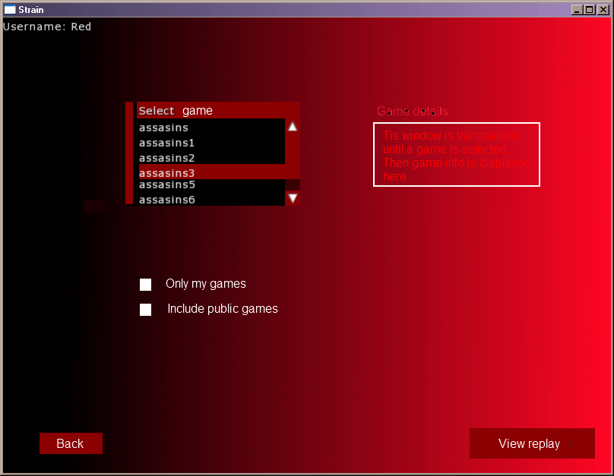

- 'Select game' – games list
- 'Only my games' –show only my games in the list
- 'Public games' – include public games in the list
- 'Game details' – when a game is selected int he list, display its details here
- 'Back' button – leads to Game browser screen
- 'View replay' – starts replay

