1. $Θ\left(n^{2}\right)$ $c_{1}=2, c_{2}=3,n_{0}=1$

2. $O({n^{2}2}^{n})$ $c=101, n_{0}=10$

3.

(1) O($n^{3}$)

i will iterate from 0~n-1, it take n times

j will iterate from 0~n-1 each i, it take $n^{2}$ times

k will iterate from 0~n-1 each j, it take $n^{3}$ times

total cost $n^{3}+n^{2}+n$

when $c=2, n_{0}=2$

$n^{3}+n^{2}+n≤{cn}^{3}, when {n≥n}_{0}$

So the time complexity is O($n^{3}$)

(2) $O(n^{3})$

i will iterate from 0~n-1, it take n times

j will iterate from 0~n-1 each i, it take $\sum_{t=1}^{n}{t}=\frac{\left(n+1\right)n}{2}$ times

k will iterate from 0~n-1 each j, it take $\sum_{t=1}^{n}{\frac{\left(t+1\right)t}{2}}=\frac{\sum_{t=1}^{n}{t^{2}+t}}{2}=\frac{2n^{3}+6n^{2}+2n }{12}$ times

total cost $\frac{1}{6}n^{3}+n^{2}+\frac{10}{6}n$

when $c=\frac{2}{6}, n_{0}=8$

$\frac{1}{6}n^{3}+n^{2}+\frac{10}{6}n≤cn^{3},when n≥n_{0}$

So the time complexity is O($n^{3}$)

4.

(1)

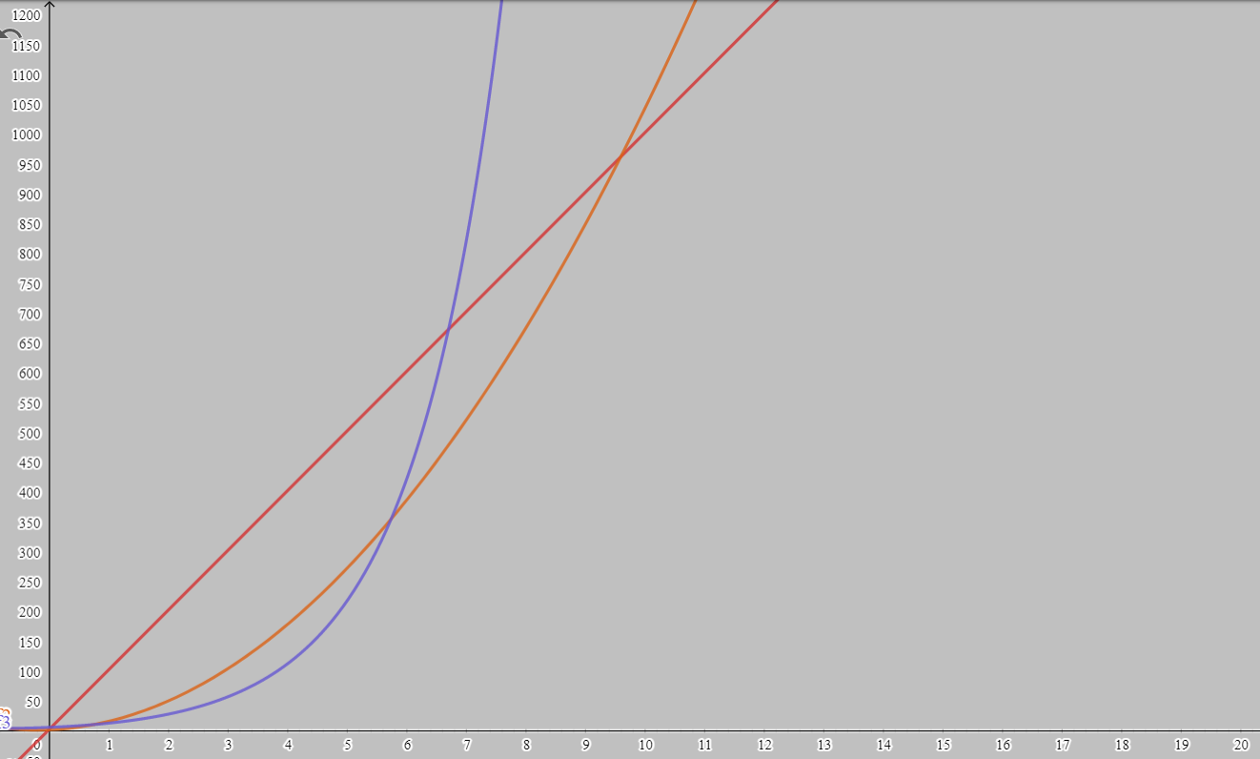

f1

f2

f3

(2) f3’(n)>f2’(n)>f1’(n), when n>=4.8

O(f1(n))=O(n)

O(f2(n))=O($n^{2}$)

O(f3(n))=O($2^{n}$)

(3) O($n^{t}$) is meaning $f\left(n\right)≤{c*n}^{t},when n≤n_{0} f\left(n\right)is n-polynomial$,

so the constant can put into c

(4) $n^{2}+n<cn^{2}, when n≤n_{0}$

let c = 2, $n_{0}=0$, then $n^{2}+n$‘s time complexity is O($n^{2}$)