Xianthium

By Kay Piotrowski
ECE102
December 3, 2018
This report documents the process of designing and creating the game Xianthium for the ECE102 class. The product being designed is a fantasy text-based role-playing game that follows a series of written code based off of instructions given by the user. This means it is a fictional game with no images or animations and the role of the character must be personified by the user through a list of given commands. This product was chosen to offer another story to follow in a world full of games. Although there are many games today, this is an open-source product meaning it is uploaded to the internet to allow people to use the ready-made design, create changes, and submit their edits to the original designer to be considered in the next release of the product. The end goal is to create an open-source game that people can edit and make their own. This creates a much more user customized game and one day can become the game that people want to play to enjoy the fantasy adventures they crave, and to escape the real world.
Many of today's games are made in a visual 3D world with a limited amount of options to customize the character and their actions. That is where the freedom of a text-based game becomes unique. The actual visuals are words which make it easier to customize the character, the world around them, and how they behave. The difference between, “She opened the door.” and “She opened the door slowly as it creaked loudly announcing her arrival.” is that the second is very descriptive. The details mark the difference between a story and a good story. This creates the setting and mood of the game while bringing it to life in a way that puts the user in control of the universe within the game based on their commands.
This game was built so it starts out by speaking to the user and instructing them on how to pick a race for their character. They have a choice between being a human, an elf, a fairy, a dwarf, or a giant. These simply give more of a description to the character to put the user more into the game. If none are chosen, they are auto-generated to human. In the future of the game, this will also allow more personalization to the characters. A class gives them an idea as to what they look like to play the story like a movie in their head a bit. The visual is your own imagination in action!
The following construction was the most intense which is where it has them pick a class that will determine how their character will fight in the game and how they will interact with the world around them. It also determines the base score of health and mana or energy based on the skills necessary to be the class they chose. The class choices are Soldier, Engineer, Necromancer, Elementalist, Sage, and Assassin.
The Soldier begins with health and energy and they fight with a large weapon such as a sword and use energy to move around or fight. The Engineer starts with health and energy and they use a machine weapon such as a crossbow or other type of advanced weapon to fight. Their energy is spent on moving and shooting their weapon although less energy is used on their weapon than a soldier uses. The Necromancer starts with health and mana and they fight using their magic to raise the undead. Damage taken by their undead will be taken from the character at half the rate of normal damage to other weapons-based characters but they begin with less health. The Elementalist starts with health and mana and fights using their magic to control earth, fire, wind, and water. The Sage starts with health and mana and fights with a divine maul given by the gods that can heal them twice as fast and steals health from their foes. Lastly, the Assassin begins with health and energy and fights with smalls weapons such as daggers and can attack more than once at a time due to their speed which makes them need more energy. (Images of each will be pictured below to provide a mental image to work with.)
The next part built is when it has them choose a name for their character. If they decide to skip forward without putting a name down, they will automatically receive Balducci as their name. This name was chosen because the base version or bone structure of the game was originally created by Francesco Balducci in 2010. It then puts the character in-game and instructs the user how to control the game. Each class that is chosen at the beginning follows the basic storyline with customizations based on the class which is described above.
This game was created using Python, an object-oriented programming language that has an easy to learn syntax (structure of how it is written) that helps with creating new programs and reduces the cost of program maintenance. Python is a widely used modern day programming language that makes the difficulty of programming a bit easier to learn and branch off from. Although python was the programming language, the software used was Visual Studios to run the program as many times as necessary without the hassle of typing in the run command each time. The building of the game was long not due to difficulty, but having it how you want it to work, and having a foolproof design that keeps the game from crashing. Another program used was a “py to exe converter” to change python files to executable files that can run on any and all computers. This also gives the ability to share to anywhere and have it run without having them to understand the programming language or things necessary to use that programming language.
This project took several months to design and build and it will be in constant update and construction in the future. The designer begins by coming up with a basic design of a game on paper. They describe what they want to do and how they want the game to behave. They decide what commands they want to have, what limitations they want to create and where they want to let the user unleash their imagination. Once the code is being written, the designer jumps between the written notes, and the code being produced and determines what they want to put through, things they want to add or change and what they want to get rid of. Much of what is written at the beginning of the design process is totally overhauled and changed throughout the build of the program. This specific project was much different in the beginning and has changed much more than anticipated already let alone in the coming future.
This project will give the user options to play forward in the storyline being able to level up and gain more power as they go forward. They are able to explore the land, attack enemies, heal themselves, rest, flee from a fight, look at their status, and finally quit. They can explore the land and in the future, a given map will be available. They will defeat goblins and also in the future, other creatures. They can heal to regain health or rest to regain energy or mana. Also available is the ability to flee from a fight when their health is low and to check the status of their characters health, energy or mana, and their current level. When they quit the game, there is not a current save method which means their character will cease to exist or die. Each character based on their class has a specific way to quit the game.
This game could end now or it could go on for years. This game will be an open-source game as mentioned before meaning that this game will be put online with all the code and information and people will be able to copy what has already been made and make edits to it to make it a game that is customized to the users liking while also making it a more unique game for all. The imagination is endless, especially in a text-based game. The collaboration needed to make this game into an amazing user-oriented game could last years. This project is meant to combine a text-based game and the users' desires making it a user-oriented game. Meaning, in the end, the hope is to have this game last for many years to come in different versions and a variety of change in the future editions.
This marks the beginning of working in the gaming industry or simply with programming languages in general. Becoming a software engineer means taking the goals of a client and putting it into action in the best way possible. In this instance, the idea was to build something that was a product of software engineering in it and of itself. The finished product thus far is an example of a beta version of a text-based game that is ready to be tested by the users. This kind of open-source game can go on for years and morph into anything the imagination can create and inspire others to create new and exciting games and adventures!

The following are examples of what the characters may look like.

Soldier
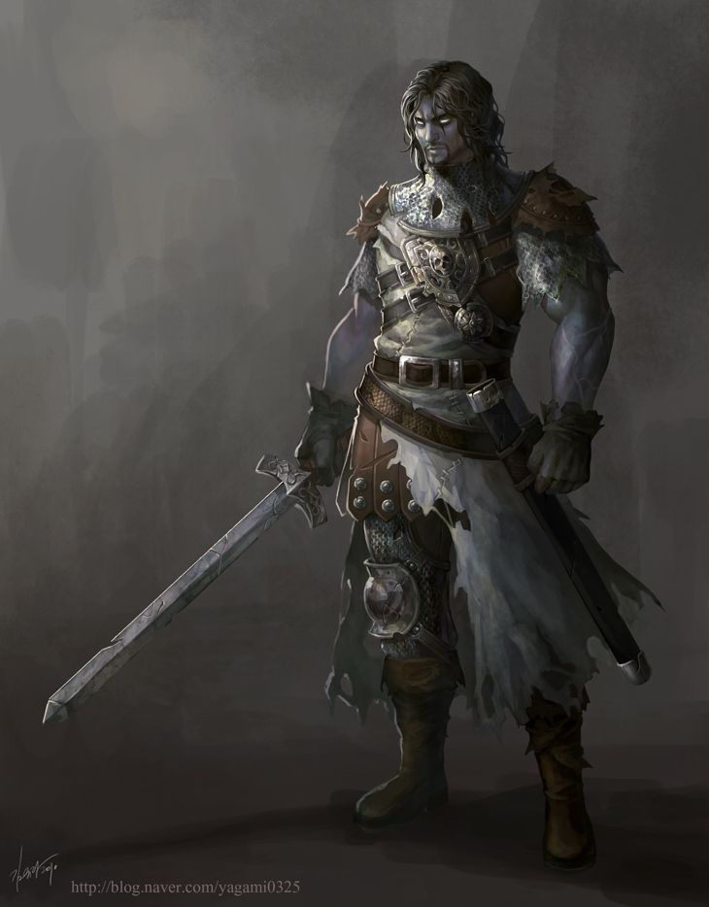

Necromancer
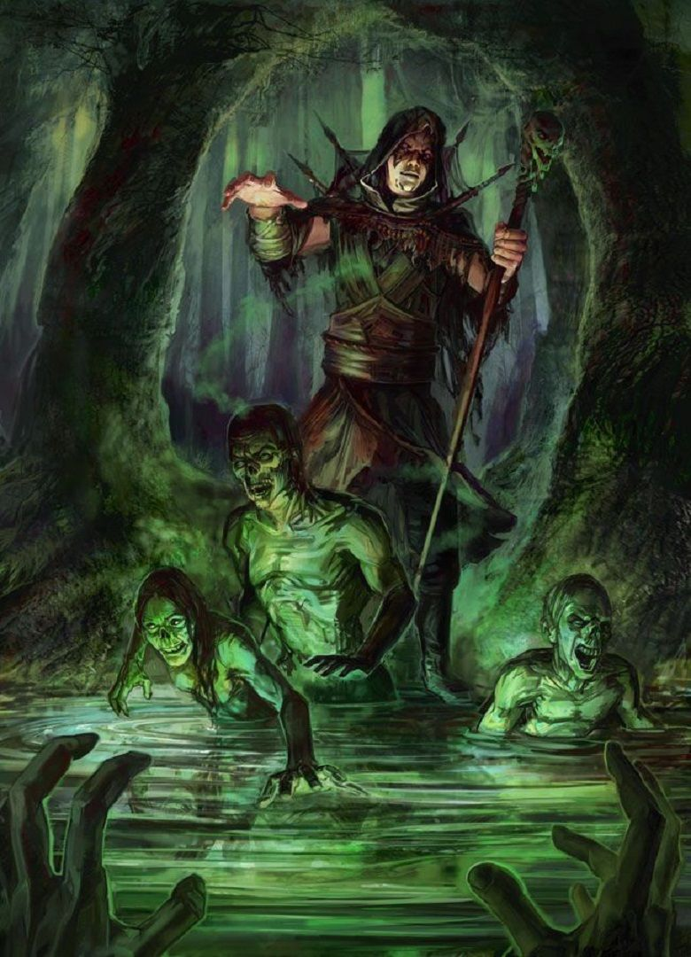

Sage
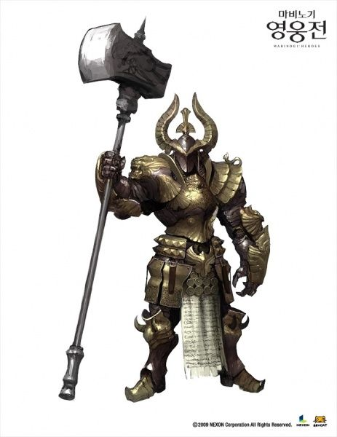

Engineer
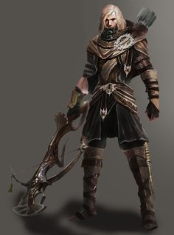

Elementalist
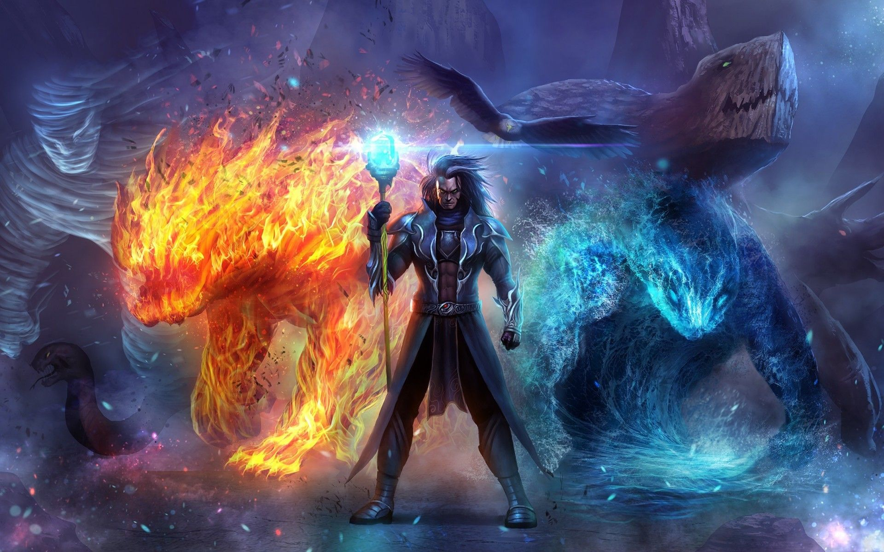

Assassin
