**Ashish Assist (Tiny helper for coders)**

**A MINI PROJECT REPORT**

***Submitted by***

**THOMAS CHERAIN** (0015113148)

**Under the guidance of**

MS. **LINDA** JOSEPH

***in partial fulfillment for the award of the degree***

***of***

**BACHELOR OF ENGINEERING**

**IN**

**COMPUTER SCIENCE AND ENGINEERING**

**

**HINDUSTAN INSTITUTE OF TECHNOLOGY AND SCIENCE CHENNAI - 603 103**

OCTOBER 2017

**Ashish Assist (Tiny helper for coders)**

**A MINI PROJECT REPORT**

***Submitted by***

**THOMAS CHERAIN** (0015113148)

**Under the guidance of**

MS. **LINDA** JOSEPH

***in partial fulfillment for the award of the degree***

***of***

**BACHELOR OF ENGINEERING**

**IN**

**COMPUTER SCIENCE AND ENGINEERING**

**

**HINDUSTAN INSTITUTE OF TECHNOLOGY AND SCIENCE CHENNAI - 603 103**

APRIL 2017

**

**BONAFIDE CERTIFICATE**

Certified that this project report **“Ashish Assist”** is the bonafide work of **“THOMAS CHERIAN (0015113148)”** Who carried out the project work under my supervision during the academic year 2016-2017.

**SIGNATURE SIGNATURE**

**HEAD OF THE DEPARTMENT SUPERVISOR**

**DR.RAJESWARI MUKESH** **MS. LINDA JOSEPH**

**INTERNAL EXAMINER EXTERNAL EXAMINER**

Name: ________________________ Name: ________________________

Designation: ____________________ Designation: ____________________

Institution Name: ___________________

Project Viva - voce conducted on ___________

**ACKNOWLEDGEMENT**

We wish to express our heartfelt gratitude to **Mrs. Rajeswari Mukesh, Head of the Department, School of Computer Science Engineering** for much of her valuable support, encouragement in carrying out with this project.

I am very grateful to my project supervisor MS. LINDA JOSEPH**, Associate Professor, Department of Computer Science and Engineering** for the guidance, inspiration and constructive suggestions that helpful me in the preparation of this project. I won’t forget to also mention class mates for their wonderful and skillful guidance in assisting me with the necessary support to ensure that my project is a success. I also thank my parents and family at large for their moral and financial support in funding the project to ensure successful completion of the project.

**ABSTRACT**

Ashish Assist is basically a script to remind me to take water, go out and exercise while I code. It also uses to machine learning to protect my computer from intruders and toddlers alike. Apart from that it provides me with a random comic to lighten my mood every 30 minutes.

|  |  |  |
| --- | --- | --- |
| **TABLE OF CONTENTS** | | |
| **CHAPTER NO.** | **TITLE** | **PAGE NO.** |

Contents

1. INTRODUCTION 1

1.1 INTRODUCTION: 1

1.2 ABOUT: 1

1.3 SUMMARY: 1

2 PROJECT DESCRIPTION 2

2.1 INTRODUCTION: 2

2.2 EXISTING SYSTEM:. 2

1. My mom coming to my room and asking me to go out. 2

2. A toddler coming and using my system and jamming my keys 2

3. Me drinking water when I’m completely parched. 2

2.2.1 SHORT COMES OF EXISTING SYSTEM: 2

Can get a tad bit irritating, especially when doing some work. 2

2.2.2 PROBLEMS OF THE EXISTING SYSTEM: 2

2. 3 PROPOSED SYSTEM: 2

2.3.1 BENEFITS OF PROPOSED SYSTEM 2

CHAPTER 3 4

3 SYSTEM DESIGN 4

3.1 INTRODUCTION: 4

3.2 OBJECTIVES OF THE DESIGN: 4

3.2.1 FACTORS CONSIDERED IN THE DESIGN: 4

3.3 OUTPUT DESIGN: 4

3.5 PROGRAM DESIGN: 5

3.5.1 Main module 5

3.5.2 Face Recognition Module: 5

3.5.2 Brightness Module: 9

3.5.4 Comics Module: 10

3.5.5 Get out Module: 11

3.7 SUMMARY: 11

4. TESTING 12

4.1 INTRODUCTION: 12

4.2TESTING METHODS: 12

4.2.1 Testing your face recognition: 12

4.3 SUMMARY: 13

5 SOFTWARE REQUIREMENT ANALYSIS 14

5.1 INTRODUCTION: 14

5.2 PROBLEM DEFINITION: 14

5.3 FEASIBILITY ANALYSIS: 14

5.3.1 ECONOMIC FEASIBILITY: 15

5.3.2 TECHNICAL FEASIBILITY: 15

5.3.3 BEHAVIORAL FEASIBILITY: 15

5.4 METHODOLOGY: 15

5.5 LIFECYCLE MODELS 16

5.6 SOFTWARE AND HARDWARE REQUIREMENTS: 16

5.7 SYSTEM ANALYSIS: 17

5.8 SUMMARY: 18

6. CONCLUSION 19

6.1 FUTURE ENHANCEMENT 19

7. RFERENCES 20

APPENDIX 21

|  |  |  |
| --- | --- | --- |
|  | **LIST OF FIGURES** |  |
| **FIGURE NO** | **NAME** | **PAGE NO** |
| 3.5.1 | Chat interface | **14** |
| 3.5.2 | Language tools | **15** |
|  |  |  |

**CHAPTER 1**

1. **INTRODUCTION**
   1. **INTRODUCTION:**

I keep having toddlers over my place that completely mess up my system. So I decided to make a script to help me fight of pesky intruders and keep me in check while I am doing work.

**1.2 ABOUT:**

Ashish Assist as the name suggests is built over my use case scenario and helps me.

It has the following functions

1. Face Recognition
2. Smart Brightness setting
3. Automatic lockdown
4. Age detection
5. Alert for me to go and drink water
6. Alert for me to go out and do some stretching
7. Periodic display of random comic to lighten the mood

**1.3 SUMMARY:**

This document contains the design of a module for the Ashish Assist. This module offers the above functions. It uses high level azure api’s and offline DLIB modules for face recognition.

**CHAPTER 2**

**2 PROJECT DESCRIPTION**

**2.1 INTRODUCTION:**

This chapter reviews how the existing system and proposed system works as well as to produce a better alternative for its improvement.

**2.2 EXISTING SYSTEM:.**

1. My mom coming to my room and asking me to go out.

2. A toddler coming and using my system and jamming my keys

3. Me drinking water when I’m completely parched.

**2.2.1 SHORT COMES OF EXISTING SYSTEM:**

Can get a tad bit irritating, especially when doing some work.

**2.2.2 PROBLEMS OF THE EXISTING SYSTEM:**

* I am not allowed to tell the kid to leave my laptop alone.
* Not allowed to tell Mom that I’ll go out later.
* Have to keep setting my screen brightness
* Have to search for the comic to set a lighter mood while working.

**2. 3 PROPOSED SYSTEM:**

* Automates all the above problems and does a great job at it.

**2.3.1 BENEFITS OF PROPOSED SYSTEM**

* Mom doesn’t shout
* Kid doesn’t cry
* I’m hydrated
* My laptop can be used by me alone

**2.4 SUMMARY:**

In this chapter we have discussed about short coming of the existing system, problems of the existing system .so that we can overcome with the new proposed system. We have also discussed about advantages of proposed system.

**CHAPTER 3**

**3 SYSTEM DESIGN**

**3.1 INTRODUCTION:**

System design is the specification or construction of a technical, computer-based solution for the business requirements identified in system analysis. It gives the overall plan or model of a system consisting of all specification that give the system its form and structure (i.e. the structural implementation of the system analysis).

**3.2 OBJECTIVES OF THE DESIGN**:

The objective of designing the new system is to provide an automated response to all the problems mentioned in the previous chapter.

**3.2.1 FACTORS CONSIDERED IN THE DESIGN:**

The following are the factors put into consideration during the design of the new system;

To design

• Should not slow the computer

• Should work at all times

• A time effective system.

**3.3 OUTPUT DESIGN:**

The output design contains all the necessary details of the processed input by the system which is drawn from different data inputs to the machine learning module and the other input it gets during use of the laptop.

**3.5 PROGRAM DESIGN:**

This is where the programs that will run the modules identified in the control center are specified. This will enable the researcher to capture the complete working picture of the application, how each component is related to another, the calling program modules and the ones called. The Ashish Assist consists of various program modules. Each module of the system is a complete module and part of the entire system. Below are the various modules contained in the application.

**3.5.1 Main module**

The main module is responsible for making the processes and running the other modules efficiently without slowing down my system.

**3.5.2 Face Recognition Module**:

The first step in our pipeline is face detection. Obviously we need to locate the faces in a photograph before we can try to tell them apart! If you’ve used any camera in the last 10 years, you’ve probably seen face detection in action:

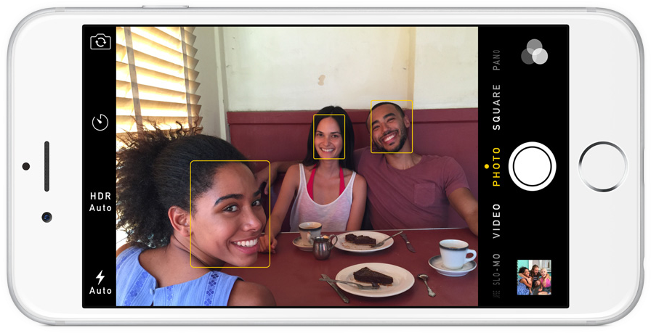

**Fig 3.5.2: Face Detection**

To find faces in an image, we’ll start by making our image black and white because we don’t need color data to find faces:

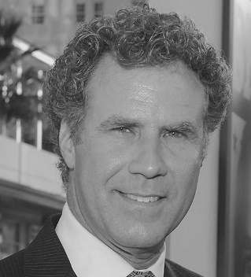

**Fig 3.5.3: Will Farrell**

Then we’ll look at every single pixel in our image one at a time. For every single pixel, we want to look at the pixels that directly surrounding it:



**Fig 3.5.4: Eye Detection**

Our goal is to figure out how dark the current pixel is compared to the pixels directly surrounding it. Then we want to draw an arrow showing in which direction the image is getting darker: Looking at just this one pixel and the pixels touching it, the image is getting darker towards the upper right. If you repeat that process for every single pixel in the image, you end up with every pixel being replaced by an arrow. These arrows are called gradients and they show the flow from light to dark across the entire image.

To find faces in this HOG image, all we have to do is find the part of our image that looks the most similar to a known HOG pattern that was extracted from a bunch of other training faces:

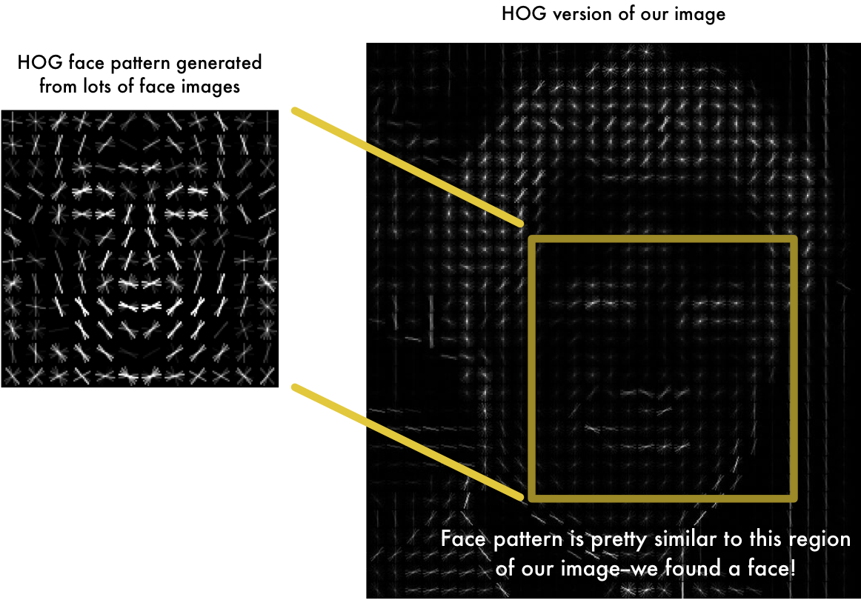

**Fig 3.5.5: Face Pattern Detection**

**Using this technique, we can now easily find faces in any image:**

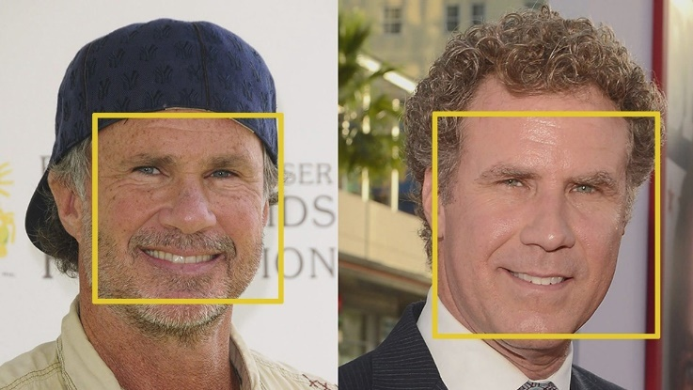

**Fig 3.5.6: Face Pattern Detected**

#### Encoding our face image

This process of training a convolutional neural network to output face embeddings requires a lot of data and computer power. Even with an expensive NVidia Telsa video card, it takes about 24 hours of continuous training to get good accuracy. But once the network has been trained, it can generate measurements for any face, even ones it has never seen before! So this step only needs to be done once. Lucky for us, the fine folks at OpenFace already did this and they published several trained networks which we can directly use. Thanks Brandon Amos and team! So all we need to do ourselves is run our face images through their pre-trained network to get the 128 measurements for each face. Here’s the measurements for our test image:

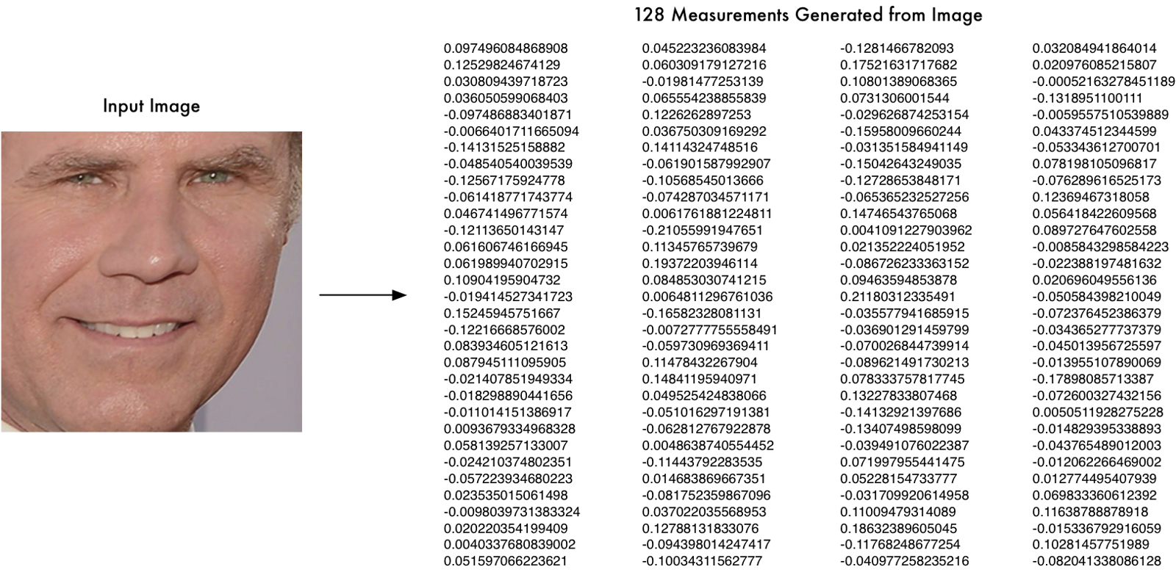

**Fig 3.5.7: Face Encoding**

**3.5.2 Brightness Module**:

To set the brightness of the screen, you must first find what the brightness of the room is. To do that, you must first get an image of the room. Then follow the following steps

1. Convert image into array. Done by converting the image from an object and converting it into numpy array.
2. To understand this further let us first understand what each pixel is.   
   A pixel is nothing but a tuple of three values- Red, Green and Blue.  
   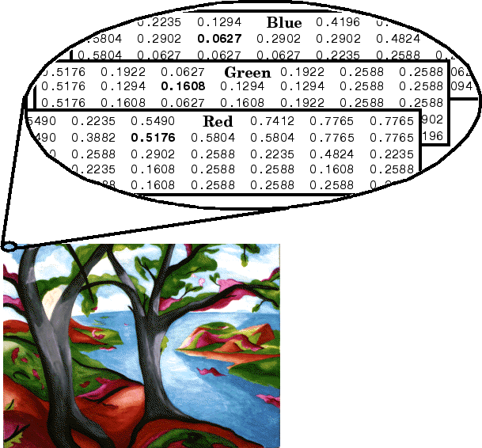

**Fig 3.5.8: Pixel Encoding**

1. Now we calculate a mean of these values to get the mean brightness in the entire picture of the room
2. Now using the formula   
   value = int(10 / 13) * value  
   we calculate the next brightness value for the screen.

**3.5.3 Age Module**:

The age module goes into Microsoft azure and uses the face api to calculate and get the age.

This happens using the following steps

1. Gets an unidentified face
2. Sends face to azure
3. Extracts age from the json response
4. Sends back the age

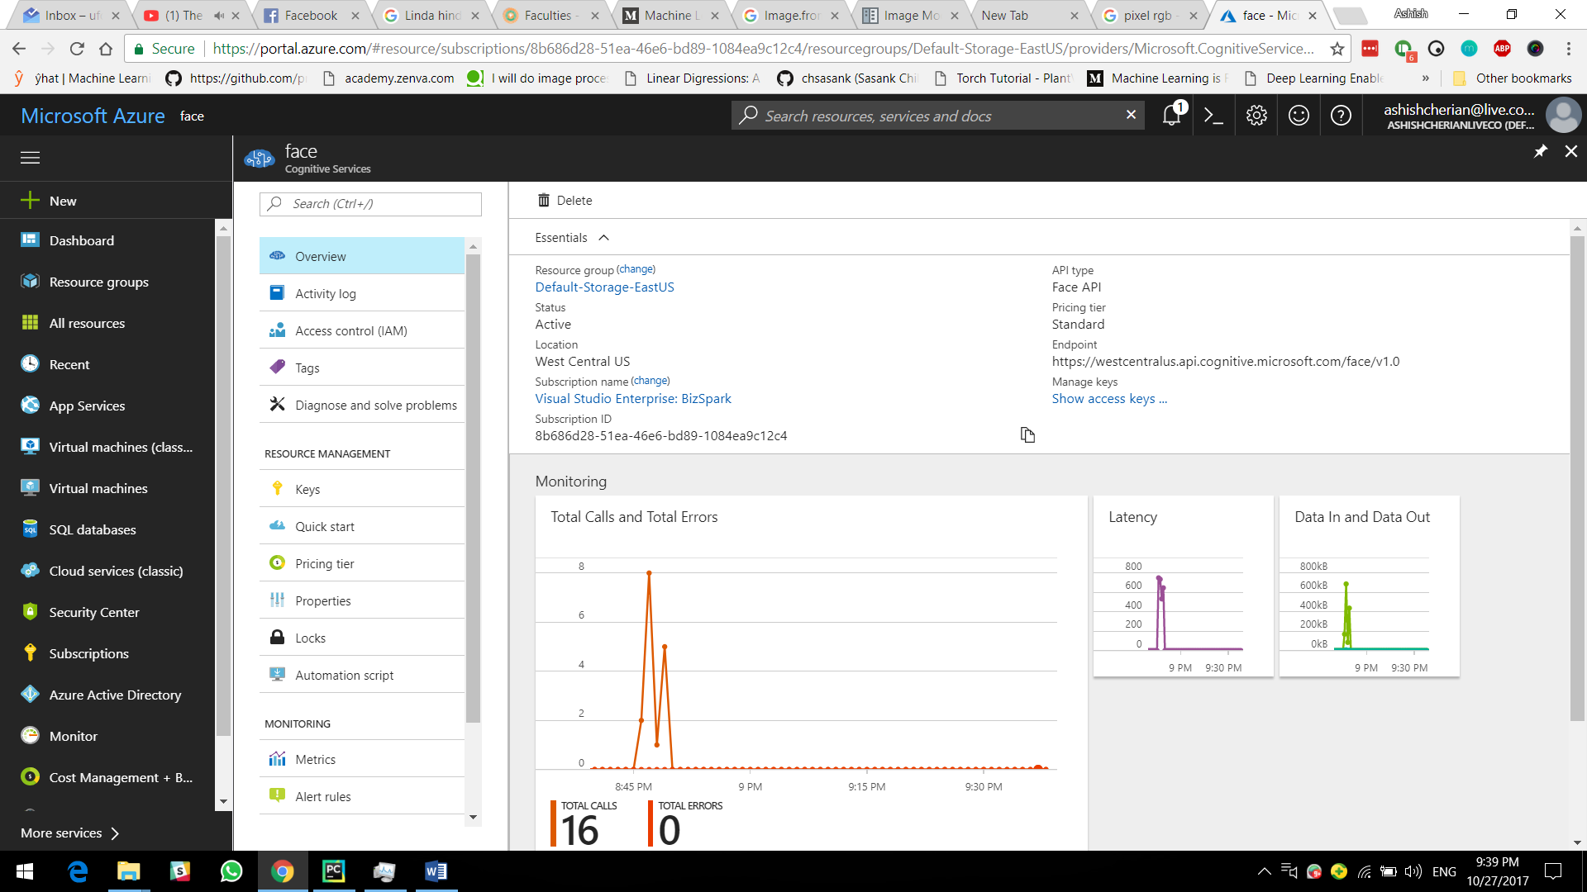

**Fig 3.5.9: Azure Face API**

**3.5.4 Comics Module:**

The comics module does the following tasks

1. Queries the webpage for the latest comic number
2. Generates a random comic number from 1 – latest
3. Gets the comic from the webpage
4. Saves the comic as jpg
5. Open the comic to show

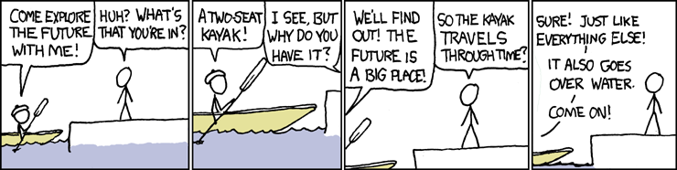

**Fig 3.5.10: Random comic**

**3.5.5 Get out Module:**

**Just alerts me every 2 hours to go out of my room and stretch and also drink water.**

**3.7 SUMMARY:**

In this chapter we have discussed about the how the image processing, face detection, face recognition and other modules using in Ashish Assist.

**CHAPTER 4**

**4. TESTING**

**4.1 INTRODUCTION:**

Firstly we will start testing with individual module and will perform unit testing on that. So we successfully verify and validate all modules by successively integrating each module. Moreover checking the work done was very important to reduce risk factor. Checking was being ultimately handled by testing but interim checking was required.

**4.2TESTING METHODS:**

**4.2.1 Testing your face recognition:**

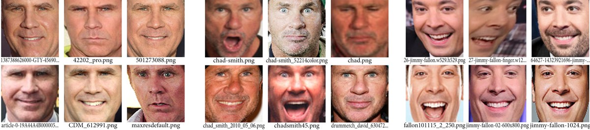

**Fig 3.5.11: Labeled faces**

Have a dataset filled with labelled faces to carry out the testing.  
We will use the Yale Face Database that contains 165 grayscale images of 15 individuals in gif format, There are 11 images for each individual. In each image, the individual has a different facial expression like happy, sad, normal, surprised, sleepy etc. Indeed, there are 166 images with 12 images for the first individual. We will use this database by using 10 images of the total 11 images of each individual in training our face recognizer and the remaining single image of each individual to test our face recognition algorithm.

The images corresponding to each individual are named like subject<number>.<facial_expre ssion>where number ranges from 01, 02, 03…, 14, 15 and facial_expression is the expression that the individual has in the image.

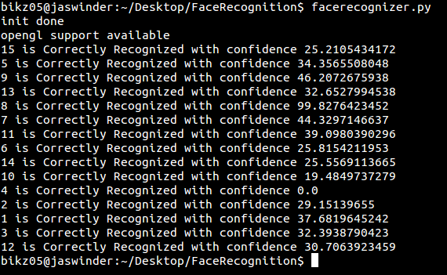

**Fig 3.5.12: Labeled faces**

Now we just test each of the faces and see if you get a correct label.

**4.3 SUMMARY:**

In this chapter we have discussed about testing and also importance of testing and also we have discussed about testing method. Mainly these testing methods are useful to reduce the risk factor.by using these testing methods we can easily know what are all the risks are involved in the project or software.

**5 SOFTWARE REQUIREMENT ANALYSIS**

**5.1 INTRODUCTION:**

Currently since the work load is less, the hardware and the software requirements for the script is less. As it increases in both numbers and also in data, the hardware as well as the software requirements might increase.

**5.2 PROBLEM DEFINITION:**

The system’s rule-based approach is simple enough to enable users to write their own rules, yet it is powerful enough to catch many typical errors. Most rules are expressed in a simple XML format which not only describes the errors but also contains a helpful error message and example sentences. Errors which are too complicated to be expressed by rules in the XML file can be detected by rules written in Python. These rules can also easily be added and do not require any modification of the existing source code.

An error corpus will be assembled which will be used to test the software with real errors. The errors will be collected mostly from mailing lists and websites. The errors will be categorized and formatted as XML. Compared to the previous version, many new rules will be added which detect typical errors found in the error corpus.

**5.3 FEASIBILITY ANALYSIS:**

A feasibility study was an evaluation of a proposal designed to determine the difficulty in carrying out a designated task. Generally, a feasibility study precedes technical development and project implementation.

**5.3.1 ECONOMIC FEASIBILITY:**

To develop the proposed system, it needs no extra facilities and devices. All dependencies are satisfied from the open source modules that includes language tools and python. All tools used are free, open source and the programming language is python and hence its development is economical.

**5.3.2 TECHNICAL FEASIBILITY:**

Proposed system is technically feasible because the proposed system requires only those H/Wand S/W tools that are available in the system. More over expandability will be maintained in the new system. New modules can be added later on the application, if required in the future. Additionally the application will have user-friendly forms and &screens.

**5.3.3 BEHAVIORAL FEASIBILITY:**

Behavioral feasibility determines how much effort will go in the proposed information system, and in educating and training the users on the new system. Since the user interface is very simple and easily understandable, no training is required for using this software.

**5.4 METHODOLOGY:**

The establishment and use of sound engineering principles in order to obtain economically developed software that is reliable and works efficiently on real machines is called software engineering.

Software engineering is the discipline whose aim is:

➢Production of quality software

➢Software that is delivered on time

➢Cost within the budget

➢Satisfies all requirement’s

Software process is the way in which we produce the software. Apart from hiring smart, knowledgeable engineers and buying the latest development tools, effective software development process is also needed, so that engineers can systematically use the best technical and managerial practices to successfully complete their projects.

A software life cycle is the series of identifiable stages that a software product undergoes during its lifetime .A software lifecycle model is a descriptive and diagrammatic representation of the software life cycle .A life cycle model represents all the activities required to make a software product transit through its lifecycle phases .It also captures the order in which these activities are to be taken.

**5.5 LIFECYCLE MODELS**

There are various life cycle models to improve the software processes.

➔WATERFALL MODEL

➔PROTOTYPE MODEL

➔ITERATIVE ENHANCEMENT MODEL

➔EVOLUTIONARY MODEL

➔SPIRAL MODEL

**5.6 SOFTWARE AND HARDWARE REQUIREMENTS:**

Platform forms the foundation on which the architecture, design, and implementation of a product is built. &system specification defines the full functionality of the system. In many systems we work on, some functionality performed in hardware and some in software. System specification documents can thus be defined as the requirement’s documentation that formally specifies the system level requirements of an application. This application developed in windows platform.

**Hardware Requirement:**

Processor : Intel Core Duo 2.0 GHz or more

RAM : 2 GB or More

Hard disk : 1GB or more

Monitor : not required, can run on a server

Keyboard : Normal or Multimedia

Mouse : Compatible mouse

Webcam : Any USB compatible camera

Network : Proper net connection to work with API’s

**Software Requirement:**

Front End : None

Back End : python server

Operation System : Windows/ MAC/ Linux

**5.7 SYSTEM ANALYSIS:**

System analysis, sometimes called requirement analysis, is the process of gathering information about the current system, identifying its strengths and problems, and analyzing them to produce a concept for the new system. The goal of this analysis stage is to truly understand the requirements for the new system and develop a system concept that addresses them. In the current case, there is a current system that used globally. The analysis that will be done would be on how a current system works and the new requirement to improve the timetable system.

**5.8 SUMMARY:**

In this chapter we have discussed about software and hardware requirements that are used in the process of a project and also we have discussed about feasibility analysis. These feasibility analysis mainly describes the difficulty in carrying out a designated task and also we have discussed about the methodology which mainly describes the Production of quality software, Software that is delivered on time ,Cost within the budget and Satisfies all requirement’s ,and also we have named various life cycle models.

**CHAPTER 6**

**6. CONCLUSION**

Thus the bot made using python and several other API's is deployed successfully and functions without a hitch. All modules running properly. The grammar module has a lot of scope for improvement.

**6.1 FUTURE ENHANCEMENT**

* Better use of multithreading
* Better use of dataset
* Better learning model
* Faster recognition
* Faster training
* Offline age detection

**Hence my aim would be to improve upon the face recognition module and implement better deep learning models to make sure the prediction is faster and better.**

The Automatic Timetable Generator is driven portal for educational

organization and is a web based application which will be helpful for creating

Timetabels . This project will be a great helpful for the institiutions because, It is

a great difficult task that to manage many Faculty's and allocating subjects for

them at a time manually and this project will help to manage it properly. This

manage timetable for faculty with considering maximum and minimum

workload , and can be managed easily

**CHAPTER 7**

**7. RFERENCES**

[1] Python Image Module,

http://pillow.readthedocs.io/en/3.1.x/reference/Image.html

[2] Face recognition using open CV

http://hanzratech.in/2015/02/03/face-recognition-using-opencv.html

[4] Face Recognition with deep learning

<https://medium.com/@ageitgey/machine-learning-is-fun-part-4-modern-face-recognition-with-deep-learning-c3cffc121d78>

[5] yale face dataset:

https://azure.microsoft.com/en-in/services/cognitive-services/face/

[6] Dlib

http://dlib.net/

[7] Dlib Face detection

http://dlib.net/face_detector.py.html

**APPENDIX**

**Source Code**

Main Activity Code

import apscheduler  
from apscheduler.schedulers.background import BackgroundScheduler  
from multiprocessing import Process  
from run import capture_video  
sched = BackgroundScheduler()  
sched.start()  
from comics import GetComics  
from brightness import setBrightness  
from bacha import getage  
from getOUT import showAlert  
from run import brightness  
  
sched.add_job(brightness, 'interval', seconds=30)  
sched.add_job(showAlert, 'interval', seconds=7200)  
sched.add_job(GetComics, 'interval', seconds=10)  
  
if __name__ == '__main__':  
 p = Process(capture_video())  
 p.start()

**Comics.py**

import urllib.request, random  
from PIL import Image  
import io  
import re  
from bs4 import BeautifulSoup  
  
  
def f(n):  
 try:  
 page = 'http://xkcd.com/' + n + '/'  
 response = urllib.request.urlopen(page)  
 text = str(response.read())  
 # Now finding the link of the comic on the page  
 ls = text.find('embedding')  
 le = text.find('<div id="transcript"')  
 link = text[ls + 12:le - 2] # + ".jpg"  
 # Now finding the title of the comic  
 ts = text.find('ctitle')  
 te = text.find('<ul class="comicNav"')  
 title = text[ts + 8:te - 8]  
 img = title + '.jpg'  
 # Now downloading the image  
 # print('Now downloading - ' + img)  
 print(link, img)  
 # urllib.request.urlretrieve(link, img)  
 fd = urllib.request.urlopen(link)  
 image_file = io.BytesIO(fd.read())  
 im = Image.open(image_file)  
 im.show()  
 except:  
 pass  
  
  
def getNum(link):  
 num = ""  
 for c in link:  
 if c.isdigit():  
 num = num + str(c)  
 return num  
  
  
def latest():  
 try:  
 comic = urllib.request.urlopen("http://xkcd.com")  
 # content = comic.text  
 content = str(BeautifulSoup(comic.read().decode('utf-8', 'ignore'), "lxml"))  
 # Now finding the latest comic number  
 ns = content.find('this comic:')  
 newstring = content[ns: ns + 40]  
 link = re.findall(r'(https?://[^\s]+)', newstring)[0]  
 latest = int(getNum(link))  
 return int(latest)  
 except Exception as e:  
 print(e)  
 print('Try again later')  
 exit()  
 return 0  
  
  
def GetComics():  
 val = str(random.randint(1, latest()))  
 f(val)

**Brightness.py**

import wmi  
  
  
def setBrightness(value):  
 value = int(10 / 13) * value  
 wmi.WMI(namespace='wmi').WmiMonitorBrightnessMethods()[0].WmiSetBrightness(value, 0)

**Run.py**

from comics import GetComics  
from brightness import setBrightness  
from bacha import getage  
from getOUT import showAlert  
import face_recognition  
import cv2  
from apscheduler.schedulers.background import BackgroundScheduler  
import ctypes  
from datetime import datetime  
from PIL import Image, ImageStat  
import wmi  
value = 0  
  
def brightness():  
 setBrightness(value)  
  
def whatage():  
 try:  
 if getage() < 15:  
 print("BACHA SPOTTED: ")  
 startTime = 0  
 ctypes.windll.user32.LockWorkStation()  
 except:  
 print("Bag image caught")  
  
# def dostuff():  
def capture_video():  
 video_capture = cv2.VideoCapture(0)  
 user_image = face_recognition.load_image_file("training/ashish1.jpg")  
 bachaImage = face_recognition.load_image_file("training/pp.jpg")  
 user_face_encoding = face_recognition.face_encodings(user_image)[0]  
 bacha_face_encoding = face_recognition.face_encodings(bachaImage)[0]  
 known_faces = [  
 user_face_encoding,  
 bacha_face_encoding  
 ]  
 face_locations = []  
 face_encodings = []  
 face_names = []  
 process_this_frame = True  
 flag = False  
 startTime = 0  
 while True:  
 # Grab a single frame of video  
 ret, frame = video_capture.read()  
 cv2_im = cv2.cvtColor(frame, cv2.COLOR_BGR2RGB)  
 pil_im = Image.fromarray(cv2_im)  
 stat = ImageStat.Stat(pil_im)  
 value = int(stat.mean[0])  
 # Resize frame of video to 1/4 size for faster face recognition processing  
 small_frame = cv2.resize(frame, (0, 0), fx=0.25, fy=0.25)  
 # Only process every other frame of video to save time  
 if process_this_frame:  
 # Find all the faces and face encodings in the current frame of video  
 face_locations = face_recognition.face_locations(small_frame)  
 # print(face_locations)  
 face_encodings = face_recognition.face_encodings(small_frame, face_locations)  
  
 face_names = []  
 for face_encoding in face_encodings:  
 # See if the face is a match for the known face(s)  
 match = face_recognition.compare_faces(known_faces, face_encoding)  
 name = "Unknown"  
  
 if match[0]:  
 name = "Ashish"  
 flag = False  
 startTime = datetime.now()  
 elif match[1]:  
 print("BACHA DETECTED BYE BYE")  
 # LOCK Computer  
 else:  
 flag = True  
 cv2.imwrite("bacha.jpg", frame)  
 whatage()  
 # p.daemon = True  
 face_names.append(name)  
  
 process_this_frame = not process_this_frame  
 # Display the results  
 for (top, right, bottom, left), name in zip(face_locations, face_names):  
 # Scale back up face locations since the frame we detected in was scaled to 1/4 size  
 top *= 4  
 right *= 4  
 bottom *= 4  
 left *= 4  
 # Draw a box around the face  
 cv2.rectangle(frame, (left, top), (right, bottom), (0, 0, 255), 2)  
 # Draw a label with a name below the face  
 cv2.rectangle(frame, (left, bottom - 35), (right, bottom), (0, 0, 255), cv2.FILLED)  
 font = cv2.FONT_HERSHEY_DUPLEX  
 cv2.putText(frame, name, (left + 6, bottom - 6), font, 1.0, (255, 255, 255), 1)  
  
 # Display the resulting image  
 cv2.imshow('Video', frame)  
 if flag and type(startTime) != 0:  
 timenow = datetime.now()  
 seconds = (timenow - startTime).total_seconds()  
 if seconds > 30:  
 flag = False  
 ctypes.windll.user32.LockWorkStation()  
  
 # Hit 'q' on the keyboard to quit!  
 if cv2.waitKey(1) & 0xFF == ord('q'):  
 break  
  
 # Release handle to the webcam  
 video_capture.release()  
 cv2.destroyAllWindows()

**bacha.py**

import http.client, urllib.request, urllib.parse, urllib.error, base64, requests, json  
  
def getage():  
 subscription_key = '2c2c93c599a841e5ac01a2e0635fe3be'  
 uri_base = 'https://westcentralus.api.cognitive.microsoft.com'  
 # Request headers.  
 headers = {  
 'Content-Type': 'application/octet-stream',  
 'Ocp-Apim-Subscription-Key': subscription_key,  
 }  
 # Request parameters.  
 params = {  
 'returnFaceId': 'true',  
 'returnFaceLandmarks': 'false',  
 'returnFaceAttributes': 'age,gender,headPose,smile,facialHair,glasses,emotion,hair,makeup,occlusion,accessories,blur,exposure,noise',  
 }  
 filename = 'bacha.jpg'  
 f = open(filename, "rb")  
 body = f.read()  
 f.close()  
  
 # Body. The URL of a JPEG image to analyze.  
 body = body  
 try:  
 # Execute the REST API call and get the response.  
 response = requests.request('POST', uri_base + '/face/v1.0/detect', data=body, headers=headers,  
 params=params)  
 parsed = json.loads(response.text)  
 print(parsed)  
 age = parsed[0]['faceAttributes']["age"]  
 return(age)  
  
 except Exception as e:  
 print('Error:')  
 print(e)

**getOUT.py**

import ctypes  
def showAlert():  
 ctypes.windll.user32.MessageBoxW(0, "Time to skeedadle", "Go human GO!!", 1)