WORKSHEET 1
- TO - DO - Task
Please complete all the problem listed below.
4.1 Warming Up Exercise: Basic Vector and Matrix Operation with Numpy.
Problem - 1: Array Creation:
Complete the following Tasks:
- Initialize an empty array with size 2X2.
=>
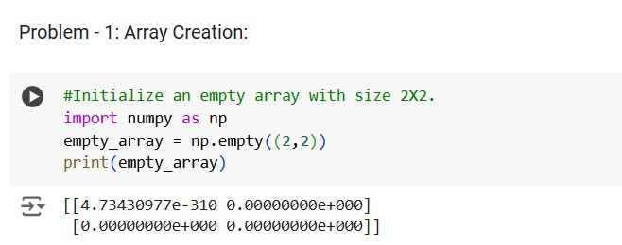
- Initialize an all one array with size 4X2.
=>
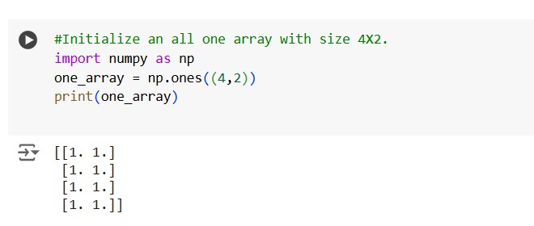
- Return a new array of given shape and type, filled with fill value.{Hint: np.full}
=>
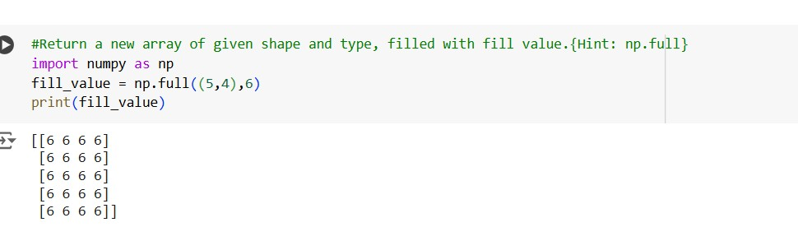
- Return a new array of zeros with same shape and type as a given array.{Hint: np.zeros like}
=>
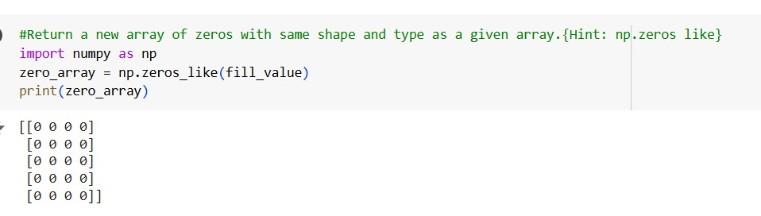
- Return a new array of ones with same shape and type as a given array.{Hint: np.ones like}
=>
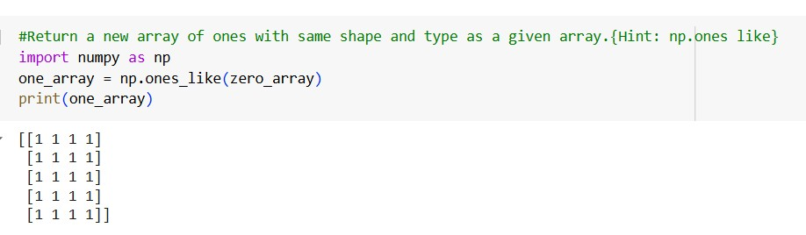
- For an existing list new_list = [1,2,3,4] convert to an numpy array.{Hint: np.array()}
=>
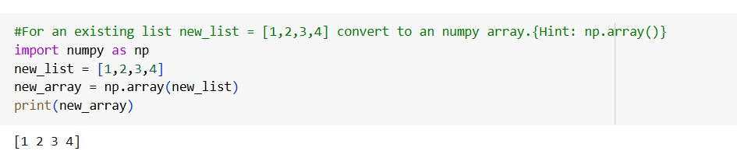
4.1.1 Problem - 2: Array Manipulation: Numerical Ranges and Array indexing:
Complete the following tasks:
- Create an array with values ranging from 10 to 49. {Hint:np.arrange()}. =>
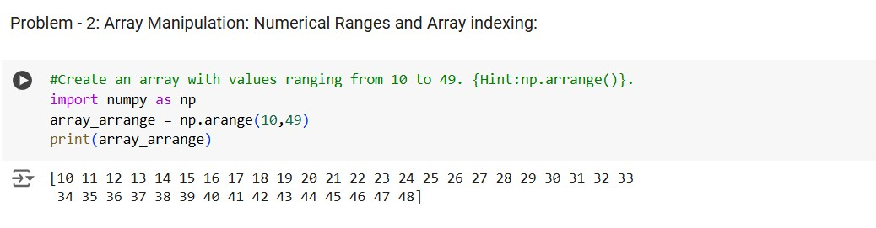
- Create a 3X3 matrix with values ranging from 0 to 8.
{Hint:look for np.reshape()}
=>
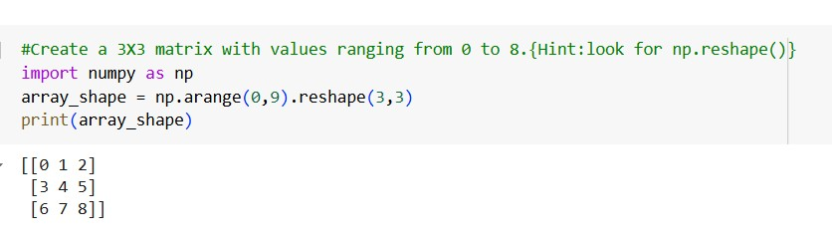
- Create a 3X3 identity matrix.{Hint:np.eye()}
=>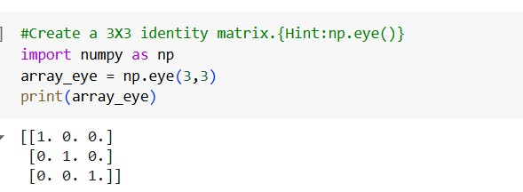
- Create a random array of size 30 and find the mean of the array.
{Hint:check for np.random.random() and array.mean() function} =>
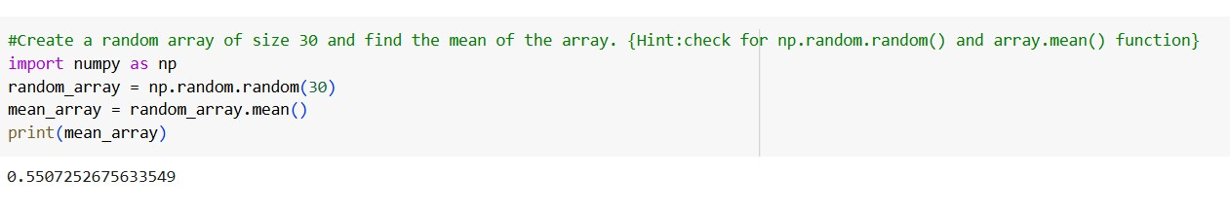
- Create a 10X10 array with random values and find the minimum and maximum values.
=>
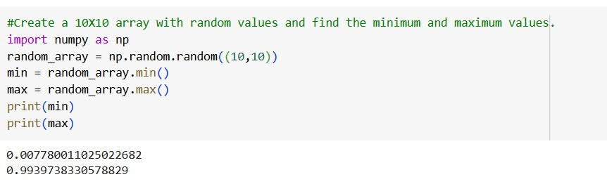
- Create a zero array of size 10 and replace 5th element with 1. =>
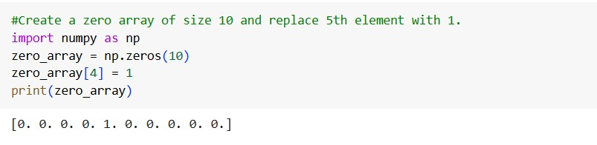
- Reverse an array arr = [1,2,0,0,4,0].
=>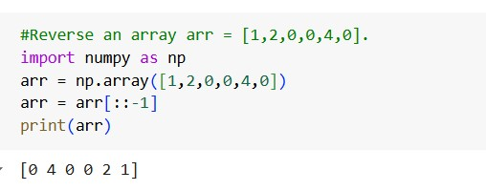
- Create a 2d array with 1 on border and 0 inside.
=>
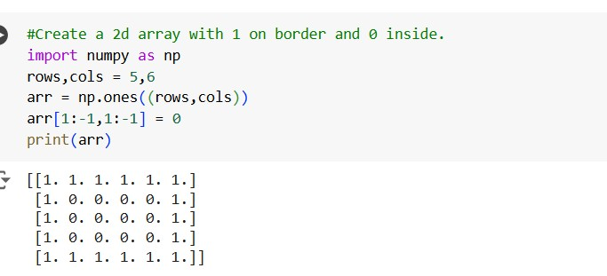
- Create a 8X8 matrix and fill it with a checkerboard pattern. =>
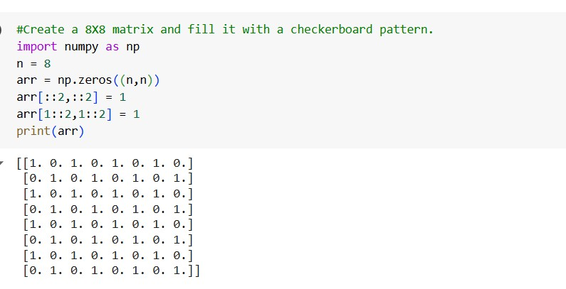
9

5CS037 Worksheet - 1: Coding Exercise on Numpy. Siman Giri

Problem - 3: Array Operations:
For the following arrays: x = np.array([[1,2],[3,5]]) and y = np.array([[5,6],[7,8]]); v = np.array([9,10]) and w = np.array([11,12]); Complete all the task using numpy:
- Add the two array.
- Subtract the two array.
- Multiply the array with any integers of your choice.
- Find the square of each element of the array.
- Find the dot product between: v(and)w ; x(and)v ; x(and)y.
=>
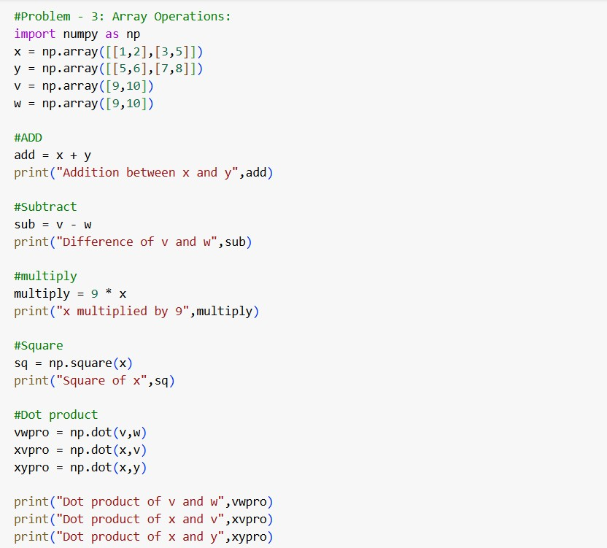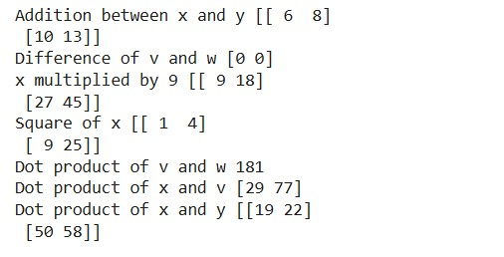

- Concatenate x(and)y along row and Concatenate v(and)w along column. {Hint:try np.concatenate() or np.vstack() functions.
- Concatenate x(and)v; if you get an error, observe and explain why did you get the error?
=>

& 7 ANS
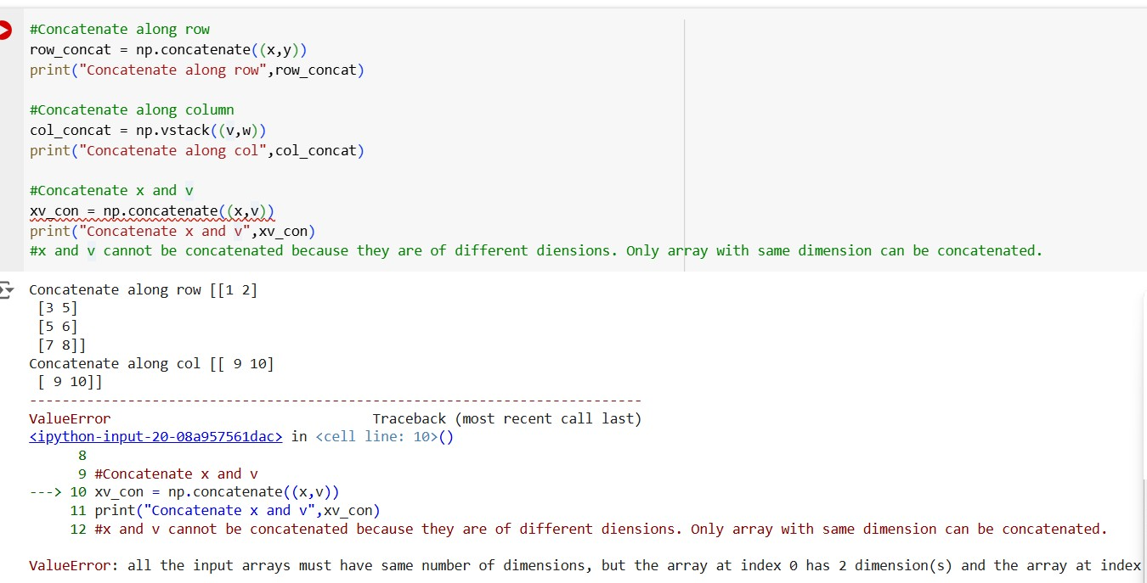
Problem - 4: Matrix Operations:
• For the following arrays:
A = np.array([[3,4],[7,8]]) and B = np.array([[5,3],[2,1]]); Prove following with Numpy:
- Prove A.A−1 = I.
=>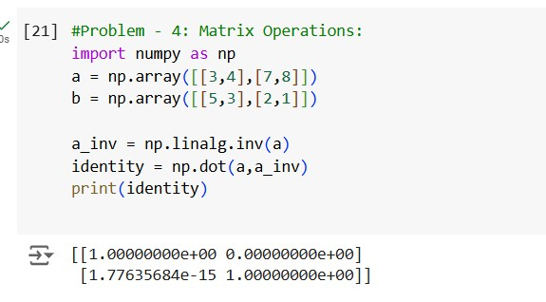
- Prove AB ≠ BA.
=>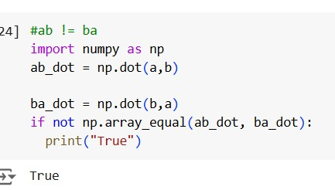
- Prove (AB)

T = BTAT
.=>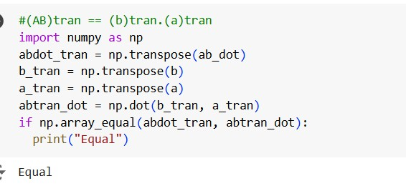

- Solve the following system of Linear equation using Inverse Methods.

2x − 3y + z = −1 x − y + 2z = −3
3x + y − z = 9

{Hint: First use Numpy array to represent the equation in Matrix form. Then Solve for: AX = B}
- Now: solve the above equation using np.linalg.inv function.{Explore more about ”linalg” function of Numpy}
=>
